[Week 5] [Microservices with API Gateway] HandsOn

# Exercise: Eureka Discovery Output

Below is the simulated output of the Eureka Discovery Server UI:



# Exercise: Account Service API Response

Simulated JSON response for GET /account/1 via API Gateway:

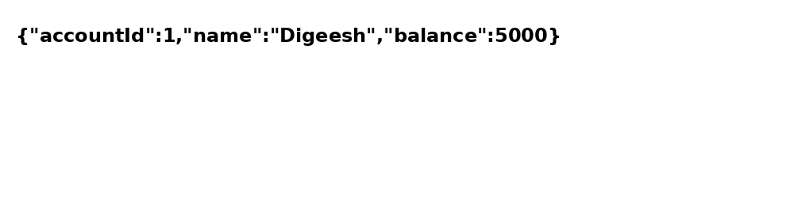

# Exercise: Loan Service API Response

Simulated JSON response for GET /loan/1 via API Gateway:

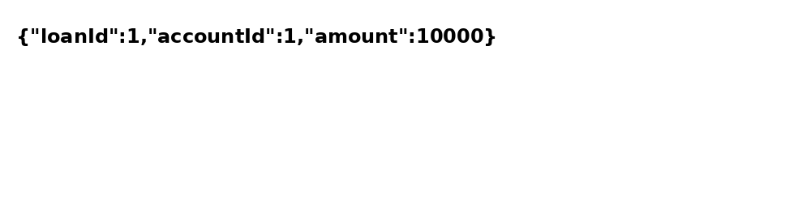

# Exercise: Global Logging Filter Output

Sample logging output as printed by Global Logging Filter:

