Scenario 1: Employee Salary Analysis
Ramishahope Artificial Intelligence Pvt Ltd
36, Old Anandas, SG Arcade, Marudhamalai Main Road, Vadavalli, Coimbatore -641041.
+91 6385383227 | www.hopelearning.net | mdaravind@hopelearning.net | 33AAMCR3722R1ZU
Question:
Find the names and salaries of employees who earn more than the average salary in the company.
Answer:
select * from employees;
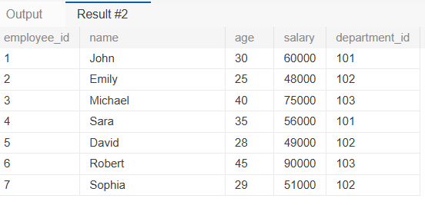
select name,salary from employees where salary > (select AVG(salary) from employees);
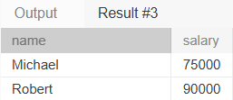

Scenario 2: Customer Orders without Matching Records
Question:
Retrieve a list of customer names who have not placed any orders.
Answer:
select * from orders;
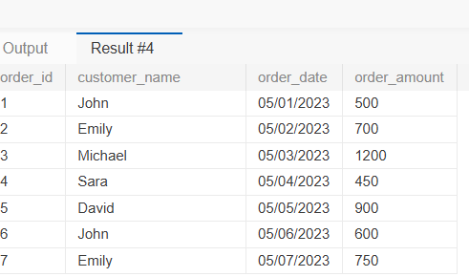
select * from orders where order_date IS NULL;
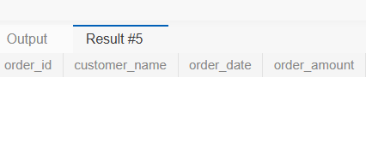

Scenario 3: Product Sales Summary
Question:
Display the total sales amount for each product.

SELECT products.product_name, sum(sales.amount) AS total_sales_amount FROM products

LEFT JOIN sales ON products.product_id = sales.sale_id GROUP BY products.product_name;

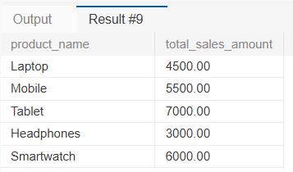

Scenario 4: Department-Wise Employee Count
Question:
List each department name with the number of employees working in it.
SELECT departments.department_name,sum(employees.employee_id) AS No_of_employees from departments
LEFT JOIN employees on departments.department_id = employees.department_id GROUP BY departments.department_name;
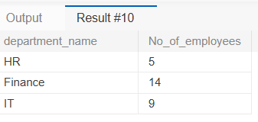

Scenario 5: Top 3 Highest Sales
Question:
Find the top 3 highest sales transactions.

Select * from sales order by amount desc LIMIT 3;
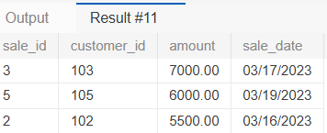

Scenario 6: Calculate Employee Salary Ranks by Department
Question:
Write a query to display each employee’s name, department name, salary, and their salary rank within their respective department.
SELECT e.name, d.department_name, e.salary,
RANK() OVER (PARTITION BY e.department_id ORDER BY e.salary DESC) AS salary_rank
FROM employees e JOIN departments d ON e.department_id = d.department_id ORDER BY salary_rank;



