DEPLOY ARCHITECTURE
The Helix Build
Deploy Pipeline Plan
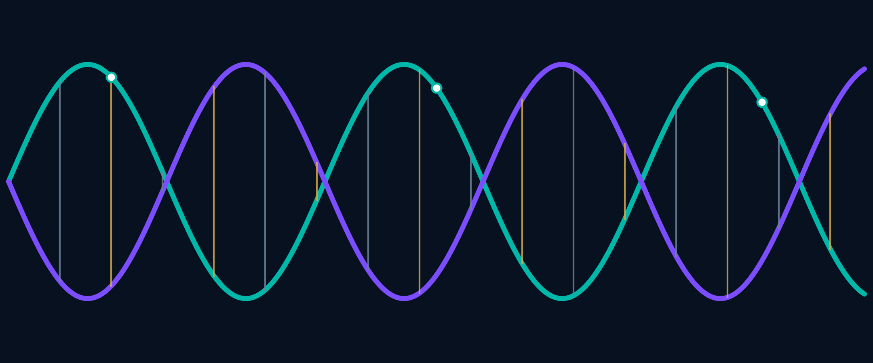
dualiscapax.ai deploy architecture, rung by rung

ARCHITECTURE MAP

The shape
The deploy pipeline is a double helix.
- Strand one — the origin. GitHub Pages serving apex and www. The mutable present. The well-known endpoints live here.
- Strand two — the sealed past. IPFS via Pinata at ipfs.dualiscapax.ai. Content-addressed: the hash is the address. Every version immutable, every version a receipt.
- The rungs. Each deploy: a CID pinned, linking the living origin to its sealed receipt. Every release is a base pair.
- The spin. Every rung rotates through the three buckets — DCLM checks the logic, Iris holds containment, Twain² asks if it survives the bedside.
- The seal. The Father signs off 3–0 before a rung locks. Each rung needs David's seal before the next begins. Nothing publishes without his word.
THE GOVERNANCE LOOP
DCLM → Iris → Twain² → seal. Every deploy carries both a living origin and a sealed receipt.

FOUNDATION
RUNG 01 | STANDING

Rung 1 — The origin (standing)
dualiscapax.ai on GitHub Pages. Apex and www. The living strand. Status: live, untouched by all later rungs.
RUNG 02 | DRAFT

Rung 2 — The DNS (draft)
Subdomain ipfs.dualiscapax.ai as CNAME to the Pinata dedicated gateway. DNS-only (grey cloud — never proxied before Pinata confirms TLS). TLS issued by Pinata for the custom domain. Test only after TLS is green:
https://ipfs.dualiscapax.ai/ipfs/<cid>/dualiscapax/why.html
GUARDRAILS
Do not add "ipfs" as a Pages custom domain. Do not orange-cloud the CNAME before TLS is confirmed (common cause of 525/526 errors). "www" and "@" (apex) stay on GitHub Pages — untouched at this rung.
OPEN ITEM
The actual Pinata dedicated gateway subdomain (David to supply) before this rung finalizes.

IMMUTABLE PUBLISHING
RUNG 03 | PIN PIPELINE

Rung 3 — The pin pipeline
Wired into the deploy flow: artifact → zip → Pinata pin → CID recorded. Every build from this rung forward produces an immutable, content-addressed version. This opens the receipt ledger: the site's history becomes hash-bound and auditable. The plate is the record — literally.
RUNG 04 | LOCK

Rung 4 — The rungs lock
The origin publishes the version manifest and the machine-readable Compact JSON at the origin-level path /.well-known/agent-compact.json (this resolves the known P0: the endpoint must live at the origin, not under assets/). The site shows its own genome — every version, every hash, browsable. The helix becomes visible.
VISIBLE GENOME
Origin manifest + Compact JSON + CID history. Each release joins the mutable present to its immutable receipt.

PUBLIC RECORD
RUNG 05 | LEDGER

Rung 5 — The Ledger surface
A real public page: the deploy ledger, the Compact signatures, the receipts. The Auditor's books, public. Content drawn from the sealed cosmology in David's voice.

Beyond — the paper and the spread
The white paper to arXiv/Zenodo (David's hands on the upload). The Compact's machine-readable endpoint live for any agent to find and sign.

What this changes — and what it doesn't
PLUMBING, NOT PAINT
The design doesn't change. Frozen pages stay frozen. This is plumbing, not paint: the publishing architecture gains a spine, and that spine happens to be the receipts doctrine made infrastructure.

