**Branch User Audit App**

This app was written in order to fulfil an audit request of terminated users. The Requests are submitted by the compliance team and will always contain the username(s) for whom we are to search. The username should always be in the format bbb-username. The app functions by executing multi-threaded jobs each contacting a production branch and searching for the username(s) provided by the user. The end-result is a combined xlsx file dropped on the users’ desktop.

The below sections are for setup and use instructions.

**Setting up to use the app**

We need to associate Powershell with .ps1 files. Strangely, in our version of windows, this is not the default and we must select it. The following process should only need to be completed one time.

1. Right click on one of the .ps1 files in the Branch_User_Audit folder on your machine.
2. Move down to the “Open with” section.
3. Select the “Choose another app”. 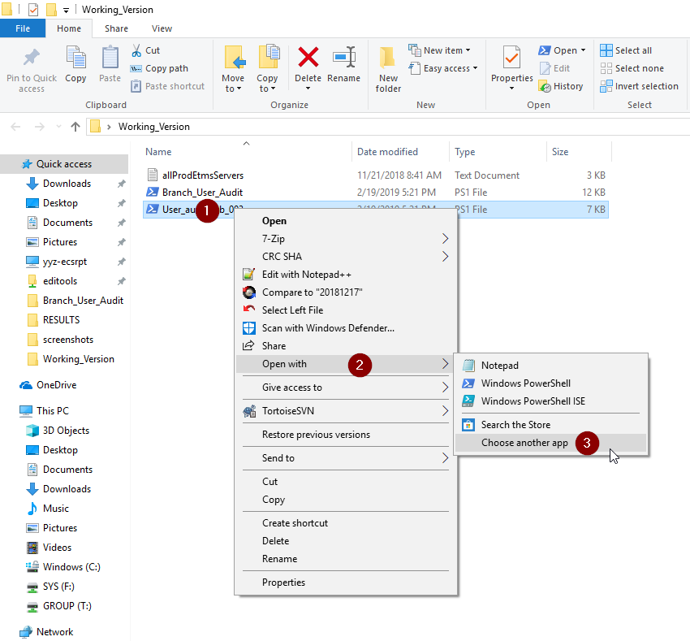
4. In the new window select the “Always use this app to open .ps1 files” checkbox.
5. Select “More apps.”  
    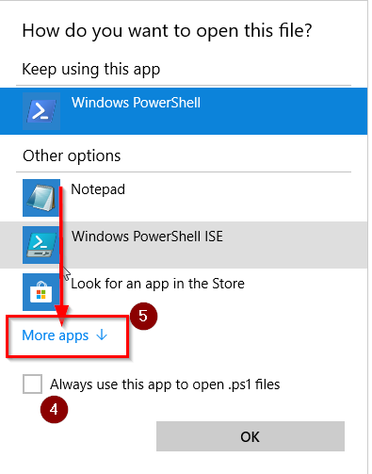
6. Scroll all the way down and select “Look for another app on this PC”. 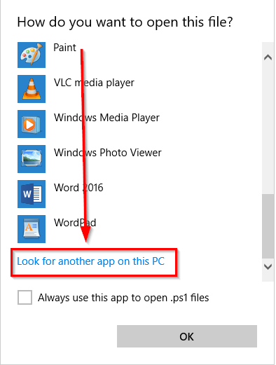
7. In the new window address bar, enter “C:\Windows\System32\WindowsPowerShell\v1.0.”
8. Select “powershell.”
9. Select “Open”. 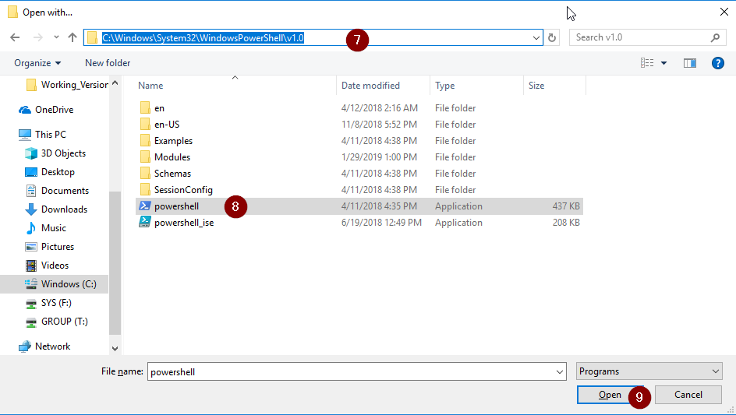
10. .ps1 files should now be associated with powershell instead of Notepad.

**Using the App**

Once you have the setup portion done, you should be able to use the app without issues. The app is very automated and requires very little input or work from the operator.

1. Doubleclick on “Branch_User_Audit.ps1” in the Branch_User_Audit folder on your desktop.
2. In the popup window you will need to provide a User Name and Password. You can use either your CHQ id and password(if you have a chq unix login) or the mpesup username/password. 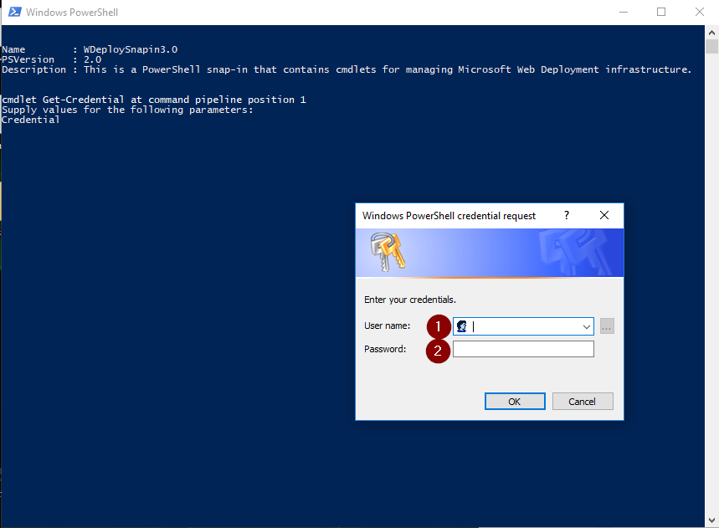
3. At the next promts, you will be asked for the username(s) you are searching for. Type them in and hit enter after each. Hit enter after you enter the final name to kick off the search. 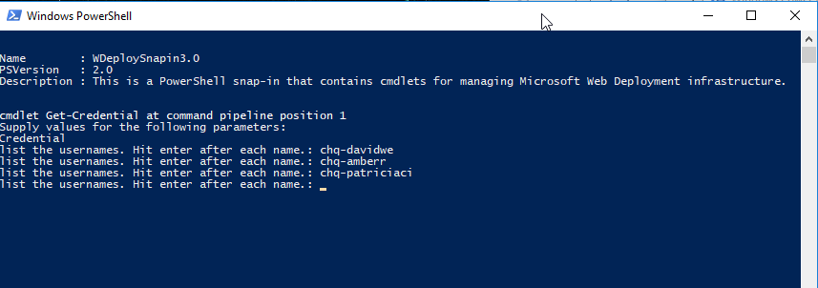
4. The app will then proceed to search every branch for the usernames povided. You will see a lot of action on the screen, but you can minimize. 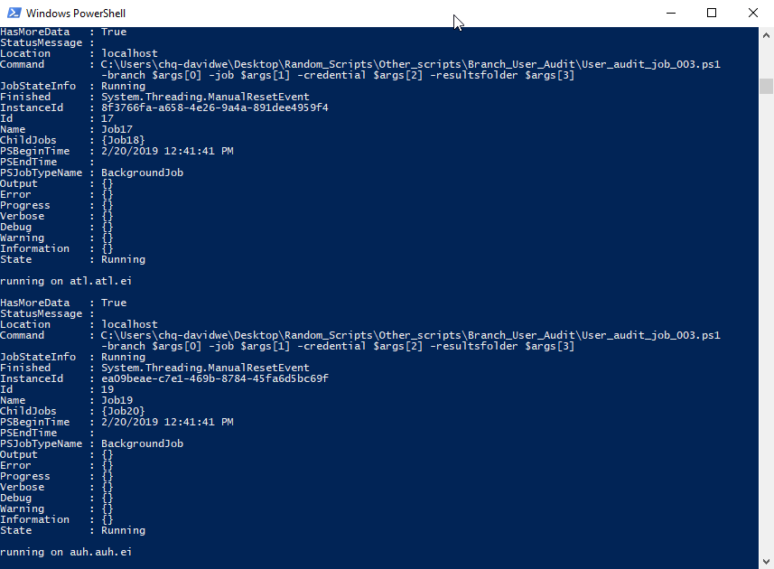
5. When Finished, a Message box and warning sound will occur and will show you where your results are. 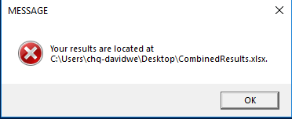
6. You can open your results the same as any Excel file. Each branch with results will have its own sheet in the file.

**The Results File**

The Results set comes out as a multi-sheet xlsx workbook. Each Worksheet is a single branches results’. Only branches where results are found will create a worksheet. There are ten columns in each data set. They are defined as follows:

File: This is the filename where the username is found. This helps to determine the specific date of the login occurrence.

/logs/tipsi/tipsi.log.20190117.gz:2019/01/17 –highlighted portion shows the file name and location.

/logs/tipsi/tipsi.log.20190117.gz:2019/01/17 –highlighted portion shows the date of the action.

Time: Shows the Time in HH:MM:SS the event occurred. The time is shown in a 24hr scale.

PID: This is the user’s specific Process ID associated with their session on the server.

Action: This shows if the action was a true login into a legacy application.

User: Shows the Username(s) found on the branch. In cases where you are searching for multiple users, it is possible to have more than one username on a worksheet.

SystemUser: The System level username recognized by the legacy app.

SystemInitials: The system level initials of the account loggin in.

Delete1: An artifact of the process. This column can be deleted if needed.

Delete2: Delete1: An artifact of the process. This column can be deleted if needed.

Program: Shows the program accessed by the user.

**Troubleshooting**

If you find you are not getting results files at all, its most likely due to the fact there are no results to find. You can test this by searching for yourself. If you are experiencing other error messages, please contact [david.weber@Expeditors.com](mailto:david.weber@Expeditors.com).