# 

Field Data Collection Protocol

# Introduction

This document *must be read* prior to starting any field data collection for the SWOT, which makes use of paired and time-stamped water quality data from both distribution points (initial measurements) and households (follow-up measurements) across a site. Please visit the SWOT website for any further information on the tool and its application and for any questions regarding implementation please contact the SWOT support desk here: [support@safeh2o.app](mailto:support@safeh2o.app).

# Organizing data collection

Data collection teams need to be organised to ensure a good spread of time intervals between initial and follow-up measurements. These intervals can only be determined from knowledge of the context, principally how long people are keeping water at the household. Guidance is given in the document ‘*Measurement Interval and Team Organization Guide’*, which can also help team leaders to create a simple schedule suitable for the site that their teams are working.

# Equipment needs

Required items:

* The means to measure free residual chlorine (FRC) in milligrams per liter (mg/L) – ideally a digital meter with resolution to two decimal places will be used,
* An accurate watch or other clock – all times must be entered in 24-hour format,
* A jug or other sample receptacle – a clear plastic 1L measuring jug is ideal,
* A means to record data – this can be done on the hardcopy form (see below) using pen and paper, or via a mobile data collection platform (such as KoBo), using a phone or tablet[1],
* The means to measure water temperature and electrical conductivity[2] (using the units given below).

Other (optional) items:

* Numbered ‘calling cards’ – these can be used to ensure the correct households are visited for the follow-up measurements.

# Field data collection protocol

PART 1: At the distribution point

1. Select a water distribution point at random or according to a predefined schedule - ensure that people are using (or approaching) the site to take water,
2. Ask someone for their consent to carry out water quality measurements later at their household (use the *Verbal Consent Script* below as guidance on what to say),
3. Flush the tap for at least 10 seconds before sampling,
4. Take a sample of water (approx. 250ml) from the tap in a clean container – a plastic 1L measuring jug is ideal – and continue to let the person take water as normal,
5. Enter the current time and date – using the correct format (*yyyy-mm-dd & hh:mm*),
6. Measure and record the free residual chlorine (FRC) of the water sample using the method appropriate to the equipment being used, making sure to properly rinse the sample vial with the water to be tested prior to taking a sample,
7. Measure and record the water temperature, using degrees Centigrade (0C) and the electrical conductivity, using micro-Siemens per centimeter (µS/cm),
8. Ask the person where they live and make sure you will be able to find their house again – if necessary, and after asking permission, make a small mark on the side of the container they have used so you can be sure to find the same one later on,
9. You can also hand them a numbered *Calling Card* if you want to ensure that you find the right household again,
10. Tell them to use the water as they normally would and that there is no problem if they finish it, you will return at some point to make more measurements.
11. If you are using a mobile data collection solution, then DO NOT finalise the form but save it for later.

PART 2: At the household

1. Return to the same house that you identified in Part I at the pre-determined time,
2. Ask the householder for the calling card that you gave them before (if you used this system) and check that the calling card matches the number you recorded on the data form,
3. Verify that consent has been given for this part of the survey – if the householder refuses then end the survey and don’t make use of this data,
4. Enter the current time (24hr) and date – using the correct format (yyyy-mm-dd & hh:mm),
5. Confirm that all or part of the water is the same as that which was tested at the tapstand, if not then end the survey,
6. Note if the water has been mixed with other water, answer ‘Yes’ on the form and continue to make the water quality measurements,
7. Take a sample of the water (100ml should be enough) into a clean container and carry out the FRC measurement using the same procedure you used before,
8. Thank the participant and then finalise the form if you are using mobile data collection.

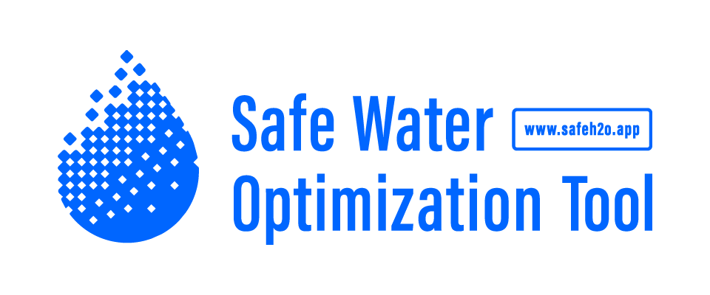

Verbal Consent Script - *example*

Hello, my name is _______________________ , and these are my colleagues ___________________________ , we work for *name of organization here*, who are helping this community by providing water and monitoring its quality. You have been chosen at random for this data collection and you can refuse to participate at any time. This will not influence the nature of your relationship with *name of organization here*. We would like to inform you that no one is being paid or charged for participating in this data collection. We hope to improve the quality of the water that you are being supplied to make it as safe as possible for you and your family to use.

**If you agree we would like to do the following:**

* Take some basic water quality measurements here at the tapstand,
* Accompany you to your home so that we can return later, either today or tomorrow to make some follow-up water quality measurements.

Please continue to collect and use water as you normally do. We will record these practices, and this should all take about 15 minutes of your time.

**Possible Discomforts:**

* We require a small amount of water from you in order to carry out the tests and might need to make a small, non-permanent mark on your container.

*Name of organization here* is committed to maintaining the highest standards of confidentiality:

* We do not record or keep your name, address or the location of your home,
* We store all data securely, and,
* We only allow researchers or those supplying and treating water to access the data.

*Name of organization here* respects your choice to refuse to participate at any point.

Thank you for your cooperation!

1. Additional resources and guidance are available if a project team wants to use KoBo Collect or another mobile data platform for data collection in the field.
2. Ideally these measurements will be made as well as FRC, although they are not obligatory for the SWOT analysis.