**Team Members**

|  |  |
| --- | --- |
| M Ali Ahmed | BSCS13016 |
| Moazzam Shoukat | BSCS13032 |
| Ahmad Nawaz | BSCS13046 |

**Problem Domain**

Currently the food apps and paper menu which exists are quite limited like there is no way to show a new introduction of deal. They have to reprint the whole paper menu and distribute. Usually it does not make sense what is on the menu people cannot visualize the food ordered that will appear in front of them.

**Initial POV**

Initially we met with a girl who go out and eat. We also met a person who sets up the menu and manages new deals

We also met a restaurant owner.

There needs were to have a better visual app to make food ordering system a better experience.

We then interviewed more people who go out and eat.

We contacted people from facebook restaurant pages where they have posted food pictures and people commented on them.

We interviewed them about how they find this service better than other services like paper menu or other apps

We met person who usually order food online and get it deliver at home

We met the person who sets up new menu and manages the new deals and promotions.

We also met usman at advertising department of restaurant who manages the advertising of restaurants deal on facebook and instagram.

We also met a salman who go out and eat at a restaurant.

Salman said he need a better digital menu app because they cannot visualize a new food deal before ordering and it would be game changing if it will be built now.

Usman said that he has to manage and advertise deals on fb, magazines especially in ramadan. He has to deal with other advertising agencies

He said it they need a system where they can themselve manage the backend and their deals come front end it would be game changing if they get this type of thing.

**HMW**

1. HMW built something to show the pictures of food items

2. HMW show actual pictures

3. HMW take pictures

4. HMW bring customers and restaurant on board

5. HMW take orders

6. HMW use tech to help us

7. HMW build a better UI and UX

8. HMW market it

9. HMW use AI to recommend food

10. HMW design our app

HMW we make website

1. HMW make app page
2. HMW get customers
3. HMW appearance on social media
4. HMW give special deals
5. HMW give discounts and rewards to users
6. HMW market the restaurant page

3 best HMWs were

1. HMW make app
2. HMW we set up pages
3. HMW build a better UI and UX

**Three Experience Prototypes:**

We looked into the HMWs and povs the requirements were going in the right direction of our problem domain. We saw that the competitors were having food ordering system but none was offering the food menu.

We made the prototype on photoshop and corel draw.

We tested the front end of prototype only among our friends.

We got some good feedback on UI.

To add more pictures of food. To add customers photo reviews etc. to use social reviews from facebook.

Our assumption were valid but new assumptions obviously emerged. Like to make a simple app. No color popping etc. but big food pictures were really appreciated on the whole.

We also learned that people going to dine in also wanted this type of app to look at food an recommended deals.

* 1)

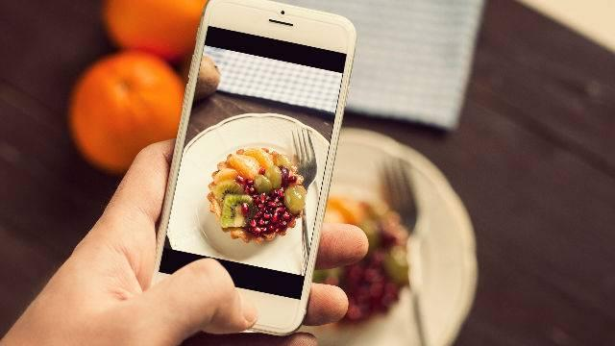

* 2)

