**Configuration and Deployment Document**



**Product Name : guildKraft**

**Version :**

**Team Members:**

|  |  |
| --- | --- |
| **System Architect** | Suresh Balabisegan |
| **Development Lead** | Dhivya Shanmugaraj |
| **Developers involved** | 1. Dhivya Shanmugaraj 2. Prabhu P |
| **System Administrator** | Suresh Balabisegan |
| **Database Administrator** |  |
| **Project Manager** |  |

**Start Date:**

**End Date:**

**Description:**

The main objective of this proposal is to create and organize meetings and events efficiently and quickly with less complexity manner. This system was developed by the simple and most powerful architect plan. The goal of this project is to achieve the organization’s objectives by aligning the business processes with these objectives and to continually improve these processes. This system gives a fully automated business process.

**Configuration and Deployment:**

1. **Windows Configuration:**

Install the windows or windows server using default configuration.

1. **Application Server Configuration:**

**JBOSS Configuration:**

**Step 1:** Copy the jboss folder from disk and paste it your C: Drive File Name on Disk: **jboss-4.2.2.GA_8380**

**Step 2:** After copy past the jboss in your system jboss path like this, Jboss Path on your system: **C:** **\jboss-4.2.2.GA_8380**

**Step 3:** Copy the WAR file from disk on below location EAR Path on Disk: \ WAR File\ guildKraft.war

**Step 4:** Paste EAR file into below location on your system **Path: C:\jboss-4.2.2.GA_8380\server\default\deploy**

**Step 5:** Open the file “gldkt-mssql-ds.xml” inside the below location.

**Path: C:\jboss-4.2.2.GA_8380\server\default\deploy**

**Step 6:** Change the password to your database server password.

Ex: “<password>**digiBlitz@12345**</password>”

**Step 7:** Open the bin folder on your jboss the path like this

**Path: C:\jboss-4.2.2.GA_8380\bin**

**Step 8:** Double click the “run.bat” file on above bin folder

**MS SQL Configuration:**

**Step 1:** Open the “guildKraft_DataBase” folder on the disk.

**Step 2:** Copy the files from **“EID-DIGIBLITZ-TEST”** location.

**Step 3:** Paste file into the below location on your system.

[Note: Make sure SQL 2012 Server installed]

Path: C:\Program Files\Microsoft SQL Server\MSSQL11.SQLEXPRESS\MSSQL\DATA

**Step 4:** Open the SQL server on your System

**Step 5:** Right click the database folder on the SQL server and select Attach option.

Now new Dialog box will open.

**Step 6:** Click Add button on the new dialog box

**Step 7:** Select the file from opened list, which you paste on “Step 3” location.

**Step 8:** Finally Click Ok.

**Eclipse Configuration:**

**Note 1:** Check your system is a 32bit processor or 64bit processor. If your system is 32, you can copy and paste the eclipse_32 folder or (64) you can copy and paste the eclipse_64 folder

**Example 1:** Consider your system is 32bit processor, now installation steps are bellow

**Step 1:** Copy the eclipse Folder from disk and paste into your C: Drive File Name on Disk: eclipse_32

**Step 2:** copy past the eclipse in your system eclipse path like this, File Name on Your System: C:\eclipse_32

**Java Configuration:**

**Note 1:** Check java is already installed on your system. If java already installed, leave it below steps. You don’t have java Please follow below steps.

**Note 2:** Check your system is a 32bit processor or 64bit processor. If your system is 32, you need to open **“JDK_6u23_32”** folder double click **“jdk-6u23-windows-i586.exe”** file to install the JDK or (64) you need to open **“JDK_6u23_64”** folder double click **“jdk-6u23-windows-x64.exe”** file to install.

**Example 1:** Consider your system is 32bit processor, now installation steps are bellow

**Step 1:** Launch the installer. If User Account Control given a security warning click the **“Yes”** button. The installer should begin loading. Please be patient.

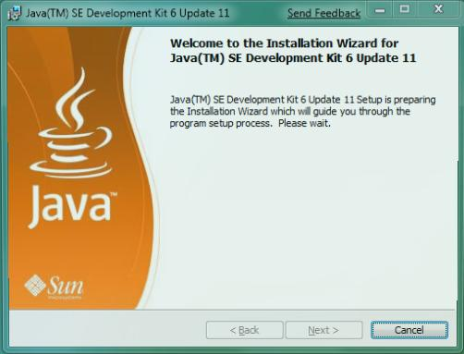

**Step 2:** Eventually you will be presented with an End User License Agreement (EULA). Read it before clicking the **“Accept >” button.**

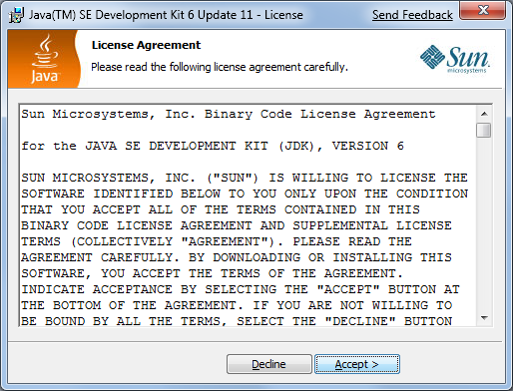

**Step 3:** For this course, a default installation is completely fine, so just click the **“Next”** button.

**NOTE:** Pay attention to the **“Install to:”** location, you will need it later.

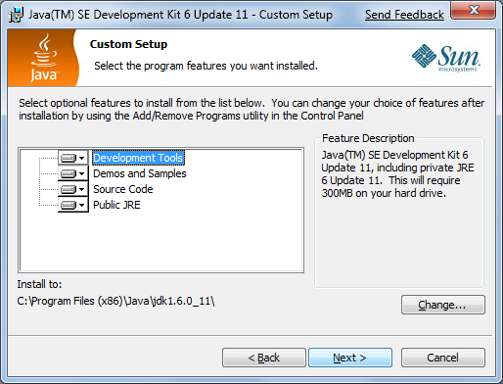

**Step 4:** Be patient while Java installs the JDK.

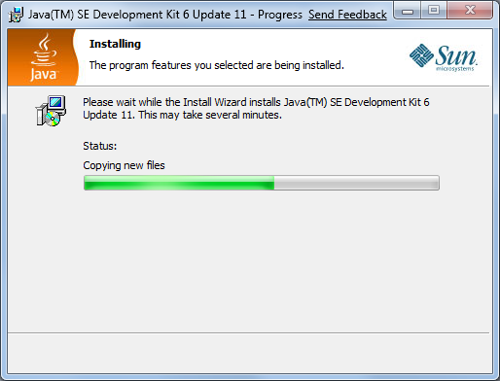

**Step 5:** You will then be asked to install the Java Runtime Engine (JRE.) Click the **“Next >”** button.

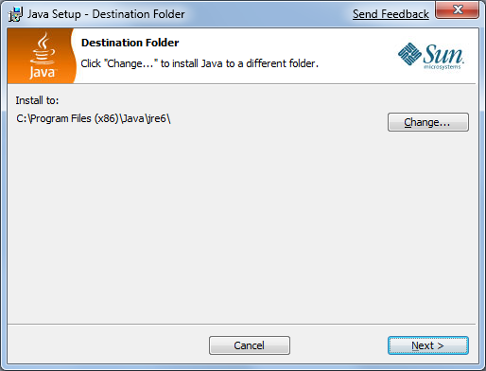

**Step 6:** Be patient while Java installs the JRE.

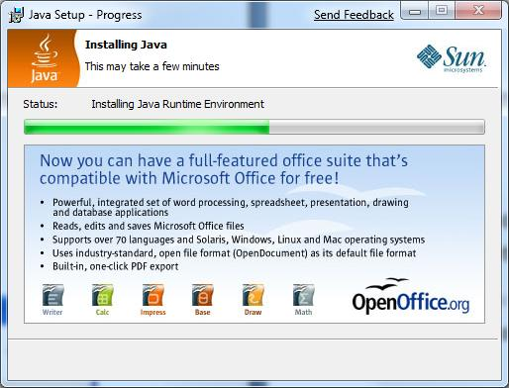

**Step 7:** You are now done installing Java. All that is left is configuration.

**Note:** You may be asked to reboot your computer at this point. If you are, please do so.

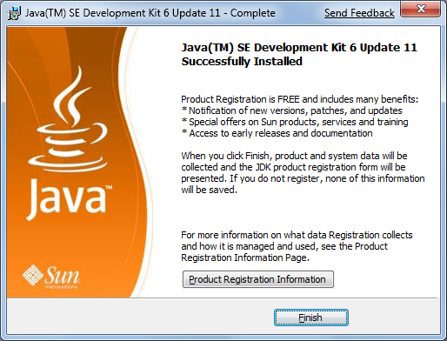

# Environment Settings:

## Path Settings:

**Step 1:** Now load the System Information Window by right clicking on “Computer” in the start menu and selecting properties.

**Note:** This step can be done in other ways too. Such as…

• Right clicking on Computer on the desktop and selecting properties.

• Holding the Windows-key () on your keyboard and pressing the “Pause” key.

(This may require holding FN on some laptops.)

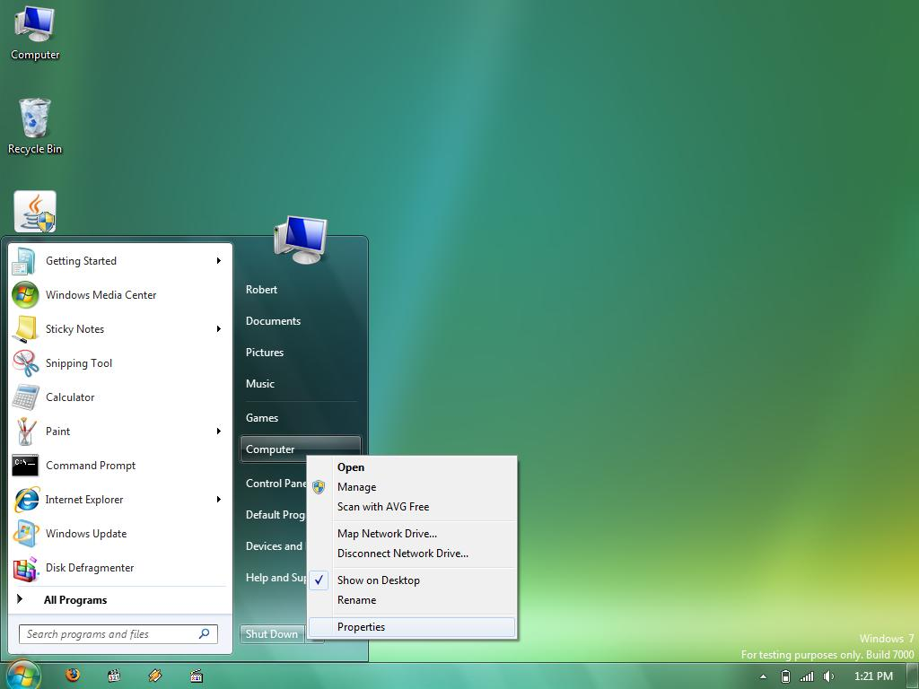

**Step 2:** The System Information Window should load.

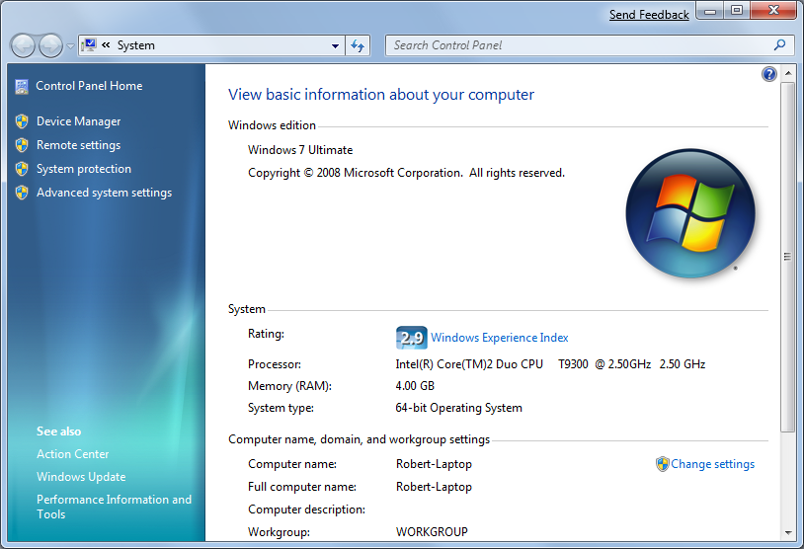

**Step 3:** Click on **“Advanced system settings”** on the left of the window.

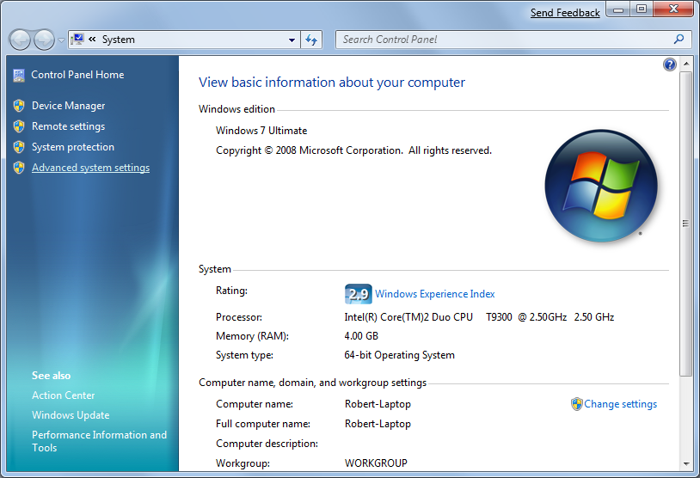

**Step 4:** The System Properties window should open with the **“Advanced”** tab already selected. Click on **“Environment Variables”** button.

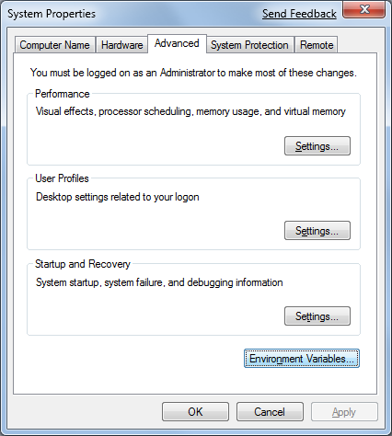

**Step 5:** The **“Environment Variables”** dialog should load.

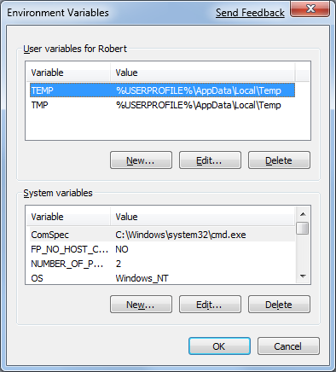

**Step 6:** In the **“System variables”** region, scroll down until you see the **“Path”** variable.

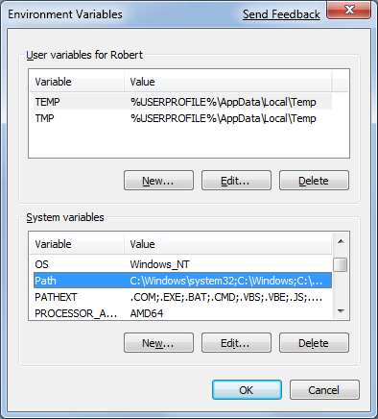

**Step 7:** Click the lower **“Edit”** button.

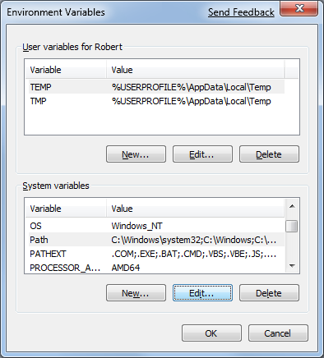

**Step 8:** You should now be editing the **“Path”** variable.

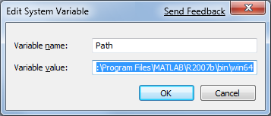

**Step 9**: Remember the “Install to:” location on Step 12? That is the line you need to add to the  **end**of the path. Be sure to prefix the location with a **;** and post fix it with **bin**

Therefore you want to add:

**;<YOUR_INSTALL_LOCATION>bin**

On MY computer, a Windows 7 beta x64 machines where I installed the 32-bit JDK, that meant:

**; C:\Program Files (x86)\Java\jdk1.6.0_11\bin**

**WARNING: BE VERY CAREFUL**

**NOT TO OVERWRITE ALL THE EXISTING ENTRIES IN YOUR PATH!**

**Step 10:** Click the **“OK”** button to confirm your change.

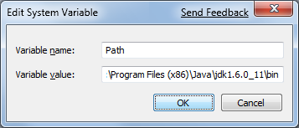

**Java Home Configuration:**

**Step1:** Under System Variables, click **New**.  
**Step 2:** Enter the variable name as **JAVA_HOME**  
**Step 3:** Enter the variable value as the installation path for the Java Development Kit as something like this **C:\Program Files\Java\jdk1.6.0_45**

[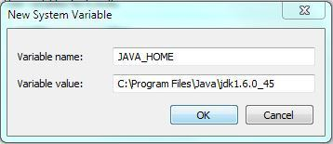](http://kaanmutlu.files.wordpress.com/2013/04/set-java-home-1.jpg)

**Step 4:** Click **OK**.

[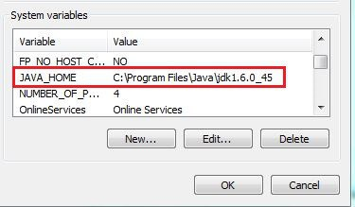](http://kaanmutlu.files.wordpress.com/2013/04/set-java-home-2.jpg)

**ELMT MODULER CONFIGURATION:**

**Ant configuration:**

**Step 1:** Copy the Ant Folder from disk and paste into your C: Drive File Name on Disk: **apache-ant-1.8.4**

**Step 2:** copy past the Apache Ant in your system Ant path like this, File Name on Your System: **C:\apache-ant-1.8.4**

**PostgreSQL Configuration:**

* Download the pgInstaller version to enable advanced installation options
* Use included wizard for installation
  + Within the install wizard select "install postgreSQL as service"
* ATTENTION: The page after "Initialize database cluster" (called "Enabled procedural languages") has to show PL/python (otherwise python installation failed. (Re-)Install PL/python.)
  + Ensure that PATH Enviroment variable is extended with "\bin"-folder of postgresql installation dir (e.g. "C:\program files\PostgreSQL\8.3\bin")
  + IMPORTANT: remember the password for windows user postgres and database. You will need them later...

**Python Configuration:**

Download here <http://www.python.org/download/releases/2.5.2> and install the Python version 2.5.2 using default configuration. Install 32bit-Pyhton also on 64bit Windows!

**IMPORTANT:** Use exactly this version

**Apache Configuration:**

**Step 1:** Copy the Apache folder from disk and paste it your C: Drive File Name on Disk: apache-tomcat-Version

**Step 2:** After copy past the Apache in your system Apache path like this, Apache Path on your system: C: \apache-tomcat-Version

**Step 3:** Copy the WAR file from disk on below location WAR Path on Disk: \ WAR File\oryx.war

**Step 4:** Paste WAR file into below location on your system Path: C:\ apache-tomcat-Version \ webapps

**Step 4:** Open the bin folder on your Apache the path like this Path: C:\ apache-tomcat-Version\bin

**Step 5:** Double click the **“startup.bat”** file on above bin folder

**Access on Browser:**

**Step 1:** Open the browser

**Step 2:** Type **“http://oe.guilkdkraft.com”**or **“http://www.guildkraft.com:8380/guildkraft”** then click enter. Now you will get the login screen of the guildKraft like this.

**Installed Configuration On Server:**

|  |  |
| --- | --- |
| Java | **Version:** JDK 1.6.0_23  **Installed Directory:** {Server Directory}:\Program Files\Java\jdk1.6.0_23 |
| Eclipse | **Version:** Eclipse Indigo 3.7.2  **Installed directory:** { Server Directory} |
| JBOSS | **Version:** jboss-4.2.2.GA  **Port:** 8080  **Installed directory:** { Server Directory} |
| Database Server | * **SQL Server:**   **Version:** MS SQL Server 2012 Express Edition  **Port:** 1433  **Installed directory:** { Server Directory}   * **SQL Server Studio:**   **Version:** MS SQL Server 2012 Management Studio  **Installed directory:** { Server Directory} |
| Apache-tomcat | **Version:** apache-tomcat-6.0.18  **Port:** 8380  **Installed directory:** { Server Directory} |
| PostgreSQL | **Version:** PostgreSQL 8.3  **Port:** 5432  **Installed directory:** { Server Directory} |
| Python | **Version:** 2.5.2  **Installed directory:** { Server Directory} |
| Apache-ant | **Version:** Apache-ant-1.8.4  **Installed directory:** { Server Directory} |