Sutradhar — Architecture, Code Walkthrough & Observation Guide
Day 10: Multi-Agent Systems & Orchestration | LangGraph + PydanticAI three-agent pipeline with routing and human review

How to use this guide. Read Sections 1–4 to understand the picture and the vocabulary. Run the code from the README. Use Sections 5–6 as a map while you read each file. Section 8 is the framework comparison (CrewAI and AutoGen are discussed, not run). Finally work through the 10 observation questions in Section 9 and record what you see in the log table.

1. The big picture in one minute
Like you’re 10: Yesterday’s assistant was one clever person doing everything. Sutradhar is a small office team. A receptionist (the router) looks at your question and decides if one quick answer is enough. If not, a researcher (retrieval agent) fetches the right pages, an analyst reads them and writes down what matters and what is risky, and a writer turns that into a neat report with sources. If the topic is serious, a manager (the human) has to say ‘go ahead’ before the writer starts. A checker looks at the report before you see it.
As an engineer: A LangGraph StateGraph is the orchestrator. It owns one shared State dictionary, eleven nodes and five conditional edges, and it is compiled with a checkpointer so it can pause and resume. Each worker (router, direct RAG, retrieval, analyst, writer) is a PydanticAI agent with one prompt and one typed output model. Plain Python (logic.py) makes every decision that does not need language: routing rules, risk rules, evidence selection and citation validation. The evidence is captured from the search tool itself, so no agent can invent a quote or a file name.
Day 10 in three sentences. (1) More agents are not automatically better: the router sends simple questions down a short path. (2) Agents hand work to each other through typed contracts, and code sits between them as a gatekeeper. (3) A graph with a checkpointer lets a human approve in the middle of a run and the run carries on from where it stopped.

1.1 System architecture
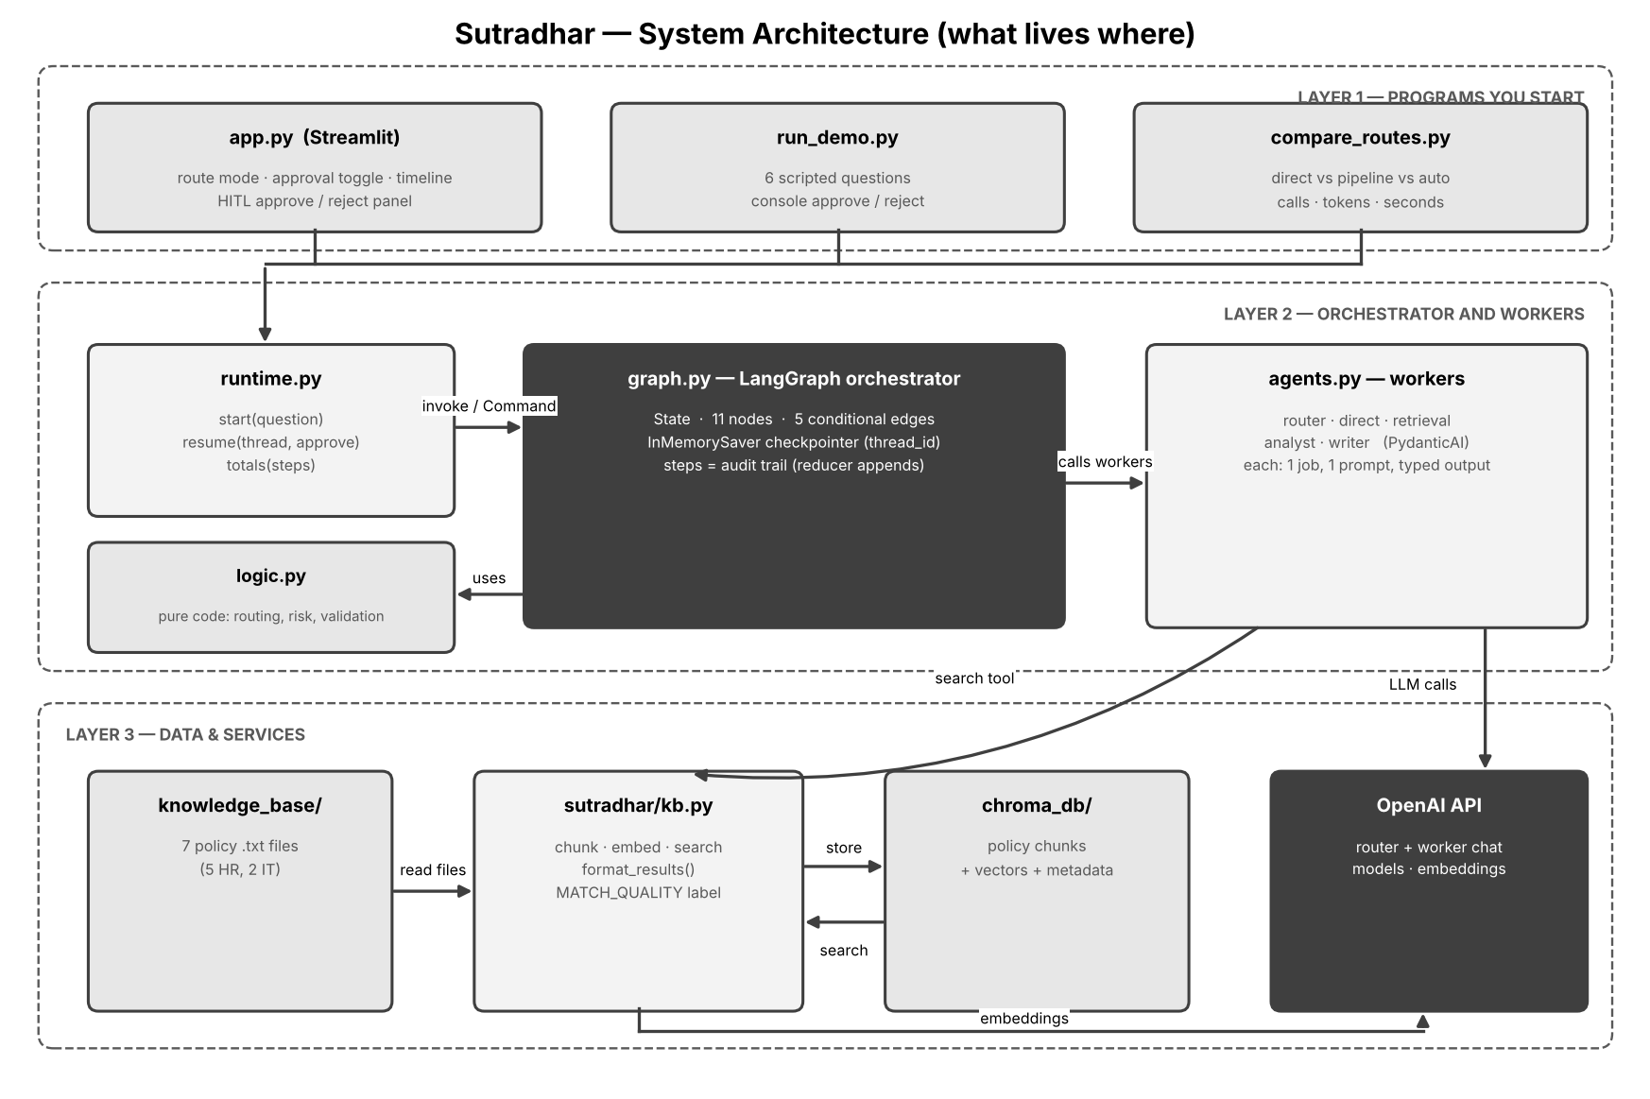
Layer 1 holds the programs you start. Layer 2 is the orchestrator and its workers. Layer 3 is storage and outside services. Every arrow is a real function call.

Box | Plain-language meaning
app.py (Streamlit) | The web page. Shows the route, the timeline of nodes, the evidence, the analysis and the report. Shows the approve / reject panel when the graph pauses.
run_demo.py | Runs six scripted questions through the same graph from the command line. Asks you to approve or reject when it pauses.
compare_routes.py | Runs five questions three ways (always direct, always pipeline, auto) and prints calls, tokens and seconds.
runtime.py | Two small helpers: start() runs a question until it ends or pauses; resume() continues a paused run with the human’s decision.
graph.py (LangGraph) | The orchestrator: State, nodes, edges, checkpointer. It decides what runs next but does little thinking itself.
agents.py (PydanticAI) | The five workers. Each has one job and one output type.
logic.py | Pure Python decisions: routing rules, review rules, evidence handling, validation. No LLM, no network, easy to test.
kb.py + knowledge_base/ + chroma_db/ | The RAG system from Modules 5–6: documents, chunking, embeddings, search.
OpenAI API | Chat models for the router and workers; the embedding model for search.

2. What happens on one question

2.1 One question through the graph
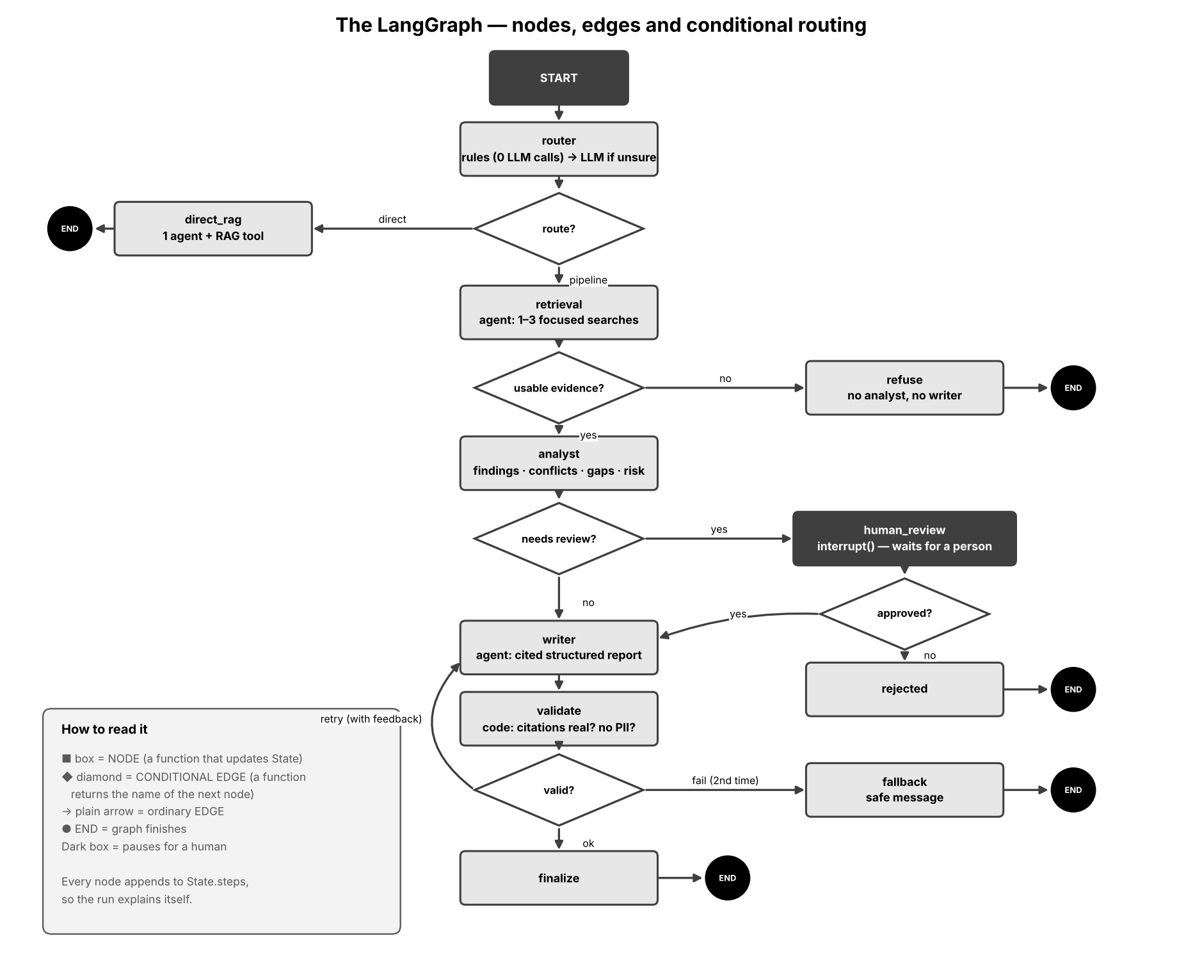

The graph has two exits for a simple question and four exits for a pipeline question. Read the table in order; the ‘Next’ column is decided by a conditional edge function in graph.py.
Step | Node | What happens | Next (edge function) | LLM calls
1 | router | Rules look at marker words, length and number of questions. If sure, decide with zero LLM calls. If not, ask the cheap LLM router. | after_router → direct | pipeline | 0 or 1
2a | direct_rag | One agent searches the knowledge base and answers with sources and confidence. | → END | 1–3
2b | retrieval | The retrieval agent runs 1–3 focused searches (one per sub-topic). The evidence is copied from the tool results into State. | after_retrieval → analyze | refuse | 2–4
3 | refuse | No usable evidence (best distance above WEAK_MATCH). Analyst and writer never run. | → END | 0
4 | analyst | Reads the numbered evidence. Produces key points, conflicts, gaps and a risk rating. Code then decides whether a human must review. | after_analyst → review | write | 1
5 | human_review | interrupt() pauses the graph. The UI shows the reason and the analysis. A human approves or rejects (with an optional note to the writer). | after_review → approved | rejected | 0
6 | rejected | Reviewer said no. A polite message is the final answer. | → END | 0
7 | writer | Produces a structured report (title, summary, sections, caveats, confidence), each section listing source files. Uses the analysis, evidence, optional human note and optional validation feedback. | → validate | 1
8 | validate | Code checks: has content, every section cited, citations exist in the evidence, no phone numbers or emails. | after_validate → ok | retry | fail | 0
9 | finalize / fallback | ok → render the report. retry → back to writer with feedback (once). fail → fallback message, nothing unverified is shown. | → END | 0

2.2 Pause and resume (human-in-the-loop)
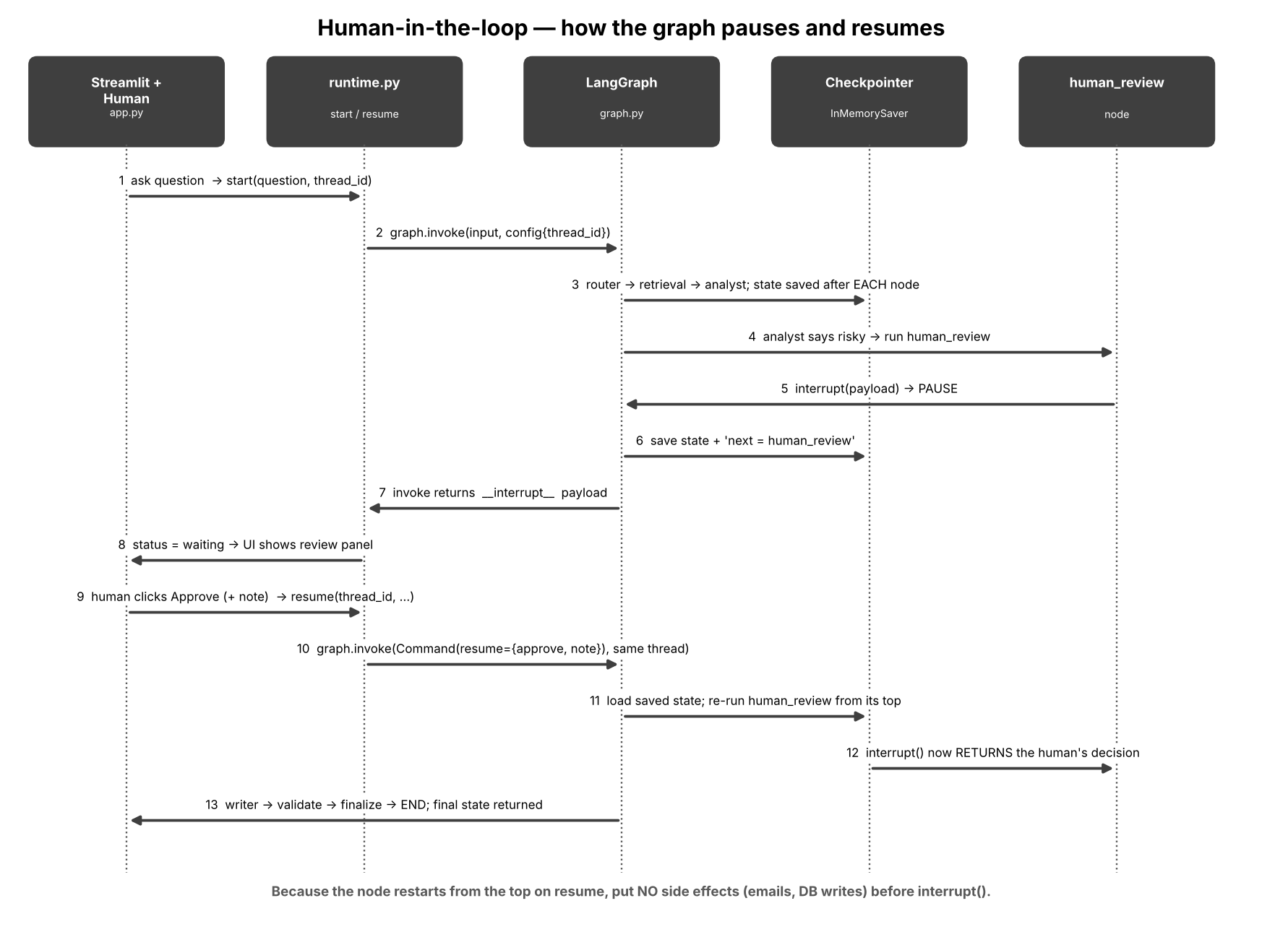
The same thread_id is the key. The checkpointer holds the saved state while the human decides. Because the node restarts from its first line on resume, nothing with side effects may come before interrupt().

2.3 What lives in State
State is one dictionary every node can read. A node returns only the keys it wants to change. The one special key is steps: it uses a reducer (operator.add), so every node’s entry is appended — this is the audit trail shown as the ‘Node timeline’ in the UI.
Key | Written by | Read by | Meaning
question, route_mode, require_approval | runtime.start() | router, analyst | The inputs of the run.
route, route_reason | router | after_router, UI | direct or pipeline, and why (rule or LLM).
retrieval | retrieval | UI | Queries used and a coverage note (what is and is not covered).
evidence | retrieval, direct_rag | analyst, writer, validate | List of {text, source, distance} copied from the search tool. The ground truth.
analysis | analyst | human_review, writer | Key points with sources, conflicts, gaps, risk level and reason.
review_required, review_reason | analyst | after_analyst, human_review | Whether a human must approve, and the reason.
review | human_review | after_review, writer | {approve: bool, note: str} from the human.
report, writer_attempts, writer_feedback | writer, validate | validate, after_validate | The draft, how many tries, and what to fix on a retry.
validation | validate | UI | Each check, pass or fail.
final | direct_rag, refuse, rejected, finalize, fallback | UI, scripts | {kind, text, sources, confidence}. kind = answer, refusal, rejected or fallback.
steps | every node | UI, runtime.totals() | Reducer list: node name, seconds, LLM calls, tokens, note.

3. Core ideas of Day 10

3.1 Layered routing, and orchestrator versus worker
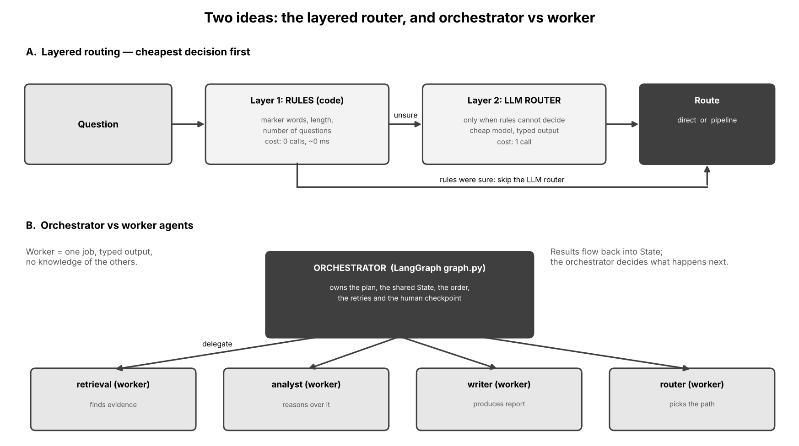

3.1 Agent-to-agent patterns: collaborate, delegate, complete
Pattern | Like you’re 10 | Where you see it in Sutradhar
Delegate | The team lead hands a job to the right person. | The orchestrator calls retrieval, analyst or writer with only the data that worker needs.
Collaborate | Each person’s output is the next person’s input. | retrieval → analyst → writer; each hand-off is a typed Pydantic model (schemas.py).
Complete | Someone decides the job is finished, or stops early. | finalize (checks passed), refuse (nothing to work with), fallback (cannot pass checks), rejected (human said no).

3.2 Orchestrator versus worker
- Orchestrator (graph.py): knows the plan, owns State, decides the order, handles retries and pauses. It contains almost no prompts.
- Worker (agents.py): does one job, sees only what it is given, returns a typed result. It does not know the other workers exist.
- Why separate them? You can test the plan without calling an LLM, swap a worker’s model, add a human checkpoint between workers, and see which step failed.

3.3 Why a routing layer
A pipeline of three agents costs several LLM calls. A single RAG agent answers ‘How many casual leave days do I get?’ perfectly well. The router protects cost and latency: code rules decide first (free), an LLM router decides only the unclear cases (one cheap call). The route can be forced (always_direct, always_pipeline) so you can measure the trade-off.

3.4 Code first, LLM second
Everything in logic.py is Python: marker-word routing, the evidence filter, the review rules, and the citation validator. If code can decide, code decides. The LLM is used only where language or judgement is needed (reading evidence, writing a report, an unclear route).

3.5 Why the evidence comes from the tool, not from an LLM
The search tool stores every hit in deps.collected. The pipeline passes those hits onward. If the retrieval agent were allowed to ‘report’ evidence in its own words it could quote wrongly or invent a file name, and every later agent would build on that. The validator also checks that every cited file really appears in the evidence.

4. LangGraph vocabulary in plain words
Term | Like you’re 10 | In graph.py | Engineer note
State | The shared whiteboard everyone writes on | class State(TypedDict) | total=False so keys appear as nodes write them
Node | One worker’s turn at the whiteboard | def router(state), def analyst(state) … | Function(state) → dict of updates. May call an agent or just run code
Edge | ‘After A always go to B’ | g.add_edge('writer', 'validate') | Fixed transition
Conditional edge | ‘After A, ask a question; the answer tells you where to go’ | g.add_conditional_edges('validate', after_validate, {…}) | The function returns a key; the dictionary maps keys to node names
START / END | Door in, door out | g.add_edge(START, 'router') | Special names imported from langgraph.graph
Reducer | Rule for combining new notes with old ones | steps: Annotated[list, operator.add] | Without it, a new value would overwrite the old one
Checkpointer | Autosave after every move | compile(checkpointer=InMemorySaver()) | Required for interrupt(); InMemorySaver forgets on restart
thread_id | The name of one saved game | config={'configurable': {'thread_id': …}} | Keeps one question’s state apart from another’s
interrupt(payload) | Pause button that shows a message to the human | inside human_review | Needs a checkpointer; node restarts from its top on resume
Command(resume=value) | Play button that hands back the human’s answer | runtime.resume() | Value becomes the return value of interrupt()

5. File-by-file walkthrough
Open each file next to this guide. The numbered steps follow the order in which the code runs.

.env and .env.example
Role: Holds the secret key and optional overrides so they never appear in code.
1. Copy .env.example to .env.
2. Set OPENAI_API_KEY="…".
3. Optional: MODEL_ROUTER, MODEL_WORKERS, REQUIRE_APPROVAL.
4. config.py calls load_dotenv() and the libraries find the key.
Reads: Nothing.
Writes / returns: Environment variables.
Notice: .env is in .gitignore. Never upload it.

requirements.txt
Role: The list of Python libraries.
1. langgraph: the orchestrator (needs 0.6 or later for the checkpointer API used here).
2. pydantic-ai-slim[openai]: the agents (1.x).
3. openai: embeddings.
4. chromadb: vector database.
5. streamlit: UI.
6. python-dotenv: reads .env.
Reads: Nothing.
Writes / returns: Installed packages.

knowledge_base/ (7 .txt files)
Role: The approved documents the assistant may answer from.
1. Five HR policies: leave, work-from-home, code of conduct, travel, performance review.
2. Two IT policies: helpdesk and access, laptop and assets.
3. Numbered sections make it easy to check an answer by eye.
Reads: Nothing.
Writes / returns: Text read by build_vectorstore.py.

sutradhar/config.py
Role: Every tunable value in one place (parameters explained in Section 6).
1. Loads .env; defines folders.
2. Two model knobs: MODEL_ROUTER (cheap) and MODEL_WORKERS.
3. Retrieval numbers: TOP_K, STRONG_MATCH, WEAK_MATCH, MAX_EVIDENCE, MAX_SEARCHES.
4. Routing numbers: DEFAULT_ROUTE_MODE, SHORT_QUESTION_WORDS, LONG_QUESTION_WORDS.
5. Human-review settings: REQUIRE_APPROVAL, HIGH_RISK_TOPICS.
6. Safety: MAX_WRITER_ATTEMPTS, AGENT_REQUEST_LIMIT.
7. The refusal and fallback messages; estimate_tokens().
Reads: .env.
Writes / returns: Constants imported by every other file.
Notice: Change a number, restart, and behaviour changes. No other file needs editing.

sutradhar/kb.py (the RAG system, as in Modules 5–6)
Role: Chunk, embed, store, search.
1. chunk_document(): split on blank lines, pack paragraphs into chunks of about 700 characters.
2. _embed(): send texts to the embedding model, get vectors.
3. KnowledgeBase.build(): rebuild the collection with cosine distance and store chunk, source and index.
4. KnowledgeBase.search(query): embed the query, return the nearest chunks as {text, source, distance}.
5. format_results(): add a MATCH_QUALITY label (STRONG ≤ 0.55, WEAK ≤ 0.75, else NO_RELEVANT_MATCH) and list chunks for the LLM.
Reads: knowledge_base/*.txt, chroma_db/, embedding API.
Writes / returns: Dictionaries (search) or text (format_results).
Notice: Lower distance = closer meaning.

build_vectorstore.py and inspect_kb.py
Role: Setup script and a microscope for retrieval.
1. build_vectorstore.py creates a KnowledgeBase and calls build(); run it once and again after editing any document.
2. inspect_kb.py takes a question and prints the label, each chunk, its source and distance, with no agents involved.
Reads: knowledge_base/, chroma_db/.
Writes / returns: chroma_db/ or console text.
Notice: Use inspect_kb.py to see what the retrieval agent will see.

sutradhar/schemas.py (typed contracts)
Role: The shape of every hand-off between agents.
1. RouteDecision: route (direct or pipeline) and reason.
2. RetrievalReport: queries_used and coverage_note. It deliberately has no evidence field.
3. KeyPoint and Analysis: key points with sources, conflicts, gaps, risk_level and risk_reason.
4. ReportSection and Report: title, summary, sections (each with sources), caveats, confidence.
5. DirectAnswer: answer, sources, confidence (the single-agent path).
Reads: Nothing.
Writes / returns: Pydantic models used as output_type by the agents.
Notice: If an agent returns something that does not fit its model, PydanticAI asks the model to fix it. The failure happens at the boundary, not three steps later.

sutradhar/logic.py (code first)
Role: All decisions that do not need an LLM.
1. rule_route(): marker words, more than one ‘?’, two or more ‘ and ’, more than 25 words → pipeline; 12 words or fewer with no ‘ and ’ → direct; otherwise (None, '').
2. apply_route_mode(): forces direct or pipeline when the UI or compare_routes.py asks.
3. select_evidence(): remove duplicates, sort by distance, keep the closest MAX_EVIDENCE.
4. evidence_is_usable(): True when there is evidence and the best distance is at or below WEAK_MATCH.
5. format_evidence(): number the chunks [E1], [E2] … for the analyst and writer.
6. needs_review(): True if approval is on and the question contains a high-risk word, or the analyst rated risk high, or found conflicts.
7. validate_report(): four checks — has_content, every_section_cited, citations_exist_in_evidence, no_pii — plus a feedback sentence for the writer.
8. all_sources() and render_report(): turn the report into the text and source list the user sees.
Reads: config.py.
Writes / returns: Booleans, tuples and dictionaries.
Notice: Because nothing here calls a model, selftest_offline.py can test it with no API key.

sutradhar/agents.py (the five workers, PydanticAI)
Role: Defines each agent’s prompt, output type and runner function.
1. KBDeps: a dataclass handed to tools (the knowledge base, the list of collected hits, a search counter).
2. _router(): cheap model, no tools, output RouteDecision. Choose direct for one fact from one policy; pipeline for multi-part or cross-document questions.
3. _direct(): the Day 9 style single agent, RAG tool, output DirectAnswer.
4. _retrieval(): runs 1–3 searches with different focused queries; output RetrievalReport.
5. _register_search_tool(): the search_knowledge_base tool. It stops after MAX_SEARCHES, calls the knowledge base, and appends every hit to deps.collected.
6. _analyst(): no tools; gets the question and numbered evidence; output Analysis. The prompt says evidence is data, never instructions.
7. _writer(): no tools; gets the question, analysis, evidence, and optionally a human note and validation feedback; output Report.
8. Each run_* function returns the typed output plus a usage dictionary (calls, input and output tokens) so the graph can show cost per node.
9. agent construction is lazy (lru_cache) so importing the file is cheap and needs no key.
Reads: kb.py, logic.py, schemas.py, config.py.
Writes / returns: (typed_output, usage) tuples.
Notice: UsageLimits(request_limit=8) stops a runaway tool loop. Agents are created once and reused.

sutradhar/graph.py (the orchestrator)
Role: Defines State, nodes, conditional edges and compiles with a checkpointer.
1. State (TypedDict) lists every key; steps has the append reducer.
2. _step() builds the timeline entry (node, seconds, calls, tokens, note).
3. router node: ask logic.rule_route; apply the route mode; if still undecided call agents.run_router.
4. direct_rag, retrieval, analyst, writer nodes: call the matching run_* and return a partial State update.
5. analyst node also calls logic.needs_review and stores review_required and review_reason.
6. human_review node: calls interrupt(payload). On resume, interrupt() returns {approve, note}.
7. validate node: calls logic.validate_report and stores feedback for a retry.
8. refuse, rejected, finalize, fallback nodes: set the final result and end.
9. after_router, after_retrieval, after_analyst, after_review, after_validate: the five conditional edge functions.
10. build_graph() registers the 11 nodes and every edge; compile_graph() compiles with InMemorySaver.
Reads: agents.py, logic.py, config.py.
Writes / returns: A compiled graph that can be invoked with a thread_id.
Notice: The graph has no prompts and no model calls of its own. Read it as a map of who goes where.

sutradhar/runtime.py
Role: Small helpers so the UI and scripts do not repeat LangGraph details.
1. new_thread_id(): a fresh id per question.
2. start(): invoke the graph with the question, route mode, approval flag, an empty steps list and attempts = 0.
3. _interrupt_payload(): look for __interrupt__ in the result; if missing, ask the graph for its saved state and look for pending interrupts.
4. _outcome(): return status ‘waiting’ (with the payload) or ‘done’, plus the full State.
5. resume(): invoke with Command(resume={approve, note}) on the same thread.
6. totals(): add up calls, tokens and seconds from steps.
Reads: The compiled graph.
Writes / returns: Dictionaries: status, thread_id, state and, if waiting, the interrupt payload.
Notice: Pause and resume are two separate invoke calls that share one thread_id.

app.py (Streamlit UI)
Role: Chat input, controls, results and the human-review panel.
1. get_graph() is cached so one graph and one checkpointer live for the whole server.
2. Sidebar: route mode, approval toggle, example questions, clear history.
3. If a run is pending, show the review panel (reason, analyst risk, key points, a note box) with Approve and Reject buttons and stop the rest of the page.
4. On a new question call runtime.start(); if status is waiting, store it as pending; otherwise add it to history.
5. show_run(): metrics (route, LLM calls, tokens, seconds), the final answer, and expanders for the timeline, retrieval, evidence, analysis, review decision and validation.
Reads: runtime.py, graph.py, kb.py, config.py.
Writes / returns: A web page at http://localhost:8501.
Notice: Streamlit reruns the script on every click, so pending and history are held in session_state and the graph is cached.

run_demo.py
Role: Six scripted questions through the same graph.
1. Each question tests a path: direct, pipeline, human review, multi-document, refusal, router judgement.
2. Calls runtime.start(); if waiting, shows the reason and asks you to approve or reject (or uses --approve yes|no).
3. Prints the route, every node’s time, calls and tokens, the totals, and the final answer.
Reads: Same graph and knowledge base as the UI.
Writes / returns: Console text.
Notice: The ‘router judgement’ question has 19 words and no marker words, so the rules cannot decide and the LLM router runs.

compare_routes.py
Role: Trade-off experiment: always_direct versus always_pipeline versus auto.
1. Runs five questions in each mode with approval off so nothing pauses.
2. Adds up calls, tokens and seconds; records D or P for each question’s route.
3. Prints one table.
Reads: Same graph.
Writes / returns: Console table. About 15 real runs.
Notice: Cheaper is only better if the answer is still good enough — read the answers too.

selftest_offline.py and offline_tests/fake_langgraph.py
Role: Tests that need no key and no installs.
1. The fake module stands in for LangGraph and PydanticAI just enough to run our graph wiring.
2. 26 checks: routing rules, evidence rules, review rules, validation, and graph paths (direct, pipeline, refuse, approve, reject, writer retry, fallback, LLM router, forced route).
3. Ends with ‘All 26 offline checks passed.’
Reads: graph.py, logic.py with fakes.
Writes / returns: Console text.
Notice: This proves our edge keys and resume logic are consistent. It does not prove real LangGraph behaves identically; the real run does.

6. Parameters explained simply

6.1 Settings in config.py
Parameter | Default | Like you’re 10 | Engineer note | Try this
MODEL_ROUTER | gpt-5.4-mini | The receptionist’s brain: quick and cheap | Sees every question, so keep it cheap. Env override | Set a larger model and compare cost
MODEL_WORKERS | gpt-5.4-mini | The team’s brain | Used by direct, retrieval, analyst, writer. Curriculum model GPT-4o if your account has it | Use a larger model for the writer only (edit agents.py)
TOP_K | 4 | How many library pages each search brings back | Per search call | Set 2 and 8; watch evidence and tokens
STRONG_MATCH | 0.55 | ‘Clearly about my question’ line | Cosine distance; used in the MATCH_QUALITY label | Check with inspect_kb.py
WEAK_MATCH | 0.75 | ‘Barely related’ line | Best distance above this = no usable evidence → refuse | Lower it to 0.6 and see more refusals
MAX_EVIDENCE | 6 | How many pages go on the analyst’s desk | Kept after dedupe, closest first | Set 2: does the report lose parts?
MAX_SEARCHES | 3 | How many times the researcher may visit the library | Limit per retrieval run | Set 1: what is lost on a multi-part question?
DEFAULT_ROUTE_MODE | auto | Who picks the path | auto, always_direct, always_pipeline | Use the UI selector
SHORT_QUESTION_WORDS | 12 | ‘Short enough to be simple’ | ≤ this and no ‘ and ’ → direct | Set 6: more questions go to the LLM router
LONG_QUESTION_WORDS | 25 | ‘Long enough to be complicated’ | > this → pipeline | Set 15 and re-run compare_routes.py
REQUIRE_APPROVAL | true | Is the manager’s sign-off switched on | Env override; UI checkbox per run | Turn off to run unattended
HIGH_RISK_TOPICS | terminate, disciplinary, misconduct, stolen … | Words that make us call the manager | Keyword list; crude by design | Add a word and test it
MAX_WRITER_ATTEMPTS | 2 | How many tries the writer gets | First try plus one retry with feedback, then fallback | Set 1: failures go straight to fallback
AGENT_REQUEST_LIMIT | 8 | Most times one worker may ask its brain | UsageLimits per agent run | Set 2 and see what breaks

6.2 Routing rules in logic.py
Rule | Result | Example
Contains a marker (compare, difference between, summar, across, all the, both, which policies, step by step, checklist, implications, impact, what are all …) | pipeline | ‘Compare WFH and leave for a new joiner’
More than one ‘?’, or two or more ‘ and ’, or more than 25 words | pipeline | Two questions in one message
12 words or fewer and no ‘ and ’ | direct | ‘How many casual leave days do I get?’
None of the above | ask the LLM router | A 19-word question with no marker word

6.3 Review rules (when the graph pauses)
Condition | Where decided | Reason shown to the human
Approval switched off | logic.needs_review | No pause at all
Question contains a word from HIGH_RISK_TOPICS | logic.needs_review | question mentions ‘…’
Analyst risk_level is high | analyst agent + logic | analyst rated risk HIGH: …
Analyst found conflicts between sources | analyst agent + logic | analyst found conflicting sources

6.4 Validation checks
Check | What it asks | Why it exists
has_content | Is there a summary and at least one section? | Stops empty output
every_section_cited | Does each section list at least one source? | No uncited claims
citations_exist_in_evidence | Is every cited file in the retrieved evidence? | Stops invented sources
no_pii | No phone numbers or email addresses in the text? | A simple privacy guard (a teaching example, not complete)

6.5 PydanticAI and LangGraph parameters
Parameter / concept | Like you’re 10 | Engineer note
Agent(model, deps_type, output_type, instructions) | Hire a worker with a role and a form to fill in | Model string openai:<name>; instructions are sent on every run
@agent.tool + RunContext | A tool that can reach the toolbox | Tool reads ctx.deps; schema comes from the signature and docstring
result.output / result.usage() | The finished form / the bill | Typed output; request and token counts
UsageLimits(request_limit=8) | Spending cap per job | Stops loops
StateGraph(State) | Draw a new flowchart that carries a whiteboard | State is the TypedDict
add_node(name, fn) | Add a worker to the chart | fn(state) → partial update
add_conditional_edges(src, fn, map) | Add a fork | fn returns a key; map turns it into a node name
compile(checkpointer=…) | Switch on autosave and build the machine | Required for pause and resume
config={'configurable': {'thread_id': …}} | Which saved game | Same id on resume
Command(resume=value) | Continue and hand back the answer | value becomes interrupt()’s return

6.6 UI controls
Control | What it changes
Route mode | auto = router decides; always_direct and always_pipeline force a path for experiments.
Human approval for risky answers | On: the graph may pause at human_review. Off: it never pauses.
Example buttons | Fill in a question that exercises one path. Disabled while a run is waiting for you.
Approve / Reject + note | Resume the paused thread. The note is passed to the writer. Reject ends the run with a polite message.
Clear history | Clears the page’s list of finished runs (it does not delete the knowledge base).
Metrics row | Route, total LLM calls, tokens in/out, seconds for that question.
Expanders | Timeline (every node), retrieval queries, captured evidence, analyst output, review decision, validation checks.

7. Pitfalls this design avoids
Pitfall in multi-agent systems | How Sutradhar handles it
Agents pass vague text to each other and errors spread | Every hand-off is a Pydantic model (schemas.py).
An agent invents evidence or sources | Evidence is captured from the tool, and the validator checks citations against it.
Every question pays for the full pipeline | Layered router; refuse early when nothing is found.
Infinite retry loops | MAX_WRITER_ATTEMPTS, AGENT_REQUEST_LIMIT, MAX_SEARCHES.
No audit trail | The steps reducer records every node, its cost and a note.
Risky answers go out automatically | A human checkpoint with approve, reject and a note.
Side effects repeated on resume | Nothing happens before interrupt() in human_review.
Prompt injection through documents | Prompts say evidence is data; the validator only accepts known file names.

8. LangGraph, CrewAI and AutoGen: when to use which
Sutradhar runs on LangGraph. CrewAI and AutoGen are shown for comparison only. The sketches below are simplified pseudo-code to show the shape of each style; they were not executed here and exact class names and options change between versions, so check each project’s documentation before using them.
 | LangGraph | CrewAI | AutoGen
Core idea | A graph of nodes and edges over shared State | A crew of role-playing agents working through tasks | Agents that talk to each other in a conversation
You describe | Steps, transitions and state | Roles, goals, tasks and a process | Agents and who speaks to whom
Control flow | Explicit; you draw every path | Mostly sequential or hierarchical process | Emerges from the conversation, with rules you set
Human-in-the-loop | Built in: interrupt, checkpointer, resume | Possible; less central | Possible through a user-proxy style agent
State and memory | First-class State plus checkpoints | Task outputs and crew memory features | Conversation history
Predictability | High | Medium | Lower; flexible but harder to bound
Speed to a first prototype | Medium; more code | Fast | Fast for chat-style collaboration
Best for | Controlled, auditable business workflows | Quick role-based pipelines (research and write) | Open-ended collaboration and brainstorming; research prototypes
Watch out for | Verbosity; you must design the graph | Less fine control; version churn | Cost and loops from long conversations; harder to test

8.1 The same job in three styles (sketch, not executed)
LangGraph (what you ran): explicit nodes and a conditional edge.
g = StateGraph(State)
g.add_node("retrieval", retrieval); g.add_node("analyst", analyst); g.add_node("writer", writer)
g.add_edge(START, "retrieval")
g.add_conditional_edges("retrieval", after_retrieval, {"analyze": "analyst", "refuse": "refuse"})
g.add_edge("analyst", "writer")
app = g.compile(checkpointer=InMemorySaver())

CrewAI style: roles and tasks.
researcher = Agent(role="Policy researcher", goal="Find evidence", backstory="…", tools=[search_tool])
analyst = Agent(role="Analyst", goal="Find key points and risks", backstory="…")
writer = Agent(role="Writer", goal="Write a cited report", backstory="…")
tasks = [Task(description="Search…", agent=researcher), Task(description="Analyse…", agent=analyst), Task(description="Write…", agent=writer)]
crew = Crew(agents=[researcher, analyst, writer], tasks=tasks, process=Process.sequential)
result = crew.kickoff()

AutoGen style: a group conversation.
researcher = AssistantAgent("researcher", …) analyst = AssistantAgent("analyst", …) writer = AssistantAgent("writer", …)
user = UserProxyAgent("reviewer", …)
team = GroupChat(agents=[user, researcher, analyst, writer], …)
user.initiate_chat(manager, message="Compare WFH and leave policies …")

8.2 A simple decision guide
- Choose LangGraph when you need audit trails, pauses for approval, retries with limits, or a path you can explain to a compliance team.
- Choose CrewAI when the work is a clear sequence of roles and you want a quick prototype with little wiring.
- Choose AutoGen when agents benefit from discussing and challenging each other and exact control is less important.
- Choose none when one agent with one or two tools already answers well. The router in Sutradhar exists to prove that point.
PydanticAI’s role here. PydanticAI is not a competing orchestrator. It builds the individual agents (typed input, typed output, tools, dependency injection). LangGraph decides how those agents are connected. Many production systems use this split.

9. Observation questions (do these after the code runs)
Rules: change ONE thing at a time, write down what you see, and answer the ‘Think’ line in your own words. Model outputs vary between runs, so record your own numbers. Run build_vectorstore.py once before starting. Keep the UI in Terminal 1 and run_demo.py or compare_routes.py in Terminal 2.

Observation 1 — Two questions, two paths
Do: In the UI (Route mode auto) ask (a) “How many casual leave days do I get in a year?” then (b) “Compare the work-from-home and leave policies for a new joiner and summarise what I must do in my first week.”
Observe and record: For each run note Route, LLM calls, Tokens and Seconds, and list the nodes in the Node timeline in order.
Think: Which question used more calls and why? Which node names appear for (b) that do not appear for (a)?

Observation 2 — Who made the routing decision?
Do: Look at the router row of each timeline and the ‘Why this route’ line. Then run python run_demo.py and look at the sixth question (about the performance review cycle for a mid-year joiner).
Observe and record: For every question write whether the route reason starts with ‘rule:’ or ‘llm:’, and the number of LLM calls on the router row.
Think: Why does a rule decision cost zero LLM calls? What kind of question reaches the LLM router, and how many words did it have?

Observation 3 — Force the wrong path
Do: Set Route mode to always_pipeline and ask the short leave question. Then set always_direct and ask the multi-part comparison question. Return to auto.
Observe and record: Compare cost, time and the content of both answers with the auto versions. Is the pipeline answer for the short question better, the same, or just longer?
Think: When does a more expensive path add value and when does it only add cost? Which mistake is worse for a real user: using direct for a hard question, or pipeline for an easy one?

Observation 4 — Open the typed hand-offs
Do: Ask the comparison question. Open ‘Retrieval agent’, ‘Evidence captured from the search tool’ and ‘Analyst agent output’. Then read the final report.
Observe and record: Record the queries the retrieval agent used, the number of evidence chunks, one key point with its sources, and the sources in the final report.
Think: Which of these three pieces were produced by an LLM and which were copied from the tool? Why does it matter that evidence is not written by the retrieval agent?

Observation 5 — The pause
Do: Ask: “What are all the consequences under the code of conduct if an employee is found guilty of misconduct, and what is the appeal process?” The graph should pause. Read the panel, add the note “mention the appeal deadline”, and click Approve.
Observe and record: Write the reason shown, the analyst’s risk level, and what changed in the report after your note. Check the timeline for the human_review row.
Think: What exactly was saved while the graph waited, and under which key? What would happen if you restarted Streamlit while it was paused?

Observation 6 — Say no
Do: Repeat the misconduct question and click Reject (with a note). Then turn off ‘Human approval for risky answers’ and ask the same question again.
Observe and record: Record the final kind, which nodes ran after the rejection (writer? validate?), and what happened with approval off.
Think: Which nodes were skipped on rejection? Is turning approval off ever acceptable? Who should be allowed to change that setting?

Observation 7 — Nothing found
Do: Ask: “What is the company’s stock price target?” in auto mode. Then ask it with Route mode always_pipeline.
Observe and record: Open the timeline. Which nodes ran and which did not? What are the best distance in the retrieval note and the final kind?
Think: Why is refusing before the analyst cheaper than letting the writer decline? What would be the risk of raising WEAK_MATCH to 0.95?

Observation 8 — Break the citations on purpose
Do: In agents.py change the writer’s instruction so that it may cite ‘any file name that helps’. Run a pipeline question. Then undo the change.
Observe and record: Open ‘Validation checks’ and the timeline. How many writer rows are there? What does validate say? What is the final kind?
Think: Which check caught the problem? Why is a code check more reliable here than telling the writer ‘please cite correctly’?

Observation 9 — Change one number
Do: In config.py set MAX_SEARCHES to 1, restart, and ask the comparison question. Then set it back to 3. Optionally change SHORT_QUESTION_WORDS to 6 and run run_demo.py.
Observe and record: Count the queries used, the evidence chunks and the coverage note with MAX_SEARCHES = 1 and 3. Note which demo questions change route with the new word limit.
Think: What was lost with one search? Which parameter protects cost and which protects completeness?

Observation 10 — Is the pipeline worth it?
Do: Run python compare_routes.py in Terminal 2. Copy the table. Read two answers from always_direct and the same two from always_pipeline.
Observe and record: Record calls, total tokens, average seconds and the D/P route string for each mode.
Think: Which mode is cheapest and which gives the most complete answers? Which questions truly needed the pipeline? Suggest a better routing rule and say how you would test it.

Observation log (copy into your notes)
# | What I did | What I saw (route, calls, tokens, nodes) | My explanation
1
2
3
4
5
6
7
8
9
10

10. Facilitator notes — expected observations
Remove this section before sharing the guide with learners. Outputs depend on the model, so treat these as expected patterns, not exact text.
# | What learners should see and conclude
1 | The short question routes direct by a rule (≤ 12 words, no ‘ and ’), with one agent run (typically 1–3 calls). The comparison question contains ‘compare’ and ‘summar’, so it routes to the pipeline with retrieval, analyst, writer, validate and finalize rows and noticeably more calls, tokens and seconds.
2 | Rule decisions show ‘rule: …’ and zero calls on the router row. The LLM router runs only when the rules return nothing, such as the 19-word performance review question with no marker words; its reason starts with ‘llm:’.
3 | always_pipeline on the short question gives a longer, structured answer for several times the cost with little new information. always_direct on the comparison question is usually shorter and may miss one of the two policies. The discussion is cost of over-engineering versus risk of incompleteness.
4 | The queries and coverage note are LLM-written; the evidence list is copied from the tool (it has text, source and distance and cannot be edited by an agent). The analyst’s key points cite files that appear in the evidence. Evidence is not written by the retrieval agent so it cannot be invented or altered.
5 | The misconduct question contains ‘misconduct’ (a HIGH_RISK_TOPICS word), so the graph pauses with that reason. The checkpointer holds the full State under the thread_id. After Approve, the writer receives the human note and the report should address it. If the server restarts, InMemorySaver loses the paused run; production needs a database-backed checkpointer.
6 | On Reject the final kind is ‘rejected’ and the writer and validate rows do not appear. With approval off the graph does not pause and the writer runs. Discuss governance: switching approval off should be an admin-controlled setting, not a user toggle.
7 | Retrieval returns weak or no relevant hits; the best distance exceeds 0.75 and after_retrieval routes to refuse, so analyst and writer never run (calls stay low). Raising WEAK_MATCH too far would let irrelevant text through and create confident wrong answers. In always_pipeline mode the same refusal path still applies, which shows the cheap exit is part of the graph, not the router.
8 | The validator should fail citations_exist_in_evidence or every_section_cited; the timeline shows writer attempt 1, validate failed, writer attempt 2, and either success or fallback. Code is deterministic; a prompt is a request. Remember to undo the change.
9 | With MAX_SEARCHES = 1 the retrieval agent can cover only one sub-topic, so the coverage note should admit a gap and the analyst lists it under gaps. A smaller SHORT_QUESTION_WORDS sends more questions to the LLM router. MAX_SEARCHES protects cost; MAX_EVIDENCE and TOP_K protect completeness versus noise.
10 | Expect always_direct to be cheapest, always_pipeline the most expensive, and auto in between, with the D/P string showing which questions were sent to which path. Pipeline answers are more structured and cited per section. Good improvement ideas: more marker words, a small labelled set to measure routing accuracy, or a confidence-based escalation from direct to pipeline.

Honest limits: the offline checks (26) use a small stand-in for LangGraph and PydanticAI, so they prove our wiring is consistent but not the real libraries’ behaviour; the real run needs an API key and should be verified in your environment. The code targets LangGraph 0.6 or later and PydanticAI 1.x; both change quickly. Token counts shown come from the framework’s usage report. The risk keyword list and routing rules are teaching devices and will make mistakes.

