Satark — Tools, Libraries & Concepts Explained
Observability Platforms, Pipelines, Production Evaluation and Drift — Lloyds Financial (Training Scenario)

0. Architecture Flow — What Happens in Each File, Step by Step
Every /ask or /chat call still runs Nidan's exact agent loop. What's new in Satark happens in a FIXED ORDER right after that loop produces an answer - every single time, not as a separate path someone has to remember to call. This section walks the request's full journey, file by file.
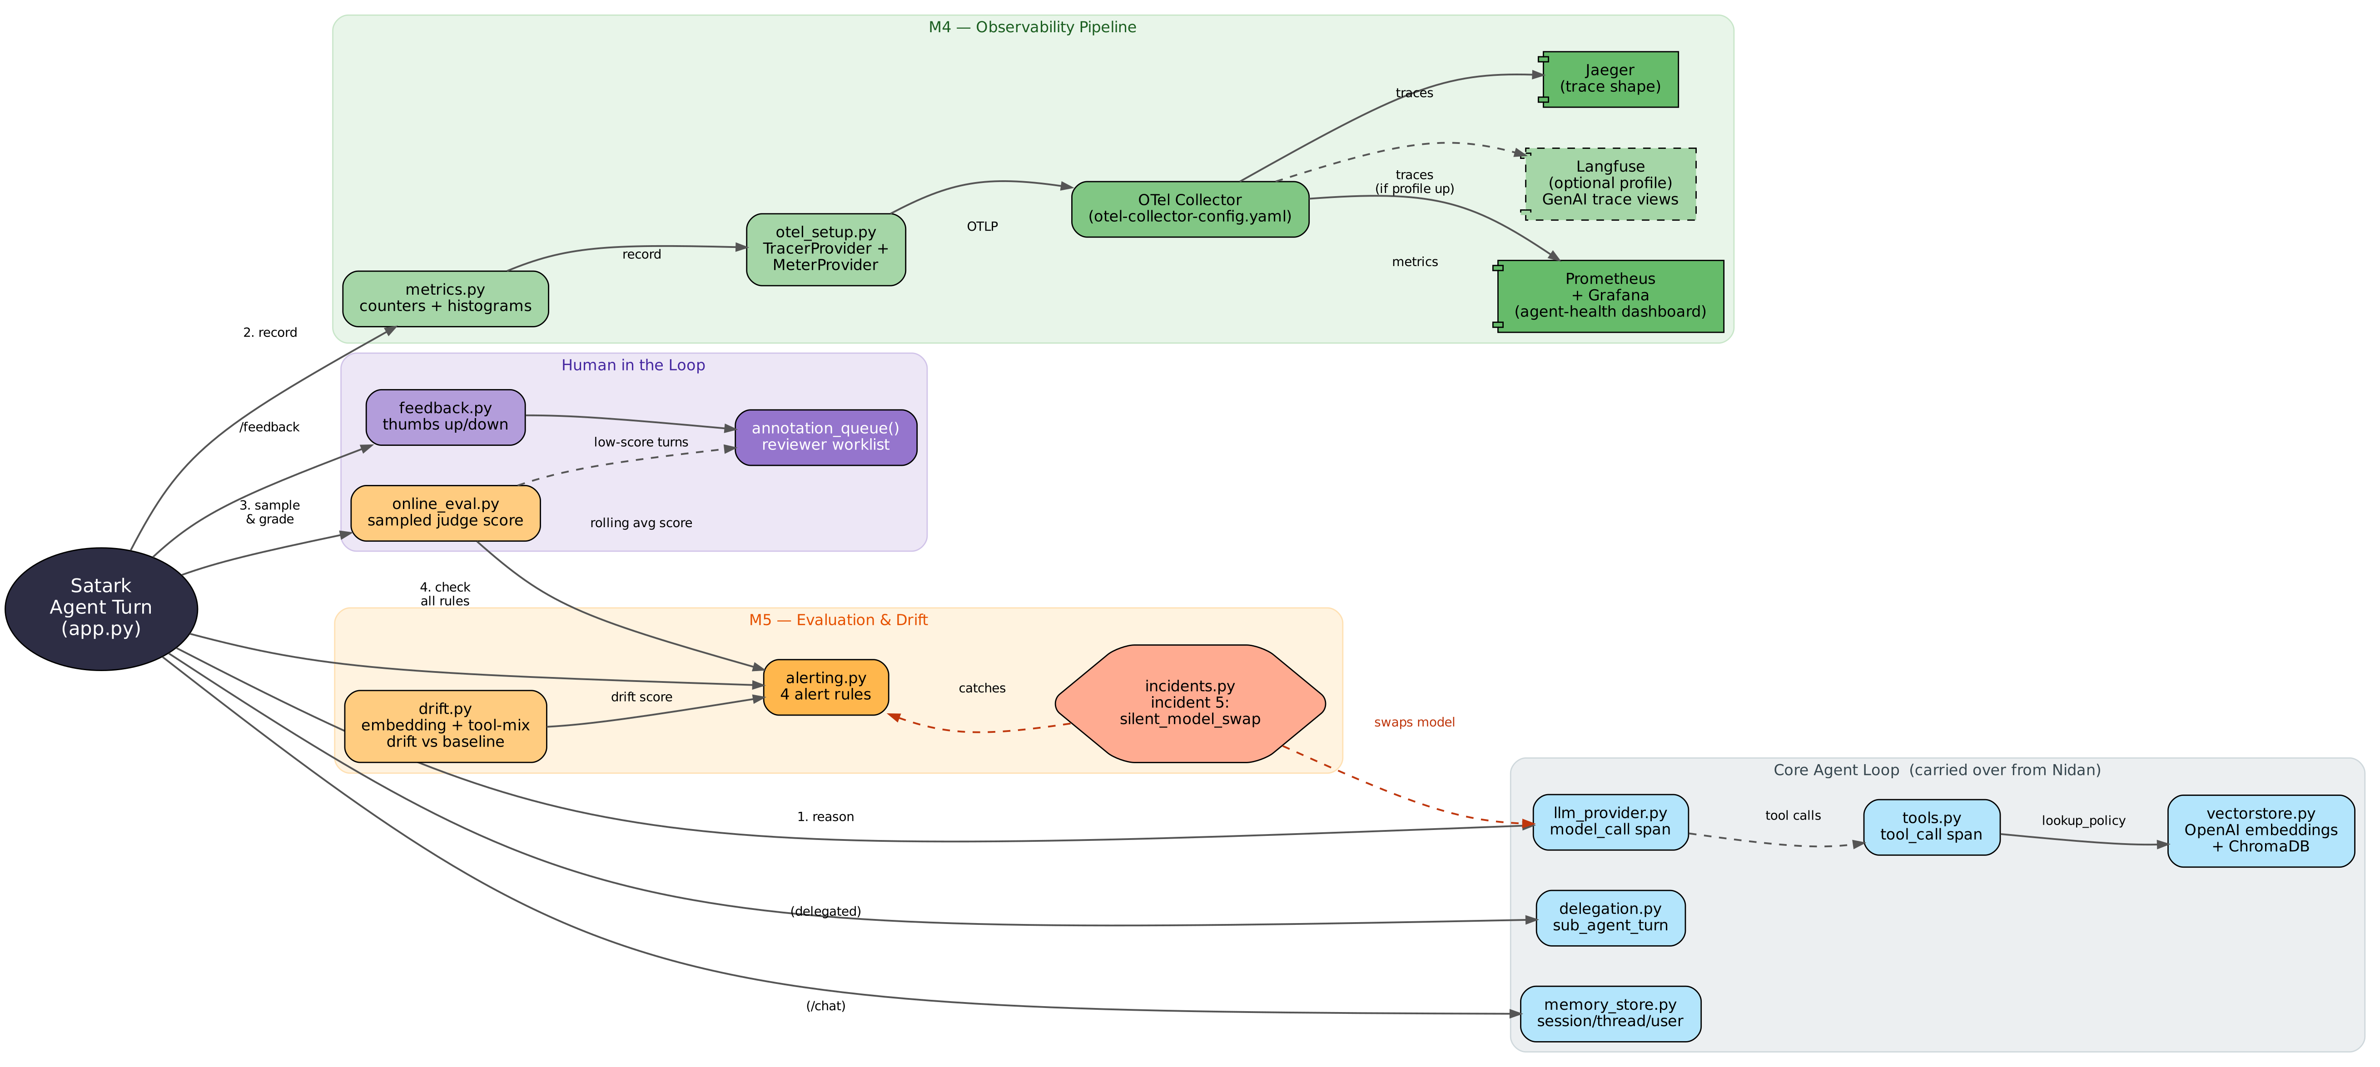
Hub-and-spoke reading: the centre node (app.py's Satark Agent Turn) is where every request starts and where every new module is called FROM. Grey = the unchanged Nidan core loop. Blue nodes inside it. Green = M4's observability pipeline (traces fan out to Jaeger and, optionally, Langfuse; metrics fan out through Prometheus to Grafana). Orange = M5's evaluation/drift layer, with incident 5 (the red dashed line) silently swapping the model inside llm_provider.py - invisible to the core loop, only caught by alerting.py reading drift.py and online_eval.py's rolling signals. Purple = the human-feedback loop, folding online_eval.py's own low scorers into one reviewer queue.
A. The unchanged core loop (carried over from Nidan)
1. Request arrives — app.py
_run_traced_agent_turn(question) opens the root agent_turn span and begins the same tool-calling loop Nidan used.
2. Model reasons, tools fire — llm_provider.py + tools.py + vectorstore.py
Unchanged in shape from Nidan, with one addition: llm_provider.py now also returns duration_ms, cost_usd, requested_model and served_model on every AgentTurn, because everything downstream in this section needs those four numbers.
B. What's NEW — runs after every turn, in this order
3. Metrics are recorded — metrics.py
record_agent_turn() takes the finished turn's model, duration, cost, and outcome/trajectory verdicts (when known) and writes them to six OTel instruments in one call - a counter, two histograms, two failure counters, a guardrail counter. These are NOT span attributes; they are separate OTel metric instruments, exported over OTLP to the Collector's metrics pipeline (otel_setup.py), which the Collector turns into a Prometheus-scrapeable endpoint (otel-collector-config.yaml).
4. Guardrail/refusal check — app.py
_detect_guardrail() runs a simple phrase match against the final answer, tagging the span with satark.guardrail.triggered and satark.refusal.detected, and feeding metrics.py's guardrail counter.
5. Online eval (sampled) — online_eval.py
maybe_grade() rolls the dice against SATARK_EVAL_SAMPLE_RATE; on a hit, it makes a SECOND chat_raw() call - a judge model - scoring the answer 1-5 with no reference answer needed. The verdict is appended to an in-memory recent-judged list and fed to metrics.py's eval-score histogram.
6. Alerting + drift — alerting.py + drift.py
observe_and_alert() runs four rules against this turn's numbers: a direct gen_ai.request.model vs gen_ai.response.model mismatch check, a cost-spike check against a rolling baseline, an eval-score-drop check against online_eval.py's rolling average, and - by calling drift.observe() - an embedding-centroid drift check and a tool-mix distribution check, both against a frozen baseline. Any rule that fires appends a structured alert to an in-memory list.
C. Where a human enters the loop
7. Feedback capture — feedback.py
POST /feedback attaches a thumbs up/down and optional note to a specific trace_id - the cheapest, most direct quality signal, independent of the judge model.
8. Annotation queue — feedback.py
annotation_queue() merges negative feedback with online_eval.py's own low-scoring sampled turns into ONE reviewer-facing list, newest first - what a human reviewer actually works, not the raw trace or feedback stream.
D. The two observability pipelines, end to end
TRACES: app.py's spans -> otel_setup.py (TracerProvider) -> OTLP -> Collector
-> Jaeger (span-shape debugging, unchanged from Nidan)
-> Langfuse, IF the `langfuse` Compose profile is running (GenAI-aware views)

METRICS: metrics.py's instruments -> otel_setup.py (MeterProvider) -> OTLP -> Collector
-> Collector's Prometheus exporter (:8889/metrics)
-> Prometheus (scrapes it every 10s, prometheus.yml)
-> Grafana (reads Prometheus, renders the 8-panel Agent Health dashboard)

Cross-cutting, on every path above:
otel_setup.py - the ONLY place that configures where traces AND metrics go
genai_conventions.py - every span-attribute name used anywhere, incl. Satark's new ones
pricing.py - priced gpt-4o-mini AND gpt-4o, so incident 5's cost jump is real, not a stub
incidents.py - incidents 1-4 unchanged; incident 5 hooks into llm_provider.py only

1. The Platform Landscape and What Each Tool Is Actually Optimising For
Plain language: a telescope and a microscope are both optical instruments, but asking for a telescope's detail on a single cell, or a microscope's view of a galaxy, is a tooling mismatch, not a quality problem with either instrument.
Engineering side: Jaeger is optimised for ONE request, deeply - exactly Nidan's exercise. Prometheus + Grafana are optimised for EVERY request, shallowly, aggregated over time - a p95 latency number across 10,000 requests, not any single one of their stories. Langfuse sits in between: the same spans Jaeger already has, re-rendered through GenAI-aware views (cost-by-model, latency-by-tool, a built-in eval UI) - no second instrumentation pass, just a second exporter destination in otel-collector-config.yaml. docker-compose.yml makes the resulting tradeoff literal: the core stack (Jaeger, Prometheus, Grafana) is always on; Langfuse's four extra containers (Postgres, ClickHouse, Redis, MinIO) sit behind an opt-in Compose profile, because standing up and maintaining that stack is the real, ongoing cost self-hosting a GenAI-aware view actually carries - not the OTLP bandwidth.

2. Self-Hosted Against Managed: Residency, Retention and the Real Cost of Telemetry
Plain language: running your own mail server gives you full control of every message and where it's stored - and makes you responsible for every outage, security patch, and backup, forever. A managed inbox trades that control for someone else handling the parts you'd rather not think about.
Engineering side: this repo's docker-compose.yml is the tradeoff you can actually see. The core stack (Jaeger, Collector, Prometheus, Grafana) is four lightweight containers you fully control - your traces never leave your infrastructure, retention is whatever your disk allows, and nobody's billing you per GB ingested. The langfuse Compose profile adds FOUR MORE containers (Postgres, ClickHouse, Redis, MinIO) just to get one GenAI-aware UI on the same data - each one a thing that can fall over, need a security patch, or fill a disk. A managed backend (Langfuse Cloud, Arize Phoenix, LangSmith, Datadog) removes all of that infrastructure burden, at the cost of your traces living on someone else's infrastructure and a recurring bill tied to volume - which is exactly the residency/retention/cost tradeoff this section's title names, made concrete instead of abstract.

3. Dashboard Design for Agent Health — What a Duty Engineer Needs on One Screen
Plain language: a car's dashboard shows speed, fuel, and engine temperature - not a live feed of every spark plug firing. The design choice is deciding which handful of numbers someone glances at BEFORE deciding whether to pull over and look closer.
Engineering side: grafana/dashboards/satark-agent-health.json has exactly eight panels, each answering ONE first-glance question - request rate, outcome/trajectory failure rate, p50/p95 latency, cost per hour, mean cost per call (the fastest incident-5 signal), online-eval score, embedding drift, and guardrail-trigger rate. Nothing here is a Jaeger replacement; the dashboard's whole job is to tell a duty engineer WHEN to go open Jaeger for a specific trace, not to replace that step.

4. Build Against Buy, Assessed Rather Than Asserted
Plain language: 'we should build this ourselves' and 'we should just buy a tool' are both opinions until someone actually stands up the alternative and compares what it costs to run, not just what it costs to buy.
Engineering side: this repo does not resolve the build-vs-buy question for you - it hands you a real, runnable self-hosted stack (Prometheus/Grafana/Jaeger, optionally Langfuse) so the comparison against a managed backend is made against something you've actually operated for an afternoon, not a slide making claims about either side. The dashboard-design exercise in Section 3, the residency discussion in Section 2, and the container count in docker-compose.yml are the assessment; this document is deliberately not the verdict.

5. Offline Evaluation Against Online Evaluation, and What Each Can and Cannot Tell You
Plain language: a spelling test graded against an answer key tells you about the words on the test. It tells you nothing about how the student spells words that were never on it.
Engineering side: trajectory_eval.py (carried over from Nidan, unchanged) is the offline case - a keyword/tool check against questions someone wrote the expected answer for in advance, run on demand via /grade. online_eval.py is the online case - sampled, continuous, model-graded scoring of REAL /ask and /chat traffic, with no reference answer, wired directly into _run_traced_agent_turn() so it runs on live traffic at SATARK_EVAL_SAMPLE_RATE without a separate endpoint call. Offline evaluation is fast, cheap, and deterministic, but only ever covers the questions you thought to write down. Online evaluation is the only way to find out how the agent is doing on the long tail of questions nobody wrote a keyword list for - at the cost of a second paid model call per sampled turn, which is exactly why it's sampled rather than exhaustive.

6. Model-Graded Evaluation at Scale, and Calibrating the Grader Before You Trust It
Plain language: a substitute teacher grading essays still needs their own grading checked occasionally - a consistently too-harsh or too-lenient substitute produces grades that are precise and wrong in the same direction every time.
Engineering side: online_eval.py's judge is just another chat_raw() call with a fixed grading prompt (JUDGE_SYSTEM_PROMPT) and a 1-5 score. GET /eval/recent returns every sampled verdict WITH the judge's one-line rationale, specifically so a human can spot-check whether the judge's scoring logic actually tracks quality the way a person would - 'calibrating the grader before you trust it' is not a one-time setup step, it's something worth re-checking any time the judge's prompt, model, or the agent's own behaviour changes.

7. Guardrail, Refusal and Fallback Telemetry as Quality Signals
Plain language: a store that suddenly turns away three times as many customers at the door has a problem worth investigating, even if every turned-away customer was, technically, following policy.
Engineering side: app.py's _detect_guardrail() is a deliberately simple phrase match (standing in for a real moderation/guardrail service) that tags every turn with satark.guardrail.triggered and satark.refusal.detected, feeding metrics.py's guardrail_counter and dashboard panel 8. The point isn't the detector's sophistication - it's treating a refusal RATE as its own quality signal worth a dashboard panel, not something you'd only notice by reading transcripts one at a time.

8. Drift Detection Across Inputs, Outputs and Embeddings
Plain language: you might not notice a friend's handwriting changing letter by letter, but laid side by side with a sample from a year ago, the drift is obvious - the comparison needs a frozen reference point, not just a feeling that 'something's different.'
Engineering side: drift.py tracks TWO independent kinds of drift, because they catch different failures. Embedding drift freezes a baseline centroid from the first SATARK_DRIFT_BASELINE_SIZE answers, then scores every later answer's cosine distance from it over a rolling window - this is what catches incident 5 (silent_model_swap), because gpt-4o's answers still look correct individually, just subtly different in phrasing and length. Tool-mix drift applies the same baseline-vs-rolling-window idea to the categorical distribution of which tools fire, via total-variation distance - catching a routing regression that shifts the agent toward the wrong tool more often, even when each individual answer still reads fine.

9. Regression Detection Across Model Versions — the Failure That Arrives Without a Deployment
Plain language: most outages start with a deploy you can point to. The harder failure is the one with no deploy at all - a vendor-side change underneath you, with nothing in your own release log to blame.
Engineering side: incident 5 (incidents.py) is built to be exactly this - chat_raw() silently serves gpt-4o instead of the requested gpt-4o-mini, no error, no log line, and no single trace that looks wrong (gen_ai.request.model still reads correctly, because that's what the caller asked for). Three independent layers catch it, each noticing something different: cost (the fastest, moves on the very first swapped call), online-eval score (slower, but catches a QUALITY shift cost alone wouldn't), and the direct gen_ai.request.model vs gen_ai.response.model comparison in alerting.py - the one incidents.py's own answer key calls out as ground-truth, because it's still reliable even when the cost or quality signal is ambiguous.

10. Human Feedback Capture and Annotation Queues
Plain language: a restaurant doesn't need a food critic to notice a dish keeps coming back half-eaten - a direct complaint is its own signal, and worth routing to someone who can act on it, same as the critic's review.
Engineering side: feedback.py's record_feedback() takes a thumbs up/down plus an optional note against a specific trace_id - no judge model, no sampling, a real person's direct signal. annotation_queue() merges that explicit negative feedback with online_eval.py's own low-scoring sampled turns into ONE reviewer-facing list, so a human reviewer isn't stuck choosing between 'only look at complaints' and 'only look at what the judge model already flagged.'

This document accompanies the Satark lab repository. See README.md for setup, the full architecture, and the incident-5 diagnosis exercise.

