
Forfatter: | June Henriksen <juneih@linpro.no>
Opprettet: | 2008-06-04
Sist endret: | 2009-09-24
Versjon | 345
Arkivreferanse: | reaktor/documentation

Technical documentation:
System Documentation for Reaktor

Index
1.Introduction 4
1.1.Document history 4
2.System Architecture 4
2.1.LAMP 6
2.2.Symfony 6
2.3.ImageMagick 8
2.4.Lightwindow 8
2.5.Flowplayer 8
2.6.XSPF player 10
2.7.FFmpeg 10
2.8.Exim 10
3.Design 10
3.1.Model-View-Controller (MVC) 10
3.2.File structure in Symfony 12
3.3.Artwork and Files 14
3.4.Tagging 18
3.5.Commenting 18
3.6.Rating and Most Popular lists 20
3.7.Articles 20
3.8.LightWindow, buttons, and Internet Explorer 22
3.9.Transcoding 22
3.10.Mail 22
4.Managing Reaktor 26
4.1.Terminology 26
4.2.Templates 30
4.3.Where to find templates in the file structure 32
4.4.Editing templates 34
4.5.Translating in Reaktor 40
4.6.Configuration 50
4.7.subReaktors and LokalReaktors 50
5.Template documentation 62
6.Summary 62
7.Dictionary 64

Introduction
Reaktor is the name of a community, its website, the development team behind it, and the administrators who run it. The initiator behind the project is Deichmanske Bibliotek (Oslo Public Library), with additional financial funding from ABM-utvikling (The Norwegian Archive, Library and Museum Authority). The project started with a prototype by Copyleft Software AS, which was completely rewritten by Linpro AS after winning an official bid process.
This is the system documentation for the new Reaktor. Its intended readers are administration and staff users of the system, but also potential future developers of the system.

Document history

Dato | Sign | Ver. | Beskrivelse
2008-06-04 | juneih | 1 | First version – how to alter the graphical part of the system
2008-07-08 | juneih | 2 | Expand document to become system documentation
2008-08-08 | bjori | 3 | Expanded the plugin usage list, and added PHP exts
2008-09-04 | juneih | 4 | Moved template doc blocks to TemplateDocument.odt
2008-09-16 | juneih | 5 | Final draft.

System Architecture
Reaktor is built using the PHP web framework Symfony, in a LAMP environment. Illustration 1: The system components of Reaktor is an overview of how the component's are put together.
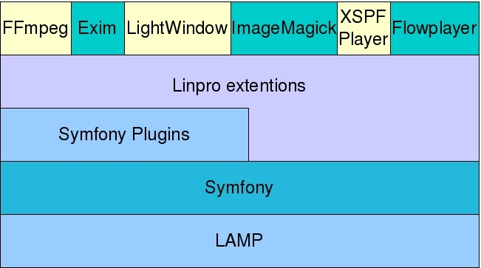Illustration 1: The system components of Reaktor
The following subchapters briefly describe what each component is and how it has been put to use in the Reaktor project.

LAMP
LAMP is an acronym for Linux, Apache, MySQL and PHP, a popular combination of open source software for use as a web server. Reaktor requires this to run, however, if necessary, some tweaking can be done for it to fit in a WAMP (Windows) environment.

PHP extensions
Reaktor requires few external PHP extensions not enabled by default, such as
- JSON – Turns PHP arrays and objects into JavaScript native types
- iconv – Character set conversion facility
- mbstring – Multibyte support
- mysql – Database support
- APC – OPcode and segment caching
For an improved debugging experience we use the XDebug extension.

Symfony
Symfony is a full-stack framework written in PHP5. It provides an architecture, components and tools for developers to build complex web applications. It follows the model-view-controller (MVC) paradigm.
Symfony is released under the MIT-license, and the project's web site is at http://www.symfony-project.org/. The next subchapters briefly describes the different parts of Symfony.

Plugins
Symfony is a module based system, meaning extra functionality can easily be installed and used as part of it. Reaktor uses several plugins as a base, and have developed them to fit the cause. The following plugins have been used:
- dwJpgraphPlugin - abstraction for the PHP Jpgraph library. Used for displaying graphs in reports.
- getId3Plugin - getID3 extracts information from multimedia file formats. Used for displaying metadata on the artwork pages, and to fulfill the Dublin Core requirements.
- the sfFeed2Plugin - offers an object interface for feeds and feed items
- sfGoogleAnalyticsPlugin - adds tracking code to the presentation layer and more.
- sfGuardPlugin - User management, authentication, and permissions handling.
- SfI18nDbTranslationPlugin - admin interface for updating translations stored in a database.
- sfI18nExtractPlugin - application to extract all the strings that need to be translated.
- sfPagerNavigationPlugin - Interface controls for paginated lists.
- sfPropelActAsCommentableBehaviorPlugin - attaching comments to Propel objects.
- SfPropelActAsRatableBehaviorPlugin - attach rating to Propel objects.
- SfPropelActAsTaggableBehaviorPlugin - attach tags to Propel objects.
- SfThumbnailPlugin - create thumbnails from images.

In addition there are some plugins used for development purposes only:
- sfPropelAlternativeSchemaPlugin – altering plugin schemas without altering the plugin itself.
- sfModelTestPlugin - creating unit tests.
- sfWebBrowserPlugin - Fetches webpages such as feeds
- sfReCaptchaPlugin – Anti-bot service that helps digitize books

script.aculo.us and Prototype
script.aculo.us provides cross-browser user interface JavaScript libraries to provide web sites and web applications with dynamic visual effects. It is licensed under MIT, and is found at http://script.aculo.us/. Prototype is a Javascript framework which provides an Ajax framework and other utilities. Prototype is distributed standalone, but also as part of larger projects, like in script.aculo.us above. It can be found at http://www.prototypejs.org/ and is also licensed under MIT. Reaktor uses visual effect from these Javascript components on almost every page.

Propel
Propel is an Object-Relational Mapping (ORM) framework for PHP5. An ORM is used because PHP5 is Object Oriented, and most databases used today are relational. An ORM provides a mapping between the two – hence the name. It means it is possible to access the database using a set of objects, provided by a simple API for storing and retrieving data. Propel comes bundled with Symfony. It is licensed under LGPL (Lesser Gnu Public License) and their web site is http://propel.phpdb.org.

ImageMagick
ImageMagick is a software suite to create, edit, and compose bitmap images. It can read, convert and write images in a variety of formats. It is among other things used to translate, flip, mirror, rotate, scale, shear and transform images. In Reaktor its mostly used to resize images.
The functionality of ImageMagick is typically utilized from the command line or from programs written in a number of programming languages. Reaktor uses the command line interface.
ImageMagick is GPL-licensed and can be found at http://www.imagemagick.org/.

Lightwindow
Lightwindow is a modal window, which is a child window which requires the user to interact with it before they can return to operating the parent application. Modal windows are commonly used in GUI (Graphical User Interface) systems to command user awareness and to display emergency states. Reaktor uses it to display slideshows, specific messages, and sometimes an entire Reaktor webpage.
LightWindow is freely distributable under the terms of an MIT-style (Massachusetts Institute of Technology) license, and can be found at http://www.stickmanlabs.com/lightwindow/.

Flowplayer
FlowPlayer is a Flash media player used to play video files on webpages. Reaktor uses Flowplayer to display video artwork.
Flowplayer is licenced under the GPL license and is found at http://flowplayer.org.

XSPF player
XML Shareable Playlist Format (XSPF), pronounced spiff, is an XML-based playlist format for digital media. Reaktor uses the XSPF player to play its sound files.
XSPF player is licensed under BSD (Berkeley Software Distribution) and can be found at http://musicplayer.sourceforge.net/.

FFmpeg
FFmpeg is a computer program that can record, convert and stream digital audio and video in numerous formats. It is a command line tool that is composed of a collection of free software/open source libraries. Reaktor uses FFmpeg to convert media files uploaded into a format the XSPF player and Flowplayer support.
FFmpeg is licensed under LGPL and it's web site is http://ffmpeg.mplayerhq.hu/.

Exim
Exim is a mail transfer agent (MTA) used on Unix-like operating systems. Like other MTAs, it replaces Sendmail, and is normally called by user agents (MUAs). Reaktor uses Exim to send e-mails to its users.
Exim is freely available under the GNU GPL and the project web site is http://www.exim.org/.

Design
The design of Reaktor is closely related to the framework it is based on. It is organized according to the MVC (Model-View-Controller) pattern, it is module-based, and makes use of plugins wherever it can. This chapter describes design decisions made throughout the project, both high-level and low-level.

Model-View-Controller (MVC)
Symfony is an MVC (model-view-controller) framework, and the Reaktor project adheres to this classic web design pattern.
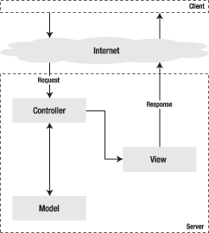Illustration 2: The Model View Controller-pattern
Quickly summarized, MVC has three levels:
- The model represents the information on which the application operates - its business logic.
- The view renders the model into a web page suitable for interaction with the user.
- The controller responds to user actions and invokes changes on the model or view as appropriate.
The idea behind this pattern is to have fat models, skinny controllers and stupid views. This means the model does most of the work, and the controller as little as possible – mostly it checks for the needed credentials, picks the correct template and redirects. The view has little intelligence it just accepts parameters from the controller and sets up pages. To learn more about Symfony and MVC look to the following chapter in the Symfony book: http://www.symfony-project.org/book/1_0/02-Exploring-Symfony-s-Code.

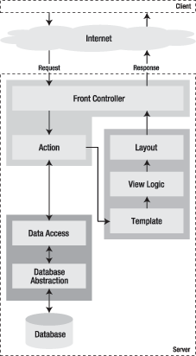Illustration 3: The symfony workflow

File structure in Symfony
The default directory structure of a Symfony project can be viewed in illustration 4. The Reaktor project does not deviate from it, but it does add to it. The following have been added on the highest level:
- The content directory has been added to hold the uploaded files in artworks.
- The plugins directory contains all the plugins mentioned in chapter 2.2.1.
- The prototype directory contains all the necessary scripts to import content from the Reaktor prototype.
- The vendor directory contains the third-party code Reaktor uses.
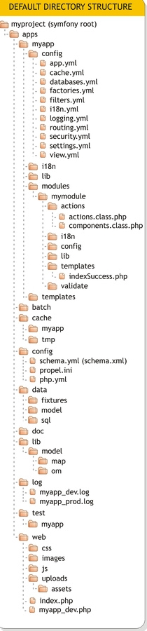Illustration 4: Default directory structure of a Symfony project

Artwork and Files
Artwork and files are what Reaktor is all about. It is important to understand the difference between the two concepts, this is explained in chapter 3.3.1. Artworks must be inspected before they become public, this is an administration task which is explained in 3.3.2.

The concept
In Reaktor, artwork and files are two completely different objects, but because most artwork consist of only one file, they can be hard to separate, particularly to new users of the system. During upload a user will add one or more files, before creating an artwork. A user can also use files added previously when creating an artwork. Illustration5: Possible relationships between artwork and files in Reaktor demonstrates how the same files can be used in many artwork.
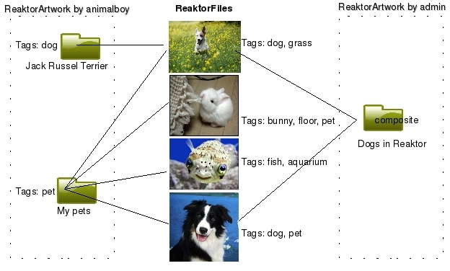Illustration5: Possible relationships between artwork and files in Reaktor
In the illustration the user animalboy has uploaded four files. The top file belong to two artwork, both Jack Russel Terrier and My pets. The Jack Russel Terrier artwork is an example of the most common type of artwork, a single ReaktorFile in a ReaktorArtwork. In this example the user admin with proper administrative permissions has also created the composite artwork Dogs in Reaktor. A composite artwork is a type of artwork where the files are picked from any artwork regardless of user.

Artwork life cycle
As each artwork is created and actions are performed on it, it will at any time during its life cycle be marked with a status. The possible statuses an artwork can have are the following:
- Draft
- Submitted
- Approved
- Rejected
- Removed
- Approved hidden
An artwork can initally be saved as a Draft. Artwork in a draft state are not ready to be approved, the next possible states are either Remove or Submitted. When the artwork is ready to be published the user can communicate this to the administration by marking it Submitted. During the creating of an artwork it is possible to skip the Draft state and go directly to the Submitted stage. The administration can browse the unapproved list to mark artwork with the next possible stages: Approved or Rejected. The user can at this stage choose to either remove the artwork, edit it – which means it will be marked as submitted again, or hide it. The latter means it is marked as approved hidden and is not displayed on the page. Such artwork can at any time be put into approved state.
An artwork cannot be completely removed, only marked as such.

Tagging
Across the Reaktor site these are the taggable objects:
- Article
- ReaktorFile
- ReaktorArtwork
Before learning more about tagging in Reaktor, it is important to understand the difference between a ReaktorFile and a ReaktorArtwork, see explanation in chapter 3.3.
As an example lets us the ReaktorArtwork called My pets seen in illustration 5. Two of the ReaktorFiles are tagged with dog in addition to the ReaktorArtwork Jack Russell Terrier. However, when viewing an artwork, all tags are put together. Jack Russell Terrier would show as having tags dog, and grass. Similarly the My pets ReaktorArtwork would have dog, grass, bunny, floor, fish, aquarium, and pet as tags.

Tag search – what is displayed?
The tag search will count all tagged objects as a match, but display only article and ReaktorArtwork objects. In Illustration 5 the tag dog will have a match twice for Jack Russell Terrier, one for a ReaktorFile and one for ReaktorArtwork, but still display the ReaktorArtwork Jack Russell Terrier once. The ReaktorArtwork My pets would also display in tag search for dog.
A tag search for tag bunny will match only the ReaktorFile with the bunny on it, but the tag search will list the ReaktorArtwork it belongs to.

Tag clouds – what counts?
Tagclouds count tagged objects to determine the size of tags in the cloud. If we use illustration 5 as an example again, the tag dog will have count 3, one for each ReaktorFile, and one for the ReaktorArtwork Jack Russell Terrier . Each tag in a tagcloud is a link to a tag search with the tag, which will account for small irregularities since it does not display all hits (it excludes ReaktorFiles). For instance, tag dog will have a size according to a count of 3, but the list is of only two ReaktorArtworks. This will yield the biggest differences in ReaktorArtworks with many files that are tagged the same. The worst case scenario is a ReaktorArtwork with say 100 image files tagged Talenter i Tusj 2007. In the tag cloud it will have a size matching a count of 100, but when the tag is clicked it will lead to a list of 1. Administrators can minimize irregularities like these by removing tags from ReaktorFiles that really should be on the ReaktorArtwork.

Commenting
Comments operate in environments. Reaktor uses two: administrator and frontend. Normal users comment in the frontend, and only on the ReaktorArtwork object. In the administrator environment both ReaktorArtworks and ReaktorFiles can be commented. To separate these environments further it's not labelled commenting in the back-end, but discussing.
It is important to understand the difference between a ReaktorFile and a ReaktorArtwork, to learn more about this difference see 3.3.

Rating and Most Popular lists
ReaktorArtwork can be rated. A user's vote only counts once, but the user can update their vote if they wish to do so. Everytime a vote is given, or updated, a new average is calculated and stored for easy retrieval in the ReaktorArtwork object.
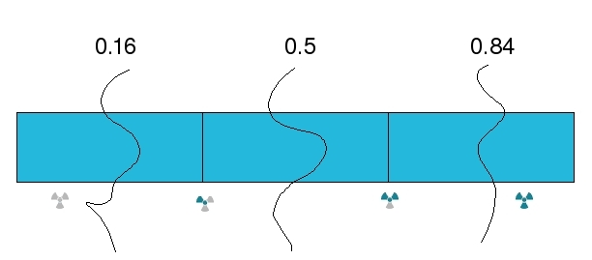Illustration 6: Limits for graphical display of rating
This average is used to display a ReaktorArtwork's current popularity, the graphical representation of the average uses images of the Reaktor Propel. Because it is an average, the model for rating needs to cope with decimals, which it does according to Illustration 6: Limits for graphical display of rating. Any average with a decimal below 0.16 will be floored, similarly an average with a decimal over 0.84 is rounded up. This is because it should be a theoretical possibility to get a maxium score using the average, which means given the maxium rating is 6, the user can have 5.84 and still get maximum score. The maximum score is configurable.
The most popular artwork lists make use of this average as well. The problem is that an average doesn't say anything about the number of votes, an artwork with one single vote with maximum score, would rate higher than an artwork with 100 votes where all are maxium scores except one that is the minimum score. On the other hand, if vote count was taken into account, older artworks would always be on top, because they have more votes than new ones. The Reaktor solution is to select votes in the last two months, and order by highest average, and then number of votes. If there are no votes within the last two months, it falls back to using the easy retrieval average instead.

Articles
Reaktor uses tinyMCE for creating and editing articles. There are seven types of articles in Reaktor:
- Regular articles
- Theme articles
- Help articles
- My page articles
- Internal articles
- Footer articles
- Protected articles
The type of an article decides which list it can appear in on the site. Regular article and theme article lists are displayed lists on the frontpages. Note that theme articles have presedence, if one is published, it will always be on top, and no other articles are listed. My page articles are listed on the my pages, internal articles are listed in the admin portal sidebar, and footer article lists as title links in the footer. Help articles are displayed in lists on artwork pages, but only if they have matching subReaktors and/or categories. Protected articles are not listed anywhere, but when they are created they can be linked to. The Login help article is an example of a protected article.
Permissions for creating articles can be set on a per article type basis. Admin users have permission to view all articles, whereas normal users, and non-logged in users cannot see internal articles. Non-logged in users cannot see my-page articles either.
Some articles can be ordered to make sure they come up top in lists. Navigate to the amin portal and click <<Articles – Order articles>>. Only regular, footer, internal, and my page articles can be ordered. This is because a theme article is always on top on the frontpages lists as long as it is published, which means it does not need to be ordered. And because my page articles depend on subReaktors and categories, they don't follow the order either. Since the protected articles are not listed anywhere, just linked to directly, it does not make sense to order them.

LightWindow, buttons, and Internet Explorer
Due to a bug in Internet Explorer LightWindow does not work properly with buttons in this browser. This is why some buttons are, in fact, not buttons at all, but links styled as buttons. Wherever this style of button is used, other buttons have followed. This is to keep a consistency on the page.

Transcoding
All files uploaded to Reaktor are automatically transcoded using ffmpeg, unless they already are on the preferred format. Video files are transcoded into flv, images files into jpg, and sound files into mp3. If something goes wrong during the automatically initiated transcoding, there will be a message about this on admin artwork lists next to the artwork in question, along with a link to restart the transcoding process. The same information can be found on the artwork's edit page.

Mail
Most of the time, emails are to be sent in HTML format, but some mail readers does not support this which is why in Reaktor all mails are sent in multipart format (enclosing both HTML and text format). This means every e-mail must be not only be written twice, but also once in every language supported.
As an example let's use the comment notification mail. The comment notification has two templates, one for HTML and one for the alternate e-mail. The templates are
- sendCommentNotificationSuccess.php
- sendCommentNotificationSuccess.altbody.php
The template's does not actually contain the e-mail itself, only a key along with the necessary parameters to write the e-mail in the translation interface.
Elaborating further on our example, say a user, Alice, comments on the artwork My city, and in the process ticks of the box saying she wants to be notified when someone answers the e-mail. Then Bob comes along and agrees with Alice that the artwork My city indeed is worth a comment. When Bob submits his comment, behind the scenes reaktor will look for the comment notification templates in the list above, and not forgetting that all mails from Reaktor are multipart, it looks for one template for HTML and one alternate. These two templates tell reaktor to use a key to look for a given translation in the translation table. Now reaktor has to choose which translation to use for the e-mail. The e-mail is going to Alice, she is the one who wants to be notified that someone has replied to her comment, so the translation used is the one Alice has chosen in her profile. The translations are the content of the actual e-mails. The e-mails are complete because the key contains the variables needed, like the name of Alice, the title of Bob's comment, which article was commented and of course, the comment itself.
The key looks similar to this:
<?php echo __('sendCommentNotificationAlternate %artwork_title% %commenter% %comment_title% %comment% %url_comment%', array(
"%artwork_title%" => $artwork->getTitle(),
"%commenter%" => $comment->getsfGuardUser()->getUsername(),
"%comment_title%" => $comment->getTitle(),
"%comment%" => $comment->getText(),
"%url_comment%" => url_for("@show_artwork?id=".$artwork->getId()."&title=".$artwork->getTitle()."#message_".$comment->getId(), true),
)) ?>

The key is: 'sendCommentNotificationAlternate %artwork_title% %commenter% %comment_title% %comment% %url_comment%'

To do the translation search for the key in the source field in the translation interface. To add the e-mail edit the translations. The english translation/e-mail for HTML and comment notification could look something like this:
----
<b> Hei!</b><br />

%commenter% has replied to your comment on %artwork_title%
<br /><br />
Klikk <a href="%url_comment%">her<a/> for å gå til kommentaren, eller se kommentaren under:
<br /><br />

------------------------<br />
<b>%comment_title%</b>
<br /><br />
%comment%
<br /><br />
------------------------<br />
<b> Hilsen Reaktor! </b>

----
Another example is the e-mail sent out when a user changes his/her e-mail (new e-mail activation) where the key looks like this:
<?php echo __('newEmailActivationHTML %oldemail% %newemail% %username% %verifylink%', array(
"%oldemail%" => $oldemail,
"%newemail%" => $newemail,
"%username%" => $sf_user->getUsername(),
"%verifylink%" => "http://".$sf_request->getHost().url_for($url),
)); ?>
------
<b> Hei, %username% </b>
<br />
Du har endret adresse fra %oldemail% til %newemail%
<br />
Før du kan endre adresse må du verifisere den nye.
Klikk <a href="%verifylink%"> her </a> for å verifisere.

<br />
Hilsen Reaktor!
-----

This is a list of all e-mails Reaktor sends to its users:
- Send comment notification (keys: sendCommentNotificationHTML, sendCommentNotificationAlternate)
- Send new e-mail activation for users changing their e-mails – this mail goes to new address (keys: sendNewEmailActivationHTML, sendNewEmailActivationAlternate)
- Send new e-mail activation notification for users changing their e-mails – this mail goes to the old address (keys: sendNewEmailActivationNotificationHTML, sendNewEmailActivationNotificationAlternate)
- Send editorial team notification when new artwork has been submittet (keys: editorialTeamNotificationHTML, editorialTeamNotificationAlternate)
- Send activation e-mail to new users (keys: sendActivationEmailAlternate, sendActivationEmailHtml)
- Send new password e-mail to users requesting it (keys: sendPasswordEmailHTML, sendPasswordEmailAlternate)
- Send email about username and password if registered by an admin. (keys: sendProfileRegisteredByAdminHTML, sendProfileRegisteredByAdminAlternate)

Note! The subject of the e-mail is set seperately and thus it is translated separately. Also it cannot contain any HTML so it is the same for HTML and alternate e-mails.

Managing Reaktor
This chapter is meant as a guide on how to edit the appearance of the site; anyone who wants to change the placing of an image, wants a list to be longer, or would like to add a new subReaktor or LokalReaktor, should look to this chapter, and the templates appendix.
If you want to edit a web page on Reaktor, you need to know which template to edit. How you map a web page to a template using the URL, is thoroughly explained in chapter 4.4.1. Once you find the template you want to change, you can do the changes you require. How to style and change the layout of a page is outside the scope of this documentation, but you will find detailed comments on the top of each template file to help you get started. These comments are also make up the template appendix.

Terminology
Before getting started on changing the layout in Reaktor, it is a good idea to get acquainted with some concepts and terms. If you have read the Symfony book, a book containing almost everything anyone needs to know about the framework used to build the new Reaktor site, you should already be familiar with the terminology. If not, the following is a short overview - the absolute basics of what you need to know to get started. It you are interested in becoming a more advanced user you can easily 'upgrade' your skills by reading more about each term in 'the book', also found at http://www.symfony-project.org/book/1_0/ .

Symfony
Symfony is the web application framework used to build the Reaktor site.

Template
A template is just a file. It contains instructions in PHP, CSS and HTML to place and shape the content of a web page - it decides the look and feel of it. The naming convention in Symfony requires all templates that are not a part of components, or partials to end with Success. Templates that are part of components and partials start with an underscore.

Example
The artwork module has a file, showSuccess.php, in its template folder which allows you to view the artwork by going to the corresponding URL: reaktor.no/no/artwork/show/8/Nice+monkeys. (To understand why this URL has numbers and monkeys in it, check out Chapter 1.2.10 Routes.)

Partial
A partial is a mini web page within a web page. It is a special kind of template, because it cannot run on its own but must be included in another template. Symfony's naming convention means all partial files start with an underscore.

Example
If you on the reaktor page see a log in box, the template, generating that page has used the login partial _login.php. To include the login partial: include_partial(“sidebar/login”).

Components
A component is a partial but with a controller, or action if you will. This means it has access to extra information. Other than that its the same as a partial.

Example
The showSuccess template includes the artwork rating component so the visitors can rate it. It does it by calling the component like such: include_component('artwork/artworkRating'). The component's template is in artworks template folder, and is named _artworkRating.php.

Action
An action is a template's controller. It collects information from the database and passes it to a template, or a component. All actions are placed in one of the two files in a module's actions folder, components.class.php or actions.class.php.

Module
A module is a collection of actions and templates, validators and configurations.

Example
Artwork is a perfect example of a module. It lets the user view and interact with an artwork, or a collection of artworks

Web site
A collection of web pages.

Example
The reaktor site is a good example: minreaktor.no.

Web page
A HTML document on the web, accessed using a browser.

Example
The front page of a subReaktor is a website: minreaktor.no/no/foto .

Object
Group of information tightly linked together, usually by a table in the database. An object has actions connected to it, which you can use to access this information.

Example
The user (name, age, residence), and an article (title, body, author) are both objects. If you want to access and objects information you do this: $user->getUserName()

Route
To hide the file structure and provide better URLs for the user, Symfony uses routes which translates the URL seen in the browser to the location of the action and template generating it.

Example
All routes can be found in /reaktor/apps/reaktor/config/routing.YAML

Each route consist of a URL, and the module and action it maps to, and in some cases also requirements.:

show_artwork:
URL: /:sf_culture/artwork/show/:id/:title
requirements: { sf_culture: (?:no|nn|en) }
param: { module: artwork, action: show }

reaktor.no/no/artwork/show/8/Nice+monkeys translates to the artwork module and the action show, and the template showSuccess.php. The number is the id of the artwork, and 'Nice monkeys' refer to the title. These are get parameters passed to the action so it can retrieve the information it needs , and pass it to the template

Generators
A generator is a single configuration file connected to a database table. The generator will generate all the needed files of the MVC parttern to edit, add, and delete rows in the table it is connected to, it can also list the table content, and provide filters for the list. The generator file relies on a special configuration with a complete syntax.

Templates
Symfony follows the MVC pattern, which divides the functionality of the site into three layers. The model, the controller and the view. The target audience for this document will mostly be dealing with the view layer. If you want to learn more about MVC, this link: http://www.symfony-project.org/book/1_0/02-Exploring-Symfony-s-Code will give you an introduction.
The view consist of yet another three layers: layout, view logic and templates (see Illustration 3: The symfony workflow). The Reaktor site has a generic layout: header, sidebar, main content and footer (see Illustration 7: Reaktor layout), which means changes in the layout will be rare (yet, still very simple to do if it comes to it). The view logic are mostly for developers to control meta data on a page. Which leaves templates.
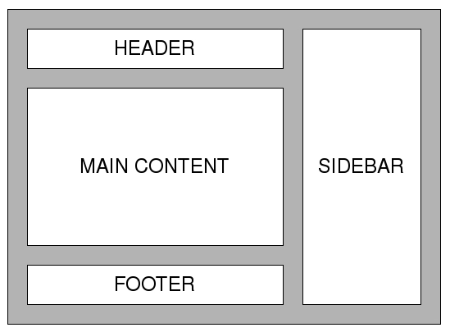Illustration 7: Reaktor layout
To understand what a template does, it might be easier to think of a web page within the Reaktor site as a wooden sculpture, and whoever created the page, or wants to change it, as the artist. Continuing with the analogy, the page content is the piece of wood the creator works with, and the template is the tool he or she uses to shape the wood into the form it should have. The CSS-file is the paint added to create contrasts, draw attention to particular areas, and give the sculpture a final touch.
The content of a template can be any type of information the page can make use of - images, videos, text, forms, variables, objects, etc. Unless you developed the page from scratch yourself, model, controller, view and all, or know where to find and how to read this information, it can be quite hard knowing what content you have access to. Chapter 4.4 will give you an overview. But first you need to know where to find the templates, which you will learn in chapter 4.3 .

Where to find templates in the file structure
Every template belong to a module, and unless it is a partial it is connected to a controller (action or component). Say you want to edit the artwork edit page on Reaktor. Artworks are a big part of the Reaktor site, so it is only natural that it has its own module. This module is called artwork. The page you want to edit is the artwork edit page, which means the action is simply called edit. This means you have to find the modules folder and locate the correct module, which is artwork, and look inside it's template folder for a file name editSuccess.php. If you take a look at Illustration 8, you can see the file is at the bottom of the image.
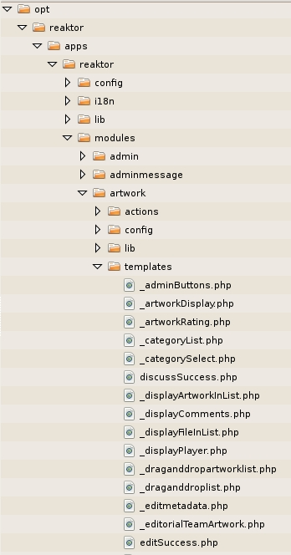Illustration 8: The file structure to get to a module's templates
Each module will at the most contain the following folders:
- Actions
- Config
- Lib
- Templates
- Validate
The templates are always found in the templates folder of each module. You find which template to edit by tracing the URL in the file reaktor/apps/reaktor/config/routing.YAML. A step by step guide is provided In chapter 4.4.1.

Editing templates
This is not as hard as it may seem, but you need to know which template to change. A first glance within the file system of a Symfony project might be overwhelming, but it is well thought through, and it is consistent. Chapter 4.4.1 is a step-by-step guide with an example on how to locate the template when given a URL.

I have a URL, which template do I change?
- Find the URL of the page you want to edit, for example http://reaktor.no/no/portfolio/userboy

- Open the following file /reaktor/apps/reaktor/config/routing.YAML. This file is the same for all URLs. It contains a collection of routes, which translates the URL so the system knows which action to run.

- Find the route that matches the URL, in our example it looks like this:

portfolio:
URL: /:sf_culture/portfolio/:user/*
requirements: { sf_culture: (?:no|nn|en) }
param: { module: profile, action: portfolio}

As you can see, the URL this route matches has some variables, you recognise variables from the colon in front of it. The sf_culture variable decides which language the page's content should be displayed in. The user variable decides which user's portfolio you are going to view, which means this route will match all URLs going to any user's portfolio page, in any language supported by Reaktor. The URL http://reaktor.no/en/portfolio/monkeyboy for instance, will also match the route above. The variables in the route are actually get parameters, which can be reached in the corresponding action (executePortfolio) and template (portfolioSuccess.php) in the module.
- Find the module (i.e the folder) as given in the matching route. In our example, the module is 'profile'. If you only want to change the template, and are not interested in the controller of the template you can skip bullet point five.

- Find the correct action (i.e the function) in the action file in the module's action folder. This file contains a collection of functions, where one will correspond to the action given in the route. Symfony's naming convention means the function will begin with execute and end with the name of the action given in the route. In our example the file is here: /profile/actions/class.actions.php, snf the function to look for is executePortfolio. All variables assigned to $this in the action, will be available in the action's corresponding template. This means looking in a template's action is always a good way to get an overview of the content that can be accessed in the template.

- Find the template that belongs to the action. Symfony will use the template with the same name as the action with the word Success added to the end. Looking at our example, the template can be found in modules/profile/templates/profileSuccess.php.

- Open the template, and locate the part you want to change. Depending on what you want to edit, this might be your final stop. If you did not find what you were looking for, please read the following bullet point.

- Remember, a page can consist of mini-pages in the form of components and partials. If you look at a page on the Reaktor site, there are some logical parts that belong together, like a list or a form. In our example, userboy's portfolio page, there are several components. The list 'My latest commented artworks' is one such component. If you want to edit something within a component or a partial read the next bullet point.
- If a component has been included on a page it looks something like this:.

include_component('sfComment','latestCommentedArtworksByUser',array(
'user_id' => $user->getId()))

The module is the first parameter in include_component call, the template the second. The third parameter is optional, it is an array passing the needed parameter in the template. If you want to edit something in a component, you have to find the template. In our example we need to find the sfComment module, and look in the template folder for _latestCommentedArtworksByUser.php. Note the underscore in front of the template, that is the Symfony naming convention, it makes it easier to separate component and partial templates from the other templates. The component's controller is found in the module's action folder, in the components.class.php file. From the example above, the module is sfComment, so the path to the file is: reaktor/apps/reaktor/modules/sfComment/actions/components.class.php.

The function to look for in the generator will have execute prepended to the name of the templaet, in our example the function is named: executeLatestCommentedArtworksByUser.

A partial is also commonly used. An example of what it looks like, can be seen below. It works in the same way as a component, except it does not have a controller. Our example, the portfolio page does not have any partials. So the following example is stand-alone.

Many of the lists are also registered as RSS feeds, in those cases a partial is used, that is our.

include_partial('feed/rssLink', array('description' => __('latest registered users'), 'slug' => __('latest_users')))

- The above list will work in most cases, but there are exceptions, so please read chapter 4.4.2 Special Cases.

Special cases
Routing is not always following a fixed path; there are exceptions. The following chapters go through most of them.

Redirects
An action normally does a series of tests. For instance it needs to check if the user asking for the action is allowed to have it, but it also needs to check for all the information it needs to successfully run the page. If any of the tests fail it might do a redirect. This means it will not choose the expected template, but ask for another URL. As long as you see the expected result when viewing the page in the browser, this will not be the case.

Actions
Sometimes an action will want to use a different template, the action will the have used the following function at one point:

$this->setTemplate('newuser');

The green text is the name of the template.

Templates outside modules
Chapter 4.4.1 describes how to find the template of the main functionality of a page. However, each page on the site also consist of a header, a menu and a footer. These do not belong to a module, and does not have actions. Their template folder is found outside of the module folder: /reaktor/apps/reaktor/templates. Chances are, these templates will never have to change.

Sidebar
The right-hand sidebar is on all of the Reaktor pages, which is why it is included directly in the layout. This means there are no routes to follow, you have to go directly to the sidebar module

Translating in Reaktor
Reaktor comes with support for internationalization, often referred to as i18n because the length of the word makes it hard to type (18 refers to the number of characters bewteen i and n). This means all text in Reaktor can be translated. We differ between text in files, such as templates, and text stored in the database which is often the case with drop-down menus.

How does it work?
For symfony to translate the phrases of a template, they must be identified as text to be translated. This is the purpose of the __() helper (two underscores). Text in validation yaml files, and generators are automatically identified for translation.
Each time the __ helper is called, symfony looks for a translation of its argument in the database using the current user's culture. If it finds a corresponding phrase, the translation is sent back and displayed in the response. This means the user interface translation relies on a table in the database to contain the string the magic __ function wants to translate.
The translation table in the database is populated using a script from a Symfony plugin. How to use this script is described in 4.5.3. The script works by extracting all phrases in templates with __ and adding them in the database. The script should be run once for each culture to be supported. When the script identifies a phrase for translation, it will check if it is in the database or not. If it is, the script will ignore the phrase and keep looking for new ones. If it is not in the database, it will add it with the following information:
- The phrase
- The name of the module the phrase was extracted from
- The name of template the phrase was extracted from
- The date it was extracted
- The culture
Each row can later on be filled with more information such as the actual translation, if it is translated, a comment on the translation.
A phrase identified as text to be translated is the source phrase. In Reaktor this is usually English, but it does not need to be. The source phrase can also be a place holder describing what the translation should say, or the source can be a different language. In Reaktor there are three cultures English, Nynorsk and Bokmål. The translation script must be run once for each culture supported, which in the Reaktor case is three times.

Using the translation interface
Once the translation table in the database is populated (see 4.5.3), you can navigate to the admin portal and in the menu and click <<Translation - Website text>>.
The page that meets you is a list (see Illustration 9: The translation list), which can be filtered on different criterias to get shorter lists, or just find the string you are looking for.
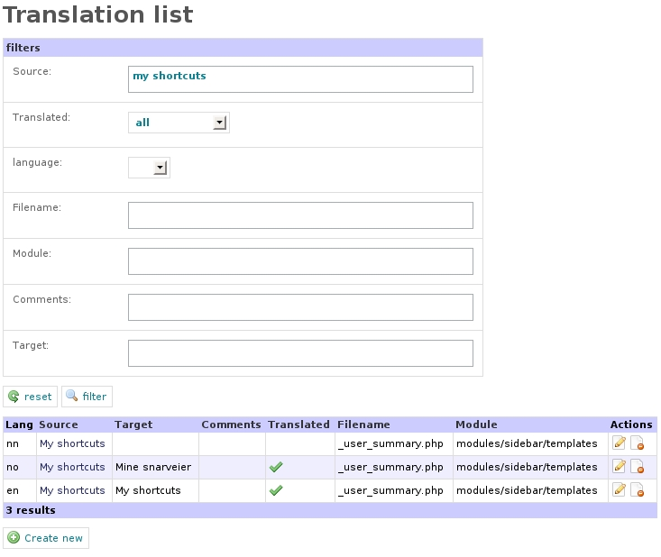Illustration 9: The translation list
Each row in the list has two actions connected to it. You can delete the translation, or you can edit it.
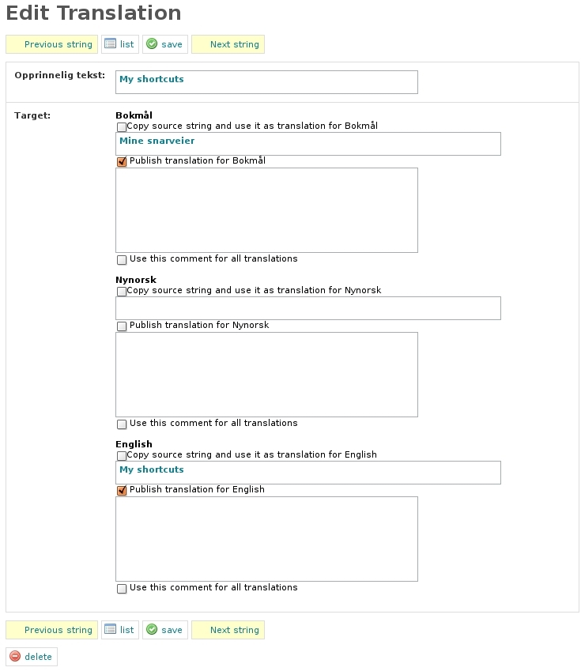Illustration 10: Phrase translation

Filtering
Filtering is extremely useful for translation purposes. For instance, say you want to find all phrases that has not been translated to Nynorsk yet. All you have to do is set the translated drop-down to 'no', and set the culture in the language dropdown to 'nn'. If you want to concentrate your translation on one webpage in Reaktor you can enter the template name in the filename box and the module name in the module box to filter on those. Note that this is not fool proof, there is a good chance the phrase exists in more than one template, in which case a phrase will not come up on the filename your filtering on, even if it used in the template. This is because the extraction script only knows of one template the phrase is in, and that is the first template it finds it in. The template name is also useful if you want to know the setting the phrase was used in.
The target filter makes it possible to search in phrase translations, which is more useful the more of the site that has been translated.
Illustration 11: Phrase translation

Translating
If you click the edit action in the translation list, the edit translation interface appear (see Illustration 11: Phrase translation). The source string is as mentioned above, the key identifier for the translation. All the cultures supported are displayed for translation in the same interface. Type the translation in the textbox and tick off the translated checkbox to translate a phrase.
Each translation also has a text area for commenting. This is because more than one person could be working on translating the site, and if discussions regarding a translation arise, this field can be used to explain the thought behind a translation. The comment field is for internal use and will never appear anywhere on the site.
The “set translation to source string” checkbox is a shortcut for setting the translated text equal to the source string. If this box is ticked, and you click save, the source is copied in as the translation for this culture.
Always press save to save the changes.
The previous and next string will take you to the next and previous phrase in the order the script found them, not the next and previous string in the filtered list.

Variables in the source
A phrase sometimes contains information that changes according to who is logged in. For instance the phrase Welcome John Doe, does not have to be translated once for each user. Instead the phrase will be something like Welcome %user%. The variables are identified by percent characters, and everything in between these should not be translated. The translation in Bokmål for this phrase would be something like Velkommen %user%, or %user%, velkommen!. The point is that the variable can be placed anywhere in the translated string, or even omitted.
The semantics of the sentence will usually be enough to understand what the variable represents. However, there are occations where they are not be totally clear, here are some variables that might require more explanation:
Translation key | Meaning
%site_title% home | Ex.: Reaktor home. %site_title% is referring to the title of the site.
Please enter at least %1% characters | Ex.: Please enter at least 7 characters. %1% refers to the number of characters
Unfortunately, your browser does not work very well with Reaktor.%break%For the best experience possible, please use an up-to-date browser, such as %firefox%, %opera% or %safari% | In this key all variables are there to avoid using html code. %break% will be replaced by break, and the browser variables by links to their respective home pages.
%number_of_messages% new | Ex.: 5 new. %number_of_messages% refers to the amount of new messages.
%1% users | Ex.: 3 users. %1% refers to an amount of users.
Remove %1% from favourites | Ex. Remove My Dog from favourites. %1% can refer to any object that can be marked as favourite. That means artwork and users.
[0]No artworks|[1]1 artwork|[1,+Inf]%1% artworks | Instead of using a key form like %1% artwork(s), this key form asks for the different conjugations of a subject, singular, plural and none-existing.
Add a new %1% | Ex. Add a new Category. %1% is referring to an object.
newEmailActivationHTML %oldemail% %newemail% %username% %verifylink% | This key should not be used as a default in any language, it is meant as just a key. The e-mails are treated in its own chapter (3.10), and variables are hopefully intuitive enough. Email keys end in HTML or Alternate.
Unable to retrieve ratable object: %s | In Reaktor it is possible to rate artworks, %s in this key refers to an artwork string.
Are you sure you wish to remove the tag: %1% from this artwork? | In Reaktor is is possible to tag files and artworks. The %1% variable in this key refers to a tagname.
Please enter at least %1% | %1% refers to the the mininimum numbers of tags.
My %filter_eg_submitted% files | Ex. My unused files. The variable in this string refers to the status a list of files have been filtered on.

Note! The keys might be used in more than one location, which might add to the confusion.

The source phrase is wrong
If the source is wrong, the phrase in the template where it was extracted can be altered directly, although strictly this is in most cases not necessary. As long as the translations are correct the source is never displayed on the page. It should only be necessary to alter the source if it is missing a variable. If this happens, instead of running the script again, you can change the source string directly in this interface. Take extreme care that the two match completely, and note that the translation helper __ is case sensitive. This is the same reason why you will have to translate 'tags' and 'Tags' separately.

Adding new phrases
Adding new phrases in templates is as simple as using the __ helper, and then adding the same phrase in the translation interface. The translation list has at the bottom of the page a button to add new sources to the translation table. If there are a lot of new phrases though, it makes sense to run the extraction script again (see 4.5.3).

Administration
Reaktor uses a plugin called sfI18nDbTranslationPlugin to translate text in templates. This plugin has been modified to work better with Reaktor.
The translation plugin has a command line tool to extract all untranslated text from the application. With the default installation of Reaktor all strings are extracted, but if phrases in templates are altered, this script must be run again so that any new strings appears in the table, and consquently in the web interface.
To extract all internationalized strings from the application, navigate go to the appliaction folder (usually /opt/reaktor) in a terminal and type:
# symfony i18n-extract –auto-save no reaktor
# symfony i18n-extract –auto-save nn reaktor
# symfony i18n-extract –auto-save en reaktor
It is repeated once for all cultures.
When the script is run, the database is filled with all internationalized strings.

Configuration
Configuring Reaktor mostly boils down to changing a line in a YAML file, the reaktor config file.

YAML files
A YAML file uses the yml extension, and contains information written in the YAML language for serialisation of data. It is a human friendly data serialization standard for all programming languages. Symfony uses YAML as the preferred language to store configuration.
In the Reaktor project the most important YAML file to know about is:
<reaktorroot>/apps/reaktor/config/app.yml

This file holds all of the configuration variable to each action, separated by modules. YAML is easy to learn, the little that is needed to know to be able to read such a file with ease, can be found here:
http://www.symfony-project.org/book/1_0/05-Configuring-Symfony

subReaktors and LokalReaktors
Reaktor is divided into several sections, namely subReaktors and LokalReaktors. subReaktors and LokalReaktors are both “subReaktors” in the sense that they are both a subset of reaktor.no, but they have some different rules applied to it, which decides what content you will see and how it is filtered.
Whenever we refer to a “subReaktor” or “LokalReaktor”, we are basing it on the definitions in 4.7.1 and 4.7.2.

subReaktor
A subReaktor in Reaktor is a section of the site that is only showing content of a given format. Some good examples are the “foto” and the “tegneserie” subReaktors, which can only display image content. When a user uploads an image artwork, they must choose which subReaktors they want to place their content in, from a list of subReaktors which can show image content. As such, if you add a “Grafitti” subReaktor, and specify that it can show image content, users will be able to choose that subReaktor whenever they upload an image (as well as the already existing “tegning” and “foto” subReaktors).

lokalReaktor
A LokalReaktor is a defined “area” in reaktor, which is defined to only show content uploaded by users living in certain locations. Artwork can be “tagged” with a LokalReaktor by an administrator (during the artwork approval workflow), or automatically during upload (if you are in that LokalReaktor when uploading). LokalReaktors will also update content automatically, so that if you create a new LokalReaktor called “finnmarksReaktor” and specify that its location includes Finnmark, it will automatically contain all artworks previously submitted by users residing in Finnmark.
LokalReaktors are not “sections” of the site in the same way as subReaktors, but they are applying filters based on geographic location. Therefore, LokalReaktors contains all the existing subReaktors, and applies the geographic filter on top of what is already defined in the subReaktor. An example is when you visit reaktor.no/no/groruddalen-foto , you will then see all content tagged as “foto”, which is uploaded by users residing in groruddalen, or have had their artwork tagged with “groruddalen” by an Administrator.

subReaktor/LokalReaktor titles and references
Each subReaktor and LokalReaktor has a title and a reference. The title is what is displayed in links, mouse-overs and on imagemaps, and the reference is what appears in the URL. For example: reaktor.no/no/foto is referring to the subReaktor with reference “foto”. This subReaktor will be presented on the site as “fotoReaktor”.
You can combine a LokalReaktor reference and a subReaktor reference, so that you can visit reaktor.no/no/groruddalen-foto, which will show you the “foto” subReaktor frontpage, with the filters defined in the “groruddalen” LokalReaktor, applied.
When creating a new subReaktor, its reference must be unique from all the other subReaktors and LokalReaktors, as well as all the existing routes. This means the reference can not be “admin” or “artwork”, since there is already an existing route called reaktor.no/no/admin and reaktor.no/no/artwork . The system will stop you if you try to add a subReaktor with a reference that already exists.

The administration interface
As Reaktor grows new trends might emerge, and there could be a need to create a new subReaktor. The following subchapters describes the process of creating new subReaktors and lokaLReaktors.

Adding a new subReaktor or LokalReaktor
The administration interface lets you create a new subReaktor or lokalReaktor by simply entering a title and a reference. The reference must be unique (see 4.7.3 ), and the name should be short and descriptive.
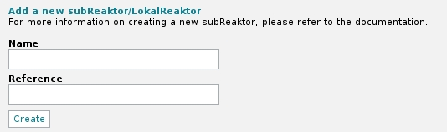Illustration 12: The administration interface for adding subReaktors
Example 1: If you want to add a “GraffitiReaktor”, you would give it the name “Grafitti” and the reference would be something like “grafitti”.
Example 2: If you want to add a “FinnmarksReaktor”, you would call it that, and give it a reference such as “finnmark”.
After you have added the subReaktor/LokalReaktor, you will be forwarded to the “edit subReaktor” page (see Illustration 13: Editing a subReaktor/LokalReaktor), where you need to define the subReaktor/LokalReaktor,, and decide if it is a lokalReaktor or subReaktor.
As part of creating a new reaktor, the system will automatically create a default logo, and a subReaktor frontpage template based on a default lokalReaktor skeleton template. The logo should be exhanged with a proper logo for the subReaktor. Replace it by giving it the same name and putting it in the same folder as the default image. The path and name of the logo file is given in the editPage (see Illustration 13: Editing a subReaktor/LokalReaktor). The template should be altered manually, how much the frontpage template needs to change depends on whether the new reaktor is a subReaktor or lokalReaktor.

Because the frontpage skeleton template is based on lokalReaktors, it will for new lokalReaktors work out-of-the-box with no altering at all. However, if your new reaktor is a subReaktor, the frontpage will have to be adapted according to the type of content it has - the template can still be used as a starting point – but it will not work out of the box, it must be altered or it will generate errors. Existing subReaktor templates will be of great help when doing this. If your new subReaktor is a graffitiReaktor, and will display images only, then use fotoReaktor as a guide. The template that needs to be altered is named in the subReaktor's edit page (see Illustration 13: Editing a subReaktor/LokalReaktor).
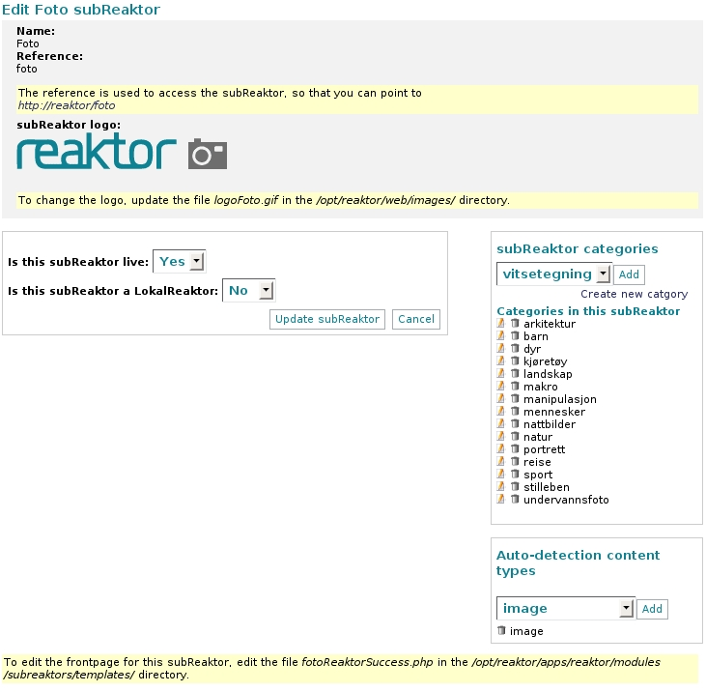Illustration 13: Editing a subReaktor/LokalReaktor
This configuration page is explained in more detail in sections 4.7.4.2, 4.7.4.3, 4.7.4.4, and 4.7.4.5.

subReaktor and LokalReaktor common settings
The edit page gives you an overview of the subReaktor/LokalReaktor settings. Common settings are
- Is the subReaktor live
If the subReaktor is live, a link to the subReaktor/LokalReaktor is displayed in the menu, and it can be accessed by normal users. If it is not live, only users with permission to edit subReaktors can access it.
- Is the subReaktor a LokalReaktor
If the subReaktor is a LokalReaktor, it will behave as described in 4.7.2. If it is not a LokalReaktor, it will behave as described in 4.7.1. Use this setting to choose between the two types of subReaktors.
- Which content types does it detect
If the subReaktor is a LokalReaktor, Reaktor will automatically add the LokalReaktor tag if you upload content of the specified type(s) from within the LokalReaktor. If the subReaktor is not a LokalReaktor, then you will be able to place artwork in this subReaktor if it is any of the specified type(s). More about this in the section that explains artwork upload.

Changing subReaktor/LokalReaktor name
The subReaktor/lokalReaktor names are translated when displayed on the page. This means that you must use the translation interface to change the name. To change the name of a subReaktor/lokalReaktor, click “Translation” → “subReaktor names” in the admin portal menu, and select the subReaktor/lokalReaktor you want to change. This will change the name for the language you are currently using. If you want to change the name for other languages as well, change the active language using the language links in the top right corner, then edit the name of the subReaktor/LokalReaktor you want to change.

Configuring your new subReaktor
A subReaktor needs to be configured so that it can be detected when users upload artworks, and so that they can place their artwork in a category inside the subReaktor. (See Illustration 13 for how the edit page looks)
- Categories
You need to add categories in the “subReaktor categories” section of the edit page. Each of the categories you add here, will be possible to add to an artwork that has been placed in this subReaktor. You can only add categories that are not connected to a subReaktor already. If you want to add a category that does not exist, you have to create it first using the Category administration interface. There is a quick link from the subReaktor edit page. Remember to make sure the category is translated.
- Content type(s)
You will also need to add content type(s) to the “Auto-detect content types” section. This section is a list of content type(s) that will be possible to add to this subReaktor. If you want a “MusicReaktor”, then you would make sure that it could detect content of “audio” type, but not content of “text” type. Similar, for “PoemsReaktor”, you would make sure that it could detect content of “text” type, but not “image”, “video”, “audio”, etc...

When you have configured the above, you can move on to editing the template (see 4.7.5).

Configuring your new LokalReaktor
A LokalReaktor has a slightly different edit page. First, make sure you change the “Is this subReaktor a LokalReaktor” setting to “Yes”. You will then have a page that looks like this:
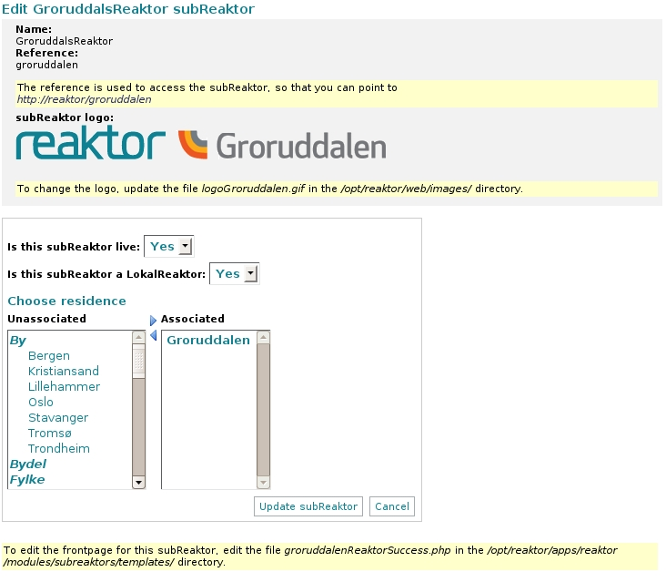Illustration 14: Editing a LokalReaktor
To properly set up a LokalReaktor, you need to set up the following:
- Residences
If you want the LokalReaktor to automatically include content uploaded by users who live in a certain area, select the residences you want to include, then click the “arrow right” button. You can remove residences by clicking the “arrow left” button between the two lists. (Make sure you click “Update subReaktor” when you are done.
- Categories
LokalReaktors doesn't have categories, so you cannot set those. However Content uploaded in a LokalReaktor needs to also have a subReaktor assigned, so the artwork will use categories from the subReaktor(s) applied to the artwork. Remember, only staff members can tag an artwork with a lokalReaktor if it wasn't done automatically.

When you have configured the above, you can move on to editing the template (see 4.7.5).
Note: as mentioned before, if you are creating a new subReaktor which is not a LokalReaktor, you must replace the new reaktor template file with one of the other subReaktor templates. simply go into /apps/reaktor/modules/subReaktors/templates and copy the file filmReaktorSuccess.php to yourNewsubReaktorSuccess.php. Replace the name with the filename reflecting your new subReaktor.

Editing subReaktor/LokalReaktor templates
subReaktor templates are normal webpages, with components on them. The template you are editing is actually only the “center” of the page, since the header, top and left menu, and the footer are automatically included. To find out which template you need to edit, look at the bottom of the “Edit subReaktor” page, which will tell you the filename. To see the template in action, you can access the URL given in the upper left part of the “Edit subReaktor” page. This URL will only be available to users with access to modify subReaktors until the subReaktor/LokalReaktor is marked as “live”.
When you edit the template (see chapter 3 for more about editing templates and adding components and partials to the page), you do not have to worry about adding parameters and other configuration options. If you put the “Latest artworks” component on the “GrafittiReaktor” frontpage, that component will automatically show you the latest artworks within that subReaktor. If you put that same component on a LokalReaktor frontpage, it will automatically show the latest artwork within any subReaktor inside that LokalReaktor. No configuration needed. If you want to manually specify that you want to show the latest artwork from “GraffitiReaktor” on the “FinnmarkReaktor” frontpage, you can pass “graffiti” as the “subReaktor” parameter to the component, and it will look for the latest artwork in the subReaktor you provide, and it will still also make sure that it only displays artwork that is inside “FinnmarksReaktor”. No configuration needed.
More information about which components are available for use on the subReaktor/LokalReaktor frontpages, see the templates appendices.

Rearranging order
By default, the subReaktors and LokalReaktors will appear in the menus and lists in the order you add them. If you want to rearrange the order, then drag and drop them in the list of subReaktors. The subReaktor closest to the top will appear first in the menus/lists.

Changing the registration form
Changing the registration form is a task that requires some effort, and competence, especially if it involves database changes. The following is an overview.

The files
The registration form is a part of the profile module, and is used by the register action and edit action. This is because the same form is in use when the user wants to change profile information after the registration process, as when actually registering. In addition, the administration has its own view of profile information in the sfGuardUser module. There are quite a few files that might need to be updated:
- <reaktorroot>/apps/reaktor/modules/profile/templates/registerSuccess.php
- <reaktorroot>/apps/reaktor/modules/profile/templates/editSuccess.php
- <reaktorroot>/apps/reaktor/modules/profile/templates/_userProfile.php
- <reaktorroot>/apps/reaktor/modules/profile/actions/actions.class.php
- <reaktorroot>/apps/reaktor/modules/profile/validate/create.yml
- <reaktorroot>/apps/reaktor/modules/profile/validate/update.yml
- <reaktorroot>/apps/reaktor/modules/sfGuardUser/config/generator.yml
- <reaktorroot>/apps/reaktor/modules/sfGuardUser/validatie/edit.yml
- <reaktorroot>/lib/model/sfGuardUser.php
- <reaktorroot>/config/sfGuardPlugin_schema.custom.yml

What to change and where
If you want to change form field labels you will only need to change the appropriate template files, just remember to update the translations keys. The field labels might also need an update in the sfGuardUser generator file.
If you want to remove a field you will get away with commenting or removing the appropriate field in the template files, removing the reference in the validation files, and make sure the value us not stored in the database. The latter is done by removing the code to stores the values in the database in sfGuardUser.php – se the registerUser and updateUser methods. In addition the field might be in use by the administration, which means you should remove any reference to the field in the sfGuardUser module's generator and validation file.
If you want to change or add something that requires a change in the database, this is a slightly bigger operation, and depends on what kind of field you would like to add or change, and what you would like it accept. Before attempting this, the recommendation is to read the following part of the Symfony documentation: http://www.symfony-project.org/book/1_0/10-Forms.
Here is a short summary of what this operation involves. If the database can be torn down (i.e it is not in production yet), after the schema file is changed, the model can be rebuilt and the database updated all in one go. Change the schema and the following command will do the rest:
user@reakor$ /opt/reaktor/symfony propel-build-all-load reaktor
Next is the validation, displaying the field in the appropriate template, and also storing the value in sfGuardUser.php – see the registerUser and updateUser method. Also, the sfGuardUser module should be updated. Change or add the field in the generator.yml and the validation/edit.yml to take care of the administration view of the profile information.
If the database cannot be torn down, a manual job will replace part of what the Symfony task performed above. The database change must be performed directly, the schema updated and finally the model can be built using this task instead:
user@reakor$ /opt/reaktor/symfony propel-build-model reaktor
After this the validation, generator, field display and storage can proceed in the same way. Do not forget to do changes to sfGuardUser module as well.
Remember all changes to YAML files (like the validation and generator files) requires the Symfony clear cache task to run before changes will have any effect:
user@reakor$ /opt/reaktor/symfony cc

E-mail
Registration and some profile update tasks results in an e-mail to the user. The e-mail author is configured in <reaktorroot>/apps/reaktor/config/app.yml under the artwork section. For this part of the system to work the system must have a functioning mail transfer agent. If no e-mail is necessary, it can be removed from the appropriate actions in the register and sfGuardUser modules.

ReCaptcha
The registration action has a ReCaptcha field, its purpose is to filter out spam bot users and at the same time help digitalising old books. This field will not function properly without configuring the system to use a key matching the system's domain name. New keys can be acquired from http://recaptcha.net. See 4.8.2 for a description of how to remove this field.

Template documentation
The documentation on what each template does is in the appendix document TemplateDocumentation. contains documentation on how to use all templates in Reaktor. They are divided into four sections, templates that belong to actions, templates that belong to components, partials and layout templates. They have been extracted directly from the templates themselves.

Summary
The Reaktor system was developed in, and is in production in a LAMP environment, using the PHP web framework Symfony, which is based on an MVC pattern. The system is modular, it makes use of external plugins, and its own modules to provide its functionality. Reaktor is a community for uploading artwork on formats such as video, images, and sound, it lets the user interact with the system in numerous ways, and it is internationalised. Administrators can write and publish articles, monitor users, and perform administration tasks such as approving and rejecting artwork, comments and files. Reaktor is built on open source software and can easily divide its content into new sections based on categories and format, or location.

Dictionary
MVC | Acronym short for Model View Controller
MIT | Acronym short for Massachusetts Institute for Technology
ORM | Acronym short for Object Relational Mapping.
LGPL | Acronym short for Lesser GPL, an open source license
GPL | Acronym short for Gnu Public License, an open source license
SWF | A file extension,
FLV | A file extension,
BSD | Berkeley Software Distribution, an open source license
API
GUI | Graphical User Interface
PHP | A scripting language

