PROJECT TITLE:
Fair MPC using Public Bulletin Boards

GROUP MEMBERS:
Anasuya Acharya 17305R004
Anugrah Gari 173050078
Digvijaysingh Gour 17305R001
Kuber Gautam 173050087

DESCRIPTION:
This is an implementation for the work in [1] that presents a new model for achieving the complete notion of fairness in MPC (Multi Party Computation) against dishonest majority by using public bulletin boards implemented via existing infrastructure (blockchains or certificate transparency logs).
The paper presents both theoretical and practical constructions using either witness encryption or trusted hardware (Intel SGX), of which we implement a versoin of the latter.

ABSTRACT:

MPC (Multi-Party Computation) is a process by which n parties: P1 … Pn, each party with local inputs: x1 … xn s.t. Pi has xi respectively, compute a function y = f(x1 … xn) s.t. each party Pi learns nothing more than xi and y. Each party either performs local computation, or communicates with other parties through point to point dedicated channels. The exact steps and order in which these are done is dictated by a Protocol, denoated by ∏.

Fairness is a notion in MPC which dictates that either all the parties get the final answer y or none of them do. It is already a proven result that in any MPC setup, and for any protocol, achieving fairness is impossible. However, what is being tried here is to achieve fairness of any MPC protocol where the setup includes a tusted functionality, i.e. a Bulletin Board.
The goal is to achieve fair MPC protocol against active adversaries, without honest majority and with allowing protocol aborts.
Public Bulletin Boards, specifically are chosen as they are already available in practice, and are practical for implementation. Furthermore, they have certain desirable properties like immutability (once something is published on the bulletin board, it cannot be altered), and robustness (as a global functionality, the probability of it failing is negligible).

In the construction and implementation of [1], it is roughly proposed that any protocol computing y be converted into a protocol computing Enc(y) under a certain key. Once this is done, this output is put on the Bulletin Board and the “Proof of Publish” on the Bulletin Board (Signature or hash, depending on the implementation) in turn serves as the decryption key. This way, as the bulletin board itself is public, both the key and Enc(y) are visible to all parties. Hence, fairness is preserved.

As a theoretical feasibility result, it can be achieved through “Witness Encryption” where the proof of publish can act as the witness key for decryption. Although this is straitforward, all known implementations of Witness Encryption are inefficient. Therefore, the practical construction shown in [1] uses secure hardware SGX to achieve the same results. However, as it has been proven in recent results, SGX is not “secure” hardware.

Therefore, in our construction, we attempt to achieve fairness in MPC using Bulletin Boards and replacing the functionality of SGX hardware with our own modifications:

1. Convert MPC Protocol ∏ -> Protocol ∏enc
a. Decryption Key Kpvt is formed from secret shares, one with each party: K1 … Kn
b. Each party commits to their share on the Bulletin Board
c. The Encryption key Kpub = f(K1 … Kn) is computed as the first part of ∏enc
d. The rest of ∏enc computes ENCKpub ( f( x1 … xn ))
2. Depending on the protocol, some party will get ENCKpub ( f( x1 … xn )). Let that party be P1
3. On getting ENCKpub ( f( x1 … xn )), P1 puts it on the Bulletin Board
4. On seeing this, each party Pi publishes the release token for Ki to the bulletin board
5. Decryption of ENCKpub ( f( x1 … xn )) with the key Kpvt is conditioned on the availability of the valid Proof of publish for all the release tokens. This is done using Ciphertext-policy Attribute Based Encryption. This prevents the last party to realease form gathering all other release tokens and decrypting without publish its own release.

This construction removes the need for SGX and its authenticated channels from the original construction. In [1], SGX was used to first create a master key Km for symmetric encryption and then the shares K1 … Kn were distributed to the parties through authenticated channels. Our construction removes this need as well as enables decentralization of the key generation process. Furthermore, the Encryption computation need not be done securely as the public key is different form the private key.

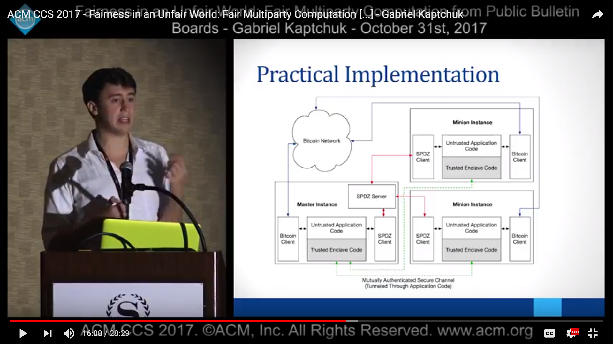
The practical implementation in [1] is as given in the figure. For a network of n client systems, each client party runs:
1. MPC library: SPDZ
2. Bulletin Board: Bitcoin Client
3. Key Sharing Secure Hardware: SGX

In our implementation, for a network of n client systems, each client party runs:
1. MPC library: SPDZ
2. Bulletin Board: Local Bitcoin Testnet Blockchain

REFERENCES:
[1] Choudhuri, Arka Rai, et al. “Fairness in an Unfair World.” Proceedings of the 2017 ACM SIGSAC Conference on Computer and Communications Security - CCS '17, 2017, doi:10.1145/3133956.3134092.
https://acmccs.github.io/papers/p719-choudhuriA.pdf

