**Color Group(Piece 4)**

Group Members: Avi Mattenson, Eliana Abraham, Jacob Hash, Jiawei Wang, Longhan Li, Yuxuan Zhou

1. Interface Design

We used Yuxuan’s homework as the foundation of this project. Our instrument will create music by changing colors the colors that are presented in front of the device’s camera. Along with the mobile phone, several sheets or projections of light will be needed in order to carry out this aspect of the piece. The instrument will determine the pitch of sounds played by sensing the color. With a rehearsed pattern of changing colors, the instrument can be used to create some nice music.

Next we will explain the UI, we have attached screenshots below.

There are two pages for this UI and it is a simple slide gesture between the two. Note that Page1 is on the left while Page is on the right. Note: you may want to slide for a distance since we set a minimum value for the dx before doing anything.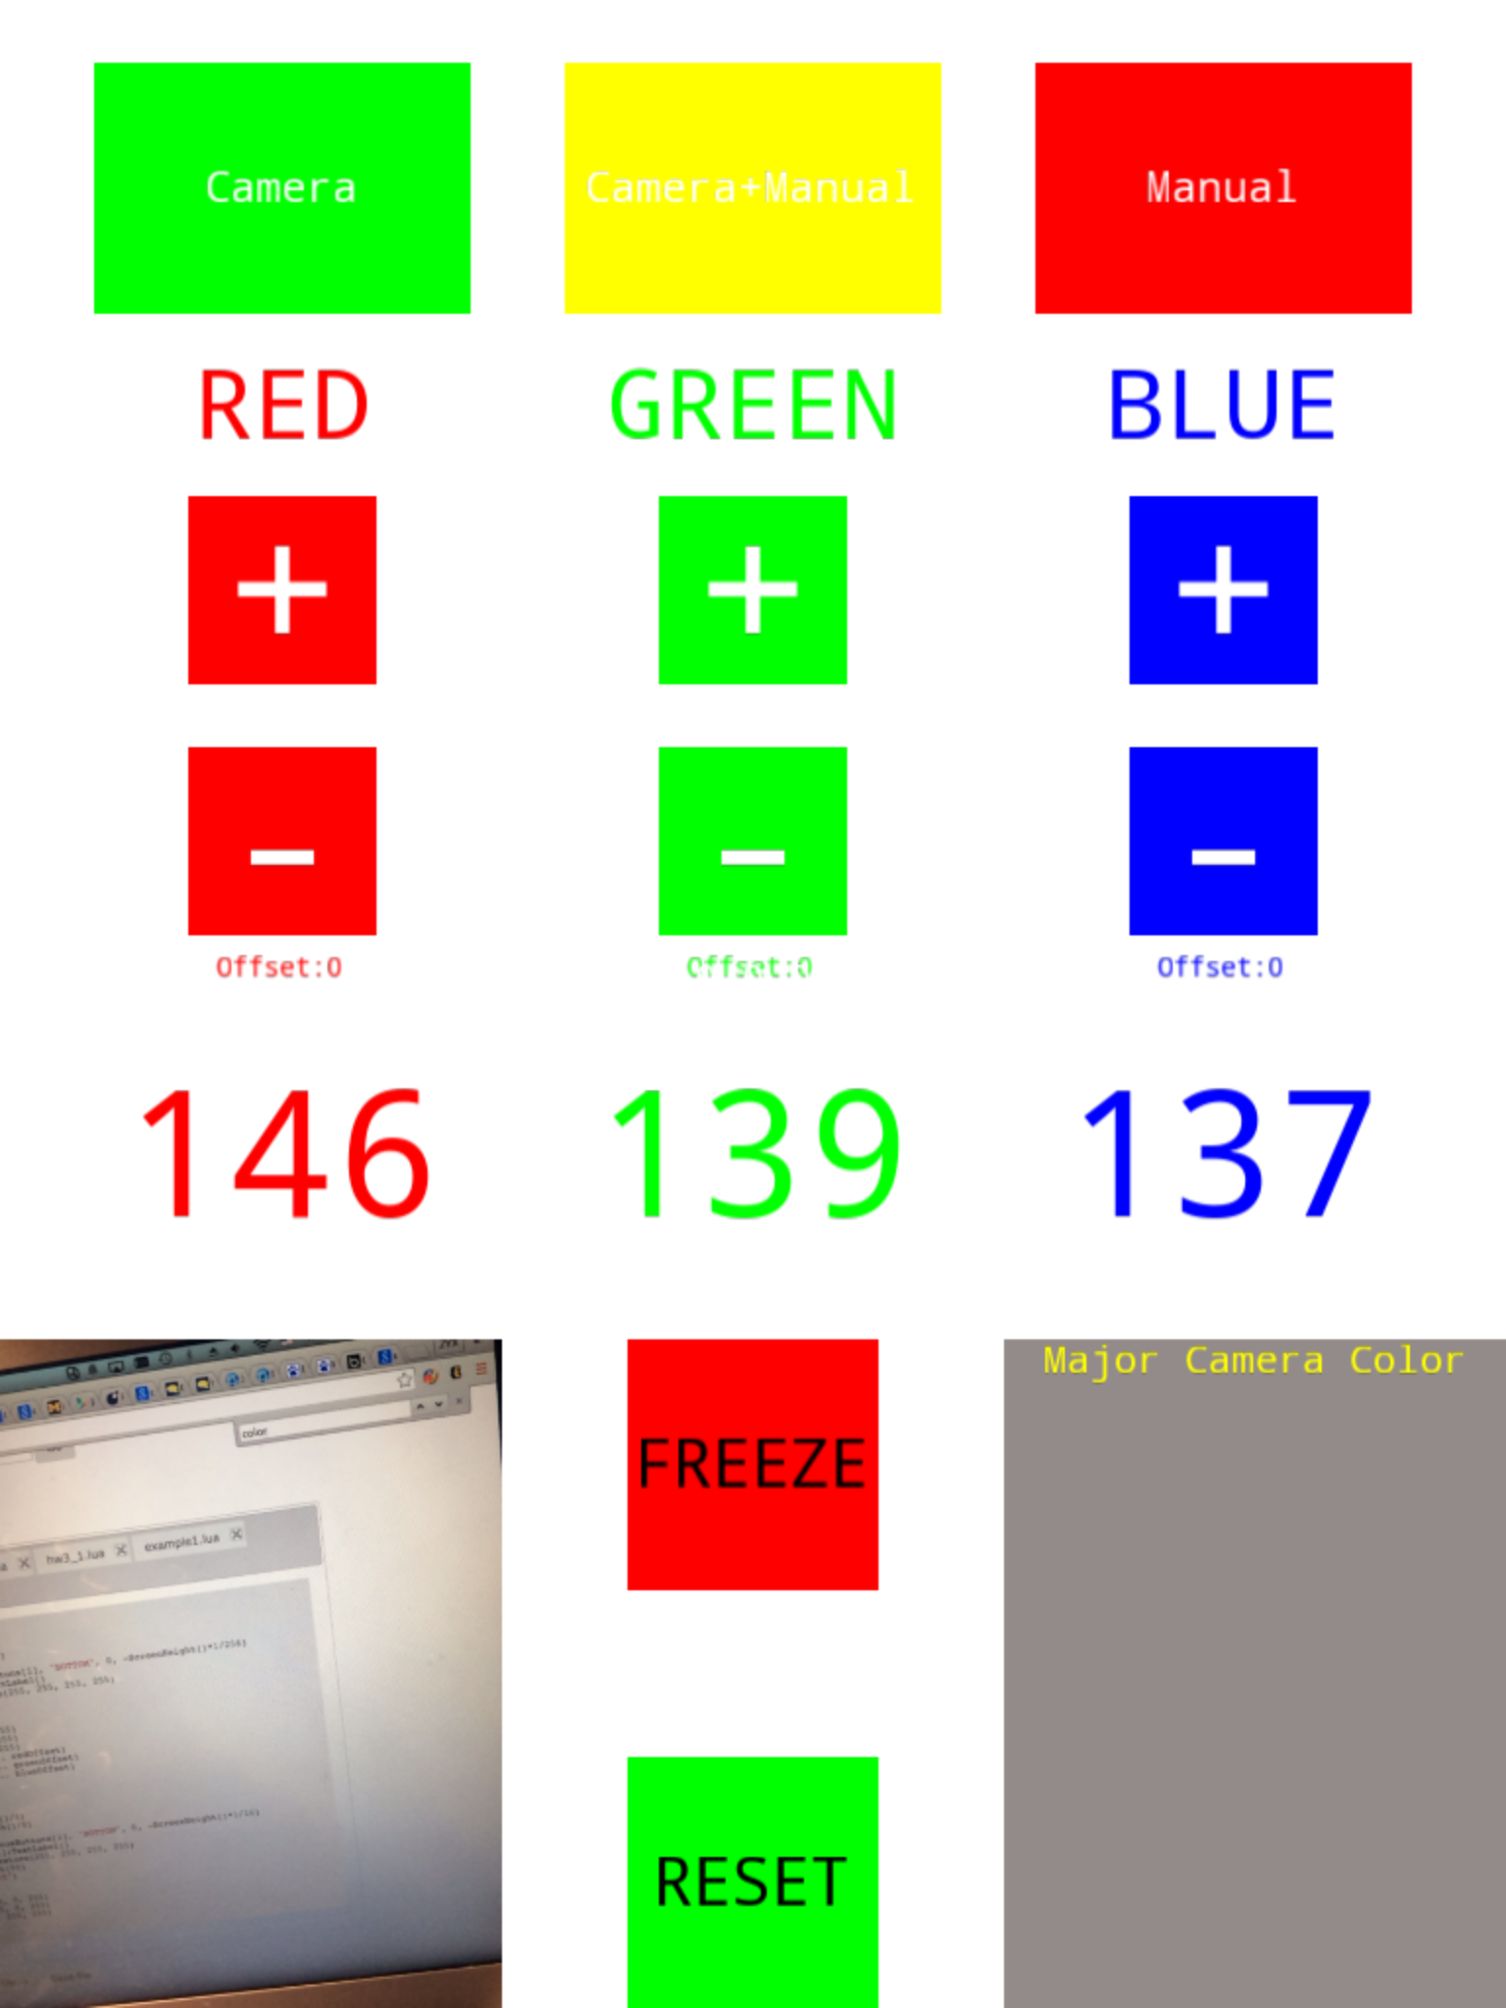 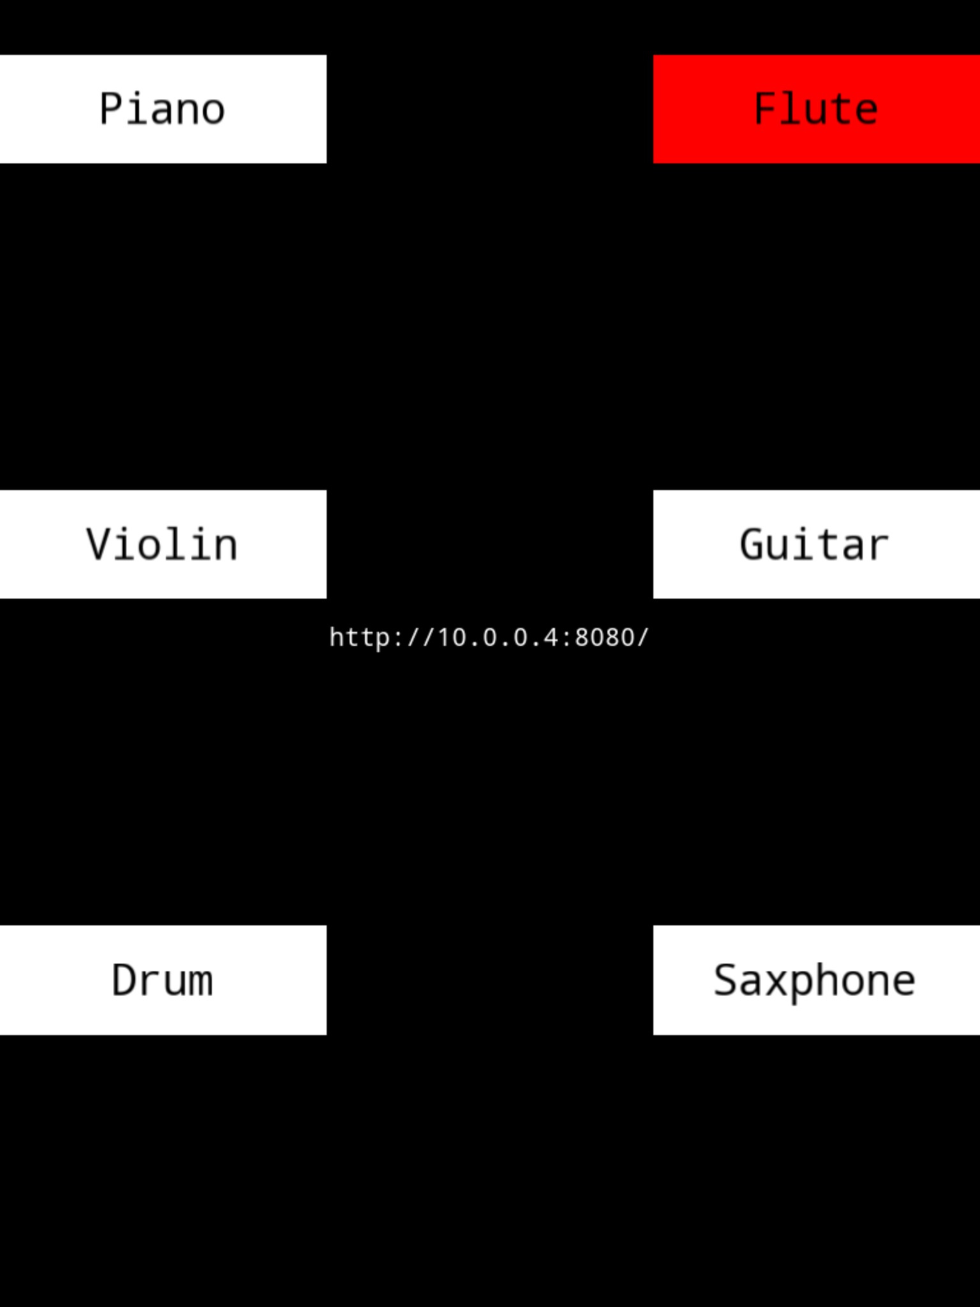

For Page1. The bottom right window shows the color read, which will be the color that determines the output of the instrument. The three large numbers in the middle represent the RGB value for this color. There are three modes for the instrument, which can be set using the three buttons on top of Page1. The “Camera” mode simply uses the major color of the camera as the output color. Note: For the performers’ convience we adjust certain range of accelX and accelY values for the output to change in this mode. In this case, when you put down the device and camera does not face the lights the output color will be frozen. The “Camera + Manual” mode will allow performer to apply an offset to the ouput color, the offset’s value can be adjusted using the middle “+” and “-” buttons and the offset values are displayed beneath them. The “Manual” mode will disable camera, and the output color can only be set manually using the middle “+” and “-” buttons. The “FREEZE” and “RESET” buttons’ usage are straightforward: “FREEZE ” will keep the current output color unchanged and “RESET” will reset the RGB offsets to zero.

For Page2. This page is mainly for all the instrument settings. The settings set the music according to appropriate sounds for different instruments. When the performer double-clicks the button, the interface erases the settings.

Future Work:

* Test the interface to find out all potential bugs that may occur during the performance.
* Coreograph/arrange and study the music or sound piece which corresponds with certain color combinations.
* Study all the possible forms that performers can interact and communicate with audience.
* Evaluate the combination effect from the different sound pieces from an aesthetic perspective.

Work list for this assignment:

* Yuxuan - programmed the entire user interface of the instrument.
* Jacob - helped formulate the idea and played a sort of project manager role.
* Eliana - wrote this work list and managed coordination between members of the group.
* Avi - contributed greatly to the idea's formulation and narrowed down aspects of the actual performance.
* Longhan - finalized the design and interaction paradigm for the piece.
* Jiawei - outlined the work to be done in the future and the problems that we currently face.