
Author: Sopra Group/ISID
Approved by: John Napier
Date: September 2011

NI Direct Online
Information Assurance Framework Process Definition

Version: 1.0
Status: For Issue
Reference: [Trim Record Ref: DF1/11/352879*



Table of Contents

1. Document Information 3
1.1 Revision History 3
1.2 Document Stakeholder List 3
1.3 Terms and abbreviations 3
2. Background and Purpose of this Document 7
3. IA Requirements 7
4. Site / Application Profile 8
5. Governance 9
6. IA Framework Processes 11
6.1 Top-level Framework Process 12
6.2 Registration Requirements and Application Assessment Review 13
6.2.1 Registration Appeals Process 14
6.3 On-boarding Process 15
6.4 Through-life Maintenance 16
6.4.1 Change Management 16
6.4.2 Renewal 17
6.4.3 Ad Hoc Audit 18
6.4.4 Incident Management 19
6.5 Removal and Archiving 21
7. Application Level Assurance 22
7.1 Application Suites 23
8. Security Committee Terms of Reference 24
8.1 Introduction 24
8.2 Responsibilities 24
8.3 Administration 25
8.4 Departmental Accreditor 25
8.5 DFP Accreditor 25
9. References 26
ANNEX 1 PROCESS NOTES 27
ANNEX 2 CHANGE MANAGEMENT PROCESS 29

Document Information
Records NI TRIM Ref: DF1/11/352879*

1.1 Revision History
Issue | Date | Description of Changes
0.1 | 6 Apr 2011 | Initial draft
0.2 | 10 May 2011 | Updates following review workshop
0.3 | 12 May 2011 | Updates following Teleconference
0.4 | 19May 2011 | Updates from 19 May review
0.5 | August 2011 | Updates to reflect comments from ITSO Forum, Accreditation Panel and SIRO Forum
1.0 | Sept 2011 | Updates to process flow chart to reflect option for Accreditor to decline recommendation and minor amendments for issue including last paragraph of section 2.

1.2 Document Stakeholder List
Name | Role
ISID IA Team | Editorial Control
Eimear Rooney | Technical lead
Tom Kennedy | CIO NICS - IA Framework Owner
Colm Shannon | Business Lead
John Napier | QA
Lorna Armstrong | IAO & Business Lead

1.3 Terms and abbreviations
Term/Abbreviation | Meaning
Accessibility | The practice of making web sites usable by people of all abilities and disabilities. When sites are correctly designed, developed and edited, all users can have equal access to information and functionality.
Application Profile | A description of the type services provided by the web site / application that determines the level of risk to which the site may be exposed. Sites may be: Static; Dynamic; Payments. (See Section 4 for detail.)
Audit | The structured review of security related events, normally to uncover unauthorised activity or to pre-empt attacks.
Authentication | The process of verifying the identity of a user or other entity to a computer system.
Authorisation | The process that determines whether an identity should be granted access to a specific resource.
BCS | Baseline Control Set
CHECK | CESG accredited penetration testing / IT security health check.
CLAS | CESG Listed Advisor Scheme.
Cookie | A piece of text sent by a web application and stored on a user's computer by their web browser. A cookie can be used for authentication, storing site preferences, shopping cart contents, the identifier for a server-based session etc.
Data Validation and Encoding | Where user controlled data is accepted and processed by an application, correct data validation and encoding is required to prevent many different types of attack. See NICS Application Development Standards, section 3 for details.
External Hosting Security Requirements | Specifically for nidirect, completion of the External Hosting Security Requirements will be required where an application is being hosted on the organisation’s own environment (other than IT Assist) or a third party environment.
Governance | A management layer and associated processes to oversee the development of the IA processes and the management of applications and their assurance going forward.
Government Gateway | The web site for online government services that forms part of the government's strategy of delivering 'joined up' government, enabling citizens to communicate and make transactions with government from a single point of entry.
HTTP | Hypertext Transfer Protocol.
HTTP Header | Record sent by clients and servers communicating with each other via the HTTP protocol defining the operating parameters of the transaction.
IA Framework | A set of NICS Information Assurance policy, standards, guidelines and processes to be followed by NICS organisations to ensure that the basic information assurance requirements for web sites and web enabled applications are designed and implemented.
IAO | Information Asset Owner – A Government mandated role; the individual appointed is responsible for ensuring that specific information assets are handled and managed appropriately, ensuring that information assets are properly protected and that their value to the organisation is fully exploited.
ISO 27001 / ISO 27002 | The international Standard and Guidelines providing a model for establishing, implementing, operating, monitoring, reviewing, maintaining and improving an Information Security Management System.
IT Assist | The organisation providing Shared Service Centre cost effective ICT infrastructure and common services to all Departments within NICS.
Logging | Recording and retention of system and user activities.
nidirect | nidirect is the official government mechanism for Northern Ireland allowing citizens access to range of government, local government and agency information and services.
Payment Card Information | Information that is recorded on a credit / debit card; specifically: Primary Account Number PAN; Cardholder Name; Service Code; Expiration Date; Full magnetic stripe data; CVC2/CVV2/CID; PIN / PIN Block.
PCI DSS | Payment Card Industry Data Security Standard. Any application that accepts and processes payments using ‘bank cards’, e.g. Visa, MasterCard, etc. must be compliant with the PCI DSS.
Performance | The defined performance requirements of a system, typically specified as: Concurrency / throughput; Server response time; Render response time.
Protective Marking | A system used to label document and systems that indicates the sensitivity of the content in order to protect information from intentional or inadvertent release to unauthorised entities.
RMADS | Risk Management and Accreditation Document Set.
Session Management | How related interactions between a user and a web application are handled and secured.
SIRO | Senior Information Risk Owner.
SPF | HMG Security Policy Framework – The HMG IA framework that sets out ‘universal mandatory standards’ for information assurance; provides guidance on risk management and defines HMG’s compliance and assurance arrangements.
SSL | Secure Sockets Layer - Cryptographic protocol that provides communications security over the Internet.
TLS | Transport Layer Security - Cryptographic protocol that provides communications security over the Internet.
Usability | The practice of making web sites easy to use for an end-user, without the requirement for any specialised knowledge or training.
W3C | World Wide Web Consortium oversees the development of web standards for programming languages, operational systems, data formats, communications protocols and electrical interfaces.

Background and Purpose of this Document
nidirect Online is the single official government website for Northern Ireland allowing citizens access to a range of government, local government and agency information and services. All citizen information for Northern Ireland and links to other organisations’ applications within the nidirect brand are published via the NICS strategic CMS within this site.
Information assurance is of paramount importance to all government departments in the UK. High profile losses of citizens’ data can severely damage the reputation of government departments and impact citizens’ willingness to use online systems. It is therefore crucial that all NICS departments ensure that appropriate security controls and countermeasures are built into their information systems and that assurance measures are in place and working effectively.
NICS departments and organisations with applications and sites associated with the nidirect brand must demonstrate a level of information assurance and provide a degree of confidence that their applications do not pose a risk to the reputation of the nidirect brand and the nidirect Community as a whole.
In addition to ensuring aspects of security, new systems must demonstrate adherence to guidelines of performance, privacy, maintainability, accessibility and usability before being accepted into nidirect as outlined in the Application Development Standards. The nidirect IA Framework introduces:
- A security framework for nidirect that will provide a baseline of information assurance controls for any system to be measured against, before acceptance into the nidirect community;
- For new applications, a set of security, performance, privacy, maintainability, accessibility & usability standards for systems development as outlined in the NICS Application Development Standards [Ref 8 Section 9] TRIM ref DF1/11/408026*;
- A Through-life Assurance process that aims to ensure that security controls continue to be effective throughout the operational life of systems and;
- The need to review existing applications.
While the Framework has been developed to ensure a high level of Information Assurance for nidirect, it represents good practice in relation to Information Assurance and the principles must be applied to all websites associated with nidirect and all public facing web applications operated by NICS Departments, Agencies and NDPBs. It is therefore recommended that departments should formally review and prioritise existing public facing web applications and apply the Framework to these on a priority basis. Where appropriate web applications which are not public facing should also adopt appropriate elements of the Framework as best practice.

IA Requirements
The Information Assurance requirements to be applied to nidirect and NICS applications are:
- Information security: Physical, technical and procedural measures must be implemented to reduce risks of compromises to the confidentiality and integrity of information stored and processed and the availability of services provided. It is expected that security controls will be applied in line with HMG Security Policy Framework (SPF) [Ref 1 Section 9], CESG Information Assurance Standards and guidelines, ISO27001 and NICS Information Assurance (IA) Policy. In principle and as a minimum, the Baseline Control Set (BCS) based on the outcome of a formal and documented risk assessment in line with HMG IA Standard 1 (IS1) [Ref 2 Section 9] shall be applied.
- Performance: All NICS Departments coming under the nidirect brand must state the necessary performance levels for the website or application. If the website or application is hosted by a third party then the Department must provide evidence that these performance levels are achievable (see NICS Application Development Standards, Section 5).
- Privacy: All websites developed for, or by, NICS must display and comply with a privacy policy. The main requirements of the NICS privacy policy are: What information is collected; What the information is used for; The measures used to secure information; The scope of the privacy policy; Methods available to restrict the amount of information collected or used; Arrangements regarding the sale, lease or distribution of collected information; How an individual can request information collected about them;
- Maintainability: The standards for maintainability documented in the NICS Application Development Standards (TRIM ref DF1/11/408026*) should be followed.
- Accessibility is about reaching the widest possible audience. It is about ensuring openness, fairness and equality. It is about exploiting the power and flexibility of the Web to ensure that people can receive and act upon your information regardless of their abilities (or disabilities), their environment, or the devices they use. The minimum standard of accessibility for all public sector websites is Level Double-A of the W3C Web Content Accessibility Guidelines. All NICS web sites/applications must conform to these guidelines from the point of publication.

- PCI DSS: If the application processes payment card information then the application is subject to PCI DSS compliance [Refs 10 & 11 Section 9].

Site / Application Profile
This framework applies to any NI citizen-facing site or application that operates under the nidirect brand. Such sites / applications are recognised as members of the nidirect Community.
The types of sites and services provided may have one or more of the attributes listed below. The level of risk to which any site is exposed depends on which attributes apply to it and these will consequently influence the rigour of on-boarding assessment requirements applied. See Application Assessment Criteria [Ref 8 Section 9].
- Static site: The site presents only fixed information to the user and contains no background application to receive, process or store user input. It is assumed that these types of sites (corporate or otherwise) are wholly managed within the existing NICS strategic Content Management System and it is not anticipated that any further assessment or on-boarding activities within the context of this framework will be needed. Where this is not the case the owning Department's ITSO/DSO and the nidirect Security Committee must be notified and appropriate assurances provided.
- Dynamic: The application presents form(s) to the user, captures the information entered and performs processing and / or storing of information based on the inputs.
- Payments: As a Dynamic site with the addition that credit / debit card payments details are supplied by the user. This will trigger a requirement for a PCI DSS assurance process.
- 3rd Party Hosted Applications: where the application is hosted by a third party supplier (or in an environment other than IT Assist), the External Hosting Security Requirements document must be completed and returned.

Governance
The IA Framework includes a governance layer which oversees the development of the IA processes and the management of applications and their assurance going forward. The governance processes include:
- Registration, Risk Assessment and Verification
  - Preparation and ongoing maintenance of the Registration Process for the nidirect Community. The purpose of Registration is to enable the connecting organisation to provide assurance to nidirect that the required levels of security, performance, privacy, maintainability, accessibility & usability are in place for the application being connected to the nidirect Community. The information provided will then be assessed by the nidirect Security Committee as part of the on-boarding process.
  - The preference is for every nidirect application to present an accredited Risk Management and Accreditation Document Set (RMADS) including a technical risk assessment following HMG IA Standard No 1. Where the risk is identified by the Departmental Accreditor as warranting accreditation e.g. the application processes payments, an accredited RMADS must be submitted. In other cases where the Accreditor accepts that an RMADS is not required, the Security Committee will review the application with greater rigour and may seek additional evidence of assurance practice.
- On-Boarding process
  - The registration and on-boarding process for organisations applying for inclusion in the nidirect community and submission of Registration Requirements responses [Ref 6 Section 9].
  - Acceptance criteria and assessment of registration documentation;
- Through-Life Assurance processes
  - The ‘Business As Usual’ periodic membership renewal / re-assessment process;
  - Through-life IA requirements - Confirmation of continued malware protection, security testing, patch management, change management processes. These will be verified through requests from the Security Committee for evidence and by auditing;
  - Requirements and a process for ‘on demand’ auditing of community members’ security management systems;
  - Forensics readiness and incident management procedures to be adopted by nidirect community systems for use in the event of a security incident.
- External Hosting Security Requirements [Ref 9 Section 9]
  - Where the application is not hosted by IT Assist an External Hosting Security Requirements document must be completed and returned.
The NI Direct IA Framework is owned by Tom Kennedy, the NICS CIO. The DFP Accreditor will formally sign-off approved applications for membership of the nidirect Community following assurance from the applying organisation’s Accreditor. The NICS Accreditation Panel will be asked to provide final ratification of Community memberships based upon the recommendation of the DFP Accreditor.
Assessments of applications and renewals fall within the remit of the nidirect Security Committee Terms of reference for the Committee are included in Section 8.

IA Framework Processes
It is assumed that, before commencing the application process, organisations have engaged with their respective ITSOs and that their Accreditor has been consulted.
Further, it is assumed that the organisation has engaged with the nidirect Central Editorial Team / Central Web Team prior to commencing application development for guidance on nidirect branding, ‘look & feel’ etc. This should be agreed with the IAO for the business.

6.1 Top-level Framework Process
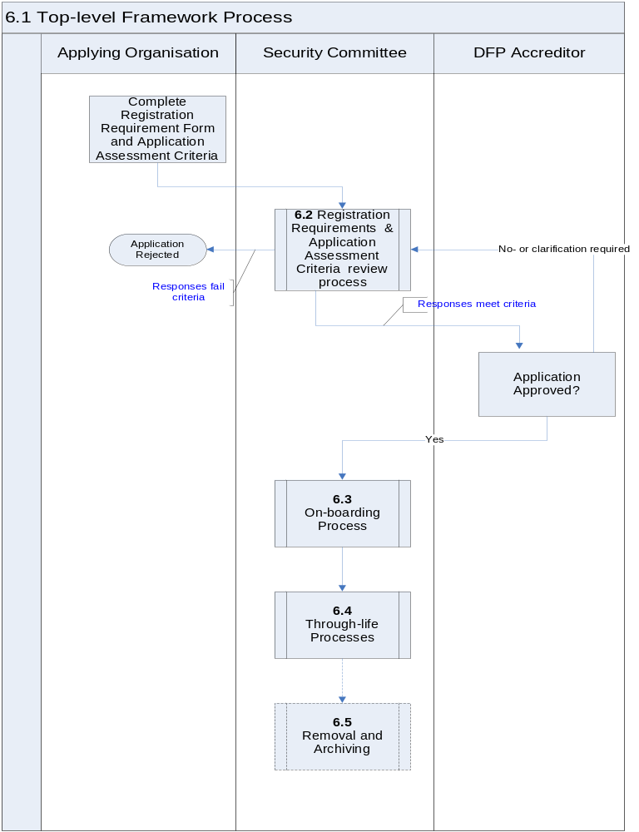
6.2 Registration Requirements and Application Assessment Review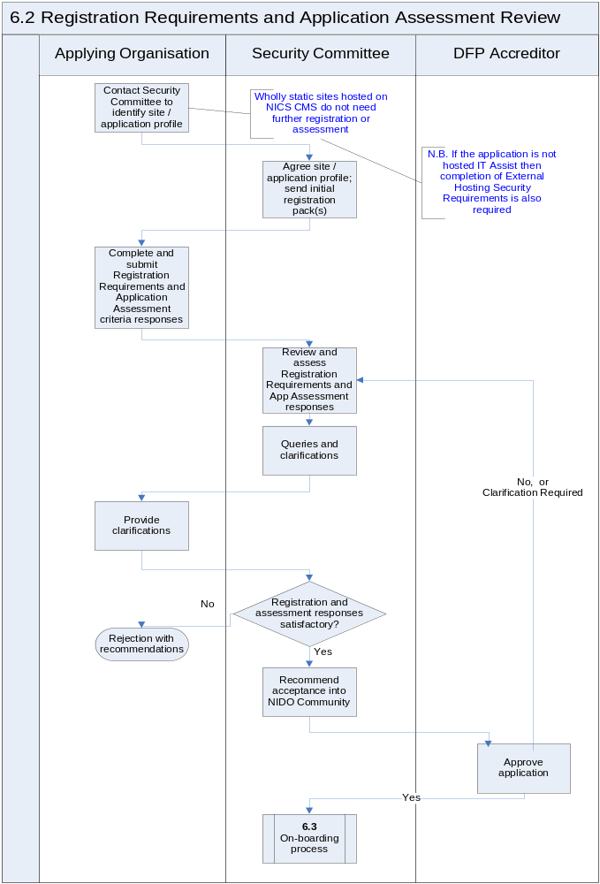
6.2.1 Registration Appeals Process
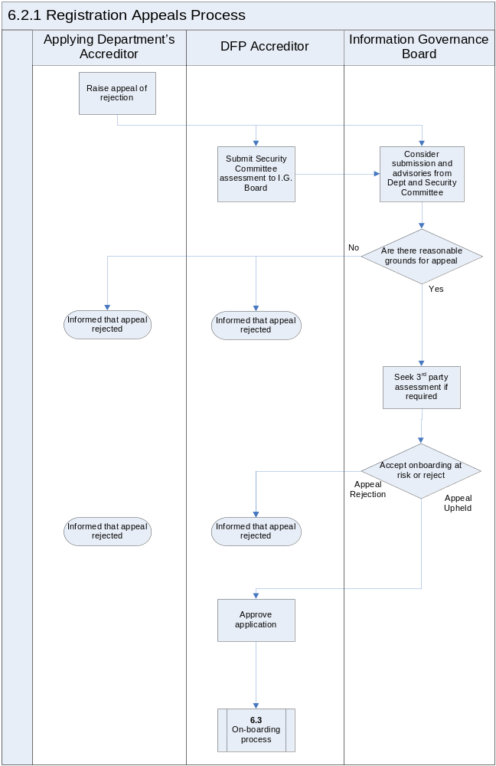
6.3 On-boarding Process
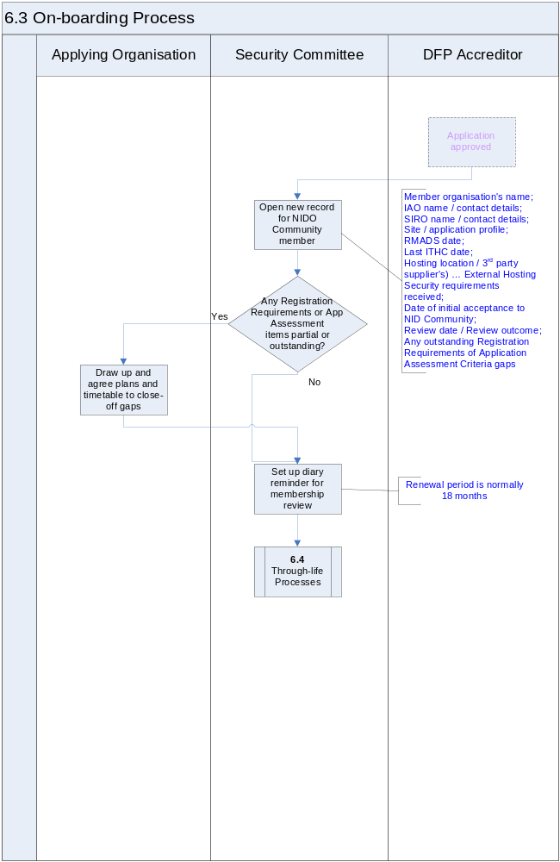

6.4 Through-life Maintenance

6.4.1 Change Management
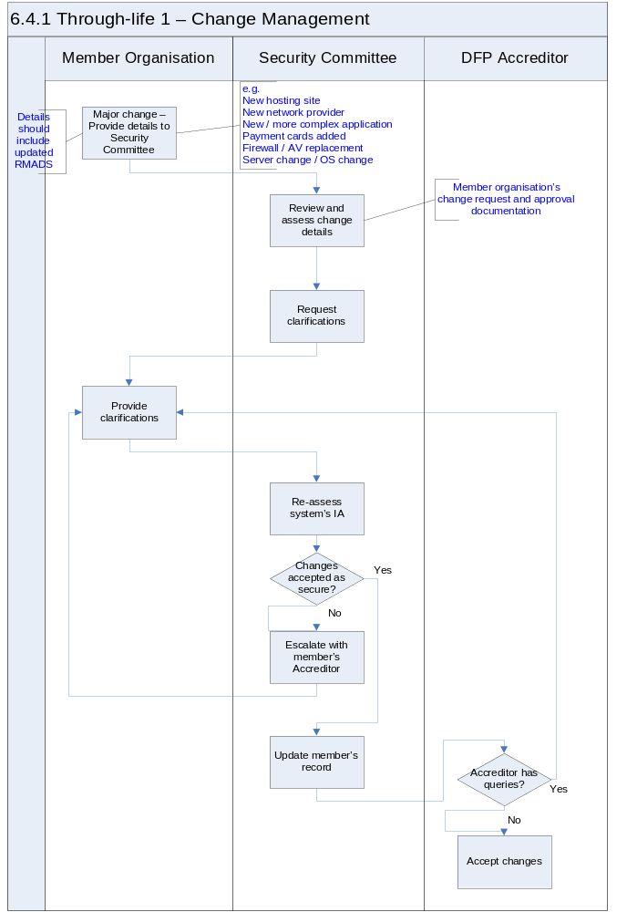

6.4.2 Renewal
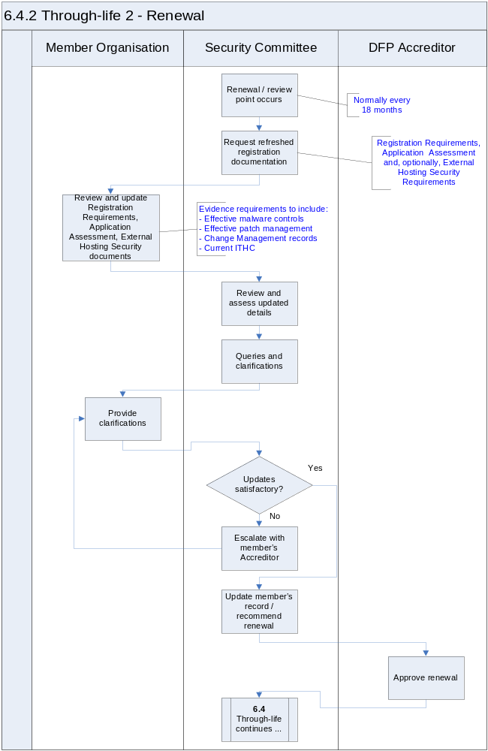

6.4.3 Ad Hoc Audit
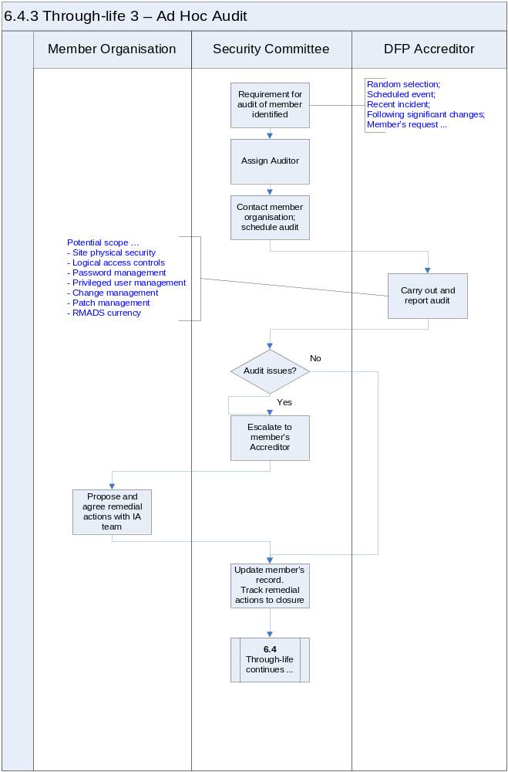

6.4.4 Incident Management
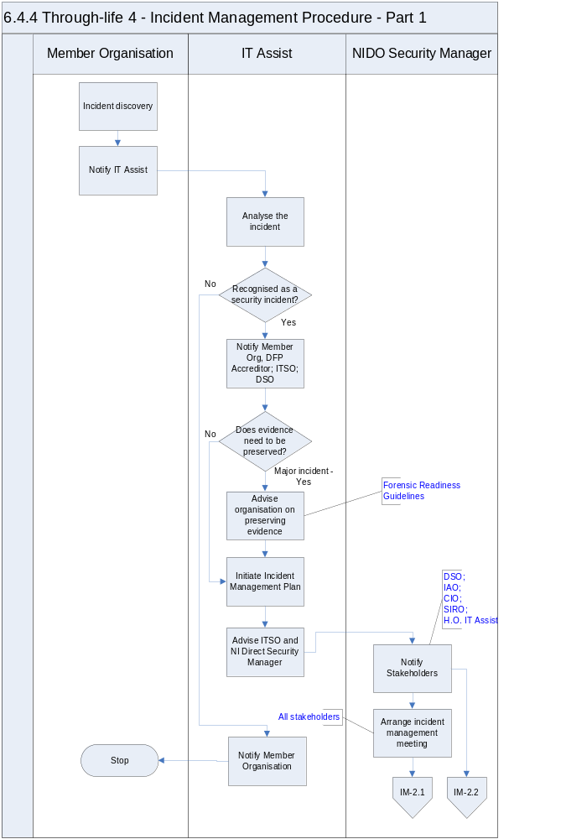
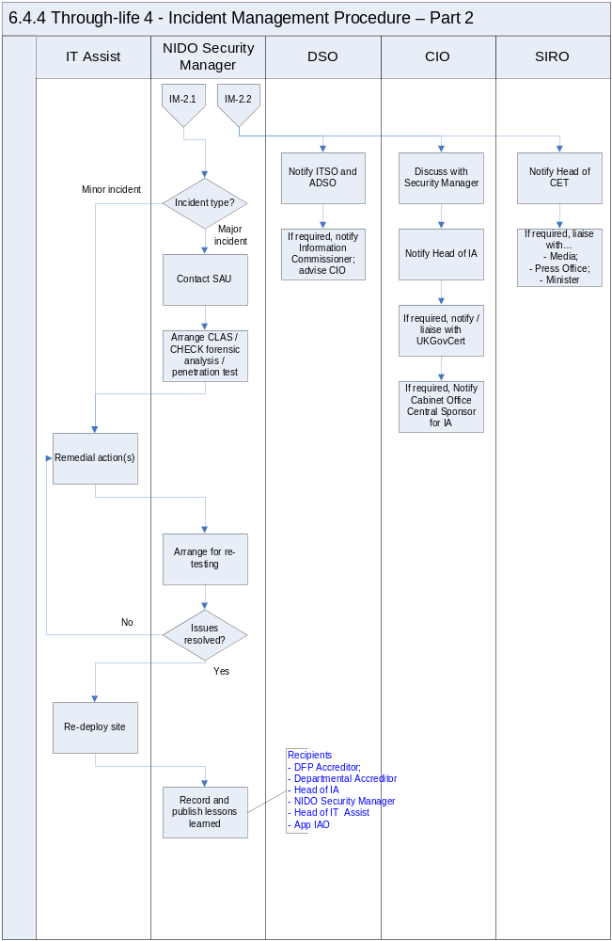

Removal and Archiving
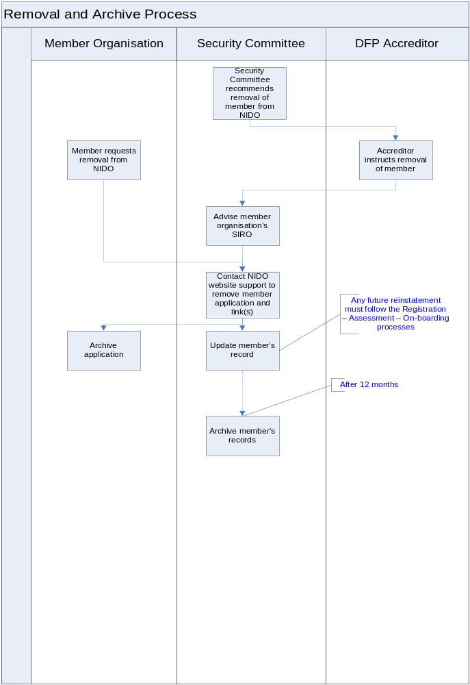

Application Level Assurance
It is important to ensure that security best practice is applied to the development of nidirect applications and processes so that code quality and common application vulnerabilities are managed and that nidirect and NICS are not exposed to application quality risks and/or security threats. The following standards have been developed to reduce security risks arising from poorly developed applications or systems.
- NICS – Information Assurance - Application Development Standards TRIM ref DF1/11/408026* [Ref 7 Section 9]. These standards are intended to cover all types of software development and coding such as internal and third party development of web portals, standalone applications, VB clients and Database Forms.
- NI Direct Application Assessment Criteria TRIM ref DF1/11/351344* [Ref 8 Section 9]. Each application being on-boarded to the nidirect environment must be subject to an assessment that covers the quality aspects of the solution. The assessment is based on the NICS Application Development Standards and enables the nidirect Security Committee to effectively manage the risks to the nidirect brand. This document is to be used by the System Owner of the organisation seeking to join the nidirect Community to perform a self-assessment of the solution.
- PCI DSS Requirements [Refs 10 & 11 Section 9]. The Payment Card Industry Data Security Standard was introduced to ensure adequate protection of payment card information. Payment card information is a special type of sensitive data and the standard covers a wide range of people, process and technology controls and countermeasures in 12 main requirements that must be used for systems processing card information. To ensure PCI DSS compliance for applications that process payment card information, organisations must ascertain their merchant level which in turn will determine the compliance process. This is summarised in the table below:

Level | Merchant Criteria | Validation Requirements
1 | Merchants processing over 6 million Visa transactions annually (all channels) or Global merchants identified as Level 1 by any Visa region | Annual Report on Compliance (“ROC”) by Qualified Security Assessor (“QSA”)  Quarterly network scan by Approved Scan Vendor (“ASV”)  Attestation of Compliance Form
2 | Merchants processing 1 million to 6 million Visa transactions annually (all channels) | Annual Self-Assessment Questionnaire (“SAQ”)  Quarterly network scan by ASV  Attestation of Compliance Form
3 | Merchants processing 20,000 to 1 million Visa e-commerce transactions annually | Annual SAQ  Quarterly network scan by ASV  Attestation of Compliance Form
4 | Merchants processing less than 20,000 Visa e-commerce transactions annually and all other merchants processing up to 1 million Visa transactions annually | Annual SAQ recommended  Quarterly network scan by ASV if applicable  Compliance validation requirements set by acquirer
Once the Merchant level is determined a process can be defined. All PCI DSS requirements will be addressed in this process, however, PCI DSS Requirement 6 mandates that software applications must be developed in accordance with PCI DSS and based on industry best practices, and in, corporate information security, throughout the software development life cycle. The details of how to meet this requirement will vary depending on the specific implementation supporting a particular application but the coding standards contained within the NICS Application Development Standards document form the basis of how nidirect should address PCI DSS Requirement 6; i.e. all applications processing payments must, at a minimum, adhere to the standards outlined in the NICS Application Development Standards (TRIM ref DF1/11/408026*).

7.1 Application Suites
The extent to which each component of an integrated suite of applications will need to be individually assessed will be determined on a case by case basis. Some typical criteria that will impact this decision are provided below.
- If the suite is built and compiled as a single common code set then it may be possible to do a single assessment; and
- If compiled and built separately, with potentially disparate applications grouped into a ‘suite’, then assess each individually as they are likely to have different issues and vulnerabilities.

Security Committee Terms of Reference

8.1 Introduction
The role of the Security Committee is to assess the quality and security of applications wishing to join the nidirect Community (the ‘On-boarding process’) and to manage the continuing security assurance by member organisations going forward (the ‘Through-life process’).
Structure
The nidirect Security Committee shall be comprised:
- nidirect Online System Security Manager (Eimear Rooney);
- DFP IT Security Officer (Jackie Wishart);
- Representative of IA (John Napier or deputy);
- Representative of the nidirect Editorial Team (Lorna Armstrong);
- Representative of nidirect Web Team (Neil Blair);
- Representative of IT Assist (Paul McNeill / Brian O’Doherty);
Other individuals may be co-opted as necessary.

8.2 Responsibilities
The Security Committee shall
- Maintain records of all member organisations in the nidirect Community, including initial applications, renewals, audits, incidents and removals;
- Process new applications for nidirect Community membership, assessing their responses to the Registration Requirements, Application Assessment Criteria and, where appropriate, External Hosting Security Requirements;
- Liaise, where necessary, with (prospective) member organisations to clarify application responses and resolve queries;
- Identify renewal dates and arrange for updated evidence of continued security management from members;
- Communicate with the DFP Accreditor and arrange for sign-off of applications and renewals;
- Review system change details as advised by member organisations to confirm that the organisation has taken sufficient steps to ensure that security will not be compromised by the change;
- Manage ad hoc auditing of member sites / systems as required;
- Support member organisations in the event of a significant security incident, engaging external specialist support if necessary;
- Agree with member organisations any required corrective or preventative actions arising from assessments, audits or incidents, together with a timetable for their implementation;
- Track agreed corrective / preventative actions through to closure;
- Escalate any significant security concerns or issues to the DFP Accreditor.

8.3 Administration
The Security Committee will provide a membership administration function to:
- Record the details of all applications for membership to the nidirect Community and outcomes of assessments;
- Update members’ details with the outcome of change control, audit and incident activities;
- Arrange periodically for refreshed system details including Application Assessment Criteria and re-Registration responses to be provided and re-assessed.

Departmental Accreditor
The role of the applying organisation’s Departmental Accreditor is to:
- Review and agree Registration, Assessment and, where appropriate, External Hosting Security Requirements to be submitted;
- Approve the application for registration / renewal by completing and signing the Organisation Declaration section.

8.5 DFP Accreditor
The role of the DFP Accreditor is to:
- Take note of organisation’s Departmental Accreditor’s views;
- Consider Security Committee’s recommendations;
- Request clarifications as necessary;
- Sign-off (or decline as appropriate) organisation’s on-boarding or renewal request;
- Instruct removal of an organisation from the Community if necessary in line with policy and procedures;
- Report to the NICS Accreditation Panel with a summary of NICS organisations On-Boarded.

References
  - HMG Security Policy Framework, v6.0
  - HMG Information Assurance Standard 1 Technical Risk Assessment: Part 1 Technical Risk Assessment; Part 2 Risk Treatment
  - HMG Information Assurance Standard 2 Risk Management and Accreditation of ICT Systems and Services
  - ISO/IEC 27001 Information Technology Security Techniques, Information Security Management Systems — Requirements
  - ISO/IEC 27002 Information technology Security Techniques, Code of Practice for Information Security Management
  - DF1/11/348425 NI Direct Online - Information Assurance Framework - Registration Requirements for Community Membership - Ver 1.0 - August 2011
  - DF1/11/408026* NI Direct Online - Information Assurance Framework - Application Development Standards - Ver 1.1 Aug 2011 - DF1/11/408026*
  - NI Direct Online - Information Assurance Framework - Application Assessment Form - DF1/11/351344*
  - NI Direct Online - Information Assurance Framework - External Hosting Security Requirements - DF1/11/354447*
  - PCI DSS (Payment Card Industry Data Security Standard) v2.0; 28 Oct 2010
  - PA-DSS (Payment Application Data Security Standard) Requirement and Security Assessment Procedures v2.0; 26/Oct 2010
  - NI Direct Online - Web Services - BCP - Business Continuity Strategy - Version 1.0; TRIM DF1/11/178157

ANNEX 1 PROCESS NOTES

New Registration
The Organisation seeking nidirect Community membership contacts the nidirect Online Security Committee to discuss:-
- application function,
- ‘consumers’,
- information processed;
- whether payments are included and
- hosting location.
The nidirect Online Security Committee will supply applicable registration documents and advise on their completion and submission.

Organisation:
- Read Overview Presentation - DF1/11/290609 - NI Direct Online - Information Assurance Framework - Presentation 23 June 2011
- Read Registration Requirements - DF1/11/348425* - NI Direct Online - Information Assurance Framework - Registration Requirements for Community Membership - Ver 1.0 - August 2011
- Read Process Definition - DF1/11/352879* - NI Direct Online - Information Assurance Framework - Process Definition - Ver 0.5 - Aug 2011
- Read - DF1/11/354251* - NI Direct Online - Information Assurance Framework - Process Notes - Ver 0.2 Aug
- Read Application Development Standards DF1/11/408026* - NI Direct Online - Information Assurance Framework - Application Development Standards - Ver 1.1 Aug 2011
- Apply standards
- Complete Application Assessment Criteria (form) DF1/11/351344* - NI Direct Online - Information Assurance Framework - Application Assessment Criteria - Ver 1.1 Aug 2011
- Complete Registration Requirements details
- If the web application is not hosted by IT Assist, arrange for completion of External Hosting Security Requirements
- Organisation’s Accreditor or authorised IA Managers completes the Organisation Declaration
- Submit completed document set to nidirect Online Security Committee at … DG_DFP GRP_NI Direct Online Security Committee
    - Include the latest IT / Application Health Check report and RMADS if available (in whatever state of completeness)
    - If card payments are processed, read and understand the PCI DSS section in Application Development Standards – the need for compliance with PCI DSS should be discussed further with the nidirect Online Security Committee
nidirect Online Security Committee
- Register the application
- Review Registration and Application Assessment material and any supporting documentation (e.g. ITHC, RMADS …); note any non-compliance that may require remediation. (NB - A completed, up to date and accredited RMADS would provide strong support for acceptance)
- Request any further information, clarifications or additional documentation from the organisation if necessary
- Discuss the application with the DFP Accreditor if necessary
- If registration can be accepted or Accreditor has agreed to on-board the application with risks …
    - Recommend acceptance of registration – DFP Accreditor formally signs-off acceptance
    - If required, advise organisation of gaps / remediation activities that are still required; agree a timetable for activities; record and track progress
    - Update member’s record
    - Move to Through-life process
- If registration cannot be accepted …
    - Advise organisation and provide recommendations for remedial actions and re-submission
    - Update organisation’s record
    - Organisation may choose to appeal decision and refer to Information Governance Board for final decision

Renewals
- nidirect Online Security Committee will monitor memberships and in advance of renewal date (max 18 months) …
    - Contact the organisation to discuss renewal
    - Identify whether there have been any significant changes to the application
    - Provide applicable registration material for the renewal application (per New Registration Requirements)
- Organisation resubmits all material
    - No changes from previous registration, or
    - Changes highlighted
Resume at nidirect Online Security Committee … Registration and Application Assessment documentation.

ANNEX 2 CHANGE MANAGEMENT PROCESS
Purpose
The purpose of this section is to detail a Change Control Process for application development/maintenance activities on the core nidirect Online website hosted in Livelink.
Process Overview
The Change Control Process consists of the following steps:
- Record / Classify
- Assess
- Plan
- Build / Test
- Implement
- Close / Gain Acceptance

Record / Classify
The client initiates change by making a request to the nidirect Web Team. The Web Team will then record and categorise the request. This categorization would include estimates of importance, impact, and complexity.
Where changes are judged to have any impact on security, the nidirect Online Security Committee must be informed of the change. DG_DFP GRP_NI Direct Online Security Committee
Plan
Management will assign the change to a specific developer. The developer's first job is to plan the change in detail as well as construct a regression plan in case the change needs to be backed out.
Build/test
If all stakeholders agree with the plan, the developer will build the solution, which will then be tested. The developer must then seek approval and request a time and date to carry out the implementation phase.
Implement
All stakeholders must agree to a time, date and cost of implementation. Following implementation, it is usual to carry out a post-implementation review.
Close/gain acceptance
When the client agrees that the change was implemented correctly, the change can be closed.

The current membership renewal period is a max of 18 months.

