Hi, Darius!

First of all, I’m not an experienced user of GitHub and I have a question: are there any possibility to restrict edits for a certain users? Everything I’ve found is



But everyone can still edit my files (with forking to their own repos). Do I need pro-account to restrict?

Now, let me describe scenario for you to tell me if I’m right.

I’ve created a new repo:

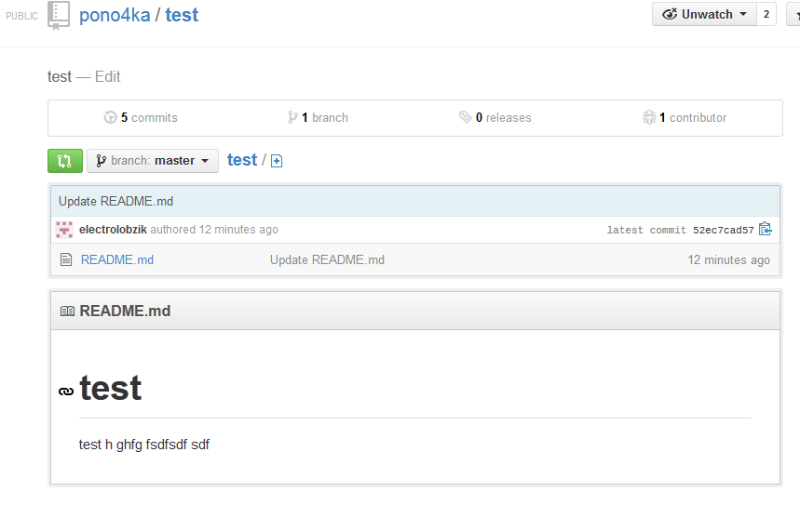

I can edit my own repo and commit to my own repo

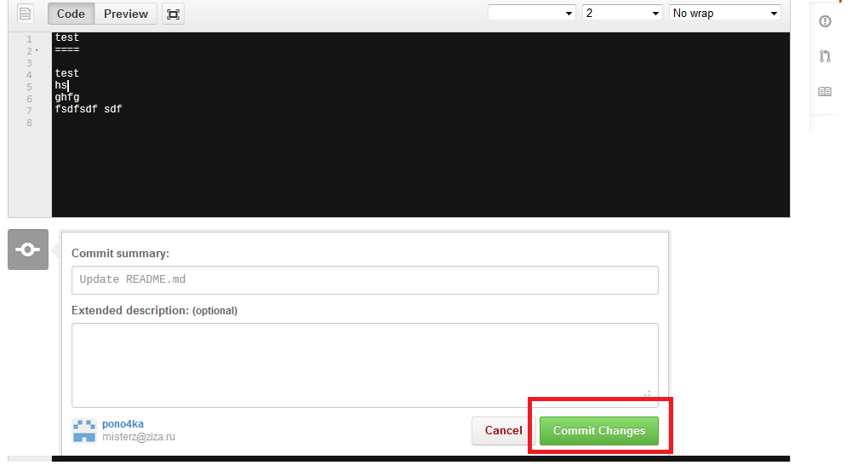

Now I log in with another random account. This user still have active button “Edit”. After few lines added:

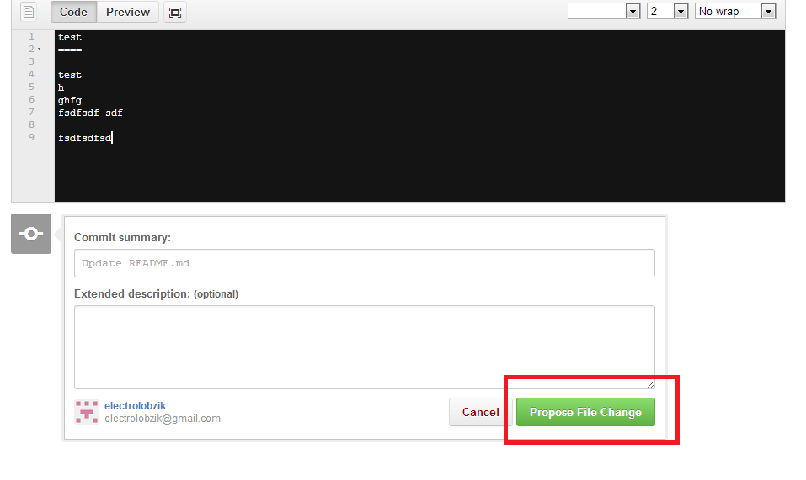

So this edit will go to his own repo with notification to the first account. Now I enable the following setting in the first account:



The second account can still edit and propose changes.

Now I add the second account as collaborator:

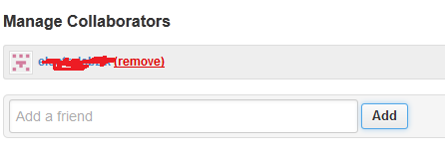

Now the second account can do edits directly to first account’s repo:

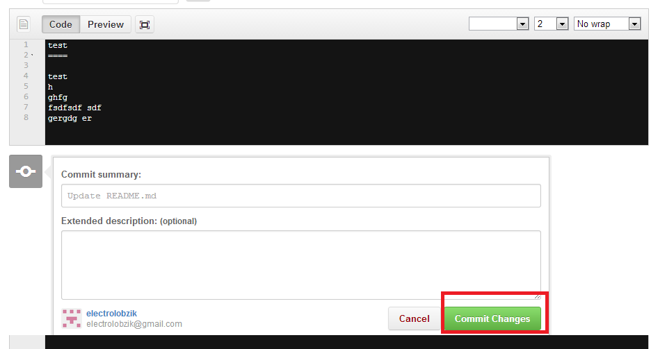

Here is my proposal:

When user clicks **edit** firepad with code opens instead of default editor. Action buttons are the same (commit changes or propose changes – we don’t change logic here).

Do I need to do something else?