New HMS Website: Concerts 13/02/2013

(Page 1)
The Society performs three concerts with the Orchestra and Chorus every year in the Haslemere Hall.
An additional orchestral concert is held in St Christopher's Church, Weyhill, often featuring a soloist from within the orchestra.
All concerts 7.30 pm in Haslemere Hall (01428 642161) except where shown

Concerts in 2013


ate/location | Performer(s) | Works
Saturday, 16th February at 2 pm  St Christopher's Church,  Haslemere GU27 1DD | Come and Sing  Conductor: Christopher Hann  Organist: Clive Osgood | Fauré: Requiem  Click here for the flyer and booking form (pdf, 215KB).
Saturday, 2nd March | Orchestra and Chorus  Conductor: James Ross  Soprano: Sara Wallander-Ross  Mezzo Soprano: Cathy Bell  Tenor: Arthur Swan  Baritone: Jon Stainsby | Mendelssohn: Elijah  Click here for the flyer (pdf, 121KB).
Saturday, 4th May | Orchestra and Chorus  Conductor: James Ross | Rossini: Overture: Il Barbiere di Siviglia  Rossini: Villagers’ Chorus: Guillaume Tell  Donizetti: Chorus of Wedding Guests: Lucia di Lammermoor  Gounod: Ballet Music: Faust  Verdi: Anvil Chorus  Mascagni: Intermezzo and Easter Hymn: Cavalleria Rusticana  Puccini: Intermezzo: Manon Lescaut  Wagner: Pilgrim’s Chorus (Act I) and March (Act II): Tannhäuser  Wagner: Prelude to Act III and Bridal Chorus: Lohengrin  Wagner: Procession and Chorale: Act III: Die Meistersinger von Nürnberg

Summer sessions and other events 2013
In addition to the concert season the Society holds a series of sight-reading sessions during June. We invite different guest conductors who bring various pieces for us to rehearse, concluding with a mini performance towards the end of the evening.
The first two sessions will be for both choir and orchestra and the remaining two for just orchestra. If you are a singer, not just Haslemere Musical Society members, please do join us for the events listed below.
Instrumentalists are welcome each Monday in June. See below for more details. All sessions 7.30 - 10 pm.
The Society welcomes musicians and singers who are not currently members of the Society. Guests are welcome to come and listen, for free.
A small charge (£4) is made for each session, half price for students.

Provisional programme
Date | Where | Performer(s) | Work(s) | Conductor
3rd June | Haslemere Hall (rear entrance) | Choir and Orchestra | Dukas’ Sorcerer’s Apprentice Choral Piece | TBA
10th June | Haslemere Hall (rear entrance) | Choir | TBA | TBA
17th June | Haslemere Hall (rear entrance) | Orchestra | TBA | TBA
24th June | Haslemere Hall (rear entrance) | Orchestra | TBA | TBA
Contact Alison Harding on 07801 627209 or Lorraine Collins on 01428 642962 for more information.

(Page 2)
Tickets
Tickets are available from the Haslemere Hall Box Office www.haslemerehall.co.uk or from Society members

(Page 3)

Photo Gallery - TBC

Concert May 2012
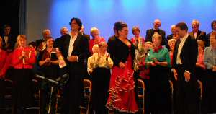

Rehearsal in 2011
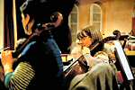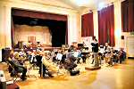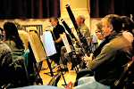

Orchestra at the walk-through of the Hindhead Tunnel May 2011
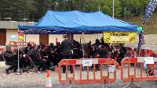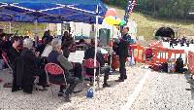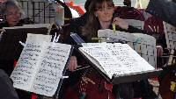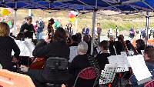

Choir at the Come and Sing day February 2011
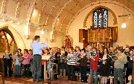

Concert on 8th May 2010
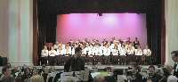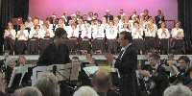

(Page 4)

Reviews

