New HMS Webpage: Members 13/02/2013

(Page 1)
News

Highlights of 2012

Membership increased by 1 to 83. We again gave an orchestral concert in St Christopher’s Church, Haslemere in October and three orchestral and choral concerts in the Haslemere Hall, in December, March and May, all of which were well received.

For the orchestral concert the church was full and the December concert was near capacity. The October programme consisted of Beethoven’s “Coriolan” overture, the Cello Concerto no.1 by Saint-Saens in which Anna Hunt, the leader of our cello section, was the soloist, and Haydn’s Symphony no 104.

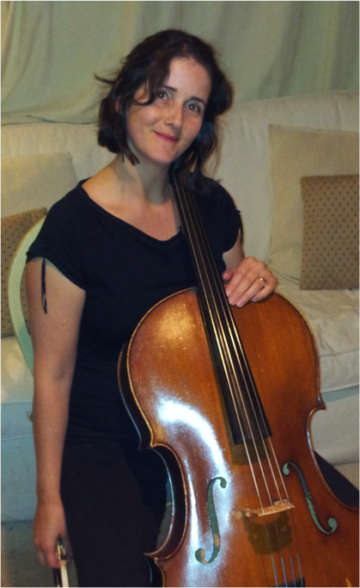

In December we performed Schumann’s Symphony no.3 (“Rhenish”) and Mozart’s Requiem. In March the programme included Mendelssohn’s “Hebrides” Overture, the Symphony no.3 of Sibelius, and Elgar’s choral work “The Music Makers”.

The May concert, on a Spanish theme, consisted of the Ballet Music from “Le Cid” by Massenet, two items by De Falla, “Danse Espagnole” from “La Vida Breve” and Suite no.1 from “The Three-cornered Hat”, and scenes from Bizet’s opera “Carmen”.

In January the orchestra recorded the music for the soundtrack of a locally-produced film “The Long Journey Home” which has been nominated for an award at the Aesthetica Short Film Festival and in May the orchestra played at the Mayor of Haslemere’s reception.

We held a successful “Come and Sing” day in February in St Christopher’s Church when the work rehearsed and performed was the choral suite from “The Armed Man” by Karl Jenkins.

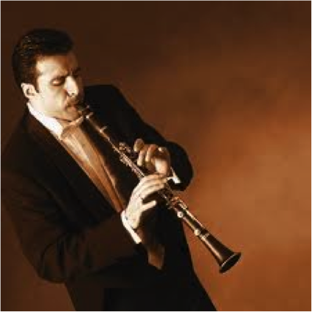

In June members and visitors enjoyed four open summer sessions, two for orchestra and two for chorus and orchestra, when a variety of music was played through under guest conductors.

During the year we enabled students of the University of Surrey and the University of Creative Arts to make recordings of the orchestra as part of their study courses. Our Chorus Master Michael Veazey left us after the May concert and has been replaced by Christopher Hann for the coming season.

2013 Performance Dates: (also see Concerts section)

Orchestra and Chorus 2nd March, 4th May, 7th December 2013

Come and Sing 16th February 2013

Summer Sessions 3rd, 10th, 17th & 24th June 2013

Rehearsal dates 7th January to 29th April 2013
AGM 14th October 2013

(Page 2)

Rehearsals

All rehearsals in the Haslemere Hall except: 18th March 2013

Summer sessions: 3rd, 10th, 17th and 24th June 2013

Haslemere Hall on Mondays (see below for dates) at 7.30 p.m. till about 10 p.m. for both choir and orchestra.

We have a tea/coffee break about half way through so that we can socialise. There is normally a rehearsal during the afternoon before each concert.

Occasionally the choir rehearses in the Methodist church in Weyhill when Haslemere Hall is not available. The orchestra also sometimes rehearses in St Christopher's Church, Weyhill.



(Page 3)

Practice Music

New Choraline Choraline practice recordings on media such as CD.

Cyberbass Learning aids for choral singers for playing on computer

(Page 4)

Fund raising

Shop Online and Raise Money for HMS at no cost to yourself!
We have registered HMS with easyfundraising.org. It's the easiest way to help raise money for the Society! If you already shop online with retailers such as Amazon, M&S, Argos, John Lewis, Comet, Vodafone, eBay, WH Smith, Waitrose, Sainsbury etc we need you to sign up for free to raise money while you shop! So how does it work?
Step 1: To start go onto the Easyfundraising web site then click on 'sign up' and register. Using this link will automatically establish HMS as the charity you are supporting.
Step 2: Each time you shop, go to the Easyfundraising website first, click on the link to the shop/business you want and make your purchase in the normal way. The retailers are easy to find as they are listed both by type and alphabetically. You pay exactly the same price as you would by going directly to the retailer but a percentage (up to 15%) is paid by the retailer to the HMS account with Easyfundraising. Your purchase is with the retailer so your normal rights are protected.
How much can you raise? Spend £100 with M&S online or Amazon and you raise £2.50 for us. £100 with WH Smith puts £2.00 in our pocket and so on. There are over 2,000 retailers on their site, and some of the donations can be as much as 15% of your purchase.
Save money too! Easyfundraising is FREE to use plus you'll get access to hundreds of exclusive discounts and voucher codes, so not only will you be helping us, you'll be saving money yourself.
We need your help to start donations coming in. Join now and sign up to start making a difference ... simply by shopping.

(Page 5)

Links
Choraline Choraline practice recordings.

Cyberbass Learning aids for choral singers

Haslemere Hall HMS location for ticket sales, practice and performances

LAMNET The Local Amateur Music Network - the UK's only free searchable database of classical musicians and groups.

Making Music National Federation of Music Societies

