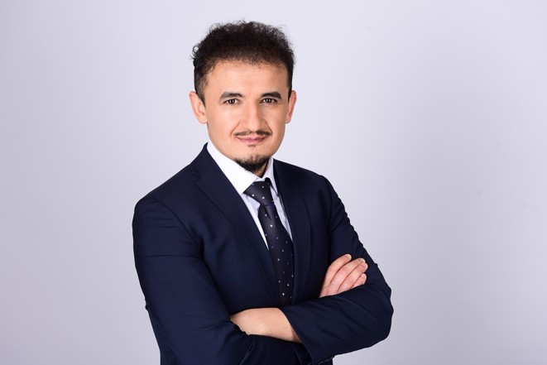

Hayrullah

**AYAN**

**Adresse:**

Am Weendespring 37077 Göttingen Germany

**Tel:**

+(+49) 176 741 93883

**Email:**

mansur@siirt.edu.tr

**Date of Birth:**

09.01.1981

**Marital Status:**

Married (3 kid)

**Language:**

English: C1 (Professional) German: A1

Turkish: Native

**Volunteering:**

İzam

# Professional Capabilities

Hands-on and leadership roles in the Siirt University integration and transformation projects – L1 Support. Total work experience: 10 years.

* Operating System: Linux, Windows
* Python (+4 years)
* AWS Cloud Practitioner
* PHP, Laravel, JavaScript, Git, RabbitMQ
* Linux, Linux Server (CPanel), Server Management, Basic Docker knowledge
* Numpy, Pandas, TensorFlow, Matplotlib, Seaborn

# Professional Experience & Projects

**IT Department Administration, Siirt University, Turkey** 05/2021 – CURRENT

* Developed and supervised in-house softwares.
* Integrated E-Government Web Services (SOAP) with in-house software.
* Created a certificate service and merged it with E-Government Web Services.

Creating CI/CD Pipeline

* Latest Project: Academic Staff Performance Evaluation application.
  + Project URL: apsis.siirt.edu.tr.
  + Used Technologies: PHP, Laravel, JavaScript

Technical responsible for ‘On-premise Servers / Applications to Cloud Migration’ project.

* Creating CI/CD Pipeline (Infrastructure as Code (IaC), Config-as-Code (CaC), Software as a Service (SaaS) ) for new projects/applications at Cloud environment.
* Working with developers to migrate legacy applications into Docker Containers
* K8s (Kubernetes) clusters and Legacy MW L3 Support
* Create meaningful monitors and alerts (For auto healing processes, for Clients, for Admins and for Vendors)
* Vendor Management (for P3-P4 Incidents)
* 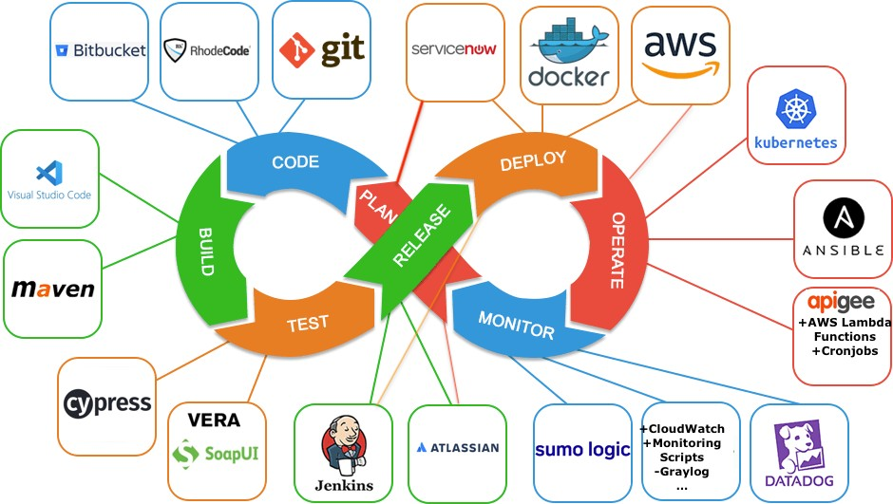This is what I use / spend 90% of my time

**SRE / App Admin at Wirecard Technologies - Munich** 04/2019 – 09/2020

Responsible for the infrastructure design, implementation, maintenance and release of new applications (Java EE, Spring Boot, Apache Tomcat etc.) and corresponding monitoring tools (ELK stack, AppDynamics, SumoLogic, Matomo, AWS CloudWatch, Datadog, Nagios etc.)

* Creating CI/CD Pipeline for internal applications.
* Automating the complex and error-prone processes with such as deployments, reports, infrastructure provisioning and DB scripts
* Responsible for Infrastructure (Legacy and Cloud) Performance tuning

**Ph.D., Management Information Systems, Ataturk University, 2021**

**Master of Science, Computer and Information Engineering**,

Sakarya University, 2011

**References:** References available upon request

05/2014 – 03/2019

**Lead Technical Consultant at WIPRO Technologies GmbH - Istanbul / Turkey**

* CI/CD Deployment and Release Manager
* Oracle Fusion Middleware (WebLogic, OSB, Oracle SOA Suite, EBS, OAG-Oracle API Gateway) server planning, installation, configuration, tuning, maintenance and L3 Support.
* ELK (FileBeat, Redis, Logstash, Elasticsearch and Kibana) Engineer
* Application Server (Java EE, Spring Boot, Apache Tomcat, Oracle WebLogic etc.) Tuning.

**Projects:** Oracle CC&B (CRM + BILLLING), MDM, ETRM (Energy Trading and Risk Management), ABB SCADA-OMS-DMS, IDAM&SSO, Oracle EAM (Enterprise Asset Management)

02/2010 – 05/2014

### Application Server / Middleware Expert at Turk Telecom

**(Telecommunication) / TTNET (ISP)/ AVEA (GSM) - Istanbul / Turkey**

* Oracle Fusion Middleware (WebLogic, OSB, Oracle SOA Suite, EBS, OAG-Oracle API Gateway) server planning, installation, configuration, tuning, maintenance and L3 Support.
* Infrastructure Architect
* Application Server Tuning
* CI/CD Change Management, ITSM Incident Management.

**Projects:** Billing, CRM, IDM&SSO, Loyalty, Dunning, OM (Order Management)

01/2008 – 02/2010

### Application Server Expert at AKBANK (Banking) - Istanbul / Turkey

* Apache Tomcat and Oracle Fusion Middleware (WebLogic, OSB, Oracle SOA Suite) Admin
* Application Server Admin (Installation + Configuration + L2 Support)

**Projects:** Investment, Campaign Management, Online Payment

06/2005 – 01/2008

### Application Server Admin at MIRSIS (Banking and Insurance) - Istanbul / Turkey

* Oracle Fusion Middleware (WebLogic, OSB, Oracle SOA Suite) Admin
* Application Server Admin (Installation + Configuration+L2 Support)

**Projects:** CRM, Online Payment

Professional Trainings

* Oracle SOA Suite Administration + Architectural Concepts of Service Design
* Oracle DBA l and Oracle DBA II + SQL Tuning
* ITIL V3, COBIT, PMP
* Google Cloud Platform Specialization

## Achievements

* Best Enterprise & IT Architecture: EBS Transformation ICMG - 2016
* Best Execution Project WIPRO Technologies - 2017
* TM Forum Excellence Awards: AVEA Order Management Project (<http://inform.tmforum.org/news/2015/06/tm-forum-names-excellence-awards-> winners/) TMFORUM - 2013