WEBSITE DESIGN AND CONTENT BLUEPRINT
Namuste Website
Complete Page Architecture
Industry-agnostic AI voice and chat assistants — with Doctors & Clinics as the first priority industry
NARRATIVE SYSTEM
Problem first. Outcome second. Namuste revealed only after the need is unmistakable.

Design direction
- Approximately 70% intentional negative space and 30% active content.
- Near-black editorial canvas, warm ivory typography and restrained Namuste green.
- One luminous conversation thread that moves from fragmented enquiry to clear outcome.
- Industry-agnostic platform identity; vertical expertise appears on dedicated pages.
- Doctors and Clinics always appear first within priority industries.

1. Strategic Foundation
CORE PRINCIPLE
Namuste turns customer conversations into organised business outcomes across voice, WhatsApp and web.

Brand hierarchy
Layer | Positioning
Platform | Industry-agnostic AI voice and chat assistant platform.
Core capability | Answer, understand, qualify, act, follow up and learn.
First priority industry | Doctors and Clinics.
Expansion | Professional services, distributors, agriculture, education, research and conglomerates.
Founding experience | Digicides is referenced only as the experience base that revealed the problem.

Global navigation
Navigation | Contents
Product | Platform, Voice AI, WhatsApp AI, Web AI, integrations and analytics.
Use Cases | Receptionist, lead qualification, support, surveys, helplines and follow-ups.
Industries | Doctors first, followed by professional services, distribution, agriculture, education and research.
Enterprise | Conglomerates, multi-brand groups and central governance.
Company | About, responsible AI, privacy, security and contact.

2. Visual System
The rules every page must follow
Design rule | Application
70% blank space | Silence is a design element. Leave large uninterrupted black areas around each content cluster.
30% active content | One headline, one short explanation, one restrained workflow and no more than two CTAs above the fold.
Typography | Editorial serif for emotional problem statements; clean sans-serif for navigation, UI and operational copy.
Green thread | A single fibre-like conversation trail visually connects problem, intelligence and outcome.
Coral accent | Used only for unresolved, missed or urgent states. Never becomes a secondary brand colour.
Glass UI | Sparse, translucent conversation or outcome cards. Avoid dense dashboard walls.
Imagery | No robots, AI brains, stock call centres, industry stereotypes or decorative photography.

Responsive behaviour
- Desktop: content occupies the left and far-right zones with a quiet central field.
- Tablet: preserve large vertical gaps; stack conversation modules without filling every viewport.
- Mobile: use one thought per screen and let the green thread continue across scroll positions.
- Motion: slow, organic and purposeful—missed enquiry becomes understood intent, then a next step.

3. Master Homepage
HOMEPAGE

Your customers are calling. Is someone always answering?
Businesses invest in creating demand, then lose opportunities when conversations are missed, delayed or never followed through.
PAGE PROMISE
Every conversation receives an intelligent response and a clear next step.

Recommended sections
- Problem-led hero with three signals: missed calls, unread enquiries and overdue follow-up.
- Product reveal: Meet Namuste.
- Transformation framework: Answer, Understand, Act, Follow up, Learn.
- Channels: Voice, WhatsApp and Web.
- Universal use cases.
- Priority industries with Doctors & Clinics first.
- Human collaboration, responsible AI and founder story.
- Final conversion section.

Hero conversation
Moment | Namuste response
Missed | 3 missed calls
Unanswered | 8 unread enquiries
Overdue | Follow-up overdue
Resolved | Every conversation gets a next step

Primary conversion
Primary CTA | Experience Namuste
Secondary CTA | Book a Demo
Next-section reveal | From hello to an outcome.

Visual reference
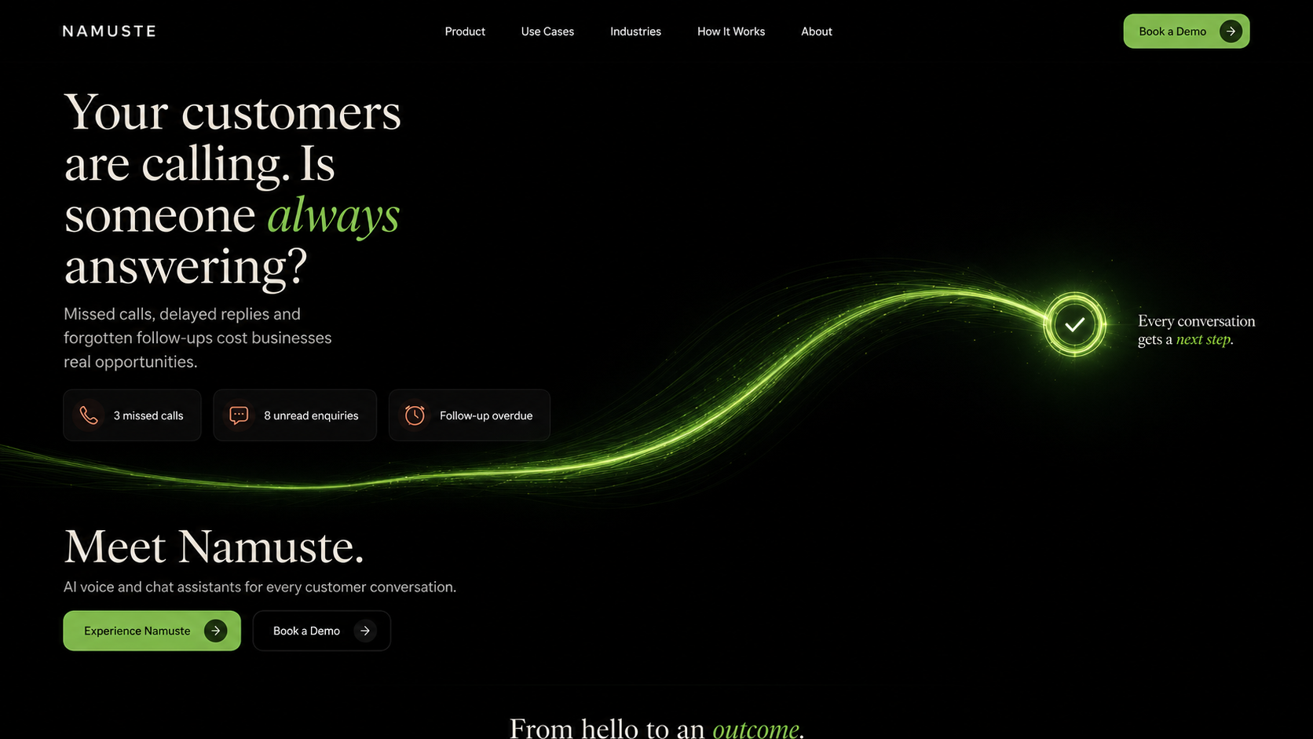

4. Product and Use-Case Pages
Page | Core proposition
Product Platform | One intelligence layer across voice, WhatsApp and web. Explain configuration, workflows, handover and learning.
Voice AI | Inbound and outbound multilingual calls, qualification, routing, transfer and outcome capture.
WhatsApp AI | Persistent messaging, information sharing, reminders, workflow completion and human handover.
Web AI | Visitor engagement, service discovery, lead capture, qualification and appointment requests.
AI Receptionist | Answers routine enquiries, captures details and manages appointments or callbacks.
Lead Qualification | Asks business-defined questions and progresses suitable prospects.
Customer Support | Resolves common requests and routes exceptions with context.
Survey Agent | Conducts structured multilingual conversations at scale.
AI Helpline | Provides accessible, consistent information across voice and messaging.
Follow-up Agent | Reminds, nurtures, reactivates and tracks next actions.

Standard use-case page structure
- Open with the failure point the business recognises.
- Show one conversation transforming into one outcome.
- Explain what Namuste handles and what remains human-owned.
- Show channel availability and integrations.
- Close with a use-case-specific experience CTA.

5. Doctors and Clinics
PRIORITY INDUSTRY 01

Patients are calling. Your front desk is already busy.
Calls arrive while reception teams are already supporting people inside the clinic.
PAGE PROMISE
Namuste answers routine patient enquiries, captures appointment requests and follows up while the team focuses on care.

Recommended sections
- Problem-led hero.
- Patient enquiry and appointment workflow.
- Capabilities: availability, appointments, FAQs, reminders and handover.
- Clinic types and speciality-specific examples.
- Human collaboration and safety boundaries.
- Analytics and operational visibility.
- Live clinic assistant demonstration.

Hero conversation
Moment | Namuste response
Patient | Is the dermatologist available tomorrow?
Namuste | Would you prefer morning or evening?
Outcome | Appointment requested

Primary conversion
Primary CTA | Experience the Clinic Assistant
Secondary CTA | Book a Demo
Next-section reveal | A calmer front desk. A more responsive clinic.

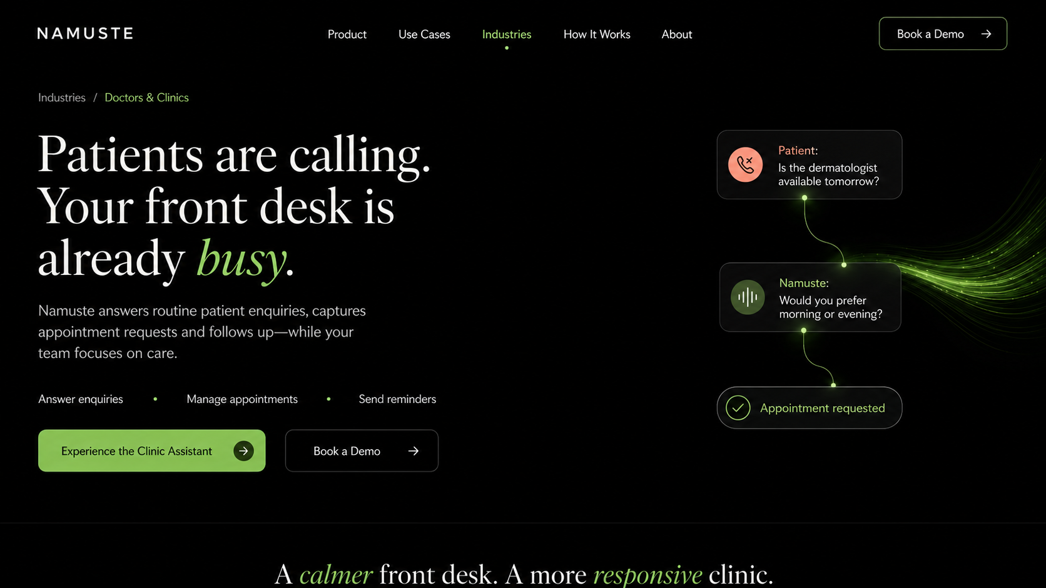

6. Professional Services
PRIORITY INDUSTRY 02

New enquiries arrive. Your expertise should not have to wait.
High-intent enquiries often arrive while experts are in consultations, meetings or focused work.
PAGE PROMISE
Namuste answers, qualifies and organises client conversations before they reach the professional team.

Recommended sections
- Profession selector: Lawyers, Accountants and Consultants.
- Client intake and initial qualification.
- Consultation scheduling.
- Document or information checklist.
- Status enquiries and automated follow-up.
- Clear boundaries: administrative assistance, not professional advice.

Hero conversation
Moment | Namuste response
Client | I need help with a property dispute.
Namuste | Which city is the property located in?
Outcome | Consultation qualified

Primary conversion
Primary CTA | Experience the Client Intake Assistant
Secondary CTA | Book a Demo
Next-section reveal | Less administrative back-and-forth. More valuable conversations.

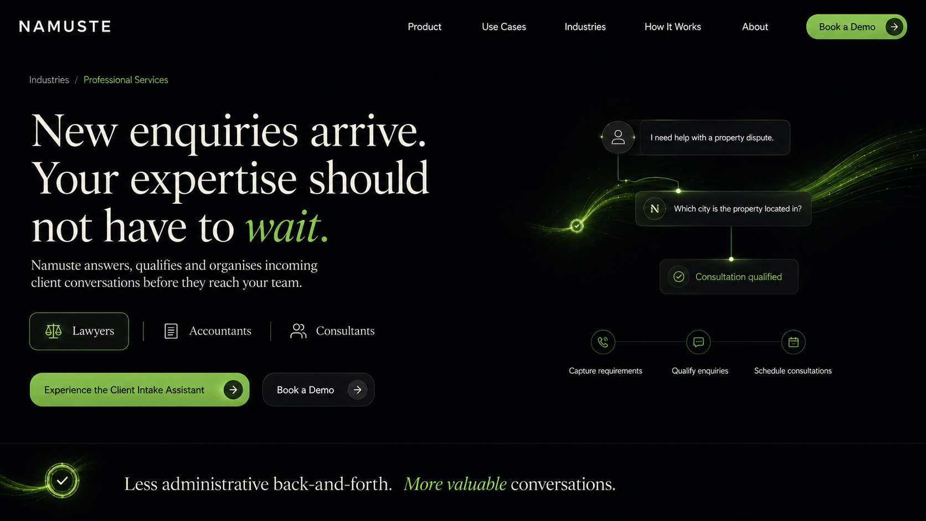

7. Distribution and Field Businesses
PRIORITY INDUSTRY 03

Orders move. Questions multiply. Support should keep pace.
Retailers, customers and field teams need answers across fragmented channels and working hours.
PAGE PROMISE
Namuste handles product, order, delivery and partner-support conversations across territories.

Recommended sections
- Retailer and partner helpline.
- Product and scheme enquiries.
- Order and delivery-status workflows.
- Complaint registration and routing.
- Field-team escalation.
- Regional language support and analytics.

Hero conversation
Moment | Namuste response
Retailer | Where is my order?
Namuste | Please share the order or registered mobile number.
Outcome | Status request routed

Primary conversion
Primary CTA | Experience the Partner Assistant
Secondary CTA | Talk to Namuste
Next-section reveal | One network. A consistent answer everywhere.

8. Agriculture and Rural Commerce
PRIORITY INDUSTRY 04

The market is multilingual. Support should be too.
Farmers, retailers and distributors need accessible support across languages, geographies and varying levels of digital comfort.
PAGE PROMISE
Namuste makes product, campaign, survey and support conversations accessible through voice and chat.

Recommended sections
- Farmer helplines.
- Retailer and distributor support.
- Product and campaign enquiries.
- Lead capture and callback routing.
- Multilingual surveys.
- Approved guidance, escalation and outcome analytics.

Hero conversation
Moment | Namuste response
Farmer | I need information about this product.
Namuste | Which crop and district are you calling about?
Outcome | Relevant workflow opened

Primary conversion
Primary CTA | Experience the Agriculture Assistant
Secondary CTA | Book a Demo
Next-section reveal | Every voice understood. Every need organised.

9. Education and Admissions
PRIORITY INDUSTRY 05

Interest is immediate. Admissions follow-up rarely is.
Prospective students ask questions across channels, but slow responses reduce counselling and application conversion.
PAGE PROMISE
Namuste answers course enquiries, qualifies students and coordinates counselling and reminders.

Recommended sections
- Course and programme discovery.
- Eligibility and application FAQs.
- Lead qualification.
- Counselling appointment scheduling.
- Deadline and document reminders.
- Applicant handover and nurturing.

Hero conversation
Moment | Namuste response
Student | What is the last date to apply?
Namuste | Which programme are you interested in?
Outcome | Counselling follow-up scheduled

Primary conversion
Primary CTA | Experience the Admissions Assistant
Secondary CTA | Book a Demo
Next-section reveal | From first question to completed next step.

10. Research and Surveys
PRIORITY INDUSTRY 06

More conversations should not require proportionately larger teams.
Large-volume research becomes expensive and inconsistent when every interview depends entirely on manual calling.
PAGE PROMISE
Namuste conducts structured multilingual voice and chat conversations while preserving research logic and escalation rules.

Recommended sections
- Respondent screening.
- Quantitative questionnaires.
- Adaptive branching.
- Validation and callback rules.
- Multilingual deployment.
- Structured outputs, monitoring and quality review.

Hero conversation
Moment | Namuste response
Namuste | May I ask you five questions about your recent experience?
Respondent | Yes, continue in Hindi.
Outcome | Verified response captured

Primary conversion
Primary CTA | Experience the Survey Agent
Secondary CTA | Discuss a Study
Next-section reveal | Structured conversations. Research-ready outcomes.

11. Conglomerates and Enterprise Groups
ENTERPRISE

Many businesses. Millions of conversations. One intelligence layer.
Large groups operate many brands, companies, departments and customer journeys—often with disconnected communication systems.
PAGE PROMISE
Deploy specialised AI assistants across companies and brands while keeping governance, knowledge and outcomes connected.

Recommended sections
- Enterprise problem and group-wide opportunity.
- Central governance with business-specific knowledge boundaries.
- Independent assistants by company, brand, function or geography.
- Shared integration, security and reporting standards.
- Unified intelligence without flattening local workflows.
- Phased rollout: one workflow, one company, then reusable group-wide playbooks.

Hero conversation
Moment | Namuste response
Consumer Brand | Customer Support
Healthcare | Appointment Desk
Distribution | Partner Helpline
Agriculture | Farmer Assistance
Group Layer | Namuste Enterprise

Primary conversion
Primary CTA | Design Your Enterprise AI Layer
Secondary CTA | Talk to Enterprise
Next-section reveal | Built centrally. Configured locally. Learned collectively.

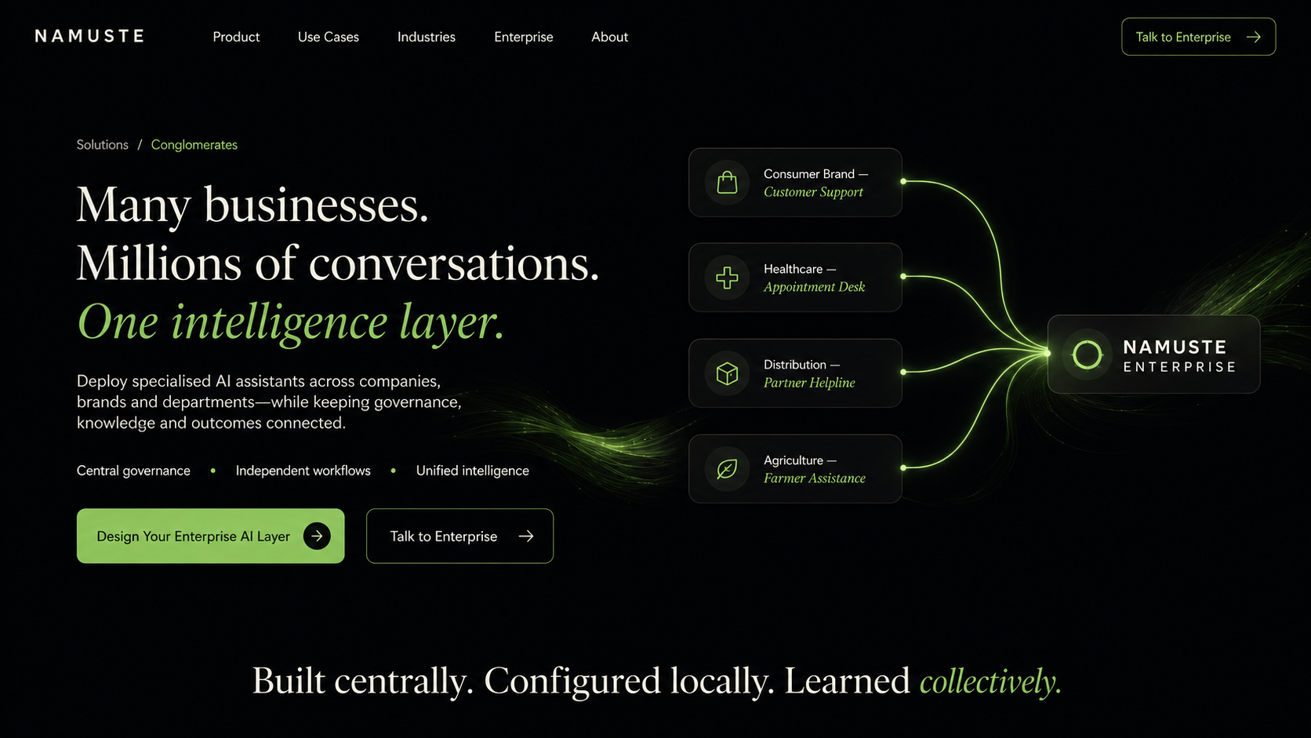

12. Supporting Pages
Page | Required content
How It Works | Choose a workflow; add business knowledge; configure actions and escalation; connect channels; test; launch; learn.
Why Namuste | Voice and chat together, multilingual operation, industry playbooks, workflow depth, human handover and outcome intelligence.
Integrations | Telephony, WhatsApp, web, calendars, CRM, helpdesk and custom systems. Clearly label Available, Pilot or Planned.
Responsible AI | AI disclosure, approved knowledge, defined boundaries, data minimisation, consent-aware follow-up and human escalation.
Pricing | Setup/configuration + recurring platform subscription + usage + integration or custom workflow charges.
About | Founder problem insight, Namuste vision, Saswati and Dipanjan, and Digicides referenced only as the experience base.
Resources | Healthcare workflows first, followed by professional services, voice AI, multilingual support and survey methodologies.
Book a Demo | Short qualification form that adapts to industry, volume, channels, languages and primary use case.

Demo form fields
- Name, company and role.
- Industry and business type.
- Approximate daily or monthly enquiry volume.
- Current channels: phone, WhatsApp, web or others.
- Languages required.
- Primary workflow and biggest communication challenge.
- Preferred demo time.

13. Build Sequence and Acceptance Checklist

Recommended release sequence
- Homepage and global design system.
- Doctors and Clinics page plus live clinic demonstration.
- Product platform and core use-case pages.
- Professional Services page.
- Enterprise / Conglomerates page.
- Distribution, Agriculture, Education and Research pages.
- Responsible AI, integrations, pricing, resources and about pages.

Content acceptance
- Every hero starts with a recognisable business problem.
- Namuste appears as the resolution, not the opening claim.
- Each page demonstrates one conversation becoming one measurable next step.
- No Digicides metric is presented as Namuste traction.
- No unsupported compliance, accuracy, savings or conversion claims.
- Healthcare copy stays administrative and never implies diagnosis or medical judgement.
- Professional-services copy never implies independent legal, financial or professional advice.

Visual acceptance
- Approximately 70% of each hero remains intentionally unoccupied.
- Only one primary visual metaphor appears per viewport.
- Green indicates understanding, connection and completed next steps.
- Coral is reserved for missed, delayed or unresolved states.
- No template-like card walls, stock people, robots or AI-brain imagery.
- Desktop, tablet and mobile preserve the same narrative sequence.
FINAL DESIGN TEST
The website should feel like a quiet intelligence layer entering a noisy conversation environment and creating order.

