README

Objective high-throughput detection of Acervuli spots of Apple blotch disease on detached leaves after artificial inoculation

If you use this repository or derivatives of it please cite:

YOLO-based phenotyping of Apple blotch disease (Diplocarpon coronariae) in genetic resources after artificial inoculation. Stefanie Reim*, Sophie Richter, Oskar Leonhardt, Virginia Maß, Thomas Wöhner

The YOLO model was trained with cropped images with a resolution of 768 x 768 pixels. The detection of Acervuli spots on uncropped images up to 3414 x 3648 pixel was also successful.

**Detection using Jupyter notebook**

The detection can be applied using the jupyter notebook script Detection_DC.ipynb (folder: Scripts), which worked on a window 10 machine.

*Following dependencies should be installed:*

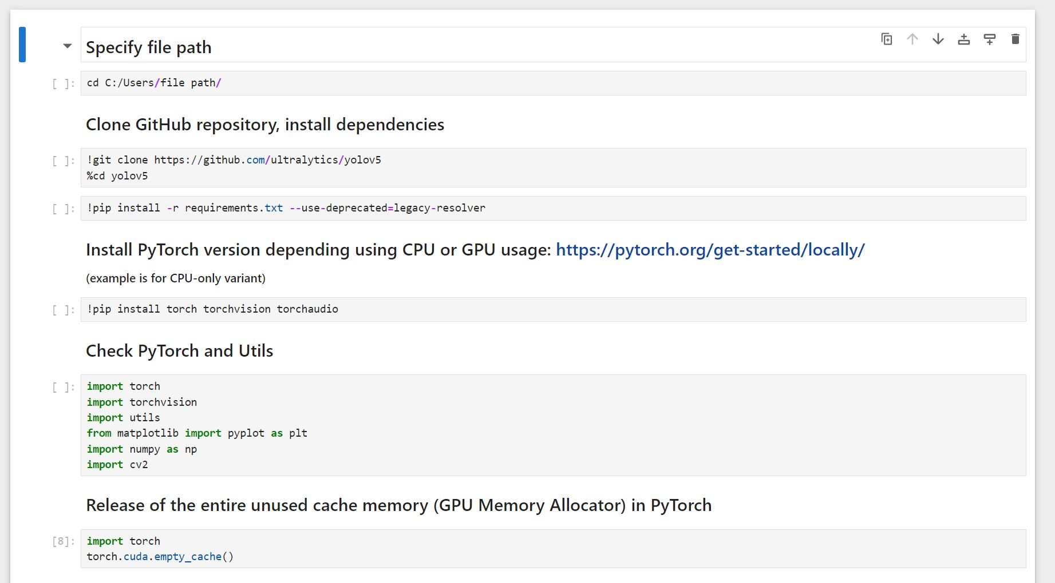

*After cloning the yolov5 dependencies on your PC, copy the Apple blotch disease detection model* ***DC_model_best.pt***  *(folder: DC_model/weights/) in the yolov5 folder.*

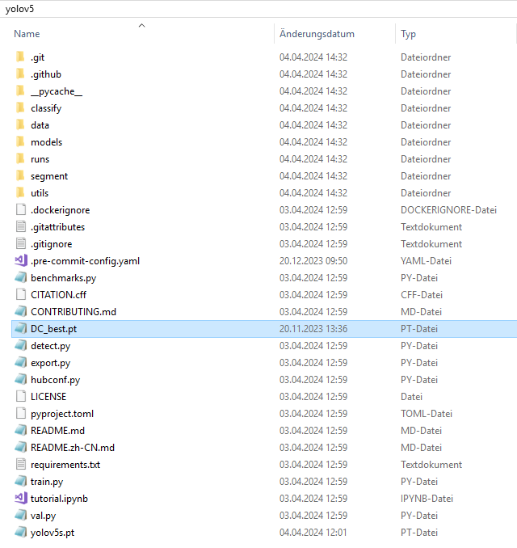

*The images for detection should be copied to the data/image folder*

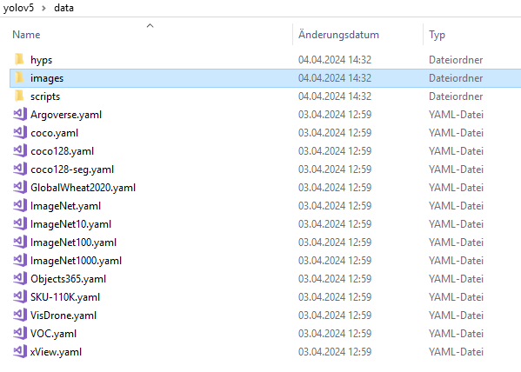

*Perform detection of the DC symptoms on images using Detection_DC.ipynb*

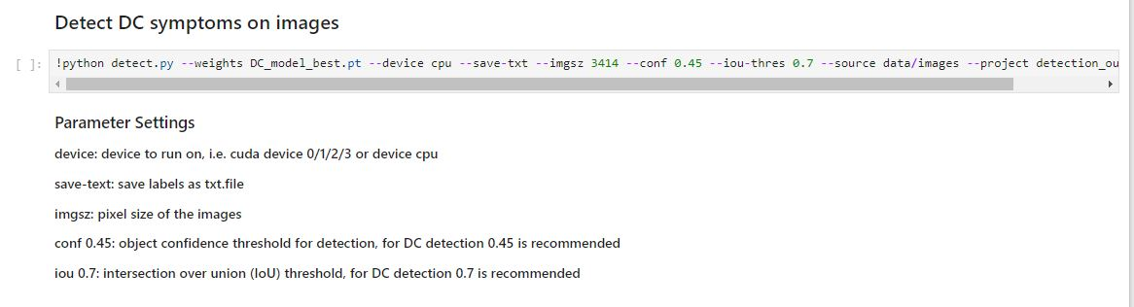

The output file (detection_output) consist the images with the labeled symptoms and the corresponding txt.file with the number and coordinates of the symptoms in each image.

*The number of labels per image can be summarized as csv.file*

