Practical-1
AIM: Observing different cables and connectors and configuring Wi-Fi Access Point.

Tools Required: None
Submission: Student need to write description of component and submit document in next lab.
Rubrics: Nicely drafted document with clarity in answers leads to full marks. Otherwise, submission carries proportional mark.

Write the description of component in your words.

Sr.  No. | Components Name & Picture | Description of Component
1 | Ethernet Cables  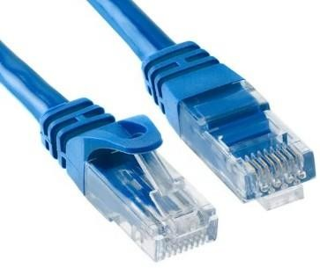 | - Ethernet cables are essential networking components that facilitate high-speed data transmission between devices in a local area network (LAN).  - These cables, commonly categorized by their Cat (Category) ratings, come in various types such as Cat5e, Cat6, and Cat7, each offering different levels of performance and bandwidth.  - Utilizing twisted pairs of copper or, in some cases, fiber- optic strands, Ethernet cables enable reliable and efficient communication by minimizing interference and signal degradation.
2 | Clamping Tool   | - A clamping tool is a versatile mechanical device designed to securely hold and immobilize objects during various industrial, woodworking, or metalworking processes.  - Typically composed of sturdy materials such as steel or aluminum, this tool features a lever or screw mechanism that allows users to tighten and release the grip on the workpiece with precision.  - The jaws of the clamping tool are often equipped with gripping surfaces or pads to prevent damage to the object being held.
3 | Console Cable  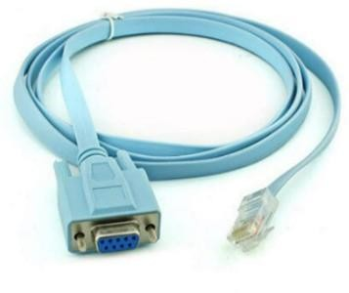 | - A console cable is a crucial networking accessory designed for configuring and managing networking devices such as routers, switches, and firewalls.  - Typically equipped with RS-232 connectors, this cable facilitates a direct, serial connection between a computer and the networking device's console port.  - The console cable serves as a communication link, enabling administrators to access the device's command-line interface (CLI) for configuration and troubleshooting purposes.

4 | Cable Tester  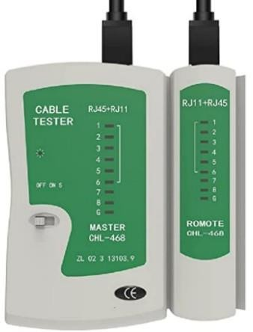 | - A cable tester is a vital electronic device designed to verify the integrity and functionality of various types of cables.  - Equipped with multiple connectors, it allows users to assess a wide range of cables, including Ethernet, USB, HDMI, and more.  - The tester employs sophisticated circuitry to identify issues such as short circuits, open circuits, and incorrect wiring configurations, ensuring that cables meet industry standards.  - This indispensable tool plays a crucial role in maintaining reliable connections in networking, audio-visual setups, and other technology-dependent applications.
5 | Manageable Switch  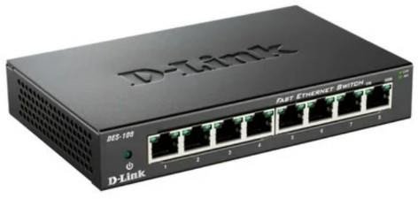 | - A manageable switch is a network device designed to efficiently control and direct the flow of data within a local area network (LAN).  - This component offers administrators the capability to monitor and configure network settings, providing a higher level of control compared to unmanaged switches. With its intuitive management interface, administrators can easily adjust settings such as virtual LANs (VLANs), Quality of Service (QoS), and port configurations.  - Additionally, the manageable switch enhances network security by supporting features like MAC address filtering and port mirroring, enabling administrators to detect and address potential issues.
6 | Normal Switch  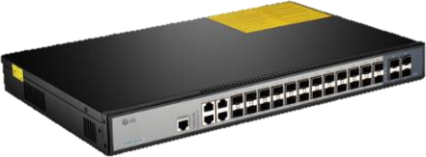 | - A normal switch, a fundamental electrical component, serves as a simple on-off control mechanism in various electronic and electrical systems.  - Comprising a lever or toggle, it enables users to interrupt or complete an electrical circuit, regulating the flow of electricity.  - Commonly found in homes, offices, and industrial settings, the normal switch facilitates the convenient operation of lights, appliances, and other devices.
7 | Router  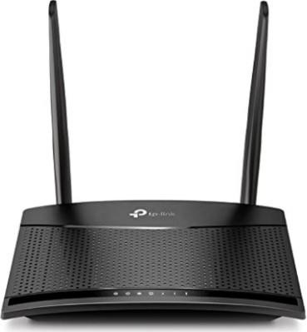 | - A router is a crucial networking component that serves as a gateway, connecting multiple computer networks and facilitating data exchange between them.  - It operates at the network layer of the OSI model, intelligently directing data packets from the source to their intended destinations.  - Routers utilize routing tables and protocols to determine the most efficient paths for data transmission, optimizing network efficiency.  - These devices play a pivotal role in managing internet traffic, ensuring that data packets reach their destinations accurately and in a timely manner. safeguard networks from unauthorized access and potential cyber threats.

8 | Chromecast   | - Chromecast is a versatile streaming device developed by Google, designed to seamlessly bridge the gap between your television and online content.  - Compact and sleek, this innovative component plugs into the HDMI port of your TV, transforming it into a smart display capable of streaming a wide array of digital content.  - Utilizing Wi-Fi connectivity, Chromecast allows users to "cast" or wirelessly transmit content from their smartphones, tablets, or computers directly to the TV screen, offering a user-friendly and convenient streaming experience.
9 | Passive Extender  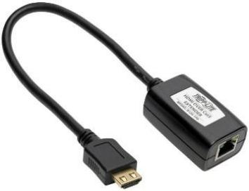 | - A Passive Extender is a vital electronic component designed to enhance the reach or length of a signal without requiring external power.  - Typically used in telecommunications and networking applications, this device serves as a reliable solution for extending the range of data transmission without introducing additional energy sources.  - The Passive Extender operates through various methods, such as signal regeneration or amplification, ensuring the signal integrity is maintained over extended distances.
10 | Active Extender  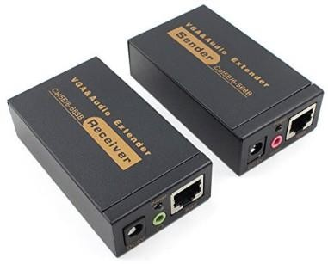 | - An Active Extender is a specialized electronic device designed to extend the reach of signals, typically used in the context of audio, video, or data transmission.  - Employing active circuitry, this component actively boosts and enhances the signal strength, allowing for longer cable runs without degradation or loss of quality.  - Active Extenders are particularly useful in scenarios where the distance between devices exceeds the inherent limitations of passive cables.
11 | Converter  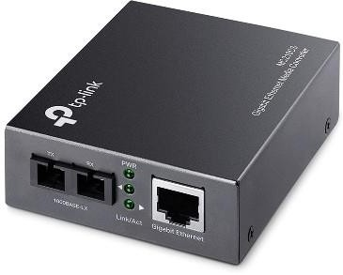 | - A converter is a vital electronic component that transforms one form of energy into another, typically converting electrical energy from one voltage or current level to another.  - Employed in various applications, converters play a pivotal role in powering electronic devices efficiently.  - They are essential for adapting power sources to meet specific requirements, ensuring compatibility between different systems.

12 | Normal ethernet extender  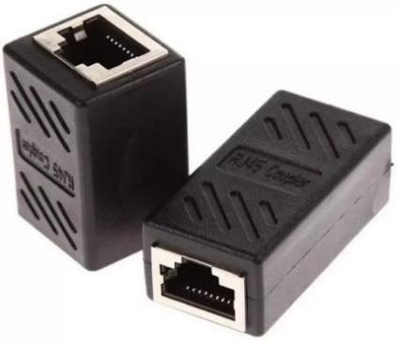 | - A normal Ethernet extender is a device designed to extend the reach of Ethernet networks beyond their typical distance limitations.  - It serves as a bridge between network devices, allowing them to communicate seamlessly over longer distances using standard Ethernet cables.  - This component employs various technologies such as Power over Ethernet (PoE) or repeaters to amplify and transmit signals, ensuring reliable data transfer.
13 | Passive Splitter  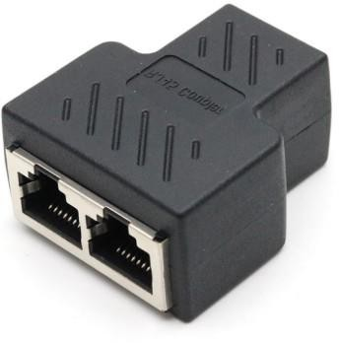 | - A passive splitter is a fundamental electronic component designed to divide an incoming signal into multiple output signals without any amplification or active circuitry.  - It operates on the principle of signal attenuation and distribution, directing the input signal across several output ports.  - Unlike active splitters, passive splitters do not require an external power source, making them simpler and more cost-effective.
14 | USB to Ethernet Cable  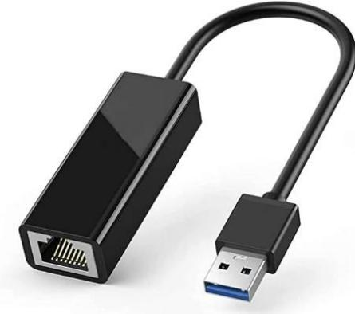 | - The USB to Ethernet cable is a versatile connectivity component designed to bridge the gap between USB and Ethernet interfaces.  - With a USB connector on one end and an Ethernet port on the other, this cable enables devices without built-in Ethernet ports to connect to wired networks.  - It is particularly useful for laptops, tablets, and other devices that may lack native Ethernet support.
15 | POE Splitter  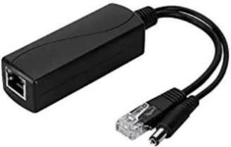 | - A Power over Ethernet (PoE) Splitter is a device designed to extract electrical power and data from a single Ethernet cable, enabling the delivery of both power and network connectivity to non-PoE compatible devices.  - This component typically features two output ports – one for power and another for data – and connects to the Ethernet cable input.  - The primary function of the PoE Splitter is to separate the power signal from the data signal, allowing devices that lack PoE support to still benefit from the convenience of a single cable for both power and data transmission.

16 | NIC Card for optical fiber  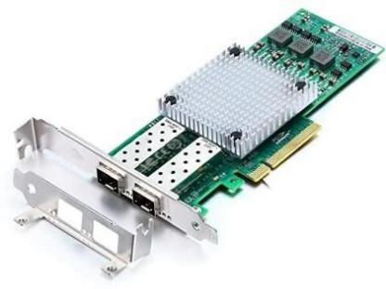 | - A Network Interface Card (NIC) designed for optical fiber connectivity serves as a crucial component in computer networking.  - This specialized NIC facilitates high-speed data transmission by utilizing optical fibers, which enable the transfer of data through pulses of light.  - The card is equipped with advanced optical transceivers, allowing seamless integration into fiber-optic networks.
17 | NIC Card for wireless  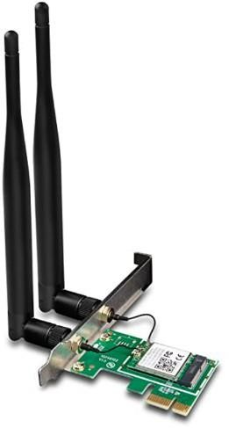 | - A Network Interface Card (NIC) designed for wireless connectivity is a crucial component that enables devices to establish and maintain connections to wireless networks.  - This card, often referred to as a wireless NIC or Wi-Fi card, functions as the interface between a device, such as a computer or laptop, and the wireless network infrastructure.  - It employs radio frequency signals to transmit and receive data wirelessly, allowing seamless communication between the device and the network.
18 | NIC Card for wireline  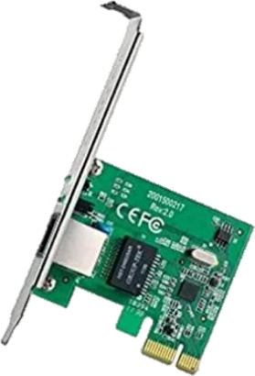 | - A Network Interface Card (NIC) for wireline communication is a crucial component that facilitates wired network connectivity in electronic devices.  - This card, often integrated into computers or other hardware, serves as the interface between the device and a wired network, enabling data transfer through cables.  - With a dedicated NIC, devices can establish reliable and high-speed connections over wired networks, such as Ethernet.
19 | Faceplate Punch Tool  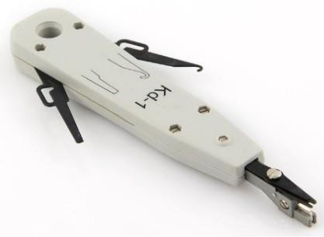 | - The Faceplate Punch Tool is an essential component in the field of networking and telecommunications.  - This handheld device is specifically designed for the installation and termination of faceplates in structured cabling systems.  - Featuring a durable and ergonomic design, the tool is equipped with a sharp punching mechanism that effortlessly creates clean and precise openings in wall- mounted faceplates.

20 | Rack  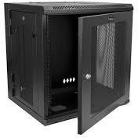 | - A rack is a fundamental structural component designed for the organized storage or display of items.  - Typically featuring a framework of horizontal and vertical supports, racks offer a modular and space-efficient solution for arranging objects.  - They come in various materials such as metal, wood, or plastic, providing versatility to suit different environments and purposes.

Assign IP Address to each Network:
- BUS Topology

A bus topology is a network in which nodes are directly linked with a common half- duplex link. A host on a bus topology is called a station. In a bus network, every station will accept all network packets, and these packets generated by each station have equal information priority. A bus network includes a single network segment and collision domain.

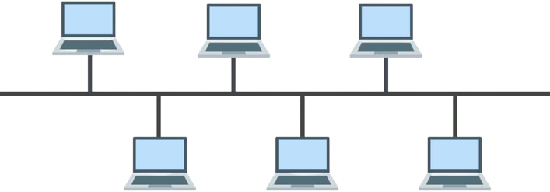
162.0.0.1
162.0.0.2
162.0.0.3
162.0.0.4
162.0.0.5
162.0.0.6

- They are all in the same network.

Star Topology

A star topology for a Local Area Network (LAN) is one in which each node is connected to a central connection point, such as a hub or switch. Whenever a node tries to connect with another node then the transmission of the message must be happening with the help of the central node. The best part of star topology is the addition and removal of the node in the network but too many nodes can cause suffering to the network.
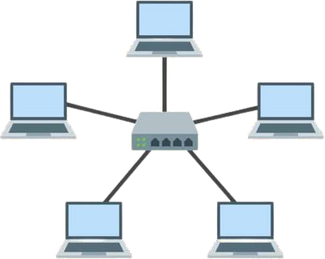
162.0.0.7
162.0.0.11
162.0.0.8
162.0.0.10
162.0.0.9

- They are all in the same network.

Ring Topology

Ring topology is a kind of arrangement of the network in which every device is linked with two other devices. This makes a circular ring of interconnected devices which gives it its name. Data is usually transmitted in one direction along the ring, known as a unidirectional ring. The data is delivered from one device to the next until it reaches the decided destination. In a bidirectional ring, data can travel in either direction.
162.0.0.15
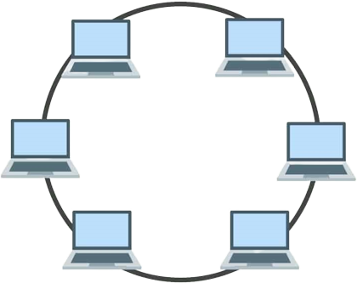
162.0.0.14
162.0.0.13
162.0.0.12

- Assigning IP address using the ipconfig command, or we can also assign an IP address with the help of a command.
162.0.0.17
162.0.0.16

Mesh Topology

In the mesh topology of networking, each and every device sends its own signal to the other devices that are present in the arrangement of the network.

162.0.0.17
162.0.0.18
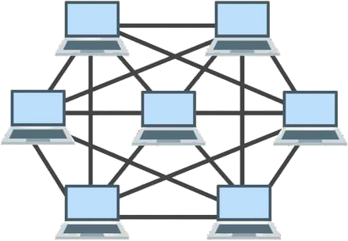
162.0.0.19
162.0.0.20
162.0.0.21
162.0.0.22
162.0.0.23

- They are all in the same network.

Tree Topology

- In the tree topology of networking, the elements and devices are arranged like a tree structure and have branches of connections between the devices connected to each other.

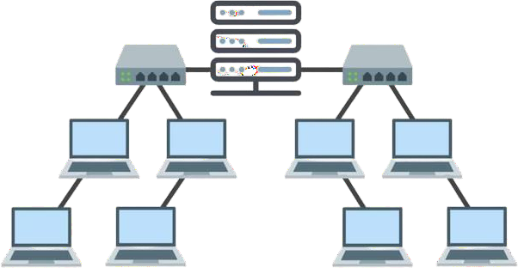
162.0.0.23
162.0.0.24
162.0.0.25
162.0.0.26
162.0.0.27
162.0.0.28
162.0.0.29
162.0.0.30

Hybrid Topology

The arrangement of a network that comprises nodes and connecting lines via sender and receiver is referred to as network topology. The combination of two or more topologies in a computer network is called Hybrid Topology. These combined topologies can be a combination of bus topology, mesh topology, ring topology, star topology, and tree topology.
162.0.0.32
162.0.0.33

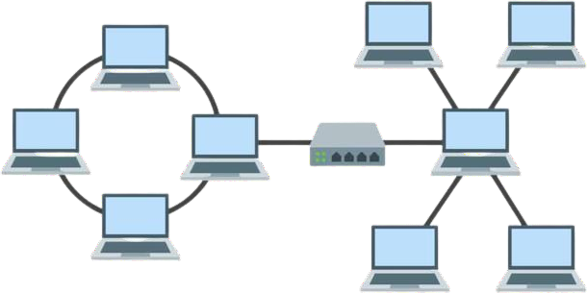
162.0.0.37
162.0.0.38
162.0.0.39
162.0.0.34
162.0.0.31
162.0.0.36
162.0.0.35

Student Signature Grade/Marks Examiner Signature

Practical-2
AIM: Observing first.cc second.cc third.cc files in NS3 and creating equivalent topologies into Cisco Packet tracer.
Tools Required: Cisco Packet Tracer, Ubuntu NS-3
Submission: Student need to write answer of the questions and submit document in next lab.
Note: While applying IP address, student need to allocate IP address as per his/her student ID. For Example, if student ID is 21ce005 then IP address allocation for first network should start with 5.0.0.0. For subsequent network, it should start with ID+1 i.e. 6.0.0.0, 7.0.0.0. and so on. Rubrics: Nicely drafted document with clarity in answers leads to full marks. Otherwise, submission carries proportional mark.

Exercise 1

➔ First.cc will be explained by faculty to students(30 mins.)

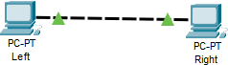

Questions:
- Which line of code will change number of nodes if one wish to create 5 nodes?
- Based on the script what is the distance between two nodes? (provide answer with calculations)
- To simulate the scenario of sending packet from India to America which line of code we need to add/change?
- What happens if we comment line number 64 and 73 simultaneously? Observe the out output and reach to a conclusion with that.
- What will happen if we put line number 59 above line number 56? why?
- On what port number the server is running?
- On what port number the client is running?

Answers:

- To change the number of nodes to 5, you need to modify the line: 44-> nodes.Create(2);
Change the argument from 2 to 5:
nodes.Create(5);

- The script sets the delay between nodes to 2 milliseconds using the line: pointToPoint.SetChannelAttribute("Delay", StringValue("2ms"));
The distance between two nodes can be calculated using the formula: Distance = (Propagation Speed) * (Transmission Delay + Propagation Delay). Assuming the propagation speed is the speed of light, the distance would be approximately 600 kilometers. This is calculated as follows:
Distance = 2 * 10^-3 seconds * (3 * 10^8 meters/second) = 600 kilometers

- To simulate the scenario of sending a packet from India to America, you would need to add/change the following line to set appropriate addresses: address.SetBase("192.168.1.0", "255.255.255.0");

- Lines 64 and 73 start and stop the client and server applications, respectively. If you comment out both lines, the applications will not be started and no data will be exchanged between the nodes. The simulation will still run, but the output will be empty.
- Lines 56 and 59 configure the IP addresses of the nodes. Line 56 creates an IPv4 address helper object with a base address of "10.1.1.0" and a subnet mask of "255.255.255.0". Line 59 assigns these addresses to the interfaces on the devices.
 If you put line 59 above line 56, the Assign method will try to assign addresses to the interfaces before the address helper object is even created. This will result in an error because the address helper object will not have any valid addresses to assign.

- The server is running on port number 9, specified in the line: UdpEchoServerHelper echoServer(9);

- The client is also running on port number 9, specified in the line: UdpEchoClientHelper echoClient(interfaces.GetAddress(1), 9);

Exercise 2

➔ Second.cc will be explained by faculty to students.(30 mins.)
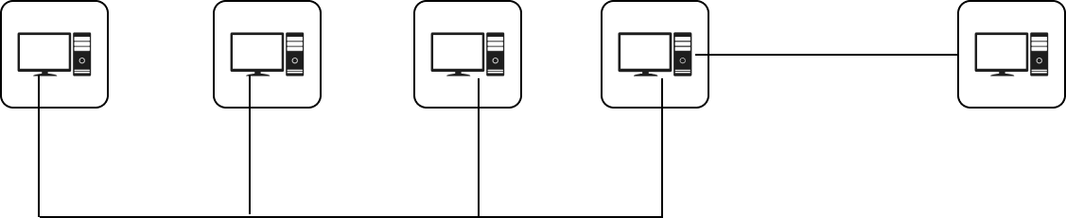

Questions:
  - What flag should be set to enable logging?
  - What is the default number of nodes used in this file?
  - What command you need to write in terminal to run this file with 5 CSMA nodes.
  - Which line of code/s you need to comment in order to separate point to point and csma from default network topology?
  - What Change you need to make to change name of generated pcap file with your roll number, generate pcap file for all the csma nodes. (write changed code ).
  - What happens when we remove line number 105 from the code? Justify your answer.
  - In line number 90 “UdpEchoServerHelper echoServer(9);” What happens when you change “9” with any other integer? Justify your answer.
Answers:
- The flag to enable logging is the "verbose" flag. If set to true, it enables logging for the UdpEchoClientApplication and UdpEchoServerApplication.
- The default number of CSMA nodes used in this file is 3. This can be changed by using the nCsma command-line argument. For example, to run the code with 5 CSMA nodes, you would type the following command into the terminal:
./second --nCsma=5
- To run this file with 5 CSMA nodes, you need to execute the following command in the terminal:
./second --nCsma=5
- To separate point-to-point and CSMA from the default network topology, you need to comment out or remove the following line:
stack.Install(csmaNodes); →line 79
- To change the name of the generated pcap file and generate pcap files for all the CSMA nodes, you can make the following changes to the code:

// Change the name of the pcap file to include your roll number pointToPoint.EnablePcap("second_YOUR_ROLL_NUMBER");

// Enable pcap for all CSMA devices for (uint32_t i = 0; i < nCsma; ++i) {
csma.EnablePcap("second_YOUR_ROLL_NUMBER", csmaDevices.Get(i), true);
}
- Line number 105 is: Ipv4GlobalRoutingHelper::PopulateRoutingTables();

Use code with caution.
This line of code adds routing information to the routing tables of all the nodes in the network. If you remove this line of code, the nodes will not be able to communicate with each other, and the simulation will fail.
- In line number 90 “UdpEchoServerHelper echoServer(9);” What happens when you change “9” with any other integer? Justify your answer.

The number 9 in the line UdpEchoServerHelper echoServer(9); is the port number that the echo server will listen on. If you change this number, the echo client will need to be configured to send its packets to the new port number. For example, if you change the number to 80, you would also need to change the following line of code:

echoClient.SetAttribute("RemotePort", UintegerValue(80));

Exercise 3

➔ Third.cc will be explained by faculty to students.(30 mins.)
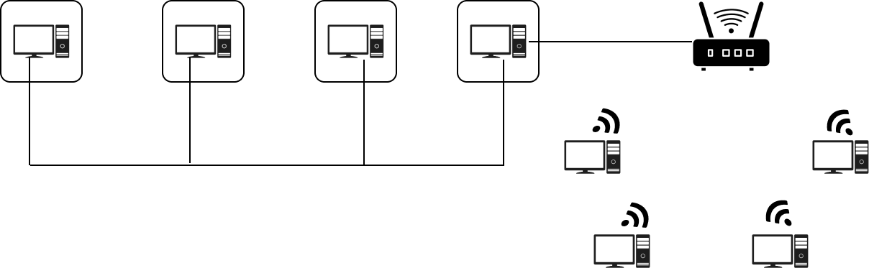

Questions:
  - List all command line attributes, with one example each, that you can provide when you run “third.cc”
  - List out the default values for all the attributes list in above question.
  - Which line of code you can comment out to separate the provided topology in a way that wireless and wired topology are disconnected from each other?
  - What will happen when you change “address.SetBase("10.1.1.0", "255.255.255.0");” (line number 146) with “address.SetBase("10.1.1.0", "255.255.0.0");” ? Observe the output and note down conclusion.
  - How many number of nodes are there in wired and wireless topology ?
  - What is the meaning of “ns3::StaWifiMac” in line number 108 and “ns3::ApWifiMac” n line number 112 ?
  - What is the significance of MobilityHelper?

Answers:

- List all command line attributes, with one example each, that you can provide when you run “third.cc”:
nCsma: Number of "extra" CSMA nodes/devices. Example: --nCsma=5 nWifi: Number of WiFi STA devices. Example: --nWifi=4
verbose: Enable verbose logging. Example: --verbose=true tracing: Enable pcap tracing. Example: --tracing=false

- List out the default values for all the attributes listed in the above question: nCsma: 3
nWifi: 3 verbose: true tracing: false
- You can comment out the following line to separate the provided topology:

C++
// line 116: wifi.Install(phy, mac, wifiApNode); Use code with caution.
This line installs the wifi devices on the AP node, which creates a connection between the wired

and wireless networks. Commenting it out will leave the wifi devices unconnected.

- Changing the subnet mask from "255.255.255.0" to "255.255.0.0" will increase the address range available for the wired topology. It will allow more IP addresses within the same subnet, potentially accommodating more devices.
- Wired Topology: 3 nodes (2 point-to-point nodes and additional CSMA nodes) Wireless Topology: 4 nodes (3 WiFi STA nodes and 1 WiFi AP node)

- ns3::StaWifiMac: It represents the WiFi Station (STA) MAC layer configuration. In the context of the code, it is used to configure the MAC layer for WiFi nodes acting as stations. ns3::ApWifiMac: It represents the WiFi Access Point (AP) MAC layer configuration. In the code, it configures the MAC layer for the WiFi node acting as the access point.
- MobilityHelper is used to configure the mobility models for nodes in the simulation. It helps in defining the movement and initial positions of nodes in the simulation space. In the given code, it sets up the mobility models for both WiFi stations and the access point, determining their positions in the simulation environment.

Conclusion: In this practical, I learned the fundamentals of network simulation and topology creation using NS3 and Cisco Packet Tracer. Through hands-on exercises, I gained proficiency in configuring various network components such as nodes, interfaces, and connections. Additionally, I explored concepts such as IP addressing, routing, and traffic simulation, which are essential for designing and troubleshooting networks.

Student Signature Grade/Marks Examiner Signature

Practical – 3

AIM: Creating cpp file for given network topologies (Ask lab faculty for network topology).
- Point-to-point

CSMA
- Wifi
o Speciifc
o Group

Tools Required: Cisco Packet Tracer, Ubuntu NS-3
Submission: Student need to (1) Print code of topology assigned (2) Submit conclusion page and submit document in next lab.

Note: While applying IP address, student need to allocate IP address as per his/her student ID. For Example, if student ID is 21ce005 then IP address allocation for first network should start with 5.0.0.0. For subsequent network, it should start with ID+1 i.e. 6.0.0.0, 7.0.0.0. and so on. Rubrics: Nicely drafted document with clarity in answers leads to full marks. Otherwise, submission carries proportional mark.
Exercise 1: Create cpp file for the topology given to you in the groups of 2 students within your batch. Lab instructor will randomly allocate one topology to group of students.
Note:
Attribute | Value
Distance | 1000 mtr.
Data rate | 10 mbps
Ip Address | As per your roll number
Blue color Box indicates :Client, Red color Box indicates: Server

Topology:
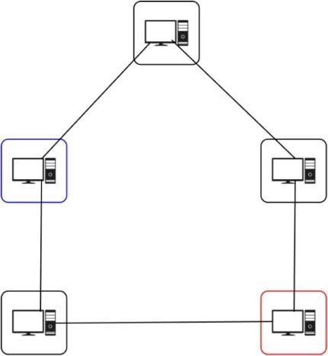

CODE :
#include"ns3/applications-module.h" #include "ns3/core-module.h" #include "ns3/internet- module.h" #include "ns3/network-module.h" #include"ns3/point-to-point-module.h" #include "ns3/netanim-module.h" #include "ns3/mobility- module.h"
using namespace ns3;

int main(int argc, char* argv[])
{
Time::SetResolution(Time::NS); LogComponentEnable("UdpEchoClientApplication", LOG_LEVEL_INFO); LogComponentEnable("UdpEchoServerApplication", LOG_LEVEL_INFO);

//creating nodes and grouping them according to link NodeContainernodes,node01,node12,node23,node34,node40; nodes.Create(5); node01.Add(nodes.Get(0));
node01.Add(nodes.Get(1));

node12.Add(nodes.Get(1)); node12.Add(nodes.Get(2));

node23.Add(nodes.Get(2)); node23.Add(nodes.Get(3));

node34.Add(nodes.Get(3)); node34.Add(nodes.Get(4));

node40.Add(nodes.Get(4)); node40.Add(nodes.Get(0));
//making link PointToPointHelperpointToPoint; pointToPoint.SetDeviceAttribute("DataRate", StringValue("10Mbps")); pointToPoint.SetChannelAttribute("Delay", StringValue("2ms"));

//making devices
NetDeviceContainerdevices01,devices12,devices23,devices34,devices40; devices01=pointToPoint.Install(node01); devices12=pointToPoint.Install(node12); devices23=pointToPoint.Install(node23); devices34=pointToPoint.Install(node34); devices40=pointToPoint.Install(node40);

//installing ip stack InternetStackHelperstack;

stack.Install(nodes);

//assignment of ip address Ipv4AddressHelper address;

address.SetBase("45.0.0.0", "255.255.255.0");
Ipv4InterfaceContainer interfaces01=address.Assign(devices01);

address.SetBase("46.0.0.0", "255.255.255.0");
Ipv4InterfaceContainer interfaces12=address.Assign(devices12);

address.SetBase("47.0.0.0", "255.255.255.0");
Ipv4InterfaceContainer interfaces23=address.Assign(devices23);

address.SetBase("48.0.0.0", "255.255.255.0");
Ipv4InterfaceContainer interfaces34=address.Assign(devices34);

address.SetBase("49.0.0.0", "255.255.255.0");
Ipv4InterfaceContainer interfaces40=address.Assign(devices40);

//configuring server UdpEchoServerHelperechoServer(9);

ApplicationContainerserverApps=echoServer.Install(nodes.Get(4)); serverApps.Start(Seconds(2.0)); serverApps.Stop(Seconds(10.0));

//configuring client
UdpEchoClientHelper echoClient(interfaces12.GetAddress(1), 9); echoClient.SetAttribute("MaxPackets", UintegerValue(4)); echoClient.SetAttribute("Interval", TimeValue(Seconds(1.0))); echoClient.SetAttribute("PacketSize", UintegerValue(1024));

ApplicationContainerclientApps=echoClient.Install(nodes.Get(1)); clientApps.Start(Seconds(1.0)); clientApps.Stop(Seconds(10.0));

();
MobilityHelper mobility; Ptr<ListPositionAllocator>positionAlloc=CreateObject<ListPositionAllocator>

positionAlloc->Add | (Vector | (10.0, | 20.0, | 0.0)); // AP at (0,0,0)
positionAlloc->Add | (Vector | (30.0, | 20.0, | 0.0)); // STA at (10,0,0)
positionAlloc->Add | (Vector | (30.0, | 30.0, | 0.0));
positionAlloc->Add | (Vector | (50.0, | 20.0, | 0.0));
mobility.SetPositionAllocator (positionAlloc);
//mobility.SetMobilityModel ("ns3::ConstantPositionMobilityModel"); mobility.Install (node01.Get(0));

mobility.Install (node01.Get(1)); mobility.Install (node12.Get(0)); mobility.Install (node12.Get(1)); mobility.Install (node23.Get(0)); mobility.Install (node23.Get(1)); mobility.Install (node34.Get(0)); mobility.Install (node34.Get(1)); mobility.Install (node40.Get(0)); mobility.Install (node40.Get(1));

AnimationInterfaceanim("cn_11.xml");

Ipv4GlobalRoutingHelper::PopulateRoutingTables(); anim.SetConstantPosition(nodes.Get(0), 40.0, 10.0);
anim.SetConstantPosition(nodes.Get(1), 20.0, 30.0);
anim.SetConstantPosition(nodes.Get(2), 20.0, 50.0);
anim.SetConstantPosition(nodes.Get(3), 60.0, 50.0);
anim.SetConstantPosition(nodes.Get(4), 60.0, 30.0);

Simulator::Run(); Simulator::Destroy(); return 0;
}

Command :./ns3 run prac3

OUTPUT :

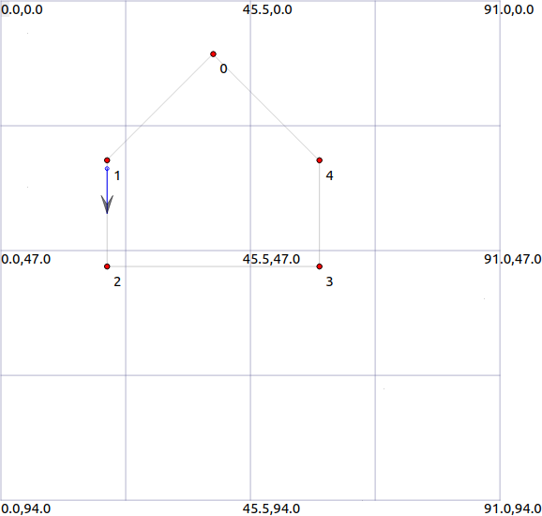

Topology:
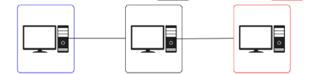
Code:
/*
* This program is free software; you can redistribute it and/or modify
* it under the terms of the GNU General Public License version 2 as
* published by the Free Software Foundation;
*
* This program is distributed in the hope that it will be useful,
* but WITHOUT ANY WARRANTY; without even the implied warranty of
* MERCHANTABILITY or FITNESS FOR A PARTICULAR PURPOSE. See the
* GNU General Public License for more details.
*
* You should have received a copy of the GNU General Public License
* along with this program; if not, write to the Free Software
* Foundation, Inc., 59 Temple Place, Suite 330, Boston, MA 02111-1307 USA
*/

#include "ns3/applications-module.h"
#include "ns3/core-module.h"
#include "ns3/internet-module.h"
#include "ns3/network-module.h"
#include "ns3/point-to-point-module.h"
#include "ns3/netanim-module.h"

// Default Network Topology
//
// 102.1.1.0 102.1.2.0
// n0 -------------- n1 -------------- n2
// point-to-point point-to-point
//

using namespace ns3;

NS_LOG_COMPONENT_DEFINE("FirstScriptExample");

int
main(int argc, char* argv[])
{
//CommandLine cmd(_FILE_);
//cmd.Parse(argc, argv);

Time::SetResolution(Time::NS);
LogComponentEnable("UdpEchoClientApplication", LOG_LEVEL_INFO);
LogComponentEnable("UdpEchoServerApplication", LOG_LEVEL_INFO);

NodeContainer nodes;
nodes.Create(3);

PointToPointHelper p2p1;
p2p1.SetDeviceAttribute("DataRate", StringValue("5Mbps"));
p2p1.SetChannelAttribute("Delay", StringValue("2ms"));

NetDeviceContainer devices1, devices2, devices3;
devices1 = p2p1.Install(nodes.Get(0), nodes.Get(1));
devices2 = p2p1.Install(nodes.Get(1), nodes.Get(2));

InternetStackHelper stack;
stack.Install(nodes);

Ipv4AddressHelper address;
address.SetBase("102.1.1.0", "255.255.255.0");

Ipv4InterfaceContainer interfaces1 = address.Assign(devices1);

address.SetBase("102.1.2.0", "255.255.255.0");

Ipv4InterfaceContainer interfaces2 = address.Assign(devices2);

UdpEchoServerHelper echoServer(9);

ApplicationContainer serverApps = echoServer.Install(nodes.Get(2));
serverApps.Start(Seconds(1.0));
serverApps.Stop(Seconds(10.0));

UdpEchoClientHelper echoClient(interfaces2.GetAddress(1), 9);
echoClient.SetAttribute("MaxPackets", UintegerValue(1));
echoClient.SetAttribute("Interval", TimeValue(Seconds(1.0)));
echoClient.SetAttribute("PacketSize", UintegerValue(1024));

Ipv4GlobalRoutingHelper::PopulateRoutingTables();

ApplicationContainer clientApps = echoClient.Install(nodes.Get(0));
clientApps.Start(Seconds(2.0));
clientApps.Stop(Seconds(10.0));

p2p1.EnablePcapAll("21ce102");

AnimationInterface anim("21ce102.xml");

anim.SetConstantPosition(nodes.Get(0), 10.0, 10.0);
anim.SetConstantPosition(nodes.Get(1), 20.0, 10.0);
anim.SetConstantPosition(nodes.Get(2), 30.0, 10.0);

Simulator::Run();
Simulator::Destroy();
return 0;
}

Output:
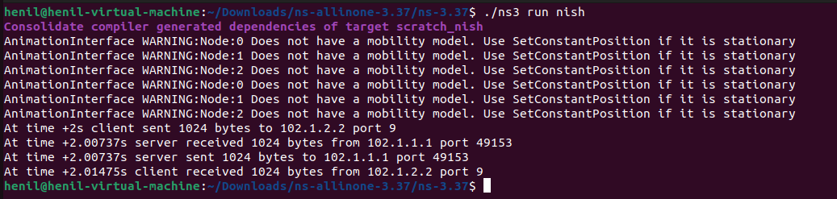

Topology:
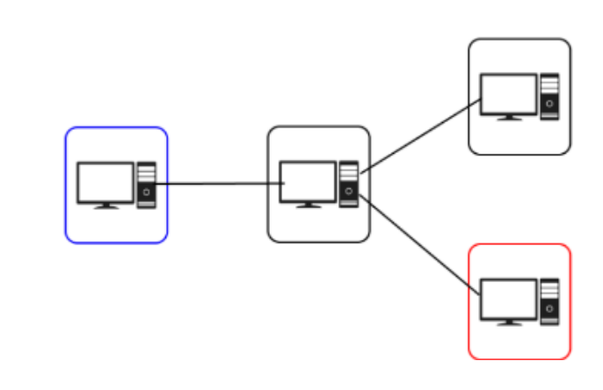
Code:
#include "ns3/applications-module.h"
#include "ns3/core-module.h"
#include "ns3/internet-module.h"
#include "ns3/network-module.h"
#include "ns3/point-to-point-module.h"
#include "ns3/netanim-module.h"
using namespace ns3;
NS_LOG_COMPONENT_DEFINE("FirstScriptExample");
int main(int argc, char* argv[]) {
Time::SetResolution(Time::NS);
LogComponentEnable("UdpEchoClientApplication", LOG_LEVEL_INFO);
LogComponentEnable("UdpEchoServerApplication", LOG_LEVEL_INFO);
NodeContainer nodes;
nodes.Create(4); // Adjust the number of nodes
PointToPointHelper p2p;
p2p.SetDeviceAttribute("DataRate", StringValue("5Mbps"));
p2p.SetChannelAttribute("Delay", StringValue("2ms"));
NetDeviceContainer devices1, devices2, devices3;
devices1 = p2p.Install(nodes.Get(0), nodes.Get(1)); // Connect Root to Child1
devices2 = p2p.Install(nodes.Get(1), nodes.Get(2)); // Connect Child1 to Child4
devices3 = p2p.Install(nodes.Get(1), nodes.Get(3)); // Connect Child1 to Child5
InternetStackHelper stack;
stack.Install(nodes);
Ipv4AddressHelper address;
address.SetBase("108.1.1.0"
, "255.255.255.0"); // Set IP address base for Root-Child1 link
Ipv4InterfaceContainer interfaces1 = address.Assign(devices1); // Assign IP addresses for Root-Child1 link
address.SetBase("108.1.2.0", "255.255.255.0"); // Set IP address base for Child1-Child4 link
Ipv4InterfaceContainer interfaces2 = address.Assign(devices2); // Assign IP addresses for Child1-Child4 link
address.SetBase("108.1.3.0", "255.255.255.0"); // Set IP address base for Child1-Child5 link
Ipv4InterfaceContainer interfaces3 = address.Assign(devices3); // Assign IP addresses for Child1-Child5 link
UdpEchoServerHelper echoServer(9);
ApplicationContainer serverApps = echoServer.Install(nodes.Get(3)); // Server on Child5
serverApps.Start(Seconds(1.0));
serverApps.Stop(Seconds(10.0));
UdpEchoClientHelper echoClient(interfaces3.GetAddress(1), 9); // Client on Child4
echoClient.SetAttribute("MaxPackets", UintegerValue(1));
echoClient.SetAttribute("Interval", TimeValue(Seconds(1.0)));
echoClient.SetAttribute("PacketSize", UintegerValue(1024));
Ipv4GlobalRoutingHelper::PopulateRoutingTables();
ApplicationContainer clientApps = echoClient.Install(nodes.Get(0)); // Client on Child1
clientApps.Start(Seconds(2.0));
clientApps.Stop(Seconds(10.0));
Simulator::Run();
Simulator::Destroy();
return 0;
}
Output:

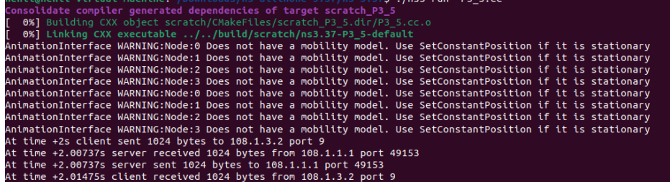

Topology:
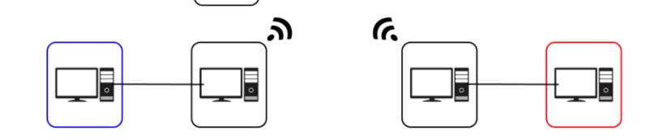
Code:
#include "ns3/applications-module.h"
#include "ns3/core-module.h"
#include "ns3/internet-module.h"
#include "ns3/network-module.h"
#include "ns3/point-to-point-module.h"
#include "ns3/csma-module.h"
#include "ns3/mobility-module.h"
#include "ns3/ssid.h"
#include "ns3/yans-wifi-helper.h"
#include "ns3/wifi-standards.h"
#include "ns3/netanim-module.h"

using namespace ns3;

NS_LOG_COMPONENT_DEFINE("CustomExample");

int
main(int argc, char* argv[])
{
//CommandLine cmd(FILE);
//cmd.Parse(argc, argv);

Time::SetResolution(Time::NS);
LogComponentEnable("UdpEchoClientApplication", LOG_LEVEL_INFO);
LogComponentEnable("UdpEchoServerApplication", LOG_LEVEL_INFO);

// step-1 = creating group of nodes....
NodeContainer allNodes,nodes01,nodes23,nodes45,wifiStaNodes_homeWifi, wifiApNodes_homeWifi,wifiStaNodes_homeWifi1, wifiApNodes_homeWifi1;
allNodes.Create(4);

nodes01.Add(allNodes.Get(0));
nodes01.Add(allNodes.Get(1));
nodes23.Add(allNodes.Get(2));
nodes23.Add(allNodes.Get(3));
wifiApNodes_homeWifi.Add(allNodes.Get(2));
wifiStaNodes_homeWifi.Add(allNodes.Get(1));

// step-2 = create link
PointToPointHelper p2pp2pLink1;
p2pp2pLink1.SetDeviceAttribute("DataRate",StringValue("10MB/s"));
p2pp2pLink1.SetChannelAttribute("Delay",StringValue("5ms"));

YansWifiChannelHelper channel_homeWifi = YansWifiChannelHelper::Default();
YansWifiPhyHelper phy_homeWifi;
WifiMacHelper mac_homeWifi;
WifiHelper wifi_homeWifi;
Ssid ssid_homeWifi= Ssid("krishna");
phy_homeWifi.SetChannel(channel_homeWifi.Create());
wifi_homeWifi.SetStandard(WIFI_STANDARD_80211a);
wifi_homeWifi.SetRemoteStationManager("ns3::ConstantRateWifiManager");

// step-3 = creating devices
NetDeviceContainer devices01, devices23, devices45;
devices01 = p2pp2pLink1.Install(nodes01);
devices23 = p2pp2pLink1.Install(nodes23);
mac_homeWifi.SetType("ns3::ApWifiMac","Ssid",SsidValue(ssid_homeWifi));
NetDeviceContainer apDev_homeWifi= wifi_homeWifi.Install(phy_homeWifi,mac_homeWifi,wifiApNodes_homeWifi);
mac_homeWifi.SetType("ns3::StaWifiMac","Ssid",SsidValue(ssid_homeWifi));
NetDeviceContainer staDev_homeWifi= wifi_homeWifi.Install(phy_homeWifi,mac_homeWifi,wifiStaNodes_homeWifi);

MobilityHelper mobility;
mobility.SetMobilityModel("ns3::ConstantPositionMobilityModel");
mobility.Install(allNodes);

// step-4 = Install ip stack
InternetStackHelper stack;
stack.Install(allNodes);

// step-5 = Assignment of IP Address
Ipv4AddressHelper address;

address.SetBase("142.0.0.0","255.255.0.0");
Ipv4InterfaceContainer interfaces01 = address.Assign(devices01);

address.SetBase("143.0.0.0","255.255.0.0");
Ipv4InterfaceContainer interfaces23 = address.Assign(devices23);

address.SetBase("144.0.0.0","255.255.0.0");
Ipv4InterfaceContainer interfaces45 = address.Assign(devices45);

address.SetBase("145.0.0.0","255.255.0.0");
Ipv4InterfaceContainer interfacesSta_homeWifi= address.Assign(staDev_homeWifi);
Ipv4InterfaceContainer interfacesAp_homeWifi= address.Assign(apDev_homeWifi);

// step-6 = server configuration
UdpEchoServerHelper echoServer(9);

ApplicationContainer serverApps = echoServer.Install(allNodes.Get(3));
serverApps.Start(Seconds(1.0));
serverApps.Stop(Seconds(11.0));

// step-7 = client configuration
UdpEchoClientHelper echoClient(interfaces23.GetAddress(1),9);
echoClient.SetAttribute("MaxPackets", UintegerValue(1));
echoClient.SetAttribute("Interval", TimeValue(Seconds(1.0)));
echoClient.SetAttribute("PacketSize", UintegerValue(1024));

ApplicationContainer clientApps = echoClient.Install(allNodes.Get(0));
clientApps.Start(Seconds(2.0));
clientApps.Stop(Seconds(11.0));

Ipv4GlobalRoutingHelper::PopulateRoutingTables();

Simulator::Run();
Simulator::Destroy();
return 0;
}
Output:
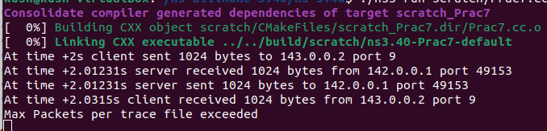

Topology:
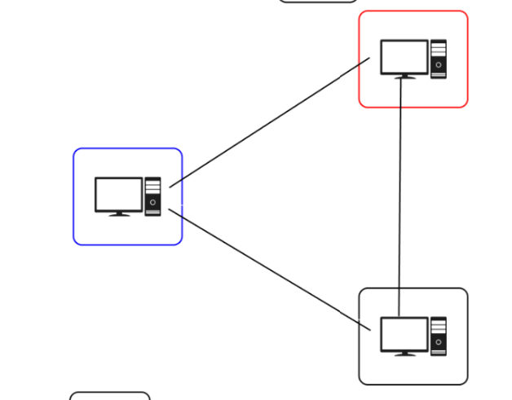
Code:
#include "ns3/applications-module.h"
#include "ns3/core-module.h"
#include "ns3/internet-module.h"
#include "ns3/network-module.h"
#include "ns3/point-to-point-module.h"
#include "ns3/netanim-module.h"
#include "ns3/mobility-module.h"

using namespace ns3;

int
main(int argc, char* argv[])
{
//CommandLine cmd(FILE);
//cmd.Parse(argc, argv);

Time::SetResolution(Time::NS);
LogComponentEnable("UdpEchoClientApplication", LOG_LEVEL_INFO);
LogComponentEnable("UdpEchoServerApplication", LOG_LEVEL_INFO);

//creating nodes and grouping them according to link
NodeContainer nodes,node01,node12,node20;
nodes.Create(3);
node01.Add(nodes.Get(0));
node01.Add(nodes.Get(1));

node12.Add(nodes.Get(1));
node12.Add(nodes.Get(2));

node20.Add(nodes.Get(2));
node20.Add(nodes.Get(0));

//making link
PointToPointHelper pointToPoint;
pointToPoint.SetDeviceAttribute("DataRate", StringValue("10Mbps"));
pointToPoint.SetChannelAttribute("Delay", StringValue("2ms"));

//making devices
NetDeviceContainer devices01,devices12,devices20;
devices01 = pointToPoint.Install(node01);
devices12 = pointToPoint.Install(node12);
devices20 = pointToPoint.Install(node20);

//installing ip stack
InternetStackHelper stack;
stack.Install(nodes);

//assignment of ip address
Ipv4AddressHelper address;

address.SetBase("113.0.1.0", "255.255.255.0");
Ipv4InterfaceContainer interfaces01 = address.Assign(devices01);

address.SetBase("113.0.2.0", "255.255.255.0");
Ipv4InterfaceContainer interfaces12 = address.Assign(devices12);

address.SetBase("113.0.3.0", "255.255.255.0");
Ipv4InterfaceContainer interfaces20 = address.Assign(devices20);

//configuring server
UdpEchoServerHelper echoServer(9);

ApplicationContainer serverApps = echoServer.Install(nodes.Get(0));
serverApps.Start(Seconds(2.0));
serverApps.Stop(Seconds(10.0));

//configuring client
UdpEchoClientHelper echoClient(interfaces01.GetAddress(0), 9);
echoClient.SetAttribute("MaxPackets", UintegerValue(2));
echoClient.SetAttribute("Interval", TimeValue(Seconds(1.0)));
echoClient.SetAttribute("PacketSize", UintegerValue(1024));

ApplicationContainer clientApps = echoClient.Install(nodes.Get(1));
clientApps.Start(Seconds(1.0));
clientApps.Stop(Seconds(10.0));

Simulator::Run();
Simulator::Destroy();
return 0;
}
Output:
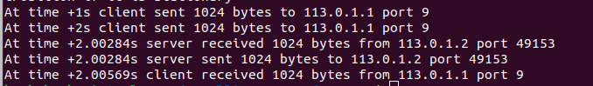

Topology:
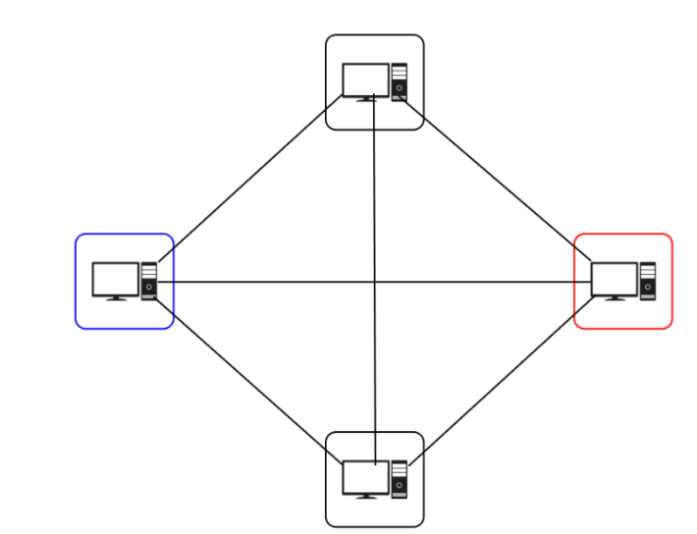
Code:
#include "ns3/core-module.h"
#include "ns3/network-module.h"
#include "ns3/internet-module.h"
#include "ns3/point-to-point-module.h"
#include "ns3/applications-module.h"
#include "ns3/netanim-module.h"

using namespace ns3;

NS_LOG_COMPONENT_DEFINE("ServerClientTopology");

/* Network topology:
*
* 0
* / | \
* / | \
* 1--|-- 2
* \ | /
* \ | /
* 3
*
* Nodes:
* 0 - Red (Server)
* 1, 2, 3 - Blue (Clients)
*/

int main(int argc, char *argv[]) {
//CommandLine cmd(FILE);
//cmd.Parse(argc, argv);

Time::SetResolution(Time::NS);
LogComponentEnable("UdpEchoClientApplication", LOG_LEVEL_INFO);
LogComponentEnable("UdpEchoServerApplication", LOG_LEVEL_INFO);

// Create nodes
NodeContainer nodes;
nodes.Create(4); // 1 server, 3 clients

// Create devices and channels
PointToPointHelper p2p;
p2p.SetDeviceAttribute("DataRate", StringValue("10Mbps"));
p2p.SetChannelAttribute("Delay", StringValue("2ms"));

// Create point-to-point links
NetDeviceContainer devices01 = p2p.Install(NodeContainer(nodes.Get(0), nodes.Get(1)));
NetDeviceContainer devices02 = p2p.Install(NodeContainer(nodes.Get(0), nodes.Get(2)));
NetDeviceContainer devices03 = p2p.Install(NodeContainer(nodes.Get(0), nodes.Get(3)));
NetDeviceContainer devices12 = p2p.Install(NodeContainer(nodes.Get(1), nodes.Get(2)));
NetDeviceContainer devices13 = p2p.Install(NodeContainer(nodes.Get(1), nodes.Get(3)));
NetDeviceContainer devices23 = p2p.Install(NodeContainer(nodes.Get(2), nodes.Get(3)));

// Create Internet stack
InternetStackHelper stack;
stack.Install(nodes);

// Assign IP addresses
Ipv4AddressHelper address;
address.SetBase("112.0.0.0", "255.255.255.0");
Ipv4InterfaceContainer interfaces01 = address.Assign(devices01);
address.SetBase("113.0.0.0", "255.255.255.0");
Ipv4InterfaceContainer interfaces02 = address.Assign(devices02);
address.SetBase("114.0.0.0", "255.255.255.0");
Ipv4InterfaceContainer interfaces03 = address.Assign(devices03);
address.SetBase("115.0.0.0", "255.255.255.0");
Ipv4InterfaceContainer interfaces12 = address.Assign(devices12);
address.SetBase("116.0.0.0", "255.255.255.0");
Ipv4InterfaceContainer interfaces13 = address.Assign(devices13);
address.SetBase("117.0.0.0", "255.255.255.0");
Ipv4InterfaceContainer interfaces23 = address.Assign(devices23);

// Setup server and client applications
UdpEchoServerHelper echoServer(9);
ApplicationContainer serverApps = echoServer.Install(nodes.Get(3)); // Server on node 0
serverApps.Start(Seconds(1.0));
serverApps.Stop(Seconds(10.0));

UdpEchoClientHelper echoClient(interfaces03.GetAddress(1), 9); // Client on node 1
echoClient.SetAttribute("MaxPackets", UintegerValue(1));
echoClient.SetAttribute("Interval", TimeValue(Seconds(1.0)));
echoClient.SetAttribute("PacketSize", UintegerValue(1024));

Ipv4GlobalRoutingHelper::PopulateRoutingTables();

ApplicationContainer clientApps3 = echoClient.Install(nodes.Get(0));
clientApps3.Start(Seconds(2.0));
clientApps3.Stop(Seconds(10.0));

Simulator::Run();
Simulator::Destroy();

return 0;
}
Output:
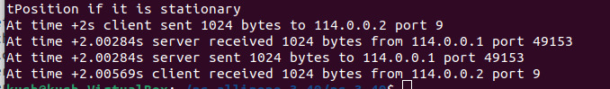

Topology:
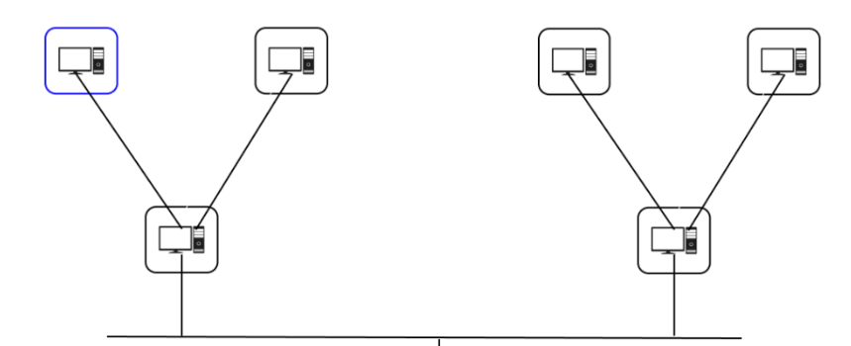
Code:
#include "ns3/applications-module.h"
#include "ns3/core-module.h"
#include "ns3/internet-module.h"
#include "ns3/network-module.h"
#include "ns3/point-to-point-module.h"
#include "ns3/netanim-module.h"

using namespace ns3;

NS_LOG_COMPONENT_DEFINE("FirstScriptExample");

int
main(int argc, char* argv[])
{
//CommandLine cmd(FILE);
//cmd.Parse(argc, argv);

Time::SetResolution(Time::NS);
LogComponentEnable("UdpEchoClientApplication", LOG_LEVEL_INFO);
LogComponentEnable("UdpEchoServerApplication", LOG_LEVEL_INFO);

NodeContainer nodes;
nodes.Create(7);

PointToPointHelper p2p1;
p2p1.SetDeviceAttribute("DataRate", StringValue("5Mbps"));
p2p1.SetChannelAttribute("Delay", StringValue("2ms"));

NetDeviceContainer devices1, devices2, devices3, devices4, devices5, devices6;
devices1 = p2p1.Install(nodes.Get(0), nodes.Get(1));
devices2 = p2p1.Install(nodes.Get(0), nodes.Get(2));
devices3 = p2p1.Install(nodes.Get(1), nodes.Get(3));
devices4 = p2p1.Install(nodes.Get(1), nodes.Get(4));
devices5 = p2p1.Install(nodes.Get(2), nodes.Get(5));
devices6 = p2p1.Install(nodes.Get(2), nodes.Get(6));

InternetStackHelper stack;
stack.Install(nodes);

Ipv4AddressHelper address;
address.SetBase("17.1.1.0", "255.255.255.0");

Ipv4InterfaceContainer interfaces1 = address.Assign(devices1);

address.SetBase("17.1.2.0", "255.255.255.0");

Ipv4InterfaceContainer interfaces2 = address.Assign(devices2);

address.SetBase("17.1.3.0", "255.255.255.0");

Ipv4InterfaceContainer interfaces3 = address.Assign(devices3);

address.SetBase("17.1.4.0", "255.255.255.0");

Ipv4InterfaceContainer interfaces4 = address.Assign(devices4);

address.SetBase("17.1.5.0", "255.255.255.0");

Ipv4InterfaceContainer interfaces5 = address.Assign(devices5);

address.SetBase("17.1.6.0", "255.255.255.0");

Ipv4InterfaceContainer interfaces6 = address.Assign(devices6);

UdpEchoServerHelper echoServer(9);

ApplicationContainer serverApps = echoServer.Install(nodes.Get(5));
serverApps.Start(Seconds(1.0));
serverApps.Stop(Seconds(10.0));

UdpEchoClientHelper echoClient(interfaces5.GetAddress(1), 9);
echoClient.SetAttribute("MaxPackets", UintegerValue(1));
echoClient.SetAttribute("Interval", TimeValue(Seconds(1.0)));
echoClient.SetAttribute("PacketSize", UintegerValue(1024));

Ipv4GlobalRoutingHelper::PopulateRoutingTables();

ApplicationContainer clientApps = echoClient.Install(nodes.Get(3));
clientApps.Start(Seconds(2.0));
clientApps.Stop(Seconds(10.0));

p2p1.EnablePcapAll("21ce017");

AnimationInterface anim("21ce017.xml");

anim.SetConstantPosition(nodes.Get(0), 40.0, 10.0);
anim.SetConstantPosition(nodes.Get(1), 20.0, 30.0);
anim.SetConstantPosition(nodes.Get(2), 60.0, 30.0);
anim.SetConstantPosition(nodes.Get(3), 10.0, 50.0);
anim.SetConstantPosition(nodes.Get(4), 30.0, 50.0);
anim.SetConstantPosition(nodes.Get(5), 50.0, 50.0);
anim.SetConstantPosition(nodes.Get(6), 70.0, 50.0);

Simulator::Run();
Simulator::Destroy();
return 0;
}

Output:
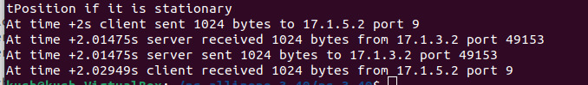
Topology:
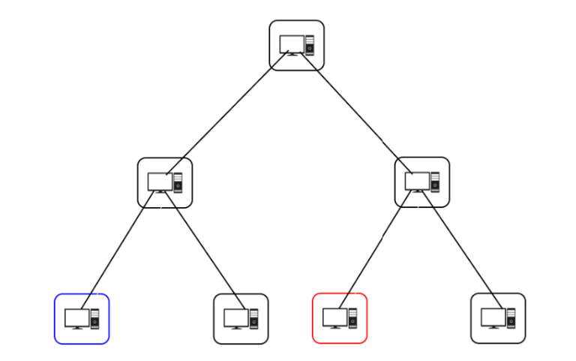
Code:
/*
* This program is free software; you can redistribute it and/or modify
* it under the terms of the GNU General Public License version 2 as
* published by the Free Software Foundation;
*
* This program is distributed in the hope that it will be useful,
* but WITHOUT ANY WARRANTY; without even the implied warranty of
* MERCHANTABILITY or FITNESS FOR A PARTICULAR PURPOSE. See the
* GNU General Public License for more details.
*
* You should have received a copy of the GNU General Public License
* along with this program; if not, write to the Free Software
* Foundation, Inc., 59 Temple Place, Suite 330, Boston, MA 02111-1307 USA
*/

#include "ns3/applications-module.h"
#include "ns3/core-module.h"
#include "ns3/internet-module.h"
#include "ns3/network-module.h"
#include "ns3/point-to-point-module.h"
#include "ns3/netanim-module.h"

using namespace ns3;

NS_LOG_COMPONENT_DEFINE("FirstScriptExample");

int
main(int argc, char* argv[])
{
//CommandLine cmd(FILE);
//cmd.Parse(argc, argv);

Time::SetResolution(Time::NS);
LogComponentEnable("UdpEchoClientApplication", LOG_LEVEL_INFO);
LogComponentEnable("UdpEchoServerApplication", LOG_LEVEL_INFO);

NodeContainer nodes;
nodes.Create(7);

PointToPointHelper p2p1;
p2p1.SetDeviceAttribute("DataRate", StringValue("5Mbps"));
p2p1.SetChannelAttribute("Delay", StringValue("2ms"));

NetDeviceContainer devices1, devices2, devices3, devices4, devices5, devices6;
devices1 = p2p1.Install(nodes.Get(0), nodes.Get(1));
devices2 = p2p1.Install(nodes.Get(0), nodes.Get(2));
devices3 = p2p1.Install(nodes.Get(1), nodes.Get(3));
devices4 = p2p1.Install(nodes.Get(1), nodes.Get(4));
devices5 = p2p1.Install(nodes.Get(2), nodes.Get(5));
devices6 = p2p1.Install(nodes.Get(2), nodes.Get(6));

InternetStackHelper stack;
stack.Install(nodes);

Ipv4AddressHelper address;
address.SetBase("17.1.1.0", "255.255.255.0");

Ipv4InterfaceContainer interfaces1 = address.Assign(devices1);

address.SetBase("17.1.2.0", "255.255.255.0");

Ipv4InterfaceContainer interfaces2 = address.Assign(devices2);

address.SetBase("17.1.3.0", "255.255.255.0");

Ipv4InterfaceContainer interfaces3 = address.Assign(devices3);

address.SetBase("17.1.4.0", "255.255.255.0");

Ipv4InterfaceContainer interfaces4 = address.Assign(devices4);

address.SetBase("17.1.5.0", "255.255.255.0");

Ipv4InterfaceContainer interfaces5 = address.Assign(devices5);

address.SetBase("17.1.6.0", "255.255.255.0");

Ipv4InterfaceContainer interfaces6 = address.Assign(devices6);

UdpEchoServerHelper echoServer(9);

ApplicationContainer serverApps = echoServer.Install(nodes.Get(5));
serverApps.Start(Seconds(1.0));
serverApps.Stop(Seconds(10.0));

UdpEchoClientHelper echoClient(interfaces5.GetAddress(1), 9);
echoClient.SetAttribute("MaxPackets", UintegerValue(1));
echoClient.SetAttribute("Interval", TimeValue(Seconds(1.0)));
echoClient.SetAttribute("PacketSize", UintegerValue(1024));

Ipv4GlobalRoutingHelper::PopulateRoutingTables();

ApplicationContainer clientApps = echoClient.Install(nodes.Get(3));
clientApps.Start(Seconds(2.0));
clientApps.Stop(Seconds(10.0));

p2p1.EnablePcapAll("21ce017");

AnimationInterface anim("21ce017.xml");

anim.SetConstantPosition(nodes.Get(0), 40.0, 10.0);
anim.SetConstantPosition(nodes.Get(1), 20.0, 30.0);
anim.SetConstantPosition(nodes.Get(2), 60.0, 30.0);
anim.SetConstantPosition(nodes.Get(3), 10.0, 50.0);
anim.SetConstantPosition(nodes.Get(4), 30.0, 50.0);
anim.SetConstantPosition(nodes.Get(5), 50.0, 50.0);
anim.SetConstantPosition(nodes.Get(6), 70.0, 50.0);

Simulator::Run();
Simulator::Destroy();
return 0;
}

Output:


Topology:
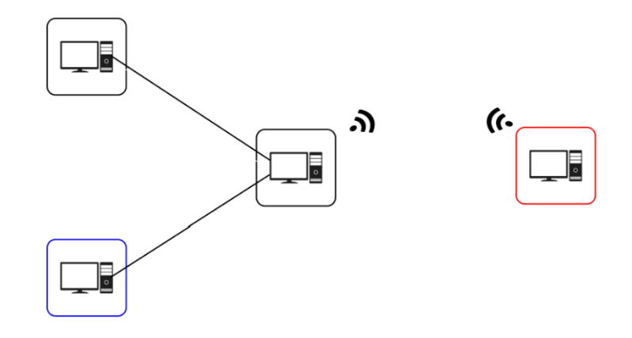
Code:
#include "ns3/applications-module.h"
#include "ns3/core-module.h"
#include "ns3/internet-module.h"
#include "ns3/network-module.h"
#include "ns3/point-to-point-module.h"
#include "ns3/csma-module.h"
#include "ns3/mobility-module.h"
#include "ns3/ssid.h"
#include "ns3/yans-wifi-helper.h"
#include "ns3/wifi-standards.h"
#include "ns3/netanim-module.h"

using namespace ns3;

NS_LOG_COMPONENT_DEFINE("CustomExample");

int
main(int argc, char* argv[])
{
//CommandLine cmd(FILE);
//cmd.Parse(argc, argv);

Time::SetResolution(Time::NS);
LogComponentEnable("UdpEchoClientApplication", LOG_LEVEL_INFO);
LogComponentEnable("UdpEchoServerApplication", LOG_LEVEL_INFO);

// step-1 = creating group of nodes....
NodeContainer allNodes,nodes01,nodes23,nodes45,wifiStaNodes_homeWifi, wifiApNodes_homeWifi,wifiStaNodes_homeWifi1, wifiApNodes_homeWifi1;
allNodes.Create(4);

nodes01.Add(allNodes.Get(0));
nodes01.Add(allNodes.Get(1));
nodes23.Add(allNodes.Get(2));
nodes23.Add(allNodes.Get(3));
wifiApNodes_homeWifi.Add(allNodes.Get(2));
wifiStaNodes_homeWifi.Add(allNodes.Get(1));

// step-2 = create link
PointToPointHelper p2pp2pLink1;
p2pp2pLink1.SetDeviceAttribute("DataRate",StringValue("10MB/s"));
p2pp2pLink1.SetChannelAttribute("Delay",StringValue("5ms"));

YansWifiChannelHelper channel_homeWifi = YansWifiChannelHelper::Default();
YansWifiPhyHelper phy_homeWifi;
WifiMacHelper mac_homeWifi;
WifiHelper wifi_homeWifi;
Ssid ssid_homeWifi= Ssid("krishna");
phy_homeWifi.SetChannel(channel_homeWifi.Create());
wifi_homeWifi.SetStandard(WIFI_STANDARD_80211a);
wifi_homeWifi.SetRemoteStationManager("ns3::ConstantRateWifiManager");

// step-3 = creating devices
NetDeviceContainer devices01, devices23, devices45;
devices01 = p2pp2pLink1.Install(nodes01);
devices23 = p2pp2pLink1.Install(nodes23);
mac_homeWifi.SetType("ns3::ApWifiMac","Ssid",SsidValue(ssid_homeWifi));
NetDeviceContainer apDev_homeWifi= wifi_homeWifi.Install(phy_homeWifi,mac_homeWifi,wifiApNodes_homeWifi);
mac_homeWifi.SetType("ns3::StaWifiMac","Ssid",SsidValue(ssid_homeWifi));
NetDeviceContainer staDev_homeWifi= wifi_homeWifi.Install(phy_homeWifi,mac_homeWifi,wifiStaNodes_homeWifi);

MobilityHelper mobility;
mobility.SetMobilityModel("ns3::ConstantPositionMobilityModel");
mobility.Install(allNodes);

// step-4 = Install ip stack
InternetStackHelper stack;
stack.Install(allNodes);

// step-5 = Assignment of IP Address
Ipv4AddressHelper address;

address.SetBase("142.0.0.0","255.255.0.0");
Ipv4InterfaceContainer interfaces01 = address.Assign(devices01);

address.SetBase("143.0.0.0","255.255.0.0");
Ipv4InterfaceContainer interfaces23 = address.Assign(devices23);

address.SetBase("144.0.0.0","255.255.0.0");
Ipv4InterfaceContainer interfaces45 = address.Assign(devices45);

address.SetBase("145.0.0.0","255.255.0.0");
Ipv4InterfaceContainer interfacesSta_homeWifi= address.Assign(staDev_homeWifi);
Ipv4InterfaceContainer interfacesAp_homeWifi= address.Assign(apDev_homeWifi);

// step-6 = server configuration
UdpEchoServerHelper echoServer(9);

ApplicationContainer serverApps = echoServer.Install(allNodes.Get(3));
serverApps.Start(Seconds(1.0));
serverApps.Stop(Seconds(11.0));

// step-7 = client configuration
UdpEchoClientHelper echoClient(interfaces23.GetAddress(1),9);
echoClient.SetAttribute("MaxPackets", UintegerValue(1));
echoClient.SetAttribute("Interval", TimeValue(Seconds(1.0)));
echoClient.SetAttribute("PacketSize", UintegerValue(1024));

ApplicationContainer clientApps = echoClient.Install(allNodes.Get(0));
clientApps.Start(Seconds(2.0));
clientApps.Stop(Seconds(11.0));

Ipv4GlobalRoutingHelper::PopulateRoutingTables();

Simulator::Run();
Simulator::Destroy();
return 0;
}

Output:


Student Signature Grade/Marks Examiner Signature

Practical – 4
AIM: Creating Visualisation of topology given in practical 3 observe packet flow using Netanim and show observation of result using Wireshark tool.
Netanim :



Wireshark :
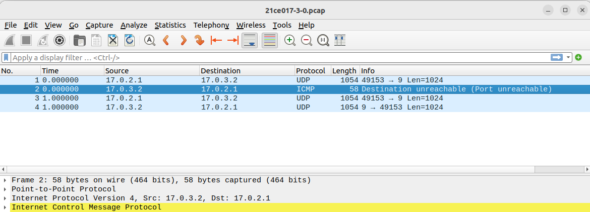

Conclusion:

In this practical, we used ns-3's visualization and packet capture features to better understand how the simulated network topologies worked.
- The NetAnim feature allowed us to visually represent the network topology and observe the movement of packets between nodes in real-time. This visual representation greatly aided in understanding the flow of data and the interactions between different components of the network. The ability to set constant positions for nodes facilitated easy interpretation of the network layout.

Additionally, the practical demonstrated the use of PCAP (Packet Capture) files, which recorded all the packet data transmitted over the simulated network. These PCAP files could be analysed using the widely-used Wireshark network protocol analyser tool.

Student Signature Grade/Marks Examiner Signature

Practical – 5

AIM: Creating cpp file for given network topologies
Use command line arguments to collect parameters of choice i.e. Number of nodes, links between nodes, UDP Server node number,

UDP client node number, net ID assigning, start
time and end time etc. and create one of the following topologies as instructed by instructor.
Note:
Attribute | Value
Distance | 1000 mtr.
Data rate | 10 mbps
Ip Address | As per your roll number
Topology:

Blue color box indicates: Client, Red color box indicates: Server

CODE :
#include "ns3/applications-module.h" #include "ns3/core-module.h" #include "ns3/internet-module.h" #include "ns3/network-module.h"
#include "ns3/point-to-point-module.h" #include "ns3/netanim-module.h" #include "ns3/mobility-module.h"

using namespace ns3;

int main(int argc, char* argv[]) {

uint32_t nNodes; double starttime; double endtime; uint32_t nlinks; uint32_t startnode; uint32_t endnode; std::vector<ns3::Ipv4Address> id;
ns3::Ipv4Address id1; ns3::Ipv4Address id2; ns3::Ipv4Address id3; ns3::Ipv4Address id4; ns3::Ipv4Address id5;

CommandLinecmd;
cmd.AddValue("nNodes", "Number of nodes", nNodes); cmd.AddValue("starttime", "Start time of server and client", starttime);
cmd.AddValue("endtime", "End time of server and client", endtime); cmd.AddValue("startnode", "Server node", startnode); cmd.AddValue("endnode", "Client Node", endnode); cmd.AddValue("nlinks", "Number of links", nlinks); cmd.AddValue("id1", "Net ID of device 1", id1); cmd.AddValue("id2", "Net ID of device 2", id2); cmd.AddValue("id3", "Net ID of device 3", id3); cmd.AddValue("id4", "Net ID of device 4", id4); cmd.AddValue("id5", "Net ID of device 5", id5);

cmd.Parse(argc, argv);

id.push_back(id1); id.push_back(id2); id.push_back(id3); id.push_back(id4); id.push_back(id5);

Time::SetResolution(Time::NS); LogComponentEnable("UdpEchoClientApplication", LOG_LEVEL_INFO); LogComponentEnable("UdpEchoServerApplication", LOG_LEVEL_INFO);

// Creating nodes and grouping them according to link NodeContainer nodes; nodes.Create(nNodes);

// Making links PointToPointHelperpointToPoint;
pointToPoint.SetDeviceAttribute("DataRate", StringValue("10Mbps"));

pointToPoint.SetChannelAttribute("Delay", StringValue("2ms"));

// Making devices std::vector<NetDeviceContainer>devices; for(uint32_t i= 0; i<nlinks; i++){
devices.push_back(pointToPoint.Install(nodes.Get(i), nodes.Get((i+1) %
5)));
}

// Installing IP stack InternetStackHelperstack; stack.Install(nodes);

// Assignment of IP address Ipv4AddressHelper address;
std::vector<Ipv4InterfaceContainer>interfaces; for(uint32_t i= 0; i<nlinks; i++){
address.SetBase(id[i], "255.255.255.0"); interfaces.push_back(address.Assign(devices[i]));
}

// Configuring server UdpEchoServerHelperechoServer(9);
ApplicationContainerserverApps=echoServer.Install(nodes.Get(startnode)); serverApps.Start(Seconds(2.0));
serverApps.Stop(Seconds(10.0));

if(startnode != 0){
startnode=startnode - 1;
}

// Configuring client
UdpEchoClientHelper echoClient(interfaces[startnode].GetAddress(1), 9); echoClient.SetAttribute("MaxPackets", UintegerValue(2)); echoClient.SetAttribute("Interval", TimeValue(Seconds(1.0))); echoClient.SetAttribute("PacketSize", UintegerValue(1024));

ApplicationContainerclientApps=echoClient.Install(nodes.Get(endnode)); clientApps.Start(Seconds(1.0));
clientApps.Stop(Seconds(10.0));

// Animation AnimationInterfaceanim("cn_11.xml");

// Set node positions for animation anim.SetConstantPosition(nodes.Get(0), 40.0, 10.0); anim.SetConstantPosition(nodes.Get(1), 20.0, 30.0);
anim.SetConstantPosition(nodes.Get(2), 20.0, 50.0);

anim.SetConstantPosition(nodes.Get(3), 60.0, 50.0);
anim.SetConstantPosition(nodes.Get(4), 60.0, 30.0); Ipv4GlobalRoutingHelper::PopulateRoutingTables();
// Enable pcap pointToPoint.EnablePcapAll("21ce017");

Simulator::Run(); Simulator::Destroy(); return 0;
}

OUTPUT :

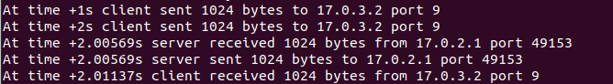
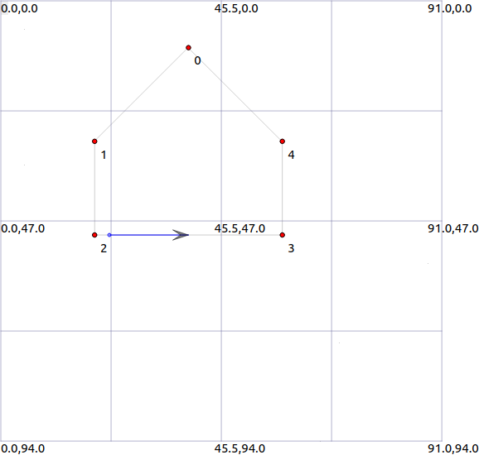
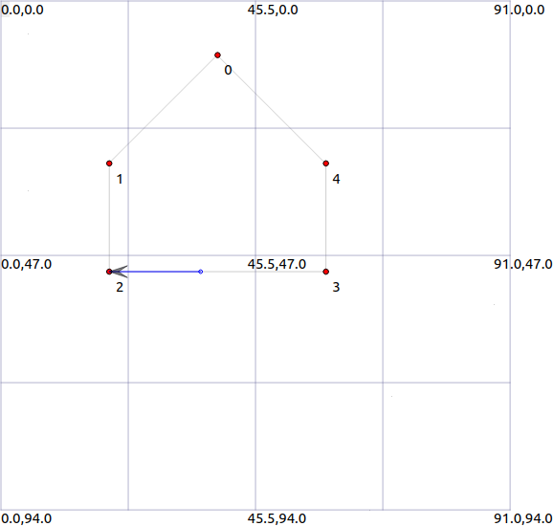



Conclusion :

In this practical, I learned the process of creating a network topology and simulating communication between nodes using NS-3. The key takeaway was understanding how to pass command-line arguments to customize the network configuration according to specific requirements. By defining parameters such as the number of nodes, server node, client node, and network IDs of devices through command-line arguments, we gained flexibility in designing and implementing the topology.

Student Signature Grade/Marks Examiner Signature

