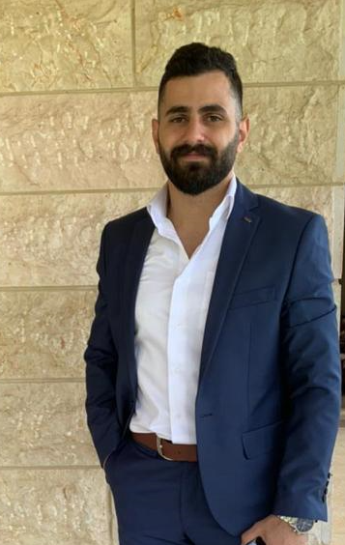
Curriculium Vitea
Name: Michael Chami
Nationality: Lebanese
Gender: Men
Address: Lebanon
Social Status: Single
DOB: 21/11/1996
Mobile: +961- 71-823260
Email: Michael.alchami@hotmail.com

ACADEMIC BACKGROUND

2020 - 2022 MBA in Finance.
Arab Open University – Beirut, Lebanon

2015 – 2019 B.S. in Business Administration-Finance and Banking
Arab Open University – Beirut, Lebanon

2013 – 2014 Lebanese Baccalaureate, Sociology and Economy
National Orthodox school – Cheikh-Taba Akkar

EXPERIENCE
- ERP Functional Consultant D365 F&O at Netways company.
- Sales at Ashty- ABC Dbayeh, 2019
- Sales at L’optique- City Mall, 2016-2019
- Cashier at supermarket Malapco-Mallah center- Jal El dib, 2015-2016
- Employee at Le Royal Hotel-Dbayeh, 2014-2015

ERP Functional Consultant Experience at Netways company:
- I am working on Dynamic 365 Finance and Operations.
- Working on all supply chain management modules (Product information management, procurement and sourcing, inventory management, warehouse management, Asset management, Sales and marketing, project management and accounting …)
- Setup and configurations.
- Prepare presentations for customers.
- Got all the requirement data from customers and resolve issues.
- Create training user manual.
- Train the customer on the system.
- Work with field service application, with the integration with D365 F&O. (Dual Write, Data integration).
- Go live support.

Knowledge

- Microsoft products (Excel, power point, word, power apps...)

LANGUAGE

Arabic Excellent
French Good
English Very Good

INTERESTS

Reading, Volunteering, Sports.

REFERENCES

Ramy Al Chami - Manager at Emirates Lebanon bank – Phone number: +96170733556
Dr. Saher Al Anan – Doctor at Arab Open University- Phone number: +9613804809

