DigiKitPro Rebuilt Blog Articles
SEO-ready editorial package · 14 September 2026
This document contains the complete rebuilt set of DigiKitPro articles currently on the site, including SEO metadata, article copy, product links, image captions, alt-text recommendations, FAQs, and research notes.

Research scope
Research was completed against official Procreate Help and Handbook pages for brush import, Brush Library, Brush Studio, canvas, DPI, custom canvases, and Blend Modes, plus the current DigiKitPro product catalogue and Terms of Service. Product claims are limited to the catalogue fields available in this repository and should be rechecked against the live product page before publication.
Procreate Help: Importing your brushes
Procreate Handbook: Brush Libraries
Procreate Handbook: Brush Studio
Procreate Handbook: Canvas
Procreate Handbook: Create a custom canvas
Procreate Handbook: Blend Modes
DigiKitPro Terms of Service

Articles

1. Best Procreate Brushes for Anime and Manga: Lines, Shading, and Texture

Best Procreate Brushes for Anime and Manga: Lines, Shading, and Texture

SEO metadata
SEO title | Best Procreate Brushes for Anime and Manga: Lines, Shading, and Texture
H1 | Best Procreate Brushes for Anime and Manga: Lines, Shading, and Texture
URL slug | /blog/best-procreate-brushes-for-anime/
Meta description | Choose Procreate brushes for anime and manga by line control, soft shading, washes, and finishing texture. A practical guide to focused DigiKitPro options.
Primary keyword | best Procreate brushes for anime
Secondary keywords | Procreate anime brushes, manga brushes for Procreate, anime line art brushes, anime shading brushes
Search intent | Commercial investigation
Target audience | Anime and manga illustrators, character artists, chibi artists, and beginners building a stylised workflow
Category | Procreate Brushes
Tags | anime, manga, Procreate brushes, character art, line art, watercolor

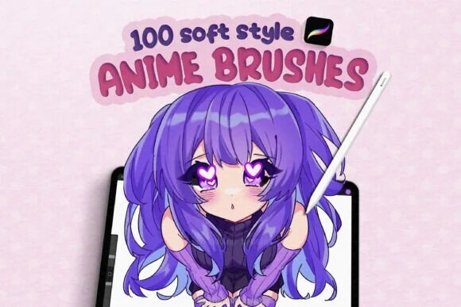
Official DigiKitPro product artwork: Anime Soft-Style Studio Kit: 100+ Procreate Brushes. This is a product visual, not a Procreate screenshot.

Article
Anime and manga art do not depend on one magic brush. A convincing character illustration usually moves through several marks: a construction pencil, a confident contour, flat colour, controlled shadow, and a few accents that guide the eye. The best Procreate brushes for anime are the ones that support that rhythm without forcing every artist into the same finish.
The recommendations below use the current DigiKitPro product descriptions as a starting point. “Soft style,” “manga,” and “semi-realistic” cover different visual languages, so treat each option as a workflow match rather than a universal ranking.

The four brush jobs in an anime workflow

1. Construction and line art
Line weight carries expression. Use a lighter brush for construction, then a liner that can vary width for outer contours, facial features, folds, and hair groups. Keep the line hierarchy deliberate: the heaviest line is not automatically the most professional.
The Essential Line Art & Sketch Kit is the most focused option in this group. If you want more variety between fine liners and marker-like strokes, the Professional Liner & Marker Studio is a broader match.

2. Soft shading and blending
A soft anime finish still needs form. Build shadows around the planes of the face, under the fringe, inside sleeves, and where objects overlap. Use a lower-opacity brush and build the value gradually instead of covering the whole character with a single airbrush pass.

3. Wash and paper texture
Watercolour-style washes can soften a background, break up flat clothing, or add atmosphere to a character piece. Use them with a clear value plan; texture cannot rescue a silhouette that is hard to read.

4. Highlights and graphic accents
Reserve sparkle, glow, halftone, and eye highlights for accents. If every surface glows equally, the viewer loses the focal point. A small, hard catchlight or a few controlled texture marks often work better than a full-canvas effect.

Which DigiKitPro set fits your style?
Your priority | Resource to inspect | Why it may fit
One broad anime workflow | Anime Soft-Style Studio Kit | The catalogue describes 100-plus brushes spanning linework, shading, blending, watercolor-style washes, details, and paper textures.
Soft, dreamy washes | 100+ Anime Soft Style Brushes | The product is positioned around watercolor brushes, shading, blending, textured details, highlights, and line art.
Ink and marker control | Professional Liner & Marker Studio | A useful comparison point when your work depends more on line and marker behaviour than on washes.
A small line-first library | Essential Line Art & Sketch Kit | A focused starting point for sketching, manga lines, and character construction.

The catalogue is the source of truth for current included files and compatibility. A brush count does not describe the quality of your finished illustration.

A simple anime brush test
Make a one-page character study before opening a large project:
Draw a head construction and one expressive eye.
Ink the face and hair with two line weights.
Add a three-value cel-shaded pass: light, local colour, shadow.
Add one soft wash to the background and one hard highlight to the focal point.
View the page at thumbnail size and remove any texture that competes with the face.
Save the brushes that helped you complete the page. Archive the rest until you know why you need them.

Common problems and fixes
• Lines feel scratchy: test a different liner or slow down the stroke; do not solve every wobble with more stabilisation.
• Skin looks flat: strengthen the value shape under the fringe, nose, chin, and jaw before adding blush.
• The character disappears in texture: keep the background lower contrast than the face and simplify decorative marks.
• Hair looks like a sticker: paint large hair groups first, then add a few directional strands; see the hair painting workflow.
• Soft shading becomes muddy: use separate layers, keep shadows purposeful, and let some base colour remain clean.

Recommended DigiKitPro resources
Anime Soft-Style Studio Kit: 100+ Procreate Brushes — A complete anime ecosystem: 100+ brushes for soft gradients, luminous shading, razor-sharp manga ink and glowing final details.
100+ Anime Soft Style Brushes: Watercolor, Shading & Line Art — 100+ soft watercolor brushes, smooth blenders and expressive liners for dreamy anime, manga and soft-style illustration.
Professional Liner & Marker Studio: 39 High-Fidelity Brushes — A curated digital ink station: 39 brushes replicating the saturated flow of alcohol markers and the razor precision of technical liners.
Essential Line Art & Sketch Kit for Procreate — 43 focused brushes plus a bonus texture brush for clean line art, natural pencil sketches and confident inking, no pack-switching.

FAQ

What are the best Procreate brushes for anime beginners?
Start with a pencil or sketch tool, a controlled liner, a basic painting brush, and a simple shading brush. A focused line-art kit or a broad anime set can work; choose based on whether you need line practice or a wider soft-style workflow.

Can I use anime brushes for chibi art?
Yes. Chibi work benefits from the same line, fill, shading, and highlight roles. Reduce detail, simplify the value structure, and choose a liner whose taper suits the smaller proportions.

Are manga brushes different from anime brushes?
They overlap, but manga workflows often prioritise black-and-white line, hatching, screentone or halftone texture, and strong value design. Anime colour work may need more blending, washes, and highlight tools.

Do anime brush packs work on iPad?
The DigiKitPro products linked here are described as Procreate brush files for iPad. Confirm the current requirements on the product page and use Procreate’s official brush import guidance.

Can I sell anime art made with these brushes?
DigiKitPro’s Terms of Service allow personal and commercial artwork unless a product page states otherwise. They do not allow redistribution of the brush files themselves. Check the terms before offering editable source assets to a client.

Sources and update note
• Procreate Help: Importing your brushes — official supported formats and import flow.
• DigiKitPro product pages linked above — current product descriptions and requirements.
• DigiKitPro Terms of Service — current commercial-artwork licence language.
Build your anime library around the marks your characters actually need: confident lines, readable values, purposeful texture, and a few well-placed accents.

Research notes
Factual claims were checked against the official sources listed in the article. DigiKitPro product counts, formats, and requirements are taken from the repository catalogue and linked product pages; availability, prices, and terms can change and should be rechecked before publication.

2. Best Procreate Brushes for Beginners: A Simple Starter Kit

Best Procreate Brushes for Beginners: A Simple Starter Kit

SEO metadata
SEO title | Best Procreate Brushes for Beginners: A Simple Starter Kit
H1 | Best Procreate Brushes for Beginners: A Simple Starter Kit
URL slug | /blog/best-procreate-brushes-for-beginners/
Meta description | Find the best Procreate brushes for beginners without downloading a chaotic library. Learn what to start with, how to practise, and when to upgrade.
Primary keyword | best Procreate brushes for beginners
Secondary keywords | beginner Procreate brushes, free Procreate brushes, Procreate brush set for beginners, iPad drawing brushes
Search intent | Informational with light commercial investigation
Target audience | New Procreate users, iPad artists, hobby illustrators, and learners building a first brush library
Category | Guides
Tags | Procreate brushes, beginners, iPad art, brush workflow, free resources

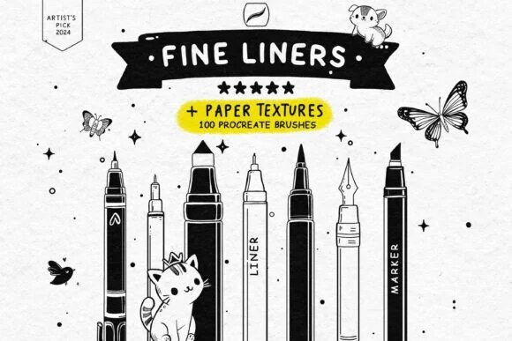
Official DigiKitPro product artwork: Free Fine Liner Set: 100 Brushes + 13 Paper Textures. This is a product visual, not a Procreate screenshot.

Article
The best Procreate brushes for beginners are not the ones with the biggest number on the cover. They are the brushes you can identify, practise with, and return to without scrolling through dozens of near-duplicates. A small starter library makes it easier to learn pressure, edges, colour, and texture before you spend money on specialist packs.
This guide gives you a practical order: start with a few focused tools, build one small drawing, then add a brush only when you can name the problem it solves. The product details below come from the current DigiKitPro product catalogue; prices and availability can change, so check the linked product page before downloading or buying.

What a beginner actually needs
You can learn the fundamentals with five roles rather than five hundred brushes:
• A sketch brush for construction lines and loose studies.
• A controlled liner for outlines, hatching, and pressure practice.
• A simple painting brush for blocking large shapes and flat colour.
• A blender or smudge tool for testing soft transitions without losing your drawing.
• One texture brush for learning how grain changes an edge or surface.
The brush is only one part of the result. Procreate’s official Brush Library documentation explains how imported brushes and sets are organised; the fundamentals still come from observation, shape design, and finishing small pieces.

A low-risk starting order

1. Begin with a focused free liner set
The Free Fine Liner Set is a sensible first stop if your goal is drawing confidence. The catalogue lists 100 brushes and 13 paper textures. You do not need to use all of them: choose one pencil-like brush, one fine liner, and one textured option, then keep the rest out of your way while you practise.
Try three short exercises:
Draw ten straight lines using different pressure from start to finish.
Fill a page with ellipses, boxes, and contour lines.
Sketch one object, keeping the construction layer visible beneath the final lines.

2. Add a forgiving texture medium
The Chalkboard Artist’s Toolkit is listed as a free set with 20-plus chalk brushes. Chalk is useful for practising broad marks, broken edges, lettering, and the habit of erasing back into a shape. Work on a large silhouette, soften one side, and carve the light back with the eraser. That simple loop teaches more about edge control than endlessly adjusting brush settings.

3. Use a limited colour starting point
Brush choice cannot fix a palette that is doing too many jobs at once. The Ultimate Procreate Color Vault is listed with 1,200-plus swatches in 40 palettes. Pick one palette for a study and limit yourself to a light, mid-tone, shadow, accent, and background colour. A constraint makes colour relationships easier to see.

4. Follow a sequence instead of collecting tools
If you are learning portraits, the free Procreate Portrait Starter Guide is a more useful next step than another random brush pack. It is a PDF guide with a four-phase structure: structure, value, surface, and finish. That sequence helps you understand when a brush belongs in a workflow.

When should you buy a paid brush set?
Upgrade when a repeated limitation is slowing down work you already enjoy. For example:
If you keep drawing… | Look for… | A relevant DigiKitPro starting point
Faces and head studies | Sketch, blend, hair, skin, and detail tools | Portrait Mastery Kit
Clean illustration or manga lines | Pressure-sensitive liners and textured pencils | Essential Line Art & Sketch Kit
Several different subjects | A broad but organised studio kit | Artista Studio Kit
Traditional-looking studies | Grain, charcoal, pencil, or wash tools | Professional Charcoal Studio

These are recommendations by workflow, not a claim that one pack is right for every artist. Read the included files and requirements on the product page before purchase.

Three beginner habits that matter more than a brush pack

Finish small work
A 20-minute study teaches more than an abandoned large canvas. Use a small subject, save the finished version, and write one sentence about what to practise next.

Name the problem before changing tools
“Looks flat” could mean weak values, not a missing brush. “Looks messy” could mean unclear construction, not a bad liner. Diagnose first; change tools second.

Keep a working set
Create a personal set with the five brushes you reach for most often. Archive experiments instead of deleting them, but do not let the library become your studio floor.

Recommended DigiKitPro resources
Free Fine Liner Set: 100 Brushes + 13 Paper Textures — Real pen precision at zero cost: 100 fine liner, micron and marker brushes plus 13 seamless paper textures. Free instant download.
Chalkboard Artist's Toolkit: 20+ Chalk Brushes (Free) — The raw essence of traditional chalk on your iPad: 20+ dusty, tactile chalk brushes with real blackboard soul. Free download.
Ultimate Procreate Color Vault: 1,200+ Swatches (Free) — 40 professional palettes, 1,200+ curated swatches, so you never burn the first hour of a painting hunting for the right shade.
Procreate Portrait Starter Guide (Free eBook) — Stop guessing. Start your first believable Procreate portrait this week: a free visual guide from a blank canvas to a structured, well-lit head study.
Artista Studio Kit: 76 Procreate Brushes — One organized 76-brush collection that covers the full studio workflow, linework, inking, sketching, shading, graphite, markers and effects.

FAQ

How many Procreate brushes does a beginner need?
A sketch brush, one or two liners, a basic painting brush, a blender, and one texture brush are enough to learn the core exercises in this guide. Add specialist brushes after you can explain what they will change.

Are free Procreate brushes useful for learning?
Yes, when they are used as focused practice tools rather than a reason to collect. DigiKitPro’s free liner, chalk, colour, and starter-guide resources are useful entry points; confirm the current download details on each product page.

Do DigiKitPro brush sets work on iPad?
The brush products listed here are described in the catalogue as Procreate brush files for iPad. Procreate’s official help lists `.brush`, `.brushset`, and `.brushlibrary` as supported brush formats. Check the individual DigiKitPro requirements before purchase.

Can beginners use Procreate brushes for commercial artwork?
DigiKitPro’s Terms of Service say that, unless a product page states otherwise, purchases include a licence for personal and commercial artwork. The same terms prohibit reselling, redistributing, copying, or sharing the source files. Read the terms and the product page before taking client work.

What should I practise first in Procreate?
Start with line control, simple forms, value grouping, and edges. A short study of a cup, leaf, or portrait landmark gives you clearer feedback than testing every brush in the library.

Sources and update note
• Procreate Help: Brush Library — official import and organisation guidance.
• DigiKitPro Terms of Service — current licence and digital-product limitations.
• DigiKitPro product pages linked above — current included items and requirements at the time of update.
Start with one free, focused resource, finish a few small drawings, and let your next brush purchase solve a real workflow problem. That is a better foundation than a crowded library.

Research notes
Factual claims were checked against the official sources listed in the article. DigiKitPro product counts, formats, and requirements are taken from the repository catalogue and linked product pages; availability, prices, and terms can change and should be rechecked before publication.

3. Best Procreate Brushes for Line Art: How to Choose a Liner

Best Procreate Brushes for Line Art: How to Choose a Liner

SEO metadata
SEO title | Best Procreate Brushes for Line Art: How to Choose a Liner
H1 | Best Procreate Brushes for Line Art: How to Choose a Liner
URL slug | /blog/best-procreate-brushes-for-line-art/
Meta description | Find Procreate brushes for line art by comparing taper, pressure response, texture, stabilisation, and workflow. Includes free and specialist options.
Primary keyword | best Procreate brushes for line art
Secondary keywords | Procreate line art brushes, best liner brush for Procreate, manga ink brushes, clean line art on iPad
Search intent | Commercial investigation with informational support
Target audience | Line-art beginners, comic and manga artists, illustrators, tattoo designers, and character artists
Category | Procreate Brushes
Tags | line art, Procreate brushes, inking, manga, sketching, iPad art

Official DigiKitPro product artwork: Free Fine Liner Set: 100 Brushes + 13 Paper Textures. This is a product visual, not a Procreate screenshot.

Article
A line-art brush should make your decisions clearer, not hide them. The right tool gives you predictable width changes, a useful edge, and enough texture to match the style you want. It cannot replace drawing practice, but it can remove avoidable friction while you learn.
This guide compares line-art brush needs by workflow rather than declaring one universal winner. The DigiKitPro recommendations are based on the current catalogue descriptions and intended use; test the stroke at your normal canvas size before committing to a full illustration.

What to look for in a Procreate line-art brush

Pressure response and taper
For expressive ink, a light-to-heavy-to-light stroke is often more useful than a line that stays the same width. Draw slow curves, quick flicks, and long pulls while changing pressure. Watch whether the mark responds gradually or jumps between sizes.

A controlled edge
A perfectly smooth digital edge suits some graphic styles. A little tooth can help pencil, dry ink, or paper-based illustration feel less sterile. The correct amount depends on your subject: comic inking often benefits from clarity, while sketchbook linework may need visible grain.

A workable level of stabilisation
Stabilisation can help with long contours, but too much can make a stroke feel delayed or remove the small variations that give a drawing character. Use it as a support for a difficult line, not as a substitute for a confident gesture.

A scale that matches your canvas
A line that looks delicate on a 2,000-pixel sketch may become too heavy on a 4,000-pixel print canvas. Test the brush at the size you will actually use and zoom out to check whether the line hierarchy still reads.

Four useful starting points
If you need… | Consider… | Why it fits
Free practice tools | Free Fine Liner Set | The catalogue lists 100 brushes and 13 paper textures; useful for testing line families without a purchase.
A compact drawing kit | Essential Line Art & Sketch Kit | A focused starting point for sketching, pencils, liners, and ink work.
Liner and marker variety | Professional Liner & Marker Studio | The product is listed with 39 high-fidelity liner and marker brushes for controlled ink and marker-style work.
A broader line-art library | Master Line-Art Vault | The catalogue lists 300-plus fine-line brushes for artists who want more range and already know their preferred marks.

The table is a decision aid, not a lab ranking. The product pages are the source of truth for current files, counts, and requirements.

A five-minute liner test
Create a small test sheet before starting a final drawing:
Draw ten tapered strokes, changing pressure across each stroke.
Draw circles, S-curves, and parallel lines at three sizes.
Ink a simple object with outer contour, interior detail, and hatching.
Flip the canvas horizontally to catch hesitant contours.
View the drawing at 25–50% and inspect the line hierarchy.
Keep the brush that helps you make a deliberate mark repeatedly. A dramatic stamp preview is less important than a stable everyday stroke.

Layer and workflow choices for cleaner ink
Sketch loosely on its own layer and reduce its opacity before inking. Keep the final line art separate until the shapes and hierarchy are resolved. If you need to clean a contour, redraw the full gesture rather than repeatedly erasing a tiny wobble; the larger action is usually more confident.
For comics or tattoo concepts, keep large black shapes separate from fine linework until the composition reads at thumbnail size. For coloured illustration, decide whether the line will remain dark, shift toward a colour, or disappear under paint before you over-render it.

Common mistakes
• Using a tiny canvas: the line cannot hold a clean hierarchy when you enlarge it later.
• Choosing the heaviest brush for every contour: outer lines and interior details need different weights.
• Over-stabilising: a smooth line can still be lifeless.
• Polishing before construction: line quality will not correct a proportion problem.
• Buying by count alone: more liners are not more useful if they all produce the same mark.

Recommended DigiKitPro resources
Free Fine Liner Set: 100 Brushes + 13 Paper Textures — Real pen precision at zero cost: 100 fine liner, micron and marker brushes plus 13 seamless paper textures. Free instant download.
Essential Line Art & Sketch Kit for Procreate — 43 focused brushes plus a bonus texture brush for clean line art, natural pencil sketches and confident inking, no pack-switching.
Professional Liner & Marker Studio: 39 High-Fidelity Brushes — A curated digital ink station: 39 brushes replicating the saturated flow of alcohol markers and the razor precision of technical liners.
Master Line-Art Vault: 300+ Fine Line Brushes — The ultimate all-in-one linework collection: 300+ fine line brushes with the precision, variety and character pro artwork demands.

FAQ

What is the best Procreate brush for clean line art?
There is no single best brush for every style. Test pressure response, taper, edge texture, and scale. Start with a focused set, then choose the brush that gives you the most repeatable mark for your subject.

Are free line-art brushes good enough for beginners?
They can be. A free set is ideal for learning pressure control and line hierarchy before you know what specialised behaviour you need.

How do I make my Procreate lines less shaky?
Practise slower shoulder and forearm movements, use a canvas size that gives you room to draw, and adjust stabilisation only as much as needed. Redrawing a line is part of the process; no brush setting replaces repeated deliberate strokes.

Should line art be on its own layer?
Usually, yes. A separate line layer makes it easier to adjust opacity, recolour, clean, or place paint beneath the lines. A finished workflow can merge layers later if the file no longer needs editing.

Can I use DigiKitPro line-art brushes commercially?
The current DigiKitPro Terms of Service permit personal and commercial artwork unless a product page says otherwise, while prohibiting redistribution of the source files. Verify the current product page and terms for your use case.

Sources and update note
• Procreate Handbook: Brush Libraries — official brush-set import and organisation guidance.
• Procreate Handbook: Brush Studio — official brush customisation reference.
• DigiKitPro product pages linked in the comparison table — current catalogue details.
Choose the smallest liner set that gives you useful pressure and texture control, then spend your next session drawing rather than browsing.

Research notes
Factual claims were checked against the official sources listed in the article. DigiKitPro product counts, formats, and requirements are taken from the repository catalogue and linked product pages; availability, prices, and terms can change and should be rechecked before publication.

4. Best Procreate Brushes for Portraits: A Workflow-Based Guide

Best Procreate Brushes for Portraits: A Workflow-Based Guide

SEO metadata
SEO title | Best Procreate Brushes for Portraits: A Workflow-Based Guide
H1 | Best Procreate Brushes for Portraits: A Workflow-Based Guide
URL slug | /blog/best-procreate-brushes-for-portraits/
Meta description | Choose Procreate portrait brushes by job: sketching, skin, blending, hair, facial detail, and finish. Includes focused DigiKitPro options and honest limits.
Primary keyword | best Procreate brushes for portraits
Secondary keywords | Procreate portrait brushes, portrait painting brushes for iPad, Procreate skin brushes, digital portrait brush set
Search intent | Commercial investigation
Target audience | Digital portrait painters, character artists, illustrators, and Procreate users building a portrait workflow
Category | Procreate Brushes
Tags | portraits, Procreate brushes, skin, hair, digital painting, iPad art

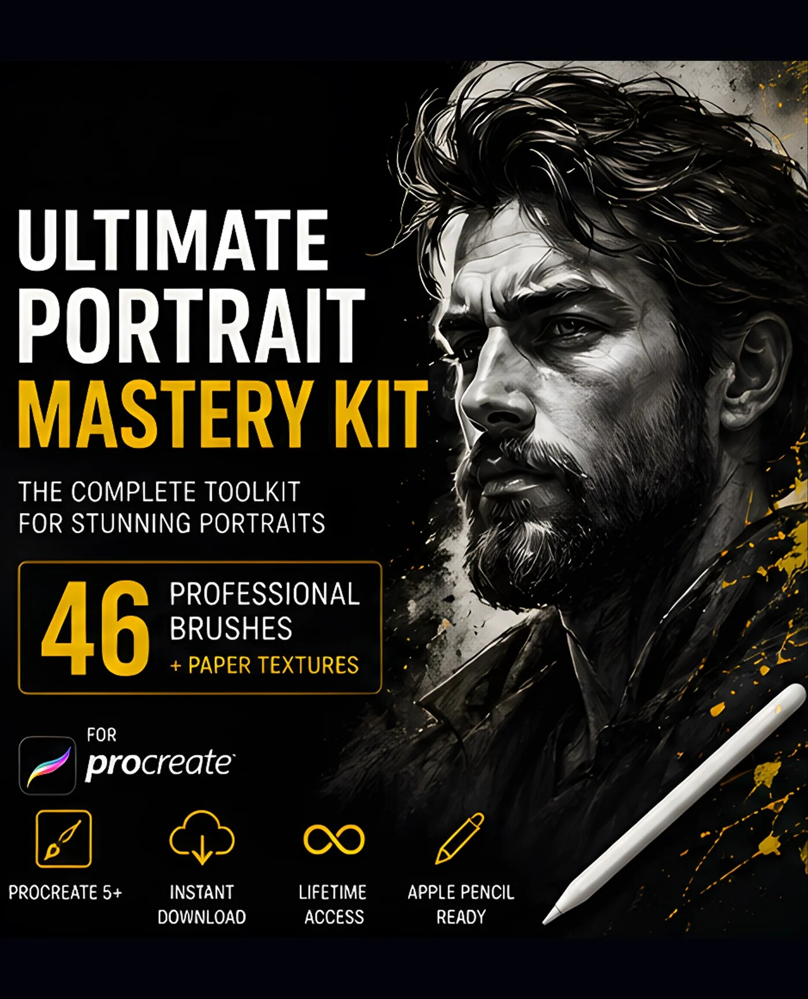
Official DigiKitPro product artwork: Portrait Mastery Kit: 46 Procreate Brushes. This is a product visual, not a Procreate screenshot.

Article
Portrait painting needs more than a “realistic” brush. You need a tool for construction, one for controlled edges, something that can build soft colour without flattening the form, and a way to place texture only where it helps. The best Procreate portrait brushes are therefore the ones that fit a sequence from drawing to finish.
This guide evaluates brush categories by the jobs they perform. DigiKitPro products appear where their current catalogue descriptions match those jobs. No brush pack can correct weak proportions, lighting, or observation, and the product grid is not a ranking of every portrait resource on the market.

The portrait brush categories that matter
Portrait stage | What the brush should help you do | Relevant starting point
Construction | Search for proportion, planes, and gesture | Portrait Mastery Kit
Line and feature design | Clarify lids, nostrils, lips, and selected contours | Essential Line Art & Sketch Kit
Base and form | Lay colour and build transitions without losing structure | Portrait Skin Brushes
Surface | Add pores, freckles, wrinkles, and selective texture | Portrait Skin Brushes
Hair | Establish mass, direction, and a few decisive strands | Professional Hair Brushes
Speed and exploration | Try hairstyles or shapes before painting over them | Hair & Hairstyle Stamp Kit

A portrait set is useful when its tools are organised around these decisions, not simply when it contains many brushes.

Recommended DigiKitPro options by artist

For a complete portrait workflow: Portrait Mastery Kit
The catalogue describes the Portrait Mastery Kit as 46 brushes plus four paper textures, organised into sketch, ink, blend, hair, detail, texture, finish, and paper sections. That makes it the most straightforward option for an artist who wants one portrait-specific kit rather than separate specialist packs.
It is a better fit when you want workflow structure and a manageable library. It is less relevant if you only need a single skin-texture brush or if your work is primarily graphic line art.

For skin texture: Portrait Skin Brushes
The Portrait Skin Brushes product page lists 19 brushes including texture, freckles, blemishes, wrinkles, eyelashes, textured blending, a base-layer brush, blusher, and highlighter tools. These are surface and transition tools, not a replacement for a portrait construction method.
Use texture after the head reads in value. If the nose, eyes, and jaw are not placed correctly, more pores will only make the wrong structure more detailed.

For hair: Professional Hair Brushes or Hair & Hairstyle Stamps
The Professional Hair Brushes are the more direct choice when you want to paint hair direction and strands. The Hair & Hairstyle Stamp Kit is useful for fast silhouette exploration or a mass foundation that you plan to repaint. A stamp is scaffolding; it should not be the final surface by itself.

For a multi-stage upgrade: Ultimate Portrait Mastery Bundle
The Ultimate Portrait Mastery Bundle is catalogued as four kits: a 43-brush line-art and sketch kit, 19 skin brushes, 160 hair stamps, and 30 glitter and shine brushes. It is relevant when you will use all four stages. If you only paint skin, the smaller skin set is a more precise purchase.

A practical brush test for portraits
Before painting a full portrait, make a swatch sheet at your normal canvas size:
Paint a flat mid-tone and blend two shadow colours into it.
Test a hard edge, a soft edge, and a textured edge.
Place a few marks for pores or freckles at low, medium, and high opacity.
Draw a hair ribbon, a clump, and three individual strands.
Zoom out. If every mark has the same visual weight, the set may not give you enough hierarchy.
Keep the tools that help you move between large shapes and small accents. Portrait realism is mostly a value, edge, and proportion problem; brushes only support those decisions.

A note about commercial use
The current DigiKitPro Terms of Service say that purchases include a licence for personal and commercial artwork unless a product page states otherwise. They also prohibit reselling or redistributing the source files. That distinction generally supports finished portraits, commissions, and prints—not selling a brush file, a modified brush pack, or a source bundle. If your client needs the brush files or editable assets, get written clarification first.

Recommended DigiKitPro resources
Portrait Mastery Kit: 46 Procreate Brushes — A portrait-specific workflow kit: 46 pro brushes plus 4 paper textures organized into sketch, ink, blend, hair, detail, texture and finish.
Portrait Skin Brushes for Procreate — 19 premium skin-texture brushes: pores, freckles, wrinkles and textured blenders that turn flat paintings into believable portraits.
Professional Hair Brushes for Procreate — A streamlined hair system that paints believable strands, texture and volume without hours of hand-drawn strokes.
Professional Hair & Hairstyle Stamp Kit for Procreate — 160 precision hair and hairstyle stamps that solve volume and flow, a solid hair foundation before you start detailing.
Ultimate Portrait Mastery Bundle: 4 Procreate Kits — Four professional portrait kits in one workflow: line art (43), skin texture (19), hair stamps (160) and glitter effects (30), 252+ assets.
The Complete Procreate Portrait Masterclass (eBook) — From a blank canvas to a believable portrait, in 15 chapters: a repeatable Procreate portrait workflow you can audit and reuse on every portrait after.

FAQ

What brushes do I need for a Procreate portrait?
Start with a sketch brush, a controlled liner, a painting brush, a textured blender, a hair tool, and one detail brush. Add skin texture or stamp tools when the portrait workflow shows a specific need.

Are skin-texture brushes necessary for realistic portraits?
No. They can add useful surface variation, but realistic skin depends first on proportion, values, colour temperature, edges, and restrained texture. Add pores and freckles after the large forms work.

Is a portrait brush bundle better than separate packs?
A bundle is better value only when you will use its included stages. If your bottleneck is only hair or skin, a focused set is easier to learn and may be better value.

Can Procreate portrait brushes be used for stylised characters?
Yes. Texture and blending tools can support stylised, anime, or semi-realistic work; adjust opacity, scale, and edge hardness to fit the style rather than copying a realistic finish.

Do these brushes work with a finger?
The product pages describe many DigiKitPro sets as designed for Apple Pencil pressure and tilt. A finger can still make marks in Procreate, but pressure-sensitive behaviours will not be available in the same way.

What should I learn before buying portrait brushes?
Learn head construction, value grouping, simple lighting, and edge control. The free Procreate Portrait Starter Guide is a lower-risk place to establish that sequence.

Sources and update note
• Procreate Handbook: Create a Custom Canvas — official canvas, colour-profile, and layer-limit guidance.
• DigiKitPro Terms of Service — current licence language.
• DigiKitPro product pages linked above — current contents and requirements.
Choose the portrait tool that matches the next stage you need to improve. A smaller, organised kit will usually teach you more than an enormous library you never learn to navigate.

Research notes
Factual claims were checked against the official sources listed in the article. DigiKitPro product counts, formats, and requirements are taken from the repository catalogue and linked product pages; availability, prices, and terms can change and should be rechecked before publication.

5. Christmas Procreate Tutorial: Design a Holiday Card with Brushes

Christmas Procreate Tutorial: Design a Holiday Card with Brushes

SEO metadata
SEO title | Christmas Procreate Tutorial: Design a Holiday Card with Brushes
H1 | Christmas Procreate Tutorial: Design a Holiday Card with Brushes
URL slug | /blog/christmas-procreate-tutorial/
Meta description | Follow this Christmas Procreate tutorial to build a printable holiday card with stamps, washi tape, chalk lettering, paper, and controlled sparkle.
Primary keyword | Christmas Procreate tutorial
Secondary keywords | Christmas card Procreate, holiday Procreate brushes, digital Christmas card, Procreate washi tape brushes
Search intent | Informational with commercial investigation
Target audience | Procreate beginners, card makers, digital scrapbookers, illustrators, and artists creating seasonal graphics
Category | Tutorials
Tags | Christmas, Procreate tutorial, greeting cards, seasonal art, brushes

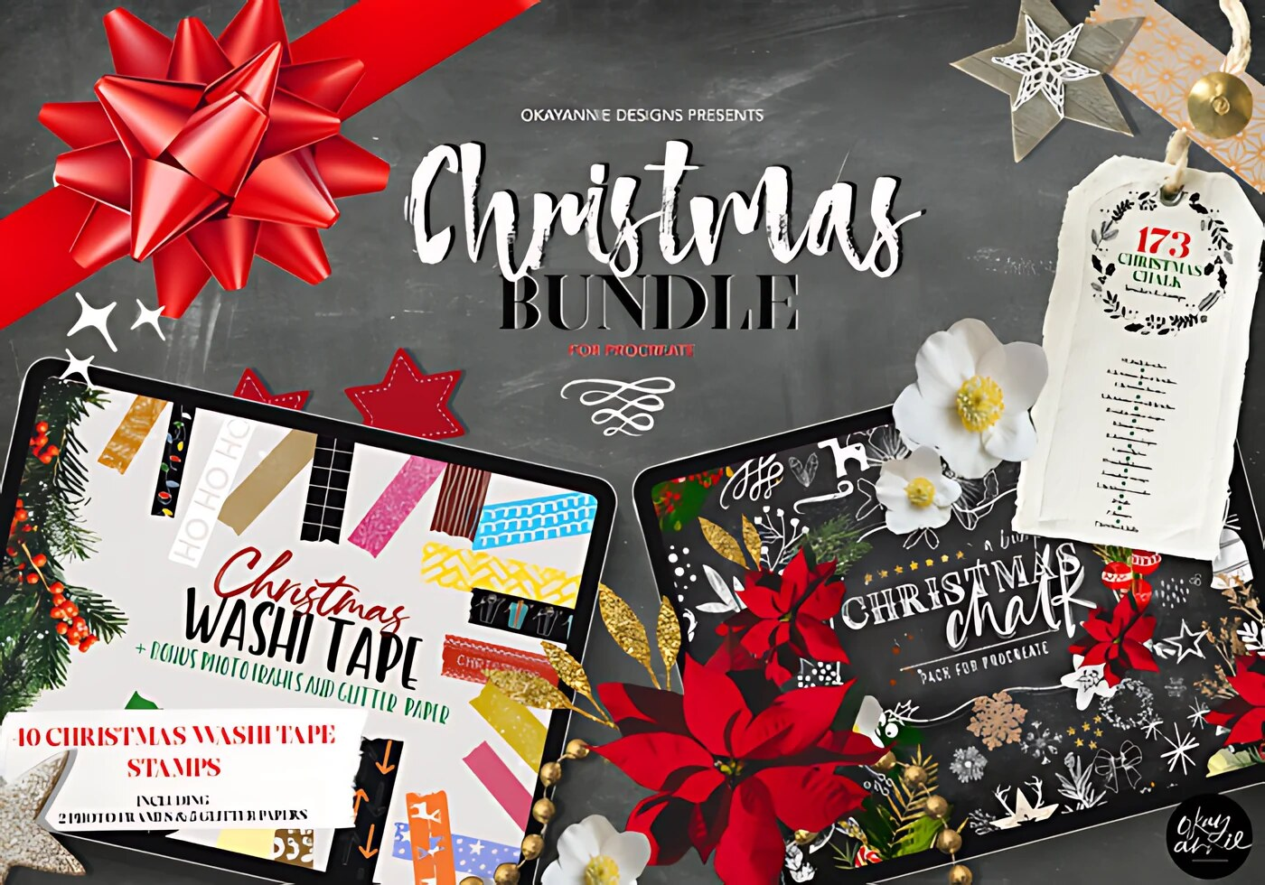
Official DigiKitPro product artwork: Christmas Procreate Brushes Bundle. This is a product visual, not a Procreate screenshot.

Article
A holiday card becomes easier to revise when the paper, decorations, message, and sparkle live on separate layers. This Christmas Procreate tutorial builds a simple card composition with the current Christmas Procreate Brushes Bundle, then shows how to keep the design printable and readable.
The product catalogue lists 173 Christmas stamps and brushes, 44 hand-drawn washi tape brushes, five glitter papers, two photo frames, four Christmas photo frames in PNG and AI format, five chalkboards, and an installation guide. Confirm current included files on the product page before starting.

What you need
• Procreate on iPad and an Apple Pencil if you want pressure-sensitive marks.
• A card size that matches your printer or delivery format.
• The Christmas bundle, or any comparable stamps, paper, and lettering tools.
• Optional sparkle brushes and the free Chalkboard Artist’s Toolkit.
If you need help with the download, follow the Procreate brush installation guide first.

Step 1: Create a card canvas
Create a portrait or landscape document based on the final card. As a suggested starting point, a 3:4 canvas such as 1,800 × 2,400 pixels at 300 DPI can work for a small print study, but use the printer’s exact size, bleed, and colour requirements when available.
Set up layers named Paper, Decor, Washi, Lettering, and Sparkle. Add a Guide layer if you need margins or a centre line; hide it before export.

Step 2: Choose a quiet background
Use a cream, muted red, deep green, or chalkboard surface. If the bundle’s paper or chalkboard files suit the format, place one on the Paper layer and keep it at full size. Leave enough contrast for the greeting to remain readable.
Do not add glitter before checking the background value. Sparkle cannot rescue a message that disappears into the paper.

Step 3: Build the main decoration
On the Decor layer, place a wreath, tree, bauble group, floral motif, or another central shape from the bundle. Use a new layer for each major stamp while experimenting. Transform, rotate, and recolour the elements to create a composition rather than a single untouched stamp.
Leave a clear area for the greeting. View the card at the size it will be printed or shared, not only zoomed in on the iPad.

Step 4: Add washi tape and supporting shapes
Use the 44 listed washi tape brushes to anchor corners, frames, or small notes. Keep the strips aligned with the card’s structure and vary the lengths. A little overlap can suggest a scrapbook feel, but repeated tape at equal angles quickly becomes a pattern.
If you add a shadow, paint it on a separate layer at a suggested low opacity. Check that the shadow does not muddy the paper.

Step 5: Add the message
Create the greeting on its own Lettering layer. Use a liner, chalk brush, or a text tool depending on the style. Keep the phrase short and test readability at the final output size. A decorative border should not compete with the words.
The free Chalkboard Artist’s Toolkit is a relevant option for hand-lettered chalkboard work, but built-in Procreate brushes can work just as well for a simple message.

Step 6: Add controlled sparkle and export
Place sparkle on the top layer only where light would naturally catch: around a star, ornament, border, or snow highlight. The Glitter Procreate Brushes are optional. Reduce the layer opacity if the effect overwhelms the message.
Hide guides, inspect the edges, and export the file type required by your printer or recipient. Save the layered Procreate file separately in case you need to change the wording or palette.

Recommended DigiKitPro resources
Christmas Procreate Brushes Bundle — A festive mega-pack: 173 Christmas stamps and brushes plus 44 hand-drawn washi tapes and seasonal extras for holiday artwork.
30 Glitter Procreate Brushes: Sparkle & Shine Set — Thirty responsive glitter, sparkle and glow brushes, from whisper-soft glimmer to radiant flare for lettering, makeup and highlights.
Chalkboard Artist's Toolkit: 20+ Chalk Brushes (Free) — The raw essence of traditional chalk on your iPad: 20+ dusty, tactile chalk brushes with real blackboard soul. Free download.

Common mistakes
• Designing at a size that does not match the final card.
• Letting decorative stamps cover the message area.
• Using one layer for every element, which makes revision difficult.
• Applying glitter across the whole card instead of using it as an accent.
• Assuming a digital preview proves print colour; make a proof when colour accuracy matters.

FAQ

What canvas size should I use for a Christmas card in Procreate?
Use the printer’s physical dimensions, bleed, and DPI requirements. If you have no specification, a 3:4 document at a print-oriented resolution is a reasonable starting study, but confirm before production.

What is included in the Christmas Procreate Brushes Bundle?
The current catalogue lists 173 Christmas stamps and brushes, 44 washi tape brushes, paper and frame bonuses, five chalkboards, and installation and brush-setting instructions. Verify the live product page for the current contents.

Do I need Procreate to use every file?
The brushset requires Procreate on iPad. Bonus PNG and AI files may require compatible software; check the product requirements and the software you plan to use.

Can I sell cards made with the Christmas resources?
DigiKitPro’s current terms permit personal and commercial artwork unless a product page states otherwise. They prohibit reselling or redistributing the brush, paper, or source files. Read the Terms of Service before selling templates or editable assets.

How do I install the Christmas brushes?
Extract the ZIP in Files, then import the `.brushset` through Procreate’s Brushes panel using Import from Files. The installation guide has the full process.

Sources and update note
• Procreate Help: Importing your brushes — official import steps.
• DigiKitPro product pages linked above — current seasonal resource contents.
• DigiKitPro Terms of Service — current licence language.
Keep the message readable, the layers editable, and the sparkle intentional. A seasonal card is finished when the recipient notices the greeting before the brush pack.

Research notes
Factual claims were checked against the official sources listed in the article. DigiKitPro product counts, formats, and requirements are taken from the repository catalogue and linked product pages; availability, prices, and terms can change and should be rechecked before publication.

6. Halloween Procreate Tutorial: Paint a Moonlit Pumpkin Scene

Halloween Procreate Tutorial: Paint a Moonlit Pumpkin Scene

SEO metadata
SEO title | Halloween Procreate Tutorial: Paint a Moonlit Pumpkin Scene
H1 | Halloween Procreate Tutorial: Paint a Moonlit Pumpkin Scene
URL slug | /blog/halloween-procreate-tutorial/
Meta description | Follow this Halloween Procreate tutorial to build a moonlit pumpkin scene with a PNG asset, fog, warm glow, and restrained sparkle.
Primary keyword | Halloween Procreate tutorial
Secondary keywords | Halloween art Procreate, spooky Procreate tutorial, pumpkin digital art, Procreate smoke brushes
Search intent | Informational with commercial investigation
Target audience | Procreate beginners, seasonal illustrators, card makers, and artists creating spooky digital scenes
Category | Tutorials
Tags | Halloween, Procreate tutorial, pumpkins, smoke, digital illustration

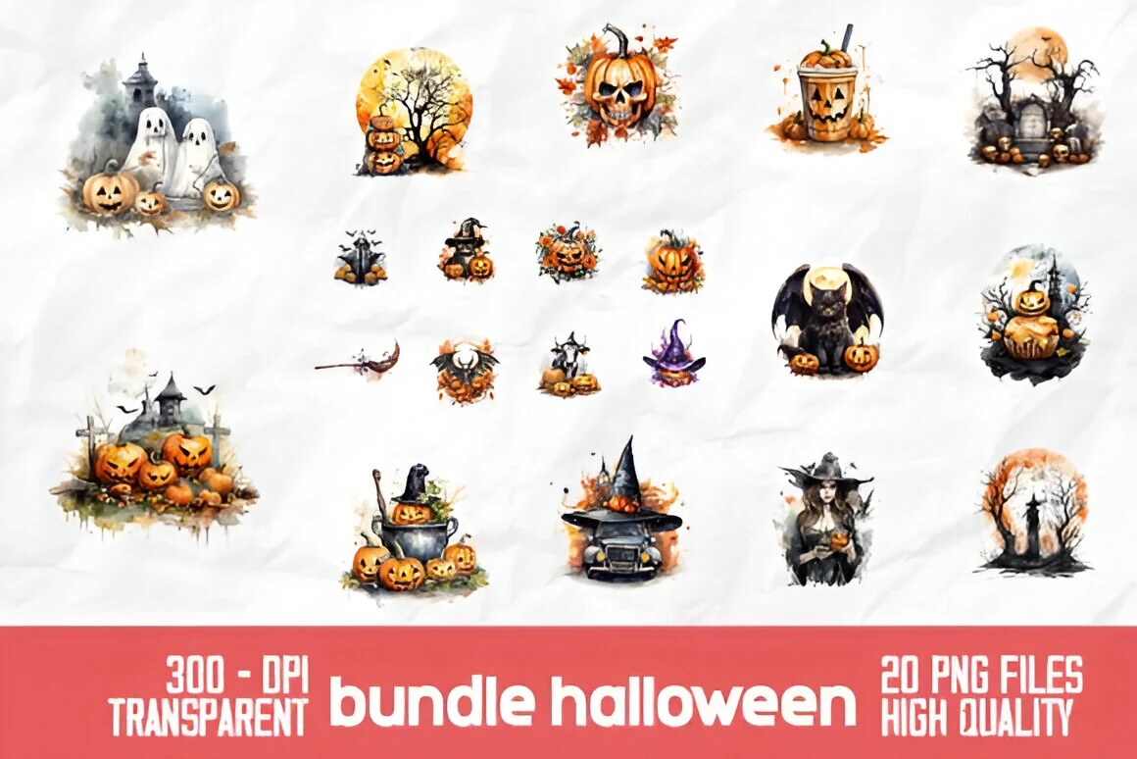
Official DigiKitPro product artwork: Halloween Spooky Pumpkin Bundle: 20 PNGs. This is a product visual, not a Procreate screenshot.

Article
A spooky scene is mostly a lighting exercise. Start with a quiet value structure, place a warm pumpkin against a cool night, then add fog and sparkle only where they support depth. This Halloween Procreate tutorial uses the current Halloween Spooky Pumpkin Bundle, Smoke Procreate Brushes, and optional Glitter Procreate Brushes.
The Halloween product is listed as 20 pumpkin-themed PNGs at 300 DPI. The PNGs do not require a brush import; the smoke and glitter resources do.

What you need
• Procreate on iPad for the brush stages.
• A square or portrait canvas matched to the final use.
• One transparent pumpkin PNG or a hand-painted pumpkin.
• A cool dark brush, a soft light brush, smoke texture, and optional sparkle.
If you are new to brush files, start with the Procreate installation guide.

Step 1: Set up the canvas and layers
Create a canvas appropriate for the final post, card, or print. If you are making a print study, use the printer’s dimensions and resolution. Add layers named Night, Moon, Ground, Fog, Pumpkin, Glow, and Sparkle. Keeping the effects separate lets you tune the atmosphere without damaging the subject.

Step 2: Paint a cool night background
Fill the Night layer with a deep blue, indigo, or near-black. Add a lighter area around the moon using a large soft brush. Keep the ground and corners darker so the focal point has room to glow.
Before adding details, squint or zoom out. The moon and pumpkin should already create a readable value hierarchy.

Step 3: Import the pumpkin PNG
In Procreate, use Actions → Add → Insert a photo or the method you normally use to bring a transparent image into the canvas. Place the pumpkin on its own layer and use Transform to set the scale and angle.
Because the product is listed as PNG, it should not need a brush import. If a file arrives compressed, extract it in Files first. The official product artwork shown with this guide is a product visual, not a Procreate screenshot.

Step 4: Build the warm inner glow
Create a layer above the pumpkin and use a clipping mask if you want the light confined to its shape. Paint a warm orange-yellow inside the face and openings, then place a broader, softer halo on a layer behind or beneath the pumpkin.
Use a suggested low opacity and build the effect gradually. Procreate’s Blend Modes reference explains modes such as Screen and Add; test them at low opacity instead of treating a mode as a guaranteed lighting fix.

Step 5: Add fog for depth
Create fog between the background and pumpkin, then add a second thin layer in front if needed. The catalogue lists 12 smoke brushes in the Smoke Procreate Brushes set. Use a cool, low-contrast colour and make the fog thicker near the ground, lighter near the moon, and broken around the pumpkin so it does not hide the focal shape.
Vary the scale and direction. Three quiet passes usually create more depth than one heavy stamp.

Step 6: Finish with sparkle and rim light
Add a few small highlights around the moon, pumpkin glow, or fog edge. The Glitter Procreate Brushes set is optional; avoid scattering equal sparkle over every area.
Use a cool rim light on the shadow side of the pumpkin if the silhouette disappears into the background. Compare the image at thumbnail size and reduce any effect that competes with the face of the pumpkin.

Recommended DigiKitPro resources
Halloween Spooky Pumpkin Bundle: 20 PNGs — Twenty high-quality 300 DPI pumpkin-themed spooky illustrations in PNG format for seasonal designs.
Smoke Procreate Brushes: 12 Realistic Smoke Effects — Twelve realistic smoke brushes for cinematic overlays, atmospheric depth and dramatic impact in seconds.
30 Glitter Procreate Brushes: Sparkle & Shine Set — Thirty responsive glitter, sparkle and glow brushes, from whisper-soft glimmer to radiant flare for lettering, makeup and highlights.

Common mistakes
• Making the background equally bright everywhere.
• Applying orange glow outside the pumpkin without a layer plan.
• Using dense fog that hides the silhouette.
• Repeating one smoke stamp at the same scale and opacity.
• Adding glitter before the value structure and focal light work.

FAQ

What is included in the Halloween Pumpkin Bundle?
The current catalogue lists 20 Halloween pumpkin PNG illustrations at 300 DPI. Check the product page for the current file list and delivery details.

Do I need Procreate to use the pumpkin PNGs?
The PNGs are listed for use in any design software that opens PNG files. The smoke and glitter brush packs require Procreate on iPad according to their product requirements.

How do I make a pumpkin glow in Procreate?
Paint warm colour inside the pumpkin on a separate layer, then add a larger low-opacity halo behind it. A clipping mask can keep the inner light inside the shape; a blend mode such as Screen or Add is optional and should be judged at reduced opacity.

How do I install the smoke brushes?
Extract the download if it is a ZIP, then import the `.brushset` in Procreate through Brushes → + → Import from Files. Follow the full installation guide if the set does not appear.

Can I sell art made with the Halloween resources?
DigiKitPro’s current Terms of Service allow personal and commercial artwork unless a product page says otherwise, while prohibiting redistribution of the source files. Check the terms before selling editable templates or asset collections.

Sources and update note
• Procreate Handbook: Blend Modes — official layer interaction reference.
• Procreate Help: Importing your brushes — official brush import steps.
• DigiKitPro product pages linked above — current seasonal asset details.
• DigiKitPro Terms of Service — current licence language.
Let the lighting do the scary work. Fog and sparkle are finishing accents, not substitutes for a clear silhouette and strong contrast.

Research notes
Factual claims were checked against the official sources listed in the article. DigiKitPro product counts, formats, and requirements are taken from the repository catalogue and linked product pages; availability, prices, and terms can change and should be rechecked before publication.

7. How to Choose Procreate Brushes: A Practical Buying Guide

How to Choose Procreate Brushes: A Practical Buying Guide

SEO metadata
SEO title | How to Choose Procreate Brushes: A Practical Buying Guide
H1 | How to Choose Procreate Brushes: A Practical Buying Guide
URL slug | /blog/how-to-choose-procreate-brushes/
Meta description | Learn how to choose Procreate brushes by subject, stroke behaviour, file format, workflow, and licence instead of buying packs you never use.
Primary keyword | how to choose Procreate brushes
Secondary keywords | which Procreate brushes to buy, Procreate brush buying guide, best brush set for Procreate, commercial use Procreate brushes
Search intent | Informational with commercial investigation
Target audience | Procreate beginners, intermediate illustrators, portrait artists, and buyers comparing brush packs
Category | Guides
Tags | Procreate brushes, buying guide, brush workflow, digital art resources, licensing

Official DigiKitPro product artwork: Portrait Mastery Kit: 46 Procreate Brushes. This is a product visual, not a Procreate screenshot.

Article
A brush pack can look impressive in a preview and still be wrong for your work. The useful question is not “How many brushes are included?” It is “What part of my process will this set improve, and can I tell before I buy it?”
Use the framework below to compare Procreate brushes without relying on inflated claims. It covers subject, stroke behaviour, organisation, compatibility, price, and licensing. DigiKitPro products are used as examples of different workflows; they are not automatically the right choice for every artist.

1. Start with the artwork you actually make
Write down the three subjects you draw most often. A portrait painter needs different tools from a lettering artist, anime illustrator, or watercolor sketcher.
Your recurring task | Brush behaviours to prioritise | Example resource
Portrait studies | Controlled sketching, textured blending, skin and hair detail | Portrait Mastery Kit
Clean line art | Predictable taper, pressure response, pencil texture | Master Line-Art Vault
Watercolor illustration | Wash variation, grain, translucent layering, soft edges | Watercolor Studio Kit
Anime and manga | Ink lines, soft shading, washes, highlights, halftone or texture options | Anime Soft-Style Studio Kit

The examples above are editorial matches based on the catalogue descriptions. Browse the product page to confirm what is included now.

2. Judge the stroke, not the thumbnail
A product preview can show a dramatic mark without telling you how it feels during a long stroke. Look for evidence of:
• Pressure response: does light pressure make a lighter or narrower mark, or only a less opaque one?
• Taper: are the entry and exit points useful for your line language?
• Texture scale: does grain remain visible at the canvas size you use?
• Spacing and repetition: do repeated stamps or particles become obvious?
• Tilt support: is Apple Pencil tilt mentioned, and is it relevant to your workflow?
• Opacity and size control: can you build a mark gradually instead of getting a full-strength result immediately?
These are evaluation criteria, not guarantees. A brush’s behaviour also depends on canvas size, stylus, pressure curve, and the artist’s hand.

3. Prefer a workflow-organised set
A useful pack tells you where its brushes belong. The Portrait Mastery Kit, for example, is catalogued as 46 brushes plus four paper textures arranged into sketch, ink, blend, hair, detail, texture, finish, and paper sections. That structure is more helpful than a flat list when you are still learning a portrait sequence.
For a large set, check whether it includes categories, a PDF guide, a swatch file, or naming that makes the brushes searchable. If you cannot tell what a brush is for, a high count may create friction rather than value.

4. Check the file, app, and device requirements
For Procreate on iPad, the official Procreate Help Center lists `.brush`, `.brushset`, and `.brushlibrary` as supported brush formats, and explains that sets can be imported from Files. That does not mean every pack works in every drawing app.
Before checkout, verify:
• the product is for the Procreate app you use;
• the download format is listed clearly;
• your iPad has enough storage for the download and extracted files;
• Apple Pencil pressure or tilt is optional or required, as applicable;
• bonus files such as PNG, PDF, or AI files have their own software requirements.
DigiKitPro’s catalogue describes many brush products as `.brushset` files for Procreate on iPad, but always read the current product page for the specific pack.

5. Compare value by use, not by brush count
A 19-brush skin set can be better value for a portrait painter than a 650-brush bundle if it removes a bottleneck you face on every portrait. Ask:
How many included brushes will I realistically use?
Does the set replace a repeated workaround?
Is the organisation worth the price and storage space?
Would a free or smaller pack answer the same need?
Does the product page state what is included and how it is delivered?
A bundle makes more sense when you genuinely work across its included subjects. It makes less sense when the size of the library is the main attraction.

6. Read the licence before commercial work
“Can I sell the art I make?” is different from “Can I sell the brush files?” DigiKitPro’s current Terms of Service state that, unless a product page says otherwise, purchases include a licence for personal and commercial artwork. They also prohibit reselling, redistributing, copying, or sharing the asset files, in original or modified form.
That wording supports finished artwork and client work, not repackaging the brushes as a competing product. If you need a special use such as a downloadable template, print-on-demand asset library, or redistribution of source files, ask for written clarification before committing.

A simple decision tree
• You are still learning: begin with a focused free set or a small workflow kit.
• You draw one subject repeatedly: buy the specialist set that addresses that subject.
• You work across several media: compare a general kit with the cost and organisation of specialist packs.
• You need a whole catalogue: inspect the included sets, file size, and licence before considering a mega bundle.

Recommended DigiKitPro resources
Portrait Mastery Kit: 46 Procreate Brushes — A portrait-specific workflow kit: 46 pro brushes plus 4 paper textures organized into sketch, ink, blend, hair, detail, texture and finish.
Master Line-Art Vault: 300+ Fine Line Brushes — The ultimate all-in-one linework collection: 300+ fine line brushes with the precision, variety and character pro artwork demands.
50+ Realistic Watercolor Studio Kit for Procreate — A real artist's watercolor palette simulated for iPad: 50+ brushes with organic bleed, pigment flow and authentic paper grain.
Anime Soft-Style Studio Kit: 100+ Procreate Brushes — A complete anime ecosystem: 100+ brushes for soft gradients, luminous shading, razor-sharp manga ink and glowing final details.
650 Procreate Brushes Mega Bundle — Every DigiKitPro brush in one legendary mega kit: 650+ brushes and paper textures covering every style, at over 80% off separate prices.

FAQ

Is a larger Procreate brush pack better?
Not automatically. Count, organisation, stroke quality, and relevance matter more than the headline number. A smaller pack that fits your workflow may be the better purchase.

How can I tell if a Procreate brush is good before buying it?
Look for clear previews of actual strokes, documented file formats, compatibility information, and a description of how the brushes are organised. If those details are missing, treat the pack as higher risk.

Do I need brushes for every art style?
No. Start with a versatile sketch, liner, painting, blend, and texture workflow. Add specialist brushes when a specific style or surface requires a different mark.

Can I use DigiKitPro brushes in Photoshop?
The DigiKitPro product requirements for the brush sets in this guide describe them as Procreate files for iPad and, where stated, not compatible with other digital art software. Do not assume a `.brushset` will work in Photoshop; check the individual product page.

Can I get a refund after downloading a brush pack?
The current DigiKitPro terms say digital-product sales are final once files are downloaded, while technical problems should be reported so the team can resolve them. Read the Refunds section of the Terms before purchase.

Sources and update note
• Procreate Help: Importing your brushes — official supported formats and import steps.
• Procreate Handbook: Brush Libraries — official organisation guidance.
• DigiKitPro Terms of Service — current licensing and refund language.
A good brush purchase is a workflow decision. Name the problem, check the file and licence, and choose the smallest resource that solves it well.

Research notes
Factual claims were checked against the official sources listed in the article. DigiKitPro product counts, formats, and requirements are taken from the repository catalogue and linked product pages; availability, prices, and terms can change and should be rechecked before publication.

8. How to Paint Realistic Skin in Procreate: A Layered Workflow

How to Paint Realistic Skin in Procreate: A Layered Workflow

SEO metadata
SEO title | How to Paint Realistic Skin in Procreate: A Layered Workflow
H1 | How to Paint Realistic Skin in Procreate: A Layered Workflow
URL slug | /blog/how-to-create-realistic-skin-in-procreate/
Meta description | Learn how to paint realistic skin in Procreate with a repeatable sequence for values, undertones, soft edges, texture, and restrained highlights.
Primary keyword | how to paint realistic skin in Procreate
Secondary keywords | realistic skin Procreate tutorial, Procreate skin painting, digital skin tones, portrait skin rendering
Search intent | Informational
Target audience | Procreate portrait artists, digital painters, character artists, and intermediates improving skin rendering
Category | Tutorials
Tags | skin, portraits, digital painting, Procreate tutorial, texture

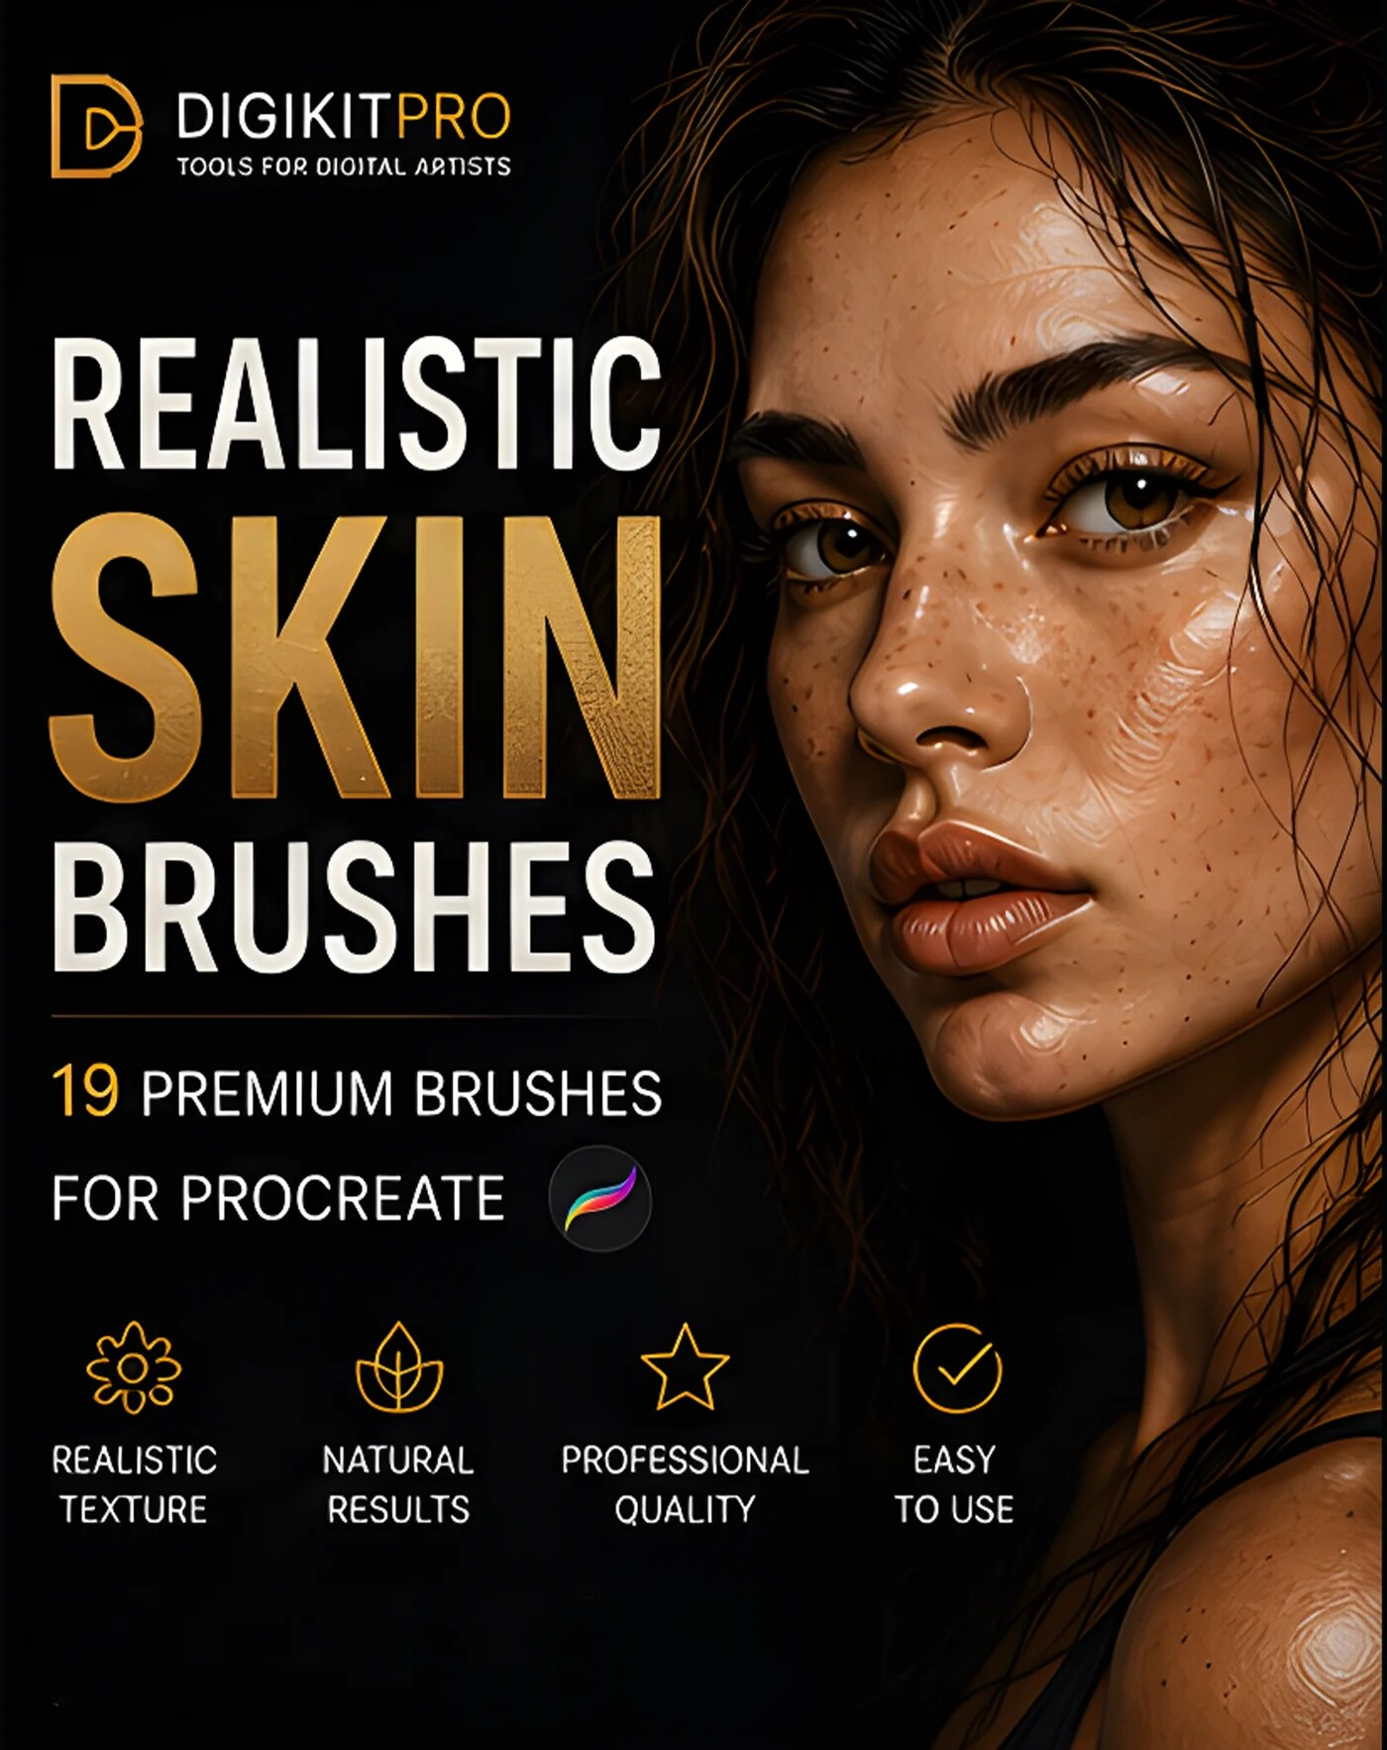
Official DigiKitPro product artwork: Portrait Skin Brushes for Procreate. This is a product visual, not a Procreate screenshot.

Article
Realistic skin in Procreate is not a matter of covering a face with a pore texture. It is a sequence of large decisions: proportion, value, colour temperature, edge control, and only then surface detail. If the first shapes are unclear, adding freckles or noise will make the wrong forms more convincing rather than fixing them.
This tutorial uses suggested starting points rather than fixed settings. Brush size, opacity, layer count, and colour depend on your canvas, reference, iPad, and style. Work from a well-lit reference and keep the reference visible while you paint.

What you need
• Procreate on iPad and an Apple Pencil if you want pressure-sensitive marks.
• A portrait reference with clear light and shadow.
• A sketch brush, painting brush, textured blender, and restrained texture brush.
• A canvas sized for your final use. For print, Procreate’s official canvas guidance explains that 300 DPI is the standard starting point for printing; your physical dimensions still determine the required pixel size.
The Portrait Skin Brushes catalogue lists 19 brushes for texture, freckles, wrinkles, lashes, blending, base colour, blush, and highlights. You can follow this workflow with built-in brushes too.

Step 1: Build a clear drawing
Start with a loose construction layer. Place the centre line, brow line, eye sockets, nose base, mouth, jaw, and major hair shape. Use light pressure and keep the layer visible while blocking colour.
Do not render features that are still moving. A portrait can have beautiful skin and still fail if the head angle or feature spacing is wrong.

Step 2: Choose a mid-tone base
Create a new layer beneath or above the sketch, depending on how you prefer to see the drawing. Fill the head with a middle value that belongs to the lighting in the reference. Avoid choosing the lightest highlight as your base; you need room for both shadow and light.
A smooth base brush is a useful starting point. Keep the silhouette clean enough to judge the head shape, but do not spend time polishing an edge that will later be covered by hair or clothing.

Step 3: Map the large shadow shapes
On a separate layer, place the main shadow family: the side of the face turned away from the light, eye sockets, underside of the nose, lower lip, jaw, and neck. Use a large brush at a suggested low-to-medium opacity and build the shape gradually.
Think in connected masses rather than isolated facial symbols. Let the shadow describe the planes of the forehead, cheek, muzzle, and chin. If the portrait looks flat, check this stage before reaching for texture.

Step 4: Add temperature and undertone variation
Skin is not one colour. Observe the reference rather than applying a fixed “skin palette.” You may find warmer colour around cheeks, nose, ears, lips, or fingertips, and cooler or less saturated colour in reflected light and deeper shadow. The exact distribution changes with complexion, lighting, environment, and camera colour.
Use large, soft glazes first. Keep the colour changes subordinate to the value structure; saturated patches placed everywhere will look like makeup rather than light passing through form.

Step 5: Model transitions without erasing the paint
Blend only where the reference calls for a transition. Keep some brush edges visible in the cheek, temple, neck, and shadow shapes. A textured blender can soften a boundary while leaving variation in the paint; a perfectly smooth pass can make the face look airbrushed.
The Portrait Mastery Kit is catalogued with blend, texture, detail, and finish sections, which can make it easier to keep the stages separate. The organisation is useful; it does not replace checking the reference.

Step 6: Add skin texture selectively
Texture belongs after the forms read. Work at a suggested low opacity on a separate layer and vary scale, spacing, and strength. Use a broad, quiet pass first, then place stronger marks only where the reference supports them: areas facing light, the nose and cheeks, or specific freckles and blemishes.
Avoid a uniform overlay. Real skin has variation, but a digital painting needs hierarchy. Keep the eye, nose, lips, and focal cheek clearer than background skin or hidden areas.

Step 7: Refine edges and focal details
A believable portrait mixes soft, lost, and hard edges. Reserve your sharpest edges for places that carry information: the upper eyelid, a selected lip edge, the nostril opening, or a small highlight on the eye. Let the jaw, cheek, and neck soften where the form turns away or meets the background.
Add lashes, pores, freckles, and wrinkles only after the value and edge structure work at thumbnail size.

Step 8: Check the portrait and stop
Flip the canvas, zoom out, and temporarily hide the texture layer. If the portrait collapses without texture, return to structure, values, or edges. If it still reads, bring texture back at a lower strength than you first used.
Export a working file with layers preserved. For a final image, use the format and colour profile required by the destination; Procreate’s custom canvas reference explains the difference between screen-oriented RGB and print-oriented CMYK choices.

Common mistakes
• Starting with pores before mapping the shadow family.
• Using one warm colour across every skin zone.
• Blending every brush edge until the planes disappear.
• Applying a texture stamp at the same opacity everywhere.
• Rendering the face while the construction is still incorrect.

Recommended DigiKitPro resources
Portrait Skin Brushes for Procreate — 19 premium skin-texture brushes: pores, freckles, wrinkles and textured blenders that turn flat paintings into believable portraits.
Portrait Mastery Kit: 46 Procreate Brushes — A portrait-specific workflow kit: 46 pro brushes plus 4 paper textures organized into sketch, ink, blend, hair, detail, texture and finish.
Ultimate Portrait Mastery Bundle: 4 Procreate Kits — Four professional portrait kits in one workflow: line art (43), skin texture (19), hair stamps (160) and glitter effects (30), 252+ assets.

FAQ

What brush is best for realistic skin in Procreate?
A brush set that covers base paint, textured blending, and selective texture is more useful than a single “skin” brush. You can start with built-in Procreate tools; the DigiKitPro skin set is relevant when you want dedicated texture, freckle, wrinkle, blend, blush, and highlight options.

How do I stop digital skin from looking plastic?
Keep the value structure strong, blend only necessary transitions, preserve some texture, and vary edge softness. Hide the texture layer to confirm that the face is working without surface detail.

Should skin texture be on a separate layer?
Usually, yes. A separate low-opacity texture layer lets you reduce, mask, or remove detail without damaging the large colour shapes. Merge only when you no longer need that flexibility.

What colours should I use for skin undertones?
Observe the reference and lighting. Warm and cool variation can be useful, but there is no universal undertone recipe for every complexion or light source. Keep value relationships clear before chasing hue.

Can I use these techniques for stylised portraits?
Yes. Keep the same order—structure, value, colour, edges, surface—then simplify the number of transitions and texture marks to match your style.

Sources and update note
• Procreate Handbook: Canvas — official DPI and resize reference.
• Procreate Handbook: Create — official canvas dimensions, colour profiles, and layer-limit guidance.
• DigiKitPro product pages linked above — current product contents and requirements.
Paint the large forms first. The texture should be the quiet evidence that the forms are believable, not the thing doing all the work.

Research notes
Factual claims were checked against the official sources listed in the article. DigiKitPro product counts, formats, and requirements are taken from the repository catalogue and linked product pages; availability, prices, and terms can change and should be rechecked before publication.

9. How to Create Realistic Skin Texture in Procreate

How to Create Realistic Skin Texture in Procreate

SEO metadata
SEO title | How to Create Realistic Skin Texture in Procreate
H1 | How to Create Realistic Skin Texture in Procreate
URL slug | /blog/how-to-create-realistic-skin-texture-in-procreate/
Meta description | Learn how to add believable pores, freckles, blemishes, and wrinkles in Procreate without covering your portrait in repetitive digital noise.
Primary keyword | how to create realistic skin texture in Procreate
Secondary keywords | Procreate pores brush, digital skin texture, realistic freckles Procreate, Procreate wrinkles brush
Search intent | Informational
Target audience | Portrait painters, character artists, and Procreate users whose digital skin looks too smooth or artificial
Category | Tutorials
Tags | skin texture, portraits, pores, freckles, wrinkles, Procreate tutorial

Official DigiKitPro product artwork: Portrait Skin Brushes for Procreate. This is a product visual, not a Procreate screenshot.

Article
Skin texture is a finishing layer, not a shortcut to realism. Pores, freckles, blemishes, and wrinkles only look believable when the underlying head has sound proportions, values, and light. The goal is not to make every pixel busy; it is to make the surface respond to form.
Use the following settings as starting points only. Texture scale changes with canvas size, and the same brush can look like a pore on one document and a large dot on another.

Before adding texture: three checks
Value check: hide detail layers and confirm the face reads in grayscale or at thumbnail size.
Light check: identify which planes face the light and which turn away.
Focal check: decide where you want the viewer to look first. Texture can be quieter outside that area.
The Portrait Skin Brushes product is catalogued with pores, freckles, blemishes, wrinkles, eyelashes, and textured blending brushes. It is optional; the method works with any texture brush that lets you control opacity and size.

Step 1: Create a controlled texture layer
Make a new layer above the painted skin and name it “texture.” Start with a suggested low opacity and a texture brush at a scale that is smaller than the facial features but visible when you zoom out. Do not fill the face with one continuous pass.
If the texture is too strong, reduce the layer opacity before erasing every mark. This preserves variation while keeping the surface integrated.

Step 2: Use a broad, quiet pass
Add a few uneven marks over the areas that should not look perfectly smooth. Keep the centre of the forehead, cheeks, and nose related to the reference, but leave some areas quieter. Vary the spacing and rotate or change the brush size when the brush supports it.
The purpose of this pass is to break digital uniformity. It should not be the first thing the viewer notices.

Step 3: Place pores with form in mind
Pores are not evenly distributed stickers. Place stronger texture on planes that face the light or on areas visible in the reference. Follow the curve of the cheek or nose rather than laying marks in a flat grid. Avoid outlining every facial plane with dots.
A few larger or darker marks can suggest variation, but keep them sparse. The viewer should read “surface” rather than count individual pores.

Step 4: Add freckles and blemishes as specific marks
Freckles are more convincing when they vary in size, value, and spacing. Cluster them naturally, then break the pattern with quieter areas. A blemish or mole should have a reason to be visible: contrast, colour, or a small change in the surrounding skin.
Use a separate layer when you want to compare a clean portrait with the more detailed version. For stylised characters, simplify the pattern instead of copying photographic detail.

Step 5: Suggest wrinkles with directional lines
Wrinkles describe compression, stretch, and movement. Place them around the eyes, forehead, mouth, or neck only where the reference and expression support them. Use a lighter mark first, then reinforce selected sections; a complete dark outline will make the line look drawn on top of the face.
Soften the ends and let some lines disappear into surrounding texture. A textured blender can help, but do not blur the whole layer.

Step 6: Blend the texture into the painting
Use a textured blending brush with light pressure across selected areas. Preserve the strongest marks near the focal area and soften the rest. If the face becomes muddy, undo the blend and lower the texture layer opacity instead.
The Portrait Mastery Kit is listed with texture, blend, detail, and finish categories, which can support a staged approach rather than one destructive pass.

Step 7: Review at three distances
• Zoomed in: check whether marks are too repetitive or too large.
• Working view: check whether texture follows the form.
• Thumbnail: check whether the face still reads before the surface takes over.
Temporarily hide the texture layer. If the portrait only works when every mark is visible, return to the painting stage and strengthen the large forms.

Common texture mistakes
• Adding the same pore brush at full strength over the whole face.
• Using texture to hide weak values or uncertain anatomy.
• Making every freckle the same size and opacity.
• Drawing wrinkles as dark, complete lines.
• Forgetting that a low-resolution canvas changes texture scale.

Recommended DigiKitPro resources
Portrait Skin Brushes for Procreate — 19 premium skin-texture brushes: pores, freckles, wrinkles and textured blenders that turn flat paintings into believable portraits.
Portrait Mastery Kit: 46 Procreate Brushes — A portrait-specific workflow kit: 46 pro brushes plus 4 paper textures organized into sketch, ink, blend, hair, detail, texture and finish.

FAQ

What is the best Procreate brush for pores?
Choose a texture brush whose scale and spacing you can control at your canvas size. A dedicated pore brush can speed up the process, but placement, opacity, and variation matter more than the brush name.

How do I make freckles look natural in Procreate?
Vary size, opacity, spacing, and clustering. Follow the reference and keep some quiet areas; evenly distributed identical dots look like a pattern.

Should skin texture be on a separate layer?
A separate layer is the safest starting point because you can reduce opacity, mask areas, or compare the portrait with and without texture. Merge only after you are confident in the result.

What canvas size should I use for skin texture?
Use the final output and your iPad’s layer budget to choose the canvas. Texture is resolution-dependent, so test the brush on the actual document rather than copying a pixel size from another artist.

Can texture brushes be used for non-human skin?
Yes. The DigiKitPro skin set is listed with a bonus scaly texture brush for fantasy, alien, or reptile skin. Use the same principle: establish the form first, then make surface marks follow it.

Sources and update note
• Procreate Handbook: Create a Custom Canvas — official guidance on dimensions and layer limits.
• DigiKitPro product pages linked above — current included texture categories.
Texture is successful when the viewer feels the surface before noticing the brush. Keep it varied, subordinate, and tied to the form.

Research notes
Factual claims were checked against the official sources listed in the article. DigiKitPro product counts, formats, and requirements are taken from the repository catalogue and linked product pages; availability, prices, and terms can change and should be rechecked before publication.

10. How to Create Realistic Watercolor in Procreate

How to Create Realistic Watercolor in Procreate

SEO metadata
SEO title | How to Create Realistic Watercolor in Procreate
H1 | How to Create Realistic Watercolor in Procreate
URL slug | /blog/how-to-create-realistic-watercolor-in-procreate/
Meta description | Learn how to create realistic watercolor in Procreate by building washes, blooms, granulation, paper grain, and soft-edged layers.
Primary keyword | how to create realistic watercolor in Procreate
Secondary keywords | Procreate watercolor tutorial, digital watercolor, watercolor brushes for Procreate, watercolor paper texture
Search intent | Informational
Target audience | Digital painters, sketchbook artists, illustrators, and Procreate users seeking traditional-media effects
Category | Tutorials
Tags | watercolor, traditional media, Procreate tutorial, texture, digital painting

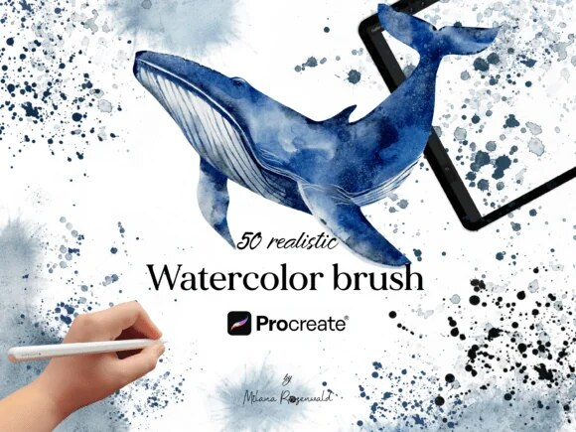
Official DigiKitPro product artwork: 50+ Realistic Watercolor Studio Kit for Procreate. This is a product visual, not a Procreate screenshot.

Article
Digital watercolor looks artificial when pigment stays perfectly where the stylus put it. A convincing result suggests several behaviours at once: translucent washes, uneven edges, pigment pooling, paper tooth, and controlled overlaps. Procreate cannot reproduce every physical interaction, but you can design a workflow that avoids the clean-gradient look.
The settings below are starting points for a study. Watercolour style varies widely, so let the reference and the brush response guide you rather than chasing a single recipe.

What you need
• A drawing brush for a light sketch.
• A wash or painting brush with opacity variation.
• A textured blender or dry brush for broken edges.
• A paper or grain texture used with restraint.
• A limited palette. The Free Color Vault is listed with 40 palettes and 1,200-plus swatches if you want a structured starting point.
The Watercolor Studio Kit is catalogued with more than 50 brushes, while the Organic Watercolor Kit is a broader option for artists who want more wash and texture variety. Product contents can change; check the linked pages.

Step 1: Set up paper and a light drawing
Create a canvas suited to the final output. Add a paper texture layer at low opacity, or paint the paper effect into the background if you do not need an editable texture later. Keep the sketch light and open; a heavy digital outline can overpower translucent colour.
For print work, Procreate’s official canvas guide explains the relationship between pixel dimensions and DPI. Use the printer’s specifications when they are available.

Step 2: Block the first transparent wash
Choose a base colour and lay a large, uneven wash. Leave areas of paper showing. Avoid colouring every shape to the same edge; watercolour feels more natural when boundaries vary between crisp, soft, and disappearing.
Build colour through several light passes instead of one opaque fill. Keep the first wash lighter than you think you need so later overlaps have somewhere to go.

Step 3: Create blooms and pooled edges
Real watercolour often becomes darker where pigment collects at a drying edge. Suggest that behaviour with a darker pass along selected boundaries, then soften or break it so it does not become an outline around every shape.
Use a bloom or textured brush sparingly. One or two visible blooms can add material character; repeated blooms across every shape become a pattern.

Step 4: Layer colour with a limited palette
Add a second colour while the first visual layer is still open. Use related hues for shadows and reflected colour instead of defaulting to grey. Keep your strongest contrast at the focal point.
If you use separate layers, Procreate’s Blend Modes reference explains how modes such as Multiply, Screen, and Overlay alter the relationship between layers. Test at low opacity; a blend mode is not a substitute for choosing a good colour.

Step 5: Add granulation and paper tooth
Place texture only where the surface needs it. A paper layer with a low opacity can unify separate washes, but too much grain can make the painting look like a filter. Mask or erase texture from the focal features if it competes with them.
Zoom out regularly. At working size the grain may look beautiful; at the final viewing size it may be too strong.

Step 6: Restore selected edges and details
Watercolour needs a mixture of lost and found edges. Use a smaller brush for a few structural lines, a dry mark for broken accents, and a darker wash for the deepest value. Do not outline everything.
Leave some early wash visible under the detail. That overlap is part of the medium’s character.

Step 7: Unify and stop
Compare the painting in colour and grayscale. If the value range is weak, simplify the shapes before adding more texture. Hide the paper layer to check whether the paint works on its own, then bring it back at a quieter level if it helps.

Recommended DigiKitPro resources
50+ Realistic Watercolor Studio Kit for Procreate — A real artist's watercolor palette simulated for iPad: 50+ brushes with organic bleed, pigment flow and authentic paper grain.
80 Organic Brushes: Watercolor Studio Kit for Procreate — 80 organic watercolor brushes engineered for real bleed, pigment flow and grain, digital watercolor with genuine soul.
Professional Digital Sketchbook for Procreate — A complete tactile sketchbook environment: sketching tools, seamless paper textures and torn-paper stamps that give digital work real soul.
Ultimate Procreate Color Vault: 1,200+ Swatches (Free) — 40 professional palettes, 1,200+ curated swatches, so you never burn the first hour of a painting hunting for the right shade.

FAQ

How do I make digital watercolor look less flat?
Use transparent overlapping washes, varied edges, darker pooled accents in selected areas, and a restrained paper texture. Keep the value structure clear and avoid applying the same bloom everywhere.

What are the best watercolor brushes for Procreate?
Look for washes, textured marks, blending or softening tools, and paper-grain options. A kit is useful when those roles are organised; a large brush count alone does not guarantee a convincing result.

Should watercolor layers use Multiply?
Multiply can be useful for darkening transparent washes, but it is a suggested workflow choice rather than a requirement. Procreate’s official blend-mode reference explains that Multiply darkens based on the blend layer’s luminosity; use low opacity and judge the colour.

Can I use watercolor brushes commercially?
DigiKitPro’s current terms allow personal and commercial artwork unless a product page states otherwise, and prohibit redistributing the source files. Read the Terms of Service for the current licence language.

Is a paper texture layer necessary?
No. It is one way to add surface variation. A brush can also create grain during the paint pass, and a clean digital watercolor style may intentionally omit visible paper.

Sources and update note
• Procreate Handbook: Canvas — official DPI and resize guidance.
• Procreate Handbook: Blend Modes — official blend-mode definitions.
• DigiKitPro product pages linked above — current watercolor resource descriptions.
Aim for the behaviour of watercolor rather than a decorative watercolor filter: transparent paint, varied edges, and a surface that still shows the hand behind it.

Research notes
Factual claims were checked against the official sources listed in the article. DigiKitPro product counts, formats, and requirements are taken from the repository catalogue and linked product pages; availability, prices, and terms can change and should be rechecked before publication.

11. How to Install Procreate Brushes on iPad: .brushset Step by Step

How to Install Procreate Brushes on iPad: .brushset Step by Step

SEO metadata
SEO title | How to Install Procreate Brushes on iPad: .brushset Step by Step
H1 | How to Install Procreate Brushes on iPad: .brushset Step by Step
URL slug | /blog/how-to-install-procreate-brushes/
Meta description | Learn how to install Procreate brushes and .brushset files on iPad from Files, including ZIP extraction, in-app import, drag-and-drop, and fixes.
Primary keyword | how to install Procreate brushes on iPad
Secondary keywords | how to import Procreate brushes, install .brushset on iPad, Procreate brush ZIP file, Procreate brush library
Search intent | Informational
Target audience | Procreate beginners, iPad artists, and customers who have downloaded a brush file but cannot find it in the app
Category | Guides
Tags | Procreate brushes, installation, iPad, brushset, troubleshooting

Official DigiKitPro product artwork: Free Fine Liner Set: 100 Brushes + 13 Paper Textures. This is a product visual, not a Procreate screenshot.

Article
Installing a Procreate brush set is simple once you know which file you are looking for. Most confusion comes from opening the ZIP instead of the extracted `.brushset`, importing a single `.brush` and looking in the wrong set, or trying to use a Procreate file in another app.
The steps below follow Procreate’s official Importing your brushes help article. Menu labels can change between app versions, so use the official help page if your interface looks different.

What the file extensions mean
• `.brush` — one Procreate brush.
• `.brushset` — a set of brushes imported together.
• `.brushlibrary` — a Procreate brush library.
• `.abr` — Adobe Photoshop brush files that Procreate’s help documentation also lists as importable.
• `.zip` — a compressed folder that must be extracted before you can open the brush file inside.
DigiKitPro’s brush products are described in the catalogue as Procreate `.brushset` downloads, usually delivered as ZIP files. Check the individual product page for the current download structure.

Step 1: Download the purchase or free resource
Download the file on the iPad you use for Procreate, or transfer it to the iPad with a method such as AirDrop or cloud storage. The file will usually appear in the Files app, often in Downloads, On My iPad, or iCloud Drive.
If you are using the Free Fine Liner Set or another free resource, the same file-handling process applies.

Step 2: Extract a ZIP file
Open Files and tap the ZIP once. iPadOS should create a folder with the extracted contents. Open the folder and look for the `.brushset`, `.brush`, or `.brushlibrary` file.
Do not try to import the ZIP itself. If the download contains several ZIP files, extract the one that contains the brushes and keep any PDF guide or bonus files with it.

Step 3: Import from Procreate’s Brushes panel
Procreate’s official instructions are:
Open a canvas in Procreate.
Tap Paint, Smudge, or Erase to open the Brush Library.
Tap the + button in the top-right of Brushes.
Choose Import from Files.
Navigate to the extracted `.brush`, `.brushset`, or `.brushlibrary` file.
Tap the file to import it.
An imported single brush appears in an Imported brush set. An imported brush set appears near the top of the Brush Library under recently imported sets, according to Procreate’s help article.

Step 4: Use drag and drop if that is faster
Procreate also supports dragging a brush file from Files or another compatible app into the Procreate interface. In Split View, press and hold the file, drag it to the Brush Library, and release when the app indicates the import target.
If drag and drop feels unreliable, use Import from Files instead. Both routes rely on the same file format.

Step 5: Find and organise the set
Open Brushes and look near the top of the library for a newly imported set. Test one or two brushes on a blank layer before starting a final illustration. Rename or move brushes only after confirming that the full set imported correctly.
For large libraries such as the Portrait Mastery Kit, Essential Line Art & Sketch Kit, or a mega bundle, create your own working set with the brushes you actually use.

If the brush will not import
• Confirm that you extracted the ZIP first.
• Check the extension: a `.brushset` is not the same as a PDF or preview image.
• Re-download if the file appears incomplete or will not open.
• Check that you are opening Procreate for iPad, not another art app.
• Try Import from Files instead of tapping the file in another app.
• Check the product requirements and contact the seller if the problem persists.
Do not rename an extension unless the seller or official documentation instructs you to. A renamed file is not necessarily a valid brush file.

Recommended DigiKitPro resources
Free Fine Liner Set: 100 Brushes + 13 Paper Textures — Real pen precision at zero cost: 100 fine liner, micron and marker brushes plus 13 seamless paper textures. Free instant download.
Essential Line Art & Sketch Kit for Procreate — 43 focused brushes plus a bonus texture brush for clean line art, natural pencil sketches and confident inking, no pack-switching.
Portrait Mastery Kit: 46 Procreate Brushes — A portrait-specific workflow kit: 46 pro brushes plus 4 paper textures organized into sketch, ink, blend, hair, detail, texture and finish.

FAQ

Where do imported Procreate brushes go?
A single imported `.brush` normally appears in an Imported brush set. An imported `.brushset` appears near the top of the Brush Library under recently imported sets, according to Procreate’s current help article.

Can I install Procreate brushes from a ZIP file?
Extract the ZIP in the Files app first, then import the `.brush`, `.brushset`, or `.brushlibrary` inside. Procreate does not need the ZIP itself.

Why can’t I find Import from Files?
Open a canvas and tap Paint, Smudge, or Erase to open Brushes, then tap the plus button in the top-right. If the interface differs, use Procreate’s official help article for your app version.

Can I use a `.brushset` in Photoshop?
A `.brushset` is a Procreate brush-set format. Do not assume it will work in Photoshop; check the product page for any bonus formats and software requirements.

Do DigiKitPro brushes work on iPad?
The brush products linked here are catalogued as files for Procreate on iPad. Confirm the current requirements on the individual product page before downloading or buying.

I downloaded the file but it is not a brush set. What should I do?
Check whether the download is still compressed, open the extracted folder, and look for the file extension. If the expected brush file is missing or corrupted, contact the product seller with the order and file details.

Sources and update note
• Procreate Help: Importing your brushes — official formats, import steps, and destination folders.
• Procreate Handbook: Import and Share — official drag-and-drop and file guidance.
• DigiKitPro product pages linked above — current download and compatibility notes.
Once the set is visible, stop importing and make something with it. Organisation becomes useful when it returns you to drawing faster.

Research notes
Factual claims were checked against the official sources listed in the article. DigiKitPro product counts, formats, and requirements are taken from the repository catalogue and linked product pages; availability, prices, and terms can change and should be rechecked before publication.

12. How to Make Digital Art Look Traditional: 7 Practical Techniques

How to Make Digital Art Look Traditional: 7 Practical Techniques

SEO metadata
SEO title | How to Make Digital Art Look Traditional: 7 Practical Techniques
H1 | How to Make Digital Art Look Traditional: 7 Practical Techniques
URL slug | /blog/how-to-make-digital-art-look-traditional/
Meta description | Make digital art look traditional in Procreate with paper tooth, broken edges, limited colour, layered marks, and medium-specific workflows.
Primary keyword | how to make digital art look traditional
Secondary keywords | traditional digital art Procreate, Procreate paper texture, digital painting texture, traditional media brushes
Search intent | Informational
Target audience | Digital painters, sketchbook artists, illustrators, and Procreate users who want less sterile-looking work
Category | Tutorials
Tags | traditional media, texture, Procreate tutorial, charcoal, watercolor, digital painting

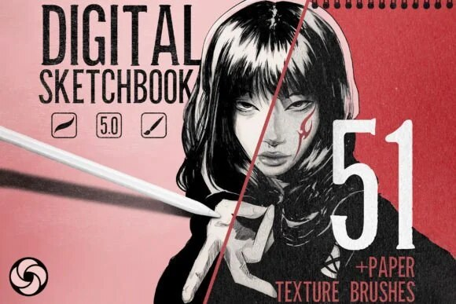
Official DigiKitPro product artwork: Professional Digital Sketchbook for Procreate. This is a product visual, not a Procreate screenshot.

Article
Traditional media does not look handmade because it has a special colour grade. It looks handmade because the tool, surface, pressure, and medium interact imperfectly. Pencil catches paper tooth, charcoal breaks at the edge, pastel leaves a visible deposit, and watercolor changes as it overlaps.
To make digital art look traditional in Procreate, reproduce those decisions deliberately. Do not cover a clean painting with one texture filter at the end and expect it to carry the whole image.

1. Start with a medium-specific tool
Choose the behaviour you want before choosing the colour. The Professional Digital Sketchbook and Pro-Sketch Traditional Art Kit are relevant if you want a drawing-led workflow. The Professional Charcoal Studio is a better fit for broken, dusty marks, while a watercolor set serves translucent washes rather than dry grain.
The recommendation is about the kind of mark, not a claim that any pack automatically creates traditional art.

2. Let the paper affect the mark
Place a paper or grain texture beneath, above, or inside your painting depending on the result you want. Keep it subtle at first. If the texture is the first thing you see, lower its opacity or mask it away from the focal area.
A paper layer can unify a digital piece, but visible grain should support the medium. Coarse paper under a soft pastel study and fine tooth under a pen drawing will produce different visual expectations.

3. Break perfect edges on purpose
Digital marks often stop with a clean, identical edge. Traditional marks vary because the tool lifts, skips, or runs out of pigment. Create a soft or broken edge where a form turns away, then keep a few decisive edges to preserve readability.
Use the eraser as a drawing tool: carve back into charcoal, lift a highlight from a wash, or break a shape so the paper reappears.

4. Work with a limited palette
A narrow palette makes material changes easier to see. Choose a warm neutral, a cool neutral, a shadow colour, a light, and one accent. If you need a structured palette library, the Ultimate Procreate Color Vault is listed as a free resource with 1,200-plus swatches in 40 palettes.
Colour limitation is not the same as desaturation. Let the selected colours vary in value and temperature while keeping the overall harmony intentional.

5. Build marks in layers instead of blending everything
Traditional surfaces show a history of decisions. Place a dry mark, a translucent wash, a soft transition, and a sharper accent rather than averaging the whole surface into one gradient. If you blend, do it only where the medium would soften.
Procreate’s official Blend Modes reference can help you understand how layers interact, but Normal mode with good colour and opacity is often enough. Blend modes should support the material, not make every piece look the same.

6. Keep imperfection selective
A believable traditional effect is not random dirt. Vary pressure and texture where the hand or medium would vary, but keep the composition, value hierarchy, and focal point intentional. A perfectly rough texture over every surface is still a repeating digital pattern.
Zoom out often. If the texture disappears at the final viewing size, it may be doing less work than you think; if it dominates, it is doing too much.

7. Finish with a material check
Ask three questions:
• Can I tell what the medium is supposed to be?
• Do the large shapes still read without the texture layer?
• Are the sharpest edges and strongest marks placed where I want attention?
If the answer to the second question is no, return to drawing, value, or colour before adding more surface detail.

Recommended DigiKitPro resources
Professional Digital Sketchbook for Procreate — A complete tactile sketchbook environment: sketching tools, seamless paper textures and torn-paper stamps that give digital work real soul.
Professional Charcoal Studio for Procreate — Raw carbon, deep blacks and real paper tooth, charcoal brushes with the crumbly, smudgy energy of the traditional medium.
The Dreamy Pastel Art Kit for Procreate — Soft, grainy, nostalgic pastel brushes that bring the organic texture and effortless blending of real pastels to your iPad.
Pro-Sketch Traditional Art Kit for Procreate — Wax crayon grain, oil pastel blends and real sketchbook grit, physical media's raw soul delivered to your iPad.
50+ Realistic Watercolor Studio Kit for Procreate — A real artist's watercolor palette simulated for iPad: 50+ brushes with organic bleed, pigment flow and authentic paper grain.

FAQ

What makes digital art look too clean?
Uniform edges, perfect gradients, repeated texture, and a lack of visible mark variation can make a piece feel sterile. Reintroduce medium-specific friction through pressure, layering, paper, and selective edge control.

Is a paper texture enough to make digital art look traditional?
No. Paper helps, but it cannot replace the way the mark behaves. Build the medium into the strokes and layers, then use paper as a supporting surface.

Which Procreate brushes are best for a traditional look?
Choose by medium: pencil and sketch tools for drawing, charcoal for broken dusty marks, pastel for deposited colour, and watercolor for translucent washes. Start with the smallest set that gives you the behaviour you need.

Should I use a blend mode for traditional digital painting?
Only when it helps the material or colour. Procreate’s blend modes change how layers interact, but a blend mode cannot correct weak values or make an unrelated texture look like paper.

Can I sell traditional-style art made with DigiKitPro brushes?
The current DigiKitPro Terms of Service permit personal and commercial artwork unless a product page states otherwise. They prohibit redistribution of the source files, so sell your finished art rather than the brush assets.

Sources and update note
• Procreate Handbook: Blend Modes — official layer interaction reference.
• DigiKitPro product pages linked above — current traditional-media resource descriptions.
• DigiKitPro Terms of Service — current licence language.
The most convincing traditional effect comes from letting the medium influence your decisions throughout the painting, not from applying “paper” as a final costume.

Research notes
Factual claims were checked against the official sources listed in the article. DigiKitPro product counts, formats, and requirements are taken from the repository catalogue and linked product pages; availability, prices, and terms can change and should be rechecked before publication.

13. How to Paint Realistic Hair in Procreate Without Drawing Every Strand

How to Paint Realistic Hair in Procreate Without Drawing Every Strand

SEO metadata
SEO title | How to Paint Realistic Hair in Procreate Without Drawing Every Strand
H1 | How to Paint Realistic Hair in Procreate Without Drawing Every Strand
URL slug | /blog/how-to-paint-realistic-hair-in-procreate/
Meta description | Learn how to paint realistic hair in Procreate with a mass-first process for silhouette, clumps, highlights, strands, and flyaways.
Primary keyword | how to paint realistic hair in Procreate
Secondary keywords | Procreate hair tutorial, realistic digital hair, hair brushes for Procreate, paint hair on iPad
Search intent | Informational
Target audience | Procreate portrait artists, character illustrators, and digital painters who struggle with stiff or stringy hair
Category | Tutorials
Tags | hair, portraits, digital painting, Procreate tutorial, character art

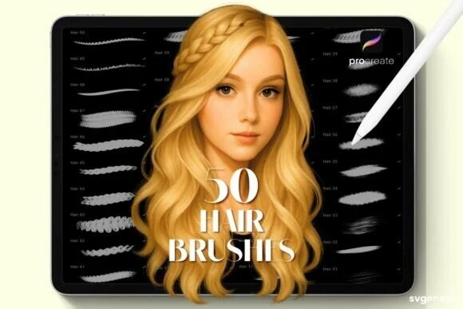
Official DigiKitPro product artwork: Professional Hair Brushes for Procreate. This is a product visual, not a Procreate screenshot.

Article
The fastest way to make digital hair look stiff is to draw every strand too early. Realistic hair is read first as a silhouette and a set of large clumps, then as directional ribbons, and only at the end as selected strands and flyaways.
This tutorial follows that mass-first order. The brush sizes and opacity ranges are suggested starting points, not fixed Procreate settings. Change them for the canvas, hair texture, lighting, and style in your reference.

What you need
• A clear reference showing the hair’s overall shape and light direction.
• A sketch or painting brush for the mass.
• A directional hair brush for clumps and strands.
• An eraser or opaque brush for carving edges.
• Optional stamp brushes for exploring hairstyles quickly.
The Professional Hair Brushes are suited to a hand-painted approach. The Hair & Hairstyle Stamp Kit is catalogued as 160 hairstyle stamps and can help you explore a silhouette before repainting it.

Step 1: Draw the head and hairline first
Before touching hair texture, establish the skull, face angle, ears, neck, and hairline. Hair grows from a form; it does not sit on top of a flat oval. Keep a construction layer beneath the painting and mark the direction of the part, fringe, and major growth areas.

Step 2: Block the entire mass
Choose a brush large enough to fill the main shape in broad strokes. Paint the base colour as one connected mass, including the shadowed interior. Ignore individual strands.
Check the silhouette at thumbnail size. Hair can have beautiful texture and still feel wrong if the outer contour does not describe the reference or character design.

Step 3: Divide the mass into large clumps
On a new layer or with an opaque brush, separate the hair into a few directional groups: fringe, crown, side sections, ponytail, curls, or loose ends. Each group should follow a clear flow from root to tip.
Use a darker value between clumps rather than outlining every section. The gaps create rhythm and depth without turning the hair into a collection of strings.

Step 4: Paint the major light ribbons
Observe where the light catches the form. Add broad, soft-to-firm ribbons that travel with the clumps. Keep them irregular: repeated identical highlights look like stripes.
Use a suggested low-to-medium opacity and build the light gradually. A highlight brush can speed up the mark, but it should follow the volume rather than flatten it.

Step 5: Add selected strands
Now switch to a smaller directional brush. Place strands near the part, around the silhouette, across a few clumps, and in places where the hair overlaps the face. Vary length, pressure, and value. Leave large areas without individual strands so the hierarchy stays clear.
For curls, describe the ribbon or spiral movement first. For straight hair, keep strands grouped and directional instead of drawing a parallel barcode.

Step 6: Refine the edge and flyaways
Use a light background colour or eraser to carve a few gaps in the silhouette. Add flyaways sparingly, especially against a contrasting background. Some stray hairs should disappear; a complete halo of equal lines looks intentional in the wrong way.
Return to the large mass if the edge becomes too noisy. Realistic hair needs both lost edges and crisp accents.

Step 7: Check the value and face relationship
Hide the texture layer and compare the hair mass to the face. The hair should frame the features without competing with the eyes unless the reference calls for that emphasis. At thumbnail size, you should still see the main light direction and shape.
The Portrait Mastery Kit includes hair, detail, texture, and finish categories according to its current product description, which can support keeping the stages separate.

Common mistakes
• Drawing strands before the head and hair mass are placed.
• Using one line weight for every strand.
• Making every highlight equally bright.
• Filling the silhouette with identical stamp shapes.
• Forgetting the hairline, part, or shadow between clumps.

Recommended DigiKitPro resources
Professional Hair Brushes for Procreate — A streamlined hair system that paints believable strands, texture and volume without hours of hand-drawn strokes.
10 Premium Hair Brushes for Procreate — Ten realistic hair-texture brushes covering different hair types, flowing strands, texture and volume for digital portraits.
Professional Hair & Hairstyle Stamp Kit for Procreate — 160 precision hair and hairstyle stamps that solve volume and flow, a solid hair foundation before you start detailing.
Portrait Mastery Kit: 46 Procreate Brushes — A portrait-specific workflow kit: 46 pro brushes plus 4 paper textures organized into sketch, ink, blend, hair, detail, texture and finish.

FAQ

What is the best Procreate hair brush?
The best choice depends on whether you need to block a mass, paint clumps, draw strands, or add flyaways. A versatile directional brush is more useful for final painting than a stamp used without repainting.

How do I make hair look less stringy?
Return to the large mass and clumps. Reduce the number of individual strands, vary their length and value, and let broad ribbons carry most of the lighting.

Are hair stamp brushes useful?
Yes, for hairstyle exploration, silhouette blocking, and speed. Keep the stamp editable, repaint the important shapes, and vary the result so the final illustration does not look like an untouched stamp.

Should hair be painted on a separate layer from the face?
Usually. Separate hair layers make it easier to adjust the silhouette, place overlaps, and protect the face. Consolidate only after the main decisions are settled.

Can I use these brushes for anime hair?
Yes. Simplify the clumps, exaggerate the silhouette, and reduce strand detail to match the character style. The mass-first order still applies.

Sources and update note
• Procreate Handbook: Brush Studio — official brush customisation reference.
• DigiKitPro product pages linked above — current hair brush and stamp descriptions.
Paint the hair as a form first. The individual strands are the accents that explain the form, not the form itself.

Research notes
Factual claims were checked against the official sources listed in the article. DigiKitPro product counts, formats, and requirements are taken from the repository catalogue and linked product pages; availability, prices, and terms can change and should be rechecked before publication.

14. Procreate Blending Brushes: How to Blend Without Plastic Skin

Procreate Blending Brushes: How to Blend Without Plastic Skin

SEO metadata
SEO title | Procreate Blending Brushes: How to Blend Without Plastic Skin
H1 | Procreate Blending Brushes: How to Blend Without Plastic Skin
URL slug | /blog/procreate-blending-brushes-guide/
Meta description | Learn how Procreate blending brushes work, when to use Smudge, and how to keep texture while building soft digital-paint transitions.
Primary keyword | Procreate blending brushes
Secondary keywords | best blending brush for Procreate, how to blend in Procreate, Procreate smudge brush, digital painting blending
Search intent | Informational
Target audience | Procreate portrait painters, digital illustrators, beginners learning to blend, and artists fighting overly smooth results
Category | Tutorials
Tags | blending, Procreate brushes, digital painting, skin, portraits

Official DigiKitPro product artwork: Portrait Skin Brushes for Procreate. This is a product visual, not a Procreate screenshot.

Article
Blending is not the same as making every transition smooth. In a convincing digital painting, some colour changes are soft, some are broken, and some are hidden by a firm edge. Procreate’s Smudge tool can merge colour quickly, but if you drag it over everything the painting loses the marks that give it surface and direction.
The best Procreate blending brush is therefore the one that gives you the kind of transition your subject needs: soft, textured, wet, dry, or nearly invisible.

Brush versus Smudge: what are you trying to change?
Tool or approach | Useful for | Main risk
Smudge with a soft brush | Quiet transitions and small corrections | Over-blurring and muddy colour
Textured blending brush | Softening while preserving tooth | Can leave a visible pattern if overused
New paint over the transition | Deliberate colour and shape changes | Slower, but usually more controllable
Layer opacity or blend mode | Unifying a glaze or wash | Can create a generic look if used without colour planning

Procreate’s Brush Studio documentation and Blend Modes reference are useful for confirming current controls and layer behaviour.

A three-pass blending method

Pass 1: Place the colours without blending
Paint the light, middle, and shadow shapes first. Use a brush that gives you a clean enough edge to judge the forms. If the colours are wrong, blending will only make the wrong transition softer.

Pass 2: Soften only the necessary boundary
Use a suggested low opacity and a large brush for a few strokes across the transition. Lift the stylus often. The aim is to reduce an abrupt edge, not to smear the entire value family into one average.
For skin, keep the planes around the nose, cheekbone, and jaw readable. For watercolor, allow overlaps to remain visible. For pastel, preserve the deposit and paper tooth.

Pass 3: Paint back the lost structure
After blending, restore a firm plane, edge, or colour note with the painting brush. This “blend then repaint” loop keeps the result intentional. It is often faster than trying to blend perfectly in one pass.

How to choose a blending brush
Look for these behaviours in a product preview or test sheet:
• Does it preserve some texture while softening a mark?
• Can you build the effect with pressure rather than getting a full-strength smear?
• Does it move colour in the direction of your stroke?
• Does the grain match your canvas and medium?
• Can you reduce the strength with brush opacity or layer opacity?
The Portrait Skin Brushes product is catalogued with textured blending brushes intended to avoid an overly airbrushed look. The Portrait Mastery Kit is organised with blend and texture categories. Both are relevant to portrait work, but built-in Procreate tools can teach the same decision-making.
For watercolor and pastel, choose a brush that keeps the medium’s surface rather than a generic blur. The Watercolor Studio Kit and Dreamy Pastel Art Kit are examples of medium-specific resources in the catalogue.

Suggested practice exercise
Paint three overlapping circles with a light, middle, and shadow colour. Make three versions:
Blend with a smooth brush.
Blend with a textured brush.
Paint the transition manually without Smudge.
Compare them at thumbnail size. Then add one hard edge to each. The exercise teaches you that a good painting usually needs all three behaviours, not one perfect blend.

Common blending mistakes
• Blending before the large forms are correct.
• Using the same smooth brush for skin, hair, paper, and watercolor.
• Holding the stylus down and dragging until the colour turns grey.
• Ignoring the layer opacity slider as a non-destructive control.
• Making every edge soft, so nothing in the painting carries focus.

Recommended DigiKitPro resources
Portrait Skin Brushes for Procreate — 19 premium skin-texture brushes: pores, freckles, wrinkles and textured blenders that turn flat paintings into believable portraits.
Portrait Mastery Kit: 46 Procreate Brushes — A portrait-specific workflow kit: 46 pro brushes plus 4 paper textures organized into sketch, ink, blend, hair, detail, texture and finish.
50+ Realistic Watercolor Studio Kit for Procreate — A real artist's watercolor palette simulated for iPad: 50+ brushes with organic bleed, pigment flow and authentic paper grain.
The Dreamy Pastel Art Kit for Procreate — Soft, grainy, nostalgic pastel brushes that bring the organic texture and effortless blending of real pastels to your iPad.

FAQ

What is the best blending brush in Procreate?
The best brush depends on the surface and transition. A textured blender is often more useful for skin and painterly work, while a soft Smudge brush can be appropriate for a quiet gradient. Test the brush on your actual canvas size.

Why does my digital painting look like plastic?
The common causes are uniform smoothness, weak value structure, and no variation in edge or texture. Reduce blending, repaint key transitions, and keep some of the original marks visible.

Should I use the Smudge tool or paint over the colour?
Use both. Smudge can soften an edge quickly; painting over it gives you control over the new colour and shape. A short blend-then-repaint loop is easier to correct than a long smear.

Can I use a blending brush for watercolor?
Yes, if it supports the wash and grain you want. A generic smooth blender may remove the paper-like variation, so test a medium-specific brush and use it sparingly.

Do Procreate blending brushes work with a finger?
They can make marks, but Apple Pencil pressure and tilt responses will not behave the same way. The linked DigiKitPro product pages describe many sets as designed for Apple Pencil.

Sources and update note
• Procreate Handbook: Brush Studio — official brush settings reference.
• Procreate Handbook: Blend Modes — official layer interaction reference.
• DigiKitPro product pages linked above — current brush-category descriptions.
Blend to support the form, then put back the marks that make the painting yours.

Research notes
Factual claims were checked against the official sources listed in the article. DigiKitPro product counts, formats, and requirements are taken from the repository catalogue and linked product pages; availability, prices, and terms can change and should be rechecked before publication.

15. Best Procreate Canvas Size and DPI for Digital Art

Best Procreate Canvas Size and DPI for Digital Art

SEO metadata
SEO title | Best Procreate Canvas Size and DPI for Digital Art
H1 | Best Procreate Canvas Size and DPI for Digital Art
URL slug | /blog/procreate-canvas-size-dpi-guide/
Meta description | Choose a Procreate canvas size and DPI for screen art, portraits, line art, and print without sacrificing layer space or texture control.
Primary keyword | best Procreate canvas size and DPI
Secondary keywords | Procreate canvas size for print, Procreate DPI guide, Procreate canvas size for digital art, how many pixels for Procreate
Search intent | Informational
Target audience | Procreate beginners, illustrators, portrait artists, print designers, and iPad users planning a new canvas
Category | Guides
Tags | canvas size, DPI, Procreate, print, digital painting

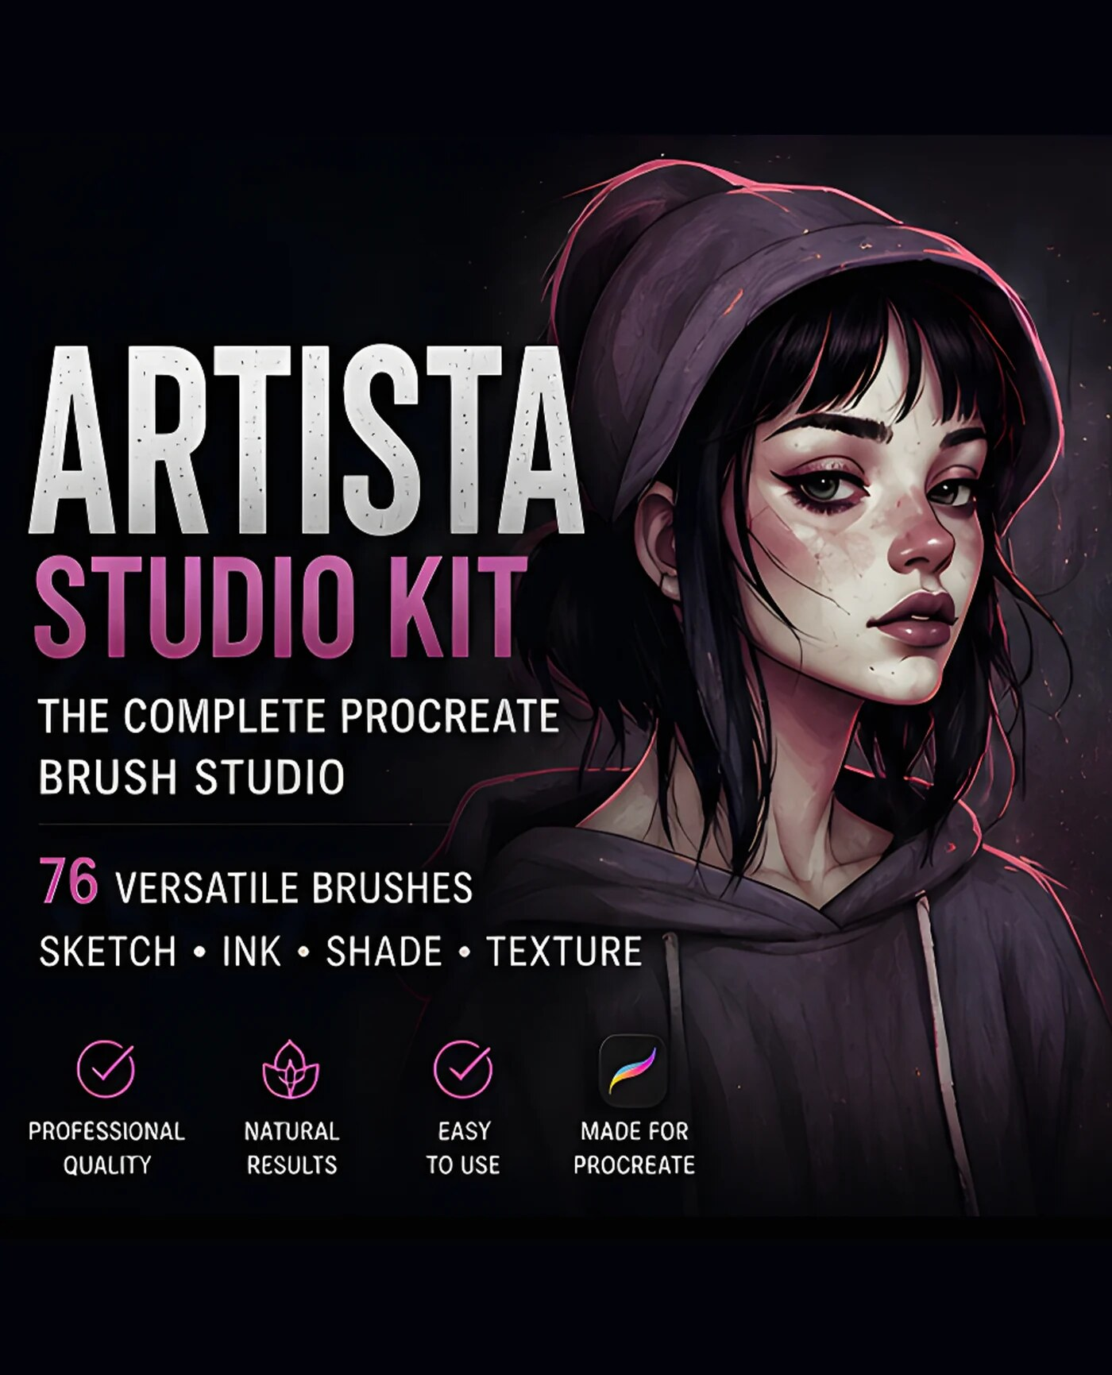
Official DigiKitPro product artwork: Artista Studio Kit: 76 Procreate Brushes. This is a product visual, not a Procreate screenshot.

Article
The best Procreate canvas size depends on where the artwork will be used. Screen artwork is governed mainly by pixel dimensions. Print artwork also needs a physical size and a resolution target. A huge canvas is not automatically better: Procreate says larger canvases offer fewer maximum layers, and texture scale changes with the document.

The formula: pixels = inches × DPI
If you want an 8 × 10 inch print at 300 DPI, the working pixel dimensions are 2,400 × 3,000 pixels. If the artwork is only for a screen, choose pixel dimensions that fit the platform or display; DPI is less important to the on-screen appearance.
Procreate’s official Canvas reference says 300 DPI is the standard starting point for printing and 72–144 DPI is a standard range for screens. Confirm the final requirements with your printer or publishing platform.

Practical starting points
Use case | Suggested starting canvas | DPI starting point | Why
Social square or study | 2,000–3,000 px square | 72–144 | Easy to view and quick to work on; match the platform’s current requirements.
Portrait or character print | Final physical size × 300 DPI | 300 | Gives a print-oriented document and room for texture.
A4 print | 2,480 × 3,508 px | 300 | Pixel dimensions for A4 at 300 DPI; confirm bleed and printer requirements.
Line-art print | Final physical size × 300 DPI | 300 or printer specification | Preserves clean contours without wasting layer capacity.
Thumbnail or composition study | 1,600–2,000 px on the long edge | 72–150 | Encourages speed and keeps the file light.

These are starting points, not rules. Your iPad model, layer needs, print size, colour profile, and delivery format should decide the final document.

How to create the document in Procreate
From the Gallery, tap the + icon.
Choose a preset or create a custom canvas.
Enter the width, height, and DPI required for the destination.
Choose a colour profile appropriate to the project. Procreate’s handbook explains that RGB is suited to screens and CMYK is commonly used for print workflows; ask your printer when in doubt.
Check the maximum layer count before starting.
The official Create a Custom Canvas guide confirms that larger dimensions reduce the maximum number of layers available, and that the available maximum also depends on the iPad model.

DPI is not a magic quality switch
Changing DPI without changing pixel dimensions changes the physical size metadata; it does not create new detail. Resampling changes the pixel dimensions and can affect sharpness. Procreate notes that enlarging an image creates new data from existing pixels, which may produce unexpected results.
If you know the final print size, create the canvas at that size and resolution at the start. If you are working for screen, prioritise pixel dimensions and the export requirements.

Why your brushes look different on different canvases
Brushes are resolution-sensitive. A texture mark that reads as a pore on a 4,000-pixel portrait can look like a large dot on a 1,200-pixel canvas. Make a small test sheet on the actual document before judging a brush pack.
This matters for portrait, skin, watercolor, and fine line tools. The Portrait Mastery Kit and Master Line-Art Vault can support different workflows, but neither removes the need to test scale.

When to reduce the canvas
Reduce the dimensions when:
• your layer budget is too small for the workflow;
• the iPad becomes slow or difficult to navigate;
• the artwork is only for screen display;
• you are still thumbnailing composition;
• the texture is oversized at the current resolution.
To resize an existing document, use Actions → Canvas → Crop and Resize. Procreate’s official guide distinguishes cropping from resampling; read the dialog carefully before applying a change.

Recommended DigiKitPro resources
Artista Studio Kit: 76 Procreate Brushes — One organized 76-brush collection that covers the full studio workflow, linework, inking, sketching, shading, graphite, markers and effects.
Portrait Mastery Kit: 46 Procreate Brushes — A portrait-specific workflow kit: 46 pro brushes plus 4 paper textures organized into sketch, ink, blend, hair, detail, texture and finish.
Master Line-Art Vault: 300+ Fine Line Brushes — The ultimate all-in-one linework collection: 300+ fine line brushes with the precision, variety and character pro artwork demands.

FAQ

Is 300 DPI required for Procreate digital art?
No. It is a common print starting point. Screen artwork is primarily determined by pixel dimensions and the destination’s requirements. DPI matters when a physical size is involved.

What is the best Procreate canvas size for portraits?
Choose the final output first. For a print portrait, calculate the physical size at the printer’s DPI requirement. For practice or screen work, use a size that leaves enough layers for your process and keeps brush texture manageable.

Does a larger Procreate canvas give more detail?
It can provide more pixels, but it also reduces the available layer count and may slow the iPad. More pixels only help if the artwork needs that output size and your workflow can support the document.

Can I change DPI in Procreate later?
You can change DPI from Canvas settings. Procreate’s official documentation notes that changing DPI without changing pixel dimensions changes physical-size metadata rather than adding detail. Resampling is a separate operation and can affect quality.

What colour profile should I use?
Use RGB for screen work and the printer’s requested profile for print when available. Procreate’s custom-canvas documentation explains the general RGB and CMYK distinction; your destination’s specification takes priority.

Sources and update note
• Procreate Handbook: Canvas — official DPI, resampling, and crop guidance.
• Procreate Handbook: Create — official custom-canvas, colour-profile, and layer guidance.
• DigiKitPro product pages linked above — current resource descriptions.
Pick the canvas from the delivery requirement backwards. That decision protects your layer budget and makes every brush test more honest.

Research notes
Factual claims were checked against the official sources listed in the article. DigiKitPro product counts, formats, and requirements are taken from the repository catalogue and linked product pages; availability, prices, and terms can change and should be rechecked before publication.

16. The Complete Procreate Portrait Workflow: Sketch to Final Polish

The Complete Procreate Portrait Workflow: Sketch to Final Polish

SEO metadata
SEO title | The Complete Procreate Portrait Workflow: Sketch to Final Polish
H1 | The Complete Procreate Portrait Workflow: Sketch to Final Polish
URL slug | /blog/procreate-portrait-workflow/
Meta description | Follow a repeatable Procreate portrait workflow from reference and canvas setup through construction, values, skin, hair, edges, and final polish.
Primary keyword | Procreate portrait workflow
Secondary keywords | how to paint a portrait in Procreate, digital portrait process, Procreate portrait tutorial, portrait layers
Search intent | Informational
Target audience | Procreate portrait beginners, intermediate digital painters, character artists, and illustrators building a repeatable process
Category | Tutorials
Tags | portraits, Procreate workflow, digital painting, skin, hair

Official DigiKitPro product artwork: Portrait Mastery Kit: 46 Procreate Brushes. This is a product visual, not a Procreate screenshot.

Article
A portrait becomes easier to finish when each stage has one job. The sketch checks proportion. The value pass makes the head three-dimensional. The colour pass establishes temperature. Skin, hair, edges, and polish come later. If you ask a detail brush to solve a construction problem, the file becomes busy without becoming better.
This Procreate portrait workflow is a repeatable sequence for a head study or illustrative portrait. It uses suggested layer names and settings, not fixed rules. Adjust the canvas and brush scale to your output and iPad’s layer budget.

What you need
• A reference with a clear light direction and a pose you can actually study.
• Procreate on iPad and an Apple Pencil if you want pressure and tilt response.
• A sketch brush, painting brush, textured blender, hair tool, and a detail brush.
• A working document with enough layers for your process. Procreate’s custom canvas guide notes that larger canvases offer fewer maximum layers.
The Portrait Mastery Kit is catalogued with 46 brushes and four paper textures organised by portrait stage. The free Procreate Portrait Starter Guide is a lower-risk companion if you want more structure before buying resources.

Step 1: Choose the reference and plan the crop
Pick a reference that gives you a readable head angle, simple enough lighting, and a crop that suits your goal. Decide whether the portrait is a study, profile image, print, or character illustration before you start detailing.
Make a small thumbnail. Check the position of the head, background shape, and brightest light. If the composition works small, the painting has somewhere to go.

Step 2: Create a practical canvas and layer stack
Create the document for the final destination. For print, calculate the physical size at the requested DPI; for screen, prioritise pixel dimensions and the platform requirements. A suggested layer stack is:
• Reference / notes
• Construction
• Sketch
• Flat colour
• Form shadows
• Colour variation
• Skin texture
• Hair
• Details
• Background / finish
You do not need every layer in every portrait. The point is to keep decisions reversible until the large forms work.

Step 3: Build the construction
Place the head shape, centre line, brow line, eye sockets, nose base, mouth, jaw, ears, neck, and hairline. Compare angles and distances rather than drawing features as symbols. Keep the sketch lighter than the final line or paint.
Flip the canvas and zoom out. Fix proportion now; it is cheaper than correcting it after texture.

Step 4: Establish the value groups
Fill the local colour simply, then add the major light and shadow families. Ask whether the portrait reads without eyelashes, pores, hair strands, or bright highlights. If it does not, simplify the forms and improve the value structure.
Use a large brush and suggested low-to-medium opacity so you can build the shadow gradually. Keep reflected light subordinate to the main light.

Step 5: Add colour temperature and surface planes
Introduce warm and cool shifts based on the reference and environment. Keep the changes connected to the form: cheeks, nose, ears, lips, and reflected light may behave differently from the forehead or shadow side. Do not apply a generic skin recipe to every complexion.
The Portrait Skin Brushes product is catalogued with base, blusher, highlighter, textured blend, and skin-detail tools. Use texture only after the value and colour planes are stable.

Step 6: Paint the hair as a mass
Block the hair silhouette and large clumps before strands. The Hair & Hairstyle Stamp Kit can help explore a hairstyle foundation, while a painting brush is better for adapting the flow and finishing the surface. See the dedicated hair tutorial for the mass-to-strand process.

Step 7: Refine features and edges
Use the hardest edges where information matters: selected eyelids, the pupil, a lip edge, a nostril opening, or a small highlight. Soften the cheek, jaw, neck, and background transitions where the form turns away.
Eyes deserve attention, but do not render them at full detail while the head is still unresolved. Return to the thumbnail repeatedly.

Step 8: Add texture and finish
Place pores, freckles, hair strands, paper grain, or small accents at the end and at controlled strength. Hide the texture layer to make sure the painting still works. Procreate’s Blend Modes reference explains the available layer interactions; use them as optional tools rather than automatic fixes.

Step 9: Review and export
Flip the canvas, check the silhouette, inspect the values in grayscale, and compare the finished work to the reference. Remove details that compete with the focal point. Save the layered working file, then export the format required by the final destination.

Recommended DigiKitPro resources
Portrait Mastery Kit: 46 Procreate Brushes — A portrait-specific workflow kit: 46 pro brushes plus 4 paper textures organized into sketch, ink, blend, hair, detail, texture and finish.
Portrait Skin Brushes for Procreate — 19 premium skin-texture brushes: pores, freckles, wrinkles and textured blenders that turn flat paintings into believable portraits.
Professional Hair & Hairstyle Stamp Kit for Procreate — 160 precision hair and hairstyle stamps that solve volume and flow, a solid hair foundation before you start detailing.
Ultimate Portrait Mastery Bundle: 4 Procreate Kits — Four professional portrait kits in one workflow: line art (43), skin texture (19), hair stamps (160) and glitter effects (30), 252+ assets.
The Complete Procreate Portrait Masterclass (eBook) — From a blank canvas to a believable portrait, in 15 chapters: a repeatable Procreate portrait workflow you can audit and reuse on every portrait after.

FAQ

What is the best order for painting a portrait in Procreate?
Use reference and crop planning, canvas and layers, construction, values, colour, hair mass, features and edges, texture, then final review. The exact order can flex, but large structure should come before surface detail.

How many layers do I need for a Procreate portrait?
There is no fixed number. Use enough to keep the major decisions reversible without making the file difficult to manage. Larger canvases may reduce the maximum layer count; Procreate shows that limit when you create or edit the canvas.

Should I paint skin or hair first?
Establish the head and major hair silhouette early so the composition and background values are clear. Detailed skin and hair rendering can happen after the large value structure works.

Can I follow this workflow with Procreate’s built-in brushes?
Yes. A purchased kit can organise specialist marks, but the workflow depends on drawing, values, colour, and edges rather than any single product.

Is a portrait brush bundle worth it?
It is worth considering when you use its included stages. The Ultimate Portrait Mastery Bundle is relevant for artists who need line art, skin, hair-stamp, and finishing resources; a focused kit is better if you only need one stage.

Sources and update note
• Procreate Handbook: Create — official canvas, colour profile, and layer guidance.
• Procreate Handbook: Blend Modes — official layer interaction guidance.
• DigiKitPro product pages linked above — current contents and requirements.
A repeatable portrait workflow gives you a place to return when a painting feels wrong. Diagnose the stage before reaching for another brush.

Research notes
Factual claims were checked against the official sources listed in the article. DigiKitPro product counts, formats, and requirements are taken from the repository catalogue and linked product pages; availability, prices, and terms can change and should be rechecked before publication.

17. Procreate Stamp Brushes vs Painting Brushes: When to Use Each

Procreate Stamp Brushes vs Painting Brushes: When to Use Each

SEO metadata
SEO title | Procreate Stamp Brushes vs Painting Brushes: When to Use Each
H1 | Procreate Stamp Brushes vs Painting Brushes: When to Use Each
URL slug | /blog/stamp-brushes-vs-painting-brushes/
Meta description | Understand the difference between Procreate stamp brushes and painting brushes, when each is useful, and how to paint over stamps so your work stays personal.
Primary keyword | Procreate stamp brushes vs painting brushes
Secondary keywords | Procreate stamp brushes, painting brushes for Procreate, how to use stamp brushes, hair stamp brushes
Search intent | Informational
Target audience | Procreate beginners, character artists, portrait painters, concept artists, and illustrators comparing brush types
Category | Guides
Tags | stamp brushes, painting brushes, Procreate workflow, hair, figure drawing

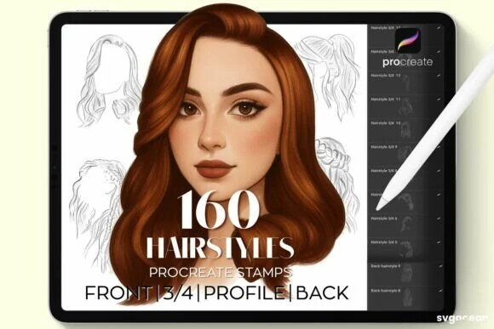
Official DigiKitPro product artwork: Professional Hair & Hairstyle Stamp Kit for Procreate. This is a product visual, not a Procreate screenshot.

Article
Stamp brushes and painting brushes solve different problems. A painting brush makes a stroke whose direction, pressure, and rhythm come from your hand. A stamp brush places a designed shape with one tap. Neither is inherently more “real” or more creative; the useful question is where the mark belongs in your process.
Use stamps for speed, exploration, and scaffolding. Use painting brushes when the surface needs your own decisions, variation, and edge control. The strongest workflow often uses both.

Quick comparison
Aspect | Stamp brush | Painting brush
Main output | A shape, silhouette, texture, or repeated motif | A continuous mark or painted transition
Best stage | Thumbnailing, blocking, layout, repeated elements | Construction, rendering, linework, and finishing
Main risk | Repetition or an untouched “sticker” look | Slow construction and inconsistent results while learning
Artist’s job | Adapt, repaint, combine, and edit the foundation | Control pressure, edges, colour, and direction

The table describes common use, not a rule. A stamp can become a painterly texture, and a painting brush can be used as a single mark.

When stamp brushes help

Explore silhouettes quickly
A pose stamp can give you a starting balance for a figure. Place it on a separate layer, lower its opacity, and redraw the gesture and landmarks on a new layer. The stamp is a reference scaffold, not the finished figure.
The Female Pose Brushes and Male Pose Brushes are relevant when you want to generate figure-drawing starting points quickly. Use them to study proportion and movement, then make the final drawing your own.

Block hair volume
Hair is easier to paint when the mass and direction are established before individual strands. The Hair & Hairstyle Stamp Kit is catalogued as 160 hairstyle stamps. It can speed up exploration of silhouette and volume; a painting brush is still needed for clumps, highlights, flyaways, and the edges that match the head.

Repeat a decorative element
A stamp is appropriate when repetition is intentional: stars, leaves, texture particles, or a planned pattern. Change scale, angle, opacity, and placement so the eye reads a designed rhythm rather than a copy-and-paste grid.

When painting brushes are the better choice
Use a painting brush when the mark must respond to a form. Facial planes, expressive lines, skin transitions, hair ribbons, and irregular organic edges benefit from hand-directed variation. The Professional Hair Brushes are a more appropriate starting point when you want to paint hair direction rather than place a finished hairstyle silhouette.
A painting brush is also the better choice when a stamp’s proportions fight your composition. Redrawing may take longer, but it keeps the design in service of your idea.

The paint-over workflow
Place the stamp on its own layer. Keep it editable and transform it before painting.
Lower opacity to a suggested starting range of 30–60%. Adjust by eye; the goal is to see the guide without letting it dictate the finish.
Redraw key landmarks. Rebuild the head angle, joints, silhouette, or hairline with your own line.
Paint the large forms. Use a painting brush to establish value and volume over the guide.
Hide or delete the stamp. Check whether the illustration still reads without it.
Vary the surface. Add your own edges, texture, and selective details rather than leaving the stamp’s texture untouched.
Always check the licence for the resource and your intended use. A brush licence is not a blanket transfer of copyright in every source shape.

Common mistakes
• Repeating one stamp at the same size and angle.
• Leaving a stamp at full opacity under a thin layer of colour.
• Bending a composition around a stamp instead of sketching what you need.
• Assuming a stamp’s included shape can be redistributed as a new asset.
• Adding detail before checking whether the silhouette works at thumbnail size.

Recommended DigiKitPro resources
Professional Hair & Hairstyle Stamp Kit for Procreate — 160 precision hair and hairstyle stamps that solve volume and flow, a solid hair foundation before you start detailing.
Female Pose Procreate Brushes: Figure Drawing Stamps — Dynamic female pose stamps for strong anatomy and balanced figures, for characters, covers, social artwork and KDP interiors.
Male Pose Procreate Brushes: Figure Drawing Stamps — Ready-to-use male pose stamps for accurate anatomy and dynamic figure compositions in minutes, directly inside Procreate.
Professional Hair Brushes for Procreate — A streamlined hair system that paints believable strands, texture and volume without hours of hand-drawn strokes.

FAQ

Are stamp brushes cheating?
No. They are tools for blocking, layout, repetition, and exploration. The artistic responsibility is to use them intentionally, edit them where needed, and follow the product licence.

Can I use stamp brushes for client work?
DigiKitPro’s current terms permit finished personal and commercial artwork unless a product page says otherwise. They prohibit reselling or redistributing the source files. If a client needs the editable brush or source stamp, request permission rather than assuming it is included.

How do I stop a stamp from looking repetitive?
Vary scale, angle, spacing, opacity, and placement. Paint over the most visible edges, combine several marks, and remove stamps that do not support the composition.

Are painting brushes better for realistic hair?
They are usually better for the final directional work because hair needs changes in flow, edge softness, and value. Stamps can accelerate the initial mass; the hair workflow explains how to build from mass to strands.

Can I modify a Procreate stamp brush?
Procreate lets you create and edit brushes in Brush Studio. The official Brush Studio reference is the right place to confirm current controls. Save a new variant so you can compare the original and your edit.

Sources and update note
• Procreate Handbook: Brush Studio — official brush-editing reference.
• DigiKitPro product pages linked above — current product contents.
• DigiKitPro Terms of Service — current commercial-artwork and redistribution limits.
Use a stamp to solve the repetitive part of the job, then return the important decisions to your own hand.

Research notes
Factual claims were checked against the official sources listed in the article. DigiKitPro product counts, formats, and requirements are taken from the repository catalogue and linked product pages; availability, prices, and terms can change and should be rechecked before publication.

18. How to Design a Tattoo in Procreate: From Sketch to Stencil

How to Design a Tattoo in Procreate: From Sketch to Stencil

SEO metadata
SEO title | How to Design a Tattoo in Procreate: From Sketch to Stencil
H1 | How to Design a Tattoo in Procreate: From Sketch to Stencil
URL slug | /blog/tattoo-design-in-procreate/
Meta description | Learn a responsible Procreate workflow for tattoo concepts: plan the body placement, build clear linework, add value, and prepare a clean stencil reference.
Primary keyword | how to design a tattoo in Procreate
Secondary keywords | tattoo design Procreate, tattoo flash on iPad, Procreate tattoo stencil, tattoo linework brushes
Search intent | Informational
Target audience | Tattoo artists, apprentice designers working under supervision, illustrators creating tattoo flash, and clients preparing concepts
Category | Tutorials
Tags | tattoo design, Procreate tutorial, line art, dotwork, iPad art

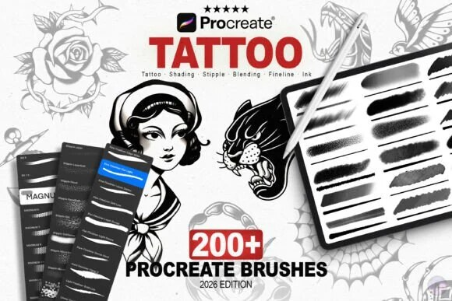
Official DigiKitPro product artwork: Tattoo Artist's Studio Kit: 200+ Procreate Brushes. This is a product visual, not a Procreate screenshot.

Article
Procreate is useful for exploring tattoo concepts quickly, but a digital drawing is not the same as a tattooing procedure. This guide covers design, line clarity, value, placement mockups, and file preparation. It does not replace supervised tattoo training, local regulations, client consent, skin knowledge, or a tattoo artist’s judgement about what will heal well.
A tattoo design has to read at the intended size, follow the body’s movement, and preserve enough spacing for the marks to remain legible. That makes the workflow different from a highly rendered illustration.

What you need
• Procreate on iPad and an Apple Pencil if you want pressure-sensitive marks.
• A reference or brief with the subject, placement, approximate size, and style.
• A liner, a broad fill brush, and a dotwork or textured shader.
• A body photo or simple placement template when the design needs to wrap around an arm, leg, or torso.
The Tattoo Artist’s Studio Kit is catalogued with 200-plus brushes for linework, stipple and dotwork, shading, and traditional texture. The Master Line-Art Vault and Essential Line Art & Sketch Kit are relevant comparisons for artists who need a line-first workflow.

Step 1: Clarify the brief and body placement
Write down the subject, orientation, approximate dimensions, placement, and whether the design is intended as a standalone piece or part of a larger composition. Ask how the design will be viewed: straight-on, wrapped, or at a distance.
If the concept is for a client, confirm approval milestones before moving from sketch to finished linework. Keep the brief and reference separate from the artwork so you can revise without flattening the file.

Step 2: Create a thumbnail at a useful size
Start with several small compositions. Test the silhouette and the direction of movement before investing in detail. A tattoo should still read when reduced; if the subject disappears at thumbnail size, more hatching will not solve the problem.
When the placement is known, create a document whose physical dimensions match the design brief as closely as practical. For print references, use the printer’s requirements; do not treat DPI as a guarantee of tattoo healing.

Step 3: Block the main shapes
Place the largest darks, open spaces, and key focal points. Think about the negative space that will remain between marks. Keep the design balanced when it is rotated or wrapped.
For a koi or other themed concept, the Koi Fish Tattoo Brushes can provide a starting motif. Adapt the composition to the placement and client brief instead of leaving a ready-made shape untouched.

Step 4: Build linework by hierarchy
Use a heavier line for the main silhouette and lighter lines for internal detail, where the style calls for it. Leave breathing room between close parallel lines. A design that looks elegant on a large iPad screen can become crowded when reduced.
Keep primary linework on its own layer. Save a version before adding shading so you can return to a clean reference.

Step 5: Add black, dotwork, or limited shading
Treat solid black as a compositional shape, not a final decoration. Add it deliberately to anchor the design. Build dotwork or textured shading in controlled groups and check the design at the intended size.
Avoid relying on smooth digital gradients alone if your design language depends on stipple or whip-style texture. The brush can suggest a mark; a qualified tattoo artist still decides how to translate it to skin and equipment.

Step 6: Mock the placement
Import a placement photo or body template on a lower layer. Put the design above it, reduce opacity when checking alignment, and use Transform or Warp to explore the curve. Label the mockup clearly as a concept so it is not mistaken for a stencil or a healed result.
Check the design from more than one angle. A good flat composition can need adjustment when it crosses a joint or wraps around a limb.

Step 7: Prepare the clean reference
Hide the photo and background layers. Check that the linework is crisp, the black areas are intentional, and any shading is separated or clearly identified. Export the file type requested by the studio or stencil workflow. Keep an editable Procreate file for revisions and a flattened presentation image for approval.

Recommended DigiKitPro resources
Tattoo Artist's Studio Kit: 200+ Procreate Brushes — 200+ brushes with real needle weight, dotwork grit and stipple texture, pro flash and tattoo concepts designed on iPad.
Koi Fish Tattoo Procreate Brushes — Bold, clean, highly detailed koi fish tattoo brushes, professional koi artwork drawn directly on your iPad.
Master Line-Art Vault: 300+ Fine Line Brushes — The ultimate all-in-one linework collection: 300+ fine line brushes with the precision, variety and character pro artwork demands.
Essential Line Art & Sketch Kit for Procreate — 43 focused brushes plus a bonus texture brush for clean line art, natural pencil sketches and confident inking, no pack-switching.

Common mistakes
• Designing without knowing the placement or approximate size.
• Packing detail into spaces that will be viewed at a distance.
• Treating a digital gradient as a finished tattoo shading plan.
• Ignoring negative space and healed readability.
• Presenting a concept mockup as a guarantee of the final tattoo.

FAQ

Can I design tattoos in Procreate?
Yes. Procreate is useful for sketching, linework, flash, placement mockups, and client concepts. It does not replace tattoo training, sterile practice, or the decisions of a qualified tattoo artist.

What brushes are useful for tattoo design?
A controlled liner, a broad fill brush, and dotwork or textured shader tools cover many design workflows. Choose the brush by the mark you need and the final size of the concept.

Should a tattoo design be created at 300 DPI?
300 DPI is a common print starting point, but tattoo work is not determined by DPI alone. Use the intended physical size, the studio’s workflow, and the final output requirements. Procreate’s official canvas guide explains DPI and pixel dimensions for digital documents.

How do I preview a tattoo on a body?
Place the design above a body photo or template, use Transform or Warp to explore the curve, and label the result as a concept mockup. Get client approval on placement before preparing a final reference.

Can I use DigiKitPro tattoo brushes for commercial artwork?
The current DigiKitPro Terms of Service allow personal and commercial artwork unless a product page states otherwise, while prohibiting redistribution of the brush files. Confirm the current product terms for your use case.

Sources and update note
• Procreate Handbook: Canvas — official dimensions and DPI reference.
• DigiKitPro product pages linked above — current tattoo resource descriptions.
• DigiKitPro Terms of Service — current licence language.
Design for clarity and placement first. The brush pack should support the decision, never replace the tattoo artist’s judgement about the final procedure.

Research notes
Factual claims were checked against the official sources listed in the article. DigiKitPro product counts, formats, and requirements are taken from the repository catalogue and linked product pages; availability, prices, and terms can change and should be rechecked before publication.

