Sarcasm and Fragmentation: Twitter Networks on Indonesia’s Free Nutritious Meal Programme
Indri Anjar Kartika Sari¹, Catur Suratnoaji¹, Agus Widiyarta¹
¹Master of Communication Science, Faculty of Social, Cultural and Political Sciences, Universitas Pembangunan Nasional “Veteran” Jawa Timur, Surabaya, Indonesia
Corresponding author: 25067020011@student.upnjatim.ac.id
Submitted: [date]; Revised: [date]; Accepted: [date]
ABSTRACT
Indonesia’s Free Nutritious Meal programme (Makan Bergizi Gratis, MBG) is one of the country’s largest public spending commitments, and its 2026 budget cut and kitchen incidents drew criticism on Twitter, much of it sarcastic. This study examines how that criticism was expressed, how users engaged with it, and how the conversation was structured as a network. Using a quantitative descriptive design, 5,263 public posts from 2,420 accounts published between 2 March and 24 May 2026 were collected with NodeXL Pro. Emotion, sarcasm and issue were coded by the researcher on a random sample of 150 posts after automated labels failed validation; engagement was summarised for the full corpus; and a directed mention network of 971 accounts was analysed with graph measures and Louvain clustering. Among the 49 sampled posts that discussed the programme, anger and disgust dominated, and 20 (40.82%) contained sarcasm, concentrated on budget and political issues. Almost half of the sarcastic posts were labelled positive or neutral by the automated classifier. Engagement was highly unequal: the top 10% of posts received 96.51% of all engagement, and likes far outnumbered replies. The mention network was sparse, split into 341 components, and almost entirely one-directional (1.23% reciprocity); the President’s account was the most mentioned, an AI reply account was the most active mentioner, and the National Nutrition Agency was absent. Read through Social Information Processing theory and graph theory, the findings indicate that policy criticism circulated as sarcasm across fragmented clusters that bypassed the programme’s official channels.
Keywords: computer-mediated communication; emoji; Free Nutritious Meal programme; sarcasm; social network analysis
INTRODUCTION
Indonesia’s Free Nutritious Meal programme (Makan Bergizi Gratis, hereafter MBG) is a flagship policy intended to improve the nutritional status of school children and other vulnerable groups as part of the national long-term development plan (Peraturan Presiden Nomor 83 Tahun 2024; Undang-Undang Nomor 59 Tahun 2024). The programme carries a fiscal commitment of unusual scale. The 2026 allocation was set at Rp335 trillion and was formally revised to Rp268 trillion on 19 May 2026, while by 30 April 2026 the programme reported Rp75 trillion in realised spending, 61.96 million beneficiaries and 27,952 kitchen units, known as Satuan Pelayanan Pemenuhan Gizi (SPPG) (ANTARA, 2026a; Bisnis.com, 2026).
Implementation problems became public during the same months. The National Nutrition Agency (Badan Gizi Nasional, BGN) suspended thousands of SPPG units for quality improvements, and 1,152 units were still suspended in May 2026 (ANTARA, 2026b). Reports of food poisoning involving school children accumulated in April and May 2026 (Kompas.id, 2026; Kompas.com, 2026), and the agency later reported serious violations by hundreds of kitchens (CNBC Indonesia, 2026). The gap between achievement figures and field conditions became a recurring subject of public conversation.
The agency itself framed the situation as a communication problem. In April 2026, its public relations bureau stated that fast, accurate and responsive communication was needed to protect the programme’s reputation amid hoaxes and negative perceptions (Badan Gizi Nasional, 2026). This framing places the MBG debate within the field of government communication: how citizens talk about a policy online, and whether the institution responsible for it is part of that conversation, are questions with practical consequences.
Twitter (now X) is a central arena for such conversation in Indonesia. Its short text format, rapid sharing and reply threads make it suitable for debating public policy, and studies have shown that Twitter opinion can be used to monitor public responses across the policy cycle (Ceron & Negri, 2016). Indonesian users frequently criticise policy indirectly, through irony, wordplay and dark humour, often marked with emoji. A sentence that praises a programme can mean the opposite when it ends with a clown or a crying-with-laughter face. Analyses that read only the literal text of such posts risk recording criticism as support.
Computer-mediated communication (CMC) research offers a framework for this behaviour. Early approaches regarded online communication as poor in social cues (Culnan & Markus, 1987), but Social Information Processing (SIP) theory argues that users compensate for missing nonverbal cues with the cues available to them, including word choice, punctuation and symbols (Walther, 1992). Emoticons and emoji shape how messages are interpreted (Derks et al., 2008; Walther & D’Addario, 2001), emoji carry relatively stable sentiment values (Kralj Novak et al., 2015), and experimental studies show that emoji function similarly to facial expressions and influence how receivers read the sender’s emotion (Boutet et al., 2021; Erle et al., 2022).
The same cues make sarcasm possible. Sarcasm relies on an incongruity between what is literally said and what is meant (Camp, 2012). Emoji can act as irony markers that readers process in the same way as verbal irony (Weissman & Tanner, 2018), and the interpretation of emoji-based sarcasm depends on the mismatch between the emoji and its context (Cui et al., 2023). Because a single emoji can be interpreted differently by different users (Miller et al., 2016), sarcasm is difficult to detect automatically, and benchmark studies show that Indonesian sarcasm remains a challenge for language models (Suhartono et al., 2024). These studies explain how sarcastic messages work, but they rarely examine where such messages travel.
Research on the behavioural side of social media shows that emotionally charged political posts are shared more often and more quickly than neutral ones (Stieglitz & Dang-Xuan, 2013). Engagement can be separated into popularity (likes), commitment (comments or replies) and virality (shares), which distinguishes passive approval from dialogue (Bonsón & Ratkai, 2013). Engagement therefore indicates not only how much attention a topic receives but also what kind of participation it invites.
Graph theory provides the tools to study the structure through which messages travel. Centrality measures identify accounts that receive attention or connect otherwise separate groups (Freeman, 1979; Wasserman & Faust, 1994), and community detection reveals clusters within a conversation (Blondel et al., 2008; Newman & Girvan, 2004). Twitter topic networks take distinct shapes, from polarised crowds to fragmented clusters (Himelboim et al., 2017), and NodeXL-based studies have mapped political conversation in Indonesia (Suratnoaji et al., 2018). In a study of COVID-19 discourse, health agencies were not central to the conversation, and a decentralised network made official messages harder to spread (Pascual-Ferrá et al., 2022).
Research on MBG itself has so far focused on sentiment and information flow. Sianturi (2025) analysed news and social media in the programme’s first week and found that negative posts outnumbered positive ones, while Suaib and Pratiwi (2025) mapped information dissemination about MBG on X without identifying strong broker accounts. Neither study examined sarcasm, emoji or the link between message content and network position. More generally, studies of message content have rarely examined the networks that carry those messages, network studies have rarely read the sarcasm and emoji inside them, and most evidence comes from Europe and North America rather than Indonesian-language policy talk. No study has yet examined MBG conversation during March–May 2026, when the budget cut coincided with a series of kitchen incidents.
This study addresses these gaps by reading the MBG conversation on Twitter from three angles: message content, user behaviour and network structure. It asks three questions. First, what patterns of emotion, sarcasm, emoji use and issue appear in public posts about MBG? Second, what patterns of communicative behaviour, particularly engagement and account activity, characterise the conversation? Third, how is the communication network structured, and how far does MBG content reach within it? The study is descriptive and does not test causal relationships.
RESEARCH METHODS
This study used a quantitative descriptive design combining content analysis (Krippendorff, 2018; Neuendorf, 2017), engagement analysis and social network analysis (Wasserman & Faust, 1994). The unit of analysis was the individual post for content and engagement, and the account for the network.
Data collection. Public posts were collected with NodeXL Pro using the Twitter search function and the keywords “Makan Bergizi Gratis”, “MBG”, “Makan Siang Gratis”, #MakanBergiziGratis and #MBG. The collection returned 5,272 posts. Nine posts without a valid timestamp inside the study window were removed, leaving a corpus of 5,263 posts from 2,420 accounts published between 2 March and 24 May 2026. The window was divided into Period 1 (2 March–30 April; 902 posts from 502 accounts) and Period 2 (1–24 May; 4,361 posts from 1,987 accounts), the month in which the budget revision was announced.
Corpus checks. Two limitations of keyword collection were identified before analysis. First, 402 posts (7.64%) from 27 accounts were Portuguese-language shopping promotions captured by the abbreviation “MBG”. Second, the abbreviation was also used for unrelated topics; only 532 posts named the programme in full or mentioned BGN or SPPG. Both groups were retained for corpus-level counts of volume, engagement and network structure, and these counts are therefore reported as describing keyword-matched conversation. Content findings were restricted to posts that the researcher judged to be about the programme.
Coding scheme. Emotion was coded with the 9 Emoji scheme developed for this study: Plutchik’s (1980) eight basic emotions plus a neutral category, each represented by an anchor emoji informed by the Emoji Sentiment Ranking (Kralj Novak et al., 2015). Each post received the single most salient emotion expressed by the author, read from text, emoji and issue together. Sarcasm was coded as present when the intended meaning differed from or reversed the literal meaning and was signalled by a marker such as a contrasting emoji, wordplay, a rhetorical question or hyperbole; direct criticism without reversal was not coded as sarcasm. When a post contained more than one marker, the dominant marker was recorded and the others were noted. Three marker types were recorded: subtle derision (belittling a target through nicknames or wordplay), expectation reversal (a positive claim overturned by a negative reality) and mock praise. Issue was coded into five categories: budget and accountability, politics and economy, food safety and quality, implementation and distribution, and nutrition and social benefits.
Validation procedure. An automated classifier built on an Indonesian pretrained language model (Wilie et al., 2020) was first applied to assign 9 Emoji labels to every post, a keyword dictionary assigned issues, and a rule-based filter flagged sarcasm candidates. Following recommendations to validate automated text measures against human judgement before interpreting them (Birkenmaier et al., 2024), the first author coded 150 posts drawn at random from the corpus excluding the promotional posts, without seeing the automated labels. Agreement was reported as the share of identical labels and as chance-corrected agreement (Cohen’s kappa), with 0.61, the lower bound of substantial agreement (Landis & Koch, 1977), set as the minimum for using automated labels. The coder worked only from the post text, including emoji, and flagged ambiguous cases for a second reading; posts that did not concern MBG or public policy, such as advertisements, fan conversation or personal anecdotes, were coded as irrelevant. Four pairs of posts with identical text were identified in the sample and retained, because each was published separately. Proportions are reported with 95% Wilson confidence intervals.
Engagement analysis. Following Bonsón and Ratkai (2013), engagement was measured as popularity (likes), commitment (replies) and virality (retweets), supplemented by quotes and views. Follower counts were not available in the NodeXL export, so all measures are reported per post. Totals, means, medians and concentration (the share of engagement received by the top 1% and 10% of posts) were calculated for each period.
Network analysis. A directed mention network was built in which nodes are accounts and edges are mentions or retweets of one account by another. The 692 edge rows were merged into 666 unique directed relations among 971 accounts. Density, connected components, reciprocity, in-degree, out-degree and betweenness centrality (computed on the undirected graph) were calculated (Freeman, 1979), and communities were detected with the Louvain algorithm (Blondel et al., 2008), whose modularity was interpreted with reference to Newman and Girvan (2004). Measures were computed in NodeXL Pro and recomputed with Python scripts kept in the project repository.
Ethics. Only publicly available posts were analysed. Accounts of public figures, institutions and the automated reply account are named; other accounts are anonymised in this article. Example posts are paraphrased rather than quoted to limit traceability.
RESULT AND DISCUSSION
Validation of automated labels and relevance of the corpus
Table 1 summarises the comparison between the researcher’s coding and the automated labels. Automated emotion labels matched the researcher’s coding for only 22 of 150 posts, and agreement was barely above chance. Among the posts relevant to MBG, agreement was no better than chance. The issue dictionary performed better but still only at a fair level, and the sarcasm filter identified 1 of the 26 sarcastic posts found by the researcher. Automated emotion and sarcasm labels were therefore not used as findings; emotion, sarcasm and issue findings below are based on the researcher’s coding.
Table 1. Agreement between researcher coding and automated labels (n = 150)
Component | Automated comparison | Identical labels | Cohen’s κ | Interpretation
Emotion (9 Emoji) | Automated classifier | 22 of 150 (14.67%) | 0.05 | Slight
Emotion, relevant posts | Automated classifier | 7 of 49 (14.29%) | −0.01 | No better than chance
Issue | Keyword dictionary | 103 of 150 (68.67%) | 0.39 | Fair
Sarcasm | Rule-based filter | 1 of 26 detected | – | 1 of 7 candidates correct
Note. Interpretation follows Landis and Koch (1977). Source: researcher’s coding sheet.
The validation also showed that only 49 of the 150 sampled posts (32.67%; 95% CI 25.7–40.5) discussed the programme. The remainder used the abbreviation or the word “gratis” for other topics. Relevance was higher in Period 1 (13 of 26 sampled posts) than in Period 2 (36 of 124). This finding qualifies every corpus-level figure that follows: keyword collection on an abbreviation such as “MBG” captures a conversation that is substantially larger than the policy debate itself.
Volume and activity
Average daily volume rose from 15.3 posts in Period 1 to 181.7 in Period 2, so that 82.86% of the corpus was published in Period 2 (Figure 1). Volume rose in the weeks ending 12 and 19 April, close to reported poisoning cases involving school children (Kompas.id, 2026), and surged from the second week of May. The three busiest days were 24 May (1,188 posts), 13 May (907) and 10 May (475). The surge was not entirely about the programme: on 13 May, 391 of 907 posts (43.11%) were Portuguese promotions, and on 24 May only 218 of 1,188 posts contained a keyword from any of the five issues.
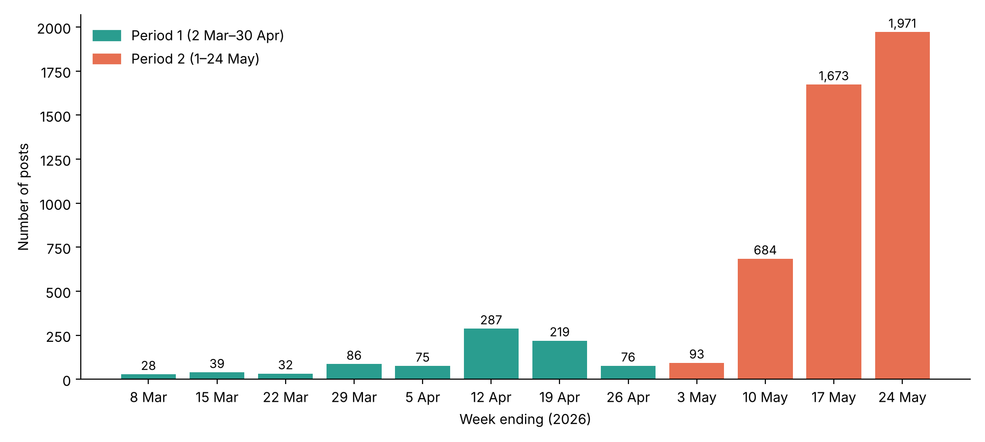
Figure 1. Weekly number of MBG posts, March–May 2026
Note. N = 5,263 posts. Source: researcher’s analysis of NodeXL Pro data.
Participation was fleeting. A total of 1,156 accounts (47.77%) posted only once, while the ten most active accounts produced 611 posts (11.61%). Two Portuguese promotional accounts ranked first and second, and @grok, the platform’s AI reply account, ranked third with 93 posts.
Emotion, sarcasm and issue
Table 2 compares the researcher’s emotion coding of the 49 relevant posts with the automated labels for the same posts. Anger was the most frequent emotion (17 posts, 34.69%; 95% CI 22.9–48.7), followed by disgust (10) and trust (7); more than half of the relevant posts (27 of 49) expressed anger or disgust. The automated classifier produced a different picture: it assigned disgust to 28 posts and anticipation to 9, and did not assign anger to any post.
Table 2. Emotion in the 49 MBG-relevant posts: researcher coding and automated labels
Emotion | Researcher (n) | Researcher (%) | Automated (n) | Automated (%)
Anger | 17 | 34.69 | 0 | 0.00
Disgust | 10 | 20.41 | 28 | 57.14
Trust | 7 | 14.29 | 7 | 14.29
Neutral | 4 | 8.16 | 3 | 6.12
Sadness | 3 | 6.12 | 0 | 0.00
Joy | 3 | 6.12 | 2 | 4.08
Anticipation | 2 | 4.08 | 9 | 18.37
Surprise | 2 | 4.08 | 0 | 0.00
Fear | 1 | 2.04 | 0 | 0.00
Total | 49 | 100.00 | 49 | 100.00
Source: researcher’s coding sheet.
Twenty of the 49 relevant posts (40.82%; 95% CI 28.2–54.8) contained sarcasm (Table 3). Sarcasm was most common in posts about budget and accountability (9 of 15) and politics and economy (5 of 9), and least common in posts about nutrition and social benefits (1 of 9). Across all 26 sarcastic posts in the sample, including six not about MBG, subtle derision was the most frequent marker (15), followed by expectation reversal (10) and mock praise (1). The emotions underlying these posts were disgust (15), anger (8) and sadness (3). Yet 11 of the 26 (42.31%) were labelled trust (5), anticipation (4) or neutral (2) by the automated classifier.
Table 3. Sarcasm in MBG-relevant posts by issue
Issue | Relevant posts | Sarcastic | % sarcastic
Budget and accountability | 15 | 9 | 60.00
Politics and economy | 9 | 5 | 55.56
Food safety and quality | 9 | 3 | 33.33
Implementation and distribution | 7 | 2 | 28.57
Nutrition and social benefits | 9 | 1 | 11.11
Total | 49 | 20 | 40.82
Source: researcher’s coding sheet.
Emoji were almost universal: 5,248 posts (99.71%) contained at least one emoji or pictographic symbol, with 15,073 occurrences of 678 types. The loudly crying face (😭) appeared 1,961 times in 836 posts, far ahead of any other emoji, and three of the five most frequent emoji (😭, 🤣 and 😂) are faces commonly used for crying, laughing or mocking. Their meaning depends heavily on the sentence they accompany. The next most frequent symbols, such as sparkles (✨, 405 occurrences), fire (🔥, 357), check mark (✅, 308), pointing finger (👉, 227) and folded hands (🙏, 205), served mainly to emphasise or direct attention, and the Brazilian flag (about 295 occurrences) came almost entirely from the Portuguese promotional posts.
At corpus level, the issue dictionary placed 66.96% of posts in the “other” category, consistent with the low relevance found in validation. Among the five issues, the dictionary ranked nutrition and social benefits first (16.59%), whereas the researcher’s coding ranked budget and accountability first. Of the 49 relevant posts, the dictionary agreed with the researcher on 18, missed 19, and assigned an issue to 16 irrelevant posts. The dictionary ranking is therefore treated as indicative only.
Read through SIP theory (Walther, 1992), the dominance of face emoji indicates that users replace absent facial expression and tone with pictographic cues, consistent with evidence that emoji operate as social information (Boutet et al., 2021; Erle et al., 2022). The flexibility of these emoji (Miller et al., 2016) is also what makes them effective sarcasm markers. The concentration of sarcasm on budget and politics, rather than on nutrition, suggests that users were less inclined to reject the programme’s goal than to criticise how it was financed and politicised. The misreading of almost half of the sarcastic posts follows directly from the incongruity on which sarcasm depends (Camp, 2012; Cui et al., 2023): literal words point one way and intended meaning another. This is consistent with the difficulty of Indonesian sarcasm detection reported by Suhartono et al. (2024) and supports the argument that monitoring based on literal sentiment would record part of the criticism as approval. Because the estimates rest on 49 relevant posts, the confidence intervals are wide and the proportions should be read as approximate.
The dominance of anger and disgust is broadly consistent with Sianturi (2025), who found that negative posts outnumbered positive ones by a wide margin in the programme’s first week, with 41.2% of social media posts negative and 13.1% positive. The two studies are not directly comparable, because Sianturi used a three-way sentiment classification on a much larger dataset more than a year earlier, whereas this study used a nine-category emotion scheme on a validated sample. The comparison nevertheless suggests that critical affect has persisted from the launch of the programme into the period of budget revision, and that a nine-category scheme distinguishes forms of negativity, such as anger at budget decisions and disgust at food safety failures, that a single negative category would merge.
The validation results also carry a methodological lesson. Automated labels that look plausible at corpus level, such as disgust in 55.10% of all posts, proved unreliable when checked against human coding, and the issue dictionary reversed the ranking of issues. Large social media datasets invite claims that exceed what the data can support (boyd & Crawford, 2012), and validation against human judgement is the step that keeps such claims in check (Birkenmaier et al., 2024). For policy conversation in Indonesian, where abbreviations are reused across unrelated topics and criticism is often indirect, checking relevance and meaning on a sample is a precondition for interpretation rather than an optional refinement.
Engagement
The corpus received 4,023,061 engagements and 126,118,016 views (Table 4). Mean engagement was 764.40 per post, but the median was 1: 2,570 posts (48.83%) received no engagement at all, while the top 1% of posts (52 posts) received 52.28% of engagement and the top 10% received 96.51%. Mean engagement rose from 562.55 in Period 1 to 806.16 in Period 2. The most prolific accounts were not the most engaged: the three accounts with the most posts received between 0 and 12 engagements each.
Table 4. Engagement summary
Measure | Total | Mean per post | Median | Mean P1 | Mean P2
Likes (popularity) | 3,177,111 | 603.67 | 0 | 439.58 | 637.61
Replies (commitment) | 78,286 | 14.87 | 0 | 10.67 | 15.74
Retweets (virality) | 723,781 | 137.52 | 0 | 105.01 | 144.25
Quotes | 43,883 | 8.34 | 0 | 7.28 | 8.56
Total engagement | 4,023,061 | 764.40 | 1 | 562.55 | 806.16
Views | 126,118,016 | 23,963.14 | 156 | 18,756.66 | 25,040.02
Note. P1 = Period 1; P2 = Period 2. Corpus-level figures include posts not about the programme.
In Bonsón and Ratkai’s (2013) terms, likes outnumbered replies by about 40 to 1, indicating that participation took the form of passive approval far more than dialogue. Stieglitz and Dang-Xuan (2013) found that emotional political posts are shared more often; that relationship could not be tested here because emotion and sarcasm were coded only for the sample. The extreme concentration of engagement means that a few widely viewed posts, rather than the bulk of users, set the visible tone of the conversation.
Network structure and reach
The mention network had a density of 0.000707 and broke into 341 unconnected components (Figure 2). The largest component contained 89 accounts (9.17%), and 234 components consisted of a single pair. Of 651 relations between distinct accounts, only 8 (1.23%) were reciprocated. In total, 588 accounts were mentioned and 415 mentioned others.
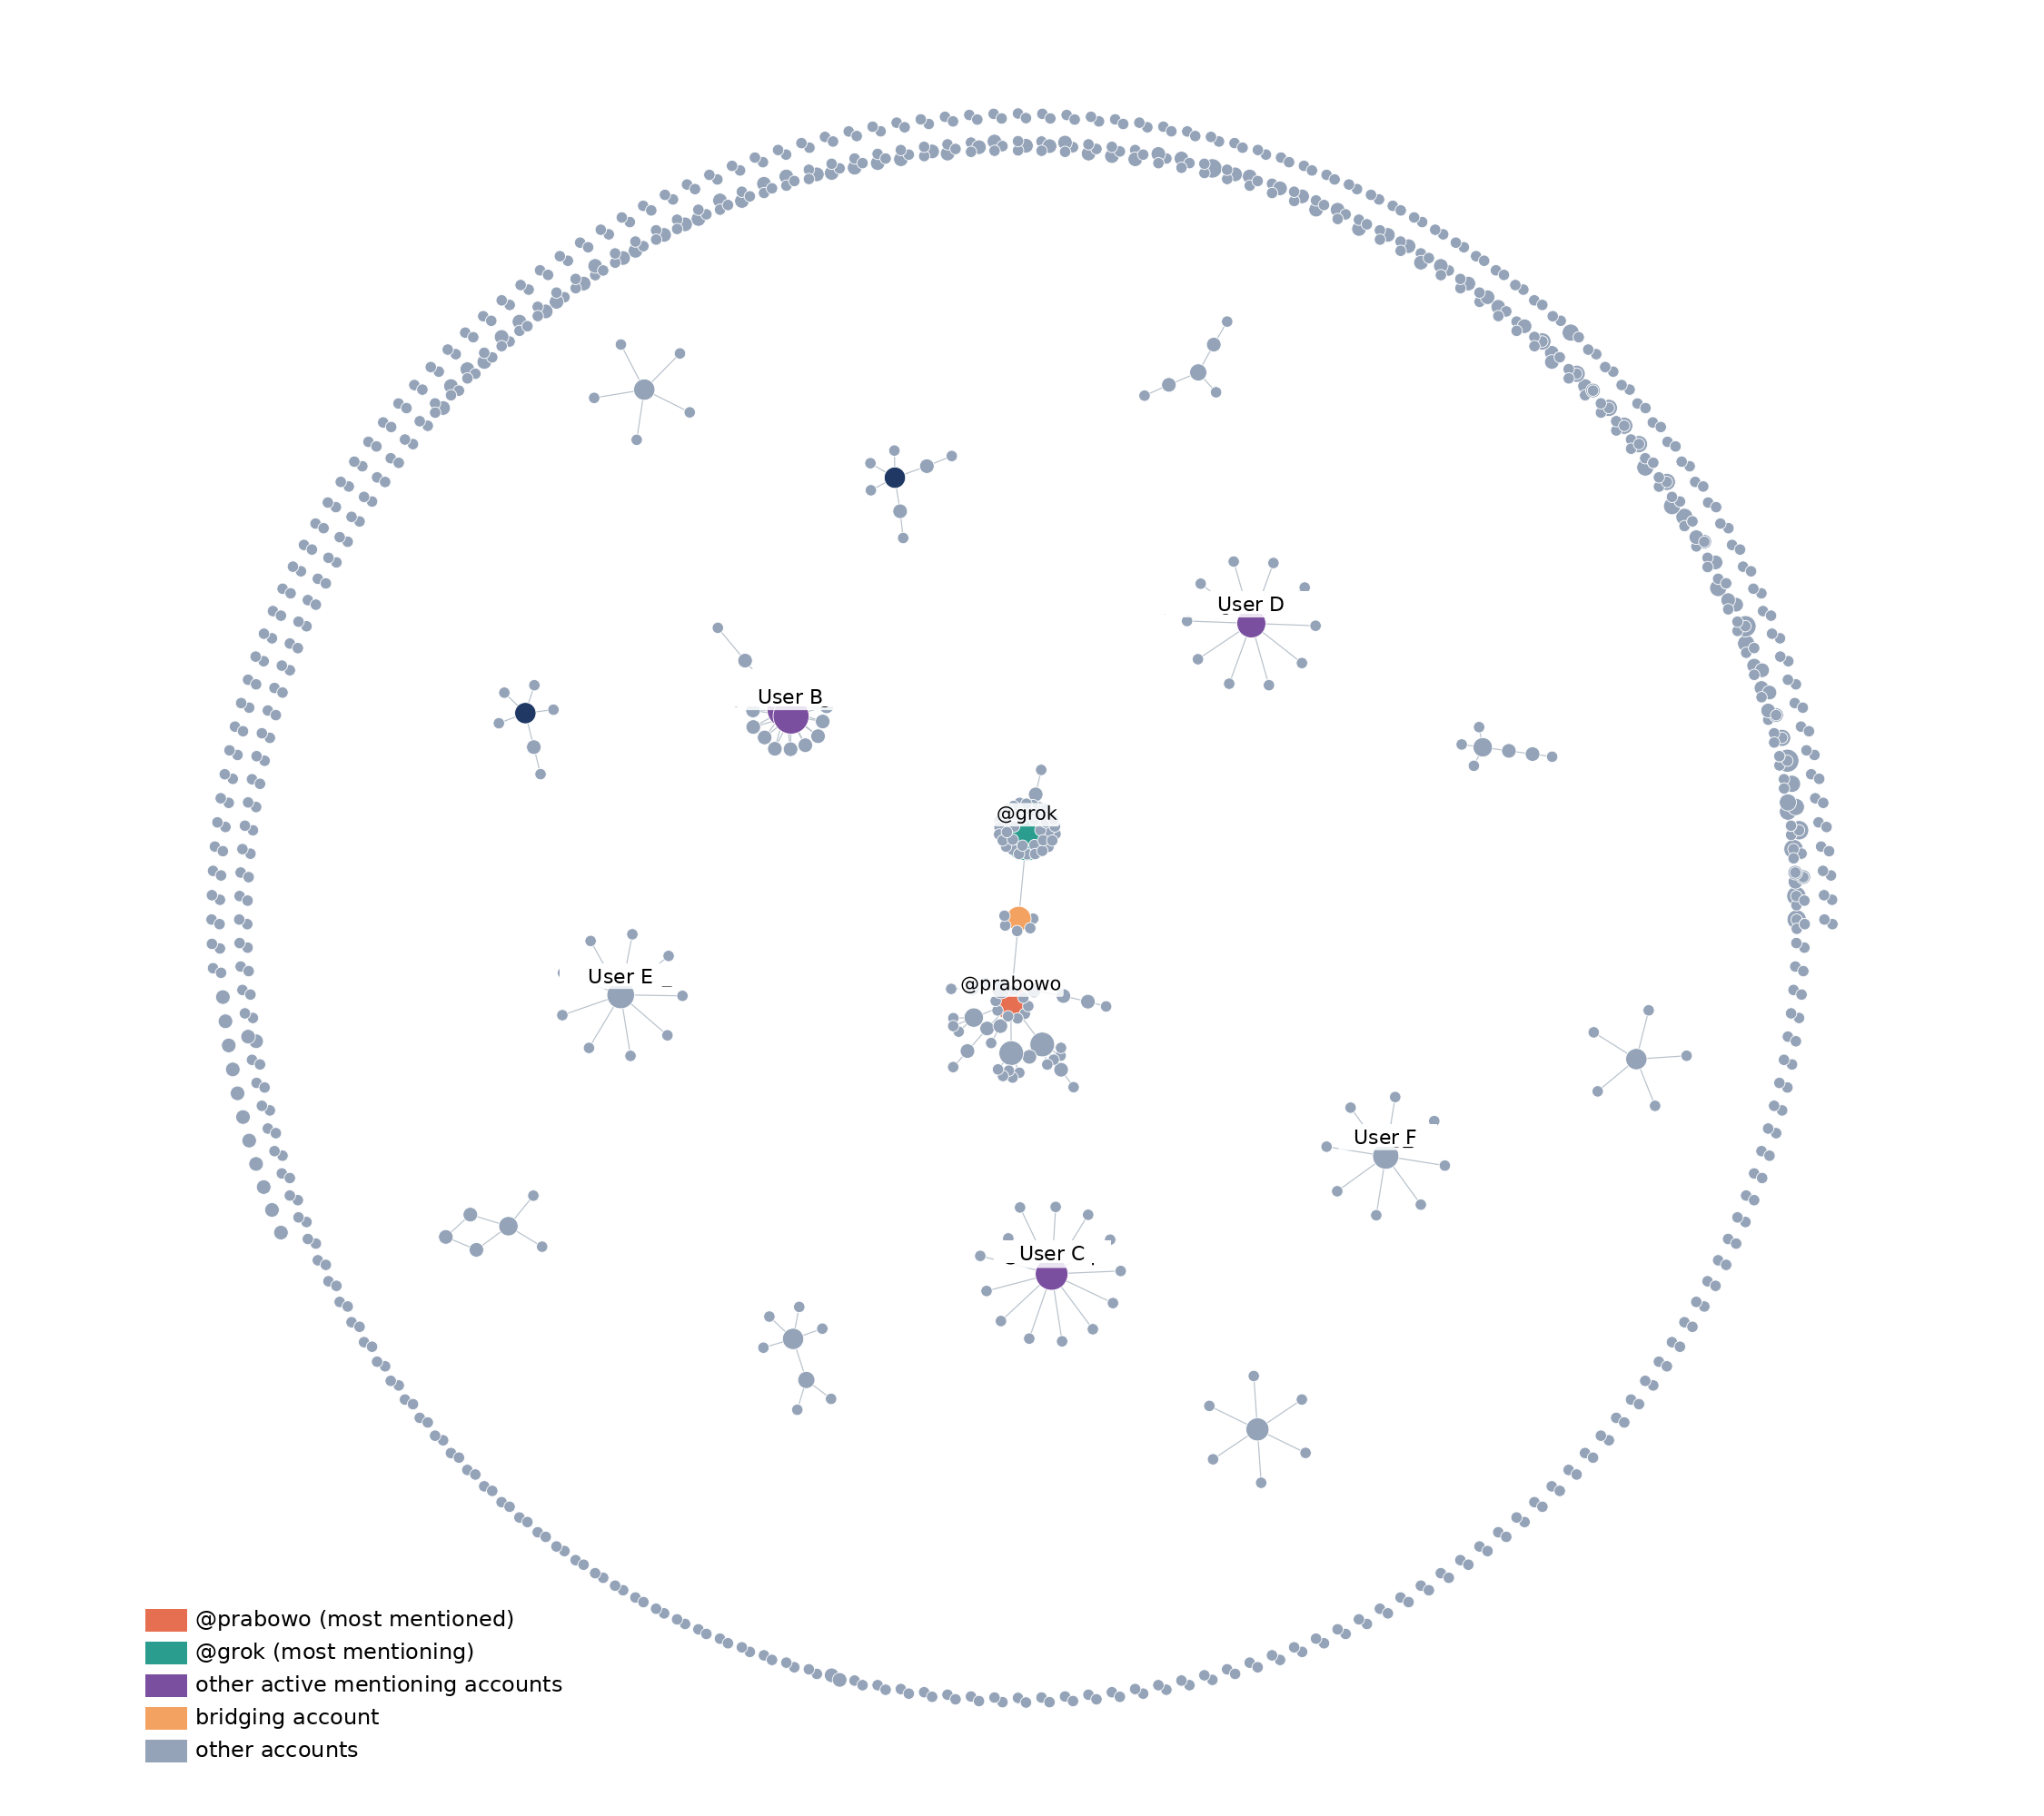
Figure 2. MBG mention network (971 accounts, 666 directed relations)
Note. Node size reflects number of relations. Ordinary users are anonymised. Source: researcher’s analysis of NodeXL Pro data.
Table 5 lists the most central accounts. The President’s account, @prabowo, had the highest in-degree (15), three times that of the next accounts. @grok had the highest out-degree (42), followed by two ordinary users (15 each). @grok and @prabowo also had the highest betweenness (0.005941 and 0.005413), although these values are low in absolute terms. No BGN account appeared as a node, and no post mentioned a BGN account; the government account that did appear was the Ministry of Health (@KemenkesRI).
Table 5. Accounts with the highest in-degree and out-degree
Rank | Most mentioned | In-degree | Most mentioning | Out-degree
1 | @prabowo | 15 | @grok | 42
2 | User G | 5 | User A | 15
3 | User H | 5 | User B | 15
4 | User I | 5 | User C | 13
5 | User J | 4 | User D | 10
Note. Ordinary users are anonymised. Source: researcher’s analysis of NodeXL Pro data.
Louvain clustering produced 342 communities with a modularity of 0.9837 (0.9831 when recomputed), but only 24 communities had five or more members. The two largest centred on @prabowo (46 accounts) and @grok (43 accounts); the rest had 7–18 members. Posts in the @prabowo community most often concerned politics and economy (40 of 116), whereas the @grok community was dominated by unrelated posts (54 of 103) and nutrition questions (25). Between the two periods, the network grew from 109 to 871 accounts and from 65 to 601 relations, but density fell from 0.005522 to 0.000793 and the number of components rose from 46 to 304. Reciprocity appeared only in Period 2 (1.36%). @prabowo remained the most mentioned and @grok the most active mentioner in both periods. Through mentions, content reached 588 distinct accounts, and the median post received 156 views.
Table 6. Mention network in Period 1 and Period 2
Measure | Period 1 | Period 2
Accounts | 109 | 871
Unique directed relations | 65 | 601
Density | 0.005522 | 0.000793
Components | 46 | 304
Reciprocity (%) | 0.00 | 1.36
Most mentioned | @prabowo (3) | @prabowo (12)
Most mentioning | @grok (5) | @grok (37)
Source: researcher’s analysis of NodeXL Pro data.
@grok’s role deserves attention. Of its 93 posts, 24 referred to nutrition, calories or protein, which suggests that users summoned it mainly to ask about nutritional content and food safety. Its answers attracted almost no response: in total they received 8 likes, 4 replies, no retweets and 8,389 views, and 85 of the 93 posts received no engagement. The answers functioned as replies to individual questioners rather than as messages that spread further.
In graph-theoretic terms (Freeman, 1979; Wasserman & Faust, 1994), very low density, hundreds of separate components and near-maximal modularity describe a fragmented network. A modularity far above the 0.3 benchmark (Newman & Girvan, 2004) here reflects many small, disconnected clusters rather than two opposing camps, a shape closer to Himelboim et al.’s (2017) fragmented clusters than to a polarised crowd. This differs from the 2019 presidential election network studied by Suratnoaji et al. (2018), which formed large clusters around candidates. The direction of mentions towards the President, together with the absence of the implementing agency, indicates that citizens addressed criticism upwards to the highest political figure rather than to the institution responsible for the programme. A similar pattern was reported for COVID-19 discourse, where health agencies were not central and decentralisation hindered official messaging (Pascual-Ferrá et al., 2022). The weak brokerage observed here is consistent with Suaib and Pratiwi (2025), who found no strong intermediary accounts in MBG dissemination. The prominence of @grok also departs from earlier work on automated accounts, which focused on bots disguised as humans (Ferrara et al., 2016; Pacheco et al., 2021): here an openly automated account served as a reference point for factual questions.
For government communication, the structure matters as much as the sentiment. In a network where almost every relation runs one way and most clusters do not connect, a message posted by an official account does not travel along existing paths of conversation; it has to be carried into each cluster separately. The growth of the network in Period 2 did not create new bridges: newcomers formed new small clusters instead of joining existing ones. The absence of BGN as a node therefore reflects not only a lack of mentions but a lack of any position from which the agency’s messages could reach the clusters where criticism circulated. The questions put to @grok about calories, protein and food safety indicate an information need that the agency’s own channels might have addressed.
Taken together, the three analyses describe criticism that was frequently indirect and circulated in a network with almost no dialogue. The content side shows sarcasm concentrated on budget and politics; the network side shows fragmentation, one-directional mentions and the absence of the agency’s account. Whether sarcastic posts occupied particular network positions could not be established, because sarcasm was coded on a random sample that was not drawn by network position.
CONCLUSION
This study set out to describe how the MBG programme was discussed on Twitter during the budget revision and kitchen incidents of March–May 2026. On message content, posts about the programme were dominated by anger and disgust, about two in five contained sarcasm, and sarcasm concentrated on budget and political issues, most often as subtle derision. On behaviour, the conversation surged in May, participation was fleeting, and engagement was concentrated in very few posts, with likes far outnumbering replies. On structure, the mention network was sparse, fragmented and almost entirely one-directional; the President was the most mentioned account, an AI reply account was the most active mentioner, and the implementing agency was absent.
Theoretically, the study shows that SIP theory can account for the role of emoji as substitutes for nonverbal cues in policy talk, including their use as sarcasm markers, and that combining content analysis with network analysis reveals a pattern that neither shows alone: indirect criticism circulating among small, disconnected clusters. It also shows that high modularity in policy conversation can signal fragmentation into many small groups rather than polarisation into two camps.
Practically, the absence of BGN from the mention network and the direction of mentions towards the President suggest that the programme’s official channels were not where citizens directed their views on Twitter. The concentration of sarcasm on budget and political issues indicates which criticisms most need a public response. Monitoring that relies only on automated sentiment classification risks reading sarcasm as support, so government media monitoring should include human reading of sarcastic posts.
The study has limitations. Emotion and sarcasm were coded by a single coder on a sample of 49 relevant posts, so the proportions carry wide confidence intervals. Keyword collection captured many posts unrelated to the programme, follower counts were unavailable, the network covers only mention and retweet relations, and Twitter users do not represent the general population (Mellon & Prosser, 2017). Future research should code larger samples with multiple coders, adapt classifiers to Indonesian sarcasm, filter corpora by language and topical relevance at collection, cross-tabulate sarcasm with network position, and examine how citizens respond to AI reply accounts in policy conversation.
REFERENCES
ANTARA. (2026a, May 19). Pemerintah pangkas anggaran MBG jadi Rp268 triliun pada 2026 [Government cuts the MBG budget to Rp268 trillion in 2026]. ANTARA News. https://www.antaranews.com/berita/5573624/pemerintah-pangkas-anggaran-mbg-jadi-rp268-triliun-pada-2026
ANTARA. (2026b, May 25). Tak ada kompromi standar MBG, BGN masih tangguhkan operasi 1.152 SPPG [No compromise on MBG standards: BGN still suspends 1,152 SPPG units]. ANTARA News. https://www.antaranews.com/berita/5581401/tak-ada-kompromi-standar-mbg-bgn-masih-tangguhkan-operasi-1152-sppg
Badan Gizi Nasional. (2026, April 6). BGN antisipasi hoaks, jaga kepercayaan Program MBG [BGN anticipates hoaxes to maintain trust in the MBG programme] (Press Release No. SIPERS-188/BGN/04/2026). https://www.bgn.go.id/news/berita/bgn-antisipasi-hoaks-jaga-kepercayaan-program-mbg
Birkenmaier, L., Lechner, C. M., & Wagner, C. (2024). The search for solid ground in text as data: A systematic review of validation practices and practical recommendations for validation. Communication Methods and Measures, 18(3), 249–277. https://doi.org/10.1080/19312458.2023.2285765
Bisnis.com. (2026, May 20). Purbaya estimasikan anggaran MBG 2026 bakal dihemat Rp67 triliun [Purbaya estimates the 2026 MBG budget will be cut by Rp67 trillion]. https://ekonomi.bisnis.com/read/20260520/10/1974982/purbaya-estimasikan-anggaran-mbg-2026-bakal-dihemat-rp67-triliun
Blondel, V. D., Guillaume, J.-L., Lambiotte, R., & Lefebvre, E. (2008). Fast unfolding of communities in large networks. Journal of Statistical Mechanics: Theory and Experiment, 2008(10), P10008. https://doi.org/10.1088/1742-5468/2008/10/P10008
Bonsón, E., & Ratkai, M. (2013). A set of metrics to assess stakeholder engagement and social legitimacy on a corporate Facebook page. Online Information Review, 37(5), 787–803. https://doi.org/10.1108/OIR-03-2012-0054
Boutet, I., LeBlanc, M., Chamberland, J. A., & Collin, C. A. (2021). Emojis influence emotional communication, social attributions, and information processing. Computers in Human Behavior, 119, 106722. https://doi.org/10.1016/j.chb.2021.106722
boyd, d., & Crawford, K. (2012). Critical questions for big data. Information, Communication & Society, 15(5), 662–679. https://doi.org/10.1080/1369118X.2012.678878
Camp, E. (2012). Sarcasm, pretense, and the semantics/pragmatics distinction. Noûs, 46(4), 587–634. https://doi.org/10.1111/j.1468-0068.2010.00822.x
Ceron, A., & Negri, F. (2016). The “social side” of public policy: Monitoring online public opinion and its mobilization during the policy cycle. Policy & Internet, 8(2), 131–147. https://doi.org/10.1002/poi3.117
CNBC Indonesia. (2026, July 31). 414 dapur MBG bikin pelanggaran berat, diserahkan ke penegak hukum [414 MBG kitchens committed serious violations and were referred to law enforcement]. https://www.cnbcindonesia.com/news/20260731154207-4-755541/414-dapur-mbg-bikin-pelanggaran-berat-diserahkan-ke-penegak-hukum
Cui, J., Dandan, Y. R., & Jiang, G. (2023). Judging emoji by occupation: A case of emoji-based sarcasm interpretation. Acta Psychologica, 234, 103870. https://doi.org/10.1016/j.actpsy.2023.103870
Culnan, M. J., & Markus, M. L. (1987). Information technologies. In F. M. Jablin, L. L. Putnam, K. H. Roberts, & L. W. Porter (Eds.), Handbook of organizational communication (pp. 420–443). SAGE Publications.
Derks, D., Fischer, A. H., & Bos, A. E. R. (2008). The role of emotion in computer-mediated communication: A review. Computers in Human Behavior, 24(3), 766–785. https://doi.org/10.1016/j.chb.2007.04.004
Erle, T. M., Schmid, K., Goslar, S. H., & Martin, J. D. (2022). Emojis as social information in digital communication. Emotion, 22(7), 1529–1543. https://doi.org/10.1037/emo0000992
Ferrara, E., Varol, O., Davis, C., Menczer, F., & Flammini, A. (2016). The rise of social bots. Communications of the ACM, 59(7), 96–104. https://doi.org/10.1145/2818717
Freeman, L. C. (1979). Centrality in social networks: Conceptual clarification. Social Networks, 1(3), 215–239. https://doi.org/10.1016/0378-8733(78)90021-7
Himelboim, I., Smith, M. A., Rainie, L., Shneiderman, B., & Espina, C. (2017). Classifying Twitter topic-networks using social network analysis. Social Media + Society, 3(1), 1–13. https://doi.org/10.1177/2056305117691545
Kompas.com. (2026, May 12). Kemenkes catat 37.000 korban keracunan program Makan Bergizi Gratis hingga Mei 2026 [Ministry of Health records 37,000 poisoning victims of the Free Nutritious Meal programme up to May 2026]. https://regional.kompas.com/read/2026/05/12/184946778/kemenkes-catat-37000-korban-keracunan-program-makan-bergizi-gratis-hingga
Kompas.id. (2026, April 9). Sejak 2025, sebanyak 33.626 pelajar jadi korban keracunan MBG [Since 2025, 33,626 students have been victims of MBG poisoning]. https://www.kompas.id/artikel/sejak-2025-sebanyak-33626-pelajar-jadi-korban-keracunan-mbg
Kralj Novak, P., Smailović, J., Sluban, B., & Mozetič, I. (2015). Sentiment of emojis. PLoS ONE, 10(12), e0144296. https://doi.org/10.1371/journal.pone.0144296
Krippendorff, K. (2018). Content analysis: An introduction to its methodology (4th ed.). SAGE Publications.
Landis, J. R., & Koch, G. G. (1977). The measurement of observer agreement for categorical data. Biometrics, 33(1), 159–174. https://doi.org/10.2307/2529310
Mellon, J., & Prosser, C. (2017). Twitter and Facebook are not representative of the general population: Political attitudes and demographics of British social media users. Research & Politics, 4(3), 1–9. https://doi.org/10.1177/2053168017720008
Miller, H., Thebault-Spieker, J., Chang, S., Johnson, I., Terveen, L., & Hecht, B. (2016). “Blissfully happy” or “ready to fight”: Varying interpretations of emoji. Proceedings of the International AAAI Conference on Web and Social Media, 10(1), 259–268. https://doi.org/10.1609/icwsm.v10i1.14757
Neuendorf, K. A. (2017). The content analysis guidebook (2nd ed.). SAGE Publications.
Newman, M. E. J., & Girvan, M. (2004). Finding and evaluating community structure in networks. Physical Review E, 69(2), 026113. https://doi.org/10.1103/PhysRevE.69.026113
Pacheco, D., Hui, P.-M., Torres-Lugo, C., Truong, B. T., Flammini, A., & Menczer, F. (2021). Uncovering coordinated networks on social media: Methods and case studies. Proceedings of the International AAAI Conference on Web and Social Media, 15(1), 455–466. https://doi.org/10.1609/icwsm.v15i1.18075
Pascual-Ferrá, P., Alperstein, N., & Barnett, D. J. (2022). Social network analysis of COVID-19 public discourse on Twitter: Implications for risk communication. Disaster Medicine and Public Health Preparedness, 16(2), 561–569. https://doi.org/10.1017/dmp.2020.347
Peraturan Presiden Nomor 83 Tahun 2024 tentang Badan Gizi Nasional [Presidential Regulation No. 83 of 2024 on the National Nutrition Agency]. (2024).
Plutchik, R. (1980). Emotion: A psychoevolutionary synthesis. Harper & Row.
Sianturi, H. R. P. (2025). Politics on a plate: Equivocal communication in Indonesian presidential nutrition policy. Frontiers in Communication, 10, 1612652. https://doi.org/10.3389/fcomm.2025.1612652
Stieglitz, S., & Dang-Xuan, L. (2013). Emotions and information diffusion in social media—Sentiment of microblogs and sharing behavior. Journal of Management Information Systems, 29(4), 217–248. https://doi.org/10.2753/MIS0742-1222290408
Suaib, N. R., & Pratiwi, D. A. (2025). Social network analysis in the dissemination of Makan Bergizi Gratis (MBG) program information on social media X. Jurnal Sosial Humaniora dan Pendidikan, 4(2), 9–16. https://doi.org/10.56127/jushpen.v4i2.2067
Suhartono, D., Wongso, W., & Tri Handoyo, A. (2024). IdSarcasm: Benchmarking and evaluating language models for Indonesian sarcasm detection. IEEE Access, 12, 87323–87332. https://doi.org/10.1109/ACCESS.2024.3416955
Suratnoaji, C., Arianto, I. D., & Sumardjijati, S. (2018). Strength map of presidential candidates 2019 in Indonesia based on a NodeXL analysis of big data from Twitter. Asian Journal for Public Opinion Research, 6(1), 31–38. https://doi.org/10.15206/ajpor.2018.6.1.31
Undang-Undang Nomor 59 Tahun 2024 tentang Rencana Pembangunan Jangka Panjang Nasional Tahun 2025–2045 [Law No. 59 of 2024 on the National Long-Term Development Plan 2025–2045]. (2024).
Walther, J. B. (1992). Interpersonal effects in computer-mediated interaction: A relational perspective. Communication Research, 19(1), 52–90. https://doi.org/10.1177/009365092019001003
Walther, J. B., & D’Addario, K. P. (2001). The impacts of emoticons on message interpretation in computer-mediated communication. Social Science Computer Review, 19(3), 324–347. https://doi.org/10.1177/089443930101900307
Wasserman, S., & Faust, K. (1994). Social network analysis: Methods and applications. Cambridge University Press.
Weissman, B., & Tanner, D. (2018). A strong wink between verbal and emoji-based irony: How the brain processes ironic emojis during language comprehension. PLoS ONE, 13(8), e0201727. https://doi.org/10.1371/journal.pone.0201727
Wilie, B., Vincentio, K., Winata, G. I., Cahyawijaya, S., Li, X., Lim, Z. Y., Soleman, S., Mahendra, R., Fung, P., Bahar, S., & Purwarianti, A. (2020). IndoNLU: Benchmark and resources for evaluating Indonesian natural language understanding. In Proceedings of the 1st Conference of the Asia-Pacific Chapter of the Association for Computational Linguistics and the 10th International Joint Conference on Natural Language Processing (pp. 843–857). Association for Computational Linguistics. https://aclanthology.org/2020.aacl-main.85

