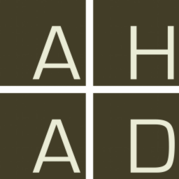

|  |
| --- |
|  |

Your use of AHAD indicates your acceptance of the following Terms & Conditions of Use:

Knowledge gained through the efforts of many researchers is shared through AHAD in order to encourage and facilitate archaeological and related research. Use of this information is subject only to the minimal conditions of a Creative Commons Attribution License (as adapted here) but applicable whether or not the data provided by this site are legally subject to copyright.

You are free to copy or distribute this content or to use it in derivative works (e.g., to publish or otherwise distribute an argument based on analyses of these data) under the following four conditions:

1. You must accompany all uses and applications of this content with proper citation and attribution of relevant contributors (as provided by AHAD with the content).
2. For any redistribution of information resources, you must clearly cite and attribute relevant contributors, and make clear to others the license terms of this work.
3. You will not use content obtained through AHAD in ways that could be reasonably expected to lead, directly or indirectly, to damage to the archaeological record.
4. You acknowledge that neither AHAD, its sponsors and associates, nor those individuals and institutions providing content through AHAD, guarantee the accuracy or usability of the content and further agree that you may not hold any of these parties liable for any direct or consequential damage arising from your use of AHAD or its content.