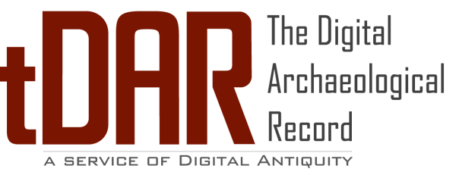

|  |
| --- |
|  |

Your use of tDAR indicates your acceptance of the Terms & Conditions of Use, available at <http://www.tdar.org/support/policies/term-of-use/>. tDAR is an international digital repository developed and maintained by the Center for Digital Antiquity, a not-for-profit organization that helps scholars, researchers, educators and students, and interested members of the general public discover, use, and preserve a wide range of information about archaeology and archaeological resources. For more information about the Center for Digital Antiquity, visit our web site <http://digitalantiquity.org>. For more information about tDAR, see <http://www.tdar.org>. We welcome your comments via email at [comments@tdar.org](mailto:comments@tdar.org) or phone at 480-965-1387.