HyperAether: A Semantic-Native Distributed Architecture for Collaborative Processing Among Heterogeneous Large Language Models
Hirofumi Inomata | Hyper-Aether Laboratory | inomata@acm.org
Revised manuscript • 20 October 2026 • Architecture proposal

Abstract
HyperAether (HA) is a semantic-native distributed system designed to enable collaborative distributed processing among heterogeneous large language models (LLMs). The revised architecture uses a Semantic Data Unit as its common unit of processing, exchange, memory management, and synchronization. The choice is motivated by the possibility of expressing semantic information in natural language and reconstructing it in different LLM environments without transferring model-specific embedding vectors or sharing a common latent coordinate system. Each VM or node hosts an LLM, independent Semantic Memory, semantic conversion, local tools, and an optional /sleep internal-learning process. A shared HA Semantic Fabric provides semantic routing, cooperation, provenance management, and Semantic Knowledge Interchange (SKI). SKI transports both natural-language-compatible meaning and structured metadata, including conditions, identity, truth status, provenance, version, and source–destination references. This paper revises an earlier VM-graph-based Hyper-Aether proposal: VM-graph dynamics remain a potential deployment and adaptive-coordination model, while semantic data and heterogeneous LLM interoperability become the principal architectural focus. We specify operational semantics, exchange and synchronization protocols, consistency boundaries, failure modes, and an evaluation plan. The proposal is conceptual; no measured interoperability, scalability, or learning results are claimed.
Keywords: HyperAether; distributed LLM; semantic interoperability; SKI; Semantic Memory; semantic routing; natural-language interchange; knowledge synchronization; continual learning.

1. Introduction
The objective of HyperAether is to make collaborative distributed LLM processing possible. HA is not defined as an alternative to, or performance comparison with, conventional distributed computing. Instead, it addresses a specific architectural problem: how multiple LLMs, potentially different in tokenizer, weights, architecture, and semantic vector space, can exchange knowledge and process interdependent semantic requests while retaining local autonomy.
An earlier Hyper-Aether manuscript modeled computation as a dynamically evolving graph of virtual machines governed by an AI Shell. It treated virtual machines as semantic computational units. The present revision narrows and clarifies the system’s purpose. A VM is a host and isolation boundary for LLM capabilities, whereas the transferable processing unit is semantic data. Existing graph-dynamics ideas are retained as optional mechanisms for node discovery, routing, and reconfiguration, not as a requirement that meaning be encoded directly in VM graph topology.

2. Motivation and Design Requirements

2.1. Why semantic data is the interchange unit
Embedding vectors are meaningful only in relation to a model, its representation basis, and its training or projection conventions. Therefore, direct transfer of an arbitrary embedding between heterogeneous LLMs does not by itself ensure interpretable knowledge transfer. Semantically expressible content can instead be serialized in natural language and supported by structured fields. A receiving LLM interprets that content and constructs local semantic representations, including its own embeddings if useful.
A conventional task may have a natural-language description of its intent, but arbitrary executable state, stack frames, locks, and side effects are not generally convertible into a complete natural-language semantic representation. HA therefore distinguishes portable semantic intent and knowledge from local executable tasks. This is a distinction of representational purpose, not a claim that no tasks can be described in natural language.

2.2. Requirements
- Heterogeneous LLMs must exchange knowledge without requiring parameter or embedding-space equivalence.
- Semantic units must preserve identity, assertions, conditions, truth status, provenance, and revision history.
- Each node owns its local Semantic Memory and decides independently how to interpret and operationalize received units.
- Routing and collaboration must operate on semantic capabilities and policy, not only on compute location.
- Semantic Memory replication and model-parameter internal learning must be distinct operations.
- The protocol must expose ambiguity, contradictions, stale knowledge, duplication, and partial failures rather than silently treating every transfer as equivalent.

3. Revised Architecture
Figure 1 presents the revised HA decomposition. The HA Semantic Fabric coordinates information exchange among independent VM/node environments. Each node contains an LLM, its Semantic Memory, a natural-language/semantic conversion function, a local executor or tool interface, and optional /sleep learning. The fabric offers SKI exchange, semantic routing, policy, record identity, provenance, and coordination.
Here and below, “distributed LLM processing” refers to cross-node collaboration on meaning, reasoning requests, shared knowledge, and delegated execution. It does not imply partitioning a single neural-network forward pass or synchronizing neural weights.
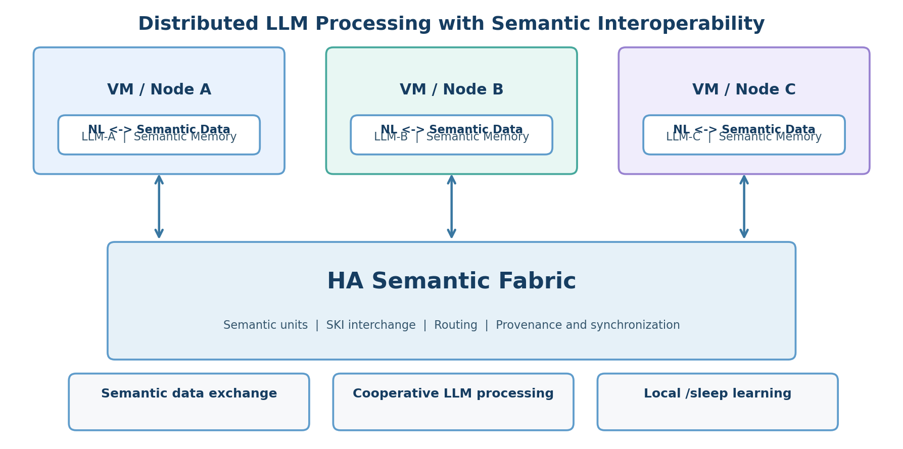
Figure 1. Revised HyperAether architecture: independent LLM nodes connected through a semantic fabric.

3.1. Logical components
LLM node: Provides interpretation, generation, inference, and local task dispatch. LLM implementations may differ across nodes.
Semantic Memory: Stores locally interpreted assertions, relations, provenance, versions, and pending internalization state.
Semantic converter: Renders semantic units into natural language and parses natural language into candidate structured semantic records.
SKI interface: Serializes, transports, validates, acknowledges, and associates corresponding semantic records across nodes.
Semantic routing and coordination: Selects relevant nodes by semantic capabilities, scope, confidence, policy, and availability.
/sleep internal learning: Optionally converts selected, validated Semantic Memory records into local parameter updates; this is not required for knowledge exchange.

4. Semantic Data Model
A Semantic Data Unit (SDU) is a portable representation of a proposition, relation, instruction intent, question, or update, accompanied by interpretation and governance metadata. It is not merely a vector and is not assumed to be fully captured by a sentence alone.
SDU = (id, meaning, context, conditions, status, provenance, version, links) (1)
The canonical meaning may comprise subject–predicate–object structures, typed arguments, natural-language renderings, constraints, and disambiguation annotations. Vectors, graphs, or symbolic forms remain node-local implementation artifacts derived from the SDU.

4.1. Illustrative SKI payload
{
"semantic_id": "urn:ha:node-a:sem-001",
"type": "assertion",
"statement": "A quantum sensor uses quantum-mechanical effects.",
"language": "en",
"structure": {"subject": "quantum sensor", "predicate": "uses",
"object": "quantum-mechanical effects"},
"truth_status": "ASSERTED",
"context": {"scope": "general description"},
"version": 1,
"origin_node": "node-a",
"correspondences": [{"node": "node-b", "semantic_id": "urn:ha:node-b:sem-884"}]
}
This payload is illustrative, not a finalized SKI schema. ASSERTED denotes a record’s assertion state, not independently verified scientific truth. A production schema should distinguish asserted, verified, disputed, false, and outdated claims and define who can change these labels.

4.2. Cross-model interpretation
SDU_A --serialize--> (natural language + structured metadata) --interpret_B--> SDU_B (2)
The intended invariant is meaning preservation subject to declared context and uncertainty, not bytewise identity or equality of embedding vectors. The source and destination SDUs may have different local representations but retain an explicit correspondence link.

5. Semantic Knowledge Interchange (SKI)
SKI is the exchange mechanism for semantic units across LLM nodes. A source constructs a canonical exchange record, records the transmission event, and forwards it to one or more destinations. A destination validates the message, interprets it, stores or rejects a local semantic record, and returns its local record identifier and disposition. Both ends maintain the relationship between source and destination records. For multiple destinations, separate correspondence entries are retained for each peer.

5.1. Proposed transfer lifecycle
- Prepare: select SDU, serialize meaning and metadata, include originating ID and version.
- Receive and validate: check schema, authenticity, duplicate identifiers, context, and policy.
- Interpret: construct destination-local candidate meaning; retain ambiguity and uncertainty flags.
- Commit or reject: persist accepted candidate, or return a reason for rejection or manual review.
- Acknowledge and link: exchange destination record ID; persist bidirectional correspondence.
- Synchronize: exchange subsequent revisions and resolve concurrent edits under explicit policies.
Bidirectional reference metadata enables traceability, but it does not alone ensure distributed consistency. Delivery ordering, idempotency, conflict detection, authentication, and reconciliation must be specified as independent protocol concerns.

5.2. Synchronization semantics
A practical implementation can begin with versioned records, causal metadata, idempotent updates, and asynchronous eventual convergence where policy permits. Contradictory statements must not be automatically merged into a single unqualified truth. A provenance-preserving multi-version record can represent disagreement until validation or authorized reconciliation.

6. Distributed Processing and Semantic Routing
A semantic request is represented as an SDU with intent, dependencies, context, and expected output form. A coordinator resolves the request to capable nodes, delegates selected semantic work, and aggregates the returned results. Node-specific tools execute concrete tasks locally; semantic units describe why and what should be done, without pretending to serialize arbitrary execution state.
route(SDU, capabilities, policy, context) -> candidate nodes (3)
Suggested routing criteria include relevance to known domains, trust policy, source quality, data locality, estimated cost, uncertainty, availability, and required execution tools. Routing decisions and their rationale should be logged to support reproducibility and audit.

7. Distributed Semantic Memory and /sleep
Each node maintains an independently interpretable Semantic Memory. Exchanged knowledge becomes available to inference and retrieval after local acceptance; no model weight synchronization is necessary. The optional /sleep process subsequently learns selected memory items into local weights. A staged rollout can require pre-learning validation, preserved-known-answer checks, hold-out tests, and rollback upon regression.
A shared semantic record is thus distinct from internalized model knowledge: Memory synchronization transfers explicit records, whereas /sleep updates model parameters. The latter may be asynchronous, node-specific, and incomplete. HA must not interpret successful SKI acknowledgement as proof of successful internal learning.

8. Relationship to the Original VM-Graph Framework
The July 2026 Hyper-Aether proposal introduced H = (C, V, R, A): compute substrate, VM space, routing network, and AI Shell. It modeled a VM as a stateful transformer and proposed stochastic graph transitions. These constructions can still describe infrastructure-level adaptation and node composition, but they no longer define HA’s basic semantic processing unit. The revised logical system is more directly characterized as:
HA = (N, M, S, K, Q, L) (4)
where N denotes distributed LLM nodes, M local Semantic Memories, S transferable semantic units, K the SKI interchange protocol, Q coordination/routing policy, and L optional local internal-learning mechanisms. This is a conceptual decomposition rather than a formal proof of completeness.
For traceability, Figures 2–4 reproduce the three diagrams in the source manuscript. They are labeled legacy because their VM-graph emphasis is historical and should not be misread as the new system boundary.
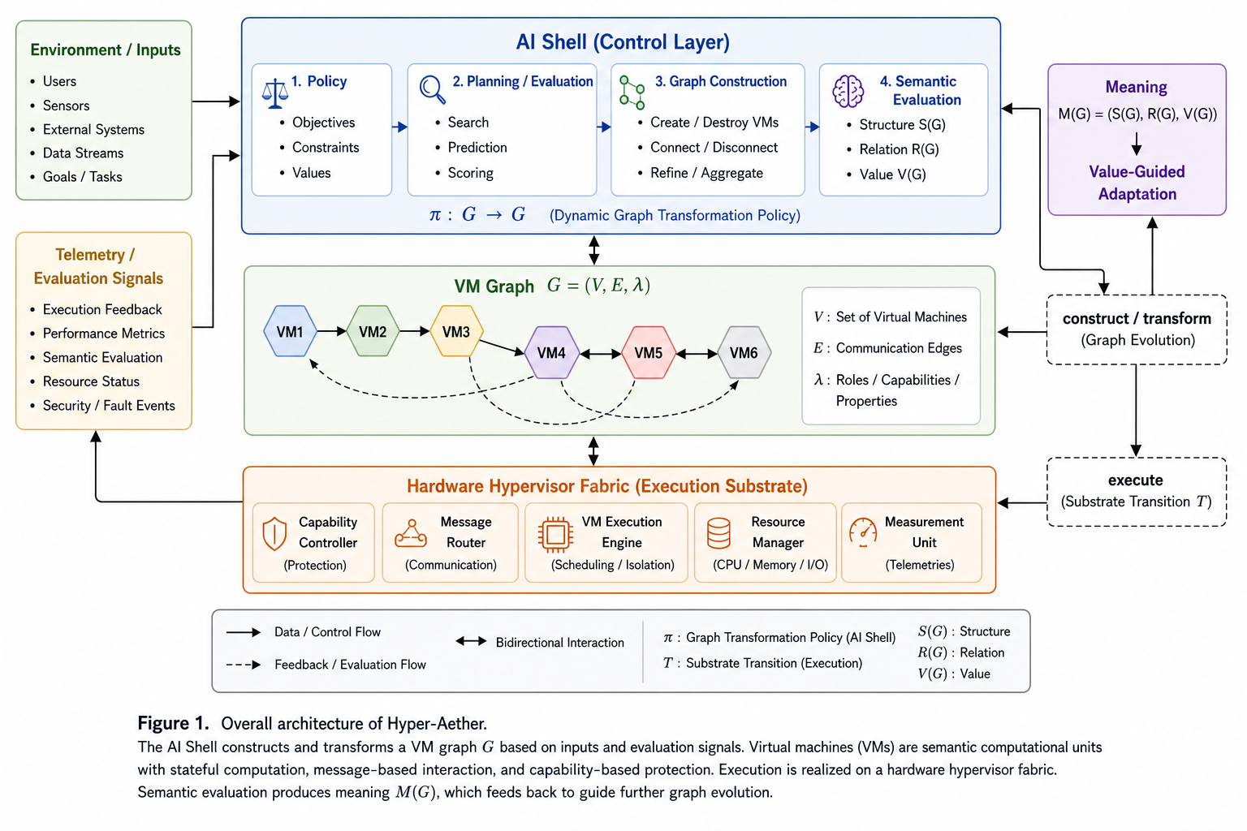
Figure 2 (legacy). Original AI Shell and VM-graph architecture from the July 2026 manuscript.
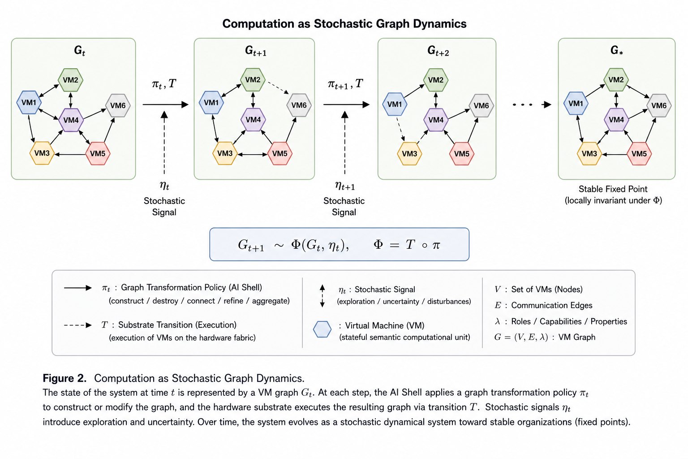
Figure 3 (legacy). Original stochastic graph-dynamics view of VM reconfiguration.
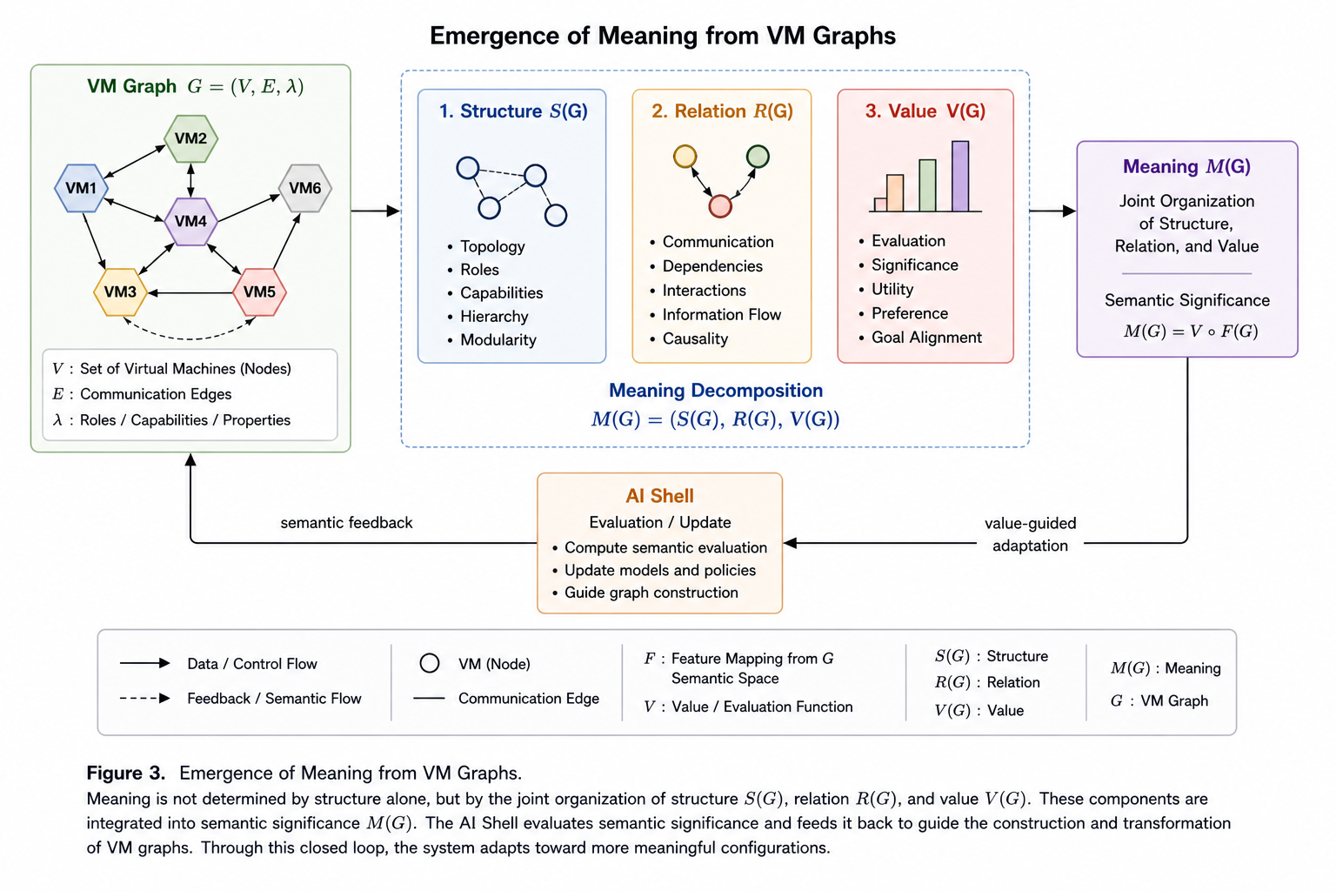
Figure 4 (legacy). Original account of structure, relation, value, and meaning.

8.1. Preserved theoretical concepts
The original manuscript also discussed evolving formal systems, VM granularity, symbolic/neural/reactive models, stochastic graph dynamics, creativity, category-theoretic interpretation, and Turing-complete expressiveness. These are retained as exploratory background hypotheses rather than validated consequences of the revised SKI architecture. In particular, Gödelian incompleteness does not, by itself, establish a need for dynamically expanding VM networks or a proof of superior semantic interoperability.

9. Research Hypotheses and Evaluation Plan
The proposed system should be evaluated through reproducible experiments rather than architectural claims alone. The following measurements are suggested; they are not reported experimental results.
Dimension | Proposed observations
Semantic preservation | Round-trip proposition/condition retention; human-graded equivalence; ambiguity and contradiction rates
Cross-model portability | Accuracy across dissimilar LLMs without shared embeddings; comparison of plain text versus structured SKI
Distributed correctness | Duplicate-message handling, conflict convergence, missing acknowledgements, and correspondence integrity
Routing effectiveness | Task success, delegation precision, latency, and cost under heterogeneous node capability
Learning isolation | Before/after /sleep recall gains, known-answer retention, regression rate, and rollback success
Robustness and security | Adversarial semantic payloads, provenance tampering, stale versions, and policy violations

10. Limitations and Open Issues
- Natural-language interchange is not lossless by default: multilingual variation, implicature, scope, negation, and uncertainty can alter interpretation.
- A common syntax is not equivalent to a common ontology. Entity resolution, unit normalization, and contextual equivalence require explicit validation.
- Provenance, truth status, and trust are distinct; recorded sources do not guarantee correctness.
- Eventual consistency may be unacceptable for safety-critical or strongly ordered actions.
- /sleep internalization can introduce forgetting or contamination, and independent models may diverge after learning.
- Semantic routing can add coordination overhead and introduce privacy, authentication, and authorization risks.

11. Conclusion
This revision defines HyperAether primarily as a distributed system for collaborative processing across heterogeneous LLMs. The common portable unit is semantic data, which can be expressed in natural language and reinterpreted locally with supporting structured metadata. SKI provides the proposed exchange mechanism; independent Semantic Memories retain locally usable knowledge; the HA Semantic Fabric coordinates cross-node processing; and /sleep is an optional, separate internalization stage. The original VM-graph ideas remain relevant to adaptive deployment, but are subordinate to the new semantic interoperability objective. Demonstrating reliable meaning preservation, distributed consistency, safe coordination, and measured learning benefit is the next research priority.

Source and Revision Notes
Primary source: H. Inomata, “Hyper-Aether: AI-Native Computing Architecture with Virtual Machines as Semantic Computational Units,” Hyper-Aether Laboratory, July 2026, supplied six-page PDF (HyperAether2026-07-VM02.pdf). This revised manuscript updates its central system definition and introduces new architectural and protocol proposals from the October 2026 design discussion. The figures labeled legacy are taken from that source. No external literature survey or empirical verification is represented in this revision.

