

CHAROTAR UNIVERSITY OF SCIENCE AND TECHNOLOGY

FACULTY OF TECHNOLOGY AND ENGINEERING

B. TECH (IT/CE/CSE/AIML)

Subject: Advanced Web Development Frameworks (ITUE301) | Semester: 5th

Practical Statement:

- Develop a multi-page Student Portfolio website by extending the existing React portfolio application. Implement React Router for seamless navigation between Home, Projects, and Contact pages without page reloads. Use the useState hook to manage dynamic UI elements such as a dark/light mode toggle and a controlled contact form with live input and character count. Also, include a 404 Not Found page for invalid routes while maintaining a responsive and reusable component-based design.

Screenshots:
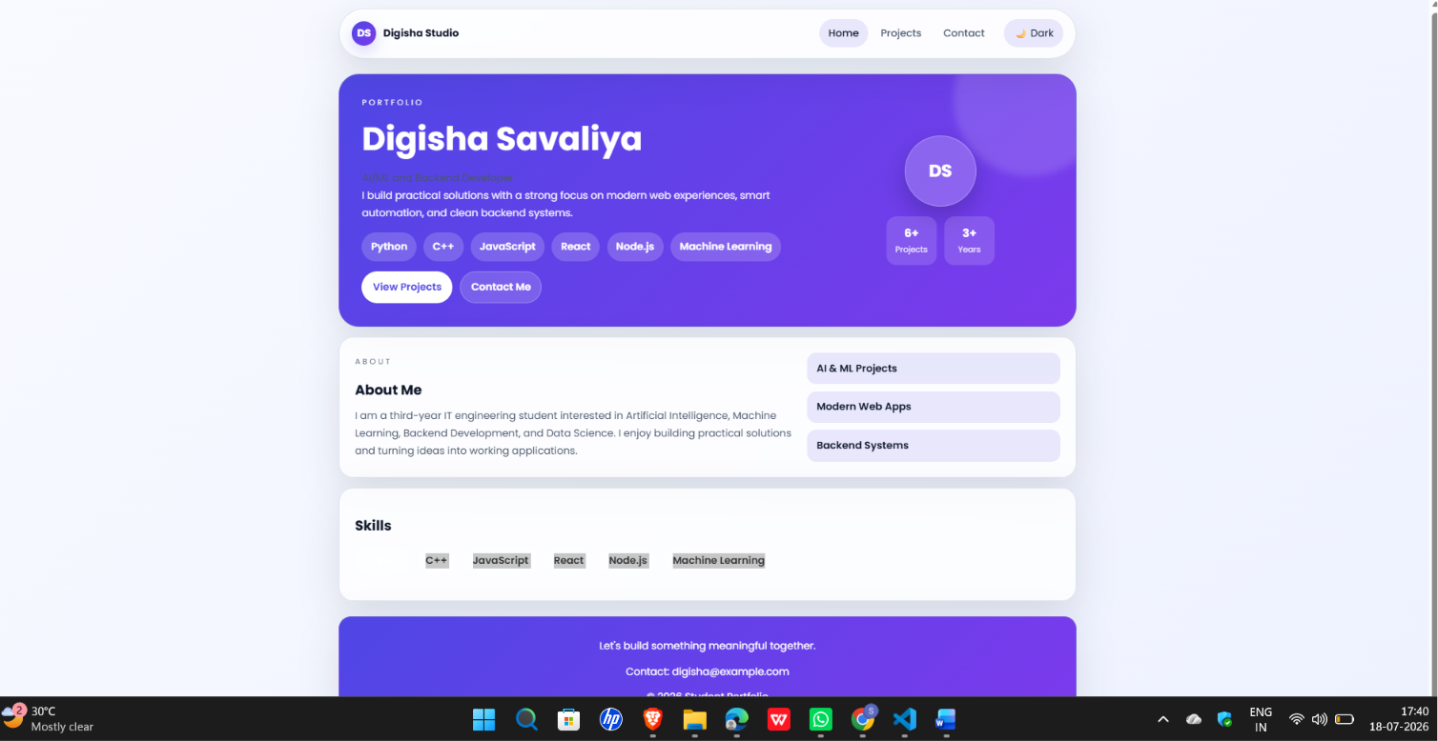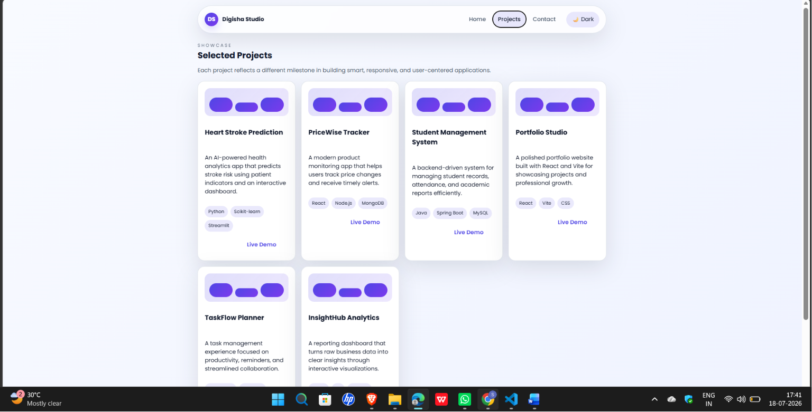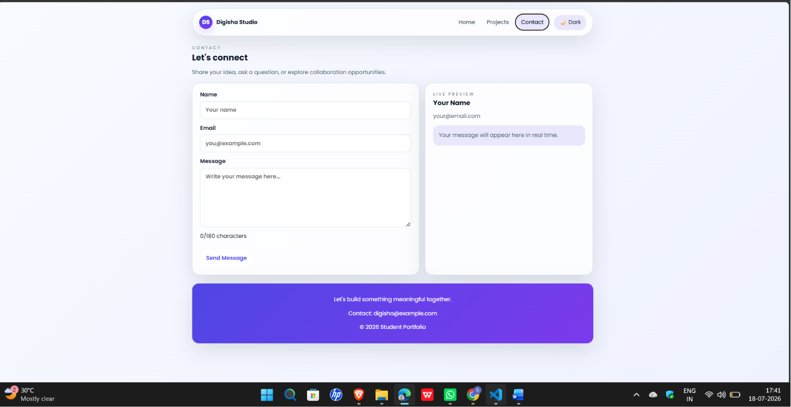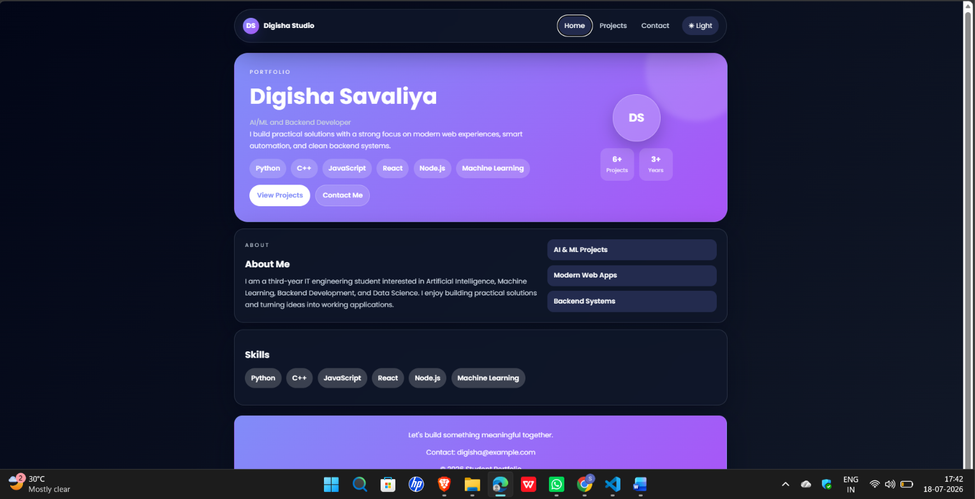

Github Repo Link:

- https://github.com/digishasavaliya/ITUE301_AWDF.git

