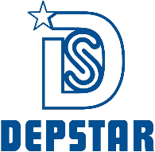

CHAROTAR UNIVERSITY OF SCIENCE AND TECHNOLOGY

FACULTY OF TECHNOLOGY AND ENGINEERING

B. TECH (IT/CE/CSE/AIML)

Subject: Advanced Web Development Frameworks (ITUE301) | Semester: 5th

Practical Statement:
- Connect the React Task UI to the Node+MongoDB backend built in Practicals 4 and 5.
- Replace the GitHub repo data from Practical 3 with task data from your own backend.
- The application must support creating, viewing, updating, and deleting tasks from the React interface through API calls.
- All data must be persisted in MongoDB confirmed by refreshing the browser and seeing data remain.
- Handle loading and error states for every API interaction, not just the initial fetch.

Screenshots:
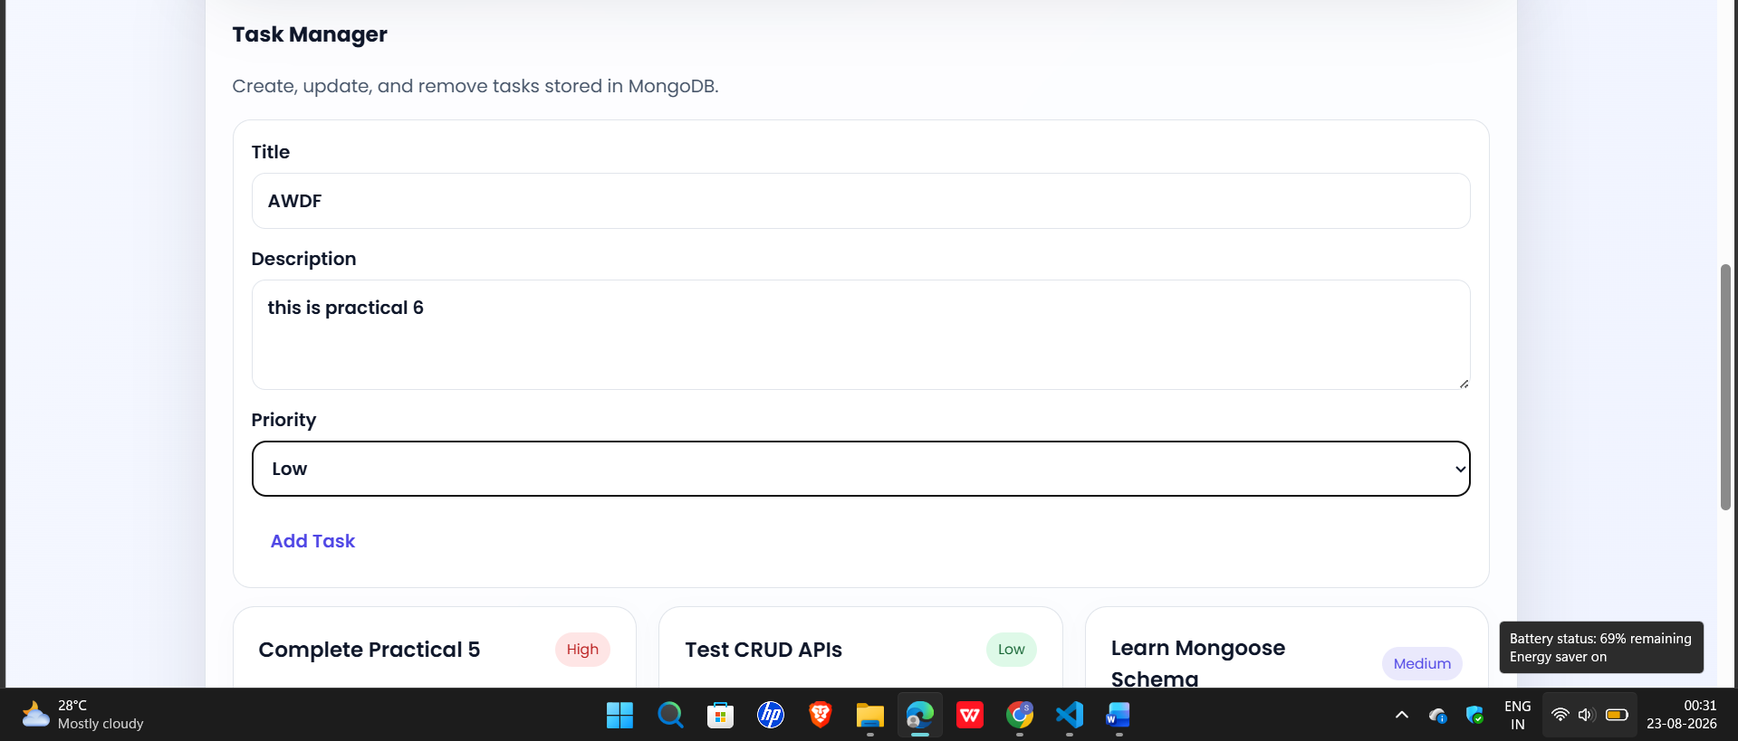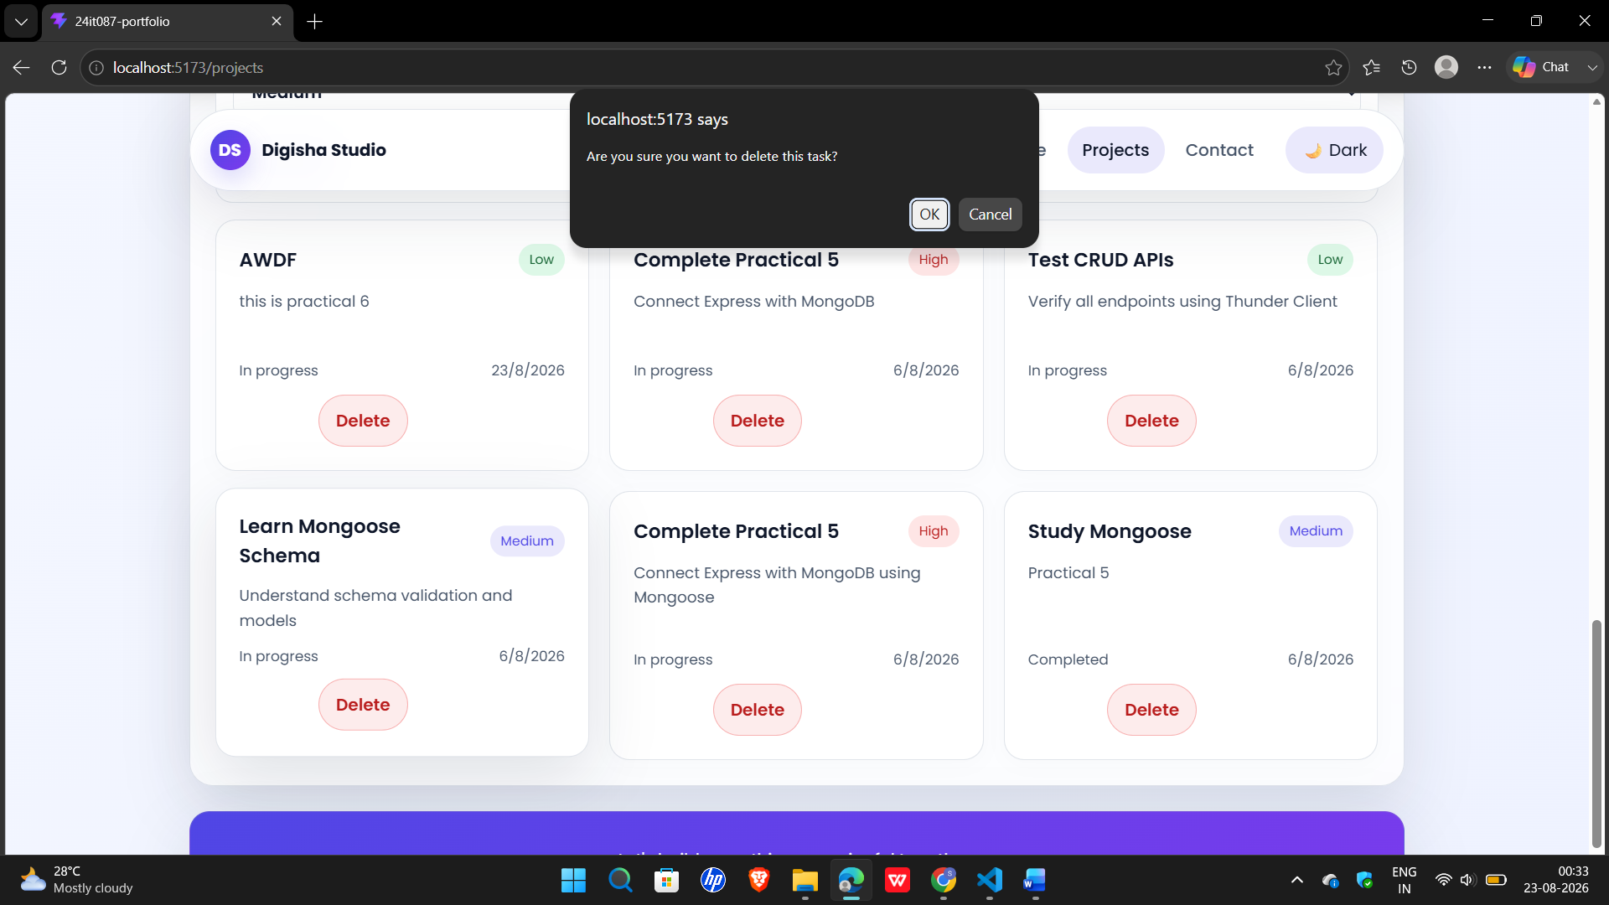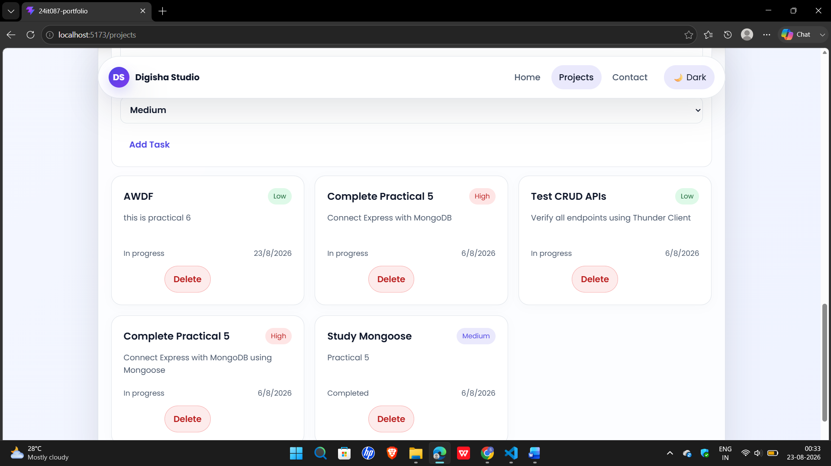

Github Repo Link:
https://github.com/digishasavaliya/ITUE301_AWDF.git

