

CHAROTAR UNIVERSITY OF SCIENCE AND TECHNOLOGY

FACULTY OF TECHNOLOGY AND ENGINEERING

B. TECH (IT/CE/CSE/AIML)

Subject: Advanced Web Development Frameworks (ITUE301) | Semester: 5th

Practical Statement:
- Add a background notification system to the Task Management application using Node.js built-in EventEmitter.
- When a new task is created via the API, emit a task-created event handled asynchronously.
- The event handler must log a notification (task title, timestamp, assigned user) without blocking the main response.
- The main API response must return immediately, before the event handler finishes executing.
- Demonstrate the difference between synchronous and asynchronous handling by logging timestamps at both the API response point and the event handler execution point.

Screenshots:
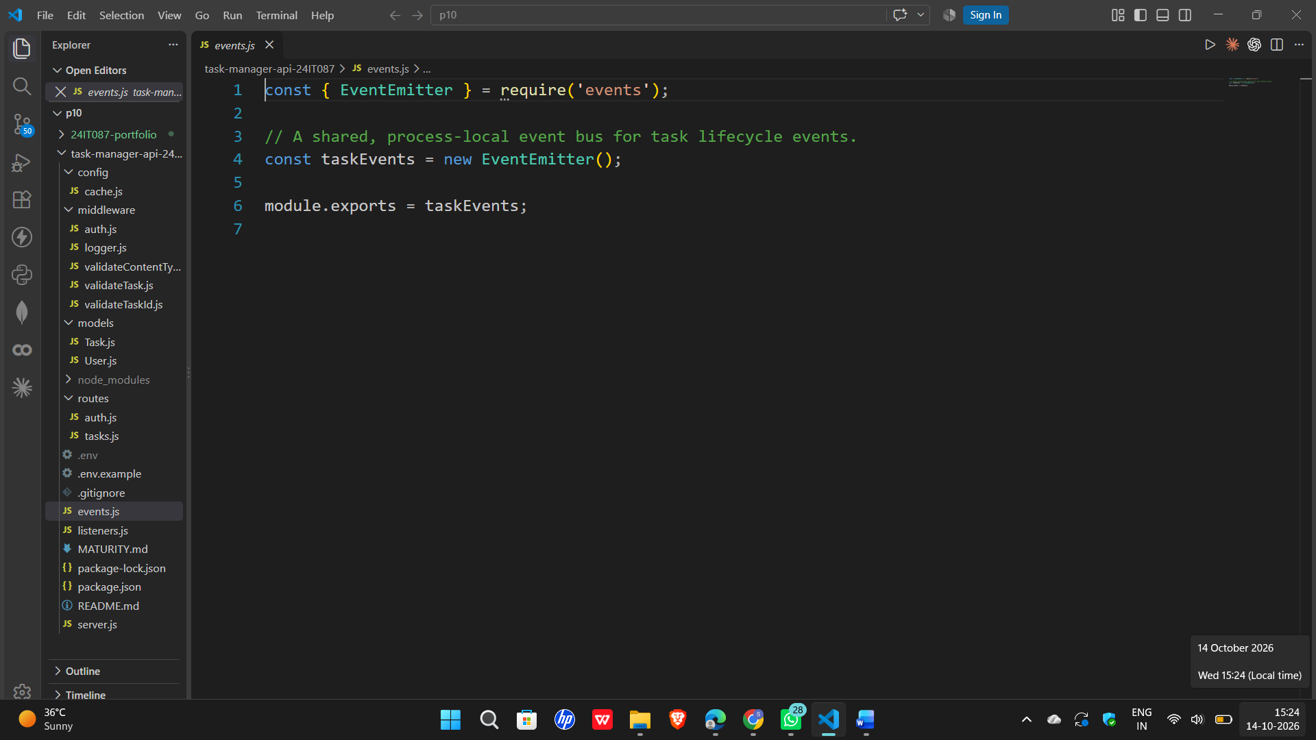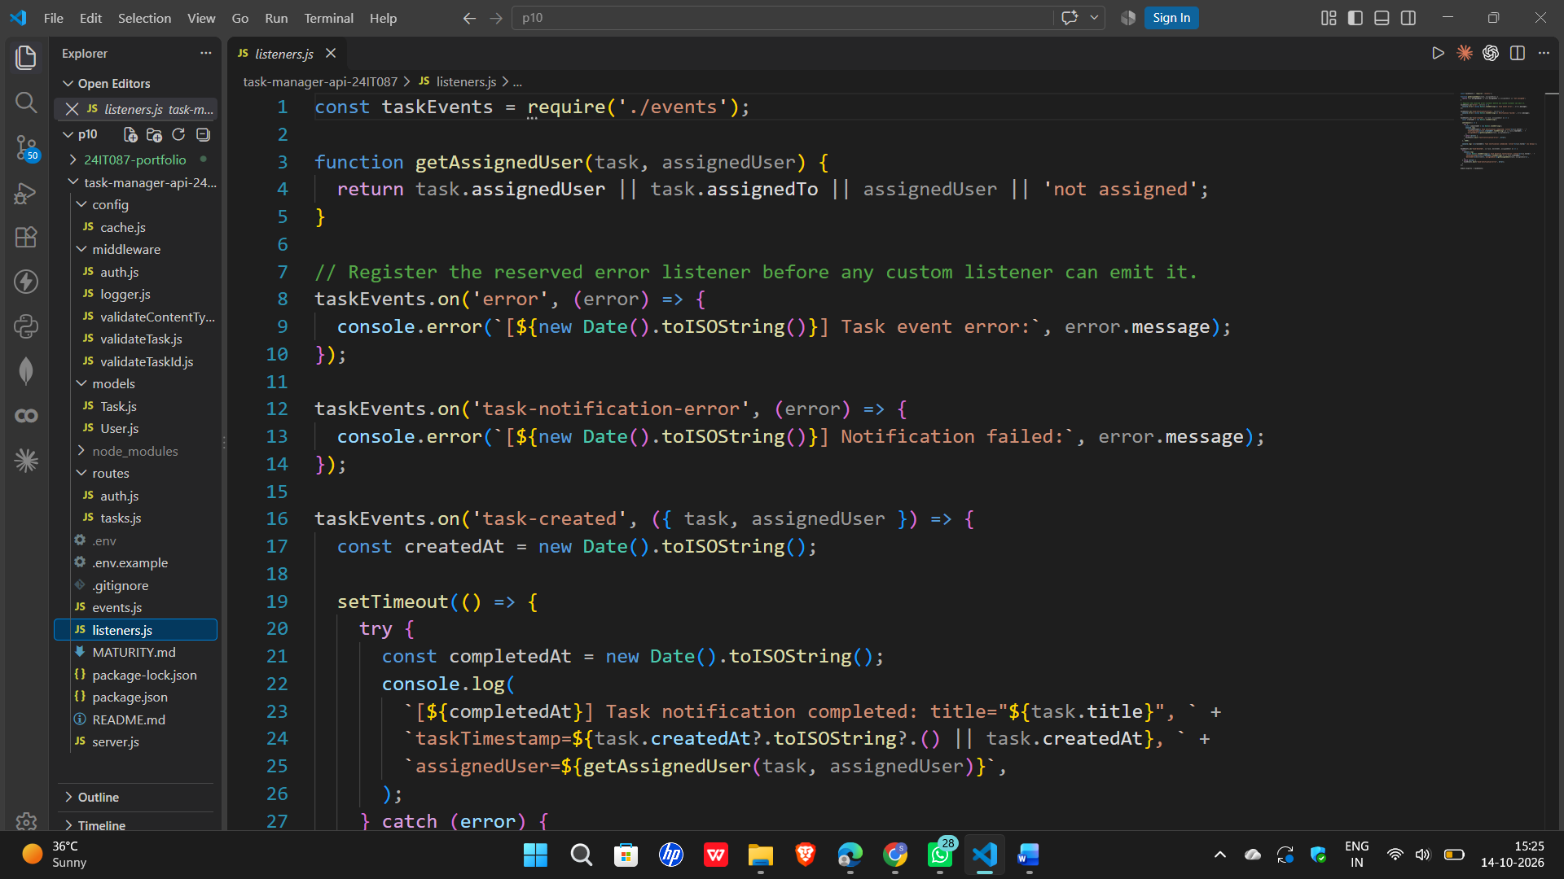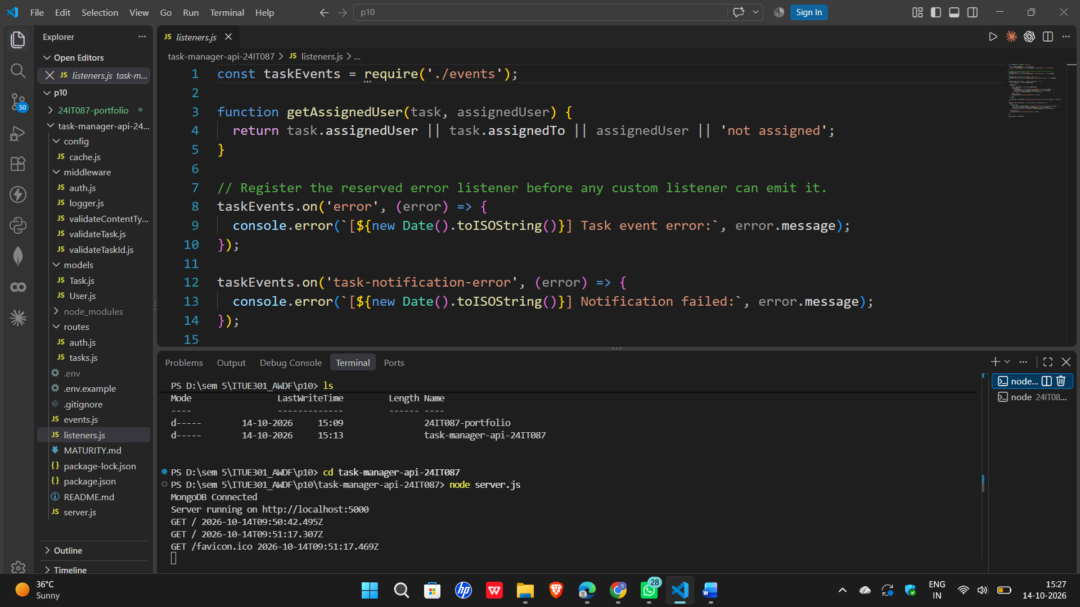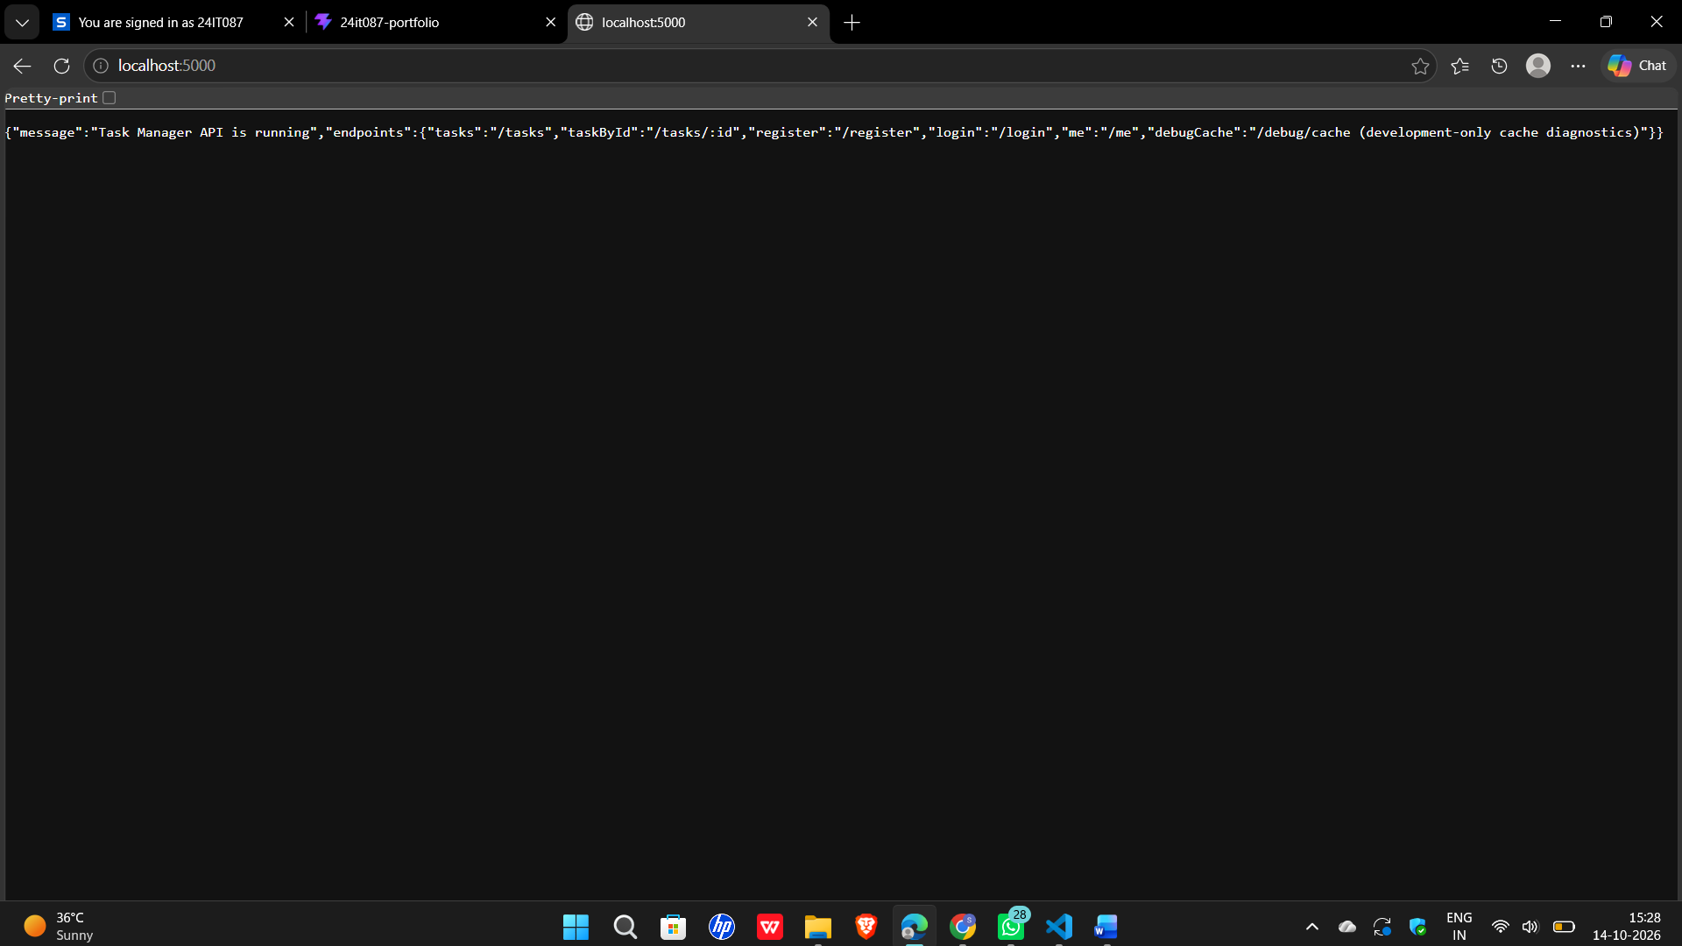

Github Repo Link:
https://github.com/digishasavaliya/ITUE301_AWDF.git

