

CHAROTAR UNIVERSITY OF SCIENCE AND TECHNOLOGY

FACULTY OF TECHNOLOGY AND ENGINEERING

B. TECH (IT/CE/CSE/AIML)

Subject: Advanced Web Development Frameworks (ITUE301) | Semester: 5th

Practical Statement:
- Write a Dockerfile for the React frontend of the Task Management application.
- Write a Dockerfile for the Node/Express backend.
- Create a docker-compose.yml file that orchestrates all 3 services: frontend, backend, and MongoDB.
- Configure correct port mappings and an internal Docker network so the services can communicate.
- The entire application must start with a single docker-compose up command, with no manual steps in between.

Screenshots:
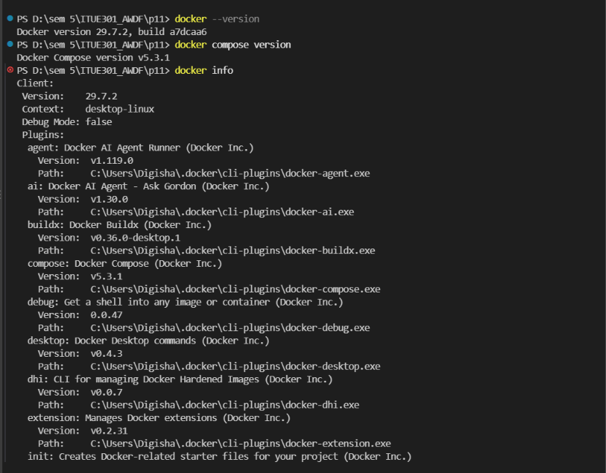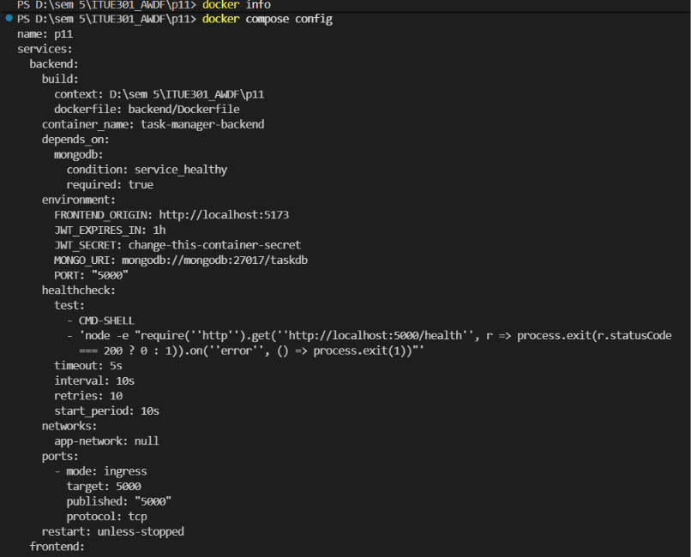
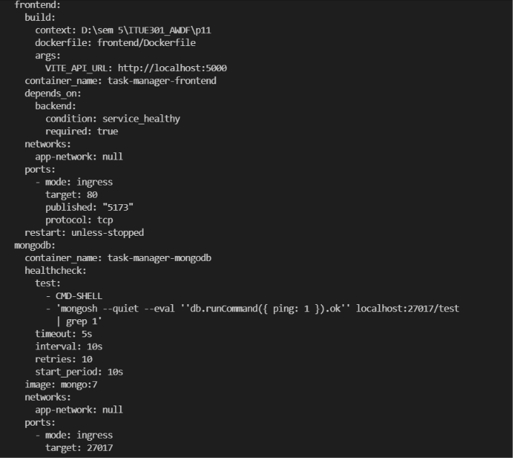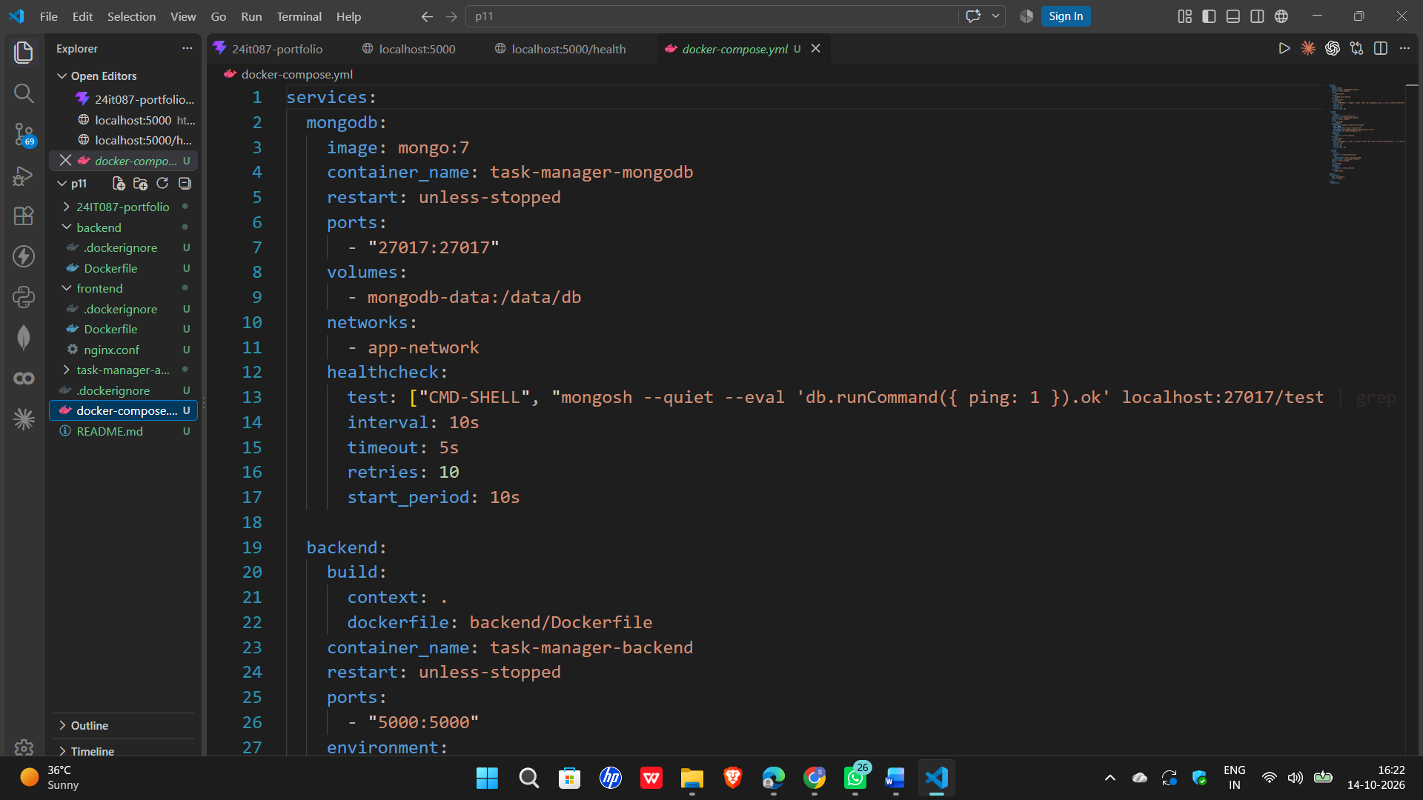

Github Repo Link:
https://github.com/digishasavaliya/ITUE301_AWDF.git

