

CHAROTAR UNIVERSITY OF SCIENCE AND TECHNOLOGY

FACULTY OF TECHNOLOGY AND ENGINEERING

B. TECH (IT/CE/CSE/AIML)

Subject: Advanced Web Development Frameworks (ITUE301) | Semester: 5th

Practical Statement:

- Create a React application using Vite for a student portfolio page.
- The application must include at least 4 reusable components: Header, About, Skills, and Footer.
- Each component must be independently structured and composed into a single-page layout.
- No logic or JSX should be duplicated across components.
- Props must be used to pass at least one piece of data into a minimum of 2 components.

Screenshots:

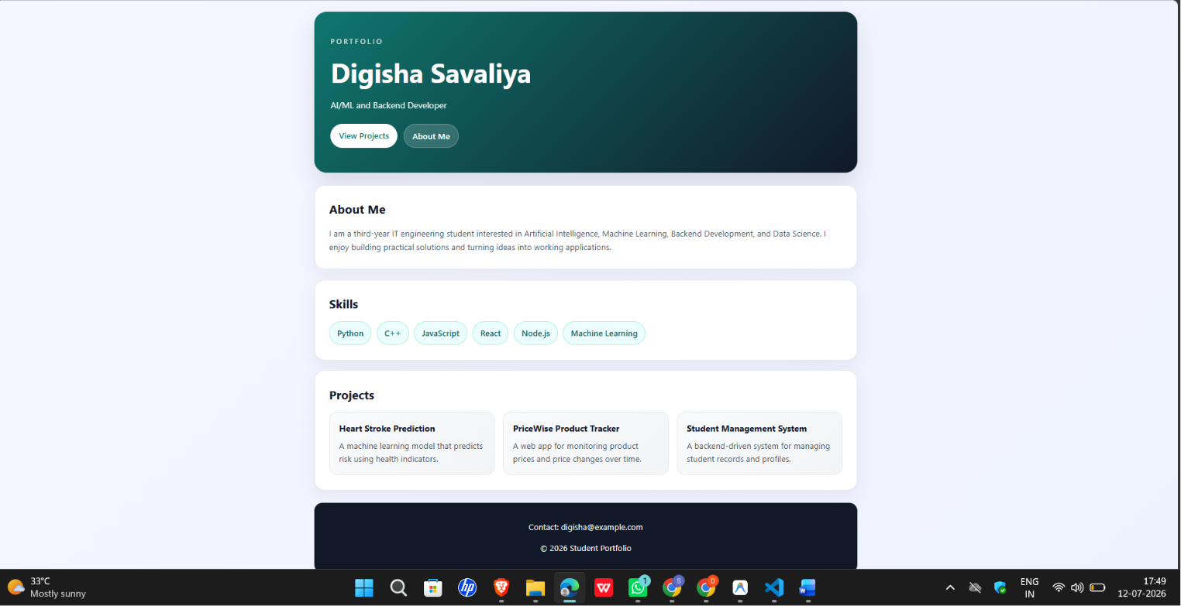

Github Repo Link: https://github.com/digishasavaliya/24IT087-portfolio

