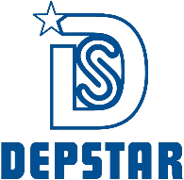

CHAROTAR UNIVERSITY OF SCIENCE AND TECHNOLOGY

FACULTY OF TECHNOLOGY AND ENGINEERING

B. TECH (IT/CE/CSE/AIML)

Subject: Advanced Web Development Frameworks (ITUE301) | Semester: 5th

Practical Statement:
To develop a RESTful Task Management API using Node.js and Express.js. The application implements CRUD (Create, Read, Update, Delete) operations using an in-memory array, applies request logging middleware, Content-Type validation middleware, route-specific task ID validation, custom 404 handling, and centralized global error handling while returning appropriate HTTP status codes.

Screenshots:
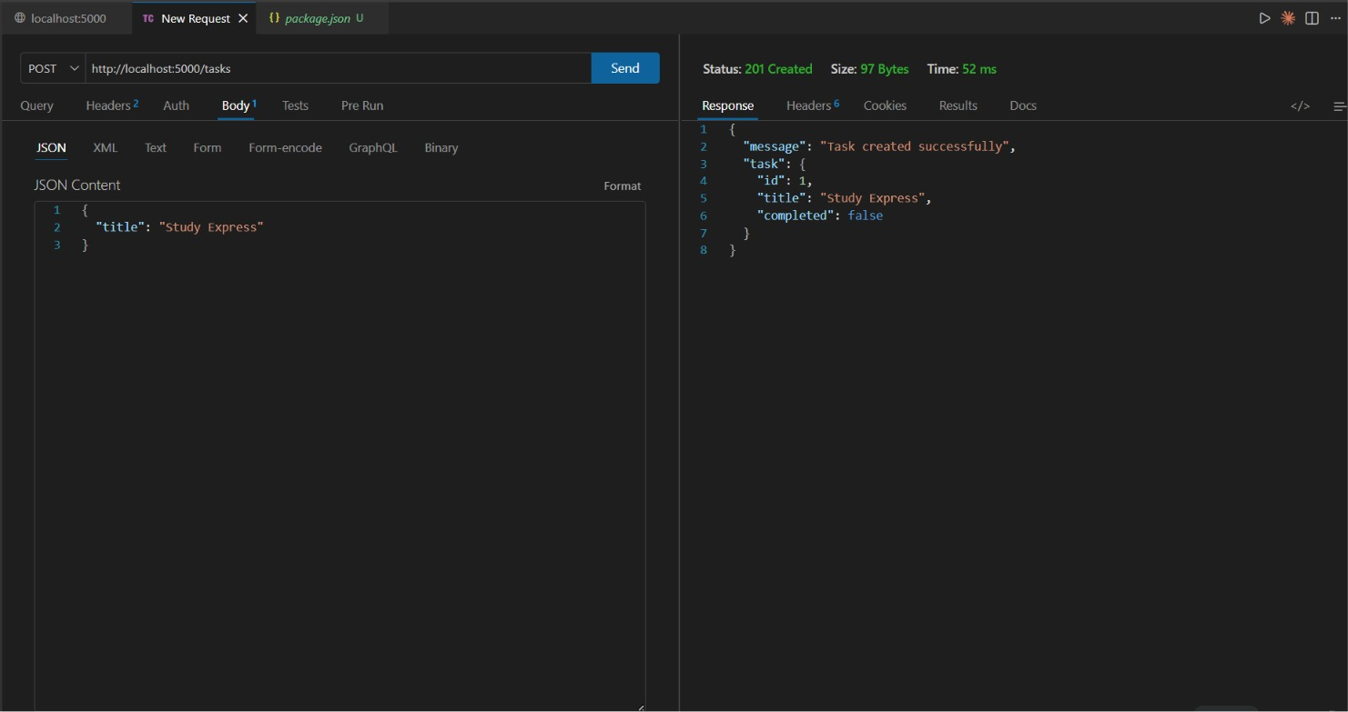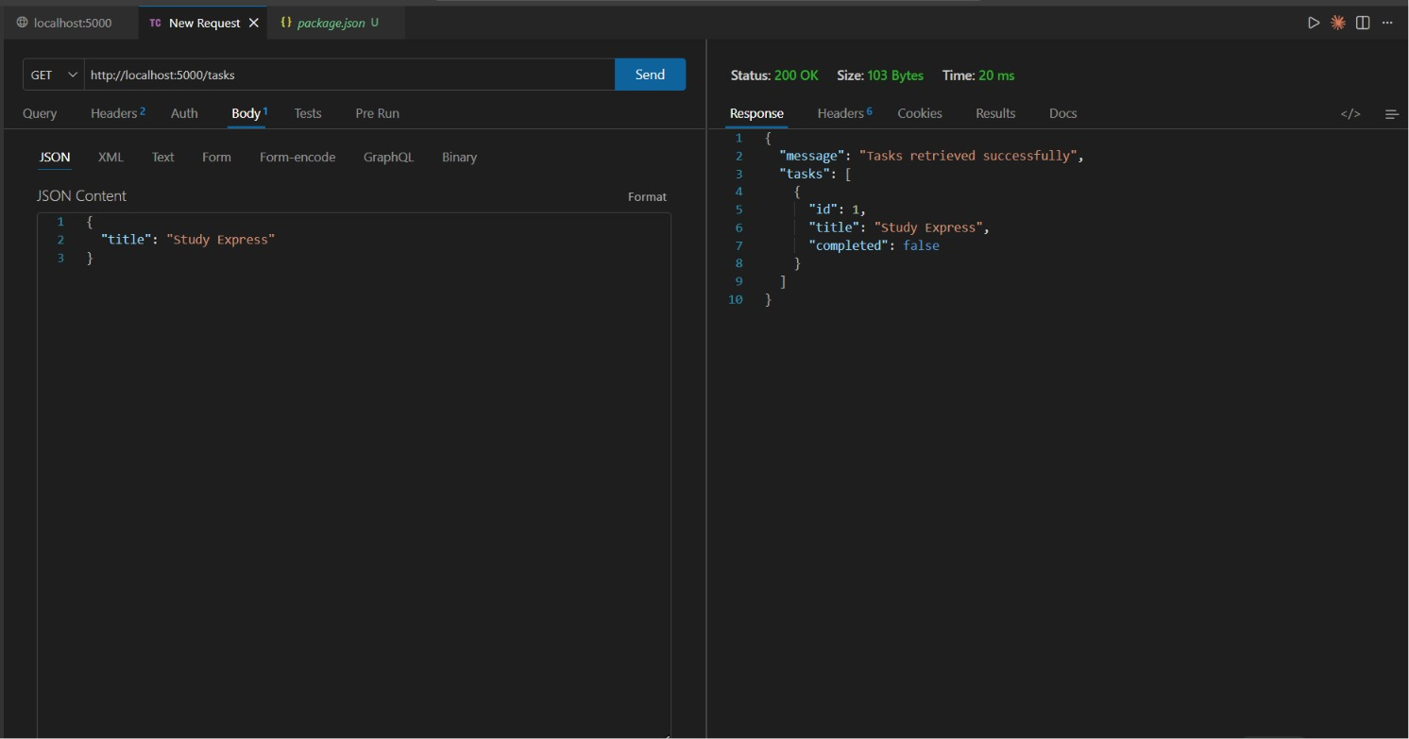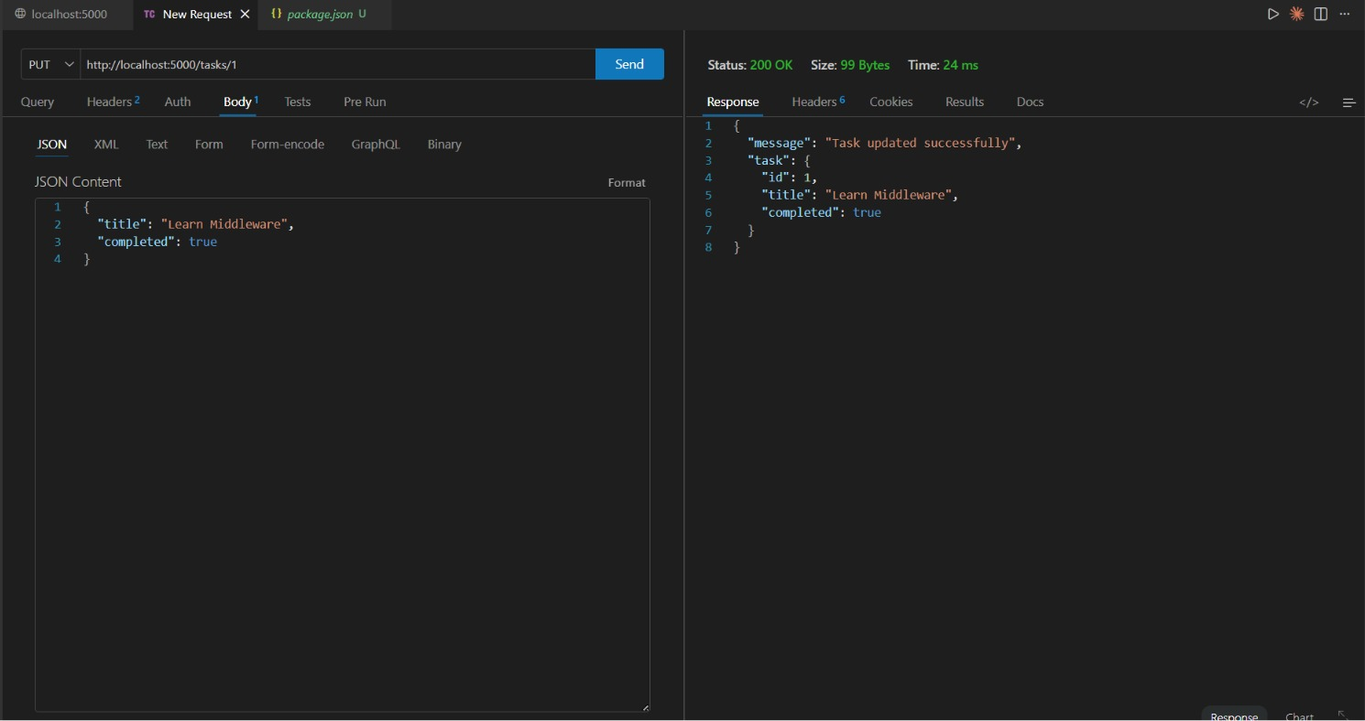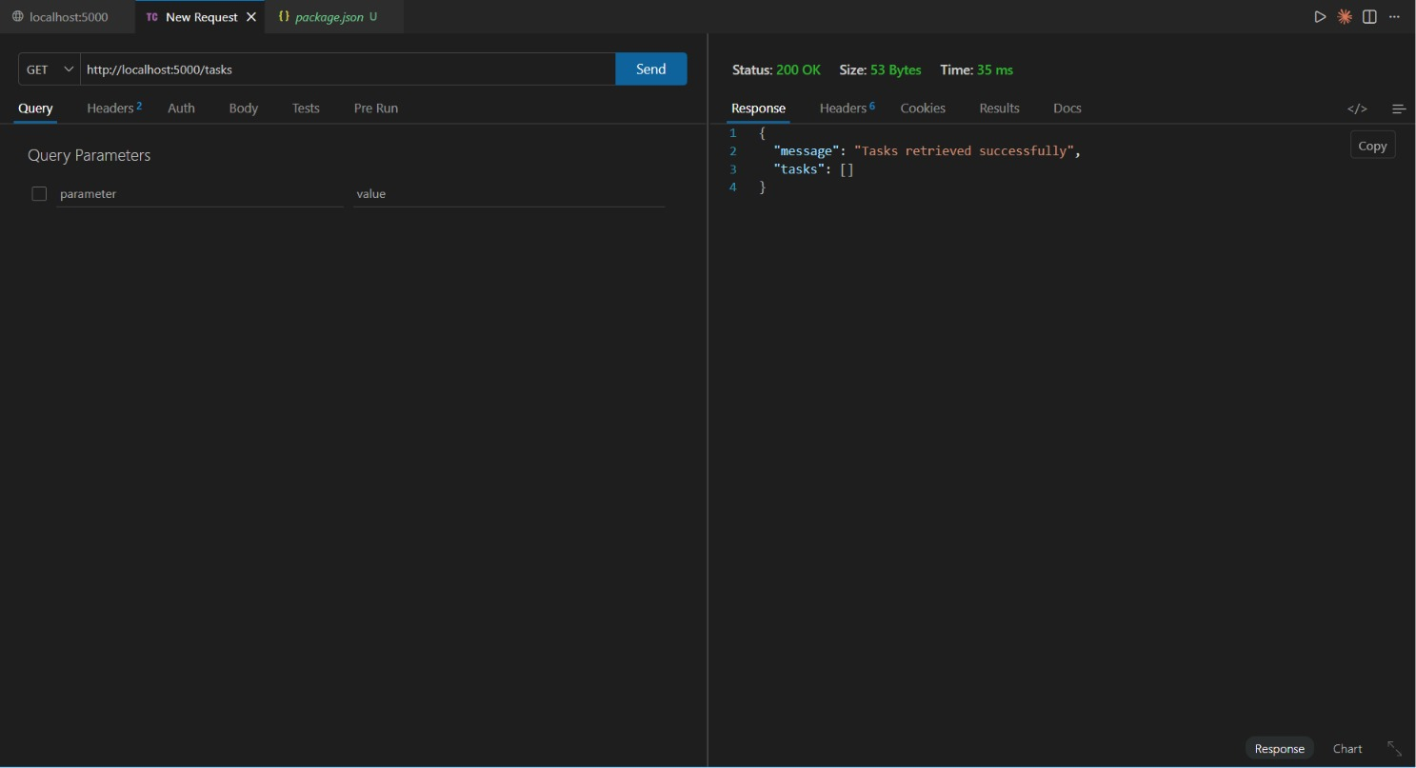

Github Repo Link:
https://github.com/digishasavaliya/ITUE301_AWDF.git

