

`CHAROTAR UNIVERSITY OF SCIENCE AND TECHNOLOGY

FACULTY OF TECHNOLOGY AND ENGINEERING

B. TECH (IT/CE/CSE/AIML)

Subject: Advanced Web Development Frameworks (ITUE301) | Semester: 5th

Practical Statement:

To integrate a public REST API (GitHub API) into the existing React portfolio application and dynamically fetch and display GitHub repositories on the Projects page using React Hooks. The application uses useEffect and useState to manage asynchronous API requests, loading and error states, and implements repository search, retry functionality, repository links, and star count display.

Screenshots
:
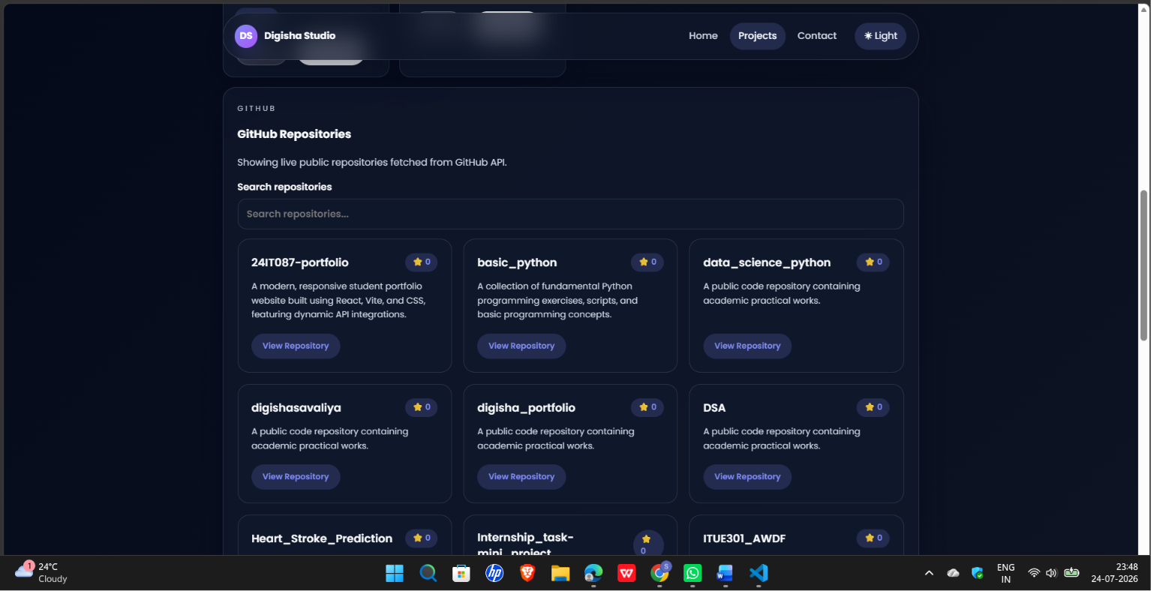

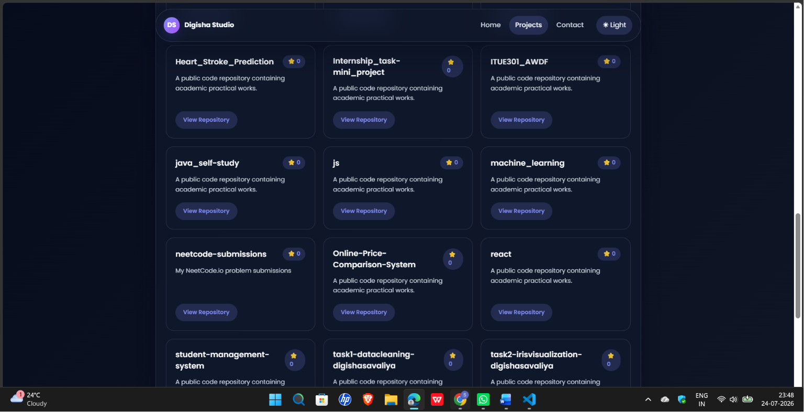
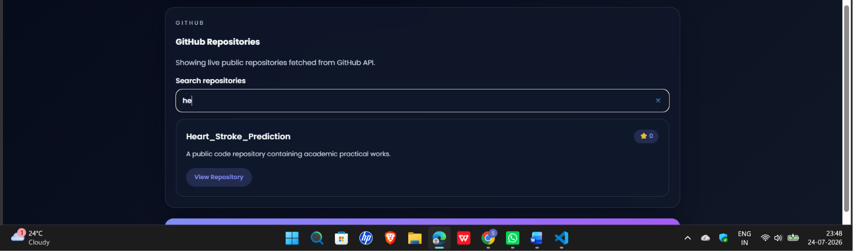

Github Repo Link:

https://github.com/digishasavaliya/ITUE301_AWDF.git

