

CHAROTAR UNIVERSITY OF SCIENCE AND TECHNOLOGY

FACULTY OF TECHNOLOGY AND ENGINEERING

B. TECH (IT/CE/CSE/AIML)

Subject: Advanced Web Development Frameworks (ITUE301) | Semester: 5th

Practical Statement:
- Optimize the React frontend of the Task Management application by implementing lazy loading for route-based components.
- Apply React.lazy() and Suspense to at least the Projects and Contact routes (or equivalent route-based components).
- Provide a meaningful fallback UI while a lazy-loaded chunk is loading.
- Measure and compare bundle size and load time before and after optimization using browser developer tools.
- Document the before/after comparison with screenshots or recorded values.

Screenshots:
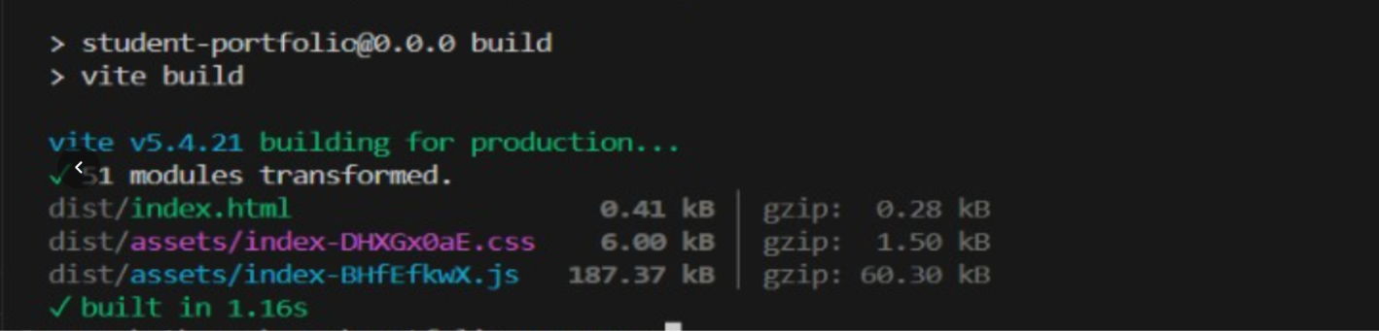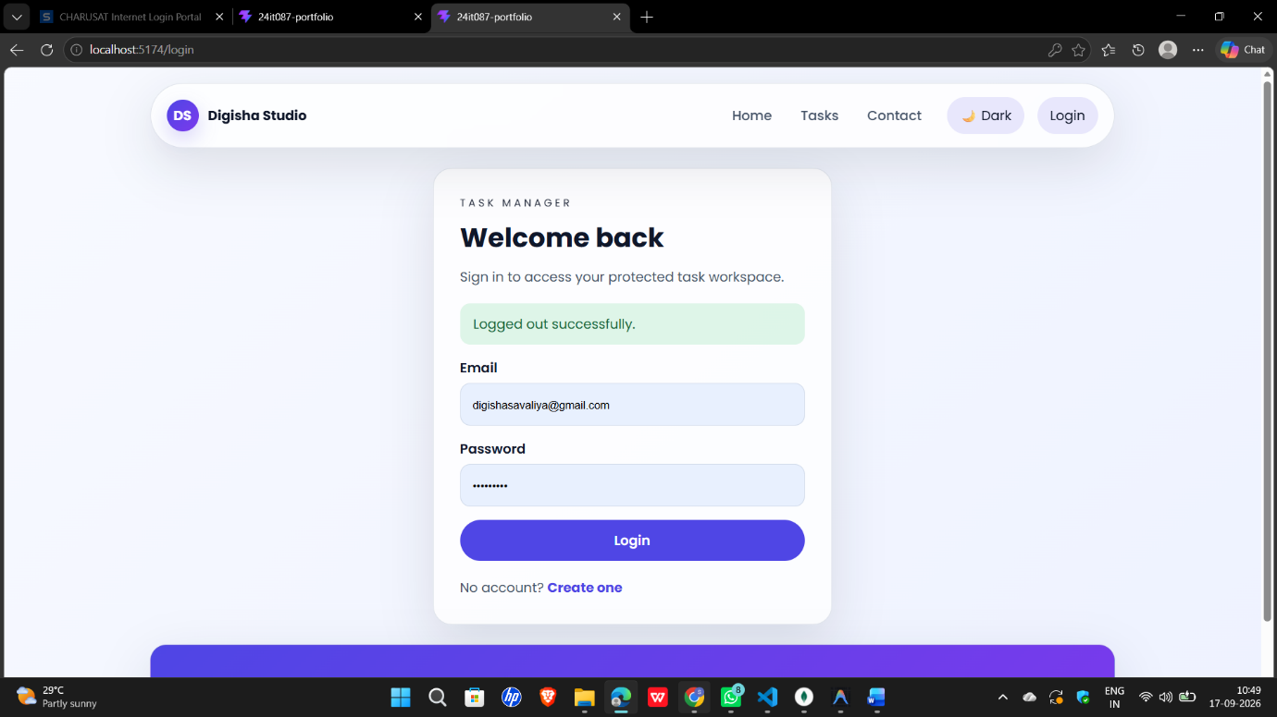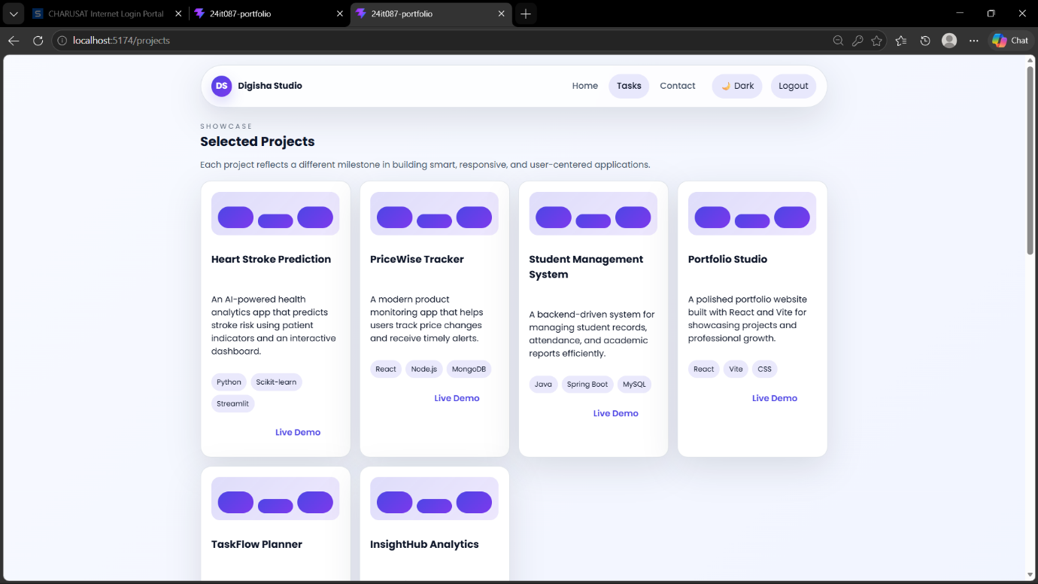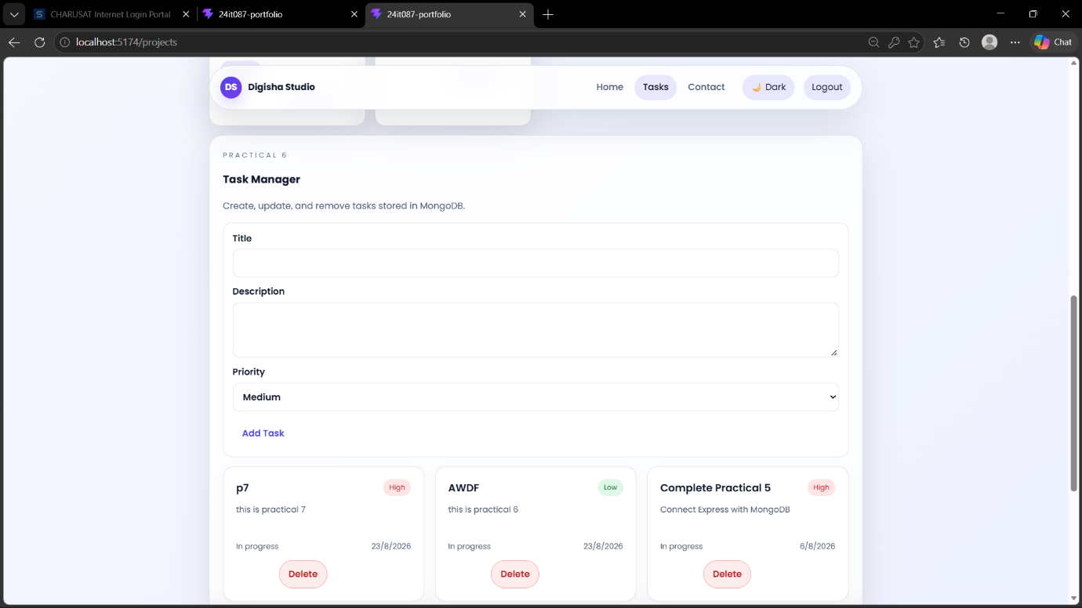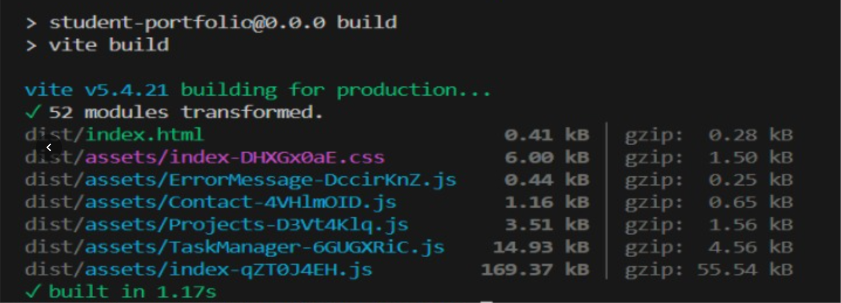

Github Repo Link:
https://github.com/digishasavaliya/ITUE301_AWDF.git

