

CHAROTAR UNIVERSITY OF SCIENCE AND TECHNOLOGY

FACULTY OF TECHNOLOGY AND ENGINEERING

B. TECH (IT/CE/CSE/AIML)

Subject: Advanced Web Development Frameworks (ITUE301) | Semester: 5th

Practical Statement:
- Add in-memory caching to the Task Management backend using node-cache.
- Cache the response of GET /tasks (all tasks) with a reasonable TTL(e.g., 60 seconds).
- Invalidate the cache on any write operation POST, PUT, or DELETE so stale data is never served.
- Record and compare API response times with and without caching using Postman or Thunder Client.
- Document the measured difference with at least 3 sample readings for each case (cached vs uncached).

Screenshots:
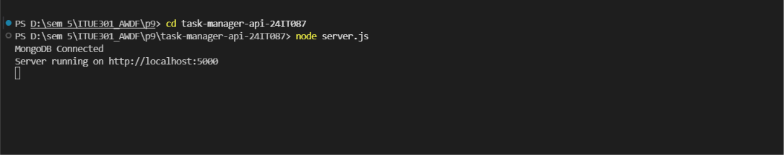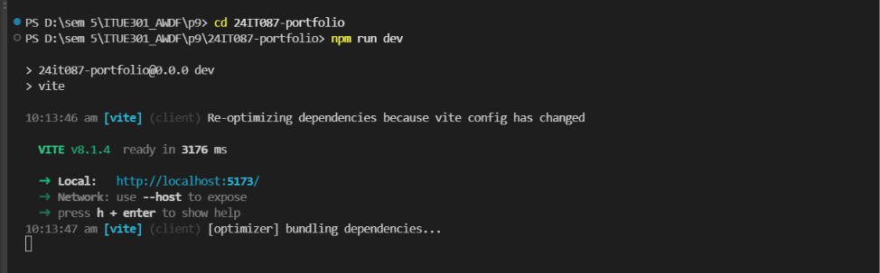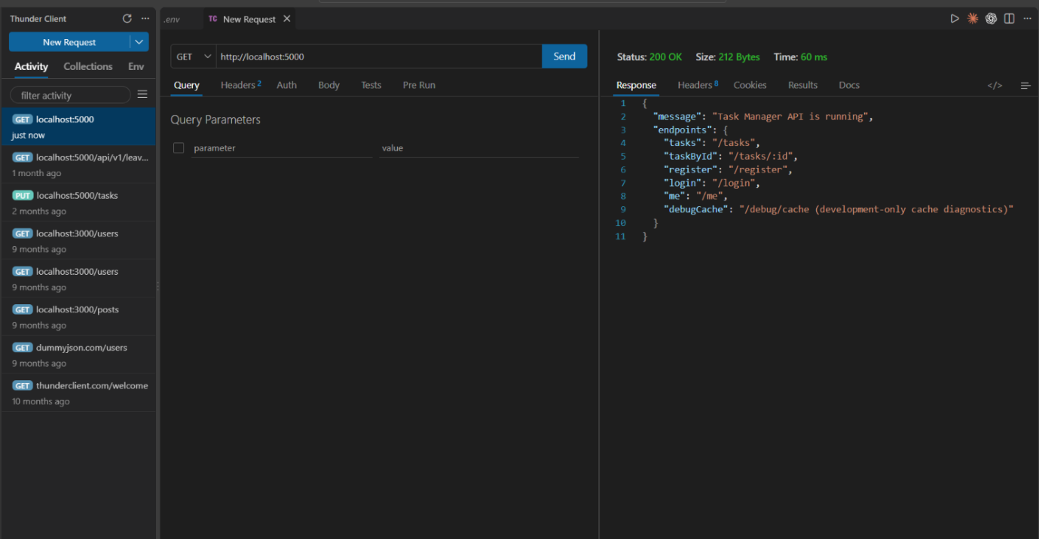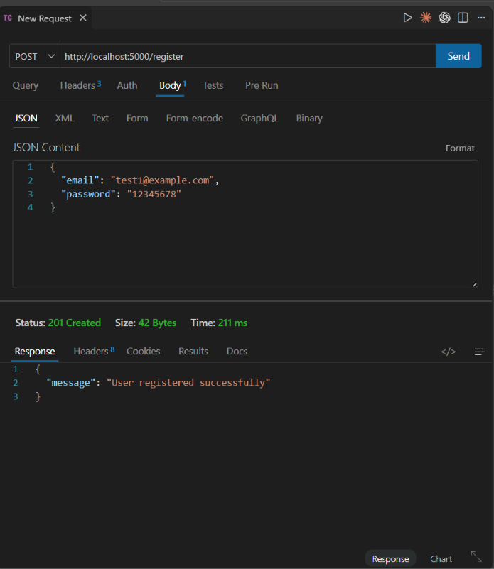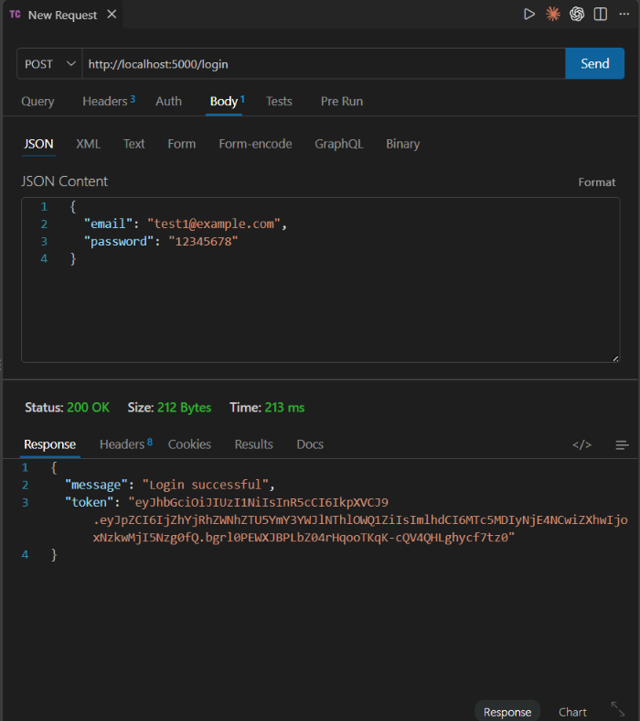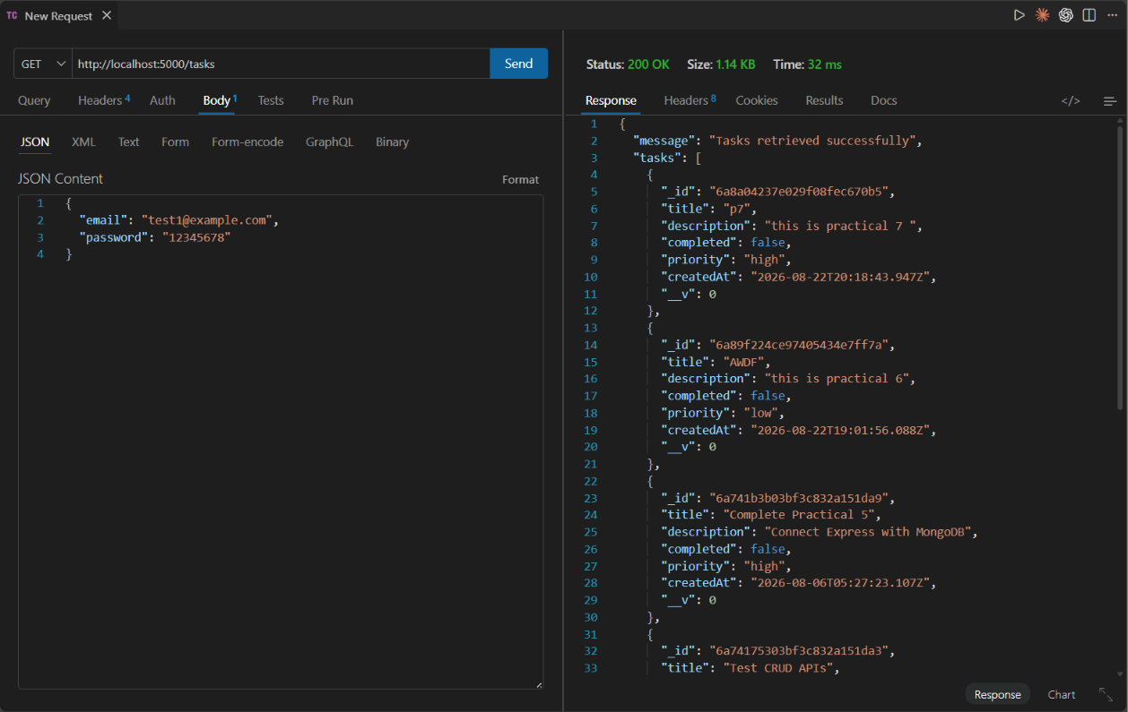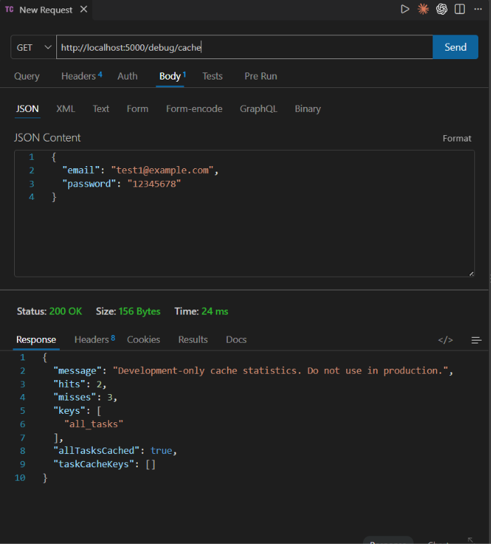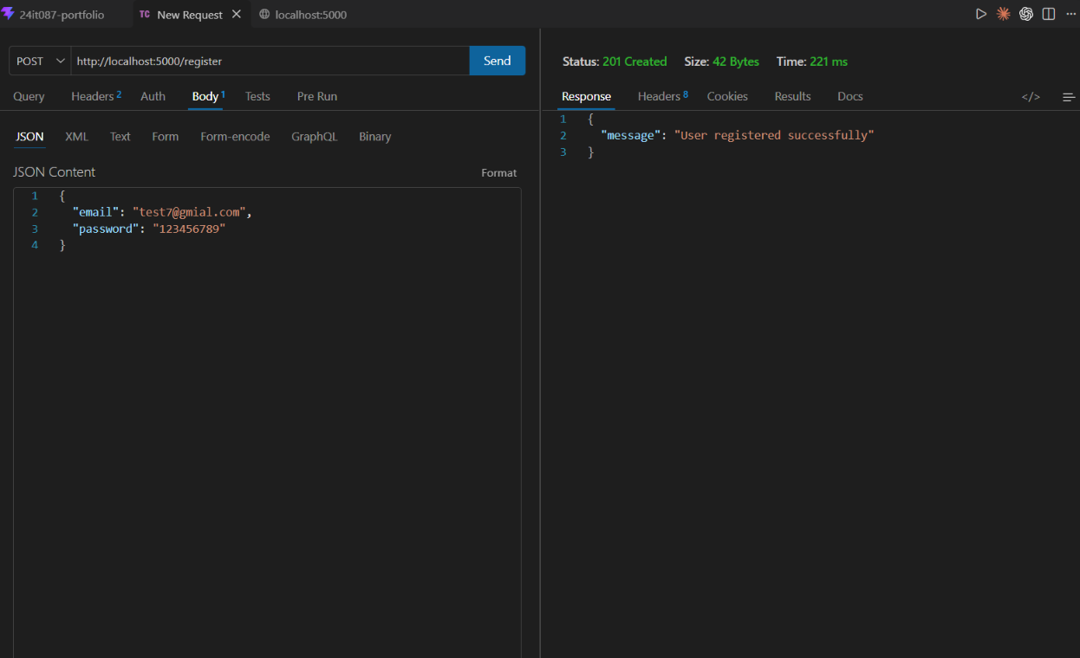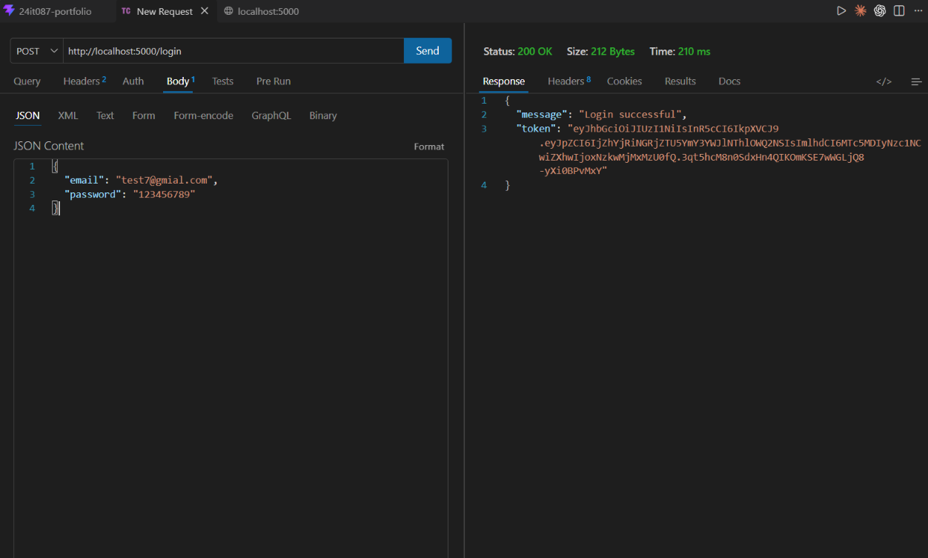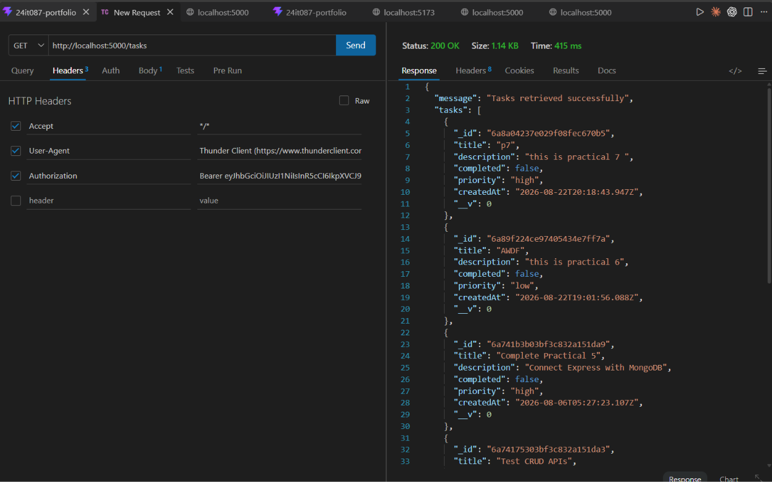

Github Repo Link:
https://github.com/digishasavaliya/ITUE301_AWDF.git

