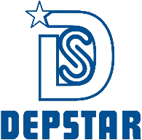

CHAROTAR UNIVERSITY OF SCIENCE AND TECHNOLOGY

FACULTY OF TECHNOLOGY AND ENGINEERING

B. TECH (IT/CE/CSE/AIML)

Subject: Advanced Web Development Frameworks (ITUE301) | Semester: 5th

Practical Statement:
To extend the Task Management REST API developed in Practical 4 by integrating MongoDB with Mongoose. The application connects to a MongoDB database, defines a validated Task schema, replaces the in-memory array with MongoDB CRUD operations, and performs Create, Read, Update, and Delete operations using Mongoose while ensuring proper schema validation and structured JSON error handling.
.

Screenshots:
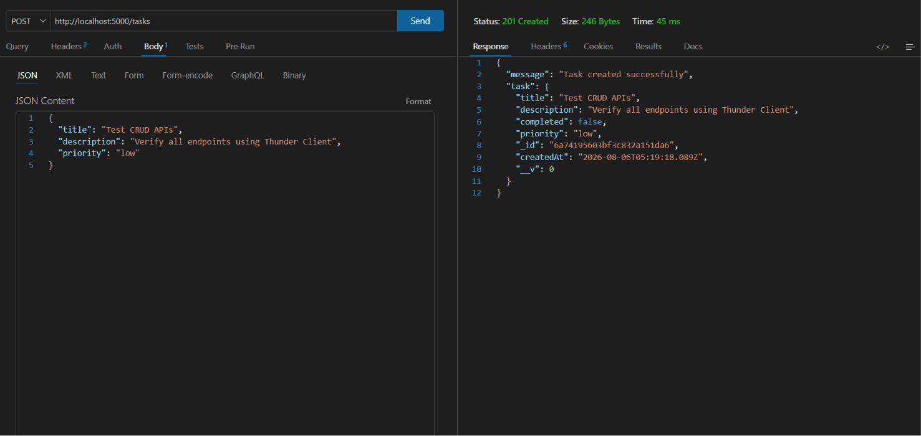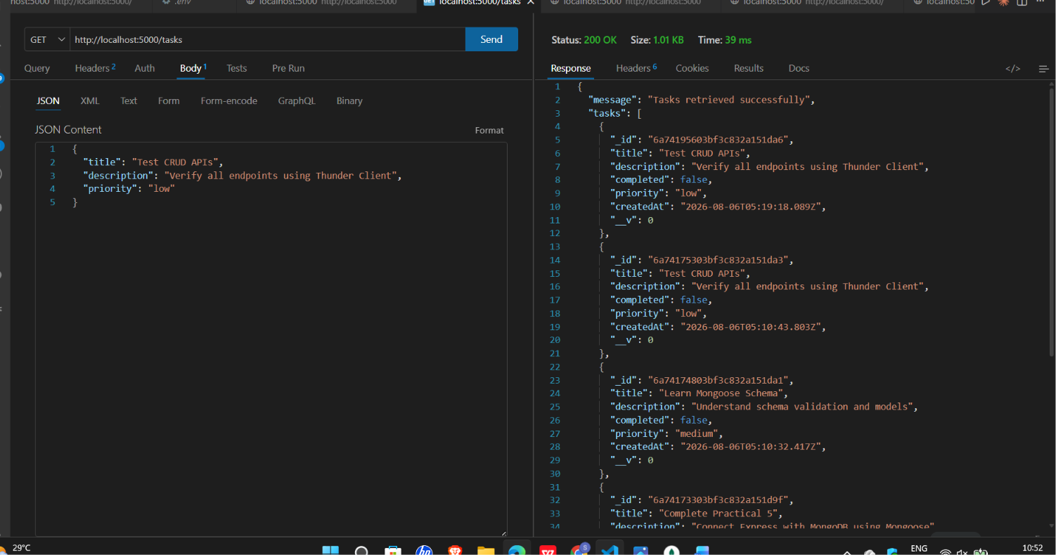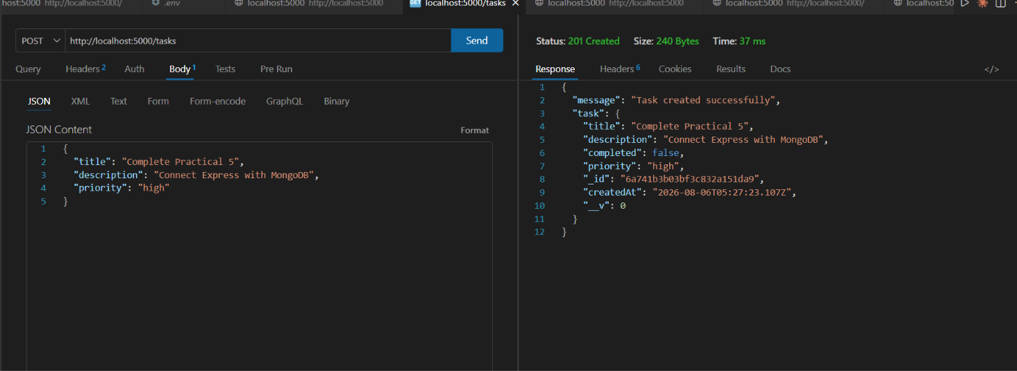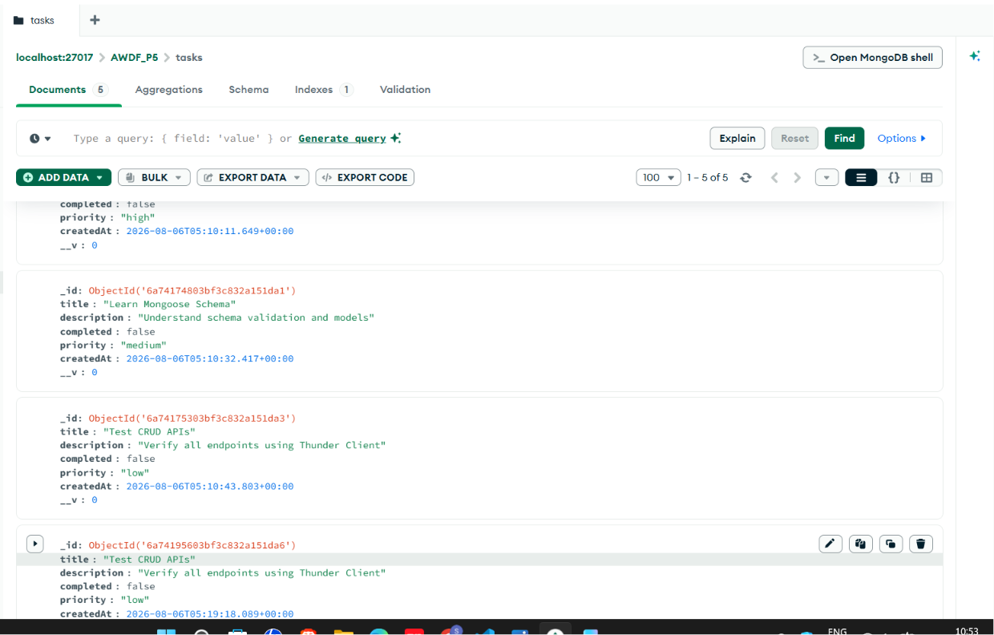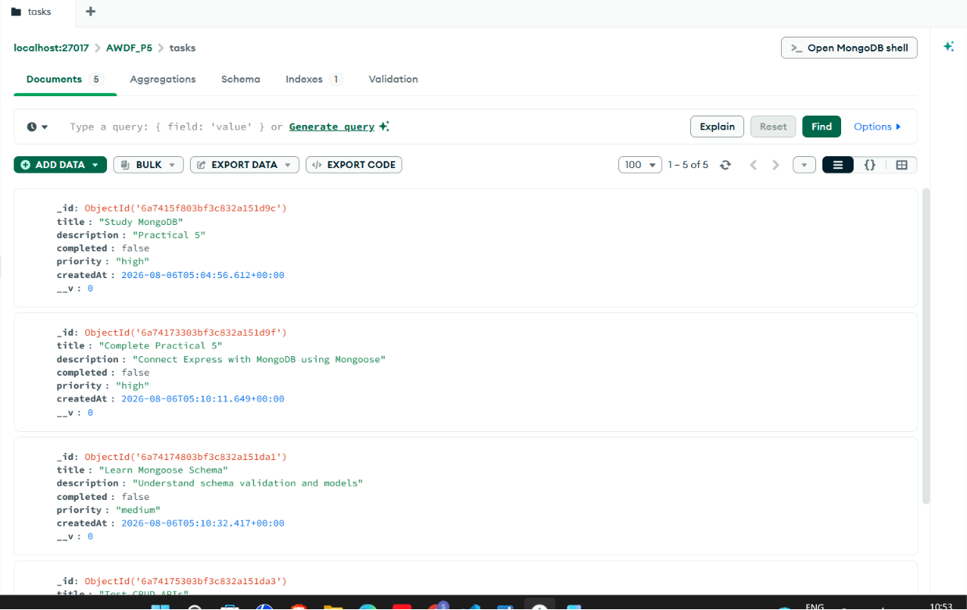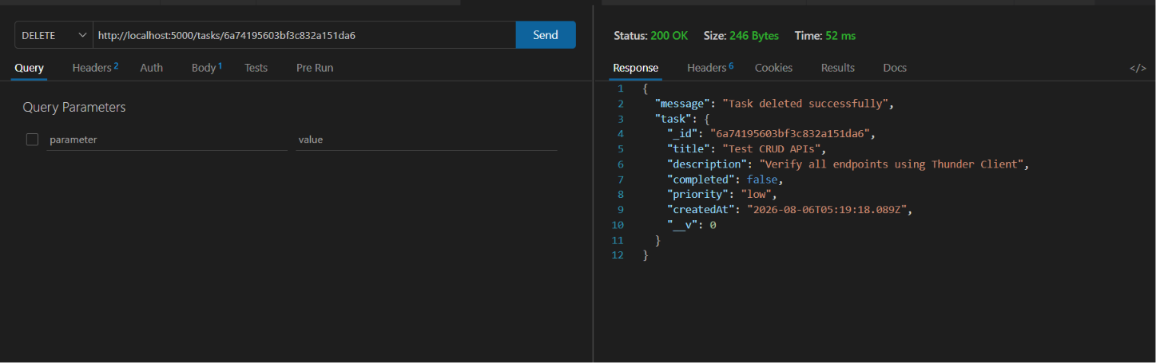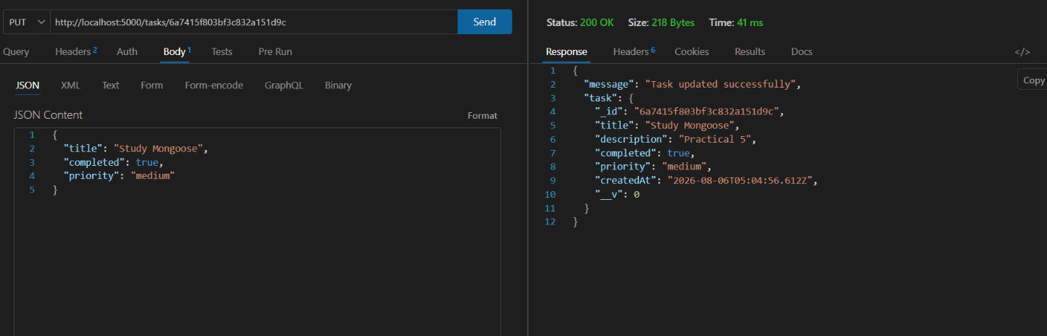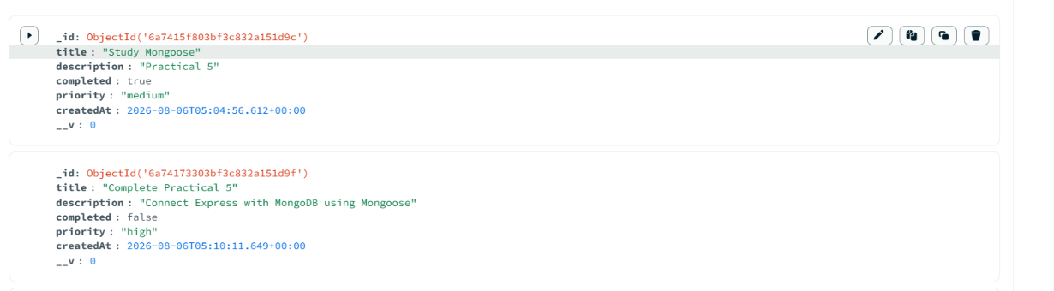

Github Repo Link:
https://github.com/digishasavaliya/ITUE301_AWDF.git

