

CHAROTAR UNIVERSITY OF SCIENCE AND TECHNOLOGY

FACULTY OF TECHNOLOGY AND ENGINEERING

B. TECH (IT/CE/CSE/AIML)

Subject: Advanced Web Development Frameworks (ITUE301) | Semester: 5th

Practical Statement:
- Set up a GitHub Actions workflow for the Task Management application that runs automatically on every push to the main branch.
- The pipeline must install dependencies (npm install) as a defined step.
- The pipeline must run at least one automated test and report a clear pass/fail status.
- Demonstrate a failed pipeline caused by a deliberately broken test.
- Demonstrate a fixed pipeline that passes after the test is corrected.

Screenshots:
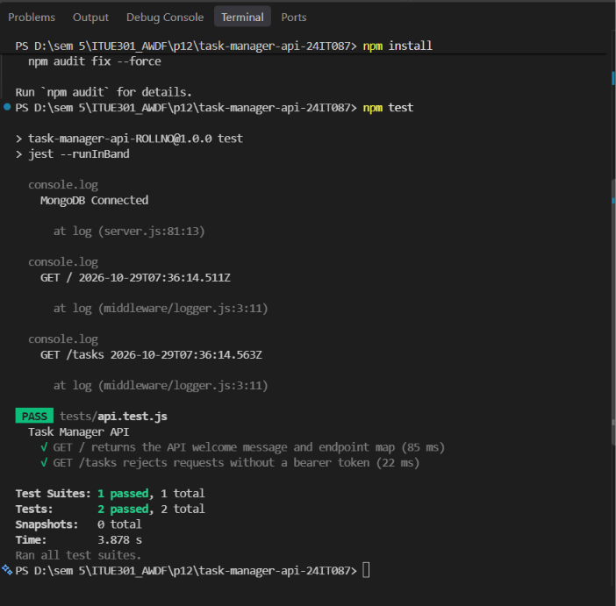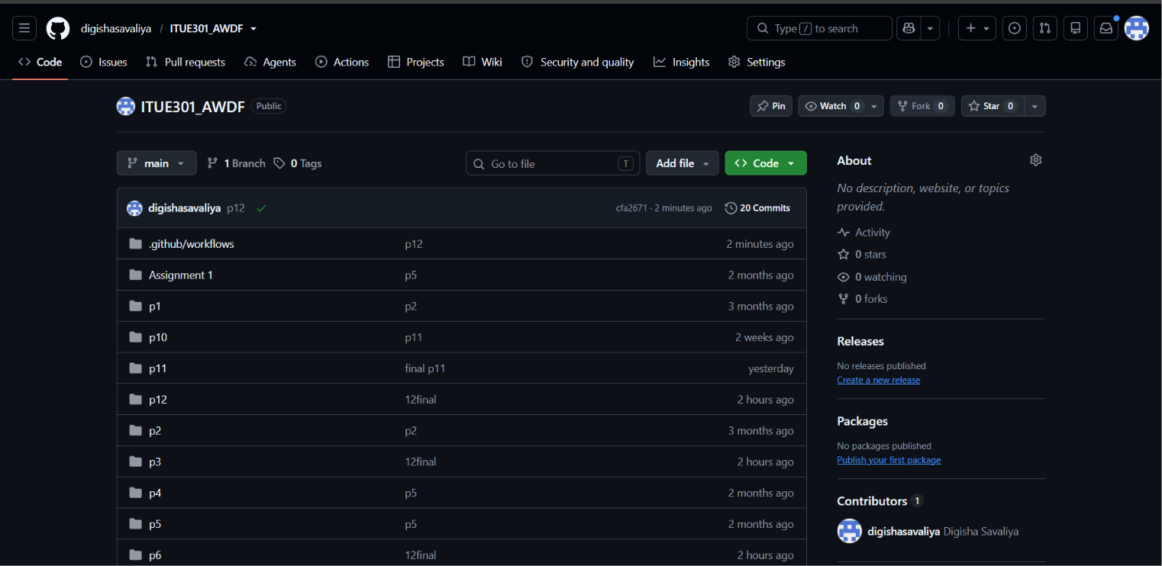
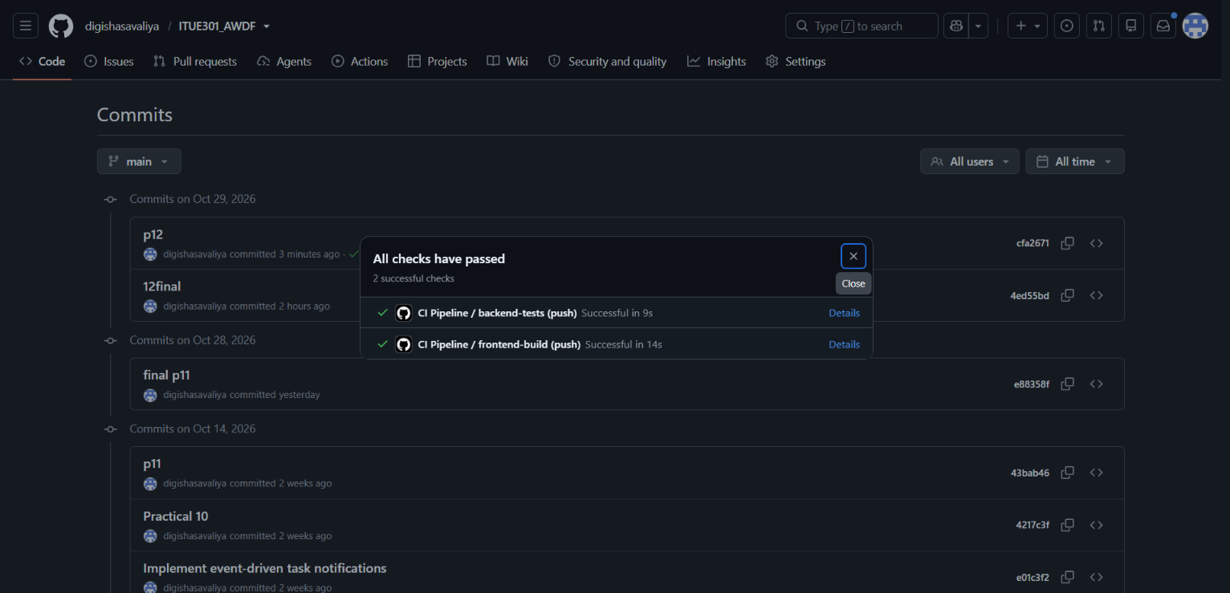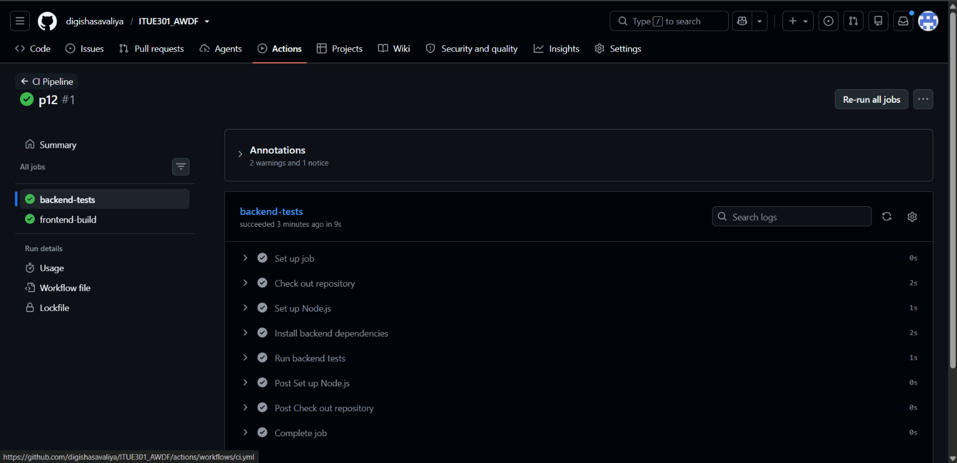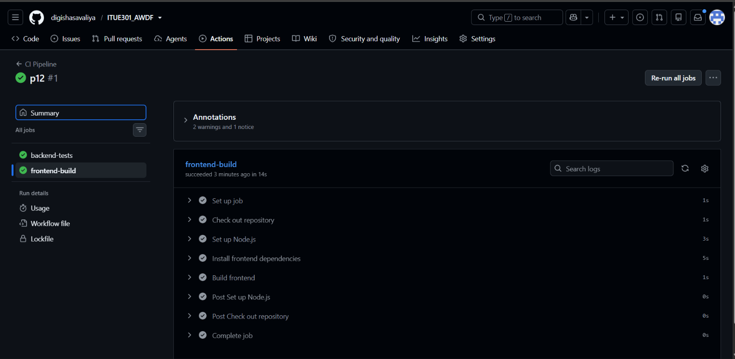

Github Repo Link:
https://github.com/digishasavaliya/ITUE301_AWDF.git

