

CHAROTAR UNIVERSITY OF SCIENCE AND TECHNOLOGY

FACULTY OF TECHNOLOGY AND ENGINEERING

B. TECH (IT/CE/CSE/AIML)

Subject: Advanced Web Development Frameworks (ITUE301) | Semester: 5th

Practical Statement:
- Add an AI-powered feature to the Task Management application using the OpenAI API or Gemini API.
- The feature must serve a meaningful purpose for example, auto- generating a task description, suggesting a priority level, or proposing a deadline based on the task title.
- The API key must be stored and used only on the backend (.env), never exposed to the frontend.
- Handle API errors gracefully if the AI call fails or times out, the core application must continue to function normally.
- Display the AI-generated response meaningfully in the React UI, not as
- raw JSON.
Screenshots:
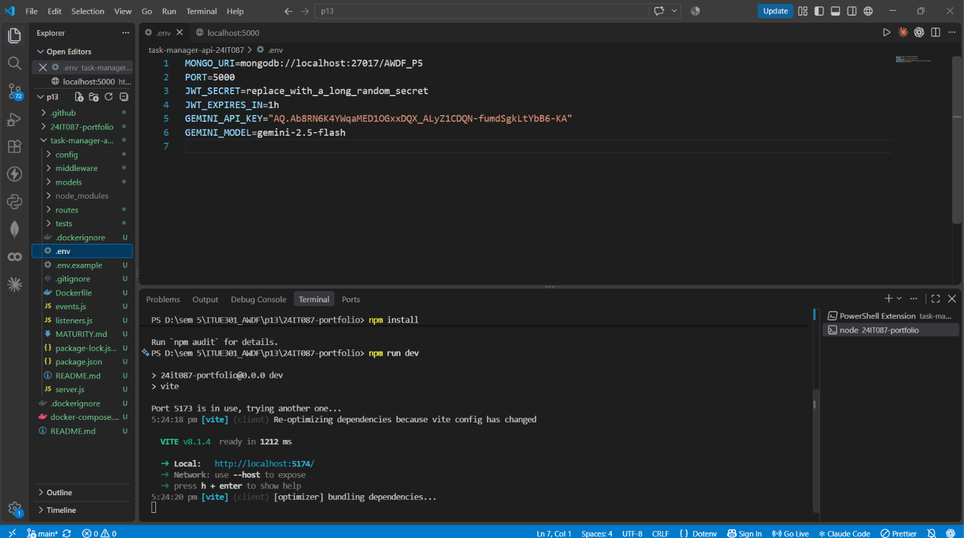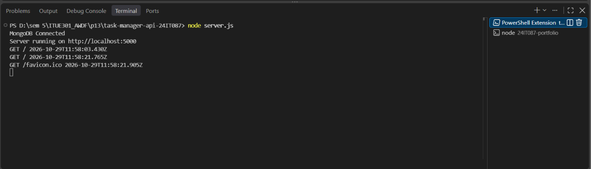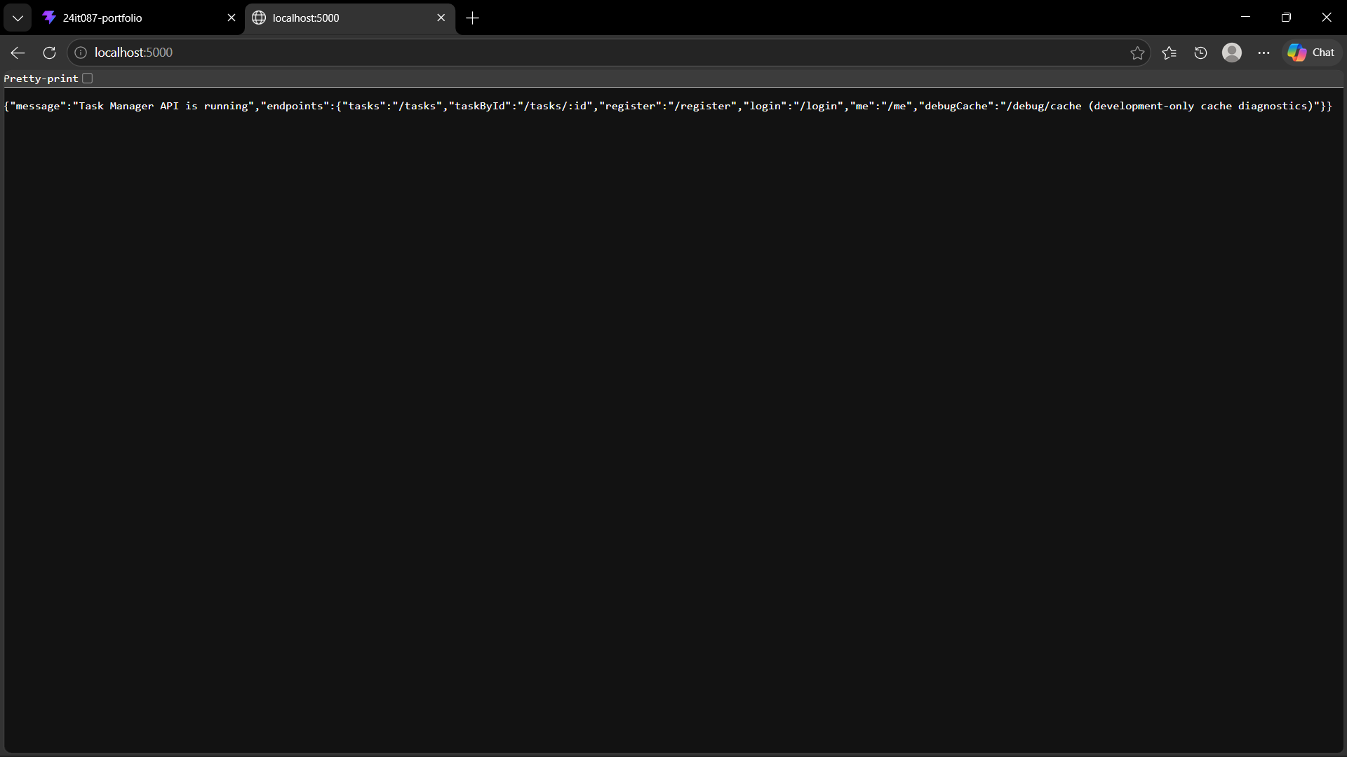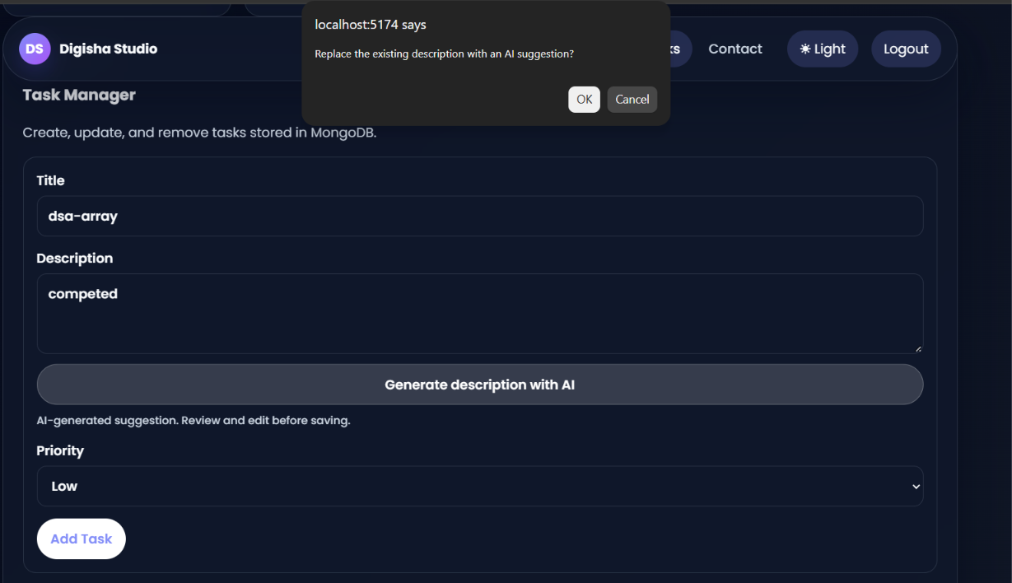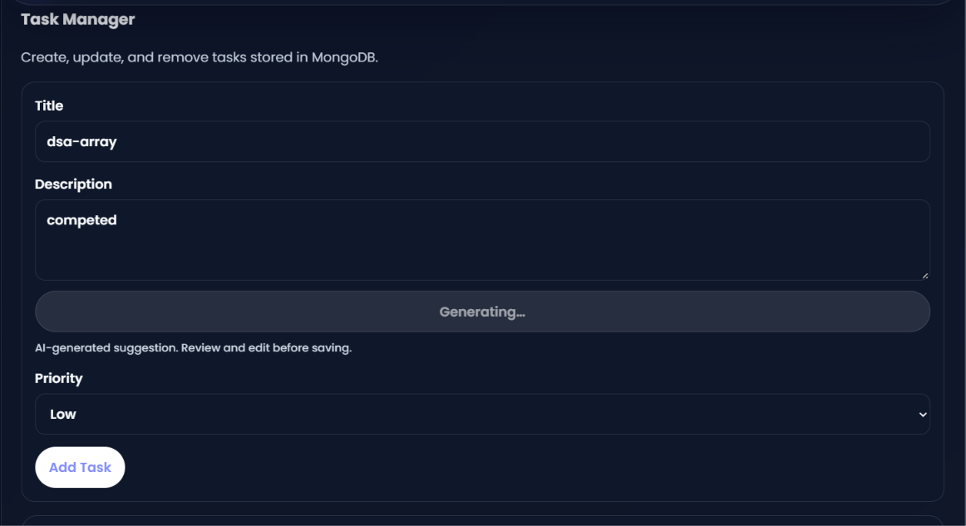

Github Repo Link:
https://github.com/digishasavaliya/ITUE301_AWDF.git

