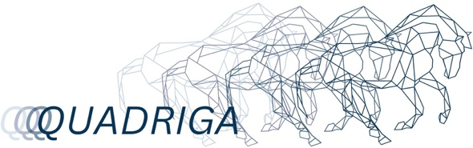Einstellungsprotokoll: Tabellarische Annotation (Template)

|  |  |  |  |  |  |  |  |  |  |
| --- | --- | --- | --- | --- | --- | --- | --- | --- | --- |
| Nr. | Dauer (sec.) | Screenshot | Bildinhalt | Einstellungs-größe | Montage (Übergang) | Kamera (Perspektive & Bewegung) | Ton/Musik | Farbe | Licht |
|  |  |  |  |  |  |  |  |  |  |
|  |  |  |  |  |  |  |  |  |  |
|  |  |  |  |  |  |  |  |  |  |
|  |  |  |  |  |  |  |  |  |  |
|  |  |  |  |  |  |  |  |  |  |
|  |  |  |  |  |  |  |  |  |  |