

Biodiversity Net Gain Objective Report
Snarlton
January 2025

.
Report Produced for Planning Matters (Albion) Limited
Written by: Digital Ecology’s ReportPackage
Checked by:
Approved by:
Issue:
Date: 23/01/25

.

EXECUTIVE SUMMARY
1.1 This report provides an assessment of the biodiversity change at Snarlton.
1.2 The existing area-based habitats include cereal crops, modified grassland, artificial unvegetated, unsealed surface and developed land; sealed surface. Proposals include the creation of allotments, developed land; sealed surface, vegetated garden, mixed scrub, modified grassland, sustainable drainage system, other neutral grassland and urban tree, and the enhancement of other neutral grassland. To facilitate development, cereal crops, modified grassland, artificial unvegetated, unsealed surface and developed land; sealed surface will be lost.
1.3 Based on the DEFRA Statutory Metric, area based habitats will generate a net gain of 29.21%.
1.4 The existing linear habitats include species-rich native hedgerow, native hedgerow, native hedgerow - associated with bank or ditch, native hedgerow with trees - associated with bank or ditch, species-rich native hedgerow - associated with bank or ditch, line of trees, ecologically valuable line of trees and line of trees - associated with bank or ditch, alongside other rivers and streams. Proposals include the creation of other rivers and streams, alongside the enhancement of species-rich native hedgerow, native hedgerow, associated with bank or ditch, line of trees and ecologically valuable line of trees, and other rivers and streams and priority habitat. To facilitate development, other rivers and streams will be lost.
1.5 Based on the DEFRA Statutory Metric, hedgerows will generate a net gain of 76.37%, and watercourses will generate a net gain of 52.55%.
As a result, the project secures a >10% gain in biodiversity for area and linear biodiversity units, and meets the trading rules within the metric. Further details regarding habitat management and establishment will be provided as part of a later application within a Habitat Management and Monitoring Plan (HMMP).

.

CONTENTS
add TOC here

.

1 INTRODUCTION
1.1 This report provides an assessment of the biodiversity change following the proposals for the site at Snarlton, as shown in Figure 1, henceforth referred to as the ‘site’.
1.2 The site is located within (LPA) and the National Character Area (NCA).
1.3 This report is submitted alongside the Statutory BNG Metric and detailed plans of the baseline and proposed habitats. This is used to inform the planning process in terms of the BNG objective for this project. A Biodiversity Net Gain Plan and Habitat Management and Monitoring Plan (HMMP) will be delivered to secure the BNG planning condition for this project within the reserved matter stage of the planning process.
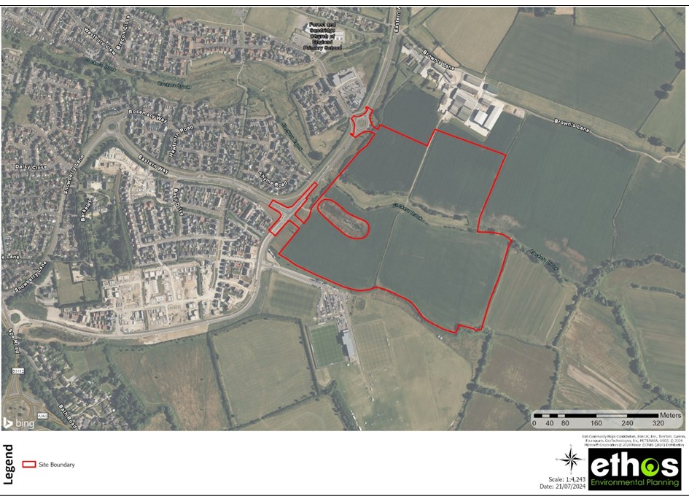
Figure 1: Site Location Map of Snarlton and Surrounding Areas

.

2 SCOPE OF REPORT
- Establishes the total number of baseline Area Habitat Units (AHU) and Linear Biodiversity Units (LBU) within the site
- Establishes the total number of AHU and LBU which will be retained, enhanced, and created under the current design of the proposed development’s landscape plan
- Determine whether the proposed development will result in a quantitative net loss, no net loss or a net gain for biodiversity on site
- Determines whether the proposed development achieves a scheme-wide net gain for biodiversity by evidencing compliance with the good practice principles

2.1 Biodiversity Net Gain (BNG) Assessment
2.1.1 This BNG assessment uses the following industry recognised best practice methods:
- CIEEM, IEMA & CIRIA (2016). Biodiversity Net Gain: Good Practice Principles for Development.
- DEFRA (2023) The Statutory Biodiversity Metric.
- CIEEM (2021). Biodiversity Net Gain Report & Audit Templates.
2.1.2 The quantitative outcomes of the calculations are one component of the BNG assessment and associated good practice principles. A BNG assessment also requires the collation of qualitative evidence on the application of the mitigation hierarchy, stakeholder engagement and post-development habitat management. Collectively, these quantitative outcomes and qualitative evidence are used to inform the outcomes of the project wide BNG assessment.

2.2 Legislation
2.2.1 The relevant primary legislation for the statutory framework for biodiversity net gain is principally set out under Section 90A and Schedule 7A (Biodiversity Gain in England) of the Town and Country Planning Act 1990. This legislation was inserted into the Act by Schedule 14 of the Environment Act 2021 and includes amendments made by the Levelling Up and Regeneration Act 2023 and the Biodiversity Gain (Town and Country Planning) (Consequential Amendments) Regulations (2024). The relevant biodiversity net gain regulations most directly relevant to planning are:
- The Environment Act 2021 (Commencement No. 8 and Transitional Provisions) Regulations (2024) which commence biodiversity net gain for most types of new planning applications and provides transitional arrangements for section 73 permissions.
- The Biodiversity Gain Requirements (Exemptions) Regulations (2024) which prescribe exemptions for categories of development to which biodiversity net gain does not apply.
- The Biodiversity Gain (Town and Country Planning) (Modifications and Amendments) (England) Regulations (2024) which amend the Town and Country Planning (Development Management Procedure) (England) Order 2015 and the Town and Country Planning (Section 62A Applications) (Procedure and Consequential Amendments) Order 2013 to include provisions related to planning applications and the Biodiversity Gain Plan, as well as modifications for phased development.
- The Biodiversity Gain Requirements (Irreplaceable Habitat) Regulations (2024) which set out the modifications for irreplaceable habitat.

2.3 BNG Hierarchy
2.3.1 The biodiversity gain hierarchy for the purpose of the statutory framework for biodiversity net gain is set out in Article 30A of the Development Management Procedure Order. This hierarchy is separate to the general mitigation hierarchy set out within the NPFF.
- Avoiding adverse effects of the development on onsite habitat with a habitat distinctiveness score, applied in the biodiversity metric, equal to or higher than six;
- So far as those adverse effects cannot be avoided, mitigating those effects;
- So far as those adverse effects cannot be mitigated, habitat enhancement of onsite habitat;
- So far as there cannot be that enhancement, creation of onsite habitat;
- So far as there cannot be that creation, the availability of registered offsite biodiversity gain;
- So far as that offsite habitat enhancement cannot be secured, purchasing biodiversity credits.

.

3 METHODOLOGY

3.1 Desktop Survey
3.1.1 The LPA and NCA have been identified within this assessment. This is displayed within the desktop survey section of this report in Figure 2.
3.1.2 A search was undertaken using publicly available information for priority using the Natural England Priority Habitat Inventory.
3.1.3 A search using publicly available information has been used to identify any irreplaceable habitats which are within or in proximity to the site. This included a search for Ancient Semi Natural Woodland (ASNW) and Ancient Trees using the Ancient Tree Inventory (ATI) online layer.
3.1.4 The desktop survey included a search for local plans, wildlife strategies, or local policy which may inform strategic significance of the habitats within this assessment. If habitats within the project are identified within a plan and are in the correct spatial location, they will be entered as being of high significance within this assessment. Habitats which are identified within a plan but fall outside spatial location or which are well suited to the area will be assigned as being of moderate strategic significance. Other habitats will be entered as being of low strategic significance. The following strategies were used to inform the strategic significance of the habitats within this project:
- POLICY NAMES
- STRATEGY NAMES

3.2 UK Habitat Classification Survey
3.2.1 The habitat survey was carried out on the 10th November 2022 according to the UKHab Classification system. The survey included a detailed assessment of the land within the development boundary, including a description and mapping of all key features and habitat types. The survey was carried out to identify the range of habitats within the site and the predominant and notable species of flora.
3.2.2 Full results of the UKHab including species lists are provided within the corresponding ES Chapter technical appendix.

3.3 Condition Assessments
3.3.1 Condition assessments were undertaken for each habitat which require condition assessment sheets. Following the methodology and criteria provided within The Statutory Biodiversity Metric – Technical Annex 1: Condition Assessments Sheets and Methodology (2023).

3.4 Grassland Survey Methodology
3.4.1 Grasslands were surveyed using a systematic approach, using 1x1m^2 quadrats sample. A minimum of three quadrats were undertaken of each grassland section. However, this can be increased to take into account variation across the grassland or the extent of the field. Information collected within each quadrat included aspect, slope, average ground cover, sward variation, species, and their percentage cover.
3.4.2 Where the grassland differed to a certain extent or was divided by field boundary such as hedgerows it was considered that the grassland was a different habitat parcel, and another assessment was undertaken.
3.4.3 This survey methodology provides information required to classify the grassland to the correct grassland habitat type and provides sufficient information to undertake a condition assessment.

3.5 Hedgerow Survey Methodology
3.5.1 Species richness is determined using the methodology for species richness within the Hedgerow Regulations Act 1997.

3.6 Morph River Assessment
3.6.1 The River Condition Assessment was completed according to the Modular River Physical (MoRPh) Survey methodology as outlined by within the MoRPh Manual 2022 (Gurnell et al. 2022).
3.6.2 The surveys were completed by trained and accredited personnel.

MoRPh Surveys
3.6.3 The River Condition Assessment consists of a series of visual inspections of sections, or sub-reaches, of a river recording the extent, and frequency of a large number of physical characteristics, such as height, width and shape, and material of the bank and bed, as well as other physical features such as presence and extent of bars and islands. The nature of the water flow is also considered, recording the nature of the water surface such as whether it is smooth, rippled, or unbroken waves. Vegetation within the river and along the bank and bank top is also recorded.

Desk Study
3.6.4 The methodology includes a desk study that identifies the wider length of the river that is relatively uniform, or reach of the river, that the site falls within, which is often several kilometres long. The study measures several characteristics such as the length, sinuosity, and gradient, which along with the information collected during the MoRPh surveys are used to categorise the river as one of 13 river types found in the UK.
3.6.5 The results of the surveys and desk top study are used to calculate a condition score which is typically between 0 and 2, though exceptionally poor or good quality rivers can score above or below this, respectively. This score is then used to allocate a condition to the river, based on the determined river type, with the sub-reach of the river categorised as either Poor, Fairly Poor, Moderate, Fairly Good, or Good.
3.6.6 Finally, the river is assessed as to whether it is over deep, i.e disconnected from the floodplain. Many streams and rivers within England, have a long history of channel modifications, as a result of which they have become ‘over deep’, and are to some extent hydrologically and ecologically disconnected from their riparian margins and floodplains. Over deep channels may support a diverse range of physical habitats but if these are hydrologically disconnected to some degree it reduces their potential to support biodiversity.
3.6.7 Where river sub-reaches are considered to be over deep, the resultant condition is downgraded by one category e.g., Fairly Good to Moderate.

3.7 Limitations and Assumptions
3.7.1 Habitat surveys were carried out at a suitable time of year, but surveys were not exhaustive and may not have recorded all species present on site.
3.7.2 Habitat areas (ha) and lengths (km) produced in GIS were rounded to two and three decimal places (respectively) for inputting into the metric. Due to rounding of values there are discrepancies in the total area of lost and created habitats within the metric. This is not considered a limitation to this BNG assessment because all habitats are considered to be captured accurately in GIS for representation in the BNG assessment.

.

4 DESKTOP SURVEY

4.1 Site Context
4.1.1 The site is located within [LPA] Local Planning Authority (LPA) and the [NCA] National Character Area (NCA), as shown in Figure 2 below.
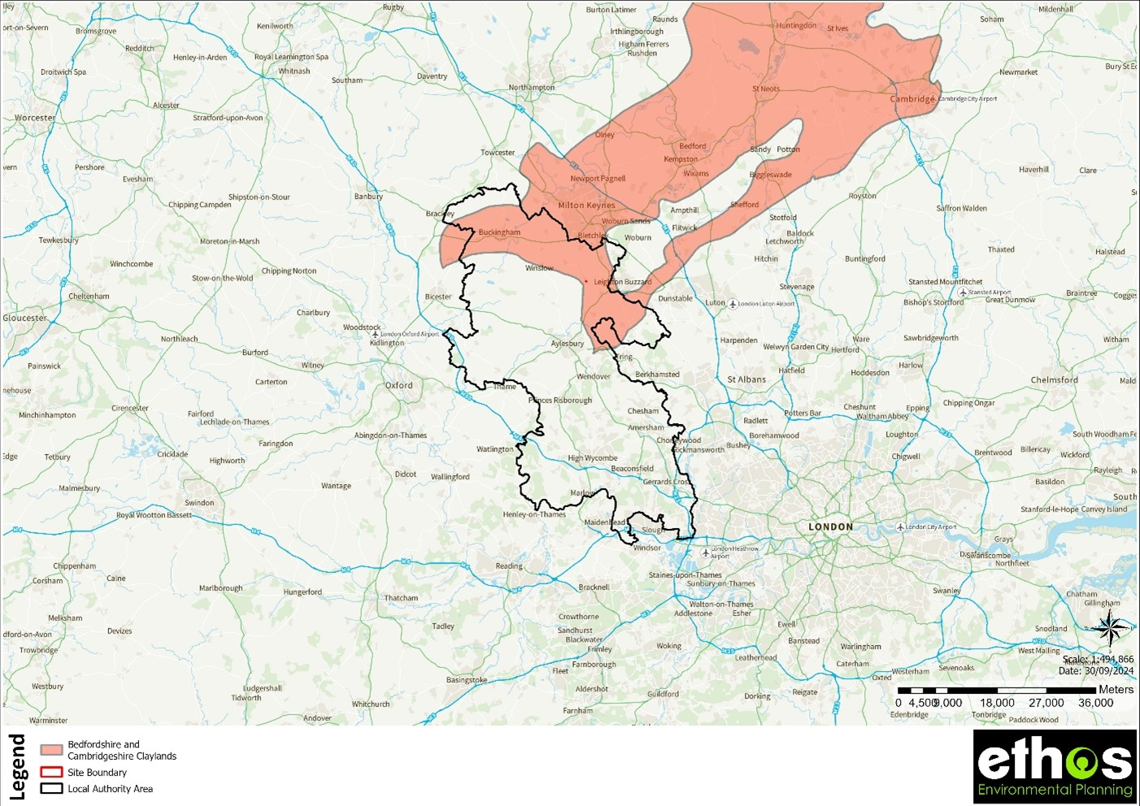
Figure 2: The LPA and NCA surrounding Snarlton

4.2 Strategic Areas and Priority/Irreplaceable Habitats
4.2.1 This site is not located within any strategic area and as such, all of the habitats within this assessment have been input as being of a low strategic significance.
4.2.2 There are no priority habitats within the site boundary. It is considered that the site proposals will not result in an impact on the nearby priority woodlands and as such, priority habitats will not be impacted by the development.
4.2.3 A desktop search using publicly available information did not identify any irreplaceable habitats onsite. This was confirmed during the UKHab survey.
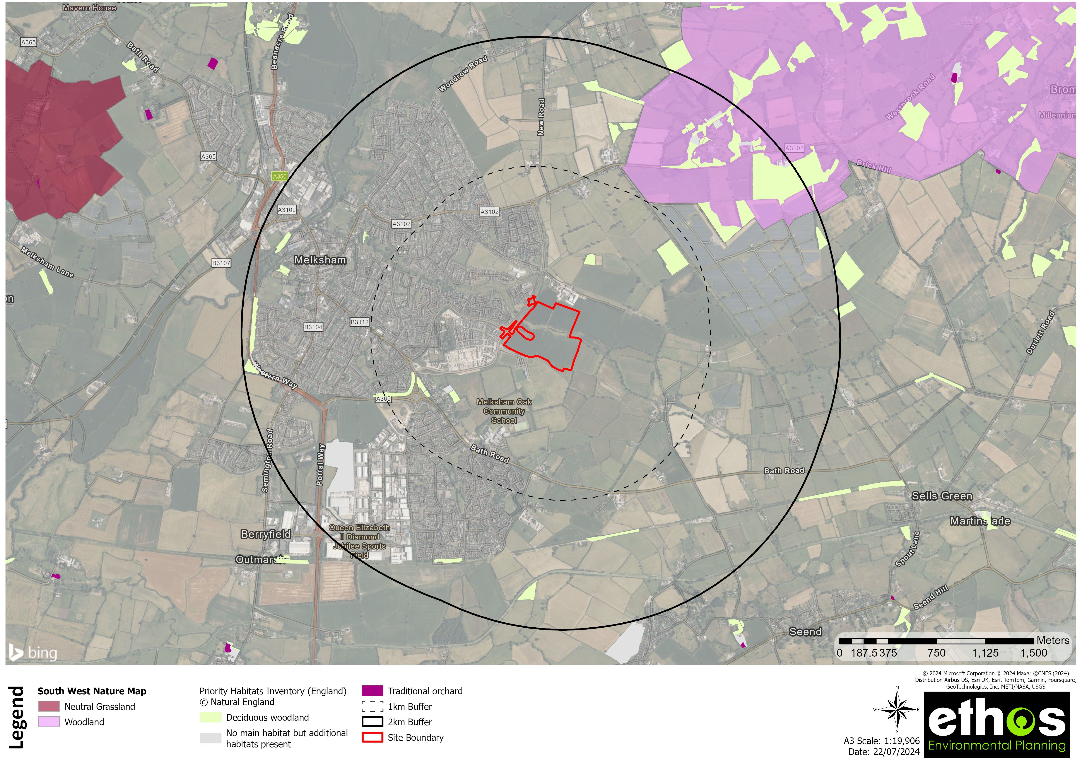
Figure 3: Priority Habitats Surrounding Snarlton

.

5 BASELINE HABITATS
5.1.1 The site encompasses 18.75 hectares. The existing habitats (Figure 4) generate 40.5 ABUs and 35.71 LBUs, and are listed below:
- Cropland - Cereal crops
- Grassland - Modified grassland
- Urban - Artificial unvegetated, unsealed surface
- Urban - Developed land; sealed surface
Linear habitats recorded on site comprise:
- Hedgerow
  - Species-rich native hedgerow
  - Native hedgerow
  - Native hedgerow - associated with bank or ditch
  - Native hedgerow with trees - associated with bank or ditch
  - Species-rich native hedgerow - associated with bank or ditch
  - Line of trees
  - Ecologically valuable line of trees
  - Line of trees - associated with bank or ditch
- Rivers and Streams
  - Other rivers and streams
5.1.2 Condition sheets for the baseline habitats are provided within Appendix 2 of this report.
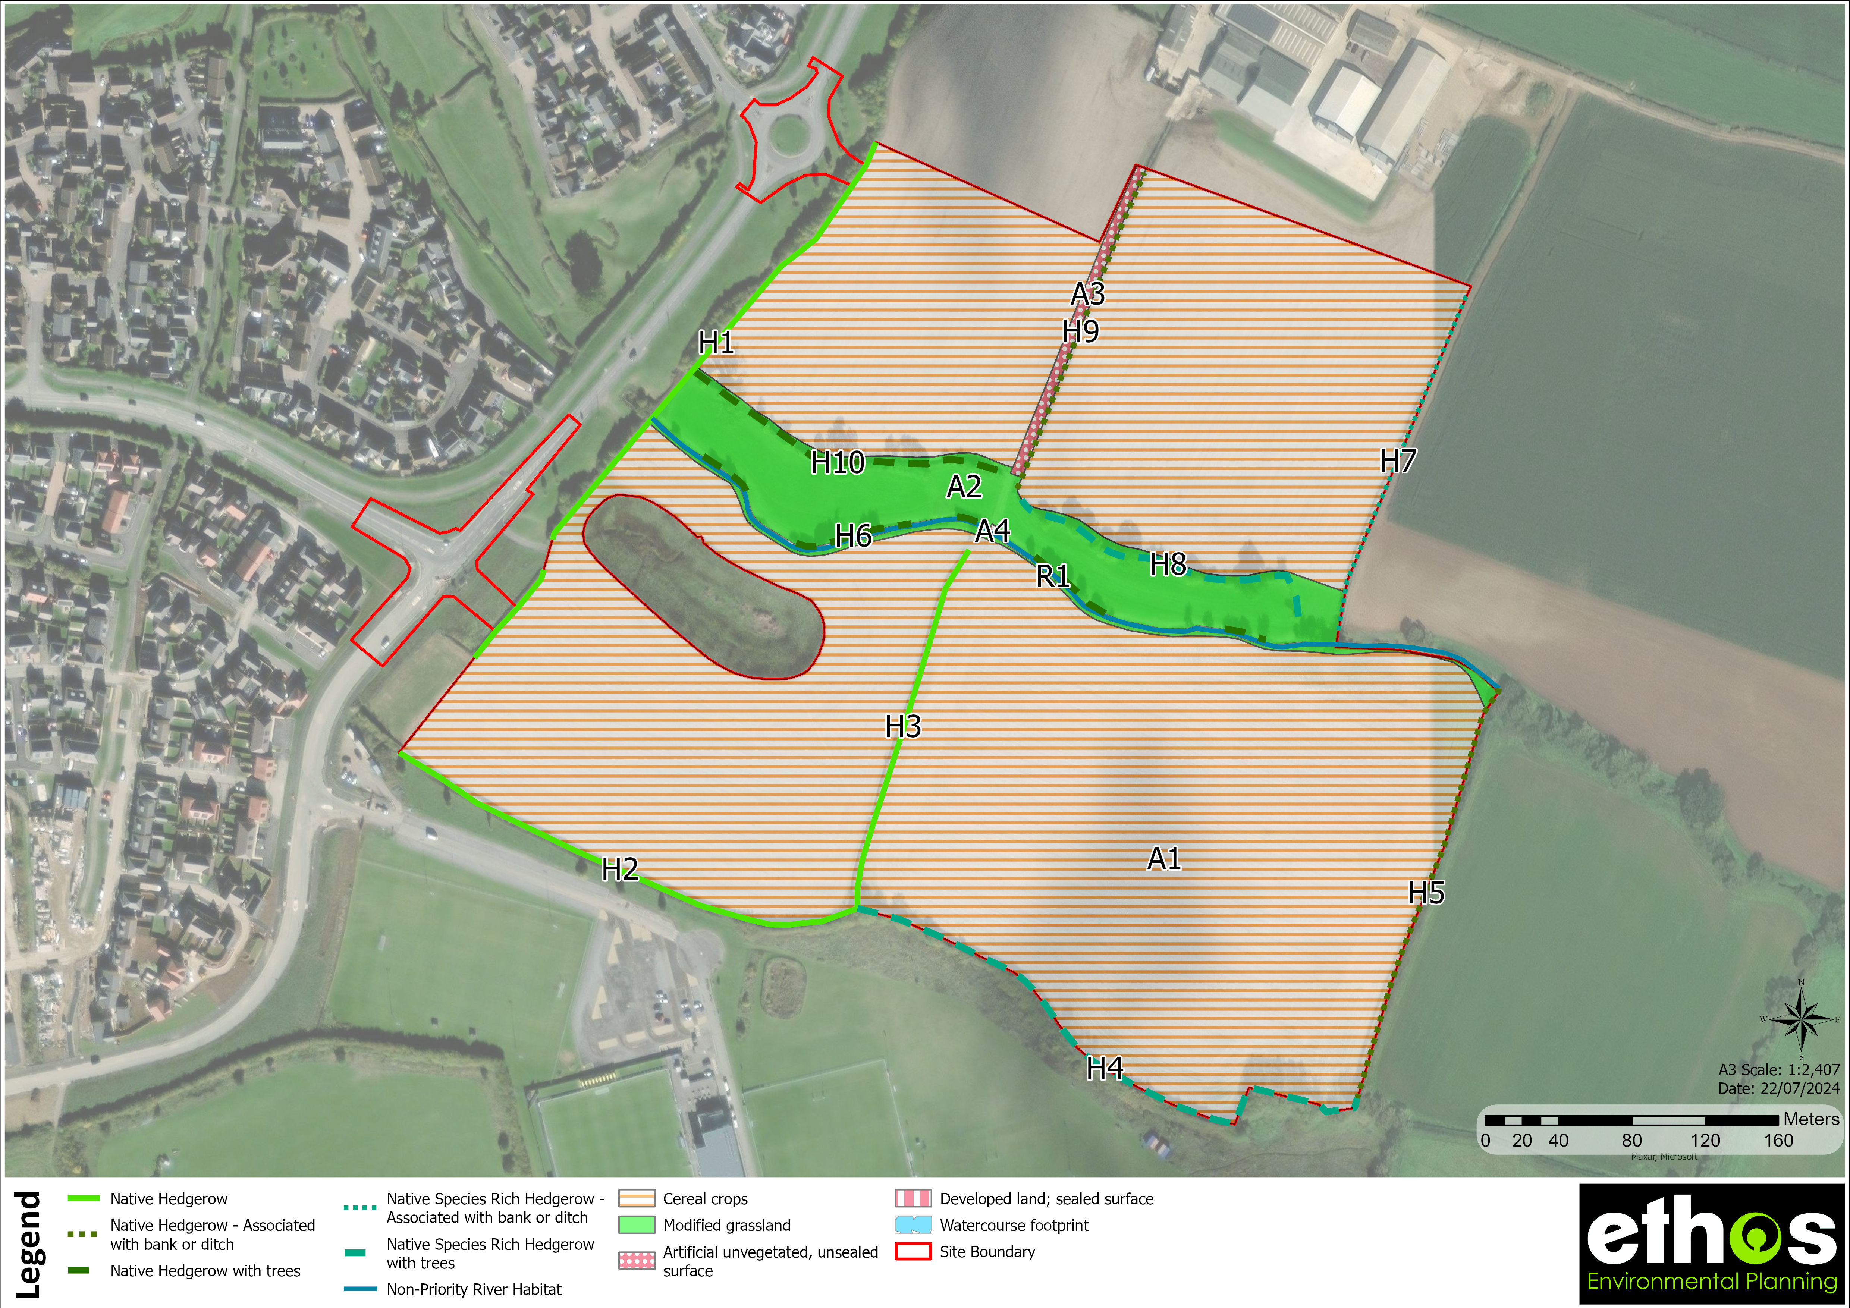
Figure 4: Baseline Habitat Map of Snarlton

5.2 Area Biodiversity Units

Cereal crops
5.2.1 The site consists of a 17.03ha area of cereal crops, a low distinctiveness, low strategic significance habitat.
5.2.2 This habitat is in an unassessable condition.

Modified grassland
5.2.3 The site consists of a 1.61ha area of modified grassland, a low distinctiveness, low strategic significance habitat.
5.2.4 This habitat is in moderate condition. It meets this condition because of x, y, and z.

Artificial unvegetated, unsealed surface
5.2.5 The site consists of a 0.11ha area of artificial unvegetated, unsealed surface, a very low distinctiveness, low strategic significance habitat.
5.2.6 This habitat is in an unassessable condition.

Developed land; sealed surface
5.2.7 The site consists of a 0ha area of developed land; sealed surface, a very low distinctiveness, low strategic significance habitat.
5.2.8 This habitat is in an unassessable condition.

5.3 Linear Biodiversity Units
5.3.1 There are 19 native hedgerow(s) present on site.
5.3.2 The existing hedgerow-type linear habitats were in good, moderate and poor condition, and were of medium strategic significance.
5.3.3 The hedgerow-type linear habitats are summarised in Table 1 below.
Table 1: Hedgerows on Site
Hedge Number | Hedgerow Type | Description | Photo
1 | Species-rich native hedgerow | A 0.45km, good condition species-rich native hedgerow, providing 5.93 baseline LBUs. | NA
2 | Species-rich native hedgerow | A 0.16km, moderate condition species-rich native hedgerow, providing 1.41 baseline LBUs. | NA
3 | Native hedgerow | A 0.25km, poor condition native hedgerow, providing 0.55 baseline LBUs. | NA
4 | Species-rich native hedgerow | A 0.23km, poor condition species-rich native hedgerow, providing 1.03 baseline LBUs. | NA
5 | Species-rich native hedgerow | A 0.23km, moderate condition species-rich native hedgerow, providing 1.99 baseline LBUs. | NA
6 | Native hedgerow - associated with bank or ditch | A 0.2km, moderate condition native hedgerow - associated with bank or ditch, providing 1.77 baseline LBUs. | NA
7 | Species-rich native hedgerow | A 0.13km, moderate condition species-rich native hedgerow, providing 1.14 baseline LBUs. | NA
8 | Species-rich native hedgerow | A 0.13km, moderate condition species-rich native hedgerow, providing 1.17 baseline LBUs. | NA
9 | Native hedgerow with trees - associated with bank or ditch | A 0.2km, poor condition native hedgerow with trees - associated with bank or ditch, providing 1.31 baseline LBUs. | NA
10 | Species-rich native hedgerow - associated with bank or ditch | A 0.04km, poor condition species-rich native hedgerow - associated with bank or ditch, providing 0.24 baseline LBUs. | NA
11 | Species-rich native hedgerow | A 0.14km, moderate condition species-rich native hedgerow, providing 1.2 baseline LBUs. | NA
12 | Native hedgerow | A 0.17km, poor condition native hedgerow, providing 0.38 baseline LBUs. | NA
13 | Species-rich native hedgerow | A 0.31km, poor condition species-rich native hedgerow, providing 1.36 baseline LBUs. | NA
14 | Native hedgerow | A 0.09km, poor condition native hedgerow, providing 0.19 baseline LBUs. | NA
15 | Line of trees | A 0.2km, poor condition line of trees, providing 0.44 baseline LBUs. | NA
16 | Line of trees | A 0.19km, moderate condition line of trees, providing 0.83 baseline LBUs. | NA
17 | Ecologically valuable line of trees | A 0.07km, moderate condition ecologically valuable line of trees, providing 0.66 baseline LBUs. | NA
18 | Line of trees | A 0.18km, poor condition line of trees, providing 0.39 baseline LBUs. | NA
19 | Line of trees | A 0.13km, poor condition line of trees, providing 0.28 baseline LBUs. | NA
20 | Line of trees | A 0.11km, moderate condition line of trees, providing 0.47 baseline LBUs. | NA
21 | Line of trees | A 0.06km, poor condition line of trees, providing 0.13 baseline LBUs. | NA
22 | Line of trees | A 0.04km, poor condition line of trees, providing 0.08 baseline LBUs. | NA
23 | Line of trees | A 0.04km, moderate condition line of trees, providing 0.17 baseline LBUs. | NA
24 | Line of trees | A 0.08km, moderate condition line of trees, providing 0.36 baseline LBUs. | NA
25 | Line of trees | A 0.34km, poor condition line of trees, providing 0.74 baseline LBUs. | NA
26 | Line of trees | A 0.2km, moderate condition line of trees, providing 0.89 baseline LBUs. | NA
27 | Line of trees | A 0.18km, poor condition line of trees, providing 0.39 baseline LBUs. | NA
28 | Line of trees | A 0.08km, moderate condition line of trees, providing 0.37 baseline LBUs. | NA
29 | Line of trees | A 0.11km, moderate condition line of trees, providing 0.48 baseline LBUs. | NA
30 | Line of trees - associated with bank or ditch | A 0.12km, poor condition line of trees - associated with bank or ditch, providing 0.27 baseline LBUs. | NA
31 | Line of trees | A 0.09km, moderate condition line of trees, providing 0.38 baseline LBUs. | NA
32 | Line of trees | A 0.15km, moderate condition line of trees, providing 0.67 baseline LBUs. | NA
33 | Native hedgerow | A 0.27km, poor condition native hedgerow, providing 0.6 baseline LBUs. | NA
34 | Native hedgerow | A 0.03km, moderate condition native hedgerow, providing 0.12 baseline LBUs. | NA
35 | Native hedgerow | A 0.35km, moderate condition native hedgerow, providing 1.53 baseline LBUs. | NA
36 | Native hedgerow | A 0.14km, poor condition native hedgerow, providing 0.3 baseline LBUs. | NA
37 | Native hedgerow | A 0.18km, moderate condition native hedgerow, providing 0.79 baseline LBUs. | NA
Other rivers and streams
5.2.1 The watercourse consists of a 1.8km length of other rivers and streams, a high distinctiveness, medium strategic significance habitat.
5.2.2 This watercourse is in moderate condition. It meets this condition because of x, y, and z.
Other rivers and streams
5.2.3 The watercourse consists of a 1.2km length of other rivers and streams, a high distinctiveness, low strategic significance habitat.
5.2.4 This watercourse is in poor condition. It meets this condition because of x, y, and z.

.

6 DEVELOPMENT PROPOSALS
6.1.1 The development proposals for the site comprise the removal of cereal crops, modified grassland, artificial unvegetated, unsealed surface, developed land; sealed surface and other rivers and streams. These proposals will accommodate residential dwellings with associated access roads, gardens and openspace.
6.1.2 The proposed development generates 11.83 ABUs and 35.77 LBUs.
6.1.3 The layout of the development has been developed to minimise impacts on important ecological features as follows…
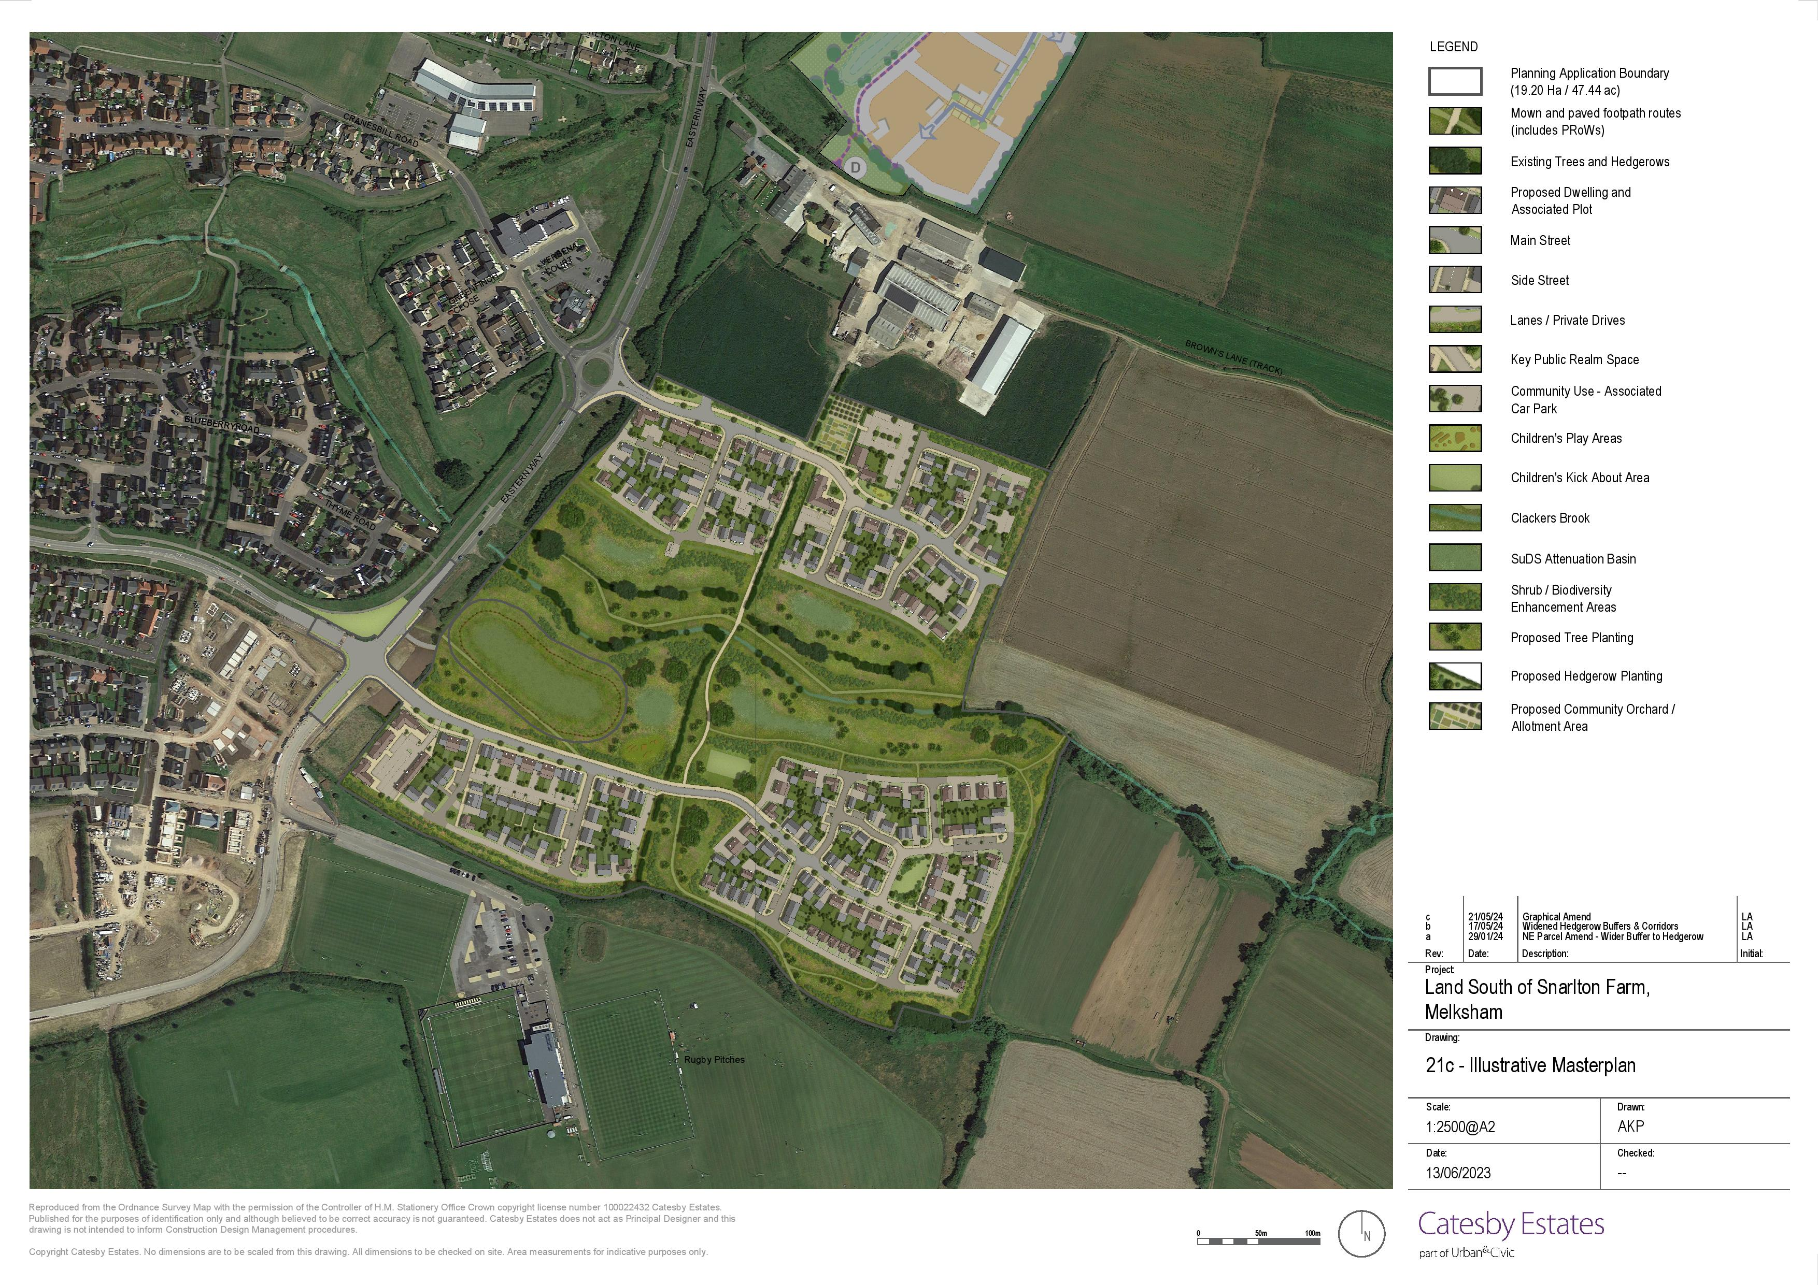
Figure 5: Illustrative Masterplan for Snarlton

.

7 POST-INTERVENTION HABITATS
7.1.1 Condition assessment sheets for which created and enhanced habitats will be provided within the HMMP report. The proposed condition assessments include justification for how the habitats will meet their target conditions.
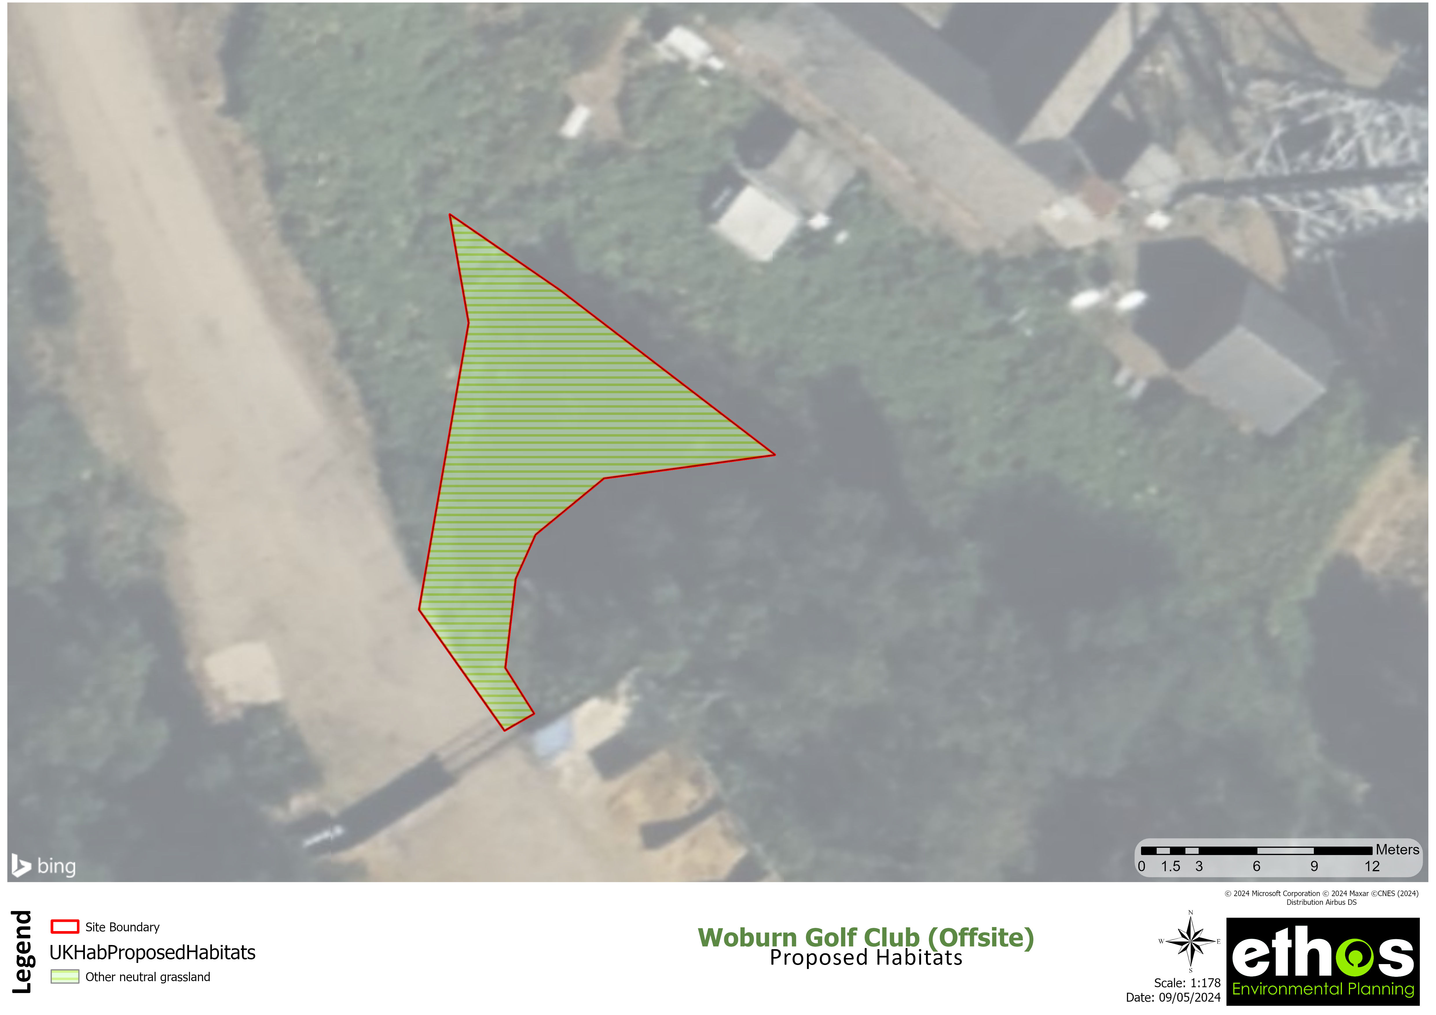
Figure 6: Proposed Habitats Map of Snarlton

7.2 Lost Area Biodiversity Units

Cropland
7.2.1 A 17.03ha area of cereal crops will be lost to the development.

Grassland
7.2.2 A 0.1ha area of modified grassland will be lost to the development.

Urban
7.2.3 A 0.11ha area of artificial unvegetated, unsealed surface will be lost to the development.
7.2.4 A 0ha area of developed land; sealed surface will be lost to the development.

7.3 Enhanced Area Biodiversity Units

Grassland
7.3.1 A 1.51ha area of grassland will be enhanced from modified grassland to other neutral grassland, a medium distinctiveness, low strategic significance habitat. The target condition for this habitat enhancement is ‘moderate’. To facilitate such an enhancement, the habitat should be…

7.4 Created Area Biodiversity Units

Urban
7.4.1 A 0.14ha area of allotments will be created, a low distinctiveness, low strategic significance habitat. The target condition for this proposed habitat parcel is ‘moderate’. To facilitate the creation of this habitat…
7.4.2 A 6.49ha area of developed land; sealed surface will be created, a very low distinctiveness, low strategic significance habitat. To facilitate the creation of this habitat…
7.4.3 A 2.3ha area of vegetated garden will be created, a low distinctiveness, low strategic significance habitat. To facilitate the creation of this habitat…
7.4.4 A 0.4ha area of sustainable drainage system will be created, a low distinctiveness, low strategic significance habitat. The target condition for this proposed habitat parcel is ‘poor’. To facilitate the creation of this habitat…

Heathland and shrub
7.4.5 A 1.68ha area of mixed scrub will be created, a medium distinctiveness, low strategic significance habitat. The target condition for this proposed habitat parcel is ‘moderate’. To facilitate the creation of this habitat…

Grassland
7.4.6 A 1.06ha area of modified grassland will be created, a low distinctiveness, low strategic significance habitat. The target condition for this proposed habitat parcel is ‘moderate’. To facilitate the creation of this habitat…
7.4.7 A 5.17ha area of other neutral grassland will be created, a medium distinctiveness, low strategic significance habitat. The target condition for this proposed habitat parcel is ‘poor’. To facilitate the creation of this habitat…

Individual trees
7.4.8 A 0.85ha area of urban tree will be created, a medium distinctiveness, low strategic significance habitat. The target condition for this proposed habitat parcel is ‘poor’. To facilitate the creation of this habitat…

7.1 Lost Watercourse Biodiversity Units
7.1.1 A 0.8km length of other rivers and streams will be lost to the development.

7.2 Retained Hedgerow Biodiversity Units
7.2.1 A 0.45km length of ecologically valuable line of trees from 17 will be retained.
7.2.2 A 7.18km length of line of trees from 15, 16, 18, 19, 20, 21, 22, 23, 24, 25, 26, 27, 28, 29, 31 and 32 will be retained.
7.2.3 A 0.45km length of line of trees - associated with bank or ditch from 30 will be retained.
7.2.4 A 3.59km length of native hedgerow from 3, 12, 14, 33, 34, 35, 36 and 37 will be retained.
7.2.5 A 0.45km length of native hedgerow - associated with bank or ditch from 6 will be retained.
7.2.6 A 0.45km length of native hedgerow with trees - associated with bank or ditch from 9 will be retained.
7.2.7 A 3.59km length of species-rich native hedgerow from 1, 2, 4, 5, 7, 8, 11 and 13 will be retained.
7.2.8 A 0.45km length of species-rich native hedgerow - associated with bank or ditch from 10 will be retained.

7.3 Retained Watercourse Biodiversity Units
7.3.1 A 11.81km length of other rivers and streams will be retained.

7.4 Created Watercourse Biodiversity Units
7.4.1 A 1.8km length of other rivers and streams will be created, a high distinctiveness, low strategic significance habitat. The target condition for this proposed habitat is ‘good’. To facilitate the creation of this habitat…
7.4.2 A 1.2km length of other rivers and streams will be created, a high distinctiveness, low strategic significance habitat. The target condition for this proposed habitat is ‘poor’. To facilitate the creation of this habitat…

7.5 Enhanced Hedgerow Biodiversity Units
7.5.1 A 0.07km length of moderate condition ecologically valuable line of trees will be enhanced to good condition ecologically valuable line of trees, a medium distinctiveness, medium strategic significance strategic significance habitat. To facilitate such an enhancement, the habitat should be…
7.5.2 A 1.05km length of moderate condition line of trees will be enhanced to good condition line of trees, a low distinctiveness, medium strategic significance strategic significance habitat. To facilitate such an enhancement, the habitat should be…
7.5.3 A 1.11km length of poor condition line of trees will be enhanced to good condition line of trees, a low distinctiveness, medium strategic significance strategic significance habitat. To facilitate such an enhancement, the habitat should be…
7.5.4 A 0.51km length of poor condition native hedgerow will be enhanced to good condition native hedgerow, a low distinctiveness, medium strategic significance strategic significance habitat. To facilitate such an enhancement, the habitat should be…
7.5.5 A 0.55km length of moderate condition native hedgerow will be enhanced to good condition species-rich native hedgerow, a medium distinctiveness, medium strategic significance strategic significance habitat. To facilitate such an enhancement, the habitat should be…
7.5.6 A 0.78km length of moderate condition species-rich native hedgerow will be enhanced to good condition species-rich native hedgerow, a medium distinctiveness, medium strategic significance strategic significance habitat. To facilitate such an enhancement, the habitat should be…
7.5.7 A 0.41km length of poor condition native hedgerow will be enhanced to good condition species-rich native hedgerow, a medium distinctiveness, medium strategic significance strategic significance habitat. To facilitate such an enhancement, the habitat should be…
7.5.8 A 0.54km length of poor condition species-rich native hedgerow will be enhanced to good condition species-rich native hedgerow, a medium distinctiveness, medium strategic significance strategic significance habitat. To facilitate such an enhancement, the habitat should be…
7.5.9 A 0.2km length of moderate condition native hedgerow - associated with bank or ditch will be enhanced to good condition associated with bank or ditch, a medium distinctiveness, medium strategic significance strategic significance habitat. To facilitate such an enhancement, the habitat should be…
7.5.10 A 0.12km length of poor condition line of trees - associated with bank or ditch will be enhanced to moderate condition associated with bank or ditch, a low distinctiveness, medium strategic significance strategic significance habitat. To facilitate such an enhancement, the habitat should be…
7.5.11 A 0.2km length of poor condition native hedgerow with trees - associated with bank or ditch will be enhanced to good condition associated with bank or ditch, a high distinctiveness, medium strategic significance strategic significance habitat. To facilitate such an enhancement, the habitat should be…
7.5.12 A 0.04km length of poor condition species-rich native hedgerow - associated with bank or ditch will be enhanced to good condition associated with bank or ditch, a high distinctiveness, medium strategic significance strategic significance habitat. To facilitate such an enhancement, the habitat should be…

7.6 Enhanced Watercourse Biodiversity Units
7.6.1 A 0.2km length of moderate condition other rivers and streams will be enhanced to fairly good condition other rivers and streams, a high distinctiveness, high strategic significance habitat. To facilitate such an enhancement, the habitat should be…
7.6.2 A 0.5km length of poor condition other rivers and streams will be enhanced to good condition priority habitat, a v.high distinctiveness, high strategic significance habitat. To facilitate such an enhancement, the habitat should be…

.

8 SUMMARY OF ONSITE BIODIVERSITY CHANGE
8.1 The habitat trading standards are met within this project, and the proposals would result in a percentage net gain of 29.21% for area based habitats, a net gain of 76.37% for hedgerow habitats, and a net gain of 52.55% for watercourse habitats.

.

9 BIODIVERSITY NET GAIN PRINCIPLES
9.1 The ten BNG principles and how they have been considered in relation to this project are set out below in Table 2.
Principle | Application to Project
Principle 1: Apply the mitigation hierarchy | X habitats on site were assessed to be of importance for nature conservation (see EcIA for further details). Therefore, avoiding impacts on the majority of habitats on site is not considered necessary. The project achieves a net gain overall for all metrics, going above and beyond the minimum requirements. The development is assessed to be compliant with the mitigation hierarchy.
Principle 2: Avoid losing biodiversity that cannot be offset by gains elsewhere | There ARE/ARENOT no irreplaceable habitats on site and therefore, impacts on habitats can be compensated.
Principle 3: Be inclusive and equitable | Ethos have engaged with the landscape architects for the project in order to identify the most suitable habitats for both biodiversity and aesthetic.
Principle 4: Address risk | Habitats to be created are RISKLEVEL risk. Management and monitoring of habitats will be set out within a HMMP, with remedial measures identified if habitats are not meeting their target conditions.
Principle 5: Make a measurable net gain contribution | The project overall ACHIEVES/DOESNT ACHIEVE a net gain across all metrics beyond the minimum requirements.
Principle 6: Achieve the best outcomes for biodiversity | The project overall ACHIEVES/DOESNT ACHIEVE a net gain across all metrics beyond the minimum requirements.
Principle 7: Be additional | The development proposals project a net GAIN/LOSS for biodiversity beyond the statutory requirements.
Principle 8: Create a net gain legacy | The HMMP will set out management actions, monitoring plan and remedial measures which therefore plans for adaptive management and will secure dedicated funding for the 30-year management period.
Principle 9: Optimise sustainability | THESE HABITATS will be created on site; this prioritises BNG as well as providing wider environmental benefits for local residents.
Principle 10: Be transparent | Draft BNG information has been provided throughout the project to the project team. This BNG report will be provided to the LPA as part of the planning application and will be available on the planning portal for comment. Therefore, it is considered transparent.

.

10 CONCLUSIONS
10.1 This project proposes the removal of cereal crops, modified grassland, artificial unvegetated, unsealed surface, developed land; sealed surface and other rivers and streams to accomodate residential dwellings with associated access roads, gardens and openspace.
10.2 Proposals for area-based habitats include the creation of allotments, developed land; sealed surface, vegetated garden, mixed scrub, modified grassland, sustainable drainage system, other neutral grassland and urban tree, and the enhancement of other neutral grassland.
10.3a Proposals for hedgerow habitats include the enhancement of the following: species-rich native hedgerow, native hedgerow, associated with bank or ditch, line of trees and ecologically valuable line of trees.
10.3b Proposals for watercourse habitats include the creation of the following: other rivers and streams and the enhancement of the following: other rivers and streams and priority habitat.
10.4 The proposals meet trading requirements, and provide an overall net gain in biodiversity for area based habitats (11.83 units, 29.21%), a net gain for hedgerow habitats (23.67 units, 76.37%), and a net gain for watercourse habitats (12.1 units, 52.55%).
10.5 In order to achieve >10% net gain a further 14.73 ABU are required, these must be medium distinctiveness grassland in order to also satisfy the trading requirements. A further 0.24 LBU are required which will also satisfy the trading requirements.
10.6 With the above offsite credits secured. This project aligns with the BNG principles, and is in accordance with local and national policy, and emerging national legislation.
10.7 The project meets the BNG objective and can form the BNG condition which can be discharged within the reserved matters of this application. A Biodiversity Net Gain Plain and HMMP will be submitted to the appropriate Local Authority within the reserved matters stage of this planning application.
10.8 Paragraph 9 of Schedule 7A of the Town and Country Planning Act 1990 requires ‘significant’ on-site habitat enhancement to be secured under a planning condition, section 106 agreement, or conservation covenant.

.

11 REFERENCES
CIEEM (2021). Biodiversity Net Gain Report and Audit Templates. Chartered Institute of Ecology and Environmental Management, Winchester, UK.
CIEEM, IEMA & CIRIA (2016). Biodiversity Net Gain: Good Practice Principles for Development.
DEFRA (2007). Hedgerow Survey Handbook: A standard procedure for local surveys in the UK.
DEFRA (2023). The Statutory Biodiversity Metric.
DEFRA (2018). 25 Year Environment Plan. His majesty’s stationary office
Gov (2023) guidance/draft-biodiversity-net-gain-planning-practice-guidance [online] Available from:
Department for Levelling Up, Housing & Communities (2023) National Planning Policy Framework.
UKHab (2023). UK Habitat Classification Version 2.0. Available from:
Wildlife and Countryside Act (1981). As amended.

.

APPENDIX 1 POLICY AND LEGISLATION

11.1 Statutory Framework
11.1.1 Biodiversity net gain is a way of creating and improving biodiversity by requiring development to have a positive impact (‘net gain’) on biodiversity.
11.1.2 In England, biodiversity net gain is required under a statutory framework introduced by Schedule 7A of the Town and Country Planning Act 1990 (inserted by the Environment Act 2021). This is referred to as biodiversity net gain in Planning Practice Guidance to distinguish it from other or more general biodiversity gains.
11.1.3 Under the statutory framework for biodiversity net gain, every grant of planning permission is deemed to have been granted subject to a general biodiversity gain condition to secure the biodiversity gain objective. This objective is to deliver at least a 10% increase in relation to the pre-development biodiversity value of the development granted permission. This increase can be achieved through onsite biodiversity gains, registered offsite biodiversity gains or statutory biodiversity credits.
11.1.4 The general biodiversity gain condition is a pre-commencement condition: once planning permission has been granted, a Biodiversity Gain Plan must be submitted and approved by the planning authority before commencement of the development. There are exemptions and transitional arrangements which disapply the condition from certain planning permissions, as well as special modifications for planning permissions for phased development and the treatment of irreplaceable habitats.
11.1.5 The statutory framework for biodiversity net gain also includes provisions about information requirements for planning applications and the treatment of the condition on planning decision notices.

11.2 Environment Act 2021
11.2.1 The Act requires a minimum of 10% net gain for biodiversity as a condition of planning permission.
11.2.2 Net gain is to be measured by the biodiversity metric published by the Secretary of State. The Act requires that gains must be secured for a minimum of 30 years post completion of development. Also, under Section 40 the NERC Act 2006, as amended by the Environment Act 2021, “A public authority which has any functions exercisable in relation to England must from time-to-time consider what action the authority can properly take, consistently with the proper exercise of its functions, to further the general biodiversity objective.”…the biodiversity objective is, “…the conservation and enhancement of biodiversity in England through the exercise of functions in relation to England”. This is referred to as the Biodiversity Duty.
11.2.3 The Environment Act received Royal Assent in November 2021, meaning that by February 2024 the expectation for all planning permissions to include a biodiversity net gain of at least 10% will become a legal requirement.

11.3 BNG Exemptions
Small sites (exempt until April 2024)
- residential development where the number of dwellings is between 1 and 9, or if this is unknown, the site area is less than 0.5 hectares
- commercial development where floor space created is less than 1,000 square metres or total site area is less than 1 hectare
- development that is not the winning and working of minerals or the use of land for mineral-working deposits
- development that is not waste development
Developments below Threshold
11.3.1 A development that’s below the threshold means that it does not impact a priority habitat and impacts less than:
- 25 square metres (5m by 5m) of habitat
- 5 metres of linear habitats such as hedgerows
Householder Applications
11.3.2 These are applications made by householders as defined within article 2(1) of the Town and Country Planning (Development Management Procedure) (England) Order 2015. It includes, for example, small projects like home extensions, conservatories or loft conversions
Self-build and Custom Applications
11.3.3 An exemption applies to this type of development when all the following conditions apply:
- it consists of no more than 9 dwellings
- it’s on a site that has an area no larger than 0.5 hectares
- it consists exclusively of dwellings that are self-build or custom housebuilding as defined in section 1(A1) of the Self-build and Custom Housebuilding Act 2015
Biodiversity Gain Site
11.3.4 Developments undertaken for the purpose of fulfilling the BNG planning condition for another development are exempt.
High Speed Railway Network
11.3.5 An exemption applies to any development forming part of, or ancillary to, the high-speed railway transport network, comprising connections between all or any of the places or parts of the transport network specified in section 1(2) of the High Speed Rail (Preparation) Act 2013

11.4 National Planning Policy Framework
11.4.1 The National Planning Policy Framework (NPPF) sets out planning policy for England. Paragraphs of particular relevance from the NPPF are listed below:
11.4.2 Paragraph 180 states “Planning policies and decisions should contribute to and enhance the natural and local environment by minimising impacts on and providing net gains for biodiversity, including by establishing coherent ecological networks that are more resilient to current and future pressures”.
11.4.3 Paragraph 185 states “To protect and enhance biodiversity and geodiversity, plans should promote the conservation, restoration and enhancement of priority habitats, ecological networks and the protection and recovery of priority species; and identify and pursue opportunities for securing measurable net gains for biodiversity.”
11.4.4 Paragraph 186 states “When determining planning applications, local planning authorities should apply the following principles development whose primary objective is to conserve or enhance biodiversity should be supported; while opportunities to improve biodiversity in and around developments should be integrated as part of their design, especially where this can secure measurable net gains for biodiversity or enhance public access to nature where this is appropriate.”

11.5 UK Governments 25 Year Environment Plan
11.5.1 The UK Government’s 25 Year Environment Plan (DEFRA, 2018) states a desire to ‘embed a ‘net environmental gain’ principle for development to deliver environmental improvements locally and nationally’ and plans to consult on making Biodiversity Net Gain a mandatory requirement.
11.5.2 On 14th March 2019, Her Majesty’s Treasury confirmed that following consultation, the government will use the forthcoming Environment Bill to mandate BNG for development in England, ensuring that the delivery of much-needed infrastructure and housing is not at the expense of vital biodiversity.

11.6 Biodiversity 2020: A Strategy for England’s Wildlife and Ecosystem
11.6.1 A strategy for England’s wildlife and ecosystem services (DEFRA, 2011) is the national strategy for biodiversity. This sets out an ambition to halt the loss of biodiversity and see an increase in the area of priority habitats by 200,000 ha by 2020. Biodiversity 2020 sets in policy the objectives to improve our wildlife Sites, make them bigger, develop more of them and join them up (summarised as ‘Bigger, Better, More and Joined’).

11.7 NERC Act
11.7.1 The Natural Environment and Rural Countryside (NERC) Act (HMSO, 2006) requires public bodies, including local authorities, ‘to have regard to the conservation of biodiversity in England when carrying out their normal functions’. Section 40 sets out that:
- Paragraph 1. “Every public authority must, in exercising its functions, have regard, so far as is consistent with the proper exercise of those functions, to the purpose of conserving biodiversity”;
- Paragraph 3. “Conserving biodiversity includes, in relation to a living organism or type of habitat, restoring or enhancing a population or habitat”.
- Section 41 sets out that: Paragraph 1. “The Secretary of State must… publish a list of the living organisms and types of habitat … of principal importance for the purpose of conserving biodiversity” based on consultation with Natural England; and that Every planning authority must “a) take such steps… to further the conservation of the living organisms and types of habitat included in any list published under this section, or (b) promote the taking by others of such steps”.

11.8 Local Policy
[ to be filled in automatically]

.

APPENDIX 2 CONDITION ASSESSMENT SHEETS
[to be filled in automatically]

