Lowerhouse Farm – BNG Feasibility Study | 

Date: 2024-03-21
Author: Madison Lucas, MBiol, Assistant Digital Ecologist
Approved by:
Issued to client:

Executive Summary
This report sets out a feasibility study for creating a habitat bank on land at Lowerhouse Farm, Surrey (the site). The key points are:
- The baseline habitats are grassland, woodland, pond, and hard hard standing.
- The proposals are to enhance existing grassland and woodland, and create further woodland.
- The proposals would generate a net 184.10 BNG units
- The report sets out the next steps for the project.

Table of Contents
Executive Summary 2
1. Introduction 4
2. Relevant Policy & Legislation 5
2.1 National Planning Policy Framework 5
2.2 Environment Act 2021 6
2.3 Local Planning Policy 7
2.3.1 Waverley Borough Local Plan 7
2.3.2 Waverley Borough Biodiversity Policy and Action Plan 2022-2032 7
2.3.3 Surrey Biodiversity Action Plan 8
2.3.4 Biodiversity Opportunity Areas in Surrey 8
2.3.5 Surrey Local Nature Recovery Strategy 8
3. Methods 9
3.1 Strategic Significance 9
3.1.1 Nature Recovery Network 9
3.2 Results 9
3.3 Desk Study Methods 10
3.4 Limitations 10
4. Baseline Conditions 12
5. Feasibility of Biodiversity Net Gain 13
6. Next steps 15
7. Conclusion 15
Index of Tables
Table 1: Statutory Designated Wildlife Sites of National Importance. 9
Table 2: Baseline BNG Units 12
Table 3: Proposed BNG Units 12
Table of Figures
Figure 1: Site Location Plan 5
Figure 2: Baseline Habitats 11
Figure 3: Proposed Habitats 13

1. Introduction
Habitat Vault have commissioned Digital Ecology to carry out a Biodiversity Net Gain (BNG) feasibility assessment of Lowerhouse Farm, Surrey, with the aim of developing existing landholdings to act as a habitat bank and thus generate BNG units for sale to developers that need to meet BNG obligations for their own development site.
Lowerhouse Farm (central grid ref: TQ114390) is located in Ewhurst, Cranleigh, GU6 7SQ, Surrey, and shall hereafter be referred to as ‘the site’. The site is within Waverley Borough Council. The location of the site is shown in Figure 1. It lies south-east of the rural village of Ewhurst, and is surrounded mostly by fragmented woodland and pasture farmland. The site is approximately 45 hectares, consisting of the following habitats:
- Grassland – Modified grassland
- Woodland and forest – Lowland mixed deciduous woodland
- Urban - Developed land; sealed surface
- Lakes – Ponds (non-priority habitat)
The current land use is as a rural estate.

Figure 1: Site Location Plan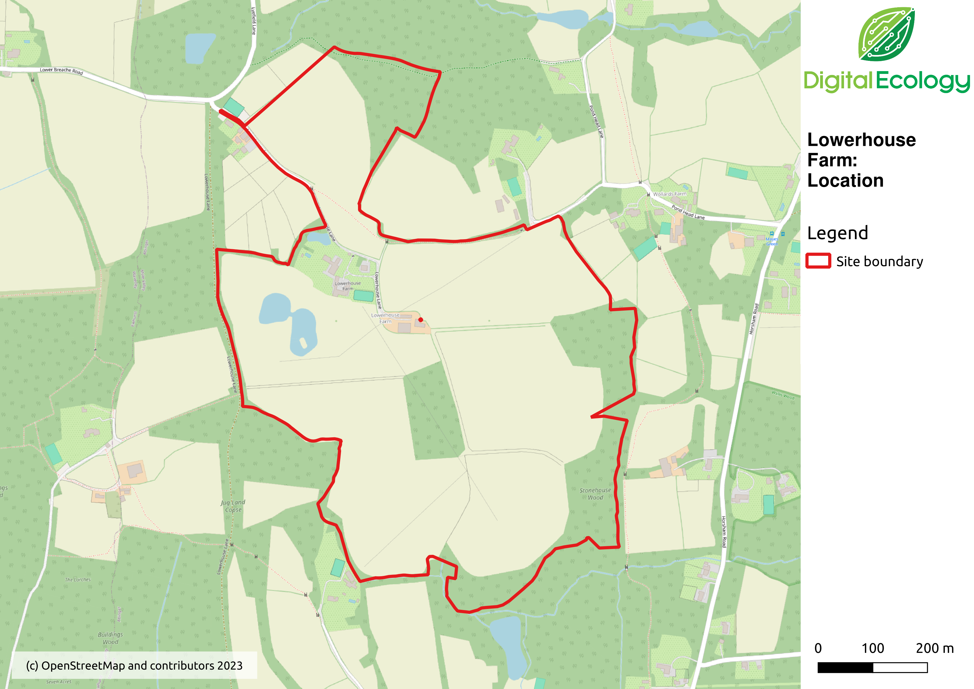

2. Relevant Policy & Legislation

2.1 National Planning Policy Framework
The National Planning Policy Framework (NPPF) sets out planning policy for England. Paragraph 174 of the NPPF states:
“Planning policies and decisions should contribute to and enhance the natural and local environment by:…
d) minimising impacts on and providing net gains for biodiversity, including by establishing coherent ecological networks that are more resilient to current and future pressures;…”

Paragraph 179 states:
“To protect and enhance biodiversity and geodiversity, plans should:…
b) promote the conservation, restoration and enhancement of priority habitats, ecological networks and the protection and recovery of priority species; and identify and pursue opportunities for securing measurable net gains for biodiversity.”
Paragraph 180 states:
“d) development whose primary objective is to conserve or enhance biodiversity should be supported; while opportunities to improve biodiversity in and around developments should be integrated as part of their design, especially where this can secure measurable net gains for biodiversity or enhance public access to nature where this is appropriate.”

2.2 Environment Act 2021
The Environment Act 2021 includes provision for biodiversity net gain to be applied to every planning permission.
Schedule 14 of the Environment Act 2021 sets out amendments to the Town and Country Planning Act 1990 for the inclusion of biodiversity net gain as follows:
“Biodiversity gain objective
(1) The biodiversity gain objective is met in relation to development for which planning permission is granted if the biodiversity value attributable to the development exceeds the pre-development biodiversity value of the on-site habitat by at least the relevant percentage.
(2) The biodiversity value attributable to the development is the total of—
(a) the post-development biodiversity value of the on-site habitat,
(b) the biodiversity value, in relation to the development, of any registered off-site biodiversity gain allocated to the development, and
(c) the biodiversity value of any biodiversity credits purchased for the development.
(3) The relevant percentage is 10%.”

The Environment Act received Royal Assent in November 2021, meaning that by November 2023 the expectation is that for all planning permissions to include a biodiversity net gain of at least 10% will become a legal requirement.

2.3 Local Planning Policy

2.3.1 Waverley Borough Local Plan
The current Local Plans for Waverley are the Local Plan Part 1: Strategic Policies and Sites, and the Local Plan Part 2: Site Allocations and Development. The former was adopted in February 2018, and the latter in March 2023. The second part of the plan replaces the previous 2002 local plan. The local plans set out a vision and framework for development in Waverley to the period 2032, addressing housing needs and other economic, social, and environmental priorities.
The Local Plan describes each of Waverley’s community areas and includes policies on jobs, homes, infrastructure, and the natural environment. The key policies within the plan that relate to the site and biodiversity are:
Local Plan Part 1:
- PSP2 – Spatial Strategy
- PRE1 – Countryside beyond the Green Belt
- PRE2 – Green Belt
- PRE3 – Landscape Character
- PNE1 – Biodiversity and Geological Conservation
- PNE2 – Green and Blue Infrastructure
- PNE3 – Thames Basin Heaths Special Protection Area
Local Plan Part 2:
- DM1: Environmental Implications of Development
- DM11: Trees, Woodland, Hedgerows and Landscaping

2.3.2 Waverley Borough Biodiversity Policy and Action Plan 2022-2032
The Waverley Borough Council Biodiversity Policy sets a clear vision as to how green spaces will be managed to improve the natural environment of Waverley through enriching biodiversity and increasing habitat connectivity.
The habitats identified of principal importance in Waverley are: mixed deciduous woodland; Beech and Yew woodland; wet woodland; wood-pasture and parkland; traditional orchards; Scots Pine; lowland meadows, lowland calcareous grassland, floodplain grazing marsh; lowland heathlands; reedbeds; rivers; standing open water; ponds; arable field margins; amenity spaces; cemeteries and churchyards; road verges; and hedgerows.

2.3.3 Surrey Biodiversity Action Plan
A Local Nature Partnership, the Surrey Nature Partnership, replaces the previous Surrey Biodiversity Partnership, which drove the implementation of the Surrey Biodiversity Action Plan (BAP) from 1999-2010. The Surrey BAP is no longer active, and all material has been archived. Though closed, its individual Habitat and Species Action Plans are available on request.
The Biodiversity Working Group division of Surrey Nature Partnership has produced a Biodiversity and Planning in Surrey manual offering advice to statutory planning practitioners, including identifying priority habitats and species. The UK BAP priority habitats identified in Surrey are: lowland heathland; lowland dry acid grassland; lowland calcareous grassland; lowland meadows; wood-pasture and parkland; lowland Beech and Yew woodland; lowland mixed deciduous woodland; wet woodland; traditional orchards; floodplain grazing marsh; lowland fens; eutrophic standing waters; ponds; reedbeds; rivers; hedgerows; open mosaic habitats; and arable field margins. A full list of UK BAP priority species can be found in Appendix I of the Biodiversity and Planning in Surrey manual.

2.3.4 Biodiversity Opportunity Areas in Surrey
The Surrey Nature Partnership has been identifying Biodiversity Opportunity Areas (BOA) in Surrey since 2009. BOAs seek to identify any areas or sites for the restoration or creation of new priority habitats which contribute to regional targets, and support this restoration or creation through appropriate policies. The BOA will form the basis for realising Surrey’s ecological network.
In Waverley, the BOAs include: North Downs Scarp; The Hog's Back; Puttenham and Crooksbury; Farnham Heaths; Thursley, Hankley, and Frensham Heaths; Devil’s Punch Bowl and Hindhead Heaths; Chiddingfold and West Weald Woodlands; Hascombe, Winkworth, and Hydon’s Heath and Woodlands; River Wey and Tributaries (Upper); River Wey (Cranleigh Waters). Many of the projects involve priority habitat enhancement for heathland and native woodland, with further detail regarding habitat and species recovery opportunities available in the Surrey Biodiversity Opportunity Areas – Objectives and Targets Summary.

2.3.5 Surrey Local Nature Recovery Strategy
The Surrey Local Nature Recovery Strategy (LNRS) is currently being developed and will consist of a document and a map which will inform and guide nature recovery across Surrey. It is expected that the strategy will be completed by the end of 2024. Further information on the LNRS can be viewed here the Surrey Council website and the Surrey Nature Partnership website.

3. Methods

3.1 Strategic Significance
Strategic significance relates to the spatial location of a habitat parcel at a landscape scale. It is based on the habitat type and its location, depending on their status in a local plan, strategy or policy related to biodiversity. Strategic significance is assigned as either high, medium, or low.
Digital Ecology examined the local strategic context of the site to identify any biodiversity plans or strategies to which a habitat bank at the site could contribute. Existing information was analysed to create a baseline of the habitats on site. Statutory designated wildlife sites were identified along with records of protected and notable species and notable habitats.

3.1.1 Nature Recovery Network
The Surrey Wildlife Trust is working to create a Nature Recovery Network across the county. It aims to create a joined up network of habitats that allows both wildlife and people to thrive.

3.2 Results
A search on MagicMaps returned three statutory designated wildlife sites of national importance (within 5km). No statutory designated wildlife sites of international importance (within 10km) or local importance (within 2km) were found. These are detailed in Table 1 below.
Table 1: Statutory Designated Wildlife Sites of National Importance.
Name | Designation | Grid Reference | Reason for designation | Location in relation to site
Statutory Designated Wildlife Sites of National Importance (within 5km)
Surrey Hills | AONB | TQ081486 | Covering a quarter of Surrey, the Surrey Hills AONB embraces a variety of countryside, from chalk downs of yew and box woodland and flower rich grasslands, to acid heaths and woodland of the Greensand Hills. | 2,250m North
Vann Lake and Ockley Woods | SSSI | TQ156392 | The woodlands include blocks of ancient woodland and are botanically rich, with diverse ground flora that varies with geology. Woods also supports a number of uncommon insects including dragonfly species and woodland lepidoptera. Lastly, woodland and freshwater habitats support a diverse range of breeding birds. | 3250m East
Leith Hill | SSSI | TQ134441 | This site consists of a wide variety of woodland habitats, and ground flora is diverse. Leith Hill supports a diverse community of breeding birds and numerous invertebrates of national and county significance. Many of these are associated with ancient semi-natural woodland. | 3,800m North-East

3.3 Desk Study Methods
The desk study used existing information to create a baseline of the habitats on site. This used aerial photography interpretation to map and identify habitats on the site. No field work was undertaken in preparing this feasibility study. Strategic significance for the existing habitats was set to low.
Proposals were based on an assessment of the strategic context, as well as the topography of the site. Any proposed habitats are indicative. Habitat condition was assumed to be moderate for those habitats that require condition assessment. For the proposals strategic significance was set to medium as the design responds to the local context, aiming to increase the habitat resources and improve connectivity between core habitats.
DEFRA metric 4.0 was used to calculate the uplift in biodiversity units as a result of the proposals.

3.4 Limitations
This is a desk-based study, using data available to Digital Ecology from a wide variety of sources. No field work has taken place to inform this study so the conclusions of the report should not be relied upon for use in supporting a planning application or the sale of BNG units to developers.
- Existing habitats have been mapped using aerial photography interpretation and other sources of habitat data.
- Habitat condition has been set to moderate for all habitats that require a condition assessment.
- Proposed habitats are based on landscape context, locally important species, habitats and designated sites and represent the author’s view of the most appropriate interventions in this location.
- No account has been taken of existing land use or management, soils types, hydrology or other environmental factors.

4. Baseline Conditions
The baseline habitats are:
- Grassland – Modified grassland
- Woodland and forest – Lowland mixed deciduous woodland
- Urban - Developed land; sealed surface
- Lakes – Ponds (non-priority habitat)
There are also hedgerows, many with mature trees, on the boundaries of the fields. These have not been included in the current assessment. The baseline biodiversity map showing existing habitats is shown in Figure 2 below.
Figure 2: Baseline Habitats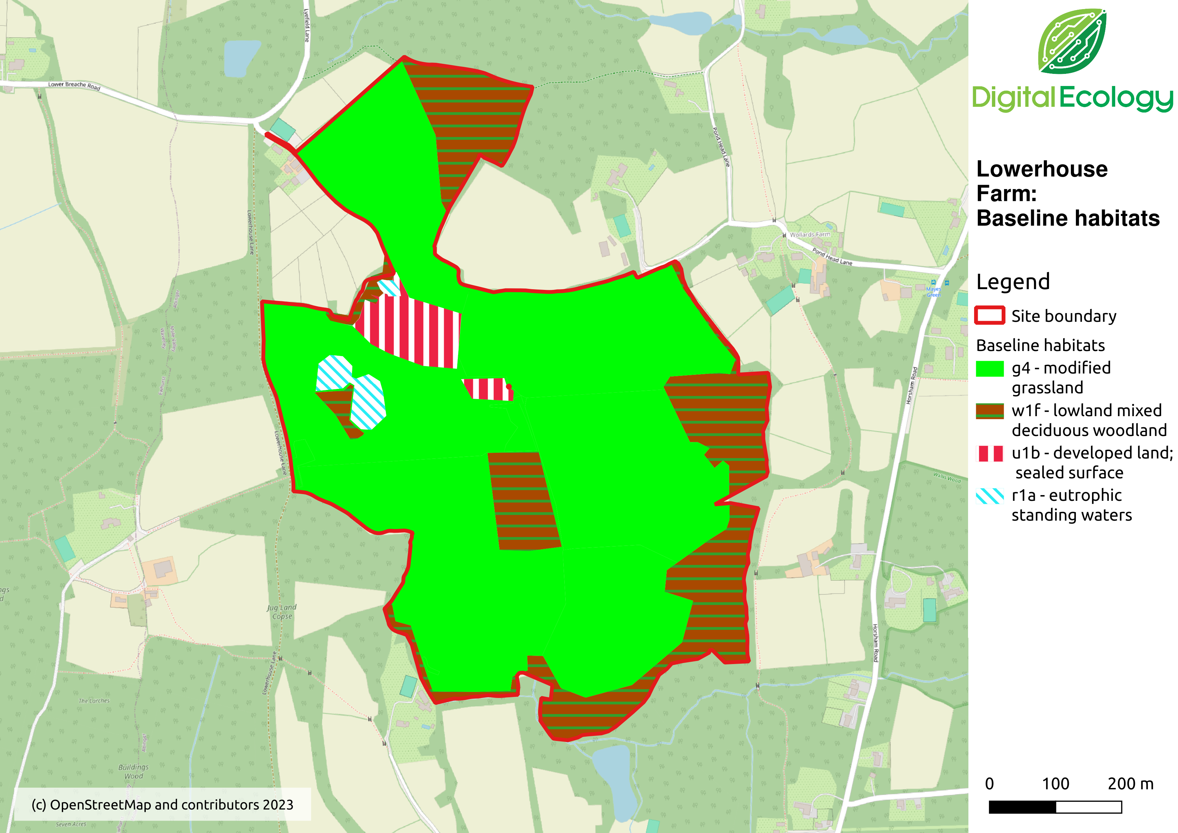
The baseline BNG units for the site are set out below in Table 2 below.
Table 2: Baseline BNG Units
Habitat | Area (ha) | Condition (assumed) | Strategic Significance | Units
Modified grassland | 30.83 | Moderate | Low | 123.32
Modified grassland | 2.33 | Moderate | Low | 9.32
Lowland mixed deciduous woodland | 9.44 | Moderate | Medium | 124.61
Developed land; sealed surface | 1.54 | N/A | Low | 0
Ponds (non-priority habitat) | 0.65 | Moderate | Low | 5.20
TOTAL | 44.79 |  |  | 262.45

5. Feasibility of Biodiversity Net Gain
The proposals reflect the local landscape context, and contribute to improving connectivity by creating both corridors and stepping stones.
The proposed habitats are:
- Other neutral grassland
- Other woodland; broadleaved
- Lowland mixed deciduous woodland
The proposed BNG units for the site are set out below in Table 3:
Table 3: Proposed BNG Units
Habitat | Area (ha) | Condition | Strategic Significance | Action | Time to standard condition | Units
Other woodland; broadleaved | 2.33 | Moderate | Medium | Create | 15 | 12.02
Other neutral grassland | 30.83 | Good | Medium | Enhance | 15 | 294.64
Lowland mixed deciduous woodland | 9.44 | Good | Medium | Enhance | 20 | 134.69
Developed land; sealed surface | 1.54 | N/A | N/A | Retain | N/A | N/A
Ponds (non-priority habitat) | 0.65 | Moderate | Low | Retain | N/A | 5.20
TOTAL | 44.79 |  |  |  |  | 446.55

A map of the proposed habitats is set out in Figure 3 below.

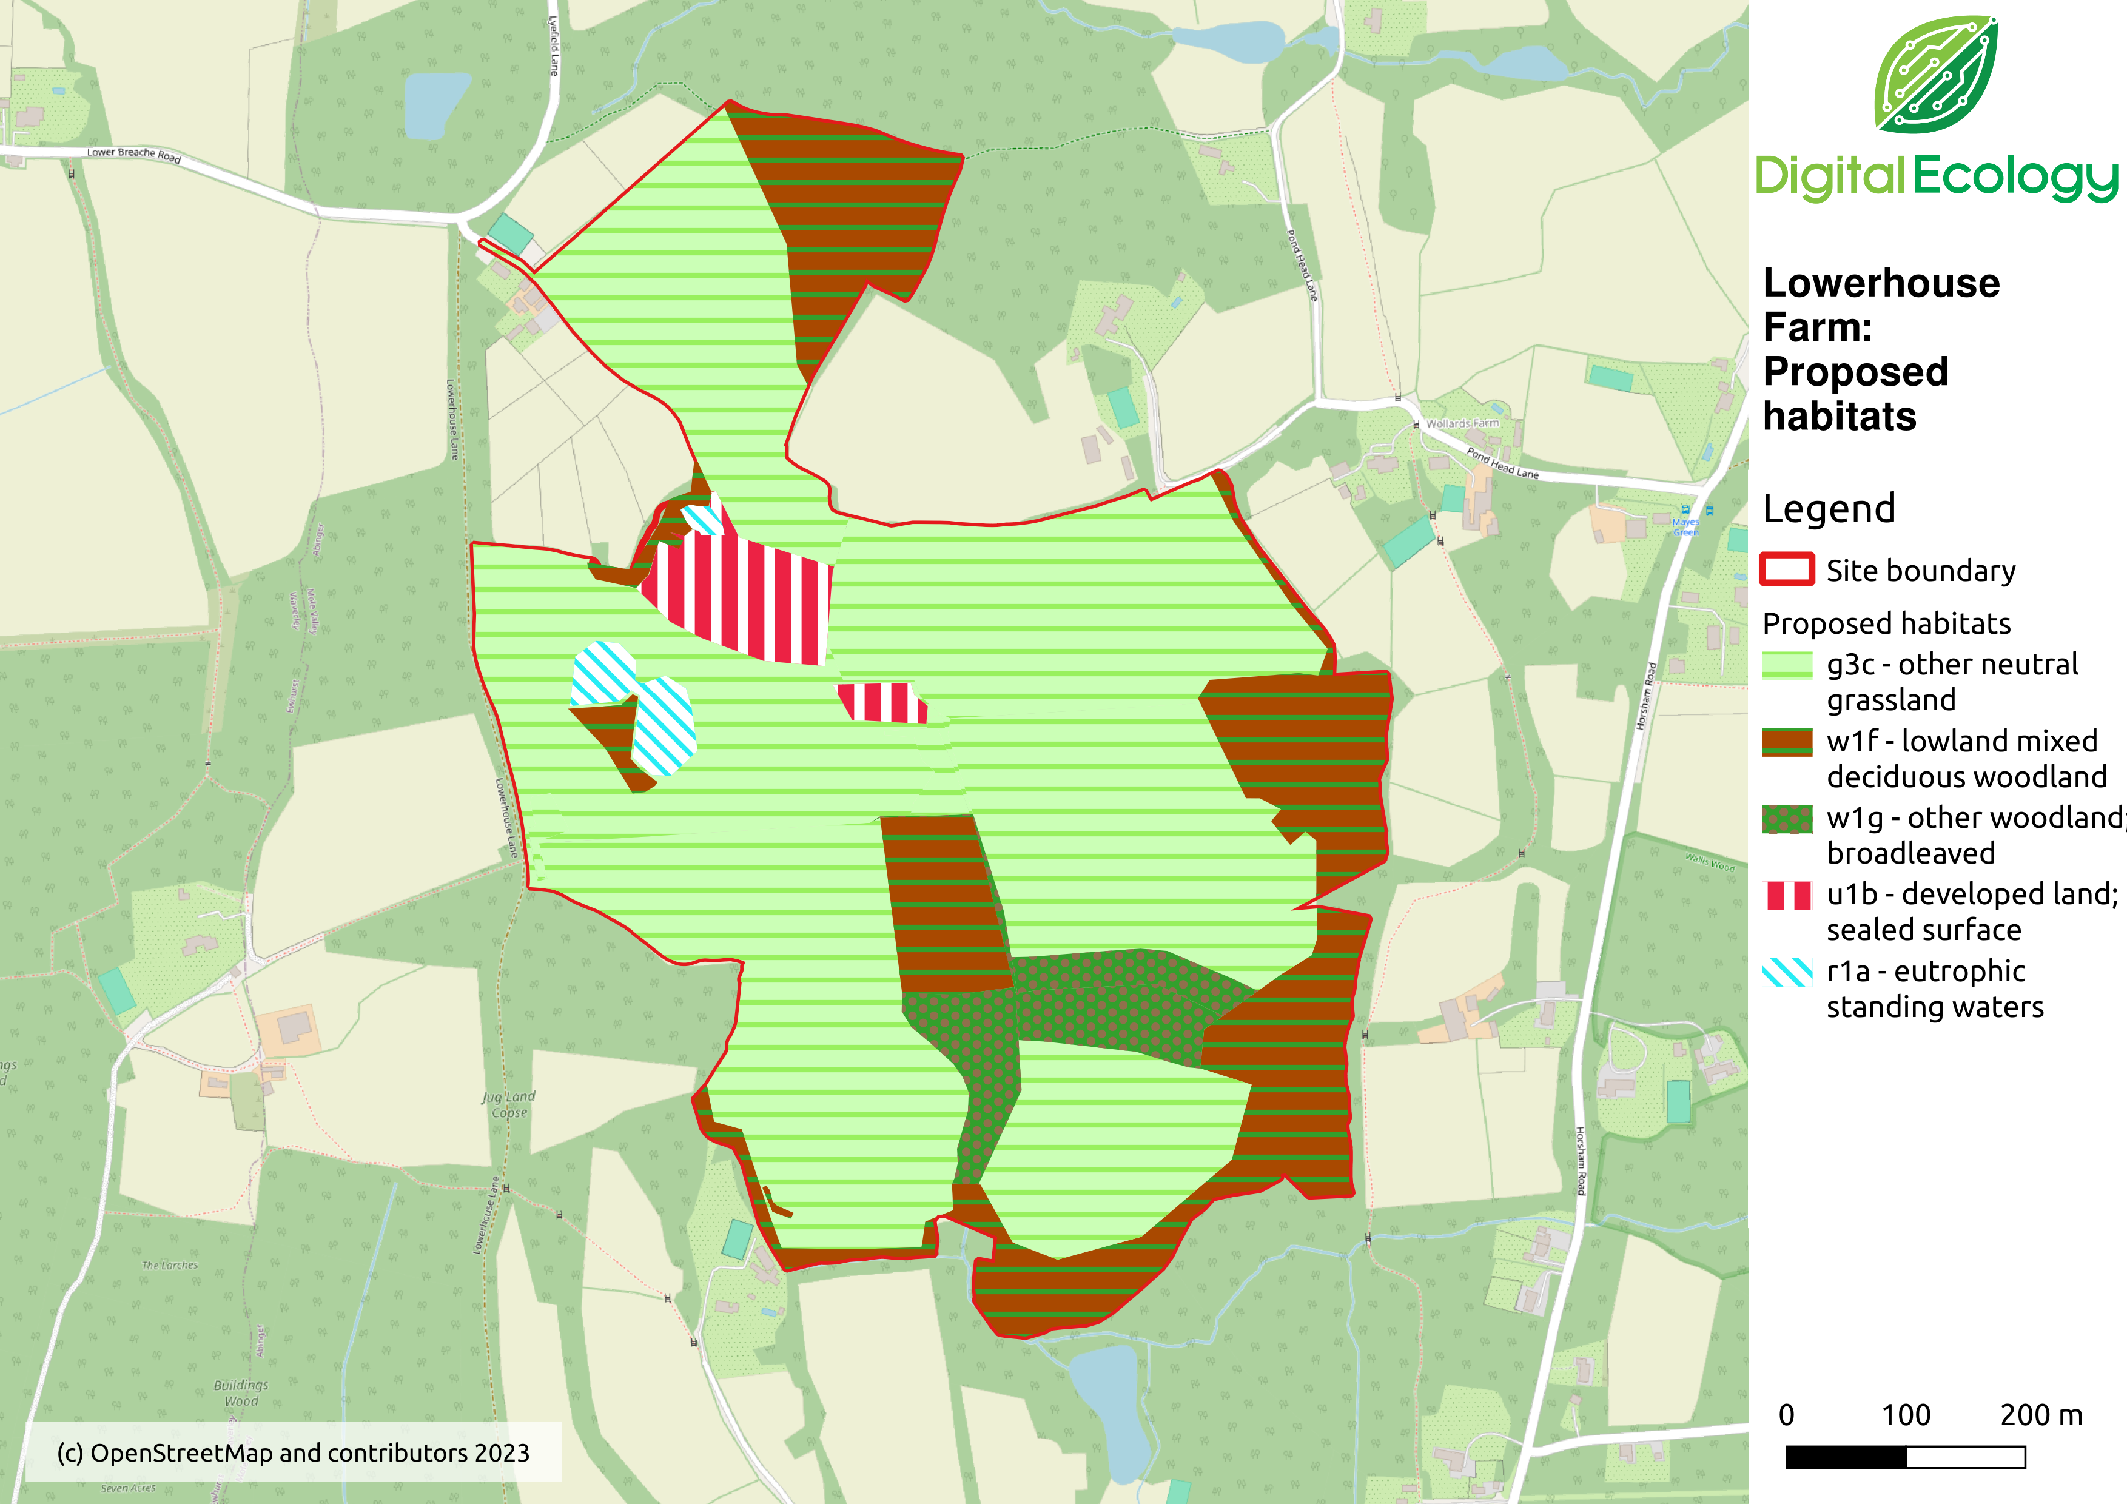Figure 3: Proposed Habitats
As a result of these proposals the site would generate a net gain of 184.10 units (70.15%). These units would be available for sale to developers in Surrey.

6. Next steps
The next steps are:
- Agree the area of the site to be put forward as a habitat bank
- Agree the types of habitats to be delivered on the habitat bank
- Agree in outline the proposed management of these habitats
- Carry out a baseline survey and condition assessment of the habitats on site in Spring / Summer 2024
- Complete a BNG assessment using DEFRA BNG metric 4.0
- Write a 30-year habitat management and monitoring plan for the proposed habitat bank

7. Conclusion
The feasibility report sets out how a habitat bank could be established on the site. The proposals include the creation of woodland and enhancement of existing woodland and grassland. These proposals would generate a net gain of 184.10 BNG units, available to developers in Surrey.
To achieve these proposed outcomes, the client will need to carefully consider the deliverability of the proposed habitats for a 30-year agreement. This means ensuring that the landowner has the knowledge skills and equipment to both create and manage these habitats according to a management plan, or can contract appropriate expertise.

PAGEBREAK

https://www.surreywildlifetrust.org/what-we-do/connecting-surreys-nature/nature-recovery-network
https://magic.defra.gov.uk/

