**To extract data from LPA when maps are provided**

**To extract Burnley data**

Went to:

<https://burnley.gov.uk/planning/planning-policies/heritage-conservation/conservation-areas/>

Then:

<https://burnley.gov.uk/planning/mapping-data/>

Then clicked on “Download”:

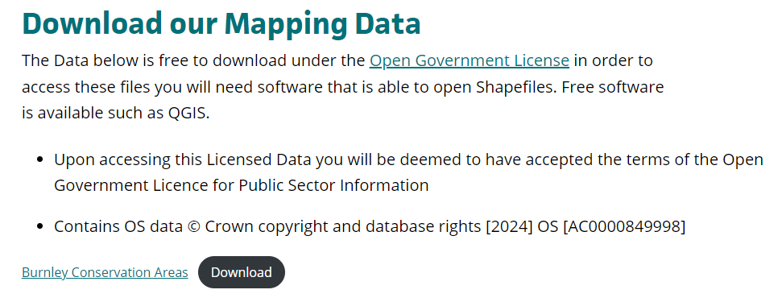

This provided a file: BurnleyConservationAreas.zip

When unzipped it exposed:

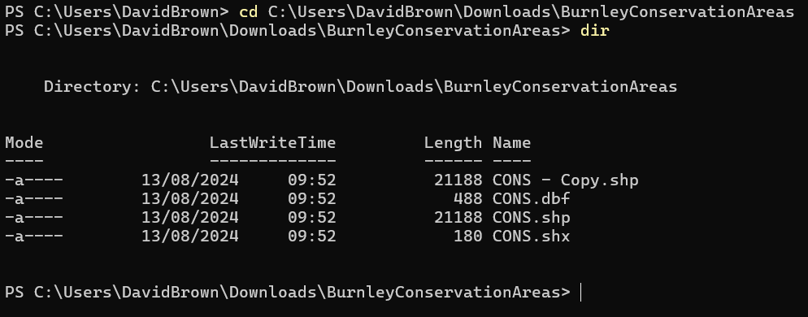

Note: I created the copy of CONS.shp

Next the shape file was Imported into QGIS

Layer CRS was set to EPSG:27700 – OSGB36 / British National Grid

**Procedure to extract each conservation area from the set provided in SHP file**

Check that the conservation areasare mapped correctly

Open the Attribute table for the set

Click on one row:

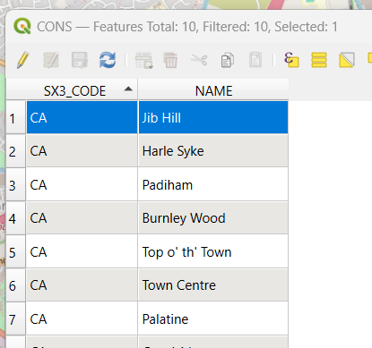

Close the table

One of the individual area should now be coloured differently, in the example below the yellow CA is the highlighted one.

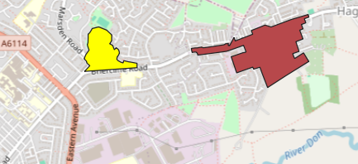

Right-hand click on the CONS layer and select “Save Selected Features As:”

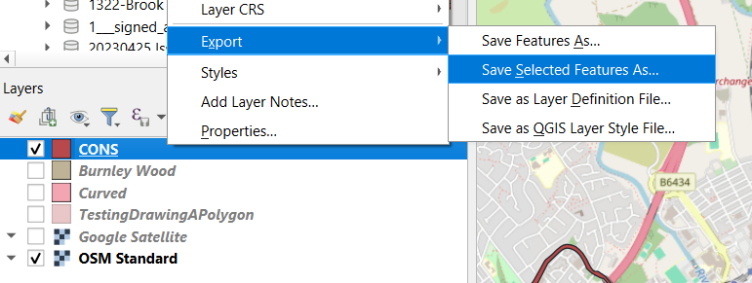

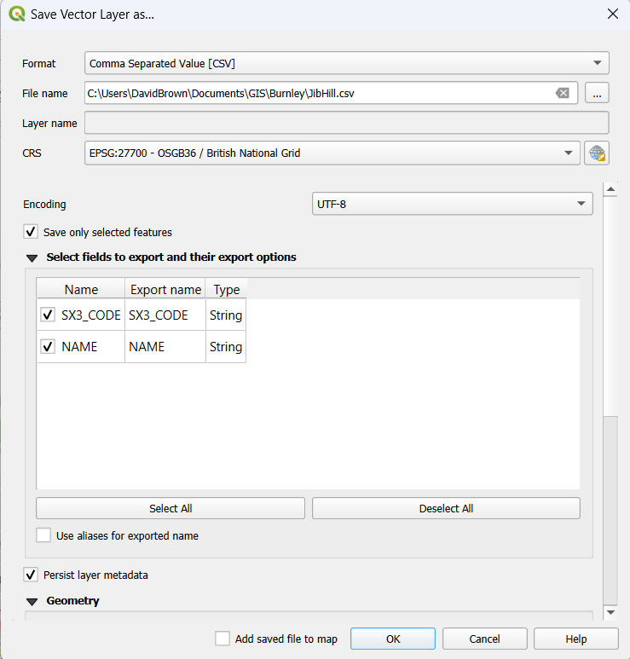

Now find the csv file and add to the layers

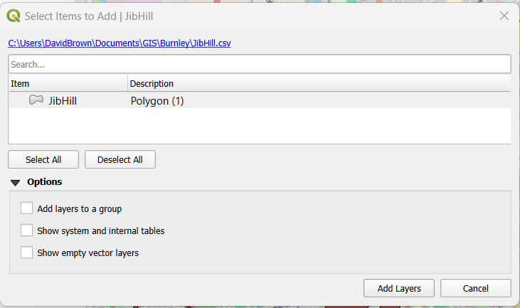

Change the CRS for the layer:

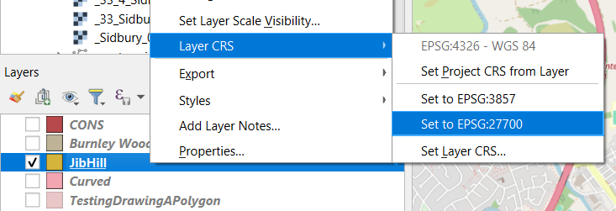

Now export the CA as a CSV file:

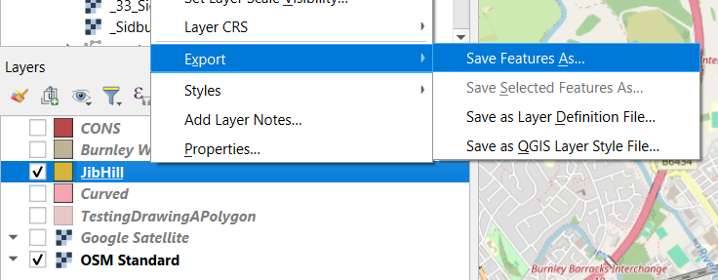

Default CRS: EPSG:3426 - WGS 84

Uncheck WKT, SX3_CODE and “Add saved file to map”

Geometry Type => Polygon

Layer Options:

GEOMETRT => AS_WKT

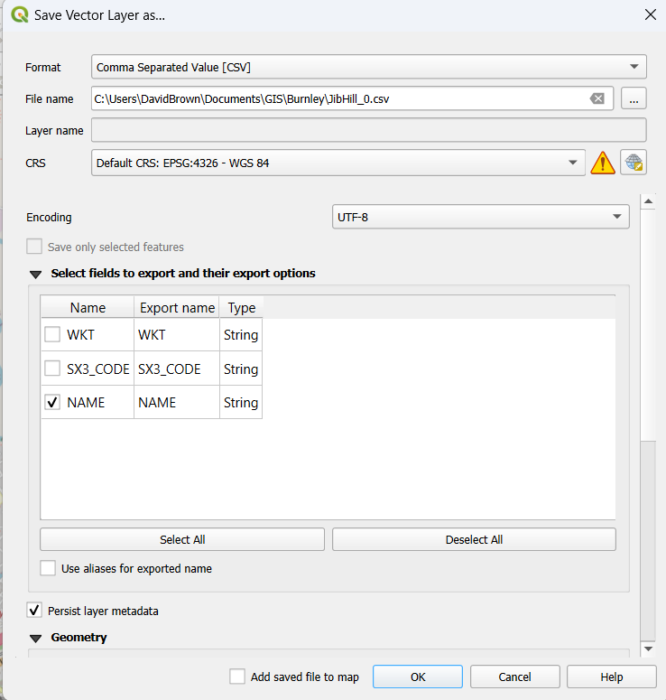

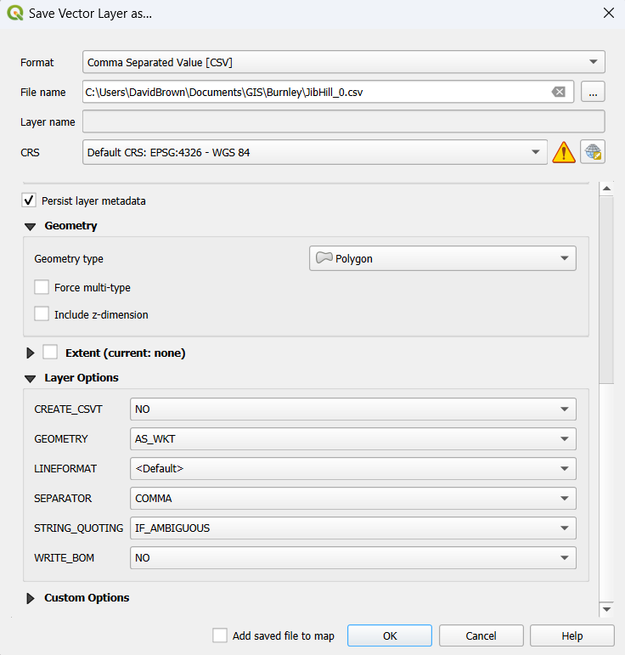

That’s all folks