air_quality Shapefile Data Analysis Report

Dataset contains data on areas in GB and NI that exceed the national air quality objectives. Main pollutants given are no2, so2, pm10, and benzene. This dataset also contains local authority names and identifiers. Geography data given as both area (in m^2 and km^2), as well as using Multi-polygon referencing system.

# Folder Contents:

The following files were found in the folder:

* All_pollutants.cpg: Size: 5 bytes
* All_pollutants.dbf: Size: 498345 bytes
* All_pollutants.prj: Size: 417 bytes
* All_pollutants.sbn: Size: 5916 bytes
* All_pollutants.sbx: Size: 476 bytes
* All_pollutants.shp: Size: 7277120 bytes
* All_pollutants.shp.xml: Size: 10895 bytes
* All_pollutants.shx: Size: 4588 bytes
* Total Folder Size: 7797762 bytes

# Shapefile Analysis:

* Geometry Type: MultiPolygon, Polygon
* Number of Records: 561
* Features/Attributes: fid_, aqma_ref, area_m2, area_km2, la_id, local_auth, title, descriptio, no2, pm10, so2, benzene, no2_lv, pm10_lv, so2_lv, benzene_lv, aqma_id, la_ons_id, la_ons_nam, change_log, SHAPE__Len, SHAPE__Are, geometry
* Coordinate Reference System (CRS): EPSG:27700
* File Size: 7277120 bytes

# Plot of Dataset

Here is a subset of the data, taking the first row of the dataset (Runnymede Borough Council):

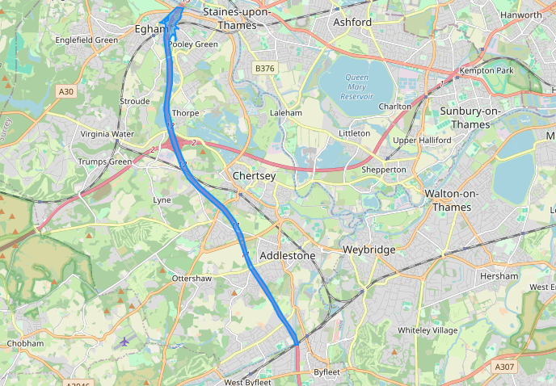

# GeoJSON Sample Data

Sample GeoJSON content:

{  
"type": "FeatureCollection",  
"name": "sample",  
"crs": { "type": "name", "properties": { "name": "urn:ogc:def:crs:EPSG::27700" } },  
"features": [  
{ "type": "Feature", "properties": { "fid_": 0, "aqma_ref": 48, "area_m2": 1612185.957, "area_km2": 1.612, "la_id": 215, "local_auth": "Runnymede Borough Council", "title": "M25 AQMA", "descriptio": "AQMA combining 2 areas. Area 1 extending 70m east and west of the centre line of the M25 between Junction 11 junction 13 plus an area where the M25 crosses over Vicarage Road/ High Street Egham. Area 2 extending 55m east and west of the centre line of t", "no2": 1, "pm10": 0, "so2": 0, "benzene": 0, "no2_lv": "annual", "pm10_lv": null, "so2_lv": null, "benzene_lv": "-", "aqma_id": 2428, "la_ons_id": "E07000212", "la_ons_nam": "Runnymede", "change_log": null, "SHAPE__Len": 24088.145749200001, "SHAPE__Are": 1611318.33045 }, "geometry": { "type": "MultiPolygon", "coordinates": [ [ [ [ 501928.349500000476837, 171617.171700000762939 ], [ 501926.562700000591576, 171607.070700000971556 ], [ 501926.262600000016391, 171605.950200000777841 ], [ 501924.483200000599027, 171596.969700001180172 ], [ 501921.215200000442564, 171586.868700001388788 ], [ 501916.283200000412762, 171576.767700001597404 ], [ 501916.161600000225008, 171576.52930000051856 ], [ 501911.071400000713766, 171566.666699999943376 ], [ 501906.060600000433624, 171557.865800000727177 ], [ 501905.241600000299513, 171556.565700000151992 ], [ 501899.013700000010431, 171546.464600000530481 ], [ 501895.95960000064224, 171542.01380000077188 ], [ 501892.067499999888241, 171536.363600000739098 ], [ 501885.858599999919534, 171528.508100001141429 ], [ 501884.021600000560284, 171526.262600000947714 ], [ 501875.75760000012815, 171517.408100001513958 ], [ 501874.496100000105798, 171516.16160000115633 ], [ 501865.656600000336766, 171507.672700000926852 ], [ 501863.732300000265241, 171506.060600001364946 ], [ 501855.555600000545382, 171498.487700000405312 ], [ 501852.425100000575185, 1714