greater_london_archaeology Shapefile Data Analysis Report

This deprecated projected coordinate system, **OSGB36_Highways_England_B16H4**, is based on the **OSGB36 datum** and the **Airy 1830 spheroid**, which models the Earth's shape. It uses the **Transverse Mercator projection**, commonly used for large-scale mapping, with a central meridian of -2°, a latitude of origin at 49°, and a scale factor of 1.000087. Coordinates are measured in meters, with a false easting of 54026.23 meters and a false northing of 111053.91 meters. It was used for mapping highways in England but is now marked as deprecated.

# Folder Contents:

The following files were found in the folder:

* Area_-_Archaeological_Priority_Areas_-_Polygon_selection.cpg: Size: 5 bytes
* Area_-_Archaeological_Priority_Areas_-_Polygon_selection.dbf: Size: 1290259 bytes
* Area_-_Archaeological_Priority_Areas_-_Polygon_selection.prj: Size: 426 bytes
* Area_-_Archaeological_Priority_Areas_-_Polygon_selection.shp: Size: 2149056 bytes
* Area_-_Archaeological_Priority_Areas_-_Polygon_selection.shp.xml: Size: 400 bytes
* Area_-_Archaeological_Priority_Areas_-_Polygon_selection.shx: Size: 8220 bytes
* Total Folder Size: 3448366 bytes

# Shapefile Analysis:

* Geometry Type: Polygon
* Number of Records: 1015
* Features/Attributes: area_type, descriptio, designatio, primary_re, resourcein, geometry
* Coordinate Reference System (CRS): PROJCS["OSGB36_Highways_England_B16H4 (deprecated)",GEOGCS["OSGB36",DATUM["Ordnance_Survey_of_Great_Britain_1936",SPHEROID["Airy 1830",6377563.396,299.3249646,AUTHORITY["EPSG","7001"]],AUTHORITY["EPSG","6277"]],PRIMEM["Greenwich",0,AUTHORITY["EPSG","8901"]],UNIT["degree",0.0174532925199433,AUTHORITY["EPSG","9122"]],AUTHORITY["EPSG","4277"]],PROJECTION["Transverse_Mercator"],PARAMETER["latitude_of_origin",49],PARAMETER["central_meridian",-2],PARAMETER["scale_factor",1.000087],PARAMETER["false_easting",54026.22785],PARAMETER["false_northing",111053.9128],UNIT["metre",1,AUTHORITY["EPSG","9001"]],AXIS["Easting",EAST],AXIS["Northing",NORTH],AUTHORITY["ESRI","102862"]]
* File Size: 2149056 bytes

column ['designatio'] has the following unique values: ['Archaeological Priority Area' 'Archaeological Priority Area - Tier III'  
 'Archaeological Priority Area - Tier I'  
 'Archaeological Priority Area - Tier II']

# Plot of Dataset

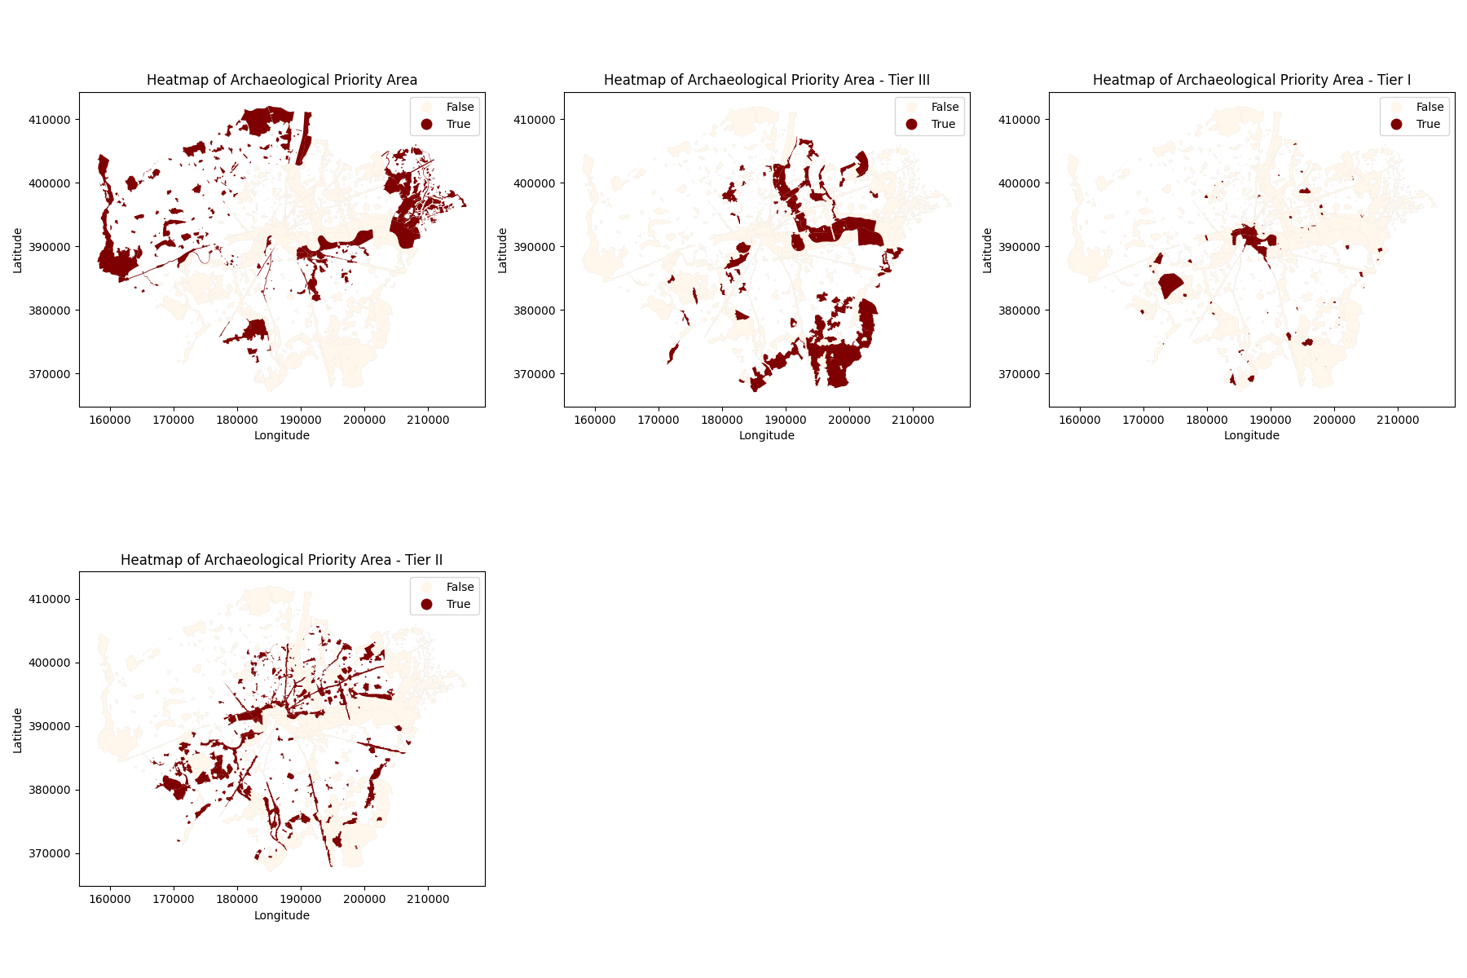

Plot of first row of data:

# GeoJSON Sample Data

Sample GeoJSON content:

{  
"type": "FeatureCollection",  
"name": "sample",  
"crs": { "type": "name", "properties": { "name": "urn:ogc:def:crs:ESRI::102862" } },  
"features": [  
{ "type": "Feature", "properties": { "area_type": null, "descriptio": "The Saxon place name is apparently derived from â€˜Beddaâ€™s settlementâ€™. The Domesday Book refers to two mills and a church, probably the original foundation of St. Maryâ€™s. Two stone sarcophagi found in the churchyard of St. Maryâ€™s reveal the pres", "designatio": "Archaeological Priority Area", "primary_re": "76962", "resourcein": "60d85e7b-9e89-43db-9af6-2ee585381d69" }, "geometry": { "type": "Polygon", "coordinates": [ [ [ 184106.911640385078499, 376081.417893437552266 ], [ 184076.469677281391341, 376073.476620264933445 ], [ 184042.056978648266522, 376073.476687863701954 ], [ 184012.938411826791707, 376074.800846500496846 ], [ 183977.202305176935624, 376077.447809292352758 ], [ 183921.612976747681387, 376066.859325987228658 ], [ 183821.021660392987542, 376045.682954568590503 ], [ 183731.019634970813058, 376031.123873425531201 ], [ 183691.312956371693872, 376024.506076425779611 ], [ 183656.900290110323112, 376024.506154376547784 ], [ 183654.252957570337458, 376074.802824481215794 ], [ 183592.045558224257547, 376073.479229068208952 ], [ 183589.398234170745127, 376058.919684839318506 ], [ 183570.868270643084543, 376058.919794024259318 ], [ 183533.808871703688055, 376092.009735268016811 ], [ 183502.043493019271409, 376089.362635223136749 ], [ 183457.042238270398229, 376089.362908377195708 ], [ 183451.747584858414484, 376068.185818013560493 ], [ 183455.718231697159354, 376052.302872877917252 ], [ 183329.980179188452894, 376021.860842523921747 ], [ 183271.743548805214232, 375999.359939881949686 ], [ 183241.301546146918554, 375984.800545684935059 ], [ 183217.476915688690497, 375971.565040427551139 ], [ 183185.711577821581159, 375964.946885143173859 ], [ 183135.416228412766941, 376125.100776677543763 ], [ 183135.416238453355618, 376135.68866268260171