radon_dataset Shapefile Data Analysis Report

# Folder Contents:

The following files were found in the folder:

* Radon_Colours.xlsx: Size: 9631 bytes
* Radon_Indicative_Atlas_v3.CPG: Size: 5 bytes
* Radon_Indicative_Atlas_v3.dbf: Size: 13812712 bytes
* Radon_Indicative_Atlas_v3.lyr: Size: 8192 bytes
* Radon_Indicative_Atlas_v3.prj: Size: 417 bytes
* Radon_Indicative_Atlas_v3.sbn: Size: 2296492 bytes
* Radon_Indicative_Atlas_v3.sbx: Size: 96068 bytes
* Radon_Indicative_Atlas_v3.shp: Size: 32956436 bytes
* Radon_Indicative_Atlas_v3.shp.xml: Size: 15429 bytes
* Radon_Indicative_Atlas_v3.shx: Size: 1938708 bytes
* User_Guide_Radon_Potential_GB_v3.pdf: Size: 2516837 bytes
* Total Folder Size: 53650927 bytes

# Shapefile Analysis:

* Geometry Type: Polygon
* Number of Records: 242326
* Features/Attributes: TILE, CLASS_MAX, VERSION, geometry
* Coordinate Reference System (CRS): EPSG:27700
* File Size: 32956436 bytes

# Column Statistics:

## Column: CLASS_MAX

* Min: 1
* Max: 6
* Unique Values: [1, 2, 3, 4, 5, 6]

Row count for each value:

* 1: 107143
* 2: 43937
* 3: 21596
* 4: 27577
* 5: 28247
* 6: 13826

# Plot of Dataset

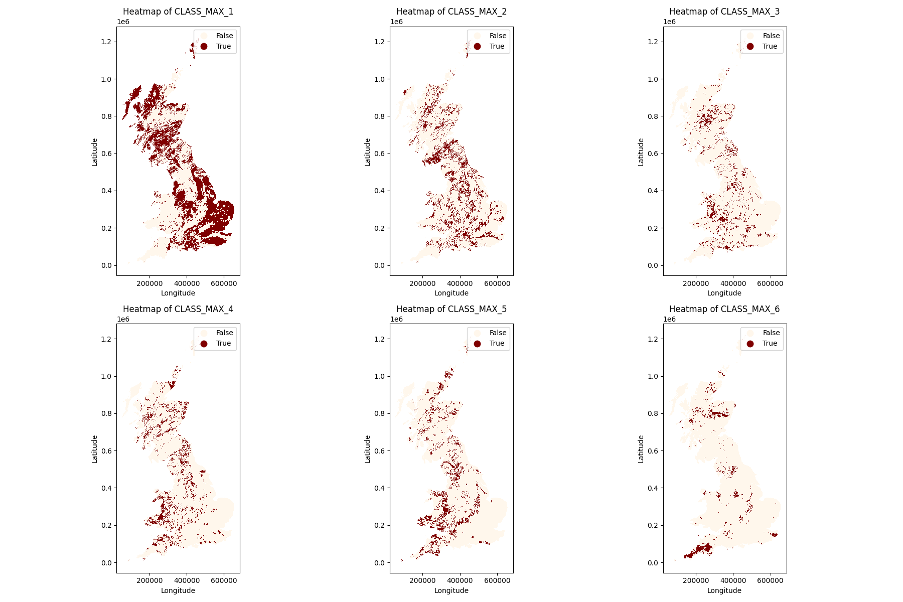

Plot of first row of data:

# GeoJSON Sample Data

Sample GeoJSON content (first 500 characters):

{  
"type": "FeatureCollection",  
"name": "sample",  
"crs": { "type": "name", "properties": { "name": "urn:ogc:def:crs:EPSG::27700" } },  
"features": [  
{ "type": "Feature", "properties": { "TILE": "NL5479", "CLASS_MAX": 1, "VERSION": "Radon Indicative Atlas GB v3" }, "geometry": { "type": "Polygon", "coordinates": [ [ [ 54000.0, 779000.0 ], [ 54000.0, 780000.0 ], [ 55000.0, 780000.0 ], [ 55000.0, 779000.0 ], [ 54000.0, 779000.0 ] ] ] } },  
{ "type": "Feature", "properties": { "TILE": "NL5480", "CLASS_