rivers Shapefile Data Analysis Report

A free dataset showing the high-level view of watercourses in Great Britain. OS Open Rivers GIS data contains over 144,000 km of water bodies and watercourses map data. These include freshwater rivers, tidal estuaries and canals.

# HydroNode Shapefile Analysis

# Folder Contents:

The following files were found in the folder:

* HydroNode.dbf: Size: 20485394 bytes
* HydroNode.prj: Size: 441 bytes
* HydroNode.shp: Size: 8666956 bytes
* HydroNode.shx: Size: 1575892 bytes
* WatercourseLink.dbf: Size: 141420202 bytes
* WatercourseLink.prj: Size: 441 bytes
* WatercourseLink.shp: Size: 85553636 bytes
* WatercourseLink.shx: Size: 1539364 bytes
* Total Folder Size: 259242326 bytes

# Shapefile Analysis:

* Geometry Type: Point
* Number of Records: 196974
* Features/Attributes: identifier, formOfNode, geometry
* Coordinate Reference System (CRS): EPSG:27700
* File Size: 8666956 bytes

column ['formOfNode'] has the following unique values: ['source' 'inapplicable' 'junction' 'outlet' 'unknown']

# Plot of Dataset

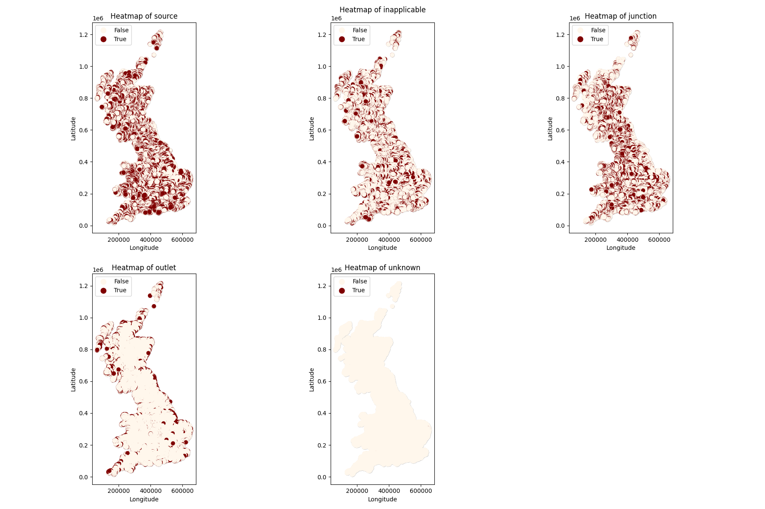

# GeoJSON Sample Data

Sample GeoJSON content:

{  
"type": "FeatureCollection",  
"name": "sample",  
"crs": { "type": "name", "properties": { "name": "urn:ogc:def:crs:EPSG::27700" } },  
"features": [  
{ "type": "Feature", "properties": { "identifier": "97092A43-6C6C-43DD-8757-E4C2BC892F70", "formOfNode": "source" }, "geometry": { "type": "Point", "coordinates": [ 462306.5, 1213048.0, 0.0 ] } },  
{ "type": "Feature", "properties": { "identifier": "0450655B-3B92-4A2F-9671-413DCD828F4C", "formOfNode": "source" }, "geometry": { "type": "Point", "coordinates": [ 462604.049999999988358, 1212998.92, 0.0 ] } },  
{ "type": "Feature", "properties": { "identifier": "71FC9AD3-1783-4662-A256-76E3D8B75B2D", "formOfNode": "inapplicable" }, "geometry": { "type": "Point", "coordinates": [ 462772.020000000018626, 1212606.41, 0.0 ] } },  
{ "type": "Feature", "properties": { "identifier": "ECE84AD7-886C-490A-ABCC-23C3F1322F65", "formOfNode": "inapplicable" }, "geometry": { "type": "Point", "coordinates": [ 462789.200000000011642, 1212663.65, 0.0 ] } },  
{ "type": "Feature", "properties": { "identifier": "2543834C-3A8D-40BB-9182-6B07589EC7B3", "formOfNode": "junction" }, "geometry": { "type": "Point", "coordinates": [ 462807.799999999988358, 1212756.9, 0.0 ] } },  
{ "type": "Feature", "properties": { "identifier": "3B75D083-891B-4C04-9DA3-30E136FDDA58", "formOfNode": "source" }, "geometry": { "type": "Point", "coordinates": [ 463060.210000000020955, 1212503.56, 0.0 ] } },  
{ "type": "Feature", "properties": { "identifier": "1F3B275B-0115-461E-80B5-547A980C8719", "formOfNode": "inapplicable" }, "geometry": { "type": "Point", "coordinates": [ 463065.68, 1212501.52, 0.0 ] } },  
{ "type": "Feature", "properties": { "identifier": "3E386D2B-9337-4857-A101-4ABEF2878D1E", "formOfNode": "source" }, "geometry": { "type": "Point", "coordinates": [ 463559.60999999998603, 1212995.55, 0.0 ] } },  
{ "type": "Feature", "properties": { "identifier": "87611984-265B-4B1B-B94A-0DCCC9B64854", "formOfNode": "inapplicable" }, "geometry": { "type": "Point", "coordinates"

# WaterCourseLink Shapefile Analysis

# Folder Contents:

The following files were found in the folder:

* WatercourseLink.dbf: Size: 141420202 bytes
* WatercourseLink.prj: Size: 441 bytes
* WatercourseLink.shp: Size: 85553636 bytes
* WatercourseLink.shx: Size: 1539364 bytes
* Total Folder Size: 228513643 bytes

# Shapefile Analysis:

* Geometry Type: LineString
* Number of Records: 192408
* Features/Attributes: name1, identifier, startNode, endNode, form, flow, fictitious, length, name2, geometry
* Coordinate Reference System (CRS): EPSG:27700
* File Size: 85553636 bytes

# Plot of Dataset

First 100 rows of dataset

First row of dataset

It is possible to plot a full river system using the start and end nodes given in the data. For example, here is a river system in Hove Burn:

To create this, I matched the start node with end nodes and stitched the river together. It is worth noting that this method doesn’t stitch all river systems some parts of some rivers might have a different node code. I will investigate further if needed. Here is the code I used to create this:

# GeoJSON Sample Data

Sample GeoJSON content:

{  
"type": "FeatureCollection",  
"name": "rivers_sample",  
"crs": { "type": "name", "properties": { "name": "urn:ogc:def:crs:EPSG::27700" } },  
"features": [  
{ "type": "Feature", "properties": { "name1": "Burn of Sulerdale", "identifier": "42D80B97-B550-4A10-9BF4-A0B8CD9B2279", "startNode": "A79EEC86-48A9-4017-B47E-ECFF3F00453E", "endNode": "4C53BC90-4085-48D3-AB3D-84ECFB352F0D", "form": "inlandRiver", "flow": "in direction", "fictitious": "false", "length": 524, "name2": null }, "geometry": { "type": "LineString", "coordinates": [ [ 462010.63, 1213199.17, 0.0 ], [ 461994.25, 1213192.56, 0.0 ], [ 461993.410000000032596, 1213214.890000000130385, 0.0 ], [ 461977.06, 1213211.59, 0.0 ], [ 461939.74, 1213231.98, 0.0 ], [ 461915.229999999981374, 1213282.49, 0.0 ], [ 461866.150000000023283, 1213272.72, 0.0 ], [ 461830.049999999988358, 1213251.42, 0.0 ], [ 461688.850000000034925, 1213103.52, 0.0 ], [ 461653.99, 1213040.67, 0.0 ] ] } },  
{ "type": "Feature", "properties": { "name1": null, "identifier": "169BB342-B076-4E04-BF46-5514EF6E5177", "startNode": "97092A43-6C6C-43DD-8757-E4C2BC892F70", "endNode": "A79EEC86-48A9-4017-B47E-ECFF3F00453E", "form": "inlandRiver", "flow": "in direction", "fictitious": "false", "length": 382, "name2": null }, "geometry": { "type": "LineString", "coordinates": [ [ 462306.5, 1213048.0, 0.0 ], [ 462275.44, 1213070.53, 0.0 ], [ 462174.0, 1213038.9, 0.0 ], [ 462139.5, 1213112.8, 0.0 ], [ 462054.5, 1213159.0, 0.0 ], [ 462010.63, 1213199.17, 0.0 ] ] } },  
{ "type": "Feature", "properties": { "name1": null, "identifier": "94B2D59B-0899-48B1-A0D4-F43CF1634075", "startNode": "0450655B-3B92-4A2F-9671-413DCD828F4C", "endNode": "2543834C-3A8D-40BB-9182-6B07589EC7B3", "form": "inlandRiver", "flow": "in direction", "fictitious": "false", "length": 424, "name2": null }, "geometry": { "type": "LineString", "coordinates": [ [ 462604.049999999988358, 1212998.92, 0.0 ], [ 462546.24, 1212906.81, 0.0 ], [ 462566.900000000023283, 1212877.7, 0.0 ], [ 462678.900000000023