# Introduction To Writing Chapters In Microsoft Word (.docx)

## Styles

We would like to emphasize the importance of MS Word styles. They are a way for the platform to recognize whether you intend a body of text to be a heading or a paragraph. For a human, it may seem like an easy task in distinguishing a paragraph from a quotation or a chapter title from a section header, but that’s because a typical human has seen lots and lots of text and developed an intuition in this regard. For instructions run by a computer, this task is not so simple.

This is why you must use MS Word styles for the computer to transform your manuscript into a book.

In order to choose a style, first find the “Home” tab at the top of your MS Word window. Secondly, either select a one of the visible styles from the “Styles” box or click the “⊽” button on the right, choose “Apply Styles” and enter the name of a style you need. Figure 1 shows you how to do it. In Table 1: you can find the most important MS Word styles you can use.

**Figure 1:** How to select a MS Word style.



|  |  |
| --- | --- |
| ##Digital source | ./assets/02_introduction_to_docx/how-to-select-a-MS-Word_style.gif |
| ##Paper source | ./assets/02_introduction_to_docx/how-to-select-a-MS-Word_style_paper_version.png |
| ##Alt text | Screen recording of selecting MS Word style |
| ##Author | Paweł Kamiński |
| ##Source | Recording of a screen of Paweł Kamiński (author of the guidelines) |

When you choose a MS Word style, selected content will change its appearance in your `.docx` file. Do not worry about it. MS Word styles will enable the system to correctly structure your work and display it in the final layout.

**Table 1:** MS Word styles that affect the structure of the end result.

|  |  |
| --- | --- |
| **MS Word Style** | **Part of a book** |
| *Heading 1* | Heading 1 (e.g. chapter heading) |
| *Heading 2* | Heading 2 (e.g. section heading) |
| *Heading 3* | Heading 3 (e.g. sub-section heading) |
| *Heading 4* | Heading 4 (e.g. heading for dividing sub-sections) |
| *Heading 5* | Heading 5 (e.g. heading for parts divided with Heading 4) |
| *Quote* | Quotes |
| *Caption* | Captions |

## Metadata Tables

### Reason Behind Metadata Tables

When publishing a book, it is important to consider not only the contents of a book, but also data concerning objects included in a book. For example, authors need to properly assign all relevant copyright data about an image in order to properly document rights to publish it without infringement. This encompasses data about who the author of the image is, what license it was published under, etc.

### Example Of A Metadata Table

The platform for digital publishing uses Metadata Tables to collect, validate and manage additional information about your book’s assets, like images, videos, etc. A Metadata Table looks like this:

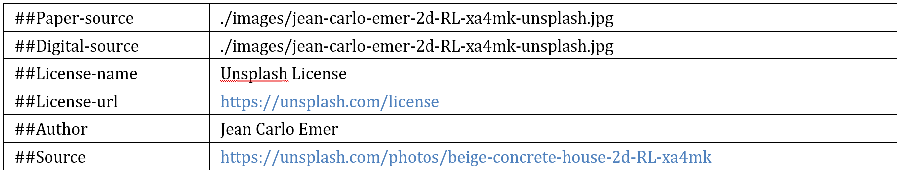

|  |  |
| --- | --- |
| ##Digital-input | ./assets/02_introduction_to_docx/metadata_tbl_example.png |
| ##Paper-input | ./assets/02_introduction_to_docx/metadata_tbl_example.png |
| ##Source | Snapshot of PC screen of Paweł Kamiński |
| ##Author | Paweł Kamiński |
| ##Alt-text | Example of a Metadata Table required to include after each object like table or multimedia |

:::{caution}  
As an author **you are required to insert a Metadata Table below each image, video or other copyrighted material** to indicate source, author (if known) and license (if known).  
:::

**Figure 2:** Example of an image with Metadata Table. Photography was taken by Jean Carlo Emer and is licensed under the Unsplash License.

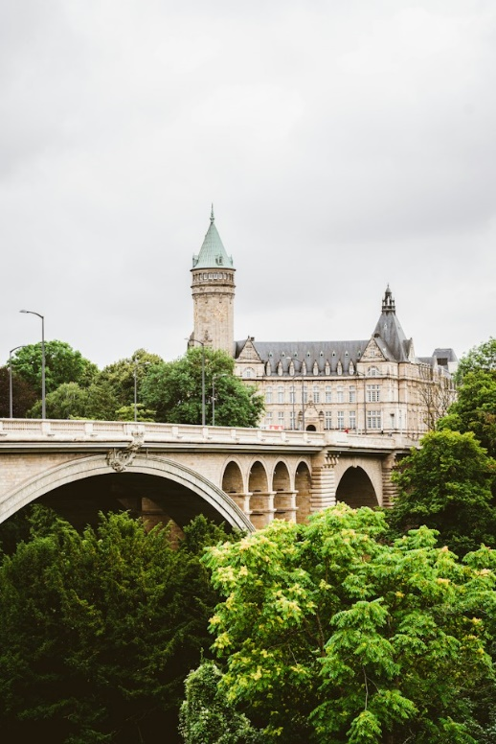

|  |  |
| --- | --- |
| ##Paper-input | ./assets/02_introduction_to_docx/jean-carlo-emer-2d-RL-xa4mk-unsplash.jpg |
| ##Digital-input | ./assets/02_introduction_to_docx/jean-carlo-emer-2d-RL-xa4mk-unsplash.jpg |
| ##Source | <https://unsplash.com/photos/beige-concrete-house-2d-RL-xa4mk> |
| ##License | Unsplash License |
| ##Author | Jean Carlo Emer |
| ##Alt-text | Pont Adolphe in Luxembourg city during the summer with Spuerkeess HQ in the background |

Metadata Tables will not be shown in a paper nor in a digital version of your book, but it will be analyzed by the computer system that generates both.

Note that a Metadata Table is just a standard MS Word table with 2 columns: the field name and the field value.

### Field Names

The field name must consist of `##` characters and the name of the field chosen among the following supported field names:

#### Supported Fields

**Table 2:** Definitions of fields in Metadata Tables.

:::{table}  
| Field name | Required | Field meaning |  
| --- | --- | --- |  
| ##Digital-input | Yes | Path to a file that will be displayed in a digital version of a book. Path should point to a location where the file is saved in the `assets` folder. Be careful to write a correct **relative** path to the file, e.g. `./assets/path/to/file.png` is valid while `C:\User\Documents\my-book\assets\path\to\file.png` is an invalid. |  
| ##Paper-input | No | Path to a file that will be displayed in a paper version of a book. Path should point to a location where the file is saved in the `assets` folder. Be careful to write a correct **relative** path to the file, e.g. `./assets/path/to/file.png` is valid while `C:\User\Documents\my-book\assets\path\to\file.png` is an invalid. If left empty, no object will not be included in the duplicate. |  
| ##Source | Yes | All relevant source and copyright information. |  
| ##License | No | Name of a license under which an object was published. Preferably [SPDX ID](https://spdx.org/licenses/) like “BSD-4-Clause”. A full name, e.g. “Creative Commons Attribution 4.0 International”, is also acceptable, although not recommended. |  
| ##Author | No | Attribute an author of an object. Institution could also be attributed. |  
| ##Alt-text | Yes* | Alt text to describe appearance or function of a multimedia object. This field is required if no alt text was provided in the “View Alt Text…” option. Read more about alt texts in the appropriate section. |  
| ##Height | No | Set object’s desired height. Note that this is only an unbinding indication to the platform, relevant to some objects like embedded interactive maps. In most cases it will be ignored. |  
| ##Delete-previous | No | Use this field if you want to remove previous object, like image, video, etc. Useful when you want to have an image directly in your MS Word file and replace it with an image indicated with “##Digital-source” or “##Paper-source”. |  
:::

:::{warning}  
Any mistake in a field name will result in invalid and missing metadata information.  
:::

For example, `##License ` is a valid field name while `#License ` or `##Name-of-a-license` are not and will not work.

:::{important}  
Please pay particular attention to the “**##Digital-input**” and “**##Paper-input**”, as well as to the “**##Source**” field.  
:::

#### Input Fields

“##Digital-input” and “##Paper-input” fields are important because they allow us to do certain operations on images and other assets that you want to include for your publication. Please make sure that you include all such assets in the “assets” folder and write a valid relative location to those files.

If your book’s folder has the following structure:

:::{code}

slug-of-my-book

├── 01_chapter_one.docx

├── 02_chapter_two.docx

└── assets/

└── chapter_1/

├── filename.tiff

:::

Then, in a Metadata Table in “01_chapter_one.docx” chapter a `##Digital-input` or `##Paper-input` field could be equal to `./assets/chapter_1/filename.tiff`. Note that your book’s folder is the point of reference here (name your book’s folder like “slug-of-my-book” is the `.`, other directories in which this folder is located does not matter).

#### Source Field

“##Source” field is essential for monitoring and managing attributions and copyright information.

In the “##Source” field please add a credit line for your asset (image/video etc.), which contains all relevant copyright information such as the source (museum/archival record/film/website etc.) and/or copyright holder (originator/artist/photographer/institution etc.). Please refer to the terms of usage specified by the institution, from which you have obtained the material, and follow their rules on how to credit their material. For own creations please write "photo/graph by the author" (or insert your name). For assets published online under a CC license, use <https://lizenzhinweisgenerator.de/?lang=en> to generate your credit line.

## References

### References To Websites

The simplest form of a reference is a hyperlink to an external website.

You can add [a link](https://www.c2dh.uni.lu/) to any website you want. To insert a hyperlink, press the Ctrl + K shortcut on your keyboard (alternatively, go to “Insert” on the top bar in MS Word > “Link” > “Insert Link…”). Enter an address you want to link to and optionally a text to display.

**Figure 3:** Inserting a hyperlink in MS Word.

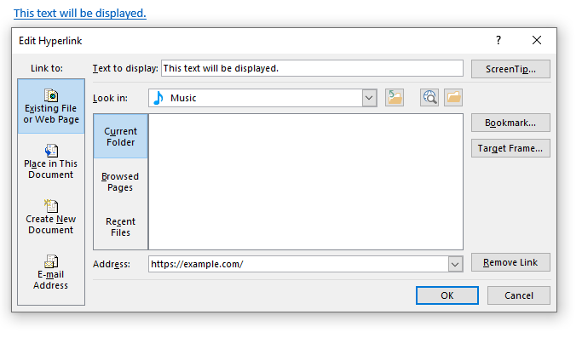

|  |  |
| --- | --- |
| ##Digital-input | ./assets/02_introduction_to_docx/edit_hyperlink_window.png |
| ##Paper-input | ./assets/02_introduction_to_docx/edit_hyperlink_window.png |
| ##Source | Snapshot of PC screen of Paweł Kamiński showing “Edit Hyperlink” feature of MS Word |
| ##Author | Paweł Kamiński |
| ##Alt-text | “Edit Hyperlink” popup window in MS Word |

**Figure 4:** To open the window to edit the hyperlink, right-click on it and select the “Edit Hyperlink…” button.

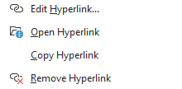

|  |  |
| --- | --- |
| ##Digital-input | ./assets/02_introduction_to_docx/hyperlink_right_click_options.png |
| ##Paper-input | ./assets/02_introduction_to_docx/hyperlink_right_click_options.png |
| ##Source | Snapshot of PC screen of Paweł Kamiński showing features of MS Word |
| ##Author | Paweł Kamiński |
| ##Alt-text | A menu in MS Word for selecting hyperlink options |

### References Within A File

To enable a navigation to a different part of the same file, you have to cross-reference it. For tables, figures and equations, you must insert a caption manually before you can cross-reference them, while for headings a caption is not needed. As an example, you can navigate to “Inserting Captions” to read about how to insert a caption and to “Figure 9” to see how to cross-reference other part of the same file.

:::{important}  
For tables, figures and equations, you must insert a caption manually before you can cross-reference them.  
:::

#### Inserting Captions

MS Word supports adding captions to tables, figures, equations.

To add a caption, simply open the “References” tab and select the “Insert Caption” button at the top of your MS Word window.

**Figure 5:** How to insert a caption.



|  |  |
| --- | --- |
| ##Digital-input | ./assets/02_introduction_to_docx/how-to-insert-a-caption.gif |
| ##Paper-input | ./assets/02_introduction_to_docx/how-to-insert-a-caption_paper_v.gif |
| ##Source | Recording of a screen of Paweł Kamiński (author of the guidelines) showing MS Word features |
| ##Author | Paweł Kamiński |
| ##Alt-text | Screen recording of inserting a caption in MS Word |

A “Caption” window should appear. Select the “Label” to choose which type of resource you are referencing. For advanced settings of caption numbering, click the “Numbering…” button.

**Figure 6:** Caption window in MS Word.

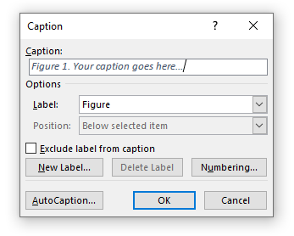

|  |  |
| --- | --- |
| ##Digital-input | ./assets/02_introduction_to_docx/caption-window.png |
| ##Paper-input | ./assets/02_introduction_to_docx/caption-window.png |
| ##Source | Snapshot of PC screen of Paweł Kamiński showing “Caption” feature of MS Word |
| ##Author | Paweł Kamiński |
| ##Alt-text | “Caption” popup window in MS Word |

Note that each caption autoincrements automatically. To update a caption manually, right-click on the numbering item (e.g. on “1” in “Table 1. Some title”) and select “Update field”.

:::{tip}  
To update whole document in MS Word you can press Ctrl + A to select whole text and then click on F9. See [Microsoft documentation for details](https://support.microsoft.com/en-us/office/update-fields-7339a049-cb0d-4d5a-8679-97c20c643d4e).   
:::

#### How To Structure Image Captions?

Please add a title to all tables and figures which includes source or copyright information as part of the caption (not in a footnote). E.g. “Fig. 1: descriptive title, source/photographer/copyright note”.

**Rule no. 1: Follow the format given by the copyright holder**

Some copyright holders will ask you to cite their work in a specific format. Please do so even if it doesn’t follow the example formats shown below.

**Example structures for image captions**

Basic structure:

`[descriptive title / title of the artwork] [all relevant source and copyright information].`

Example structures:

* [Name of artwork or monument] [ year, photographer, agency].
* [Title of the panting, original artist, year] [Museum, photographer].
* [Title or description of archival record] [archive, record number].
* [Description of the image’s content] [photographer, weblink with access date].
* [Name or description] [name of artist/photographer/originator, link to the original file, CC-license with version number, link to the license]. [for CC licenses, you can use: https://lizenzhinweisgenerator.de/?lang=en]

“Courtesy”, “©”, or “with friendly permission” may be added, but doesn’t need to be included.

#### Cross-referencing Objects

To cross-reference an object within the Word file, go to the “References” tab at the top of the MS Word tab and click the “Cross-reference” button.

**Figure 8:** How to insert a cross-reference.



|  |  |
| --- | --- |
| ##Digital-input | ./assets/02_introduction_to_docx/how-to-insert-a-cross-reference.gif |
| ##Paper-input | ./assets/02_introduction_to_docx/how-to-insert-a-cross-reference.gif |
| ##Source | Recording of a screen of Paweł Kamiński (author of the guidelines) showing MS Word features |
| ##Author | Paweł Kamiński |
| ##Alt-text | Screen recording of inserting a cross-reference in MS Word |

Choose the type of reference (e.g. header, table, figure, etc.) and select which caption you want to reference to. We recommend that you always insert a hyperlink in your cross-references.

**Figure 9:** Cross-reference window.

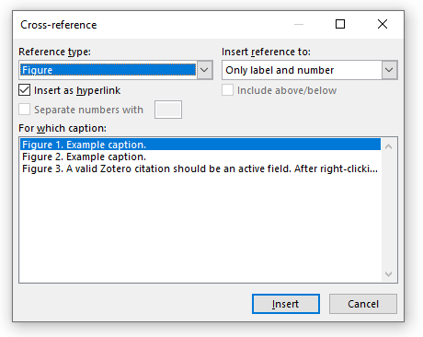

|  |  |
| --- | --- |
| ##Digital-input | ./assets/02_introduction_to_docx/cross-reference-window.png |
| ##Paper-input | ./assets/02_introduction_to_docx/cross-reference-window.png |
| ##Source | Snapshot of PC screen of Paweł Kamiński showing “Cross-reference” feature of MS Word |
| ##Author | Paweł Kamiński |
| ##Alt-text | “Cross-reference” popup window in MS Word |

The “Insert reference to:” button allows you to set how the reference will appear in your work (e.g. “heading number” vs “heading text”). With tables, figures and equations you should insert reference to “Only label and number”, e.g. “see Figure 1“. In particular, please do not reference page numbers, as this number will change when transforming your book from MS Word to the printed and the digital version.

You can also cross-reference heading. To do that, there is no need to insert a caption, just click on the “Cross-reference” button, choose the “Heading” reference type and select the object to reference to.

:::{tip}  
Cross-referencing headers can be particularly useful in referencing other parts of your literary work.  
:::

:::{tip}  
By inserting captions to your figures, tables and equations you will not have to be concerned with incrementing the numbering manually. MS Word will auto-increment captions for you.  
:::

### References Between Files

You can also create navigable references to different chapters in your book by inserting a link to a bookmark in another file. First, you have to add a bookmark in `.docx` file. Secondly, you insert a link to that bookmark.

#### Adding A Bookmark

To cross-reference an object within the Word file, go to the “Insert” tab at the top of the MS Word tab and click the “Bookmark” button. Then, type the name of your bookmark, remembering that no spaces and no special characters are allowed. Click “Add” to insert the bookmark.

**Figure 8:** How to add a bookmark.



|  |  |
| --- | --- |
| ##Digital-input | ./assets/02_introduction_to_docx/how-to-add-a-bookmark.gif |
| ##Paper-input | ./assets/02_introduction_to_docx/how-to-add-a-bookmark.png |
| ##Source | Recording of a screen of Paweł Kamiński (author of the guidelines) showing MS Word features |
| ##Author | Paweł Kamiński |
| ##Alt-text | Screen recording of adding a bookmark in MS Word |

Bookmarks are hidden by default. Managing bookmarks can be made easier by changing MS options to show them while editing `.docx` files. To do that, click on “File” tab on the top left corner of MS Word and select “Options” at the bottom left. In the Word Options window, select “Advanced” and turn on the “Show bookmarks” checkbox.

**Figure 8:** Enabling bookmarks to be shown in MS Word.

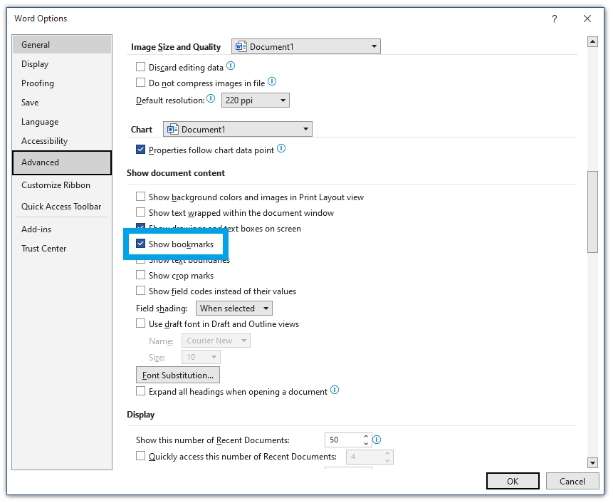

|  |  |
| --- | --- |
| ##Digital-input | ./assets/02_introduction_to_docx/show-bookmarks-option.png |
| ##Paper-input | ./assets/02_introduction_to_docx/show-bookmarks-option.png |
| ##Source | Snapshot of PC screen of Paweł Kamiński showing “Options” settings of MS Word |
| ##Author | Paweł Kamiński |
| ##Alt-text | “Advanced options” popup window in MS Word |

#### Linking To A Bookmark

Inserting a link to a bookmark begins the same as inserting a link to external websites, as described in the “References To Websites” chapter. In the “Insert Hyperlink“ window (see Figure 3) select the file where the bookmark you want to link to is located and click on the “Bookmark…” button on the right. By clicking it you should see a list of all bookmarks in that file. Select one, click “OK” and change the “Text to display” accordingly. Click “OK” to close the window.

Here is an implementation example: see this [link to a chapter about digital-specific elements of a manuscript](03_docx_advanced_elements.docx#advancedElementsInMSWord), which in reality is a link to a bookmark in that file.

:::{warning}  
Renaming your files will break all bookmarks referring to that file.  
:::

### Generate Table Of Figures

Another benefit from using cross-references is that you can automatically generate the table of figures or other objects. To do that, navigate to the “References” tab in the top of the MS Word bar and click the “Insert Table of Figures” button.



A window should appear where you can select options for your table of figures. We recommend, however, to always disable showing page numbers. You should also always use hyperlinks instead of page numbers.

**Figure 10:** Table of figures window.

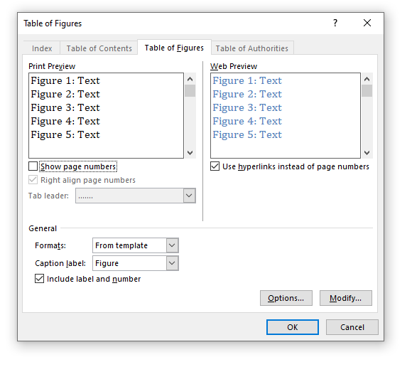

|  |  |
| --- | --- |
| ##Digital-input | ./assets/02_introduction_to_docx/table-of-figures-window.png |
| ##Paper-input | ./assets/02_introduction_to_docx/table-of-figures-window.png |
| ##Source | Snapshot of PC screen of Paweł Kamiński showing “Table of Figures” feature of MS Word |
| ##Author | Paweł Kamiński |
| ##Alt-text | “Table of Figures” popup window in MS Word |

Please see below the exemplary table of figures used in these guidelines. It is worth noting that only figures that have captions can be referenced, which means that only those figures can be referenced by a table of figures.

#### Exemplary Table Of Figures Used In This Publication

**Figure 1:** How to select a MS Word style.

**Figure 2:** Example of an image with Metadata Table. Photography was taken by Jean Carlo Emer and is licensed under the Unsplash License.

**Figure 3:** Inserting a hyperlink in MS Word.

**Figure 4:** To open the window to edit the hyperlink, right-click on it and select the “Edit Hyperlink…” button.

**Figure 5:** How to insert a caption.

**Figure 6:** Caption window in MS Word.

**Figure 8:** How to insert a cross-reference.

**Figure 9:** Cross-reference window.

**Figure 8:** How to add a bookmark.

**Figure 8:** Enabling bookmarks to be shown in MS Word.

**Figure 10:** Table of figures window.

**Figure 11:** Inserting a caption directly in MS Word.

**Figure 12:** Zotero plugin installed in MS Word.

**Figure 13:** A valid Zotero citation should be an active field. After right-clicking it you should see options like 'Toggle Field Codes' (this option will allow you to see the internal data of your citation).

:::{important}  
Remember to update the table of figures after finishing writing and adding new items. The software will not update your table of figures for you.  
To update, you can **right-click on the table and select “Update field”**.  
:::

## Headers

Your manuscript should be subdivided into sections (and, if necessary, subsections). These sections should be labeled with headings. Please do not use capitals.

Headings and contribution titles should be succinct (approximately 80-100 characters) and expressive and should not be concluded with a period. Please avoid an excessive number of sections/subsections if possible. If the manuscript is in English, please write headings in "sentence style" (i.e. capitalization of the first word and all proper nouns) or "headline style" (i.e. capitalization of all words, except articles and prepositions). The main title of the publication should be set in “headline style”. Make sure that headline capitalization is uniform throughout the entire manuscript. Use the following MS Word styles for headings in your work (e.g. for chapter titles, section headings, subsection heading, etc.):

# Example Of Heading 1 (Title)

## Example Of Heading 2

### Example Of Heading 3

#### Example Of Heading 4

##### Example Of Heading 5

Note that there is no heading 6.

Every .docx file should open with “Heading 1” as the title of this part of the book. There shouldn’t be more than one Heading 1 per file.

Please pay attention to always include at least two sections on the same hierarchy level of headings:

* Heading 1
  + 1st Heading 2
  + 2nd Heading 2
    - 1st Heading 3
    - 2nd Heading 3
  + 3rd Heading 2

Please do not add footnotes to headlines; instead place them within or at the end of the following paragraph.

## Styling Body Of Text

### Paragraphs

A block of text not styled with one of the styles included in Table 1: will be by default rendered as a paragraph. We recommend however using the “Body Text” style to avoid unnecessary errors.

Please do not indent paragraphs.

### Typography

Currently, we support the following font formatting:

*Italics* should be used for foreign-language expressions as well as for titles of books, published documents, newspapers, and journals. It may be used to draw attention to key terms in a discussion at first mention only. Thereafter, these terms should be set in roman. However, please keep the use of italics to a minimum. It may also be used to emphasize a word or phrase in a quotation indicating [emphasis mine].

**Bolded** text should be avoided.

Subscript (e.g. H2O).

Superscript (e.g. 11th of November).

## Quotes

When quoting a source, please make sure to faithfully transcribe spelling and punctuation. To add information or paraphrasing for clarity, use square brackets [ ]. To jump over a section of the source material, use ellipses [...].

Short quotes (up to 60 words) should be integrated into the body text with quotation marks.

Longer quotes (more than three lines) should be formatted as block quotes without quotation marks. Please use the “Quote” MS Word style to format a block quotation:

Sometimes you must put a lot of manual work to automate something.[1]

## Lists



### Bullet Lists

We support non-ordered bullet points…

* First point
* Second point
* Third point

### Ordered Lists (Numbering)

…as well as numbered lists.

1. First item.
2. Second item.
3. Third item.

### Multilevel Lists

Multilevel lists are also supported.

1. Item 1
   1. Item 1.1
      1. Item 1.1.1
         1. Item 1.1.1.1
2. Item 2

### Other Lists

You can also create nested unordered lists by indenting bullet points.

* point 1.
  + point 1.2.
    - point 1.3.
      * point 1.4.
* point 2.

## Multimedia

### Images

:::{card} TODO 🚧  
Feature to be added in TNB-62: “As an author I want to upload my assets to the asset management system”.  
First figure out infrastructure side of handling assets, then code the input side.  
:::

### Videos

:::{card} TODO 🚧  
Feature to be added in TNB-62: “As an author I want to upload my assets to the asset management system”.  
First figure out infrastructure side of handling assets, then code the input side.  
:::

### Alt Text

Please provide “Alt Text” to describe appearance or function of multimedia object (images and videos) you include in your manuscript. The alt attribute is used to increase accessibility and user friendliness, including for blind internet users who rely on special software for web browsing.

To add an “Alt Text” please use the “##Alt-text” field in a Metadata Table under each described object.

Alternatively, you can add “Alt Text” by right clicking on an inserted multimedia and selecting “View Alt Text…”. This solution enables you to use MS Word feature of automatically generating alt text for you.

**Figure 11:** Inserting a caption directly in MS Word.

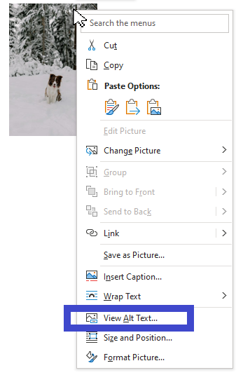

|  |  |
| --- | --- |
| ##Digital-input | ./assets/02_introduction_to_docx/view-alt-text-menu.png |
| ##Paper-input | ./assets/02_introduction_to_docx/view-alt-text-menu.png |
| ##Source | Snapshot of PC screen of Paweł Kamiński showing “View Alt Text” feature of MS Word |
| ##Author | Paweł Kamiński |
| ##Alt-text | Image of a dog in the snow in MS Word, with menu open showing image options, including “View Alt Text…” |

:::{caution}  
In the event of a conflict, the alt text in the Metadata Table takes precedence over the alt text added through 'View Alt Text…'.  
:::

## Tables

There are no explicit rules for formatting a table. If you insert a proper MS Word table, the platform should be able to recognize it and its contents and render it.

**Table 4:** The first example of a table.

|  |  |
| --- | --- |
| **Header 1** | Header 2 |
| Row 1, Column 1 | *Row 1, Column 2* |
| Row 2, Column 1 | Row 2, Column 2 |

Note that the styling of a table does not influence how the platform will render it. The general rules of styling are applied, though (see for example the bolded table headers). Please refrain from using unnecessary highlights (italics, bold).

**Table 5:** The second example of a table.

|  |  |
| --- | --- |
| **Header 1** | Header 2 |
| Row 1, Column 1 | *Row 1, Column 2* |
| Row 2, Column 1 | Row 2, Column 2 |

All tables other than Metadata Tables need to be numbered and accompanied by a table heading or caption, e.g. Table 1: Examples of formatting a table.

## Footnotes

Footnote numbering should be continuous in the manuscript. If desired, the numbering can start over at the beginning of each new chapter. We recommend resetting the footnote numbering for each new chapter.

Please avoid using footnotes in headings or titles.

The platform supports footnotes out of the box. Just insert a footnote[2] and the software will handle it further.

## Citations

### Zotero

At the current version of the platform, the only way to cite your sources is by using Zotero with the Zotero Word Plugin. Zotero allows researchers to save references from library catalogs, research databases and other websites with a single click (Puckett 2017). Using Zotero, you can simply add, update and manage all citations in your work. A Zotero citation can look like that:

:::{card} An example of a citation  
A claim (see Fickers and Tatarinov 2022, vol. 2, chap. 1 for more examples).  
:::

Note that with Zotero, you manage the contents of the source centrally within your Zotero application. In your book or other literary work, you can add a reference to that source and optionally you can also add a prefix or a suffix or a page/chapter/figure/etc. you want to cite. Thus, Zotero is the only source of truth regarding the quoted source and your current work is the only source of truth regarding the individual reference to the source.

:::{tip}  
In case of any questions about their usage, please refer to the [Zotero Word Plugin documentation](https://www.zotero.org/support/word_processor_plugin_usage).  
:::

#### Installation of Zotero

To install Zotero, please follow the instructions from the [official Zotero documentation](https://www.zotero.org/support/installation).

#### Installation of Zotero Word Plugin

Make sure that you have the Zotero Word Plugin installed by following the instructions in the [documentation](https://www.zotero.org/support/word_processor_plugin_installation). If you were able to install the plugin successfully, you should be able to see the Zotero tab in your MS Word program.

**Figure 12:** Zotero plugin installed in MS Word.

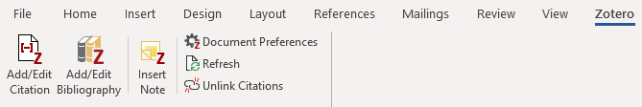

|  |  |
| --- | --- |
| ##Digital-input | ./assets/02_introduction_to_docx/ |
| ##Paper-input | ./assets/02_introduction_to_docx/ |
| ##Source | Snapshot of PC screen of Paweł Kamiński showing features of MS Word |
| ##Author | Paweł Kamiński |
| ##Alt-text | MS Word top pane showing Zotero tab open in a MS Word ribbon |

#### How To Add/Edit A Citation

Please follow the [Zotero plugin instructions](https://www.zotero.org/support/word_processor_plugin_usage) on how to add and/or edit your citations.

You can begin citing with Zotero by clicking the “Add/Edit Citation” button. Pressing the button brings up the citation dialog. The citation dialog is used to select items from your Zotero library, and create a citation. Start typing part of a title, the last names of one or more authors, and/or a year in the dialog box. Matching items will instantly appear below the dialog box.

#### How To Check If Your Citation Is Valid

A valid citation should be an active field, which can be updated, edited and to which you can toggle field codes to see their internals (see figure Figure 5). Do not use those options for editing – for that purpose use the “Add/Edit Citation” button on the top left corner of the MS Word “Zotero” tab. Please do not, under any circumstances, unlink your Zotero citations as this will irreversibly break them.

**Figure 13:** A valid Zotero citation should be an active field. After right-clicking it you should see options like “Toggle Field Codes” (this option will allow you to see the internal data of your citation).

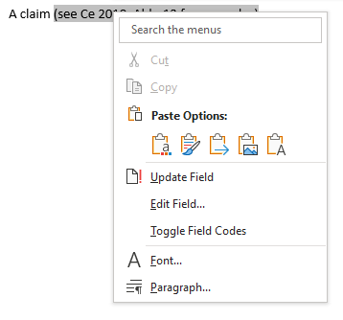

|  |  |
| --- | --- |
| ##Digital-input | ./assets/02_introduction_to_docx/zotero-citation-as-an-active-field.png |
| ##Paper-input | ./assets/02_introduction_to_docx/zotero-citation-as-an-active-field.png |
| ##Source | Snapshot of PC screen of Paweł Kamiński showing features of MS Word |
| ##Author | Paweł Kamiński |
| ##Alt-text | A citation in MS Word with right click menu open |

#### Document Preferences

You can always change options of your citations by setting the Document Preferences. In particular, you can change the citation style, language, whether the citations are displayed as footnotes or endnotes, etc. Please set your Zotero style to Chicago Manual of Style (17th edition, author-date style).

:::{important}  
In the “Store Citations as” document preferences, we recommend using the Fields option. Storing your citations as bookmarks may not render correct result.  
:::

By default, your citation will be rendered how you, the author, added it. Please note however that your document preferences might be overwritten by the platform. For example, a different citation style may be chosen by the publisher.

#### Bibliography

Please do not add a bibliography manually. The bibliography will be automatically generated for you. Creating a bibliography on your own will duplicate an already existing one.

1. Unknown Author
2. To insert a footnote in MS Word, you may click the “Insert Footnote” button or use the “Alt + Ctrl + F” key combination.