A longitudinal dataset of multi-platform video game digital trace data and psychological assessments
Nick Ballou
Tamás Andrei Földes
Matti Vuorre
Thomas Hakman
Kristoffer Magnusson
Andrew K Przybylski
Abstract
A major limitation to understanding digital technology use, and its potential psychological consequences, is the lack of sufficiently detailed, multidimensional, and accurate data. We present a dataset of 2.0K individuals’ video game play telemetry data from Nintendo Switch, Steam, and Xbox, paired with psychological assessments across multiple dimensions of mental health, motivations, well-being, and cognitive ability. The data were collected over 12 weeks that included fourteen daily assessments, six biweekly surveys, three biweekly cognitive tests, and play telemetry for X months. The data include X hours of video game play across X titles, X responses to X survey instruments, and X attention ability measures to facilitate examining longitudinal associations between play behaviors and psychological functioning. Data and codebook are available under a CC0 license at https://example.com.

Introduction
Digital trace data—behavioral logs automatically collected by digital devices and online platforms—are necessary to better understand technology use and its psychological and health effects (Burgess et al., 2024; Freelon, 2014; Griffioen et al., 2020). Self-reports of technology use do not accurately reflect objective technology use (Parry et al., 2021; Sewall & Parry, 2021), and are unsuitable for examining many phenomena of interest, such as seasonal patterns over long temporal horizons; high-frequency behavioral analysis at the level of hours, minutes, or even seconds; historical content analysis; and others due to limited accuracy and temporal resolution. Moreover, when technology use’s relations to psychological survey instruments are of interest, digital trace data removes the possibility of common methods bias.
To combat these issues, digital trace data is increasingly used in studies of smartphone and social media use (e.g. Sewall et al., 2022), but less so in studies of video game play—one of the world’s foremost leisure activities (Entertainment Software Association, 2024; Ofcom, 2023). Trace data in video games primarily falls under the field of game analytics or data science, but (1) the majority of these studies involve the use of proprietary data that is not publicly shared, and (2) the focus of this field tends to be more on player behavior metrics with clear industry value rather than academic inquiry for the common good.
Where trace data has been used in video games studies, it has largely been limited to a few games (Johannes et al., 2021; Larrieu et al., 2023; Perry et al., 2018; Vuorre et al., 2022) or single platform (Ballou et al., 2023, 2025). However, players commonly play many games on multiple platforms. Moreover, the scope of psychological attributes in these studies tends to be limited to e.g. a small set of well-being outcomes.

Current dataset
Here, we present a longitudinal dataset of digital trace data across multiple gaming platforms consisting of 2.0K participants, 18.8K daily surveys, 7.0K surveys, and a total of 1.2M of gameplay distributed across 1.3M. Digital trace data was sourced for five distinct platforms—Xbox, Nintendo, Steam, iOS, and Android—through distinct piplines detailed below. The data collection methods were preregistered as part of a Stage 1 registered report (https://osf.io/pb5nu).
The dataset is openly available under a CC0 license at https://example.com for unrestricted reuse. Table 1 shows a high-level overview of the dataset.
Table 1: Overview of the dataset and sources.
Data type | Participants | Events | Hours | Avg events / participants | Avg active days
Intake survey | 33,082 | 34K |  | 1.0 | 1.0
Daily surveys | 1,297 | 19K |  | 14.5 | 14.5
Biweekly surveys | 1,973 | 7K |  | 3.6 | 3.6
Steam | 2,738 | 306K | 254K | 111.7 | 27.7
Nintendo | 1,802 | 382K | 214K | 212.0 | 76.9
Xbox | 329 | 630K | 780K | 1.9K | 533.6
Winsorized at 99th percentile

Method

Design
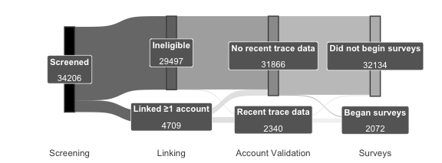
Figure 1: Participant flow during study intake.
The study consisted of four stages (Figure 1).

Stage 1: Screening
In the first stage, we screened participants in order to find people aged 18-40 who (1) self-report playing video games, (2) self-report that at least 50% of their total video game play takes place on the platforms included in the study, and (3) were willing to link their gaming accounts to provide digital trace data. We screened participants from two panel sources: PureProfile and Prolific.
Participants were recruited under an initial set of ethnicity‐based quotas designed to mirror the general population’s demographic composition. After we reached approximately 50% of our target sample under quota constraints and found that further quota‐eligible recruits were scarce, we suspended the quotas for the remainder of data collection; all subsequent participants were enrolled on a first‐come, first‐served basis. Final sample characteristic reflect both quota‐driven and open‐enrollment phases (see below).

Stage 2: Account Linking
Participants who were deemed eligible during screening proceeded directly to an account linking survey wherein they provided details of the gaming platforms they actively use. For UK participants, this includes Nintendo Switch, Steam, Android and iOS. For US participants, this includes the same four alongside Xbox. Details of how participants linked each type of account are shown in Table 2.
Table 2: Platform Details
Platform | Data Source | Account Linking Process | Type of Data Collected
Nintendo | Data-sharing agreements with Nintendo of America (US) and Nintendo of Europe (UK) | Participants share an identifier contained within a QR code on Nintendo web interface. Nintendo of America/Europe uses this identifier to retrieve gameplay data and share it with the research team.ª | Session records (what game was played, at what time, for how long) for 1st party games (games published in whole or in part by Nintendo, but not by third party publishers such as Electronic Arts).^{b}
Xbox (US only) | Data-sharing agreement with Microsoft | Participants consent to data sharing by opting in to the study on Xbox Insiders with their Xbox account. Microsoft retrieved gameplay data for all consented accounts, and shares it with the research team in pseudonymized form.^{c} | Session records (what game was played, at what time, for how long). The name of the game replaced with a random persistent identifier for all third-party games (i.e., those not published by Xbox Game Studios), but genre(s) and age ratings are shared.
Steam | Custom web app (Gameplay.Science) | Participants sign up for Gameplay.Science (https://gameplay.science), an o pen-source platform for tracking Steam gameplay. Participants consent to have their gameplay data monitored for the duration of the study. Their Steam ID is authenticated using the official Steam authentication API (OpenID). | Incremental playtime per game (every hour, the total time spent playing during the previous hour)
iOS | iOS Screen Time Screenshots | In each biweekly survey, participants submitted screenshots from the built-in iOS Screen Time app. These show details of the previous 3 weeks’ of gaming app use (what games were played and for how long). Data was extracted using OCR. | Total weekly playtime per game (e.g., 2 hours on game X, 5 hours on game Y)
Android | Digital Wellbeing Screenshots | In each biweekly survey, participants submitted screenshots from the Digital Screen Time app, if available on their Android OS. These show details of the previous 3 weeks’ of phone use (what app categories are used and for how long). Data was extracted using OCR. | Total weekly playtime per game (e.g., 2 hours on game X, 5 hours on game Y)
ª See https://accounts.nintendo.com/qrcode.
^{b} In previous research, Nintendo-published games accounted for 65% of Switch playtime [@BallouEtAl2025Perceived].
^{c} See https://support.xbox.com/en-US/help/account-profile/manage-account/guide-to-insider-program.

Stage 3: Account Validation
After players completed the account linking process, we checked each account for evidence of valid gaming—specifically, records of active gameplay sessions on one or more of Steam, Xbox, and Nintendo within the 2 weeks before survey completion. Participants who did not have recent, valid telemetry on any console platform were excluded from the rest of the study.

Stage 4: Surveys
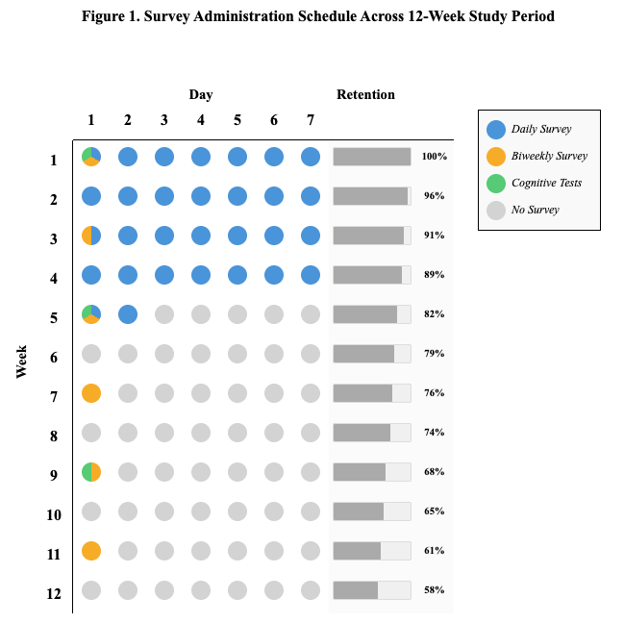
Figure 2
Eligible participants were invited to complete 6 waves of biweekly surveys, one every two weeks (Figure 2). US participants were additionally invited to complete daily surveys for 30 days, concurrently with the first biweekly surveys. During waves 1, 3, and 5, a cognitive task was also administered within the biweekly survey.
Daily survey links were sent every day at 2pm local time for the participant and remained available until 3am. Biweekly survey links were sent every second week from the first day of the study at 12pm and remained available for 96 hours.

Participants
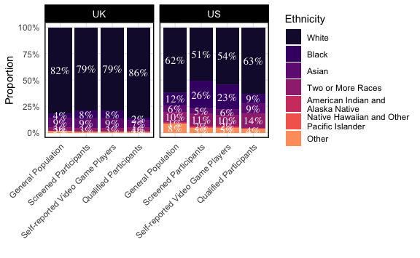
Figure 3
Our final sample consists of 2340 qualified participants, selected from a pool of 34206 screened participants. Of the 2340 with recent telemetry, 1973 also completed at least one survey.
Our screening sample was roughly representative of the general population of the US and UK by ethnicity (Figure 3) and gender identity: Man (16677, 47.8%); Other (536, 1.2%); Woman (16853, 51%).
The sample of qualified participants is less representative of the general population, containing more men and non-binary participants: Man (1514, 64.7%); Other (153, 6.5%); Woman (673, 28.8%), as well as fewer black participants (Figure 3). However, the demographics of console video game players are not well-understood; it is likely that our sample more closely represents this population than the general population.

Ethics and Compensation
This study received ethical approval from the Social Sciences and Humanities Inter-Divisional Research Ethics Committee at the University of Oxford (OII_CIA_23_107). All participants provided informed consent at the start of the study, including consent to their data being shared openly for reanalysis.
Prolific participants were paid at a rate of £12/hour for all study components, which equates to: £0.20 for a 1-minute screening, £2 for the 10-minute intake survey (plus £5 for linking at least one account with recent data), £0.80 for each 4-minute daily survey, and £2 for each 10-minute biweekly survey. Participants received £10 bonus payments for completing at least 24 out of 30 daily surveys and/or 5 out of 6 biweekly surveys.

Demographic measures
We collected the following demographic variables:
- age
- gender
For all participants who were eligible based on self-reported video game play (but who did not always successfully linked accounts), we additionally collected the following
- ethnicity
- educational attainment
- employment status
- height and weight
- self-identified neurodivergence (e.g., ASD, ADHD, dyslexia)
- political party affiliation
- diagnosed neurodivergence
- marital status
- caretaking responsibilities (children, family members)
- postal geography (general area only; first three digits of the five-digit US ZIP Code; UK outward code)

Self-report measures

Trait or traitlike measures
Table 3: Trait or traitlike measures assessed only once
Construct | Measure | Example Item | Response Format
Chronotype | Munich Chronotype Questionnaire [@RoennebergEtAl2003Life] | I go to bed at… | Times and numbers of minutes
Big 5 Personality | BFI-2-XS [@SotoJohn2017short] | I am someone who…is compassionate, has a soft heart. | 5-pt Likert scale from 1 (Disagree strongly) to 5 (Agree strongly)
Player Trait Typology | Trojan Player Typology [@KahnEtAl2015trojan] | It’s important to me to play with a tightly knit group. | 5-pt Likert scale from 1 (Strongly disagree) to 5 (Strongly agree)
Gaming Disorder Symptomsª | Gaming Disorder Test [@PontesEtAl2019measurement] | In the past 3 months…I have had difficulties controlling my gaming activity. | 5-pt Likert scale from 1 (Never) to 5 (Very often)
ª Measured twice, at biweekly waves 1 and 6.

Daily measures
Table 4: Self-report measures in the daily surveys
Construct | Measure | Example Item | Response format
Basic psychological need satisfaction and frustration - life in general | Basic Psychological Need Satisfaction and Frustration Scale [@ChenEtAl2015Basic], brief version [@MartelaRyan2024Assessing] | In the last 24 hours…I was able to do things I really want and value in life. | 7-pt Likert scale from 1 (very strongly disagree) to 7 (very strongly agree)
Basic psychological need satisfaction and frustration - video games | Basic Needs in Games scale [@BallouEtAl2024Basic], brief session-level version | In my most recent session of X…I felt disappointed with my performance. | 7-pt Likert scale from 1 (very strongly disagree) to 7 (very strongly agree)
Life satisfaction | Cantril Self-anchoring Scale [@Cantril1965pattern], daily version | I was satisfied with my life today. | Visual Analogue Scale from 1 (Strongly disagree) to 100 (Strongly agree)
Affective valence | ad hoc | How are you feeling right now? | Visual Analogue Scale from 1 (very bad) to 100 (very good)
Sleep Quality | Sleep quality item (Item 9) from Consensus Sleep Diary [@CarneyEtAl2012Consensus] | How do you rate the quality of your sleep? | 5-pt Likert scale from 1 (very poor) to 5 (very good)
Stressors | Daily Inventory of Stressful Events [@AlmeidaEtAl2002Daily], modified for digital delivery | [In the last 24 hours], what kinds of stressful event(s) occurred? [Participant selects among 7 options, including e.g. argument or disagreement] | Yes/No, followed by a 4-pt Likert scale from 1 (Not at all stressful) to 4 (Very stressful)
Self-reported displacement | ad hoc | Think back to your most recent gaming session. If you hadn’t played a game, what would you most likely have done instead? | Open response

Biweekly measures
Table 5: Self-report measures in the biweekly surveys
Construct | Measure | Example Item | Response format
General Mental Wellbeing | Warwick-Edinburgh Mental Wellbeing Scale [@TennantEtAl2007warwickedinburgh] | I’ve been feeling optimistic about the future | 5-pt Likert scale from 1 (none of the time) to 5 (all of the time)
Depression symptoms | PROMIS Short Form 8a Adult Depression Scale [@PilkonisEtAl2011item] | In the past 7 days…I felt that I had nothing to look forward to. | 5-pt Likert scale from 1 (Never) to 5 (Always)
Life satisfaction | Cantril Self-anchoring Scale [@Cantril1965pattern] | On which step of [a ladder from 0 to 10 representing the best possible life] would you say you personally feel you stood over the past two weeks? | 10-pt unlabeled scale from 0 to 10
Basic psychological need satisfaction and frustration - video games | Basic Needs in Games scale [@BallouEtAl2024Basic], gaming in general version | When playing video games during the last 2 weeks…I could play in the way I wanted. | 7-pt Likert scale from 1 (very strongly disagree) to 7 (very strongly agree)
Subjective displacement | ad hoc | Over the last two weeks, to what extent has the time you spend playing video games influenced the following areas of your life? […] Work/school performance | 7-pt Likert scale from 1 (greatly interfered) to 7 (greatly supported)

Monthly measures
Table 6: Self-report measures in alternating biweekly surveys
Construct | Measure | Example Item | Response format
Sleep quality | Pittsburgh Sleep Quality Index [@BuysseEtAl1989Pittsburgh] | During the past month, what time have you usually gotten up in the morning? | Various
Daytime sleepiness | Epworth Sleepiness Scale [@Johns1991New] | How likely are you to doze off or fall asleep in the following situations, in comparison to feeling just tired? […] Watching TV | 4-pt Likert scale from 1 (No chance of dozing) to 4 (High chance of dozing)
Harms and benefits of gaming | 2 free text questions | Do you feel that gaming is sometimes a problem for you? Please describe. | Open text

Self-reported play
Social context of play: Participants reported which types of social play they engaged in during the last 24 hours (single-player games only, multiplayer with real-world friends, multiplayer with online-only friends, multiplayer with strangers). Participants could select more than one option.
Self-reported Playtime: In each biweekly survey, participants estimated the time they spent playing games on platforms they had linked during the study (e.g., excluding other platforms such as Playstation) in each of the following periods: last 24 hours, last 7 days, and last 14 days.
Self-reported recent sessions: In each biweekly survey, participants reported details of at least 1 and up to 3 of their most recent gaming sessions (game, date, and start/end time).

Digital Trace Data
As described above, we collected video game play data from five platforms: Xbox, Nintendo Switch, Steam, iOS, and Android (full details in Table 2). To recap, on Xbox and Nintendo, we have session-level data, characterized by the following fields: a game ID (Xbox) or title (Nintendo), a start and end time, and genre(s). On Steam we have hourly aggregates - every hour, how much time people spent playing for all games they played in that hour. On iOS and Android, we have daily aggregates - every day, how much time people spent playing each game. We describe each platform in more detail below. For concision, we do not repeat the details of Table 2 in here, but direct readers to that table or our supplementary materials for the exact variables in each platform’s trace data.
All telemetry timestamps are stored as UTC, but can be converted to the participant’s local time using the local_timezone variable.

Attention Control
In study waves 1, 3, and 5 we measured participants’ attention control using the Simon Squared task of Burgoyne et al. (2023), using modified code from Liceralde & Burgoyne (2023). Although the original Squared tasks consist of the Simon, Stroop, and Flanker Squared, due to limited participation time we chose to only use the Simon Squared task as it had the greatest factor loading on attention control in the original study (Burgoyne et al., 2023).
The Simon Squared task is a short and validated measure of attention control that follows the standard Simon task (Simon & Rudell, 1967) but is completed in about three minutes. Participants see a target arrow pointing either left or right, with response labels “LEFT” and “RIGHT” printed underneath. Participants then must select the response option (e.g. “LEFT”) that matches the arrow’s direction (e.g. ◀︎). However, the arrow and response options can appear on either side of the screen, and participants must ignore this spatial configuration and attend only to the symbols’ meanings.
After reading the instructions, participants practice for 30 seconds with auditory and text feedback for response accuracy. They then see their score from the practice trials, review the instructions again, and are given 90 seconds to gain as many points as possible. Participants gain one point for each correct response, and lose one point for each incorrect response. After the 90 seconds, the number of correct responses minus the number of incorrect responses is the participant’s task score. For a complete task description, see Burgoyne et al. (2023) and Figure 6 therein.

Time Use
TODO

Data Quality Checks
We implemented a variety of data quality checks.
- In each daily and biweekly survey, one item from the BANGS (daily) and BPNSFS (biweekly) was duplicated to assess response consistency (Meade & Craig, 2012); participants whose responses to the two identical items differed by more than one scale point were flagged for potential careless responding.
- In the telemetry, we use several heuristics to identify potential unreliable sessions: sessions beginning or ending in the future (indicative of clock manipulation or other errors), sessions longer than 12 hours long, 3 or more games being played simultaneously [TODO: other heuristics]
- In the time use, we flag any cases with fewer than 5 distinct activities logged in a day, or that are missing any

Missingness
TODO - figure
TODO - text

Dataset
Here we visualize key aspects of the data to provide an overview of its contents and properties.
Figure 4 compares the average self-reported distribution of play across platforms to the distribution in our digital trace data capture. It is vital to note that the self-report data not be treated as ground truth: we have good evidence that people’s self-reports of media use are inaccurate (Kahn et al., 2014; Parry et al., 2021), with some previous work finding systemic overestimation of video game play (Johannes et al., 2021). Nonetheless, it is likely that some portion of player’s true gaming is systematically uncaptured, due to factors such as missing platforms (e.g., Playstation), missing titles (e.g., Nintendo third party), or player privacy settings (e.g., playing in invisible mode; setting certain games to private on Steam).
 Warning
I’m halfway through making changes to the stacked bar chart preprocessing, ignore the actual values.

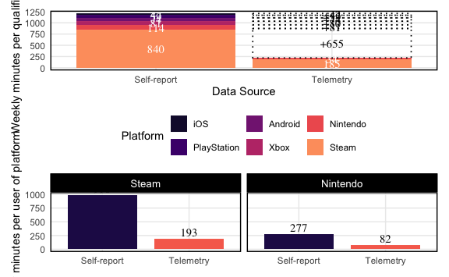
Figure 4
In Figure 5, we visualize the distribution of play across days and times. As expected, we find that the likelihood of play peaks on weekends from 8-11pm, and is lowest in the early morning.
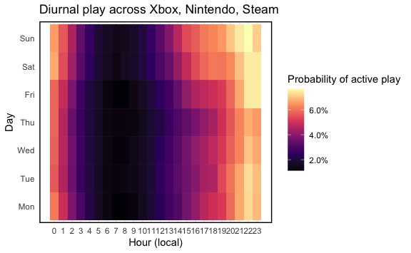
Figure 5
Figure 6 illustrates the temporal dynamics of gaming behavior and mental wellbeing through three representative case studies.
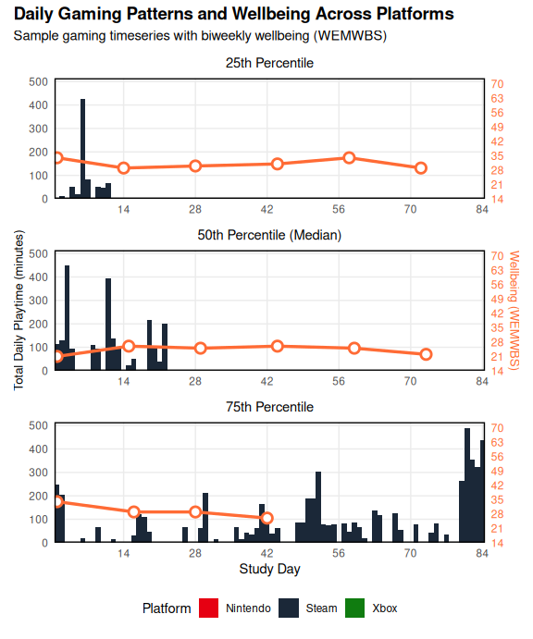
Figure 6: Daily gaming patterns and mental wellbeing for three representative participants. Stacked bars represent total daily playtime across platforms (Nintendo in red, Steam in dark blue, Xbox in green). Orange line shows biweekly mental wellbeing scores (WEMWBS, range 14-70) measured at six study waves. Participants were selected as closest representatives of the 25th, 50th, and 75th percentiles of total playtime distribution across the full 84-day study period.

Attention control
Overall, 1092, 991, and 800 participants completed the Simon task at panel waves 1, 3, and 5. The average performances were approximately 10 points lower than in the in-person study of Burgoyne et al. (2023) (Figure 16). Participants on mobile devices generally attained lower scores than those not on mobile devices (Figure 7, rows), but performance was generally stable across the three waves (Figure 7, columns).
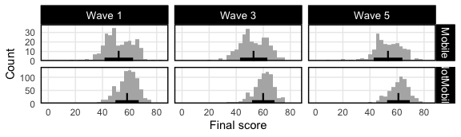
Figure 7: Histograms of participants’ Simon Squared task scores across study waves. Points and bars indicate means ±1 standard deviation.

Discussion
We believe this dataset has potential to address a wide variety of common research questions in the field.
Some of these questions will be addressed in forthcoming registered reports: specifically, we have plans to test (1) key hypotheses from the Basic Needs in Games model (Ballou & Deterding, 2024) about how gaming relates to basic psychological needs over time, (2) the relationship between late-night gaming and sleep, and (3) the relationship between playtime in different genres and wellbeing.
Nonetheless, the richness of this data means that researchers can explore numerous other questions (or, indeed, conduct and compare alternative analysis approaches to the above questions). To stimulate ideas, we present a few questions we think the data are well-suited to answering.
How do seasons and weather impact playtime? Because we capture time-stamped play sessions alongside participants’ geographic locations, researchers can merge in high‐resolution weather and daylight data to examine how environmental factors causally influence gaming behavior. Causal inference techniques such as inverse probability weighting can enable precise estimates of how, when, and how much people play in response to seasonal and meteorological changes. By quantifying these effects, researchers can better distinguish weather‐related demand from other drivers (like work schedules or weekend routines), improving the precision of studies on gaming’s impact on wellbeing, motivation, and cognition.
How do neurotypical and neurodiverse players differ in their gaming behavior? Using the neurodivergence data we collected (which includes, for example, 422 participants who identify as having autism and 569 who identify as having ADHD), researchers can. Neurodiversity in games has regularly been studied in the context of specific games and with qualitative methods
Accuracy of self-reported data - inference from other papers
We encourage researchers from a wide range of disciplines to explore these or other questions using the data we present, which is freely available for reuse under a CC0 license.

Limitations
While this dataset represents a substantial step forward in holistic coverage of video game play, it remains imperfect: we did not capture data on PlayStation (~19% of gaming market) or computer games played outside the Steam platform (~11% of gaming market); on Nintendo, we do not have access to third-party titles (42% of Nintendo play), and our coverage of smartphone play is limited by the difficulties and inconsistencies of screenshot-based donation and OCR retrieval.
We further are unable to identify idle time (when players have a game open but are not actively playing it) and account sharing (when players let friends or family use their account); some playtime values may therefore be overestimates of the person’s true playtime, though we are unable to say by how much.

Future Work
The trace data presented here is broad in scope but limited in granularity: we capture all gaming activity on a given platform, but not what happens within individual games. Prior work and theory make clear that in-game behaviors (e.g., what role a player adopts, whether they compete or cooperate, or how they perform in competitive modes) are critical determinants of player experience and thereby wellbeing (see e.g., Elson et al. (2014) for a review of how in-game contexts shape effects). This highlights a fundamental trade-off in digital trace research between breadth—how comprehensively play can be captured across platforms—and depth—the granularity of in-game behaviors and experiences. At present, our dataset emphasizes breadth, but we see strong potential in future study designs that combine platform-level telemetry with targeted in-game behavioral data to provide a more complete picture.
We also see strong potential in combining digital trace data with experimental designs that enable stronger causal inference—for example, randomizing players to single-player games only, or restricting play to certain times of day, to examine effects on social wellbeing or sleep. Previous researchers have noted a dearth of digital trace data-backed field experiments, while highlighting their potential (Stier et al., 2020): Trace data not only captures naturalistic gaming behavior but also allows researchers to assess substitution (what games or platforms participants switch to under intervention) and adherence (how closely they follow assigned play patterns).

Data Availability
All data, materials, and code related to the dataset and this manuscript are available under CC0 at https://example.com.

References
Ballou, N., & Deterding, S. (2024). The Basic Needs in Games Model of Video Game Play and Mental Health. Interacting with Computers, iwae042. https://doi.org/10.1093/iwc/iwae042
Ballou, N., Sewall, C., Ratcliffe, J., Zendle, D., Tokarchuk, L., & Deterding, S. (2023). Gaming and wellbeing: A panel study of objectively tracked playtime. https://doi.org/10.17605/OSF.IO/EDTWN
Ballou, N., Vuorre, M., Hakman, T., & Przybylski, A. K. (2025). Perceived value of video games, but not hours played, predicts mental well-being in casual adult nintendo players. Royal Society Open Science, 12, 241174. https://doi.org/https://doi.org/10.1098/rsos.241174
Burgess, R., Dolan, E., Poon, N., Jenneson, V., Pontin, F., Sivill, T., Morris, M., & Skatova, A. (2024). The Potential of Digital Footprint Data for Health & Wellbeing Research. Pre-published. https://doi.org/10.31234/osf.io/9jgn2
Burgoyne, A. P., Tsukahara, J. S., Mashburn, C. A., Pak, R., & Engle, R. W. (2023). Nature and measurement of attention control. Journal of Experimental Psychology: General, 152(8), 2369–2402. https://doi.org/10.1037/xge0001408
Elson, M., Breuer, J., Ivory, J. D., & Quandt, T. (2014). More Than Stories With Buttons: Narrative, Mechanics, and Context as Determinants of Player Experience in Digital Games: Narrative, Mechanics, and Context in Digital Games. Journal of Communication, 64(3), 521–542. https://doi.org/10.1111/jcom.12096
Entertainment Software Association. (2024). 2024 essential facts about the u.s. Video game industry. https://www.theesa.com/wp-content/uploads/2024/05/Essential-Facts-2024-FINAL.pdf
Freelon, D. (2014). On the Interpretation of Digital Trace Data in Communication and Social Computing Research. Journal of Broadcasting & Electronic Media, 58(1), 59–75. https://doi.org/10.1080/08838151.2013.875018
Griffioen, N., Rooij, M. van, Lichtwarck-Aschoff, A., & Granic, I. (2020). Toward improved methods in social media research. Technology, Mind, and Behavior, 1(1). https://doi.org/10.1037/tmb0000005
Johannes, N., Vuorre, M., & Przybylski, A. K. (2021). Video game play is positively correlated with well-being. Royal Society Open Science, 8(2), rsos.202049, 202049. https://doi.org/10.1098/rsos.202049
Kahn, A. S., Ratan, R., & Williams, D. (2014). Why We Distort in Self-Report: Predictors of Self-Report Errors in Video Game Play. Journal of Computer-Mediated Communication, 19(4), 1010–1023. https://doi.org/10.1111/jcc4.12056
Larrieu, M., Fombouchet, Y., Billieux, J., & Decamps, G. (2023). How gaming motives affect the reciprocal relationships between video game use and quality of life: A prospective study using objective playtime indicators. Computers in Human Behavior, 147, 107824. https://doi.org/10.1016/j.chb.2023.107824
Liceralde, V. R. T., & Burgoyne, A. P. (2023). Squared tasks of attention control for jsPsych. https://doi.org/10.5281/zenodo.8313315
Meade, A. W., & Craig, S. B. (2012). Identifying careless responses in survey data. Psychological Methods, 17(3), 437–455. https://doi.org/10.1037/a0028085
Ofcom. (2023). Online Nation 2023 Report (p. 106). https://www.ofcom.org.uk/siteassets/resources/documents/research-and-data/online-research/online-nation/2023/online-nation-2023-report.pdf?v=368355
Parry, D. A., Davidson, B. I., Sewall, C. J. R., Fisher, J. T., Mieczkowski, H., & Quintana, D. S. (2021). A systematic review and meta-analysis of discrepancies between logged and self-reported digital media use. Nature Human Behaviour, 5, 1535–1547. https://doi.org/10.1038/s41562-021-01117-5
Perry, R., Drachen, A., Kearney, A., Kriglstein, S., Nacke, L. E., Sifa, R., Wallner, G., & Johnson, D. (2018). Online-only friends, real-life friends or strangers? Differential associations with passion and social capital in video game play. Computers in Human Behavior, 79, 202–210. https://doi.org/10.1016/j.chb.2017.10.032
Sewall, C. J. R., Goldstein, T. R., Wright, A. G. C., & Rosen, D. (2022). Does Objectively Measured Social-Media or Smartphone Use Predict Depression, Anxiety, or Social Isolation Among Young Adults? Clinical Psychological Science, 10(5), 997–1014. https://doi.org/10.1177/21677026221078309
Sewall, C. J. R., & Parry, D. A. (2021). The Role of Depression in the Discrepancy Between Estimated and Actual Smartphone Use: A Cubic Response Surface Analysis. Technology, Mind, and Behavior, 2(2). https://doi.org/10.1037/tmb0000036
Simon, J. R., & Rudell, A. P. (1967). Auditory S-R compatibility: The effect of an irrelevant cue on information processing. Journal of Applied Psychology, 51(3), 300–304. https://doi.org/10.1037/h0020586
Stier, S., Breuer, J., Siegers, P., & Thorson, K. (2020). Integrating Survey Data and Digital Trace Data: Key Issues in Developing an Emerging Field. Social Science Computer Review, 38(5), 503–516. https://doi.org/10.1177/0894439319843669
Vuorre, M., Johannes, N., Magnusson, K., & Przybylski, A. K. (2022). Time spent playing video games is unlikely to impact well-being. Royal Society Open Science, 9(7), 220411. https://doi.org/10.1098/rsos.220411

Appendix

Deviations from Preregistration
We made several deviations from our preregistration to ensure we could recruit enough high-quality participants to meet our sample size goals. In our view, none are so severe enough to threaten the validity of the study. Deviations are summarised in Table 7.
Table 7: Summary of deviations from preregistration
Preregistered | Actual | Justification for Deviation
All participants sourced from PureProfile | Participants sourced from both PureProfile and Prolific | Exhausted PureProfile participant pool before reaching required sample size
Screening sample would be nationally representative by ethnicity and gender | Approximately 50% of screening was done using quotas for national representativeness by ethnicity and gender; all subsequent sampling used convenience sampling with no quotas | Exhausted participant pools of smaller demographic categories on both Prolific and PureProfile before reaching required sample size
Sample consists of participants aged 18–30 in the US and 18–75 in the UK | Sample consists of participants aged 18-40 in both regions | (1) Unable to recruit enough participants in the US aged 18–30; (2) near-zero qualification rates from UK adults over 50; (3) desire for results from both regions to be more easily comparable
To qualify, ≥75% of a participant’s total gaming must take place on platforms included in the study (Xbox, Steam, Nintendo Switch) | To qualify, ≥50% of a participant’s total gaming must take place on platforms included in the study (Xbox, Steam, Nintendo Switch) | Low rates of study qualification at 75% threshold, in large part due to substantial uncaptured Playstation play
Qualification contingent upon valid telemetry within last 7 days | Qualification contingent upon valid telemetry within last 14 days | Feedback from participants indicating that play during a 7-day period was subject to too many fluctuations (e.g., a busy workweek)
Daily and biweekly surveys sent at 7pm local time | Daily and biweekly surveys sent at 2pm local time | Feedback from participants indicating that evening plans often interfered with survey completion and thus adversely affected response rate
Session-level Android data captured via the ActivityWatch app | Daily-level Android data captured using screenshots of the Digital Wellbeing interface | Restrictions in PureProfile’s privacy policy preventing installation of 3rd party apps; technical challenges in supporting users with the installation and data export

