# How we investigated a viral video that incited murder

Surya Mattu and Micha Gorelick

Digital Witness Lab investigated the spread of an edited video of a Gauri Lankesh speech on social media, including YouTube, Facebook, and Twitter. Our goal was to gauge the role the video played in fueling the [right-wing Hindu animosity towards her that ultimately lead to her murder](https://theprint.in/india/governance/gauri-lankesh-murder-sit-chargesheet-names-sanatan-sanstha-as-organisation-behind-crime/153853/).

Our investigation found that the video had been shared on Facebook, YouTube and Twitter prior to her murder. As of writing, the video has received more than 130 million interactions on Facebook and more than 250,000 views on YouTube. While overall engagement was low on Twitter, there were several instances of the video being shared before her death, including by a Bajrang Dal activist who had been linked to several acts of violence and online hate speech. We also found instances of the video being shared by right-wing activists on Twitter and the BJP Karnataka’s Facebook page before she was murdered, though public interaction with those posts was low. We were unable to investigate the spread on WhatsApp due to the lack of any publicly available tools to measure historical activity.

This investigation was conducted in support of Forbidden Stories’ investigation into her murder. Read the Forbidden Stories investigation [TK LINK].

## Background

Gauri Lankesh was murdered by gunmen outside her home on Sept. 5, 2017. She was an outspoken journalist from Bangalore who was critical of right-wing Hindu extremism. One of the men who admitted to murdering her said he did so to [save his religion](https://timesofindia.indiatimes.com/india/i-killed-gauri-lankesh-to-save-my-religion-waghmore-to-sit/articleshow/64608133.cms).

The officials charged with investigating her murder found a video from YouTube downloaded onto one of the murders laptops. Local police sources said it was one element in a “gradual indoctrination” process. The video is a 5-minute excerpt of a 30-minute speech in which she discusses the plurality of Hinduism.

In their reporting, Forbidden Stories found that of the four copies of this video that existed on YouTube, two had been uploaded prior to her murder. The earliest of them, titled “Real Face of SECULARISM,” was uploaded on Aug. 8, 2012. Thanks to the [Internet Archive](https://web.archive.org/web/20120816225030/http:/www.youtube.com/watch?v=JFsbhGoBCAI&gl=US&hl=en), we know the video had been viewed more than 250,000 times between Aug. 8, 2012 and April 2019. This copy of the video was taken down sometime between 2019 and 2021. Of the remaining three videos Forbidden Stories found, one had been uploaded before her murder and is still available online.

Fig: Screenshot of the earliest Internet Archive capture of the video titled “Real Face of SECULARISM – Gouri Lankesh Speech against Hindus” with YouTube id JFsbhGoBCAI.

We sought to understand how this video spread on social media prior to her murder.

## YouTube Analysis

First, to get a sense of how many copies of this video had been circulated, we turned to YouTube, which is the most common platform for video sharing It quickly become clear that searching for the video on YouTube using her name and the title of the video was insufficient for this task. As of this writing, that query returns [only one relevant result](https://www.youtube.com/results?search_query=Real+Face+of+SECULARISM+Gouri+Lankesh) that was uploaded after her murder, even though we have evidence [of other videos](https://www.youtube.com/watch?v=aS_KnD8-KcI) on the platform with very similar titles. The first copy of the video we found on the Internet Archive had been taken down from the platform, and the account that had uploaded it also no longer exists. Because YouTube did not respond to our request for information about the video and its uploaders, we searched for public archives of the platform and came across the Internet Archive’s [YouTube metadata dataset](https://archive.org/details/Youtube_metadata_02_2019).

The metadata collection is a 1.1 TB dataset containing metadata on 1.4 billion YouTube videos that had been collected in February 2019. Given that the earliest video had not been taken down until April 2019, we felt this dataset could provide some insight into spread of this video on the platform.

We searched through the data looking for:

* Videos that contained Lankesh’s name and the terms ‘real’, ‘face’ and ‘secularism’ in that order
* Videos that contained the words ‘lankesh’, ‘hindu’ and ‘hate’ in any order
* Videos that were the same length as the first video or were between 300 and 328 seconds

This search resulted in 3374 matches with 95 videos matching at least two search criteria.

After manually reviewing these results, we narrowed it down to 8 matches. Four of these were the videos that Forbidden Stories had found in their reporting; the other four had not been identified by Forbidden Stories. Of the eight videos, four have been taken down and six were uploaded after her death. It is possible that there were other copies of this video that were not surfaced by our search criteria.

The oldest video from Aug. 8, 2012 with the id *JFsbhGoBCAI* made-up 90% of views across all eight videos. If these numbers are accurate, it means the original video had the greatest number of views and the video did not spread very widely directly on YouTube.

To get a better understanding of how these videos were shared across the web, we turned to Facebook, which is very popular in India.

## Facebook Analysis

For our analysis into the spread of the “Real Face of Secularism” video on Facebook, we used CrowdTangle to see how each of the eight YouTube video URLs listed above was disseminated on the platform.

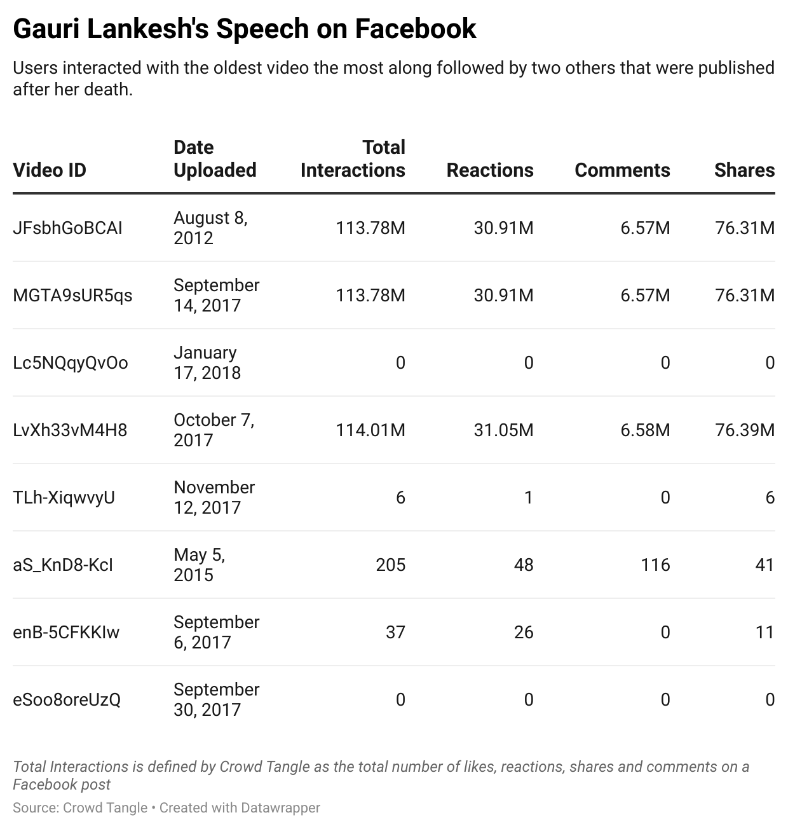

Of the four videos that had been taken down on YouTube by 2019, three had gotten more than 113 million Facebook interactions each. Like on YouTube, the most popular of these was the oldest video that was uploaded on Aug. 8, 2012, with id *JFsbhGoBCAI*. Collectively, posts that referenced this video garnered more than 30 million reactions, 6.5 million comments and 76 million shares, according to CrowdTangle.

Even though the video’s Facebook activity metrics were in the millions, the tool only surfaced three public Facebook posts that linked to it. This seems unusual, and we do not have a good explanation for why this is the case. According to CrowdTangle, Facebook Activity metrics­ include aggregated data from all public and private Facebook posts that reference a particular URL. Our hypothesis is that Facebook has likely taken down most of the posts that shared this video, and many of the shares likely happened in private posts that CrowdTangle does not surface.

Fig: Screenshot of CrowdTangle interface showing engagement metrics for the video that was uploaded on YouTube on Aug. 8, 2012.

Of the three public posts that link to this video that are still surfaced by CrowdTangle, only one of them is from before Lankesh’s murder. That post was shared by the official BJP Karnataka page on Oct. 13, 2014, and can [still be viewed](https://www.facebook.com/486980998032652/posts/806035759460506) as of this writing. It did not have much engagement, with only 11 comments, 26 shares and 30 likes.

Fig: Screenshot of the BJP Karnataka page’s post from 2014 that links to the Aug. 8, 2012 video.

Since a vast quantity of the interactions with the video took place in private posts or public posts that have since been taken down, the precise number of views this video received is hard to measure.

Next, we looked to see what the spread looked like on Twitter.

## Twitter Analysis

To understand how the “Real Face of Secularism” video was shared on Twitter, we used the Twitter API to search for links to any YouTube videos, Facebook posts, and news articles that mentioned Lankesh, as well as links to any of the eight instances of the YouTube video, posted between early 2006 and the end of 2022. Unlike Facebook, the volume was low. There remain around 486 tweets from that entire period, a third of which were posted before her assassination.

The video first appeared in a [Tweet](https://twitter.com/GarudaPurana/status/233572048058871808) by user GarudaPurana on Aug. 9, 2012. The Tweet links to the oldest video uploaded to YouTube with id *JFsbhGoBCAI* and was posted one day after the video was uploaded. The link is from a domain belonging to Facebook, indicating that the user shared the video from there.

Fig: Screenshot of the first tweet to link to the video on twitter

The @GarudaPurana account belongs to Bhuvith Shetty, a known Bajrang Dal activist who was arrested in 2015 for a tweet linked to the murder of Kannada scholar M. M. Kalburg and was again arrested later that year for his alleged involvement in the killing of Harish Poojary, a 28-year-old Hindu. In 2015 he also started a [change.org petition](https://www.change.org/p/chief-minister-arrest-gauri-lankesh-and-make-her-apologize-for-hurting-hindu-religious-sentiments) seeking the arrest of Lankesh for “hurting religious sentiments,” which amassed 587 signatures as of the time of writing.

Along with Shetty, there were other users who would periodically resurface the video. While most of the tweets surfaced in our search were posted right after Lankesh’s death, there are several instances of the video being shared before her death, such as when posts about her went viral on social media or when she appeared in the news.

Fig: Number of tweets referencing ‘Faces of Secularism’ videos with annotations for trigger events

|  |  |
| --- | --- |
| **Label** | **Description** |
| First reference of YT video | First tweet containing a reference to the “Face of Secularism” video |
| Lankesh on @headlinestoday | Lankesh appeared on @headlinestoday and there was controversy around her appearance |
| Newsxonline appearance | Lankesh appeared on @newsxonline and there was controversy around her appearance |
| FB Post + Petition | Lankesh wrote a Facebook post that was considered critical of Hinduism, which sparked controversy and led to a change.org petition against her z |
| DK Ravi Suicide | Lankesh wrote an article about D.K. Ravi’s suicide. Though the article was generally well-received, trolls still found a way to be critical of it |
| Tight Slap | Lankesh got into a Facebook argument with D.P. Satish, which was screenshotted and shared |
| Defamation Case | Lankesh was tried and convicted of defamation |
| Assassination | Lankesh was assassinated |

Table: Description of labels in the above graph

Before her assassination, most of the activity on Twitter related to Lankesh and the “Real Face of Secularism” videos came from users with low follower counts who aren’t very active on the platform. This suggests that Twitter didn’t contribute significantly to the spread of this video outside of some echo chambers.

## Limitations

### Incomplete Data

Our estimations for the view counts on YouTube are based on publicly available historical YouTube data. The dataset we used contains metadata on 1.4 billion videos collected in February 2019. While this is certainly a large dataset, it is unclear what proportion it represents of all YouTube videos online at the time. We do know it is an incomplete dataset because two of the original four videos found by Forbidden Stories are not listed in it, even though the videos were live in February 2019.

In addition to the dataset itself being incomplete, our search of the dataset could have similarly been incomplete. While we found four additional videos using various search heuristics, there may be other videos that our query did not match. This could happen, for example, if the titles of the videos significantly changed or if the duration of the videos were changed to add commentary.

Similarly, it is also possible there were other copies of this video that had already been taken down before February 2019. For these reasons, the numbers we present in this report could under-count the actual number of times this video was viewed on YouTube.

### Social Media Analysis Limitations

##### Twitter

The Twitter search results we used may have been incomplete in catching all references to Lankesh on the platform. We experimented with very targeted queries, looking specifically for content that was known to be antagonistic towards Lankesh, as well as very general ones, searching for any references to her name. However, many references to Lankesh could have been made through nicknames or pejoratives that would be difficult to untangle from unrelated conversations on the platform. In addition, we do not have any insight into Tweets that have been deleted or taken down by the platform.

##### CrowdTangle

We relied on CrowdTangle to measure the views this video on Facebook. Currently, this is the only way to calculate the interaction and sharing metrics of content posted to Facebook. While an incredibly useful tool, it has some limitations from the perspective of this analysis. The tool does not provide information on posts that have been removed from the platform, meaning we can’t tell how many of the interactions took place in private posts vs. public posts that have been taken down.

Secondly, we do not have aggregated time series data for the interactions, this means we cannot tell what proportions of the interactions reported by CrowdTangle took place before her death.

Thirdly, there is a lack of clarity on how these numbers are calculated. As stated in [the FAQs page of the platform](https://help.crowdtangle.com/en/articles/2252105-chrome-extension-why-do-the-items-add-up-to-more-than-the-totals): “As for the top Facebook Interactions section, treat it as a reasonable estimate (in most cases) that can be directionally helpful, but whose numbers we don't control and can't guarantee.” It also states that those numbers are not only from public posts, but even include shares via Messenger. We also found that two of the videos that had more than a hundred million interactions (MGTA9sUR5qs and LvXh33vM4H8) had the exact same metrics, raising the possibility that CrowdTangle might be using the same metric counts for two distinct copies of the video.

##### WhatsApp

An important component missing from our investigation is how this video spread on WhatsApp. Given the popularity of the platform in India, it is likely it played a significant role in the spread of this video. However, because of the peer-to-peer nature of the platform and lack of any publicly available tools to measure what spreads on the it, it was not possible of us to investigate this retroactively.

## Conclusion

Using the Internet Archive team’s YouTube Metadata Collection, we found eight copies of the “Real Face of Secularism” video in total, two of which had been uploaded to YouTube before Lankesh’s murder. The oldest video was by far the most popular and had been viewed more than 250,000 times on the platform by April 2019.

We determined the spread of all eight YouTube videos on Facebook using CrowdTangle. Three of the eight videos had more than a million interactions on Facebook, including the video from Aug. 8, 2012. That video was also shared by BJP Karnataka’s official Facebook page in 2014, three years before she was murdered.

Most of the activity on Twitter related to Lankesh and the “Real Face of Secularism” videos was carried out by users with low follower counts who aren’t very active on the platform. This suggests Twitter didn’t contribute significantly to the spread of this video outside of some echo chambers. Even though the activity was low-volume, the data does provide some insight into the community in which it was shared. The original video was shared by a known Bajrang Dal leader on Aug. 9, 2012, just one day after it had been uploaded. That same leader was later arrested for inciting hate and accused of murder. Lack of complete visibilities into the platforms prevented us from capturing a complete picture of the spread of this video