Extracts:

“Before buyers and vendors are able to enter the exchange, they are required to register at the website.” (Radkevitch et al. 2009, p. 400)
“1) an employer posts a CFB to describe the required services, deliverables, and duration; 2) potential service providers browse the website to find suitable CFBs that match their skills and propose bids by entering a reverse auction” (Guo et al. 2017, p. 2)
“A typical form of crowdsourcing is publishing the request for proposals through an online marketplace with the details of the needed service and its expected duration and (a range of) cost. Then potential participants bid on the task by submitting their proposals.” (Gong 2017, p. 301)
“Clients categorize each project into a specific area of expertise (type of work), provide a project description, and propose a budget and end time. Vendors who are registered with the marketplace read the project descriptions and place bids on the basis of price.” (Kathuria et al. 2015, pp. 8–9)
“One critical decision the buyer needs to make when posting a CFB of an auction is to choose a pricing rule (the way the price of the auctioned good or service is determined). Specifically, the buyer can choose to use the fixed-price (FP) mechanism, or the open-price (OP) mechanism.” (Hong et al. 2019, p. 2)
“freelancers [...] search, review projects, prepare proposals and decide which project and how much to bid” (Zheng et al. 2015, p. 2)3
“Sellers apply for the job after finding it from a list of search results based on a self-specified query; the application consists of a written cover letter, price the seller is charging, and the seller’s profile and past job performance is visible to the buyer” (Kabra and Wang 2020, p. 2)
“Having gone through the step of interviewing and selecting a worker from a pool of applicants, employers are expected to bear the responsibility of making bad online hires.” (Chan et al. 2019, p. 2)
“Buyer selects sellers to conduct an interview, and eventually selects one or more sellers to work on this job and contracts are formed” (Kabra and Wang 2020, p. 2)
“Given the limited information about workers, employers usually rely on the observable signals or some heuristics to extrapolate the individual workers capability and effort” (Liang et al. 2018, p. 5)
“At the end of the auction, clients evaluate competing bids on the basis of price and vendor attributes and award projects. [...] A reputation system tracks all feedback ratings a provider receives from historical clients and forms a key attribute of vendors at the time of bid evaluation.” (Kathuria et al. 2015, p. 9)
“Before the bidding period expires, the employer can review bidders’ basic information” (Liang et al. 2017, p. 48)
“The auction automatically closes for bidding after the auction duration expires (e.g., 7 days).” (Hong et al. 2018, p. 3413)
“An auction can fail if the buyer cannot find a satisfactory bid from those received.” (Hong et al. 2019, p. 3)
“There is no obligation for the buyer to allocate the project to any of the vendors, which results in quite a low project allocation rate of 30–40% [39].” (Radkevitch et al. 2009, p. 300)
“the buyer could end the auction early at any time (i.e., the buyer does not need to wait until the full auction duration elapses)” (Hong et al. 2018, p. 3413)
“A firm could then choose a service provider by considering the bidding price, experience, skills, past working relationships and ratings of past work done for other clients.” (Lu et al. 2015, p. 605)
“When a project is awarded, the parties can use a virtual “working space” to communicate, exchange documents, track milestones, and settle payments via an escrow account.” (Radkevitch et al. 2009, p. 300)
“process of performing and completing a task or project, and has three sub-activities or tasks: tasking, coordinating, and self-managing” (Sison and Lavilles 2018, p. 8)
“Clients are also responsible for integrating and implementing the completed jobs into their technology environments.” (Taylor and Joshi 2018, p. 284)

Notes:
- CFB: call-for-bids
- Different terms for client (buyer, firm, ...) and worker (vendor, seller, ...)

Du et al. (2018):

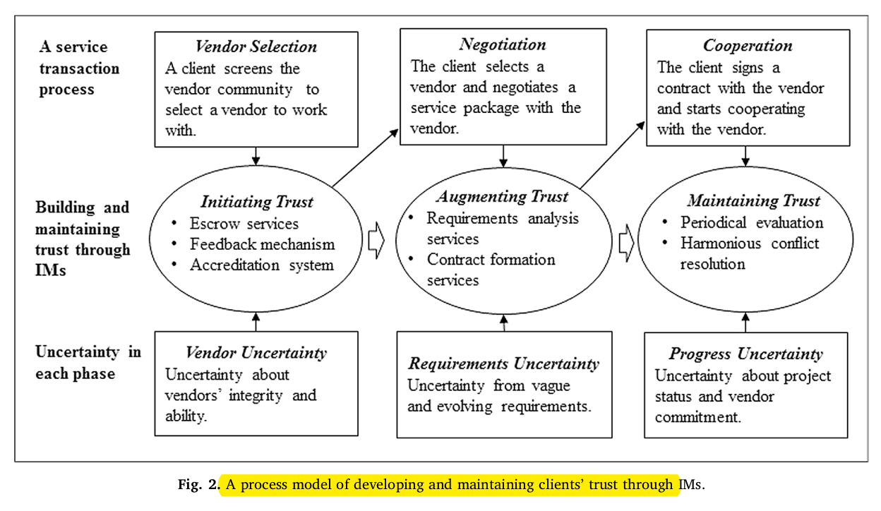
Guo et al. (2017)

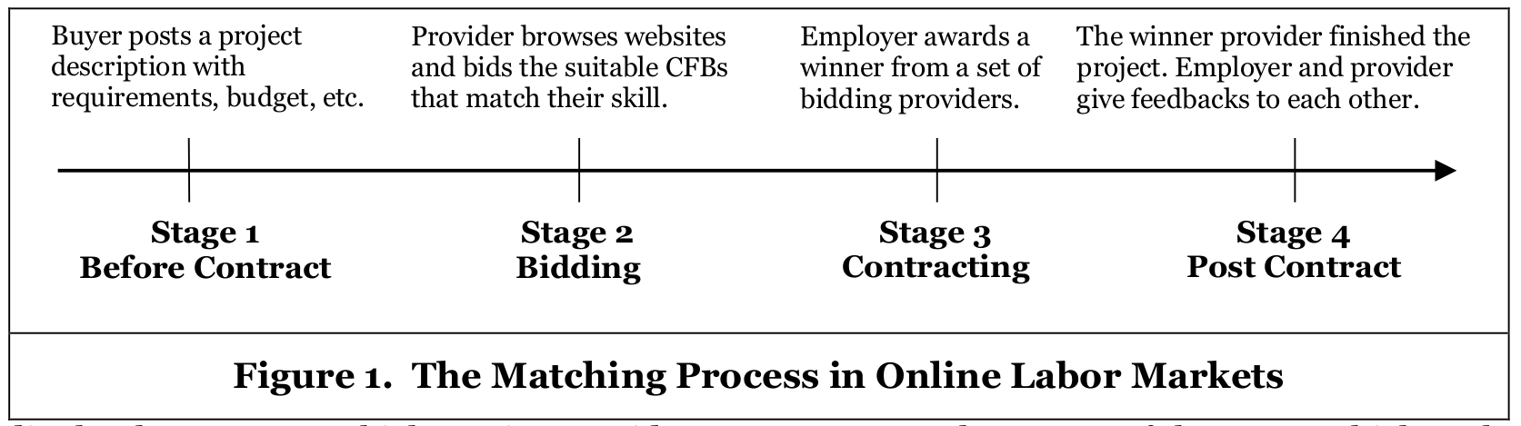
Snir (2003)

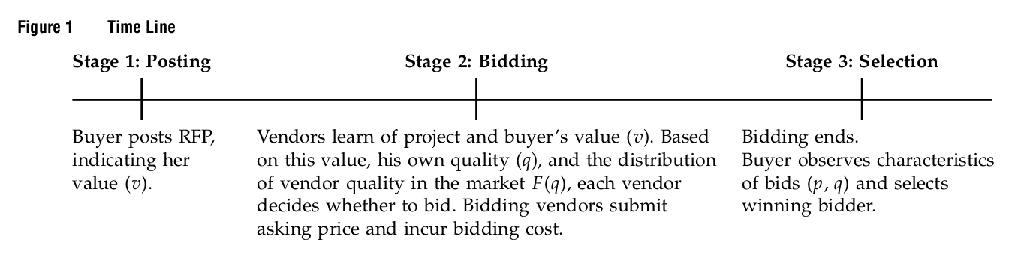
Taylor an Joshi (2018)

